REFLECTIVE REPORT
Z02DT – SOFTWARE AND dATABASES

Student Id:16863845
Student Name:Lazzat Aibekkyzy

Introduction
The below-provided screenshots demonstrate the way in which the system works, providing a friendly and easy-to-use command-line interface. The users may easily navigate between different functional modules and use them for adding new profiles, displaying old profiles, and dealing with data about schools' infrastructure.

From the below-provided screenshots, it is possible to see how the program makes the process easy for users through intuitive prompts and well-organized tables of information. Input validation routines help avoid any crashes because the program deals with input from the user properly.

Thus, it is clear that the program effectively combines technical processes with a friendly interface that is very important for users who may not be technically savvy. Moreover, using menus helps significantly reduce the time needed for performing certain tasks without having any additional skills. Therefore, it is possible to say that the program successfully completes the task of creating a ready-to-use tool for managing profiles.

Findings and Analysis

Software Development LifeCycle (SDLC)
Software development life cycle (SDLC) includes various methods for approaching software development such as Waterfall, Agile, Iterative among others (Sommerville, 2016). As opposed to the sequential Waterfall model, the Agile model emphasizes flexibility and continual development of a product. The iterative model is another combination of the two models and gives way to repeated developments.The iterative method was used for this project since the application was developed in stages beginning with its database design and then followed by CRUD implementation, validation and interactivity with users (Pressman & Maxim, 2020). The approach was useful as it allowed for continued testing and improvement.To track progress, weekly schedules for each stage of the project were prepared (refer to Appendix 1). For six weeks, tasks related to database design, development, testing, and further improvements were assigned and accomplished. Furthermore, a prioritized backlog was used to arrange tasks according to priority.Lastly, a gantt chart was prepared (refer to Appendix 1) to schedule activities and help meet set deadlines.

Requirement Elicitation and Engineering (150 words+-)
Requirements elicitation and engineering consist of identification, analysis, and documentation of system requirements prior to the development process beginning (Sommerville, 2016). In this case, the requirements for the application were gathered through the project's assignment brief and then converted into the application's functionality such as CRUD operations and database access. Requirement analysis and prioritization techniques were employed and proved useful in achieving a better understanding of the system's needs.FURPS and MoSCoW techniques serve as useful frameworks when working with system requirements. FURPS classifies requirements in terms of functionality, usability, reliability, performance, and supportability (Pressman & Maxim, 2020), whereas MoSCoW prioritizes them in relation to whether they are must-have, should-have, could-have, and won't have features for the application. The use of the two frameworks helped to organize the system requirements and prioritize its features (see Appendix 1). A prioritized task backlog was developed as a result of the analysis above, starting off with essential tasks such as designing the database and implementing CRUD operations.

Programming Constructs (150 words+-)
For this particular project, various Python readability principles have been considered. They include clear variable names, proper structure of functions, and formatting in compliance with PEP 8 recommendations (Python Software Foundation, 2023). Examples are provided in Appendix 2.Various variable types have been utilized, which included integers (for ID), strings (for name), and booleans (validation). While integers are efficient in terms of storing numerical data, they cannot hold text. Additionally, string input requires proper validation. Appendix 2 contains a table summarizing the variable types.Several major programming concepts have been used, among which were conditionals (if-else statements), loops (while), and functions. Conditionals have been used for validation purposes. Loops have been utilized to ensure proper functioning of the menu system. Appendix 2 demonstrates the use of these concepts.One of those pieces of codes that I am particularly satisfied with is the function of adding students (add_student()). Ensuring proper validation and input were not simple tasks at first, but thorough iterations helped to solve this problem (Pressman & Maxim, 2020).

TESTING (150 words+=)
Testing involves checking the system to verify whether its components work as expected and comply with predetermined standards (Sommerville, 2016). Testing helps find bugs in software, make systems more reliable, and increase their overall efficiency.In this project, testing was carried out manually. Different components of the system, such as adding students, accessing database records, and adding students to courses were tested independently. Tests on input validation for the system included testing with improper data types, like non-numerical IDs. These tests are listed in Appendix 6.This method of testing was appropriate for this project since the application in use is relatively simple and therefore there was no need for automated testing techniques. The tests helped us to identify errors in the program faster.If we used automation testing, then the process of testing may be easier. However, this process takes too much time. Future improvements in our program may include automated testing.

Object Oriented Programming (OOP) Principles (200 words+-)

Object-Oriented Programming provides benefits in software development. These benefits include code organisation, reusability and maintainability.

In this project we used Object-Oriented Programming by creating a Student class. This class helped us organise data better and separate logic from raw input handling.One key principle of Object-Oriented Programming that we applied is encapsulation.We grouped student details like ID and name within the Student class.This improved data. You can see this in Appendix 3.Although our system mainly uses functions this implementation shows we understand Object-Oriented Programming structure.We did not use Object-Oriented Programming principles like inheritance and polymorphism.The project was relatively small. Did not need complex class structures.Adding them could have made the code more complicated, without providing benefits.Our approach was effective because it introduced Object-Oriented Programming without making the design too complex.If we had used an object-oriented structure it might have made the system more scalable.However it would have required development time and complexity.In development we could add classes for teachers and courses.We could also use inheritance to improve modularity.This would make the system more scalable and aligned with software development practices.It would also make the system more like software systems.Object-Oriented Programming would help achieve this.

Database Design

SQLite (similar to MySQL used in this project) is a lightweight RDBMS that is relatively simple to install and convenient for developing simple applications. SQLite was selected as the database type because it is easy to configure and operate effectively with structured data. Nonetheless, for commercial purposes, it is recommended to use databases like MySQL or PostgreSQL, which will be more reliable, efficient, and provide support for large datasets.
Entity Relationship Diagram (ERD) is a way to illustrate how the data structure of a particular database is organized and what relationships between entities it contains. For this research, ERD was especially helpful since it was needed to design the database correctly and ensure the right relationships between entities such as students, courses, and registration (see Appendix 4).
In order to develop an efficient database, some rules have been followed while designing it, including defining primary and foreign keys, choosing necessary data types such as INT and VARCHAR, applying constraints, etc.
For the purpose of developing a clear and scalable database, normalisation of the database had been conducted until the Third Normal Form (3NF) when there were no more redundancies and all relationships were properly formed.

QL was effectively used in this project to manage and manipulate data within the database (see Appendix 5). Both DDL and DML statements were applied. DDL statements such as CREATE TABLE were used to define the database structure, including primary and foreign keys. DML statements such as INSERT, SELECT, UPDATE, and DELETE were used to perform CRUD operations.
The use of SQL allowed efficient interaction between Python and the database. Additionally, JOIN queries improved data retrieval by combining related tables. While SQL usage was effective for this project, more advanced queries and indexing could be implemented in the future to improve performance for larger datasets.

Consideration of the ethical issues in software design and data storage (100 words+-)

Ethical considerations in software design are important to ensure that user data is handled responsibly and securely. One key regulation is the General Data Protection Regulation (GDPR), which focuses on protecting personal data and ensuring privacy.In this project, ethical considerations were addressed by limiting the type of data stored in the system. Only basic information such as student names and IDs was used, avoiding sensitive personal data. This reduces the risk of data misuse and aligns with data minimisation principles.Additionally, the system design ensures that data is stored locally and not shared externally, which improves security. However, features such as encryption, authentication, and access control were not implemented due to the limited scope of the project.If this system were used in a real-world or commercial environment, stronger security measures would be required, including user authentication, secure storage, and compliance with GDPR policies. Overall, ethical awareness influenced the design by prioritising data safety and simplicity.

Conclusion and Areas of Further improvement (150 words+-)
In conclusion, this project successfully demonstrated the development of a School Management System using Python and a relational database. Key features such as CRUD operations, database normalisation, and SQL integration were implemented effectively. Throughout the project, important concepts such as OOP, database design, and testing were applied in practice.If this project were to be developed further, several improvements could be made. A more advanced object-oriented structure could be implemented, including additional classes and inheritance. Security features such as user authentication and data encryption could also be added to align with real-world standards.The project helped develop practical programming and problem-solving skills, as well as a deeper understanding of database systems. These skills will be beneficial for future software development projects.Currently, the database is functional and well-structured; however, it could be expanded by adding more entities and improving scalability. Overall, the project was a valuable learning experience that strengthened both technical and analytical abilities

List of References
Connolly, T., & Begg, C. (2015). Database systems: A practical approach to design, implementation, and management (6th ed.). Pearson.
Elmasri, R., & Navathe, S. B. (2016). Fundamentals of database systems (7th ed.). Pearson.
Gamma, E., Helm, R., Johnson, R., & Vlissides, J. (1994). Design patterns: Elements of reusable object-oriented software. Addison-Wesley.
MySQL. (2023). MySQL documentation. https://dev.mysql.com/doc/
Oracle. (2023). MySQL tutorial. https://www.mysqltutorial.org/
Pressman, R. S., & Maxim, B. R. (2020). Software engineering: A practitioner’s approach (9th ed.). McGraw-Hill.
Python Software Foundation. (2023). Python documentation. https://docs.python.org/3/
Sommerville, I. (2016). Software engineering (10th ed.). Pearson.
W3Schools. (2023). SQL tutorial. https://www.w3schools.com/sql/
AI Use Category | Tool | How AI tool was used in this assignment
Learning support | ChatGPT | Used to understand Python programming concepts, OOP principles, and database integration with MySQL.
Syntax assistance | ChatGPT | Helped verify Python and SQL syntax, including queries and error handling structures.
Text correction | ChatGPT | Used to check grammar, structure, and clarity in the reflective report.
Code assistance | ChatGPT | Assisted in writing and debugging Python code for CRUD operations and database connectivity.
Database design support | ChatGPT | Provided guidance on ERD design, normalization (3NF), and relationships between tables.

Appendix 1 – Requirement Catalogue USING FURPS & MOSCOW
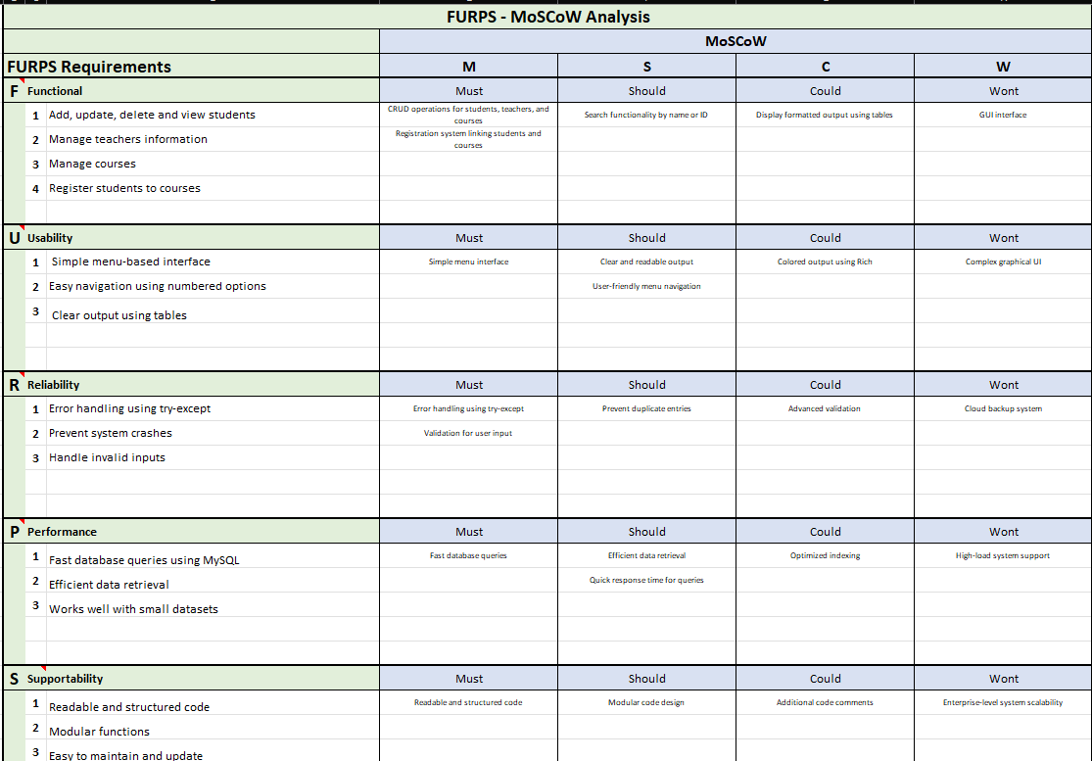

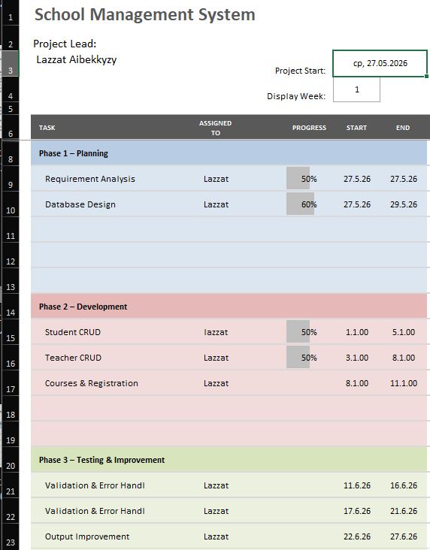

Appendix 2 - PYTHON Code Samples Screenshots of PROGRAMMING CONSTRUCTs
Figure 2 – Input validation using if statement
Figure 3 – Loop used for menu system
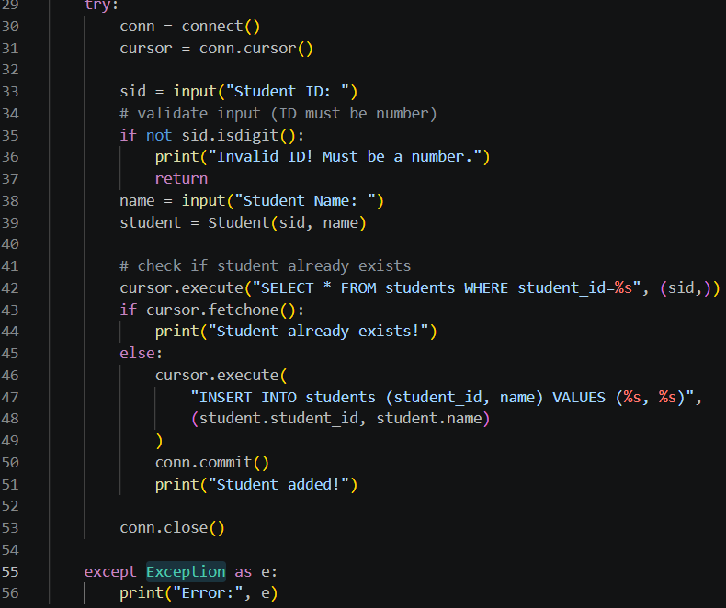
Figure 4 – Error handling using try-except
Figure 5 – SQL query execution in Python
Below is a sample of code showing how to add a new student into the database. The code shows various concepts that can be used in programming such as user inputs, input validations, database handling, and function building.
The function starts by establishing a connection to the database and receiving user inputs on the ID and name of the student. Input validation is done at this point whereby the ID must contain only digits.
The SQL command is executed using parameterized statements, which increases security against SQL injection. At last, the changes made to the database are committed, and the connection to the database is ended.

Appendix 3 - PYTHON Code Samples Screenshots of OOP
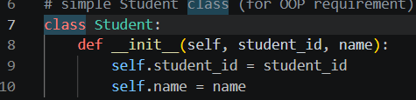
Figure 6 – Example of Student class demonstrating Object-Oriented Programming
Figure 7 – Creating an object from the student class
Object-Oriented Programming is used in this application using the Student class.
This class contains the attributes that make up a student such as Student ID and Name.
An object of this class is instantiated upon addition of a new student, illustrating how OOP can be used to organize and structure data in this application.
Even though this application relies heavily on functions, this clearly illustrates some of the concepts of Object-Oriented Programming.

Appendix 4 - Entity Relationship Diagrams (Conceptual, logical, and physical)
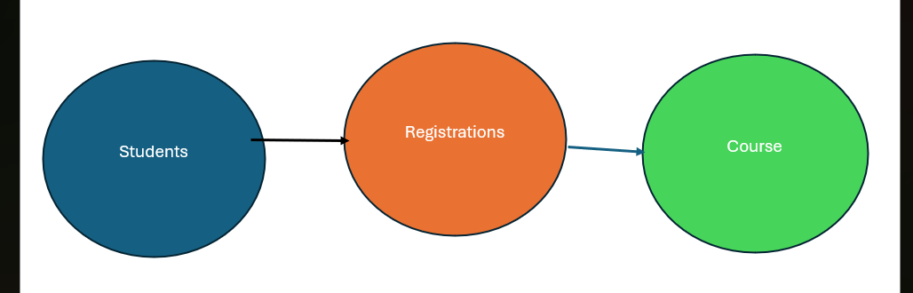
Figure 8 – Conceptual ERD showing relationships between entities
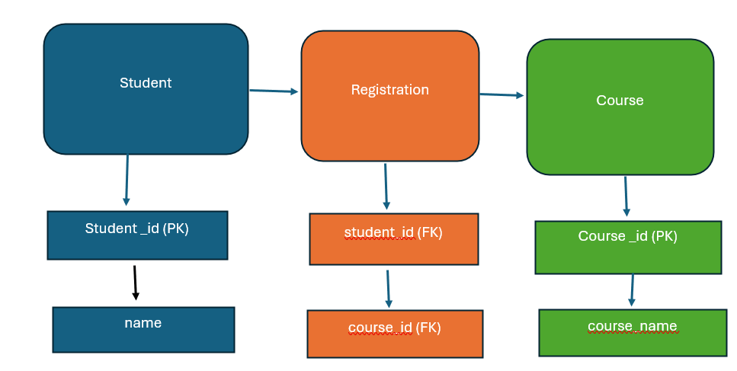
Figure 9 – Logical ERD including attributes and keys
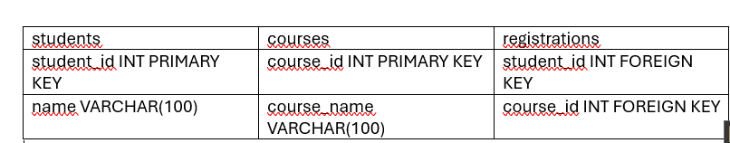
Figure 10 – Physical ERD representing database implementation

Entity Relationship Diagram (ERD) was used for planning and designing the architecture of the database for the system.
The conceptual ERD demonstrates the general relationship between the entities such as students and courses. In addition, the logical ERD further expands upon this and adds the entity’s attribute and primary and foreign keys. Lastly, the physical ERD depicts the implementation of the database using data types and constraints in the MySQL database.
This process helps in structuring the database and its normalization.

Appendix 5 – SAMPLES OF DDL/DML SQL STATEMENTS USED
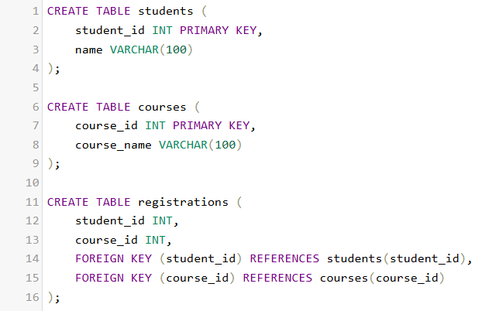
Figure 11 – Example of DDL statements used to create database tables
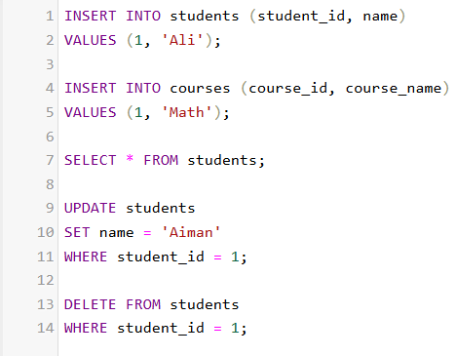
Figure 12 – Example of DML statements used to manipulate data
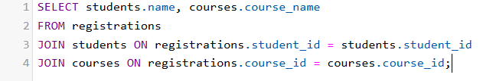
Figure 13 – Example of SQL JOIN query to retrieve related data

Appendix 6 – Test logs
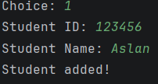
Figure 14 – Test case: Adding a new student
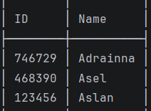
Figure 15 – Test case: Viewing students
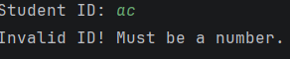
Figure 16 – Test case: Input validation for invalid ID
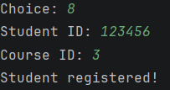
Figure 17 – Test case: Registering student to course

The results of the test show that the system works properly in all situations. Different types of tests have been performed in order to prove the proper functioning of the system including insertion, selection, and error handling.
The results indicate that the CRUD functionality, validation of input, and database management work properly. Error handling was also tested in order to make sure that the system doesn’t crash if an invalid input is given.

Appendix 7 – OUTPUT Screenshots
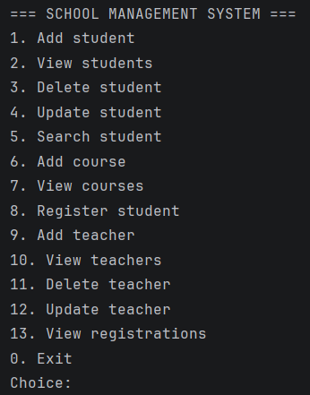
Figure 19 – Main menu interface of the application
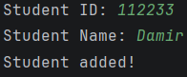
Figure 20 – Adding a new student through the system
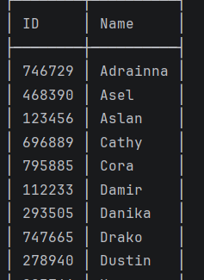
Figure 21 – Displaying student records

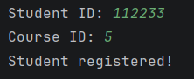
Figure 22 – Registering a student to a course
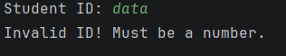
Figure 23 – Handling invalid user input
It can be noted from the output screen shots that the application is able to communicate with the user via an interface that includes menus. The system enables the user to carry out different actions such as adding, accessing, and handling the database records.
It can be observed from the screen shots that the application offers clear prompts, output formatting, and good user interaction.

