MARIO SUAREZ  
IS218 – SPRING 2020

FINAL PROJECT

GITHUB REPO: <https://github.com/njitsuarez/FlaskDockerMySQLFINAL>

PYCHARM DATABASE

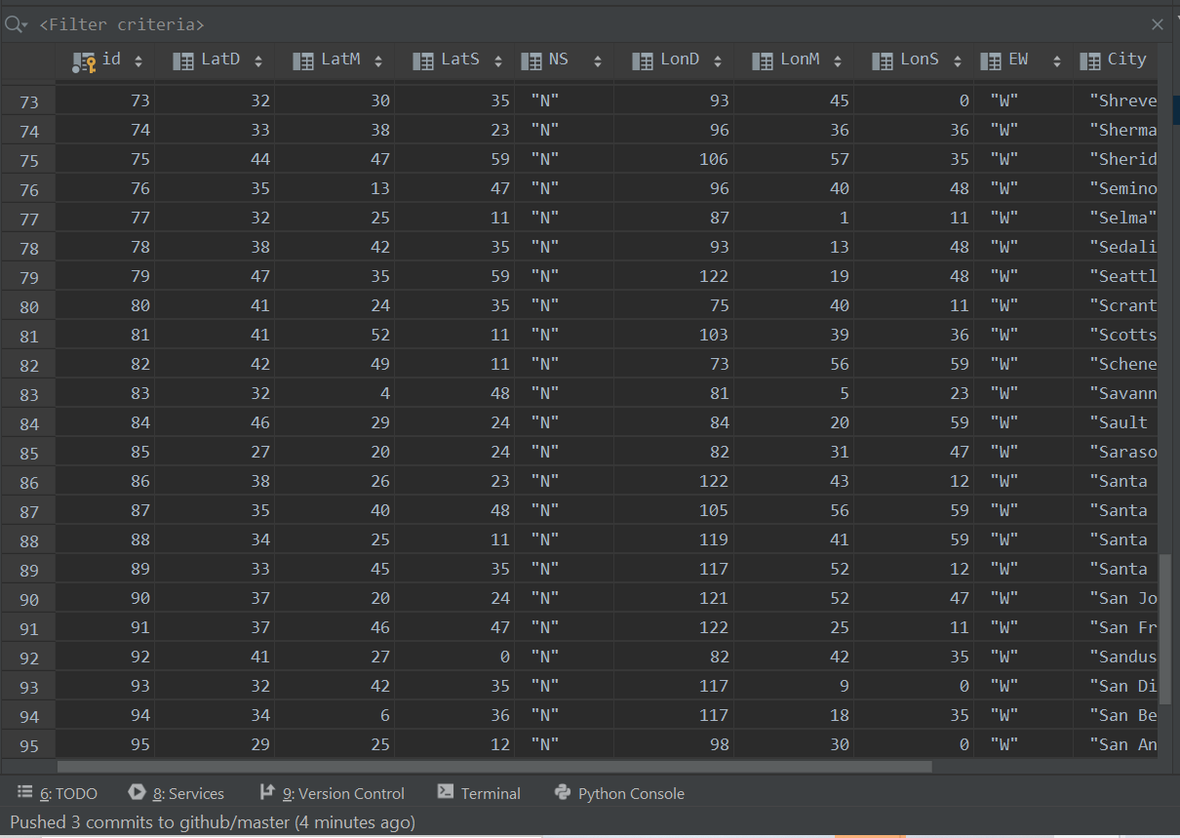

HOMEPAGE SCREENSHOT  
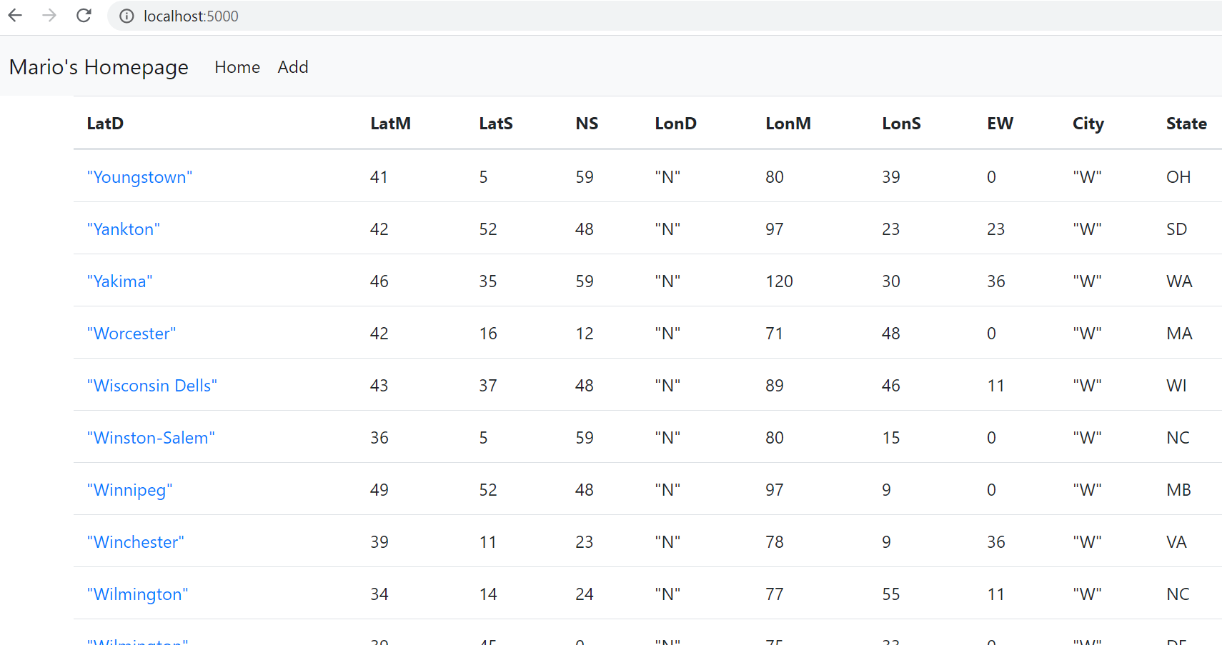

RECORD SCREENSHOT

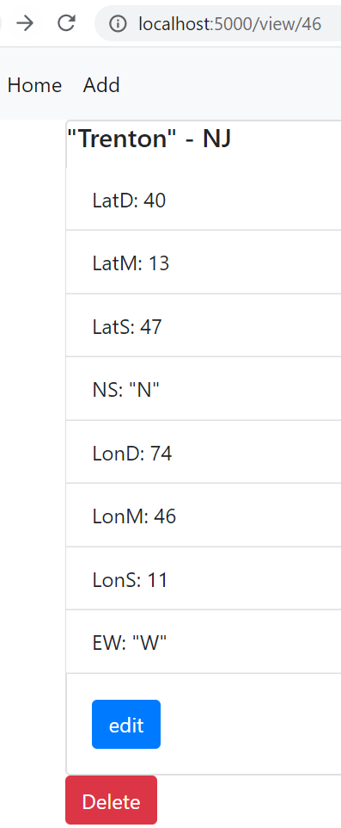

NEW RECORD PAGE (w/ data)

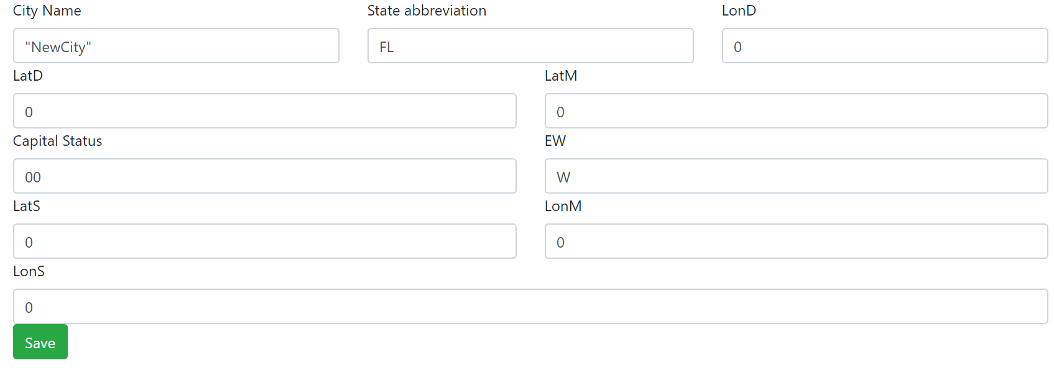

ADD NEW RECORD (HIGHLIGHTED)

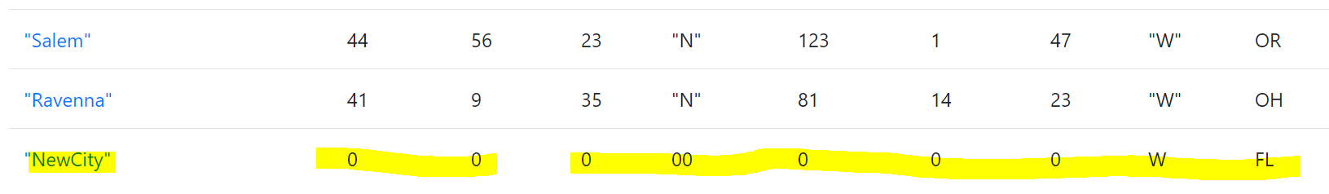

DELETED RECORD (highlighted area where record used to be)

