**桌面应用程序设计 上机作业提交**

**姓名：贾久乐**

**学号：201831062315**

**成绩：**

1. 答案（界面运行截图 + 代码（文本粘贴）， 标题栏或代码中添加姓名）

private void timer1_Tick(object sender, EventArgs e)

{

if (this.timer1.Interval % 4 == 0) {

label2.Text = "正在显示";

}

if (this.timer1.Interval % 4 == 1) {

label2.Text = "正在显示.";

}

if (this.timer1.Interval % 4 == 2){

label2.Text = "正在显示..";

}

if (this.timer1.Interval % 4 == 3) {

label2.Text = "正在显示...";

}

timer1.Interval++;

}

private void Form1_Load(object sender, EventArgs e) {

timer1.Start();

}

private void pictureBox2_Click(object sender, EventArgs e) {

Form2 form2 = new Form2();

form2.Show();

}



1. 答案（界面运行截图 + 代码（文本粘贴）， 标题栏或代码中添加姓名）

Point center;

float sweepAng;

float startAngle = 180;

private void Form1_Paint(object sender, PaintEventArgs e)

{

//获得绘图对象

Graphics g = e.Graphics;

//抗锯齿，增加绘图平滑度

g.SmoothingMode = System.Drawing.Drawing2D.SmoothingMode.AntiAlias;

Rectangle rectRed = new Rectangle(center.X - 160, center.Y - 160,320,320);

Rectangle rectOrange = new Rectangle(center.X - 140, center.Y - 140, 280, 280);

Rectangle rectYellow = new Rectangle(center.X - 120, center.Y - 120, 240, 240);

Rectangle rectGreen = new Rectangle(center.X - 100, center.Y - 100, 200, 200);

Rectangle rectGreenYellow = new Rectangle(center.X - 80, center.Y - 80, 160, 160);

Rectangle rectBlue = new Rectangle(center.X - 60, center.Y - 60, 120, 120);

Rectangle rectPurple = new Rectangle(center.X - 40, center.Y - 40, 80, 80);

g.FillPie(Brushes.Red, rectRed, startAngle,sweepAng);

g.FillPie(Brushes.Orange, rectOrange, startAngle, sweepAng);

g.FillPie(Brushes.Yellow, rectYellow, startAngle, sweepAng);

g.FillPie(Brushes.Green, rectGreen, startAngle, sweepAng);

g.FillPie(Brushes.GreenYellow, rectGreenYellow, startAngle, sweepAng);

g.FillPie(Brushes.Blue, rectBlue, startAngle, sweepAng);

g.FillPie(Brushes.Purple, rectPurple, startAngle, sweepAng);

}

private void Form1_Load(object sender, EventArgs e)

{

center = new Point(this.Width / 2, this.Height / 2);

timer1.Start();

}

private void timer1_Tick(object sender, EventArgs e)

{

sweepAng++;

if (sweepAng > 180) {

sweepAng = 0;

}

this.Invalidate();

}

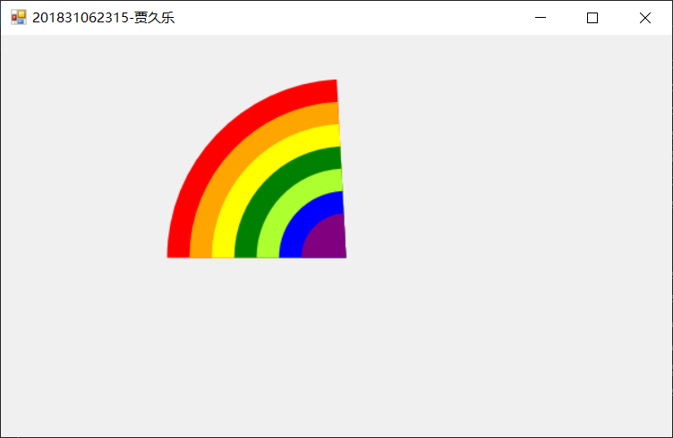

1. 答案（界面运行截图 + 代码（文本粘贴）， 标题栏或代码中添加姓名）

private void button1_Click(object sender, EventArgs e)

{

OpenFileDialog fdlg = new OpenFileDialog();

String path = null;

if (fdlg.ShowDialog() == DialogResult.OK)

{

//textBox1.Text = fdlg.FileName;

path = fdlg.FileName;

Random random=new Random();

if (path != null)

{

FileStream aFile = new FileStream(path, FileMode.Open);

try{

StreamReader streamReader = new StreamReader(aFile);

String line = null;

while ((line = streamReader.ReadLine()) != null)

{

Label label = new Label();

label.Text = line;

label.Font = new Font("微软雅黑", 20);

label.ForeColor = Color.FromArgb(random.Next(250), random.Next(250), random.Next(250));

label.Height = 40;

label.Width = flowLayoutPanel1.Width-10;

textBox1.Text = line;

flowLayoutPanel1.Controls.Add(label);

}

}

catch(Exception error) {

Console.Write(error.Message);

}

}

}else {

Console.WriteLine("文件路径为空");

}

} 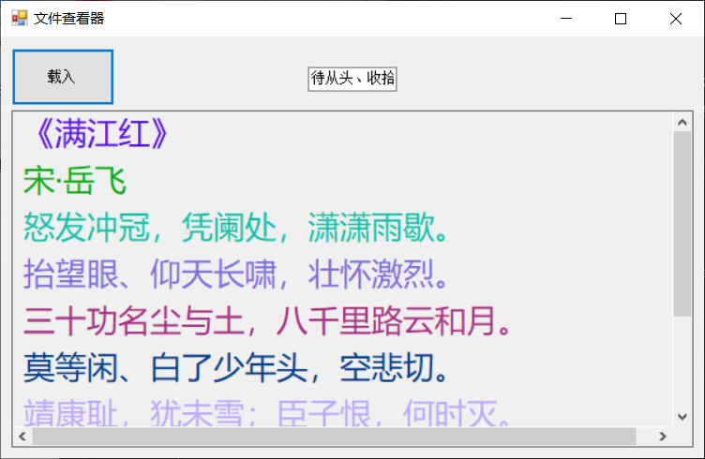

1. 答案（界面运行截图 + 代码（文本粘贴）， 标题栏或代码中添加姓名）

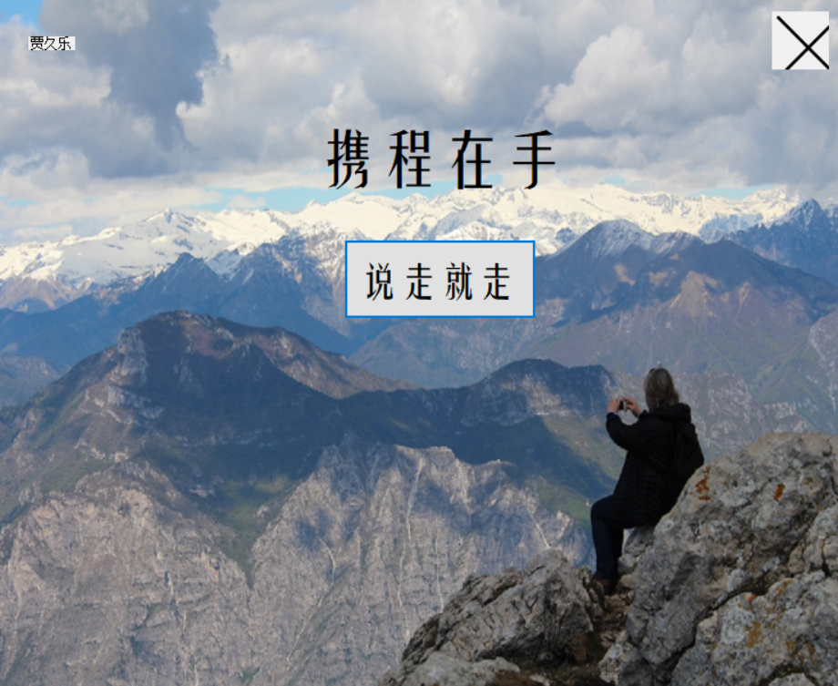 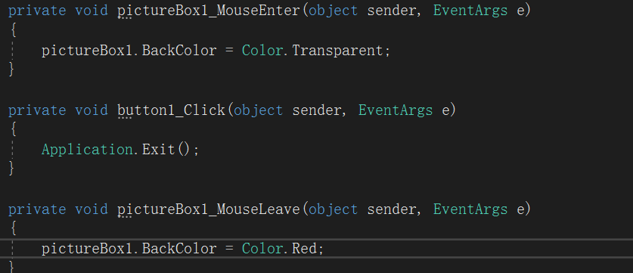

1. 答案（界面运行截图 + 代码（文本粘贴）， 标题栏或代码中添加姓名）

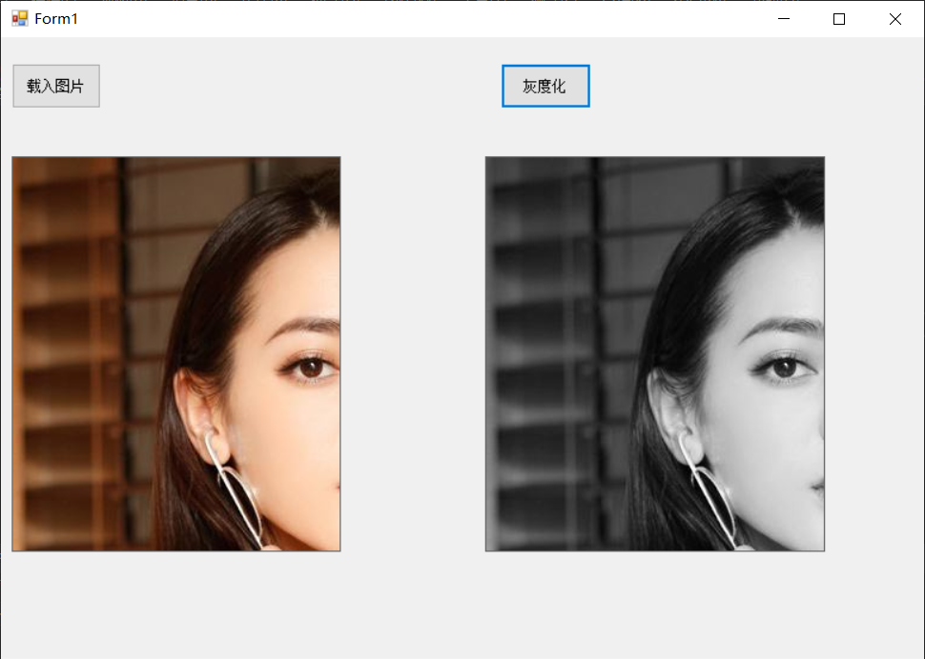Image image ;

private void button1_Click(object sender, EventArgs e)

{

OpenFileDialog openFileDialog = new OpenFileDialog();

String path = null;

if (openFileDialog.ShowDialog() == DialogResult.OK) {

path = openFileDialog.FileName;

image = Image.FromFile(path);

pictureBox1.Image = image;

}

}

private void button2_Click(object sender, EventArgs e)

{

Bitmap bmp = new Bitmap(image);

for (int i = 0; i < bmp.Width; i++) {

for (int j = 0; j < bmp.Height; j++) {

Color rgb = bmp.GetPixel(i, j);

int grey = (rgb.R + rgb.G + rgb.B) / 3;

bmp.SetPixel(i, j, Color.FromArgb(grey, grey, grey));

}

}

pictureBox2.Image = bmp;

}

1. 答案（界面运行截图 + 代码（文本粘贴）， 标题栏或代码中添加姓名）

private void button2_Click(object sender, EventArgs e)

{

int i = richTextBox1.Text.Length;

if (i>0){

Label label = new Label();

label.Text = "贾久乐(" + DateTime.Now.ToLocalTime() + ")" + ":" + richTextBox1.Text;

label.Font = new Font("微软雅黑", 15);

label.Height = 40;

label.Width = richTextBox1.Width - 20;

flowLayoutPanel1.Controls.Add(label);

richTextBox1.Text = "";

}

else {

}

}

private void button1_Click(object sender, EventArgs e)

{

richTextBox1.Text = null;

}

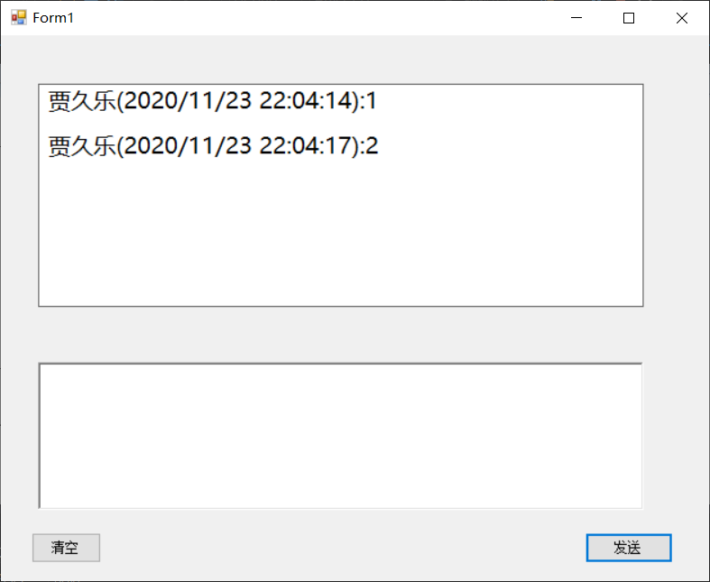

1. 答案（界面运行截图 + 代码（文本粘贴）， 标题栏或代码中添加姓名）

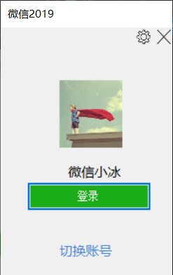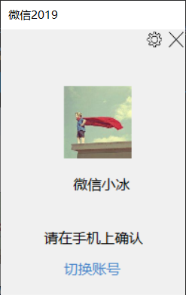 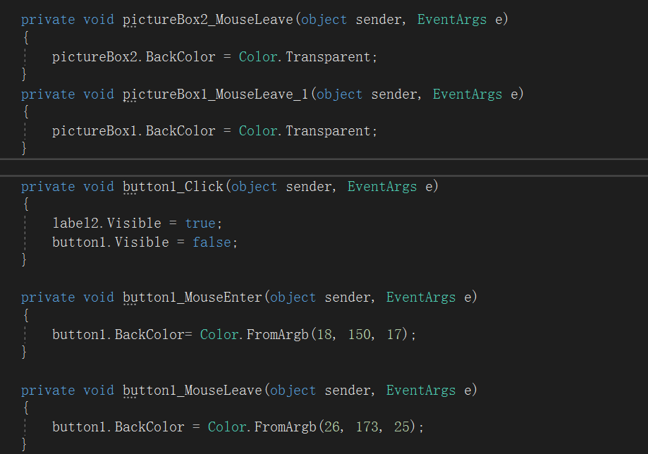

1. 答案（界面运行截图 + 代码（文本粘贴）， 标题栏或代码中添加姓名）

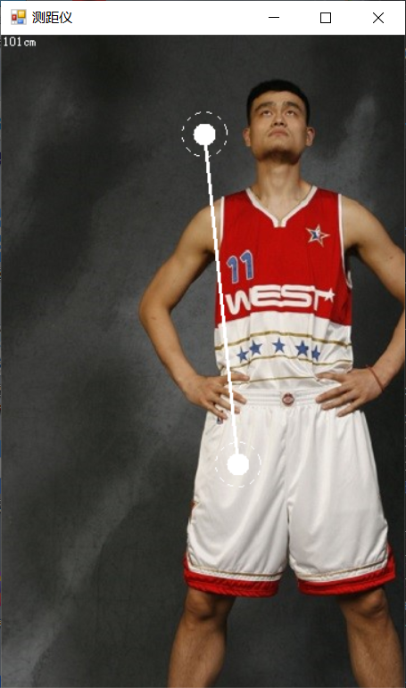 Graphics g;

Point clickPoint;//先定义两个坐标

Point movePoint;

bool isPaint = false;

bool isPaintStop = false;

private void FrmDistanceMeasure_Paint(object sender, PaintEventArgs e)

{

g = e.Graphics;

Image image = Image.FromFile("yaoming.jpg");

g.DrawImage(image, 0, 0);

if (isPaint) {

Brush brush = new SolidBrush(Color.White);

Pen pen = new Pen(Color.White);

pen.DashStyle = System.Drawing.Drawing2D.DashStyle.Custom;//让笔画虚线

pen.DashPattern = new float[] { 5, 5 };

g.FillEllipse(brush, clickPoint.X - 10, clickPoint.Y - 10, 20, 20);

g.DrawEllipse(pen, clickPoint.X - 20, clickPoint.Y - 20, 40, 40);

g.FillEllipse(brush, movePoint.X - 10, movePoint.Y - 10, 20, 20);

g.DrawEllipse(pen, movePoint.X - 20, movePoint.Y - 20, 40, 40);

g.DrawLine(new Pen(Color.White, 3), clickPoint, movePoint);

}

if (isPaintStop) {

Double distance = Math.Sqrt((clickPoint.X - movePoint.X) * (clickPoint.X - movePoint.X) + (clickPoint.Y - movePoint.Y) * (clickPoint.Y - movePoint.Y)) * 0.34; //距离换算

g.DrawString(distance.ToString("f0") + "cm", this.Font, Brushes.White, 0, 0);

}

}

private void FrmDistanceMeasure_MouseDown(object sender, MouseEventArgs e)

{

isPaint = true;

clickPoint = new Point(e.X, e.Y);//鼠标点下，把此时鼠标的坐标传递过去

Invalidate();

}

private void FrmDistanceMeasure_MouseMove(object sender, MouseEventArgs e)

{

if (!isPaintStop)

{

movePoint = new Point(e.X, e.Y);

Invalidate();//调用方法是为了调用Paint方法

}

}

private void FrmDistanceMeasure_MouseUp(object sender, MouseEventArgs e)

{

isPaintStop = true;

Invalidate();

}

1. 答案（界面运行截图 + 代码（文本粘贴）， 标题栏或代码中添加姓名）

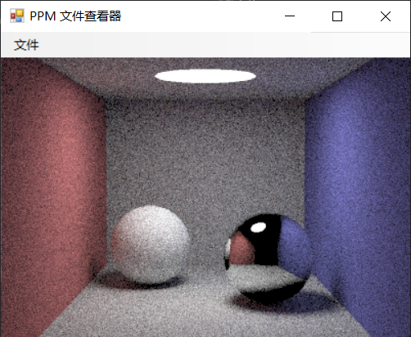 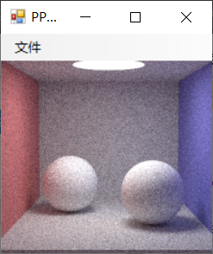

private void 打开ToolStripMenuItem_Click(object sender, EventArgs e)

{

OpenFileDialog openFileDialog = new OpenFileDialog();

try

{

openFileDialog.InitialDirectory = @"D:\桌面练习 V2\桌面练习 V2";

openFileDialog.Filter = "(ppm文件)*.ppm|*.ppm";

openFileDialog.ShowDialog();

StreamReader sr = new StreamReader(openFileDialog.FileName);

string strTotal = sr.ReadToEnd();

string[] pixels = strTotal.Split(' ');//以空格为分割点的意思

int v = 4;

Bitmap bitmap = new Bitmap(400, 300);//创建ppm相对应大小得bitmao

for (int i = 0; i < 300; i++)

{

for (int j = 0; j < 400; j++)

{

int a = int.Parse(pixels[v]);

int b = int.Parse(pixels[v+1]);

int c = int.Parse(pixels[v+2]);

bitmap.SetPixel(i, j, Color.FromArgb(a, b,c));

v = v + 3;

}

}

BackgroundImage = bitmap;

}

catch { }

}

1. 答案（界面运行截图 + 代码（文本粘贴）， 标题栏或代码中添加姓名）

if (textBox1.Text =="")

{

MessageBox.Show("用户名不能为空");

}else if(textBox1.Text != null) {

if (textBox1.Text == "20180001" && textBox2.Text == "123456"){

MessageBox.Show("登录成功");

}

else {

MessageBox.Show("登录失败");

}

} 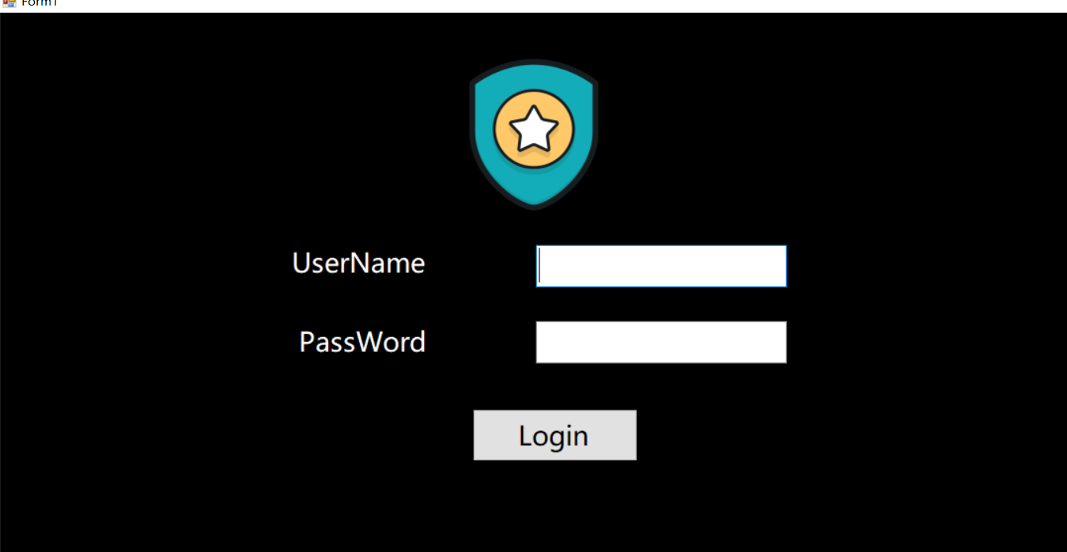

1. 答案（界面运行截图 + 代码（文本粘贴）， 标题栏或代码中添加姓名）

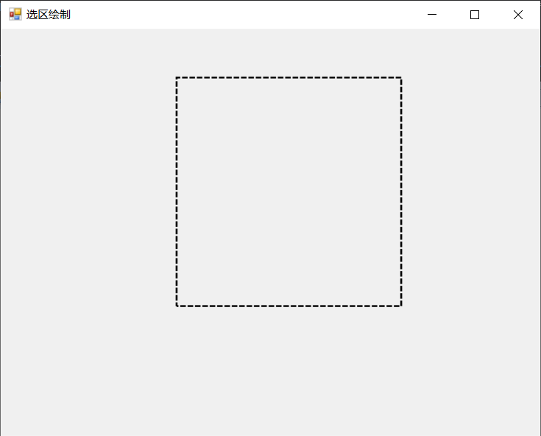 private void FrmDrawRect_MouseDown(object sender, MouseEventArgs e)

{

clickPoint = e.Location;

this.Invalidate();

}

private void FrmDrawRect_MouseMove(object sender, MouseEventArgs e)

{

movePoint = e.Location;

isPaint = true;

this.Invalidate();

}

private void FrmDrawRect_Paint(object sender, PaintEventArgs e)

{

Graphics g = e.Graphics;

Pen pen = new Pen(Color.Black, 2);

pen.DashStyle = System.Drawing.Drawing2D.DashStyle.Dash;

pen.DashOffset = dashOffset;

if (isPaint) {

g.DrawRectangle(pen, clickPoint.X, clickPoint.Y, movePoint.X - clickPoint.X, movePoint.Y - clickPoint.Y);

}

}

private void timer1_Tick(object sender, EventArgs e)

{

dashOffset++;

}

1. 答案（界面运行截图 + 代码（文本粘贴）， 标题栏或代码中添加姓名）

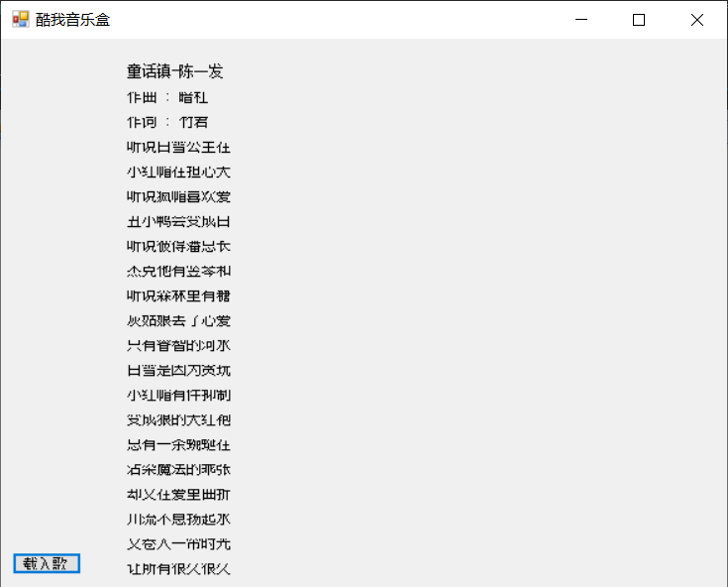 private void button1_Click(object sender, EventArgs e)

{

OpenFileDialog openFileDialog = new OpenFileDialog();

openFileDialog.ShowDialog();

String path = openFileDialog.FileName;

StreamReader streamReader = new StreamReader(path,Encoding.Default);

String line;

int j = 0;

List<String> songs=new List<string>();

while ((line = streamReader.ReadLine())!=null){

if (line.Length > 0) {

String line1= line.Substring(10);

// MessageBox.Show(line1);

songs.Add(line1);

j++;

}

}

int height = 20;

for (int i = 0; i < j; i++) {

Label label = new Label();

label.Text = songs[i];

label.Location = new Point(100, height);

height += 20;

this.Controls.Add(label);

}

1. 答案（界面运行截图 + 代码（文本粘贴）， 标题栏或代码中添加姓名）
2. 答案（界面运行截图 + 代码（文本粘贴）， 标题栏或代码中添加姓名）

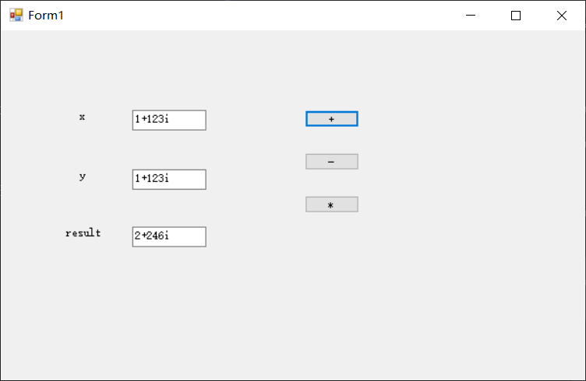 private void button1_Click(object sender, EventArgs e)

{

String x = textBox1.Text;

String y = textBox1.Text;

String[] x1 = x.Split('+');

String s = x1[0];

int a= int.Parse(s);

String s2= x1[1].Substring(0,3);

int b = int.Parse(s2);

String X = textBox2.Text;

String Y = textBox2.Text;

String[] X1 = X.Split('+');

String S = x1[0];

int A = int.Parse(S);

String S2 = x1[1].Substring(0, 3);

int B = int.Parse(S2);

int c = a + A;

int d = b + B;

String show = c.ToString() + "+" + d.ToString() + "i";

textBox3.Text = show;

}

private void button2_Click(object sender, EventArgs e)

{

String x = textBox1.Text;

String y = textBox1.Text;

String[] x1 = x.Split('+');

String s = x1[0];

int a = int.Parse(s);

String s2 = x1[1].Substring(0, 3);

int b = int.Parse(s2);

String X = textBox2.Text;

String Y = textBox2.Text;

String[] X1 = X.Split('+');

String S = x1[0];

int A = int.Parse(S);

String S2 = x1[1].Substring(0, 3);

int B = int.Parse(S2);

int c = a - A;

int d = b - B;

String show = c.ToString() + "+" + d.ToString() + "i";

textBox3.Text = show;

}

private void button3_Click(object sender, EventArgs e)

{

String x = textBox1.Text;

String y = textBox1.Text;

String[] x1 = x.Split('+');

String s = x1[0];

int a = int.Parse(s);

String s2 = x1[1].Substring(0, 3);

int b = int.Parse(s2);

String X = textBox2.Text;

String Y = textBox2.Text;

String[] X1 = X.Split('+');

String S = x1[0];

int A = int.Parse(S);

String S2 = x1[1].Substring(0, 3);

int B = int.Parse(S2);

int c = a * A - b * B;

int d = A * b + a * B;

String show = c.ToString() + "+" + d.ToString() + "i";

textBox3.Text = show;

}

1. 答案（界面运行截图 + 代码（文本粘贴）， 标题栏或代码中添加姓名）

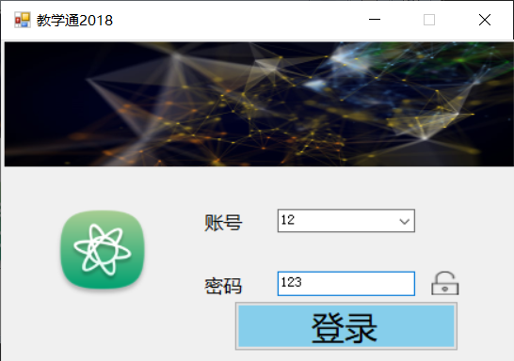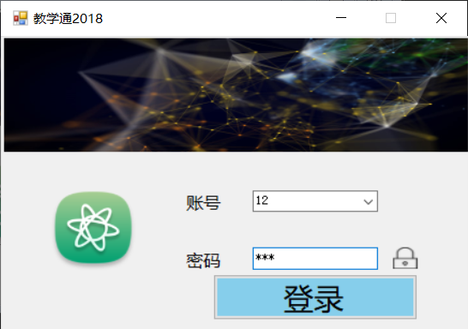 private void Form1_Load(object sender, EventArgs e)

{

pictureBox4.Visible = false;

}

private void button1_MouseEnter(object sender, EventArgs e)

{

button1.BackColor = Color.Red;

}

private void button1_MouseLeave(object sender, EventArgs e)

{

button1.BackColor = Color.Blue;

}

private void pictureBox3_Click_1(object sender, EventArgs e)

{

pictureBox3.Visible = false;

pictureBox4.Visible = true;

textBox1.PasswordChar ='\0';

}

1. 答案（界面运行截图 + 代码（文本粘贴）， 标题栏或代码中添加姓名）

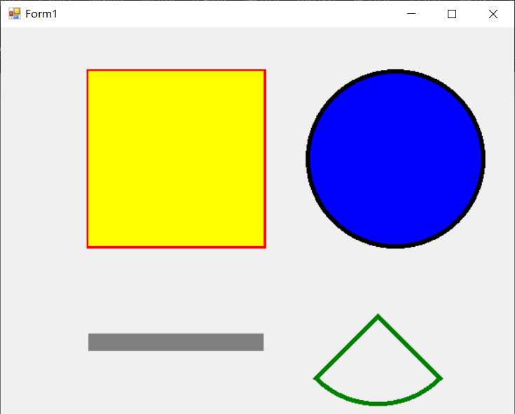 //正方形

Pen pen = new Pen(Color.Red, 5);

g = e.Graphics;

g.DrawRectangle(pen, 100, 50, 200,200);

Brush rectbush = new SolidBrush(Color.Yellow);

g.FillRectangle(rectbush, 100, 50, 200, 200);

//圆

Pen Circlepen = new Pen(Color.Black, 5);

Rectangle circleR = new Rectangle(350, 50, 200, 200);

g.FillEllipse(Brushes.Blue, circleR);

g.DrawEllipse(Circlepen, 350, 50, 200, 200);

//直线

g.FillRectangle(Brushes.Gray, 100, 350, 200, 20);

//扇形

Pen shanpen = new Pen(Color.Green,5);

Rectangle shanr = new Rectangle(330, 230, 200, 200);

g.DrawPie(shanpen, shanr, 45, 90);

1. 答案（界面运行截图 + 代码（文本粘贴）， 标题栏或代码中添加姓名）

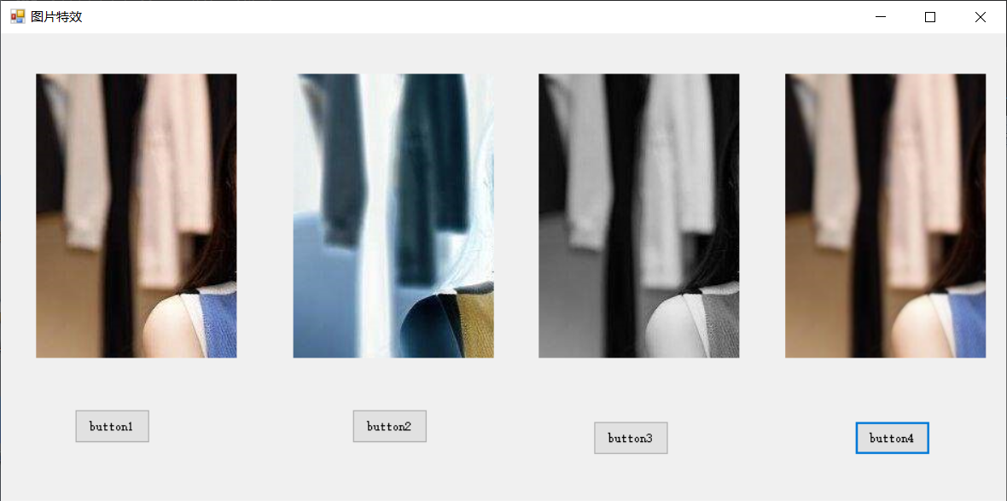 private void button1_Click(object sender, EventArgs e)

{

OpenFileDialog openFileDialog = new OpenFileDialog();

String path = null;

if (openFileDialog.ShowDialog() == DialogResult.OK)

{

path = openFileDialog.FileName;

image = Image.FromFile(path);

MessageBox.Show(path);

pictureBox1.Image = image;

}

}

private void button2_Click(object sender, EventArgs e)

{

Bitmap bitmap = new Bitmap(image);

for (int i = 0; i < bitmap.Width; i++) {

for (int j = 0; j < bitmap.Height; j++) {

Color rgb = bitmap.GetPixel(i, j);

int a = 255 - rgb.R;

int b = 255 - rgb.G;

int c = 255 - rgb.B;

bitmap.SetPixel(i, j, Color.FromArgb(a,b,c));

}

}

pictureBox2.Image = bitmap;

}

private void button3_Click(object sender, EventArgs e)

{

Bitmap bitmap = new Bitmap(image);

int ret;

for (int i = 0; i < bitmap.Width; i++)

{

for (int j = 0; j < bitmap.Height; j++)

{

Color rgb = bitmap.GetPixel(i, j);

ret = (int)(rgb.R * 0.229 + rgb.G * 0.587 + rgb.B * 0.114);

bitmap.SetPixel(i, j, Color.FromArgb(ret, ret, ret));

}

}

pictureBox3.Image = bitmap;

}

private void button4_Click(object sender, EventArgs e)

{

Bitmap bitmap = new Bitmap(image);

int ret1;

int ret2;

int ret3;

for (int i = 1; i < bitmap.Width-1; i++)

{

for (int j = 1; j < bitmap.Height-1; j++)

{

Color rgb1 = bitmap.GetPixel(i-1, j-1);

Color rgb2 = bitmap.GetPixel(i, j-1);

Color rgb3 = bitmap.GetPixel(i+1, j-1);

Color rgb4 = bitmap.GetPixel(i-1, j);

Color rgb5 = bitmap.GetPixel(i, j);

Color rgb6 = bitmap.GetPixel(i+1, j);

Color rgb7 = bitmap.GetPixel(i-1, j+1);

Color rgb8 = bitmap.GetPixel(i, j+1);

Color rgb9 = bitmap.GetPixel(i+1, j+1);

ret1 = (rgb1.R + rgb2.R + rgb3.R + rgb4.R + rgb5.R + rgb6.R + rgb7.R + rgb8.R + rgb9.R) /9;

ret2 = (rgb1.G + rgb2.G + rgb3.G + rgb4.G + rgb5.G + rgb6.G + rgb7.G + rgb8.G + rgb9.G) / 9;

ret3 = (rgb1.B + rgb2.B + rgb3.B + rgb4.B + rgb5.B + rgb6.B + rgb7.B + rgb8.B + rgb9.B) / 9;

bitmap.SetPixel(i, j, Color.FromArgb(ret1, ret2, ret3));

}

}

pictureBox4.Image = bitmap;

}

1. 答案（界面运行截图 + 代码（文本粘贴）， 标题栏或代码中添加姓名）

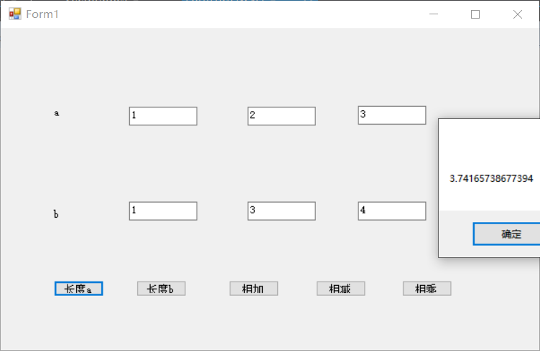 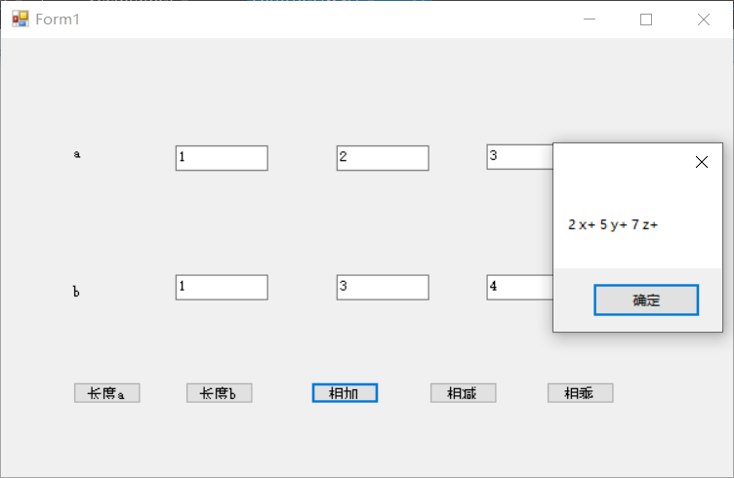

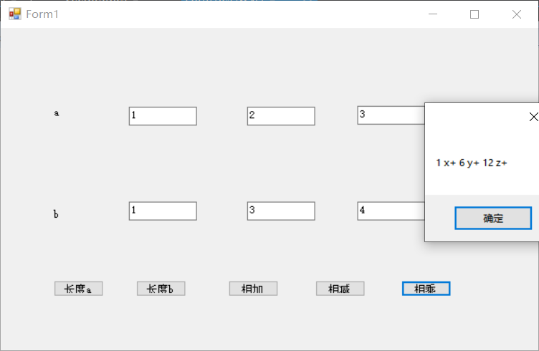 public Vector3D(String a, String b, String c) {

x = int.Parse(a);

y = int.Parse(b);

z = int.Parse(c);

}

public String getLength() {

String length= Math.Sqrt((x*x)+(y*y)+(z*z)).ToString();

return length;

}

private void button5_Click(object sender, EventArgs e)

{

int x = int.Parse(textBox1.Text);

int x1 = int.Parse(textBox4.Text);

int y = int.Parse(textBox2.Text);

int y1 = int.Parse(textBox5.Text);

int z = int.Parse(textBox3.Text);

int z1 = int.Parse(textBox6.Text);

MessageBox.Show((x * x1).ToString() + " x+ " + (y * y1).ToString() + " y+ " + (z * z1).ToString() + " z+ ");

}

private void button4_Click(object sender, EventArgs e)

{

int x = int.Parse(textBox1.Text);

int x1 = int.Parse(textBox4.Text);

int y = int.Parse(textBox2.Text);

int y1 = int.Parse(textBox5.Text);

int z = int.Parse(textBox3.Text);

int z1 = int.Parse(textBox6.Text);

MessageBox.Show((x - x1).ToString() + " x+ " + (y - y1).ToString() + " y+ " + (z - z1).ToString() + " z+ ");

}

private void button3_Click(object sender, EventArgs e)

{

int x= int.Parse(textBox1.Text);

int x1= int.Parse(textBox4.Text);

int y = int.Parse(textBox2.Text);

int y1 = int.Parse(textBox5.Text);

int z = int.Parse(textBox3.Text);

int z1 = int.Parse(textBox6.Text);

MessageBox.Show((x + x1).ToString()+" x+ "+(y+y1).ToString()+" y+ "+(z+z1).ToString()+" z+ ");

}

private void button2_Click(object sender, EventArgs e)

{

a1 = textBox4.Text;

b1 = textBox5.Text;

c1 = textBox6.Text;

Vector3D vector3D = new Vector3D(a1, b1, c1);

MessageBox.Show(vector3D.getLength());

}

private void button1_Click(object sender, EventArgs e)

{

a = textBox1.Text;

b = textBox2.Text;

c = textBox3.Text;

Vector3D vector3D = new Vector3D(a, b, c);

MessageBox.Show( vector3D.getLength());

}

1. 答案（界面运行截图 + 代码（文本粘贴）， 标题栏或代码中添加姓名）

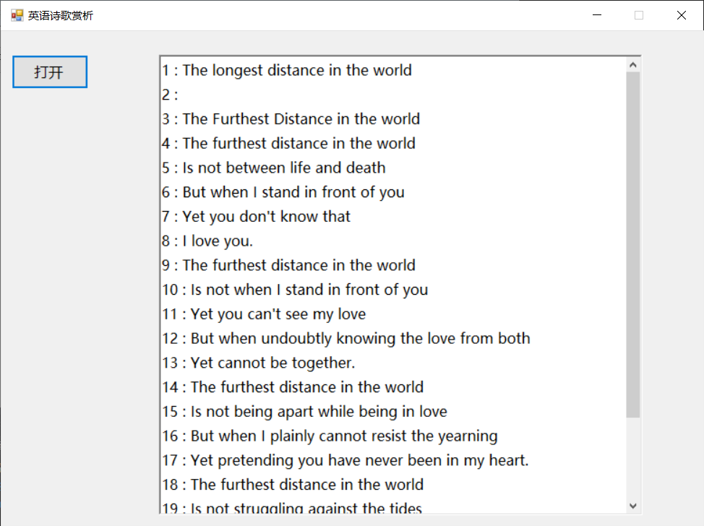 OpenFileDialog openFileDialog = new OpenFileDialog();

String path = null;

int height = 25;

int i = 1;

if (openFileDialog.ShowDialog() == DialogResult.OK) {

path = openFileDialog.FileName;

StreamReader streamReader = new StreamReader(path);

String line;

while ((line = streamReader.ReadLine()) != null) {

richTextBox1.AppendText(i.ToString()+" : "+line+"\r\n");

i++;

}

}

1. 答案（界面运行截图 + 代码（文本粘贴）， 标题栏或代码中添加姓名）

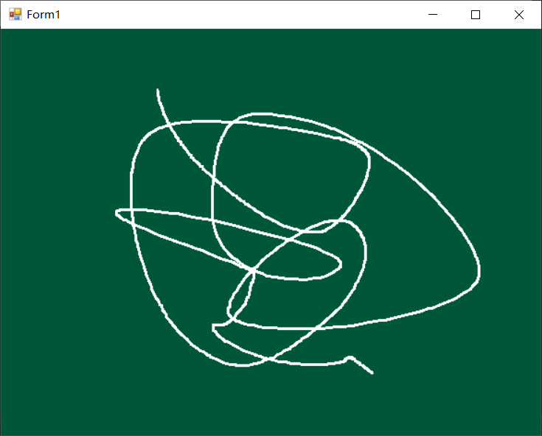 public Point MyPoint1, MyPoint2;

Boolean isdrawing = false;

private void Form1_MouseUp(object sender, MouseEventArgs e)

{

isdrawing = false;

}

private void Form1_MouseDown(object sender, MouseEventArgs e)

{

isdrawing = true;

}

Graphics g;

List<Point> plist = new List<Point>();

private void Form1_MouseMove(object sender, MouseEventArgs e)

{

if (isdrawing && e.Button == MouseButtons.Left) {

plist.Add(e.Location);

this.Invalidate();

}

}

private void Form1_Paint(object sender, PaintEventArgs e)

{

g = e.Graphics;

Pen MyPen = new Pen(Color.White, 3);

if (plist.Count >= 2) {

g.DrawLines(MyPen, plist.ToArray());

}

}

1. 答案（界面运行截图 + 代码（文本粘贴）， 标题栏或代码中添加姓名）

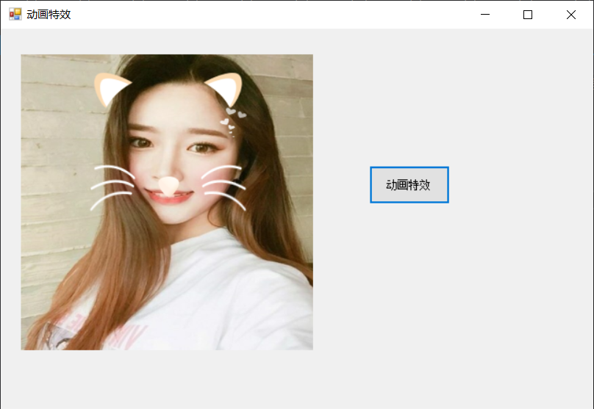 Graphics g;

List<Image> ear = new List<Image>();

List<Image> huxv = new List<Image>();

Boolean ispainting = false;

int index=0;

private void pictureBox1_Paint(object sender, PaintEventArgs e)

{

g = e.Graphics;

Image image = Image.FromFile(@"D:\桌面练习 V3\桌面练习 V3\girl2.jpeg");

g.DrawImage(image, new Rectangle(0, 0, 400, 400));

if (ispainting&&index<ear.Count) {

g.DrawImage(ear[index], new Rectangle(60, 5, 200, 90));

}

if (index<huxv.Count) {

g.DrawImage(huxv[index], new Rectangle(60,100,200,90));

}

}

private void button1_Click(object sender, EventArgs e)

{

if (ispainting)

{

DirectoryInfo di = new DirectoryInfo(@"D:\桌面练习 V3\桌面练习 V3\ear");

Image image = Image.FromFile(@"D:\桌面练习 V3\桌面练习 V3\girl2.jpeg");

foreach (FileInfo fi in di.GetFiles())

{

if (fi.Name.ToUpper().EndsWith(".BMP") || fi.Name.ToUpper().EndsWith(".PNG"))

{

ear.Add(Image.FromFile(fi.FullName));

}

}

DirectoryInfo di1 = new DirectoryInfo(@"D:\桌面练习 V3\桌面练习 V3\moustache");

foreach (FileInfo fi1 in di1.GetFiles())

{

if (fi1.Name.ToUpper().EndsWith(".BMP") || fi1.Name.ToUpper().EndsWith(".PNG"))

{

huxv.Add(Image.FromFile(fi1.FullName));

}

}

timer1.Enabled = true;

}

else {

ispainting = false;

}

this.Invalidate();

}

private void timer1_Tick(object sender, EventArgs e)

{

timer1.Interval++;

index++;

pictureBox1.Refresh();

}

private void Form1_Load(object sender, EventArgs e)

{

ispainting = true;

}

1. 答案（界面运行截图 + 代码（文本粘贴）， 标题栏或代码中添加姓名）
2. 答案（界面运行截图 + 代码（文本粘贴）， 标题栏或代码中添加姓名）