Laboratory work #2
Underlined = primary key, (FK) = foreign key.

Normalization

Task 1. Which normal form is violated
The table breaks 1NF, because the column seat_numbers has several values in one cell (like "12A, 12B"). One cell should have only one value.
It also breaks 2NF and 3NF:
- 2NF: passenger_full_name depends only on passenger_passport_number, not on the whole key (booking_id, passenger_passport_number).
- 3NF: departure_city depends on departure_airport_name, arrival_city depends on arrival_airport_name, and airline_name depends on flight_number. So non-key columns depend on other non-key columns.

Task 2. Step-by-step normalization

Step 1: 1NF (one seat in each row)
Primary key is two columns: booking_id + passenger_passport_number.
Booking_receipt_1NF
booking_id | passenger_passport_number | passenger_full_name | seat_number | flight_number | departure_airport_name | departure_city | arrival_airport_name | arrival_city | airline_name | ticket_price

Step 2: 2NF (move columns that depend on a part of the key)
Passenger
passport_number | full_name

Booking
booking_id | flight_number | departure_airport_name | departure_city | arrival_airport_name | arrival_city | airline_name | ticket_price

Booking_passenger
booking_id (FK) | passport_number (FK) | seat_number

Step 3: 3NF (move columns that depend on non-key columns)
Airline
airline_id | airline_name

Airport
airport_id | airport_name | city

Flight
flight_number | departure_airport_id (FK) | arrival_airport_id (FK) | airline_id (FK)

Booking
booking_id | flight_number (FK) | ticket_price

Passenger
passport_number | full_name

Booking_passenger
booking_id (FK) | passport_number (FK) | seat_number

Task 3. Functional dependencies
Step | Functional dependency | Why
1NF | (booking_id, passport_number) → seat_number | One seat for each passenger in a booking
2NF | passport_number → passenger_full_name | Depends on part of the key, so I moved it to Passenger
2NF | booking_id → flight_number, ticket_price | Depends on part of the key, so I moved it to Booking
3NF | flight_number → departure_airport_name, arrival_airport_name, airline_name | Moved to Flight
3NF | airport_name → city | booking_id → flight_number → airport → city, so I moved it to Airport
3NF | airline_name → airline_id | Airline got its own table

Task 4. Is the Flights table in 3NF?
Yes, Flights is in 3NF.
- Primary key: flight_id
- Functional dependency: flight_id → all other columns (times, gates, departing_airport_id, arriving_airport_id, airline_id, created_at, updated_at)
- Transitive dependency: no. departing_airport_id, arriving_airport_id and airline_id are only foreign keys. Airport name, city and airline name are stored in the Airport and Airline tables, not in Flights. So every column depends only on flight_id.

Task 5. 3NF tables: CREATE TABLE and INSERT
My source data (not normalized):
booking_id | passport | name | seat | flight | dep_airport | dep_city | arr_airport | arr_city | airline | price
1 | KZ1001 | Aigerim Nur | 12A | KC101 | Almaty Intl | Almaty | Astana Nursultan | Astana | Air Astana | 120.00
1 | KZ1002 | Daniyar Sey | 12B | KC101 | Almaty Intl | Almaty | Astana Nursultan | Astana | Air Astana | 120.00
2 | TR2001 | Mehmet Kaya | 3C | TK351 | Istanbul Airport | Istanbul | Almaty Intl | Almaty | Turkish Airlines | 450.00
3 | DE3001 | Anna Braun | 20F | LH333 | Frankfurt Main | Frankfurt | Istanbul Airport | Istanbul | Lufthansa | 300.00
4 | KZ1001 | Aigerim Nur | 8D | KC102 | Astana Nursultan | Astana | Almaty Intl | Almaty | Air Astana | 110.00

Create tables
CREATE TABLE airline_3nf (
airline_id INT PRIMARY KEY,
airline_name VARCHAR(50) NOT NULL
);

CREATE TABLE airport_3nf (
airport_id INT PRIMARY KEY,
airport_name VARCHAR(50) NOT NULL,
city VARCHAR(50) NOT NULL
);

CREATE TABLE flight_3nf (
flight_number VARCHAR(10) PRIMARY KEY,
departure_airport_id INT NOT NULL REFERENCES airport_3nf(airport_id),
arrival_airport_id INT NOT NULL REFERENCES airport_3nf(airport_id),
airline_id INT NOT NULL REFERENCES airline_3nf(airline_id)
);

CREATE TABLE passenger_3nf (
passport_number VARCHAR(20) PRIMARY KEY,
full_name VARCHAR(100) NOT NULL
);

CREATE TABLE booking_3nf (
booking_id INT PRIMARY KEY,
flight_number VARCHAR(10) NOT NULL REFERENCES flight_3nf(flight_number),
ticket_price DECIMAL(7,2) NOT NULL
);

CREATE TABLE booking_passenger (
booking_id INT REFERENCES booking_3nf(booking_id),
passport_number VARCHAR(20) REFERENCES passenger_3nf(passport_number),
seat_number VARCHAR(5) NOT NULL,
PRIMARY KEY (booking_id, passport_number)
);

Insert data
INSERT INTO airline_3nf VALUES
(1,'Air Astana'),(2,'Turkish Airlines'),(3,'Lufthansa');

INSERT INTO airport_3nf VALUES
(1,'Almaty Intl','Almaty'),
(2,'Astana Nursultan','Astana'),
(3,'Istanbul Airport','Istanbul'),
(4,'Frankfurt Main','Frankfurt');

INSERT INTO flight_3nf VALUES
('KC101',1,2,1),('KC102',2,1,1),('TK351',3,1,2),('LH333',4,3,3),('KC103',1,3,1);

INSERT INTO passenger_3nf VALUES
('KZ1001','Aigerim Nur'),('KZ1002','Daniyar Sey'),
('TR2001','Mehmet Kaya'),('DE3001','Anna Braun'),('KZ1003','Timur Ali');

INSERT INTO booking_3nf VALUES
(1,'KC101',120.00),(2,'TK351',450.00),(3,'LH333',300.00),(4,'KC102',110.00),(5,'KC103',380.00);

INSERT INTO booking_passenger VALUES
(1,'KZ1001','12A'),(1,'KZ1002','12B'),(2,'TR2001','3C'),
(3,'DE3001','20F'),(4,'KZ1001','8D'),(5,'KZ1003','15A');

Check data: SELECT * FROM flight_3nf;

Check data: SELECT * FROM booking_passenger;

DDL

1. Create tables (with primary keys and NOT NULL)
CREATE TABLE airline_info (
airline_id INT NOT NULL,
airline_code VARCHAR(30) NOT NULL,
airline_name VARCHAR(50) NOT NULL,
airline_country VARCHAR(50) NOT NULL,
created_at TIMESTAMP NOT NULL,
updated_at TIMESTAMP NOT NULL,
info VARCHAR(50) NOT NULL,
PRIMARY KEY (airline_id)
);

CREATE TABLE airport (
airport_id INT NOT NULL,
airport_name VARCHAR(50) NOT NULL,
country VARCHAR(50) NOT NULL,
state VARCHAR(50) NOT NULL,
city VARCHAR(50) NOT NULL,
created_at TIMESTAMP NOT NULL,
updated_at TIMESTAMP NOT NULL,
PRIMARY KEY (airport_id)
);

CREATE TABLE passengers (
passenger_id INT NOT NULL,
first_name VARCHAR(50) NOT NULL,
last_name VARCHAR(50) NOT NULL,
date_of_birth DATE NOT NULL,
gender VARCHAR(50) NOT NULL,
country_of_citizenship VARCHAR(50) NOT NULL,
country_of_residence VARCHAR(50) NOT NULL,
passport_number VARCHAR(20) NOT NULL,
created_at TIMESTAMP NOT NULL,
updated_at TIMESTAMP NOT NULL,
PRIMARY KEY (passenger_id)
);

CREATE TABLE flights (
flight_id INT NOT NULL,
sch_departure_time TIMESTAMP NOT NULL,
sch_arrival_time TIMESTAMP NOT NULL,
departing_airport_id INT NOT NULL,
arriving_airport_id INT NOT NULL,
departing_gate VARCHAR(50) NOT NULL,
arriving_gate VARCHAR(50) NOT NULL,
airline_id INT NOT NULL,
act_departure_time TIMESTAMP NOT NULL,
act_arrival_time TIMESTAMP NOT NULL,
created_at TIMESTAMP NOT NULL,
updated_at TIMESTAMP NOT NULL,
PRIMARY KEY (flight_id)
);

CREATE TABLE booking (
booking_id INT NOT NULL,
flight_id INT NOT NULL,
passenger_id INT NOT NULL,
booking_platform VARCHAR(50) NOT NULL,
created_at TIMESTAMP NOT NULL,
updated_at TIMESTAMP NOT NULL,
status VARCHAR(50) NOT NULL,
price DECIMAL(7,2) NOT NULL,
PRIMARY KEY (booking_id)
);

CREATE TABLE baggage_check (
baggage_check_id INT NOT NULL,
check_result VARCHAR(50) NOT NULL,
created_at TIMESTAMP NOT NULL,
updated_at TIMESTAMP NOT NULL,
booking_id INT NOT NULL,
passenger_id INT NOT NULL,
PRIMARY KEY (baggage_check_id)
);

CREATE TABLE baggage (
baggage_id INT NOT NULL,
weight_in_kg DECIMAL(4,2) NOT NULL,
created_at TIMESTAMP NOT NULL,
updated_at TIMESTAMP NOT NULL,
booking_id INT NOT NULL,
PRIMARY KEY (baggage_id)
);

CREATE TABLE boarding_pass (
boarding_pass_id INT NOT NULL,
booking_id INT NOT NULL,
seat VARCHAR(50) NOT NULL,
boarding_time TIMESTAMP NOT NULL,
created_at TIMESTAMP NOT NULL,
updated_at TIMESTAMP NOT NULL,
PRIMARY KEY (boarding_pass_id)
);

CREATE TABLE booking_flight (
booking_flight_id INT NOT NULL,
booking_id INT NOT NULL,
flight_id INT NOT NULL,
created_at TIMESTAMP NOT NULL,
updated_at TIMESTAMP NOT NULL,
PRIMARY KEY (booking_flight_id)
);

CREATE TABLE security_check (
security_check_id INT NOT NULL,
check_result VARCHAR(20) NOT NULL,
created_at TIMESTAMP NOT NULL,
updated_at TIMESTAMP NOT NULL,
passenger_id INT NOT NULL,
PRIMARY KEY (security_check_id)
);

2. Rename table airline_info to airline
ALTER TABLE airline_info RENAME TO airline;

3. Rename column price to ticket_price
ALTER TABLE booking RENAME COLUMN price TO ticket_price;

4. Change data type of departing_gate to text
ALTER TABLE flights ALTER COLUMN departing_gate TYPE TEXT;

5. Drop column info from airline
ALTER TABLE airline DROP COLUMN info;

6. Relationships (foreign keys)
ALTER TABLE security_check ADD CONSTRAINT fk_sec_passenger
FOREIGN KEY (passenger_id) REFERENCES passengers(passenger_id);
ALTER TABLE booking ADD CONSTRAINT fk_booking_passenger
FOREIGN KEY (passenger_id) REFERENCES passengers(passenger_id);
ALTER TABLE baggage_check ADD CONSTRAINT fk_bcheck_passenger
FOREIGN KEY (passenger_id) REFERENCES passengers(passenger_id);

ALTER TABLE baggage_check ADD CONSTRAINT fk_bcheck_booking
FOREIGN KEY (booking_id) REFERENCES booking(booking_id);
ALTER TABLE baggage ADD CONSTRAINT fk_baggage_booking
FOREIGN KEY (booking_id) REFERENCES booking(booking_id);
ALTER TABLE boarding_pass ADD CONSTRAINT fk_bpass_booking
FOREIGN KEY (booking_id) REFERENCES booking(booking_id);
ALTER TABLE booking_flight ADD CONSTRAINT fk_bflight_booking
FOREIGN KEY (booking_id) REFERENCES booking(booking_id);

ALTER TABLE booking_flight ADD CONSTRAINT fk_bflight_flight
FOREIGN KEY (flight_id) REFERENCES flights(flight_id);

ALTER TABLE flights ADD CONSTRAINT fk_flights_dep_airport
FOREIGN KEY (departing_airport_id) REFERENCES airport(airport_id);
ALTER TABLE flights ADD CONSTRAINT fk_flights_arr_airport
FOREIGN KEY (arriving_airport_id) REFERENCES airport(airport_id);
ALTER TABLE flights ADD CONSTRAINT fk_flights_airline
FOREIGN KEY (airline_id) REFERENCES airline(airline_id);

7. Check: list of tables
SELECT table_name FROM information_schema.tables
WHERE table_schema = 'public';
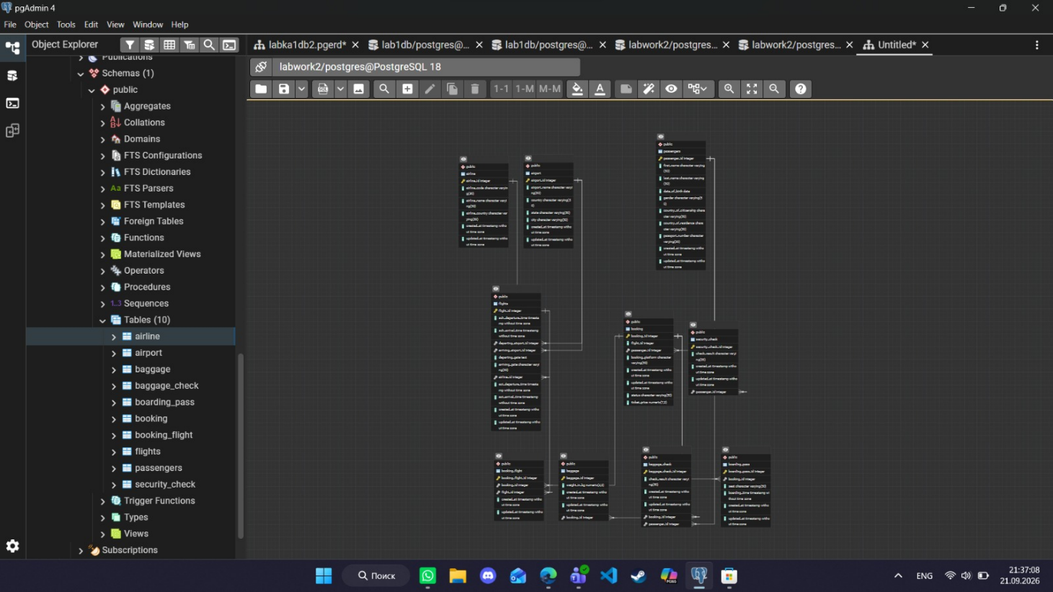
Erd-diagram
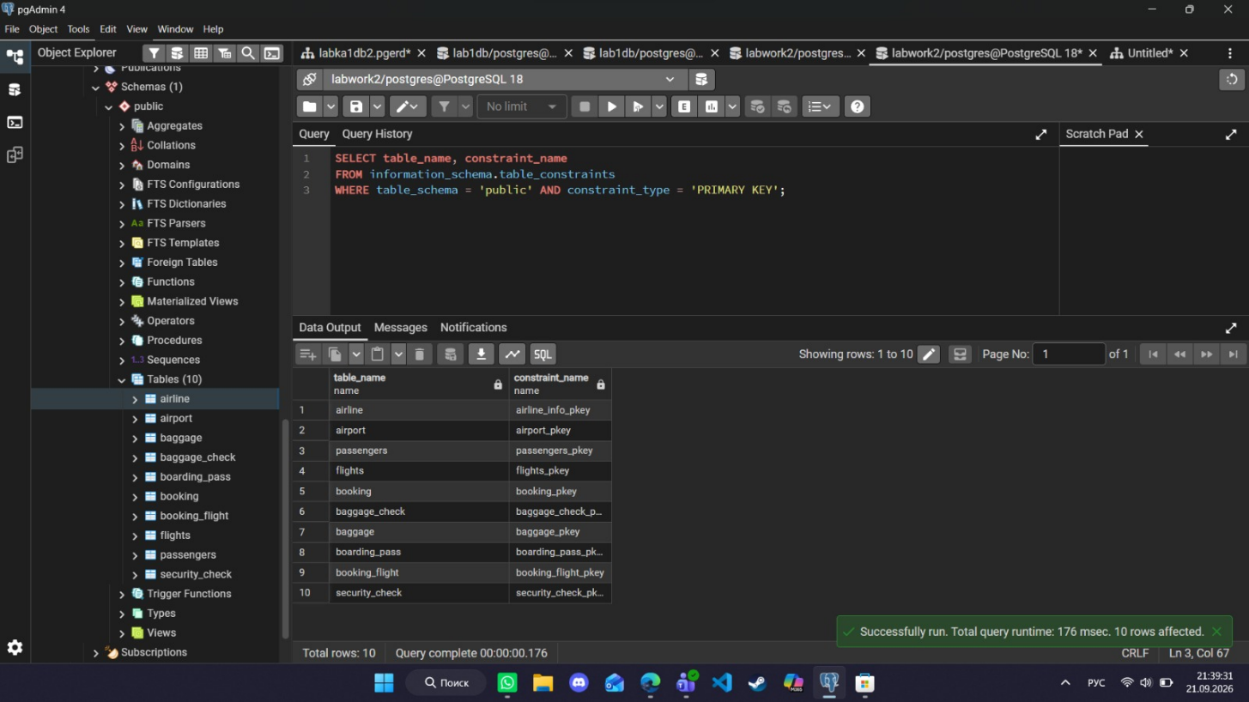
- Primary keys
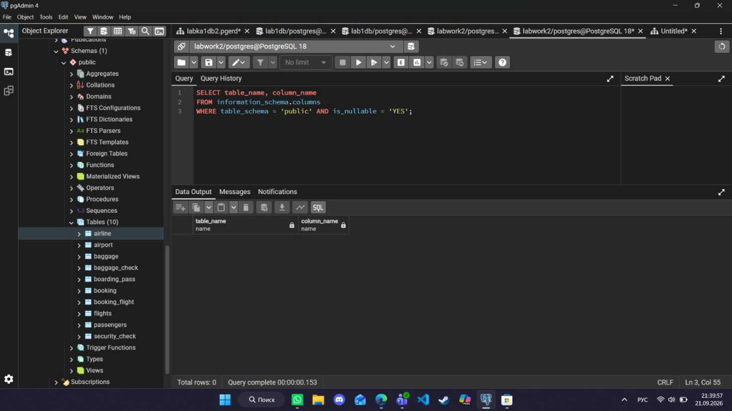
- NOT NULL
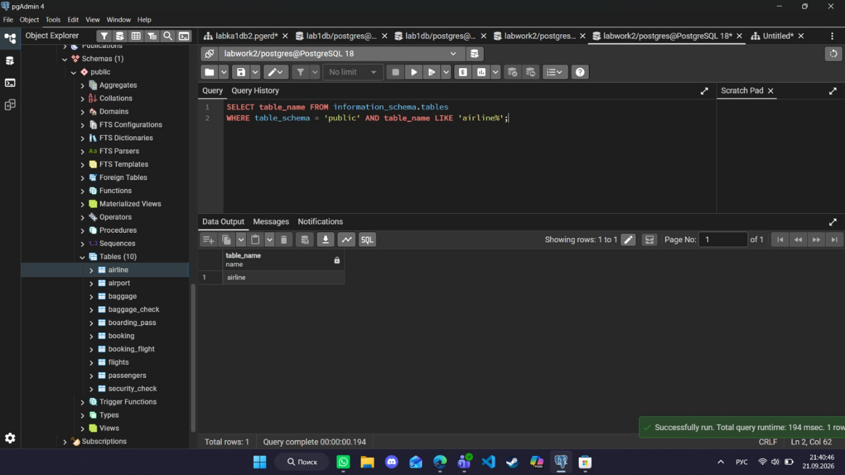
- Table airline
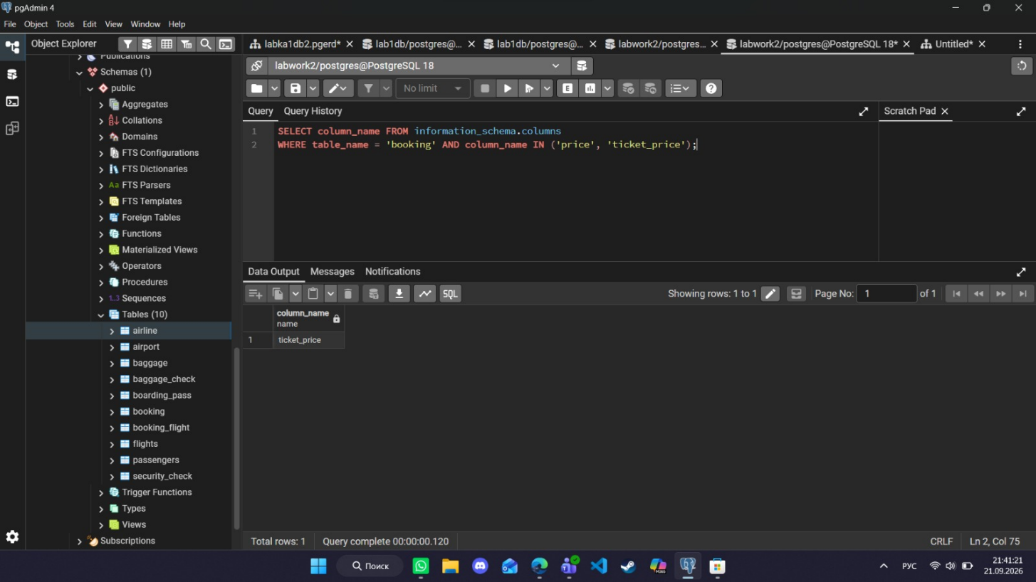
- Column ticket_price
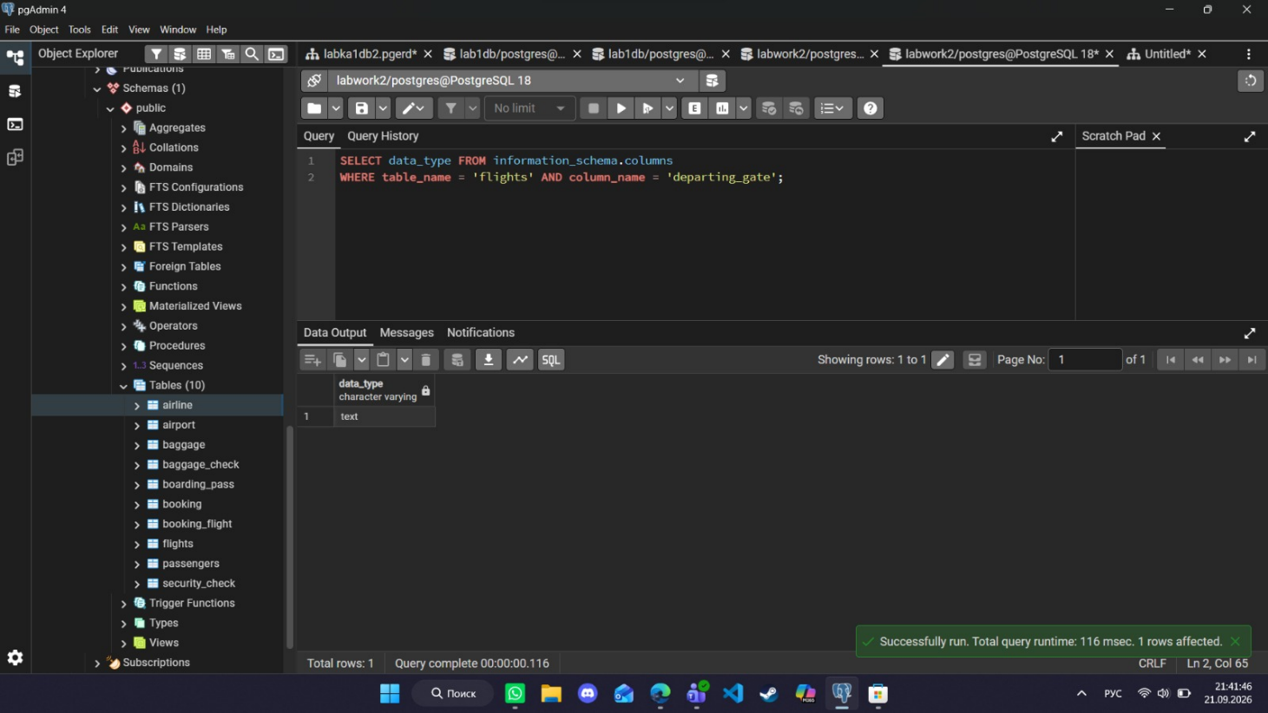
- Data type of departing_gate
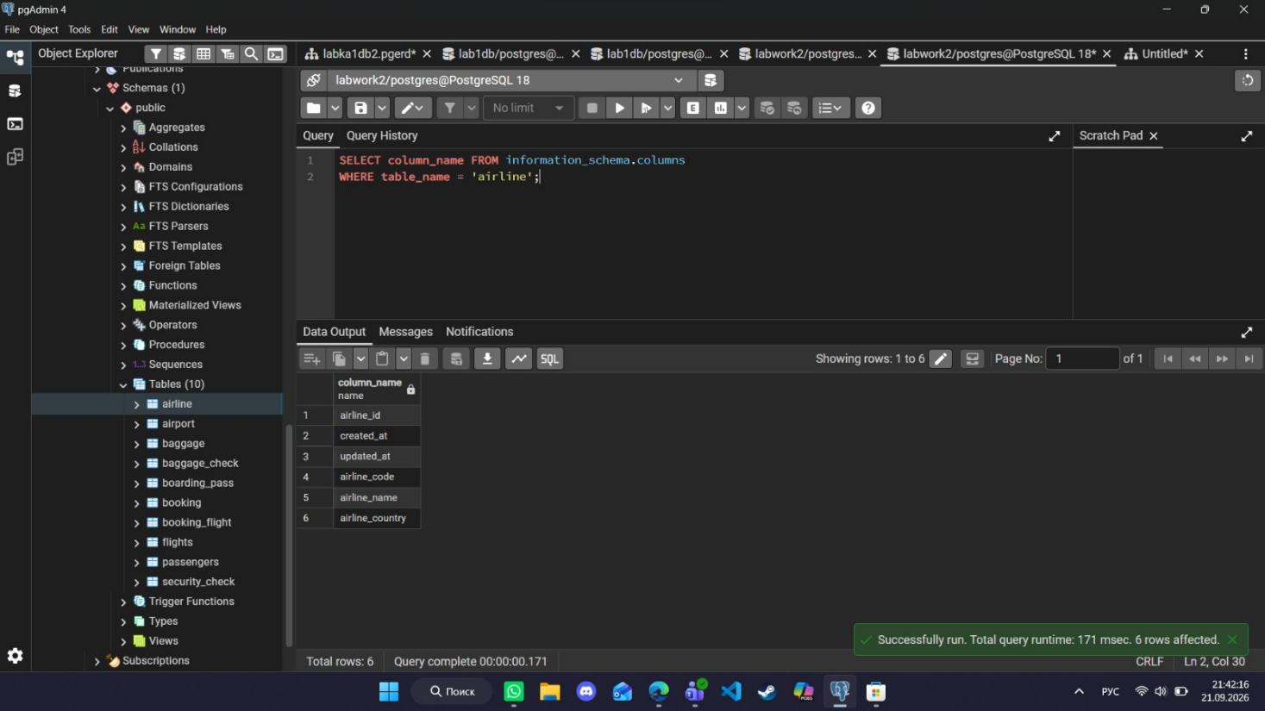
- Column info is gone

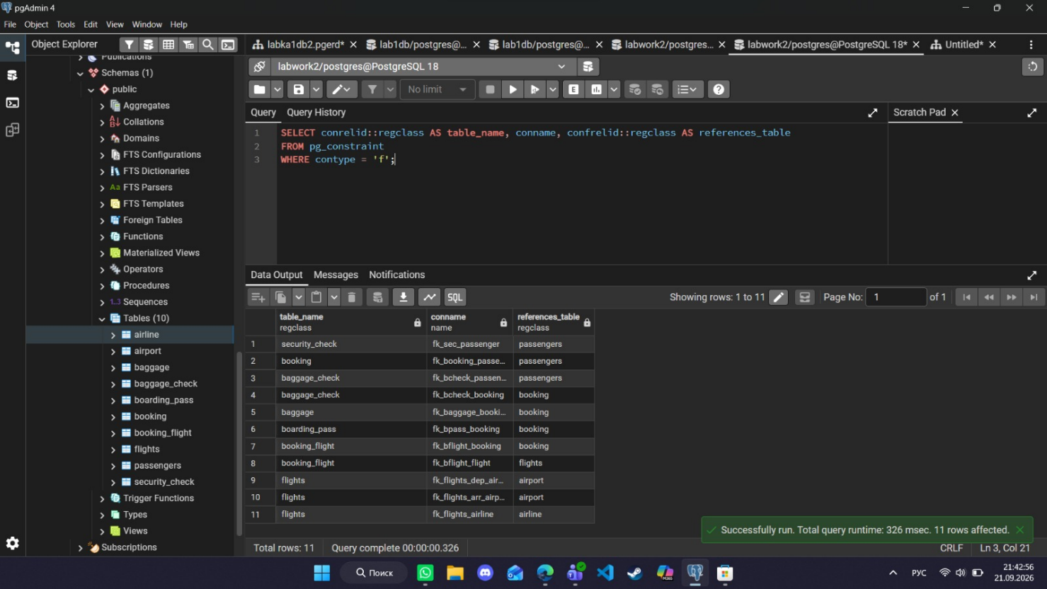
7. Foreign keys

