Guide to the Tycho-2 Catalogue

2000

E. Høg, C. Fabricius, V.V. Makarov
  
Copenhagen University Observatory
  
Juliane Maries Vej 30, DK-2100 Copenhagen 0, Denmark

S. Urban, T. Corbin, G. Wycoff
  
United States Naval Observatory
  
3450 Massachusetts Ave N.W., Washington DC 20392-5420, USA

U. Bastian, P. Schwekendiek
  
Astronomisches Rechen-Institut
  
Mönchhofstrasse 12-14, D-69120 Heidelberg, Germany

A. Wicenec
  
European Southern Observatory
  
Karl-Schwarzschild-Str. 2, D-85748 Garching, Germany

14 January 2000

A reference catalogue of 2.5 million stars
  
with positions, proper motions, BT and VT magnitudes
  
derived from observations made with the ESA Hipparcos satellite

in combination with the Astrographic Catalogue
  
and 143 other ground-based star catalogues

1 Introduction

2

The Tycho-2 Catalogue gives positions, proper motions, and BT and VT magnitudes for 2.5 mil­lion stars across the entire sky, with a density ranging from 25 stars deg~2 at the Galactic poles to 150 stars deg~2 in the Galactic plane. The detailed variation is shown in Fig.1. The catalogue supersedes in most applications the Tycho-1 Catalogue (ESA 1997), the TRC (Kuzmin et al. 1999) and the ACT (Urban et al. 1998) catalogues.

The positions and magnitudes of the Tycho-2 Catalogue were derived in a new reduction of the Tycho data from the ESA Hipparcos satellite. The proper motions given for nearly all the Tycho-2 stars were obtained by a new analysis of 144 ground-based astrometric catalogues, including the Astrographic Catalogue, bringing the positions in these catalogues firmly on the Hipparcos system.

The Tycho-2 Catalogue and its construction are described in two papers (Høg et al. 2000a, 2000b). These papers are placed on the CD-ROM as submitted to the journal, with permission from the editors. The present document is intended as a short guide to the user of the catalogue. In addition, it also presents some details of the proper motion determination which could not be conveniently included in the above mentioned papers.

The catalogue with documentation is published on a CD-ROM by Høg et al. (2000c). The catalogue can also be retrieved from CDS through anonymous ftp, and can be queried using the VizieR service : (http:Ilvizier u-strasbg.fr/cgi-bin/VizieR?-source=Tycho-2). It is also available from the Aladin interactive sky atlas : ([http://aladin.u-strasbg.fr/](http://aladin.u-strasbg.fr/))) or through the ESO skycat tool : ([http://archive.eso.org/skycat/servers/ASTROM](http://archive.eso.org/skycat/servers/ASTROM).)).

Information on the Tycho-2 Catalogue will be placed on its www site :

(<http://www.astro> ku.dk/~erik/Tycho-2), e.g. documentation, software and possible cor­rections to the catalogue.

Details of the Hipparcos mission catalogues, and on-line search facilities, can be found at the ESA Hipparcos www site : ([http://astro.estec.esa.nl/Hipparcos](http://astro.estec.esa.nl/Hipparcos).)).

2 The data files

The following catalogue files are contained in the data directory of the Tycho-2 CD-ROM. Each
  
record is terminated with a nrnn (i.e. CR,LF), giving a physical record length which is two
  
characters longer than the logical record length indicated below. In the file description we have

|  |  |  |  |
| --- | --- | --- | --- |
| adopted the Hipparcos convention: ac,* Table 1: The data files | | | crc, cos S and Ja* j, cos S. |
| File name | Rec. length | Records | Explanations |
| catalog.dat | 206 | 2 539 913 | The Tycho-2 main catalogue |
| suppl 1.dat | 122 | 17588 | The Tycho-2 supplement-1 |
| suppl 2.dat | 122 | 1146 | The Tycho-2 supplement-2 |
| index.dat | 42 | 9538 | Index to Tycho-2 and supplement-1 |

The fields in a record are separated by a vertical bar, j. In this connection the TYC identifier (TYC1, TYC2 and TYC3) constitutes one field and the pair of a HIP number with a CCDM identifier is also considered one field. In the format descriptions, the vertical bars are indicated as "1X". If a numerical field may be blank, this is indicated by a question mark following the range specification in the Explanations column, e.g. ~~ ~~~.



0 20 40 60 80 100 120

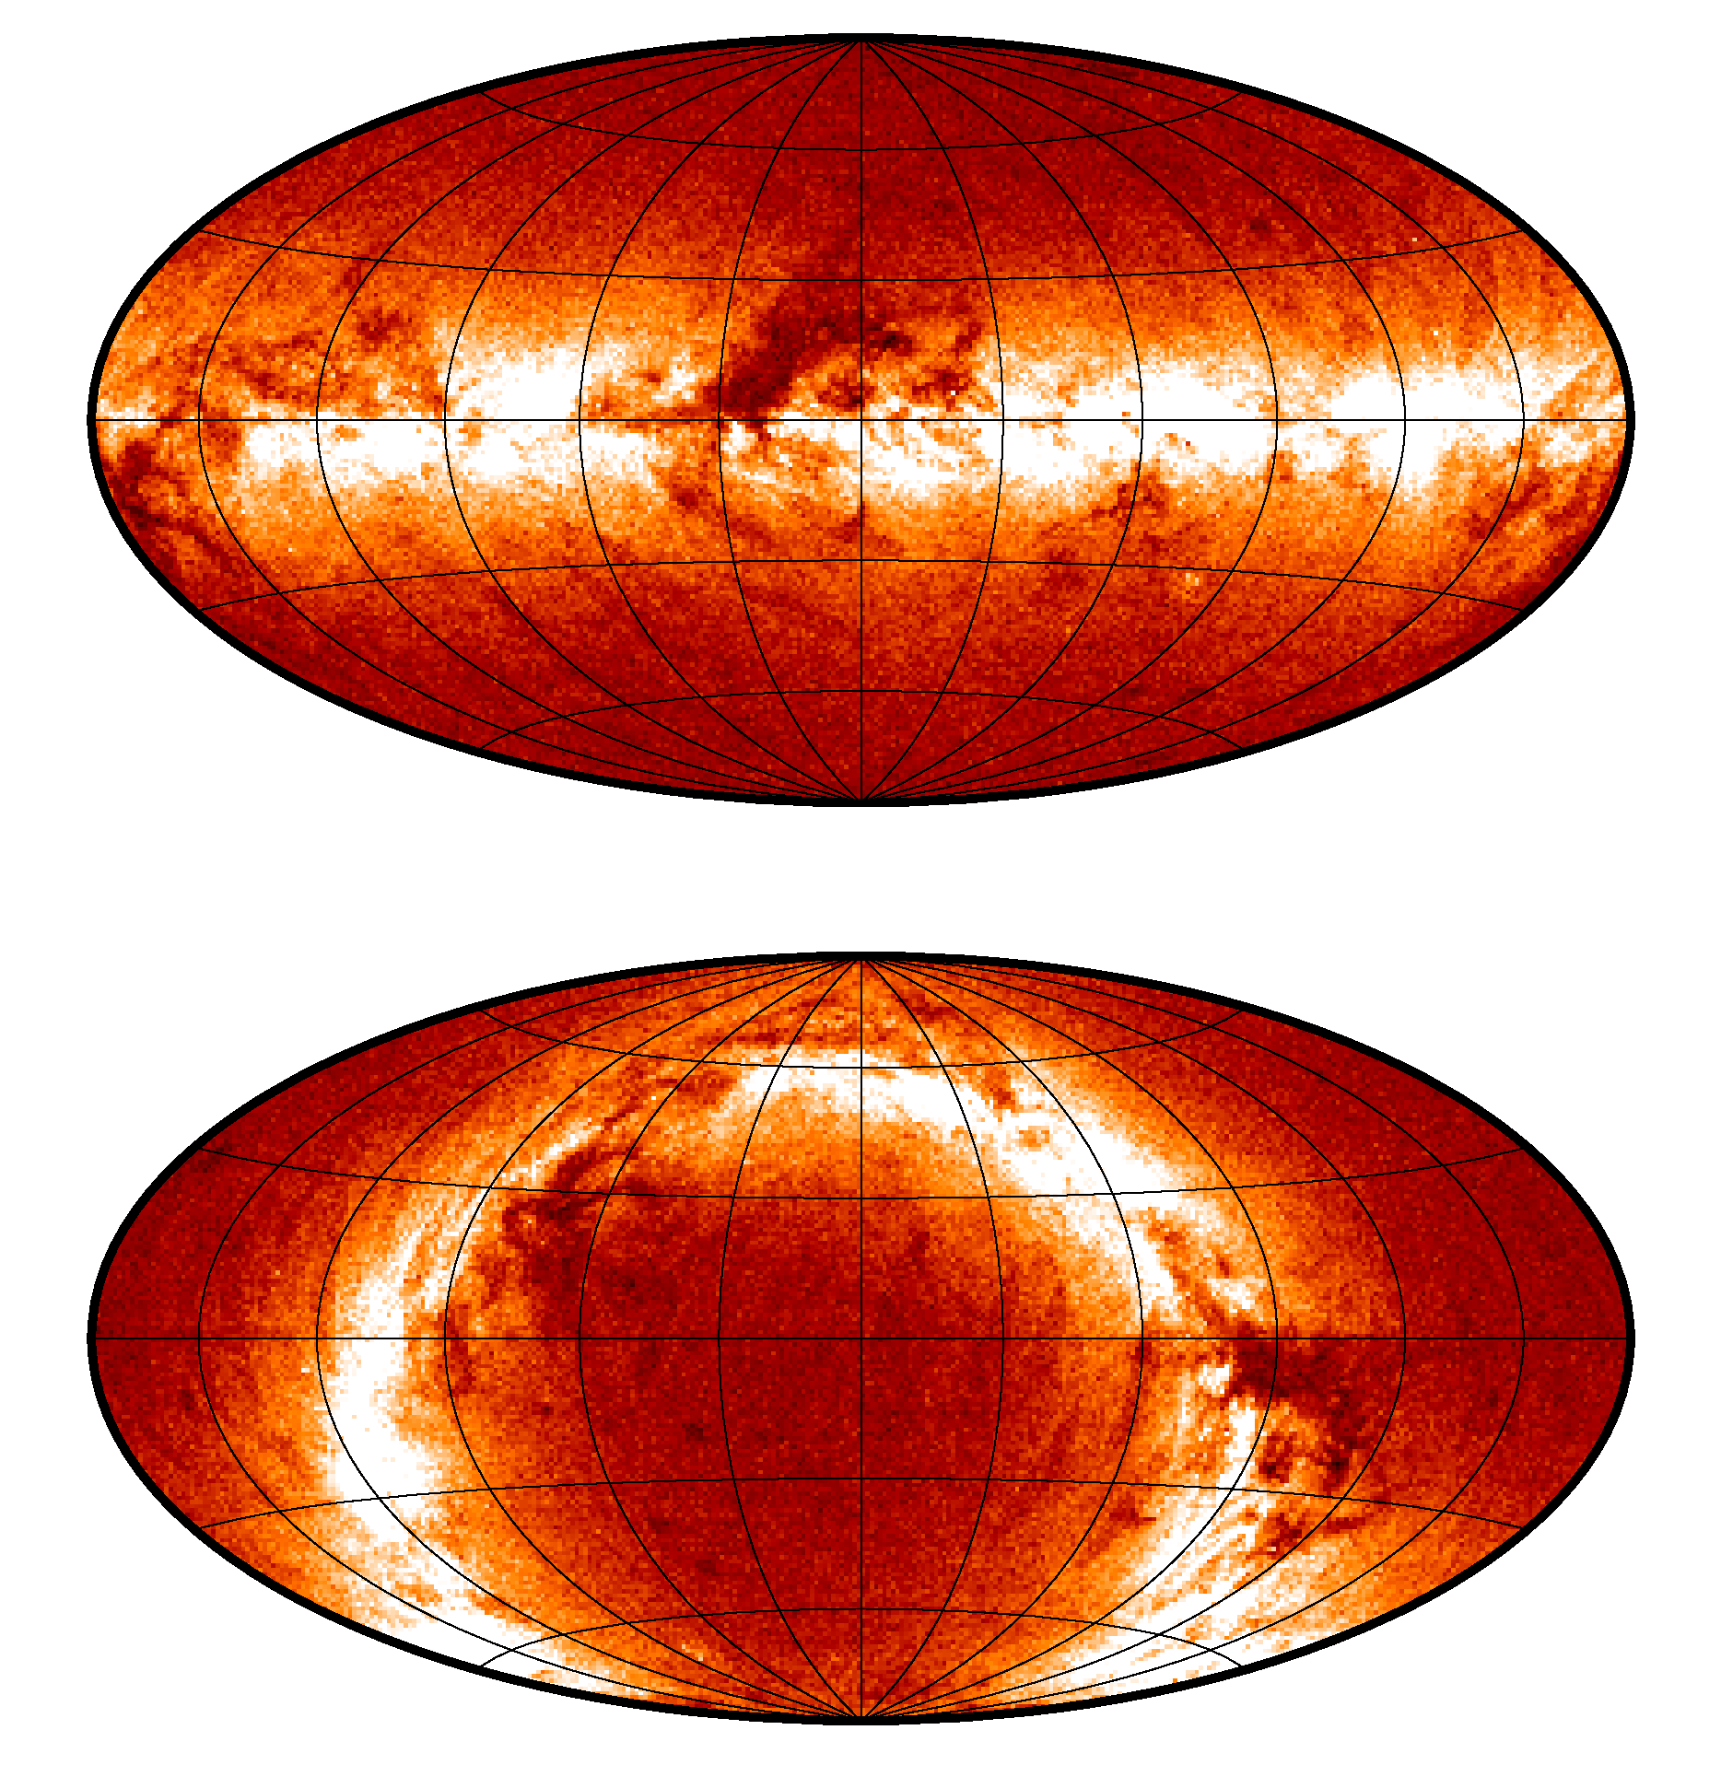

+90°

**a**

+180° -180°

-90°

+90°

**b**

+180° -180°

-90°

3

stars per square degree

Figure 1: The density of Tycho-2 stars on the sky shown in galactic coordinates (panel a) and in equatorial coordinates (panel b). Some of the dark features reveal low star density due to nearby Galactic dust clouds, while other reveal variations in the limiting magnitude caused by the scanning pattern of the satellite. The densest areas have more than 350 stars deg~2, while the thinnest have close to zero. The average density varies from 25 stars deg~2 at b = ±900 and 50 stars deg~2 at b = ±300 to 150 stars deg~2 at b = 00

Table 2: Byte-by-byte description of the file catalog.dat

4

|  |  |  |  |  |
| --- | --- | --- | --- | --- |
| Bytes | Format | Units | Label Explanations | |
| 1- 4 | I4.4 |  | TYC1 | [1, 9537]+= TYC1 from TYC or GSC |
| 6- 10 | I5.5 |  | TYC2 | [1, 12121] TYC2 from TYC or GSC |
| 12- 13 | I1,1X |  | TYC3 | [1, 3] TYC3 from TYC |
| 14- 15 | A1,1X |  | pflag | [ PX] mean position flag a |
| 16- 28 | F12.8,1X | deg | mRAdeg | [ ]? c, mean position, ICRS, at epoch J2000 |
| 29- 41 | F12.8,1X | deg | mDEdeg | [ ]? 5, mean position, ICRS, at epoch J2000 |
| 42- 49 | F7.1,1X | mas/yr | pmRA* | [-4418.0,6544.2]? j~~, ICRS, at epoch J2000.0 |
| 50- 57 | F7.1,1X | mas/yr | pmDE | [-5774.3, 10277.3]? j , ICRS, at epoch J2000.0 |
| 58- 61 | I3,1X | mas | e mRA* | [3, 183]? o~~ (model-based) at mean epoch |
| 62- 65 | I3,1X | mas | e mDE | 1. 184]? cr (model-based) at mean epoch |
| 66- 70 | F4.1,1X | mas/yr | e pmRA* | [0.2, 11.5]? ~~~ (model-based) |
| 71- 75 | F4.1,1X | mas/yr | e pmDE | [0.2, 10.3]? a,~ (model-based) |
| 76- 83 | F7.2,1X | yr | mepRA | [1915.95, 1992.53]? mean epoch of c |
| 84- 91 | F7.2,1X | yr | mepDE | [1911.94, 1992.01]? mean epoch of S |
| 92- 94 | I2,1X |  | Num | 1. 36]? Number of positions used |
| 95- 98 | F3.1,1X |  | g mRA | [0.0, 9.9]? Goodness of fit for mean c b |
| 99-102 | F3.1,1X |  | g mDE | [0.0, 9.9]? Goodness of fit for mean S b |
| 103-106 | F3.1,1X |  | g pmRA | [0.0, 9.9]? Goodness of fit for ji~~ b |
| 107-110 | F3.1,1X |  | g pmDE | [0.0, 9.9]? Goodness of fit for j b |
| 111-117 | F6.3,1X | mag | BT | [2.183, 16.581]? Tycho-2 BT magnitude c |
| 118-123 | F5.3,1X | mag | e BT | [0.014, 1.977]? cTBT |
| 124-130 | F6.3,1X | mag | VT | [1.905, 15.193]? Tycho-2 VT magnitude c |
| 131-136 | F5.3,1X | mag | e VT | [0.009, 1.468]? UVT |
| 137-140 | I3,1X |  | prox | 1. 999] proximity indicator d |
| 141-142 | A1,1X |  | TYC | [ T] Tycho-1 star flag |
| 143-148 | I6 |  | HIP | [1, 120404]? Hipparcos number |
| 149-152 | A3,1X |  | CCDM CCDM component identifier for HIP stars | |
| 153-165 | F12.8,1X | deg | RAdeg c, observed Tycho-2 position, ICRS | |
| 166-178 | F12.8,1X | deg | DEdeg 5, observed Tycho-2 position, ICRS | |
| 179-183 | F4.2,1X | a | epRA [0.81, 2.13] epoch-1990 of RAdeg | |
| 184-188 | F4.2,1X | a | epDE [0.72, 2.36] epoch-1990 of DEdeg | |
| 189-194 | F5.1,1X | mas | e RA* a~~ (model-based), observed position | |
| 195-200 | F5.1,1X | mas | e DE cr (model-based), observed position | |
| 201-202 | A1,1X |  | posflg [ DP] type of Tycho-2 solution e | |
| 203-206 | F4.1 |  | corr correlation, p ~~, observed position | |

aThe mean position flag:

t = normal mean position and proper motion

'P' = the mean position, proper motion etc refer to the BT photo-centre of two Tycho-2 entries 'X' = no mean position, no proper motion

bThis goodness of fit is the ratio of the scatter-based and the model-based error. It is only defined when Num > 2. Values exceeding 9.9 are truncated to 9.9

cBlank when no magnitude is available. Either BT or VT is always given.

dDistance in units of 100 mas to the nearest entry in the Tycho-2 main catalogue or supplement-i, computed for the epoch i99i.25. A value of 999 (i.e. 99.9 arcsec) is given if the distance exceeds 99.9 arcsec

et = normal treatment, 'D' = double star treatment, 'P' = photo-centre treatment

2.1 The main catalogue file

5

The Tycho-2 Catalogue uses a similar star numbering system as the GSC (Jenkner et al. 1990). The system is consistent with Tycho-1. The TYC identifier is constructed from the GSC re­gion number (TYC1), the running number within the region (TYC2) and a component identifier (TYC3) which is normally 1. Some non-GSC running numbers were constructed for the first Ty­cho Catalogue and for Tycho-2. The recommended star designation contains a hyphen between the TYC numbers, e.g. TYC 1-13-1.

Two positions are given for each star, the mean position at epoch 2000.0 and the observed position at the epoch of Tycho observations (around 1991.5). The mean position is a weighted mean for all the catalogues contributing to the proper motion determination, including Tycho-2. This mean has then been brought from the mean epoch to epoch 2000.0 by the computed proper motion. For four percent of the stars only the Tycho-2 position was available and neither proper motion nor mean position could be determined. For close double stars, the ground-based photographic positions referred to the photo-centre of the system and a common proper motion and mean position has been determined and identical values are given here for the two components, likely being of lower quality than for single stars. The observed position is the position derived from the Tycho observations alone and is given for all stars.

Transformation of the mean position from the catalogue epoch T0 = 2000.0 to an arbitrary epoch T = T0 + t may be done rigorously as described, e.g., in the Hipparcos and Tycho Catalogues (ESA 1997) Vol. 1, Sect. 1.2.8. A simpler transformation may be used if the proper motion and the epoch difference, t, are small and if the star is not too close to one of the celestial poles:

~t ~ c + j~*t/cosS (1)

~t = S + [Löt (2)

where c, 5, ji~* and j are given in bytes 16-57.

The standard errors of the position components are computed from the values in bytes 58-75 and the mean epochs, Ta, To, in bytes 76-91:

~~*t = (o~ ~* + (T —Ta)2o~ ~~~)°~5 (3)

~~t = (cr~ ~ + (T -T0)2cr~ ~~)°~5 (4)

The Tycho photometry gives a blue and a visual magnitude, BT and VT, for nearly all the stars. For every star at least one of the magnitudes is given. The faintest magnitudes (fainter than BT 13 and VT 12) are not to be trusted and the very faintest may simply mean that the star was too faint for detection in that passband. The Tycho magnitudes are not identical to the Johnson magnitudes, but an approximate Johnson photometry for unreddened main sequence stars may be obtained as:

V = VT -0.090(BT -VT) (5)

and

B -V = 0.850(BT -VT). (6)

The transformation depends in reality on the detailed spectrum of the star, especially on lu­minosity class and reddening, and it is recommended to work with the BT and VT magnitudes directly. Consult Sections 1.3 and 2.2 of Vol. 1 of the Hipparcos and Tycho Catalogues for details.

The stars in common between Tycho-2 and the first Tycho Catalogue, Tycho-1, are flagged in the following manner: If there is a Tycho-1 star within 0.8 arcsec of a Tycho-2 star or if