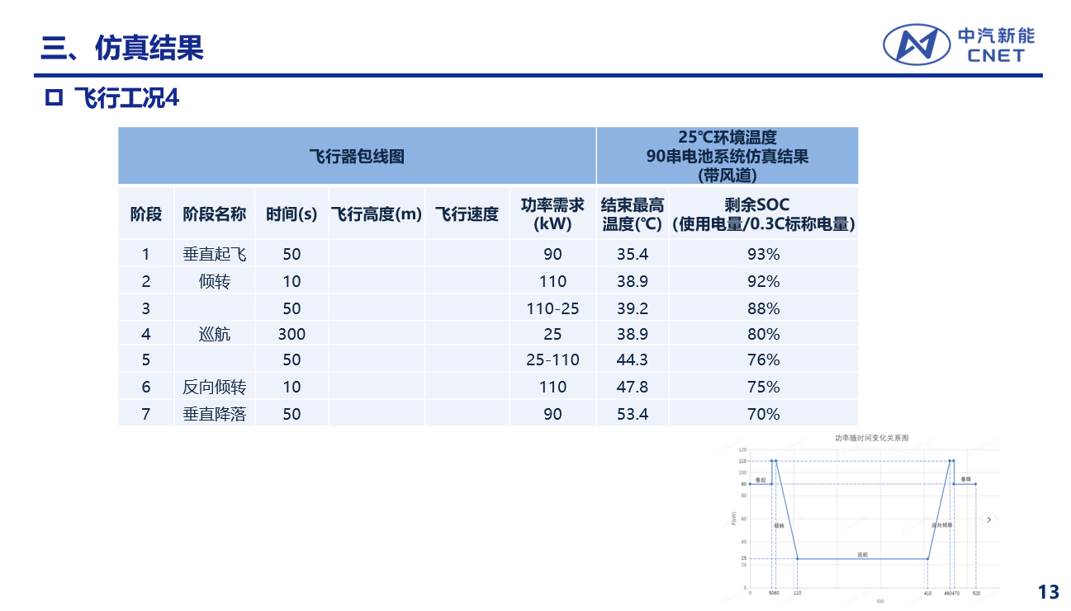

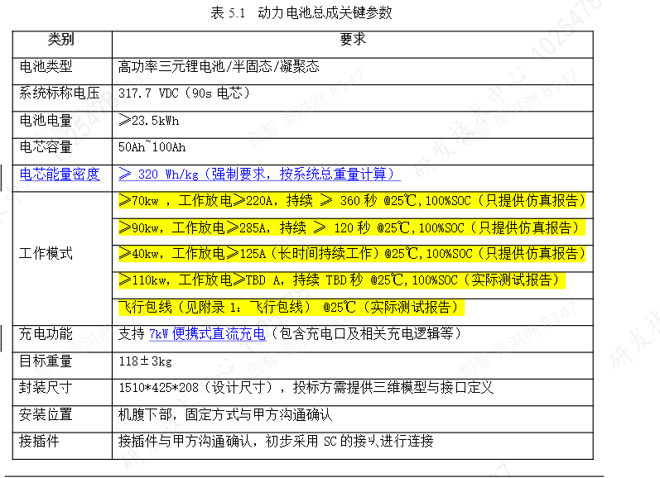

整机 350kg, 外侧60垂起桨叶，外侧40倾转桨叶，

60 垂起桨叶
电压 (V) | 电流 (A) | 拉力 (g) | 扭矩 (N·M) | 转速 (rpm) | 轴功率 (W) | 轴力效 (G/W) | 输入脉宽 (μs)
398.6 | 10.84 | 28383 | 18.77 | 1551 | 3048.05 | 9.31 | 1442
398.0 | 12.73 | 35005 | 22.39 | 1680 | 3938.31 | 8.89 | 1477
397.9 | 17.63 | 45311 | 29.07 | 1895 | 5767.68 | 7.86 | 1510
398.1 | 21.53 | 52061 | 33.53 | 2023 | 7101.93 | 7.33 | 1538
397.6 | 26.85 | 60785 | 39.22 | 2175 | 8931.28 | 6.81 | 1571
397.5 | 30.40 | 65836 | 43.08 | 2294 | 10347.03 | 6.36 | 1602
397.5 | 34.34 | 71070 | 46.81 | 2386 | 11693.80 | 6.08 | 1626
397.1 | 39.57 | 76337 | 51.04 | 2470 | 13199.40 | 5.78 | 1646
397.3 | 47.17 | 88059 | 57.71 | 2604 | 15733.99 | 5.60 | 1670
397.0 | 56.57 | 98959 | 65.99 | 2759 | 19062.35 | 5.19 | 1717
396.4 | 64.37 | 108787 | 72.48 | 2874 | 21809.80 | 4.99 | 1741
396.3 | 71.45 | 116027 | 77.60 | 2939 | 23878.55 | 4.86 | 1758
396.2 | 80.48 | 124684 | 83.83 | 3035 | 26638.20 | 4.68 | 1782
395.4 | 88.39 | 130616 | 89.55 | 3111 | 29168.38 | 4.48 | 1798
395.4 | 99.46 | 140638 | 96.21 | 3181 | 32042.81 | 4.39 | 1802

40 巡航桨叶
转速 | 风速 | 拉力* | 扭矩* | 效率 | 功率（kW）
2000.00 | 0.00 | 169.90 | 13.87 | 0.00% | 2.91
2200.00 | 0.00 | 205.84 | 16.93 | 0.00% | 3.90
2400.00 | 0.00 | 242.65 | 20.27 | 0.00% | 5.09
2600.00 | 0.00 | 283.39 | 24.00 | 0.00% | 6.53
2800.00 | 0.00 | 328.08 | 28.00 | 0.00% | 8.21
3000.00 | 0.00 | 374.22 | 32.23 | 0.00% | 10.13
3200.00 | 0.00 | 425.36 | 37.23 | 0.00% | 12.48
3400.00 | 0.00 | 478.19 | 42.48 | 0.00% | 15.12
3600.00 | 0.00 | 534.83 | 48.08 | 0.00% | 18.13
1000.00 | 2.90 | 44.85 | 3.59 | 34.58% | 0.38
1500.00 | 2.90 | 97.24 | 7.85 | 22.86% | 1.23
2000.00 | 2.90 | 168.67 | 13.91 | 16.79% | 2.91
2500.00 | 2.90 | 261.83 | 21.97 | 13.20% | 5.75
3000.00 | 2.90 | 376.06 | 32.32 | 10.74% | 10.15
3500.00 | 2.90 | 506.15 | 45.25 | 8.85% | 16.58
4000.00 | 2.90 | 652.75 | 62.08 | 7.28% | 26.00
3000.00 | 2.90 | 377.76 | 32.30 | 10.79% | 10.15
2000.00 | 9.95 | 155.74 | 14.31 | 51.68% | 3.00
2200.00 | 10.10 | 191.67 | 17.29 | 48.60% | 3.98
2400.00 | 10.15 | 230.05 | 20.56 | 45.19% | 5.17
2600.00 | 10.29 | 271.49 | 24.14 | 42.50% | 6.57
2800.00 | 10.04 | 317.58 | 28.02 | 38.81% | 8.21
3000.00 | 10.10 | 367.56 | 32.32 | 36.58% | 10.15
3200.00 | 10.11 | 419.64 | 37.02 | 34.19% | 12.40
3400.00 | 10.28 | 474.09 | 42.11 | 32.51% | 14.99
3600.00 | 10.18 | 532.37 | 48.02 | 29.93% | 18.10
2200.00 | 19.96 | 151.06 | 17.30 | 75.66% | 3.99
2200.00 | 20.04 | 152.34 | 17.26 | 76.77% | 3.98
2400.00 | 20.06 | 189.63 | 20.82 | 72.68% | 5.23
2600.00 | 20.01 | 230.87 | 24.58 | 69.03% | 6.69
2800.00 | 20.05 | 275.86 | 28.66 | 65.82% | 8.40
3000.00 | 20.09 | 325.70 | 33.10 | 62.93% | 10.40
3200.00 | 20.02 | 378.13 | 37.66 | 59.98% | 12.62
3400.00 | 20.11 | 432.85 | 42.60 | 57.38% | 15.17
3600.00 | 20.05 | 493.10 | 47.94 | 54.71% | 18.07
3800.00 | 19.95 | 558.22 | 53.77 | 52.04% | 21.40
2400.00 | 29.99 | 123.49 | 16.95 | 86.96% | 4.26
2600.00 | 30.09 | 162.89 | 21.45 | 83.91% | 5.84
2800.00 | 30.03 | 207.02 | 26.22 | 80.86% | 7.69
3000.00 | 30.06 | 255.27 | 31.13 | 78.48% | 9.78
3200.00 | 30.02 | 307.28 | 36.35 | 75.73% | 12.18
3400.00 | 29.99 | 363.00 | 41.71 | 73.31% | 14.85
3600.00 | 30.05 | 423.01 | 47.40 | 71.12% | 17.87
3800.00 | 30.07 | 486.50 | 53.32 | 68.95% | 21.22
4000.00 | 30.08 | 553.86 | 59.58 | 66.76% | 24.96
2400.00 | 39.98 | 40.23 | 7.49 | 85.39% | 1.88
2600.00 | 40.05 | 75.58 | 12.71 | 87.50% | 3.46
2800.00 | 39.99 | 115.16 | 18.07 | 86.91% | 5.30
3000.00 | 40.04 | 159.08 | 23.62 | 85.84% | 7.42
3200.00 | 40.08 | 207.34 | 29.52 | 84.02% | 9.89
3400.00 | 39.99 | 261.36 | 35.80 | 81.98% | 12.75
3600.00 | 40.08 | 318.04 | 42.15 | 80.21% | 15.89
3800.00 | 40.02 | 381.23 | 48.85 | 78.47% | 19.44
4000.00 | 40.06 | 448.29 | 55.75 | 76.90% | 23.35
2800.00 | 50.03 | 17.78 | 4.63 | 65.56% | 1.36
3000.00 | 49.99 | 55.70 | 10.75 | 82.45% | 3.38
3200.00 | 50.06 | 98.26 | 17.10 | 85.83% | 5.73
3400.00 | 50.09 | 144.75 | 23.68 | 86.00% | 8.43
3600.00 | 50.08 | 196.70 | 30.64 | 85.28% | 11.55
3800.00 | 50.05 | 255.10 | 38.06 | 84.30% | 15.14
4000.00 | 50.02 | 319.19 | 45.62 | 83.54% | 19.11
4200.00 | 50.02 | 390.18 | 53.49 | 82.96% | 23.53

