**Reference**

Algert, N.E., and Watson, K. (2002): Conflict management: introductions for individuals and organizations. Bryan, TX: (97)775-870

Balzer R. (1991): “Tolerating Inconsistency,” in Proceedings of the 13th Inter-national Conference on Software Engineering (ICSE). **4** (7), 75–89

Boehm, B. (2003). Value-Based Software Engineering. ACM SIGSOFT Software Engineering notes, 28(2) 6-13

Boehm, B. and Turner, R. (2003). *Balancing Agility and Discipline: A Guide for the Perplexed*. Boston: Addison-Wesley. **6** (7), 45–80

Benjamin, and Boehm, B. (1998). ‘A Spiral Model for Software Development and Enhancement’ IEEE Computer (21), 5-17

Brun, R. Holmes, M. D. Ernst, and D. Notkin (2011): “Crystal: Precise and Unobtrusive Conflict Warnings,” in Proceedings of the 8th Joint Meeting of the European Software Engineering Conference and the ACM SIGSOFT Symposium on the Foundations of Software Engineering (ESEC/FSE). ACM, (12), 444–447.

Eke, B.O. and Kenneth, C.(2009). Software Engineering Change Evangelism: Process to People. International Journal of Physical Science. (4) 12-23

Eke, B.O. and Nwachukwu, E.O. (2011). Software Engineering Process: YAAM Deployment in E-Bookshop Use Case Scenerio. Journal of theoretical and Applied Information Technology. 30(3) 11-45

Eke, B.O. and Okereke, N.C.(2008). Software engineering: Migration from classical Methods to XP. African Journal of Physical Science. 1(1)23-33

Fowler, Martin (2007: ["What Is Refactoring"](http://c2.com/cgi/wiki?WhatIsRefactoring) Journal of theoretical and Applied Information Technology. 30(3), 11-45

Gilb, T., “(1998): Evolutionary Development. ACM. Software Engineering Notes, (1), 17-23.

Goedicke M., T. Meyer, and G. Taentzer (1999): “Viewpoint-Oriented Software Development by Distributed Graph Transformation: Towards a Basisfor Living with Inconsistencies,” in Proceedings of the International Symposium on Requirements Engineering (8), 25-39

Guntamukala, V., Wen, H. J and Tarn, J.M. (2006).An empirical study of selecting software development life cycle models. Human systems management. 25(1), 265-278.

Highsmith, J. A. (2002). *Adaptive Software Development: A Collaborative Approach to Managing Complex Systems.* New York: Dorset House. 1(1), 5-8.

John, S (2000): Tittle Computer Sciences Corporation "Software Measurement and Outsourcing" Presentation at the QSM User Conference ([www.qsm.com](http://www.qsm.com)) (3), 5-8.

Jonas Söderström. ["Onceability: The consequence of technology rot"](http://inuseful.se/onceability-the-consequence-of-technology-rot). Journal Of Computation Methods In Sciences And Engineering. (9), 239-249.

Kerr, J., And Hunter, R., (1994). ‘Inside RAD’, Journal Of Computation Methods In Sciences And Engineering. (5), 23-34.

Labib, C., Hasanein, E., And Hegazy, O., (2009).Early Development Of Graphical User Interface (GUI) In Agile Methodologies. Journal Of Computation Methods In Sciences And Engineering. (9), 239-249.

Leffingwell, D. (2007). *Scaling Software Agility: Best Practices for Large Enterprises.* Boston: Addison-Wesley. **37** (12), 26–34.

Dubois M. and Briggs G (2011): [*The run-time efficiency of parallel asynchronous algorithms*](http://doi.ieeecomputersociety.org/10.1109/12.102830) IEEE Transactions on Computers, 40(11), 1260–1266

[Madnick, Stuart Elliot](http://web.mit.edu/smadnick/www/Resume/Publications.htm) [[1]](http://www.lecgcp.com/resources/documents/Madnick_LECG_CV_08_2006.pdf) (1968) [*Multi-processor software lockout*](http://doi.acm.org/10.1145/800186.810561)[[2]](http://web.mit.edu/smadnick/www/papers/P001.pdf) Proceedings of the 1968 23rd ACM national conference,(1), 19 – 24

McDermid, J., And Rook, P., (1993). Software Engineer’s ReferenceBook, CRC Press, (1), 15-28.

Nwachukwu, E.O. and Eke, B.O.(2008). Critical Analysis of Software Development Strategies. Journal of Science and Technology. 7(4), 1-7

Pressman, R. S. (2005). Software Engineering, A Practioners Approach, (6), 45-67

Pressman, R.S. (2012). ). Scaling Software Agility: Best Practices for Large Enterprises. Boston: Addison-Wesley. **37** (12), 26–34.

Randy J. Raynor, John M. Gwynn, (1976): Jr.[*Minimization of supervisor conflict for multiprocessor computer systems*](http://doi.acm.org/10.1145/1013610.807300) ACM SIGSIM Simulation Digest. (7), 61 – 69

Raymond M. and Eric. D. (2013): ["Bit rot"](http://www.catb.org/jargon/html/B/bit-rot.html). The Jargon File. Journal Of Computation Methods In Sciences And Engineering. (5), 23-34.

Rodgers, David P. (1985) [Improvements in multiprocessor system design](http://portal.acm.org/citation.cfm?id=327215) ACM SIGARCH Computer Architecture News archive table of contents Special Issue: Proceedings of the 12th annual [International Symposium on Computer Architecture](https://en.wikipedia.org/wiki/International_Symposium_on_Computer_Architecture) (13), 225 –230

Royce, W.W. (1970). Managing the Development Of Large Software Systems: Concept And Techniques, Proceeding WESCON. (2), 23-55

Sarma, A D. F. Redmiles, and A. van der Hoek(2012): “Palantır: Early De tection of Development Conflicts Arising from Parallel Code Changes,”IEEE Transactions on Software Engineering (TSE) (1), 23-67.

Van Gurp , Jilles, and Jan Bosch. (2002):"Design erosion: problems and causes." Journal of systems and software. 61(2), 105-119.

walia, Khalid Shergil, (2014): ”Impact of interpersonal conflict on requirements”, A Research Review”, University of westernontario , 1(2), 10-19..

Westfechtel B (2014): “Merging of EMF Models,”Software & Systems Modeling, 13(2), 757–788.

Wloka J., B. Ryder, F. Tip, and X. Ren, (2009) “Safe-Commit Analysis to Facilitate Team Software Development,” in Proceedings of the 31st International Conference on Software Engineering (ICSE) IEEE Computer Society. (7),507–517.

Wiley B. and Jonathan R. 1989: "Using Cognitive Mapping for Strategic Options Development". (In 'Rational Analysis for a Problematic World',

**Appendix A**

**Programming codes for the new software**

using System;

using System.Collections.Generic;

using System.ComponentModel;

using System.Data;

using System.Drawing;

using System.Linq;

using System.Text;

using System.Windows.Forms;

using System.IO;

namespace AppFinder

{

public partial class appForm : Form

{

public appForm()

{

InitializeComponent();

}

private void showFiles_SelectedIndexChanged(object sender, EventArgs e)

{

fPath.Text = showFiles.SelectedItem.ToString();

}

private void appForm_Load(object sender, EventArgs e)

{

}

void DirSearch(string sDir)

{

try

{

foreach (string d in Directory.GetDirectories(sDir))

{

foreach (string f in Directory.GetFiles(d, txtFile.Text))

{

// lstFilesFound.Items.Add(f);

showFiles.Items.Add(f);

}

DirSearch(d);

}

}

catch (System.Exception ne)

{

//Console.WriteLine(excpt.Message);

MessageBox.Show(ne.Message);

}

}

private void btnSearch_Click(object sender, EventArgs e)

{

// lstFilesFound.Items.Clear();

if (lblPath.Text != "")

{

try

{

txtFile.Enabled = false;

cboDirectory.Enabled = false;

btnSearch.Text = "Searching...";

this.Cursor = Cursors.WaitCursor;

Application.DoEvents();

DirSearch(lblPath.Text);

btnSearch.Text = "Search";

this.Cursor = Cursors.Default;

txtFile.Enabled = true;

cboDirectory.Enabled = true;

}

catch (System.IO.IOException ne)

{

MessageBox.Show(ne.Message);

}

}

else

{

MessageBox.Show("Please Browse Root Folder");

}

}

private void btnBroswe_Click(object sender, EventArgs e)

{

DialogResult result = folderBrowserDialog1.ShowDialog();

if (result == DialogResult.OK)

{

//

// The user selected a folder and pressed the OK button.

// We print the number of files found.

//

// string[] files = Directory.GetFiles(folderBrowserDialog1.SelectedPath);

// fPath.Text = files.

//MessageBox.Show("Files found: " + files.Length.ToString(), "Message");

string path = folderBrowserDialog1.SelectedPath;

lblPath.Text = path;

}

}

private void btnDelete_Click(object sender, EventArgs e)

{

if (System.IO.File.Exists(showFiles.SelectedItem.ToString()))

{

// Use a try block to catch IOExceptions, to

// handle the case of the file already being

// opened by another process.

try

{

System.IO.File.Delete(showFiles.SelectedItem.ToString());

showFiles.Items.Remove(showFiles.SelectedItem.ToString());

MessageBox.Show("File Deleted.......");

}

catch (System.IO.IOException ne)

{

Console.WriteLine(ne.Message);

return;

}

}

Designer codes

namespace AppFinder

{

partial class appForm

{

/// <summary>

/// Required designer variable.

/// </summary>

private System.ComponentModel.IContainer components = null;

/// <summary>

/// Clean up any resources being used.

/// </summary>

/// <param name="disposing">true if managed resources should be disposed; otherwise, false.</param>

protected override void Dispose(bool disposing)

{

if (disposing && (components != null))

{

components.Dispose();

}

base.Dispose(disposing);

}

#region Windows Form Designer generated code

/// <summary>

/// Required method for Designer support - do not modify

/// the contents of this method with the code editor.

/// </summary>

private void InitializeComponent()

{

System.ComponentModel.ComponentResourceManager resources = new System.ComponentModel.ComponentResourceManager(typeof(appForm));

this.pictureBox1 = new System.Windows.Forms.PictureBox();

this.label1 = new System.Windows.Forms.Label();

this.panel1 = new System.Windows.Forms.Panel();

this.label2 = new System.Windows.Forms.Label();

this.txtFile = new System.Windows.Forms.TextBox();

this.btnSearch = new System.Windows.Forms.Button();

this.label3 = new System.Windows.Forms.Label();

this.panel2 = new System.Windows.Forms.Panel();

this.showFiles = new System.Windows.Forms.ComboBox();

this.fPath = new System.Windows.Forms.Label();

this.btnDelete = new System.Windows.Forms.Button();

this.cboDirectory = new System.Windows.Forms.ComboBox();

this.lblDirectory = new System.Windows.Forms.Label();

this.lblFile = new System.Windows.Forms.Label();

this.lblPath = new System.Windows.Forms.Label();

this.btnBroswe = new System.Windows.Forms.Button();

this.folderBrowserDialog1 = new System.Windows.Forms.FolderBrowserDialog();

((System.ComponentModel.ISupportInitialize)(this.pictureBox1)).BeginInit();

this.panel1.SuspendLayout();

this.panel2.SuspendLayout();

this.SuspendLayout();

//

// pictureBox1

//

this.pictureBox1.BorderStyle = System.Windows.Forms.BorderStyle.FixedSingle;

this.pictureBox1.Image = ((System.Drawing.Image)(resources.GetObject("pictureBox1.Image")));

this.pictureBox1.Location = new System.Drawing.Point(456, 163);

this.pictureBox1.Name = "pictureBox1";

this.pictureBox1.Size = new System.Drawing.Size(242, 200);

this.pictureBox1.SizeMode = System.Windows.Forms.PictureBoxSizeMode.CenterImage;

this.pictureBox1.TabIndex = 0;

this.pictureBox1.TabStop = false;

//

// label1

//

this.label1.BackColor = System.Drawing.SystemColors.ButtonHighlight;

this.label1.BorderStyle = System.Windows.Forms.BorderStyle.FixedSingle;

this.label1.Font = new System.Drawing.Font("Microsoft Sans Serif", 12F, System.Drawing.FontStyle.Bold, System.Drawing.GraphicsUnit.Point, ((byte)(0)));

this.label1.Location = new System.Drawing.Point(-2, -2);

this.label1.Name = "label1";

this.label1.Size = new System.Drawing.Size(715, 42);

this.label1.TabIndex = 1;

this.label1.Text = "HIGH ORDER DESIGN CONFLICT";

this.label1.TextAlign = System.Drawing.ContentAlignment.MiddleCenter;

//

// panel1

//

this.panel1.BorderStyle = System.Windows.Forms.BorderStyle.FixedSingle;

this.panel1.Controls.Add(this.label3);

this.panel1.Controls.Add(this.txtFile);

this.panel1.Controls.Add(this.btnSearch);

this.panel1.Controls.Add(this.label2);

this.panel1.Location = new System.Drawing.Point(456, 57);

this.panel1.Name = "panel1";

this.panel1.Size = new System.Drawing.Size(242, 100);

this.panel1.TabIndex = 8;

//

// label2

//

this.label2.BackColor = System.Drawing.SystemColors.ButtonHighlight;

this.label2.BorderStyle = System.Windows.Forms.BorderStyle.FixedSingle;

this.label2.Location = new System.Drawing.Point(-1, -4);

this.label2.Name = "label2";

this.label2.Size = new System.Drawing.Size(242, 24);

this.label2.TabIndex = 2;

this.label2.Text = "SEARCH SEETING";

this.label2.TextAlign = System.Drawing.ContentAlignment.MiddleRight;

//

// txtFile

//

this.txtFile.BorderStyle = System.Windows.Forms.BorderStyle.FixedSingle;

this.txtFile.Location = new System.Drawing.Point(6, 39);

this.txtFile.Name = "txtFile";

this.txtFile.Size = new System.Drawing.Size(221, 20);

this.txtFile.TabIndex = 4;

this.txtFile.Text = "*.txt";

//

// btnSearch

//

this.btnSearch.Location = new System.Drawing.Point(3, 66);

this.btnSearch.Name = "btnSearch";

this.btnSearch.Size = new System.Drawing.Size(224, 29);

this.btnSearch.TabIndex = 3;

this.btnSearch.Text = "Search";

this.btnSearch.UseVisualStyleBackColor = true;

this.btnSearch.Click += new System.EventHandler(this.btnSearch_Click);

//

// label3

//

this.label3.AutoSize = true;

this.label3.Location = new System.Drawing.Point(3, 23);

this.label3.Name = "label3";

this.label3.Size = new System.Drawing.Size(80, 13);

this.label3.TabIndex = 5;

this.label3.Text = "Enter File name";

//

// panel2

//

this.panel2.BorderStyle = System.Windows.Forms.BorderStyle.FixedSingle;

this.panel2.Controls.Add(this.btnDelete);

this.panel2.Controls.Add(this.btnBroswe);

this.panel2.Controls.Add(this.lblPath);

this.panel2.Controls.Add(this.fPath);

this.panel2.Controls.Add(this.showFiles);

this.panel2.Location = new System.Drawing.Point(9, 57);

this.panel2.Name = "panel2";

this.panel2.Size = new System.Drawing.Size(438, 306);

this.panel2.TabIndex = 9;

//

// showFiles

//

this.showFiles.DropDownStyle = System.Windows.Forms.ComboBoxStyle.Simple;

this.showFiles.FormattingEnabled = true;

this.showFiles.Location = new System.Drawing.Point(3, 33);

this.showFiles.Name = "showFiles";

this.showFiles.Size = new System.Drawing.Size(420, 228);

this.showFiles.TabIndex = 8;

this.showFiles.SelectedIndexChanged += new System.EventHandler(this.showFiles_SelectedIndexChanged);

//

// fPath

//

this.fPath.BorderStyle = System.Windows.Forms.BorderStyle.FixedSingle;

this.fPath.Location = new System.Drawing.Point(174, 263);

this.fPath.Name = "fPath";

this.fPath.Size = new System.Drawing.Size(249, 28);

this.fPath.TabIndex = 11;

this.fPath.TextAlign = System.Drawing.ContentAlignment.MiddleLeft;

//

// btnDelete

//

this.btnDelete.Location = new System.Drawing.Point(3, 263);

this.btnDelete.Name = "btnDelete";

this.btnDelete.Size = new System.Drawing.Size(420, 29);

this.btnDelete.TabIndex = 10;

this.btnDelete.Text = "Delete";

this.btnDelete.UseVisualStyleBackColor = true;

this.btnDelete.Click += new System.EventHandler(this.btnDelete_Click);

//

// cboDirectory

//

this.cboDirectory.FormattingEnabled = true;

this.cboDirectory.Location = new System.Drawing.Point(476, 392);

this.cboDirectory.Name = "cboDirectory";

this.cboDirectory.Size = new System.Drawing.Size(121, 21);

this.cboDirectory.TabIndex = 12;

//

// lblDirectory

//

this.lblDirectory.BorderStyle = System.Windows.Forms.BorderStyle.FixedSingle;

this.lblDirectory.Location = new System.Drawing.Point(13, 416);

this.lblDirectory.Name = "lblDirectory";

this.lblDirectory.Size = new System.Drawing.Size(289, 28);

this.lblDirectory.TabIndex = 11;

this.lblDirectory.Text = "dir";

//

// lblFile

//

this.lblFile.BorderStyle = System.Windows.Forms.BorderStyle.FixedSingle;

this.lblFile.Location = new System.Drawing.Point(308, 416);

this.lblFile.Name = "lblFile";

this.lblFile.Size = new System.Drawing.Size(289, 28);

this.lblFile.TabIndex = 10;

this.lblFile.Text = "Search for files containing:";

//

// lblPath

//

this.lblPath.BorderStyle = System.Windows.Forms.BorderStyle.FixedSingle;

this.lblPath.Location = new System.Drawing.Point(2, 5);

this.lblPath.Name = "lblPath";

this.lblPath.Size = new System.Drawing.Size(383, 19);

this.lblPath.TabIndex = 12;

this.lblPath.TextAlign = System.Drawing.ContentAlignment.MiddleLeft;

//

// btnBroswe

//

this.btnBroswe.Location = new System.Drawing.Point(391, 3);

this.btnBroswe.Name = "btnBroswe";

this.btnBroswe.Size = new System.Drawing.Size(32, 22);

this.btnBroswe.TabIndex = 13;

this.btnBroswe.Text = "...";

this.btnBroswe.UseVisualStyleBackColor = true;

this.btnBroswe.Click += new System.EventHandler(this.btnBroswe_Click);

//

// appForm

//

this.AutoScaleDimensions = new System.Drawing.SizeF(6F, 13F);

this.AutoScaleMode = System.Windows.Forms.AutoScaleMode.Font;

this.ClientSize = new System.Drawing.Size(710, 372);

this.Controls.Add(this.cboDirectory);

this.Controls.Add(this.lblDirectory);

this.Controls.Add(this.lblFile);

this.Controls.Add(this.panel2);

this.Controls.Add(this.panel1);

this.Controls.Add(this.label1);

this.Controls.Add(this.pictureBox1);

this.FormBorderStyle = System.Windows.Forms.FormBorderStyle.FixedSingle;

this.MaximizeBox = false;

this.Name = "appForm";

this.StartPosition = System.Windows.Forms.FormStartPosition.CenterScreen;

this.Load += new System.EventHandler(this.appForm_Load);

((System.ComponentModel.ISupportInitialize)(this.pictureBox1)).EndInit();

this.panel1.ResumeLayout(false);

this.panel1.PerformLayout();

this.panel2.ResumeLayout(false);

this.ResumeLayout(false);

}

#endregion

private System.Windows.Forms.PictureBox pictureBox1;

private System.Windows.Forms.Label label1;

private System.Windows.Forms.Panel panel1;

private System.Windows.Forms.Label label2;

private System.Windows.Forms.TextBox txtFile;

private System.Windows.Forms.Button btnSearch;

private System.Windows.Forms.Label label3;

private System.Windows.Forms.Panel panel2;

private System.Windows.Forms.ComboBox showFiles;

private System.Windows.Forms.Label fPath;

private System.Windows.Forms.Button btnDelete;

private System.Windows.Forms.ComboBox cboDirectory;

private System.Windows.Forms.Label lblDirectory;

private System.Windows.Forms.Label lblFile;

private System.Windows.Forms.Button btnBroswe;

private System.Windows.Forms.Label lblPath;

private System.Windows.Forms.FolderBrowserDialog folderBrowserDialog1;

}

}

using System;

using System.Collections.Generic;

using System.Linq;

using System.Windows.Forms;

namespace AppFinder

{

static class Program

{

/// <summary>

/// The main entry point for the application.

/// </summary>

[STAThread]

static void Main()

{

Application.EnableVisualStyles();

Application.SetCompatibleTextRenderingDefault(false);

Application.Run(new appForm());

}

}

}

**Appendix B**

**Sample Output**

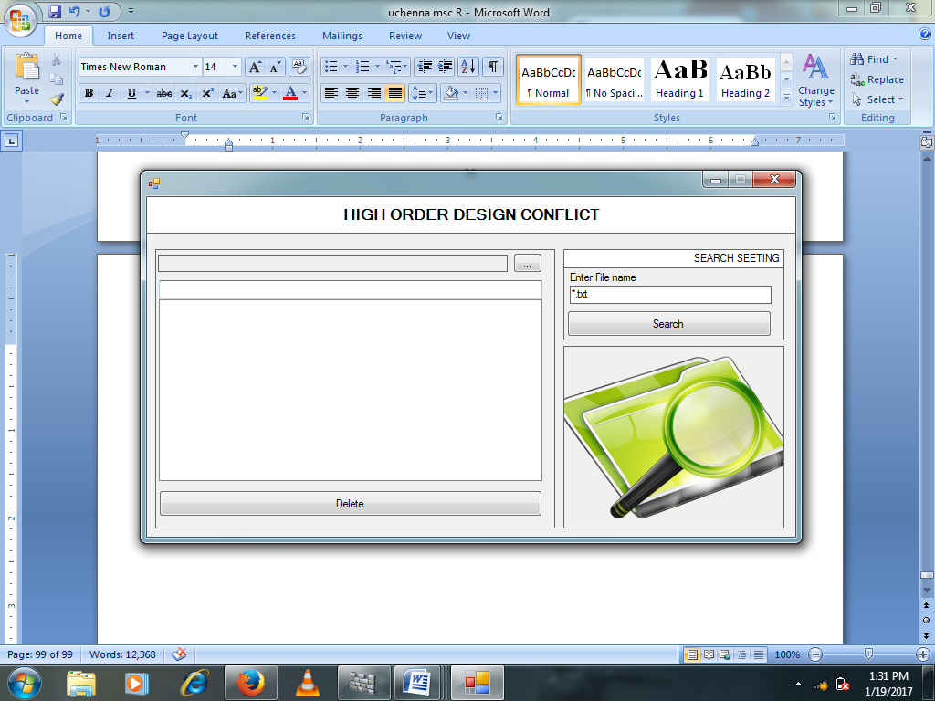

Fig.4.2: Home page for the new software

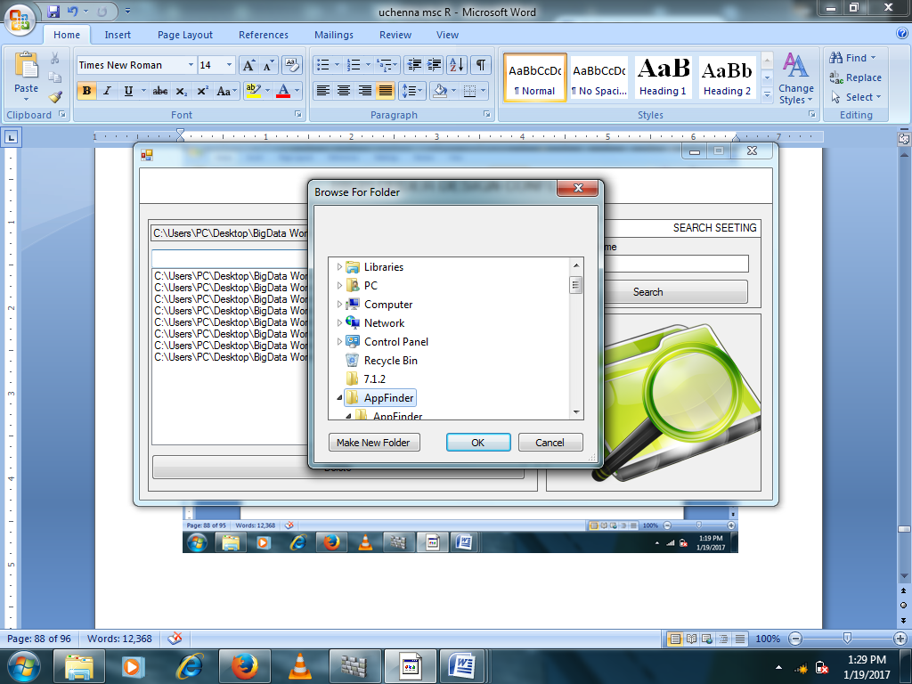

**Fig.4.5: searching for files to be scan**

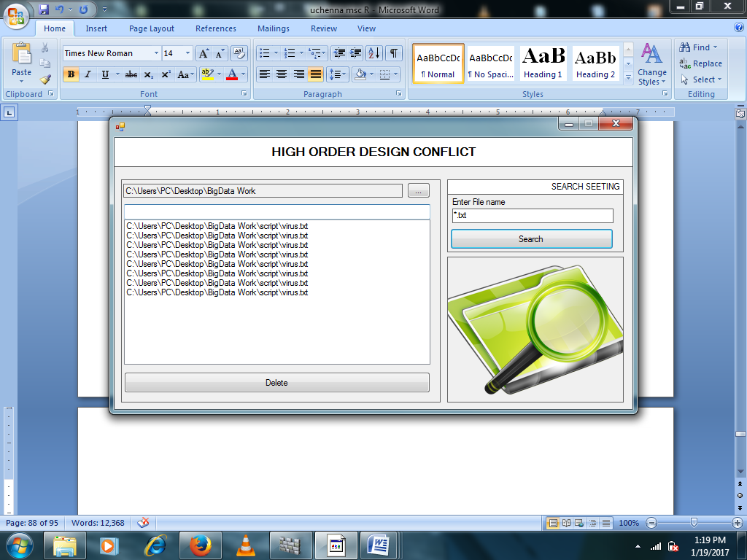

**Fig.4.6: interface for scan file and detection of conflict**