Validation transaction Tv

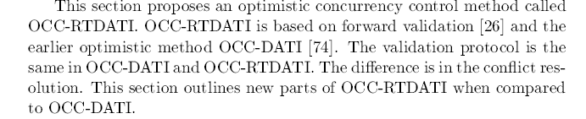

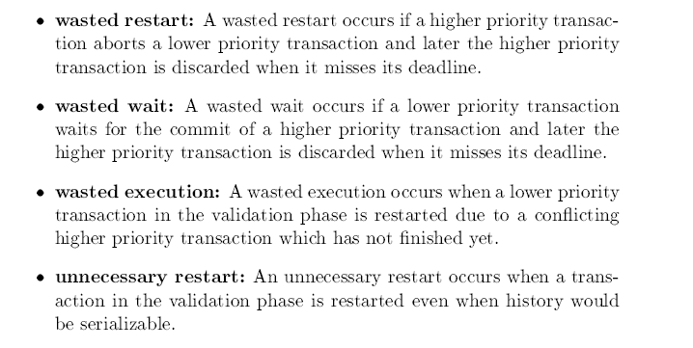

A scheduler controls the relative order in which database and transaction operations are executed and transaction commitment and abortion.

A scheduler is a program or collection of programs that controls the concurrent execution of transactions.

It makes use of this control by restricting the order in which the data manager executes the reads, writes, commits, and aborts of different transactions.

The goal of the scheduler is to order these operations so that the resulting execution is serializable and recoverable. It may also ensure that the execution avoids cascading aborts or is strict.

To execute a database operation, a transaction passes that operation to the scheduler. After receiving the operation, the scheduler can take one of three actions

* Execution: it can pass the operation to DM and wait for a result. When DM finishes executing the operation, it informs the scheduler. Additionally, if the operation is a read, the DM returns the value(s) it read, which the scheduler relays back to the transaction.
* Reject: It can refuse to process the operation, in which case it tells the transaction that its operation has been rejected. This causes the transaction to abort.
* Delay: It can delay the operation by placing it in a queue internal to the scheduler. Later, it can remove the operation from the queue and either execute it or reject it. While the operation is being delays, the scheduler is free to schedule other operations.