**IntelliJ IDEA2018.2.1破解教程**

**下载破解补丁**   
把下载的破解补丁放在你的idea的安装目录下的bin的目录下面（如下图所示），本文示例为JetbrainsCrack-3.1-release-enc.jar

1. **打开IDEA软件，点击免费试用**

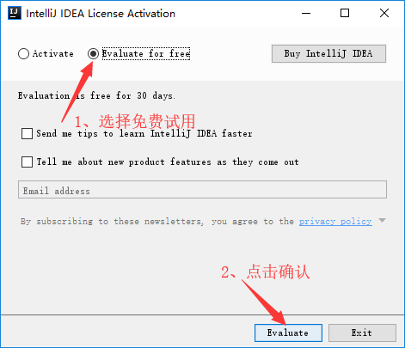



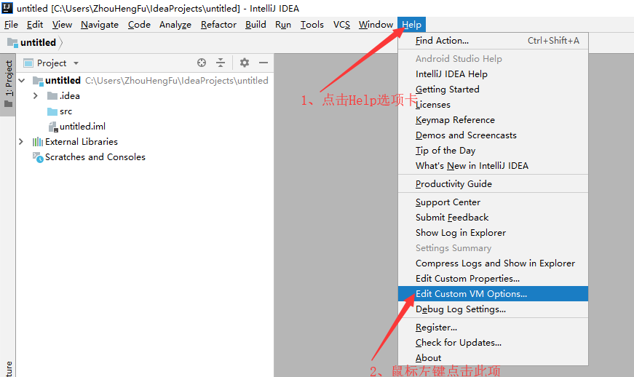

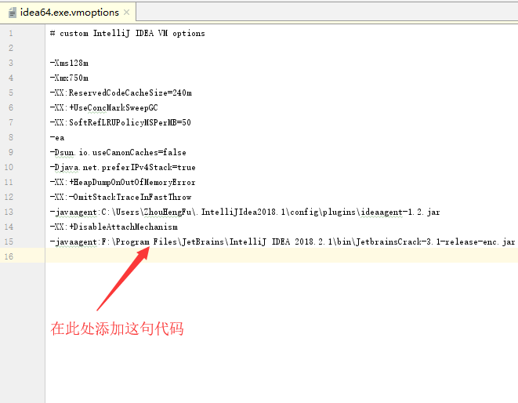

在这里添加-javaagent:F:\Program Files\JetBrains\IntelliJ IDEA 2018.2.1\bin\JetbrainsCrack-3.1-release-enc.jar即可，这时关闭IDEA，并重新打开IDEA

这时在按照如下操作进入注册界面：

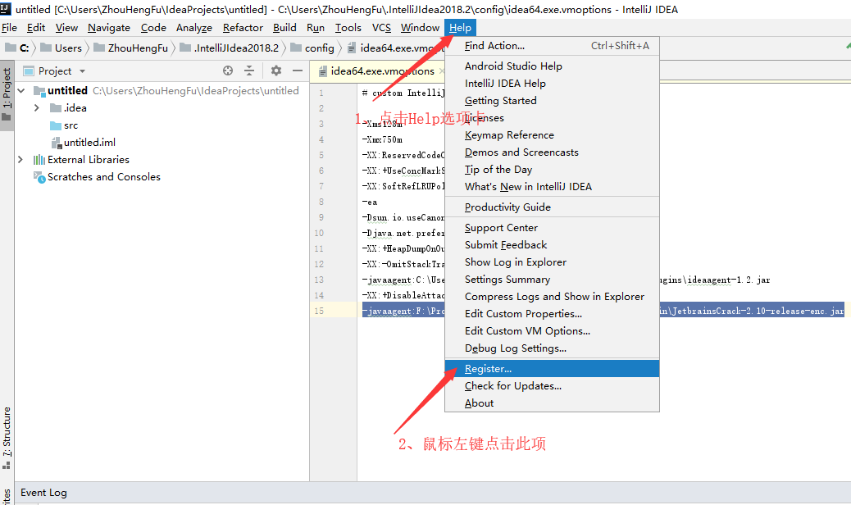

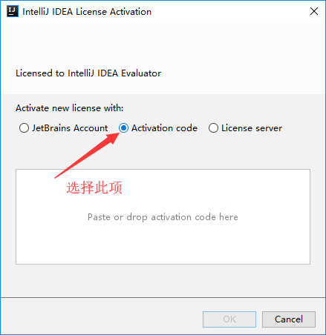

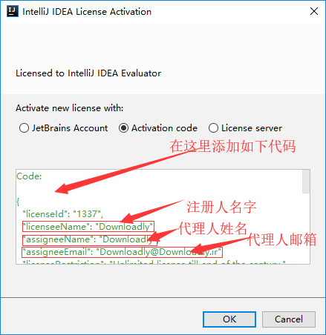

激活代码：

Code:

{

"licenseId": "1337",

"licenseeName": "Downloadly",

"assigneeName": "Downloadly",

"assigneeEmail": "Downloadly@Downloadly.ir",

"licenseRestriction": "Unlimited license till end of the century.",

"checkConcurrentUse": false,

"products":[

{"code":"II","paidUpTo":"2099-12-31"},

{"code":"DM","paidUpTo":"2099-12-31"},

{"code":"AC","paidUpTo":"2099-12-31"},

{"code":"RS0","paidUpTo":"2099-12-31"},

{"code":"WS","paidUpTo":"2099-12-31"},

{"code":"DPN","paidUpTo":"2099-12-31"},

{"code":"RC","paidUpTo":"2099-12-31"},

{"code":"PS","paidUpTo":"2099-12-31"},

{"code":"DC","paidUpTo":"2099-12-31"},

{"code":"RM","paidUpTo":"2099-12-31"},

{"code":"CL","paidUpTo":"2099-12-31"},

{"code":"PC","paidUpTo":"2099-12-31"},

{"code":"DB","paidUpTo":"2099-12-31"},

{"code":"GO","paidUpTo":"2099-12-31"},

{"code":"RD","paidUpTo":"2099-12-31"}

],

"hash": "2911276/0",

"gracePeriodDays": 7,

"autoProlongated": false

}

关闭IDEA，重新启动

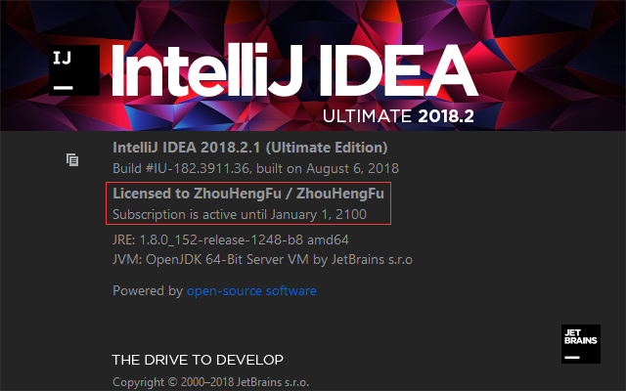

这样就代表注册成功