Model Advisor — Detailed Low-Level Design
Version 1.0 | Generated from the implemented codebase | July 2026
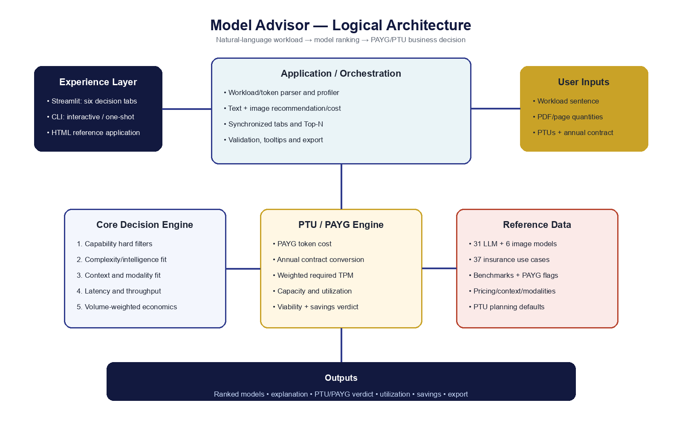

1. Purpose and scope
Model Advisor converts natural-language workloads and structured operating assumptions into a ranked cross-vendor LLM recommendation and a PTU-versus-PAYG commercial verdict. It supports Streamlit, CLI, and a standalone HTML reference surface.

2. Functional requirements
- FR1 Parse document, user/generation and explicit K/M/B token workloads with daily/weekly/monthly/yearly normalization.
- FR2 Infer or override a general or insurance use-case profile.
- FR3 Rank up to Top 20 eligible LLMs using capability, quality, latency, context, modality and cost.
- FR4 Rank dedicated image models and calculate per-image cost separately.
- FR5 expose benchmark, SLM and verified-PAYG indicators with tooltips.
- FR6 calculate PAYG and PTU cost, capacity, utilization, headroom and break-even.
- FR7 synchronize active workload, model, tokens and Top-N across six tabs.
- FR8 compare models using adjustable business weights and live scores.
- FR9 export comparison results to CSV.

3. Component design
model_advisor.py is the domain engine and single source of truth. Model and UseCase dataclasses define reference data. score_model/rank_models perform recommendation. PTUConfig and compare_ptu_vs_payg perform commercial analysis. model_advisor_streamlit.py handles parsing, presentation, widgets, state and export. model_advisor_webapp.html is a dependency-free reference UI.

4. Workload parsing
parse_workload normalizes case and punctuation, then extracts documents/pages, users, generations per user, explicit input/output tokens and K/M/B suffixes. Daily and weekly values are scaled to a monthly basis; annual values are divided by twelve. Explicit tokens override document/request estimates. Document workloads show OCR controls; general workloads show users and generations. Image-generation intent activates a separate image-model ranking and cost path.

5. Recommendation algorithm
Hard requirements are evaluated for context, vision, audio, video, image generation and open weights. Soft scoring compares Artificial Analysis intelligence against the complexity target, applies latency/TTFT and throughput effects, penalizes cost at higher volume, rewards context headroom, and applies regulated-workflow controls. Scores are sorted descending; runner-up and SLM alternatives are retained.

6. PTU/PAYG algorithm
PAYG = input_tokens/1M × input_price + output_tokens/1M × output_price. Annual contract is converted to hourly PTU rate by annual_cost ÷ (PTUs × 730 × 12). Required TPM uses input + output × output_weight divided by 43,800 monthly minutes. Available TPM = PTUs × model TPM/PTU. PTU is recommended only when cheaper and capacity covers the workload.

7. Data model
Model: identity, vendor, token prices, cache price, context, intelligence benchmark, speed, TTFT, knowledge cutoff, release, evaluation cost, reasoning and modality flags, OCR accuracy and notes. UseCase: category, complexity/latency/volume/context levels, governance and modality requirements, synonyms. PTUConfig: PTUs, hourly cost, capacity override, hours and output weight.

8. Streamlit navigation
Shared sidebar: parameterized PTU quantity and annual contract cost. 01 Recommend: reactive free-text workload, conditional document/general profile, Top-N LLMs, SLM labels, dedicated image models, what-if and quick PTU verdict. 02 Model Table: filters, active rank and PAYG verification. 03 Use Cases: inferred profile. 04 Explain Model: recommended-model rationale. 05 PTU vs PAYG: synchronized tokens, full formulas, derived values and break-even. 06 Decision Cockpit: synchronized Top-N, live weighted score bars/components and CSV export.

9. Error handling and validation
Numeric inputs enforce non-negative bounds. Zero PTUs cannot be declared a PTU win. Zero denominators use safe fallbacks. Missing benchmarks remain explicit rather than fabricated. A capacity failure overrides a nominal PTU price advantage. Streamlit test harness checks complete rendering and exceptions.

10. Security and governance
The application performs local deterministic calculations and does not transmit workload content to model providers. Production deployment should add SSO/RBAC, TLS, secrets management, audit logging, approved-model policy, benchmark refresh ownership, data-classification banners, human approval and change control.

11. Deployment
Create a Python 3.10 virtual environment, install requirements, and run Streamlit behind an enterprise reverse proxy. Use one controlled application instance per port. Health endpoint: /_stcore/health. Package model data updates through tested source control changes.

12. Testing strategy
Unit: parser quantities, matching, scoring boundaries, token/PAYG math, capacity and zero-PTU behavior. Integration: each use case produces a ranked result; UI renders six tabs; CSV generation succeeds. Regression: freeze representative workloads and expected top-N/verdict ranges. UAT: validate assumptions with underwriting, architecture, finance and Azure capacity owners.

13. Assumptions and limitations
Token-per-page (850), per-generation token estimates, output ratios and TPM/PTU are planning assumptions. Explicit user tokens take priority. Image cost is separate from LLM text cost and varies by resolution/editing. PAYG=True requires a verified first-party or named managed usage API; false values are estimates. Vendor pricing and benchmarks change frequently. PTU availability is model/region specific. Final procurement decisions require provider quotes and observed peak traffic.

14. Key interfaces
Interface | Inputs | Outputs | Failure behavior
parse_workload | free text | count, pages, profile | defaults remain visible
rank_models | UseCase | ordered (Model, score) | all models retained with penalties
compare_ptu_vs_payg | Model, PTUConfig, tokens | cost, capacity, utilization, verdict | zero PTU → PAYG
model_rows | model collection | table records | missing values displayed

