DETAILED DESIGN DOCUMENT
Model Advisor
Cross-Vendor LLM Recommendation & Cost-Optimization Platform
Three delivery surfaces, one scoring engine:
Command-Line Tool • Decision Cockpit (Streamlit) • Browser Web App
Document status | Draft v1.0 — for architecture review
Prepared for | Cross-Vendor Model Comparison, Insurance Use Cases & Recommendations — companion workstream
Data snapshot date | June 2026 (vendor API pricing pages & Artificial Analysis Intelligence Index)
Document date | July 12, 2026
Classification | Internal — Architecture & Engineering

Table of Contents
1. Introduction
2. System Overview
3. Architecture
4. Data Model
5. Scoring Engine Design
6. PTU vs. PAYG Cost Calculator
7. Surface 1 — Command-Line Tool Design
8. Surface 2 — Browser Web App Design
9. Surface 3 — Decision Cockpit (Streamlit) Design
10. Non-Functional Requirements
11. Known Limitations & Risks
12. Companion Deliverables & Traceability
13. Appendix

1. Introduction

1.1 Purpose
This document is the detailed design specification for Model Advisor, a decision-support platform that recommends which large language model (LLM) to use for a given business task, and quantifies the cost trade-off between per-token billing and reserved-capacity billing. It describes the shared core engine, the data model, the scoring algorithm, the cost calculator, and the three end-user surfaces built on top of that core: a command-line tool, a browser-based web app, and a Streamlit “Decision Cockpit” application. It is intended to give an engineering audience enough detail to maintain, extend, or re-platform the system with confidence that all three surfaces keep producing identical recommendations.

1.2 Scope
In scope: the shared model and use-case database; the ten-factor scoring engine; the Provisioned-Throughput-Unit (PTU) vs. pay-as-you-go (PAYG) cost calculator; the design of all three delivery surfaces; and the non-functional constraints that shape those designs (zero external dependencies for the core engine, full parity across surfaces, and transparent labeling of every assumed default).
Out of scope: vendor contract negotiation, live pricing API integration (the database is a manually curated point-in-time snapshot), and organization-specific rollout or change-management processes, which are addressed in the companion slide deck and reference document listed in Section 12.

1.3 Audience
- Solution architects evaluating or extending the recommendation logic
- Engineers maintaining the CLI, the Streamlit Decision Cockpit, or the HTML web app
- FinOps / procurement stakeholders assessing PTU vs. PAYG commitments
- Insurance business stakeholders (claims, underwriting, distribution, compliance) consuming recommendations through the Decision Cockpit or web app

1.4 Definitions & Abbreviations
Term | Definition
FNOL | First Notice of Loss — the initial claim intake event
SIU | Special Investigation Unit — insurer fraud investigation function
OCR | Optical Character Recognition — extracting text/fields from scanned documents or images
ACORD | Standardized insurance industry document/data forms
PTU | Provisioned Throughput Unit — Azure's reserved-capacity billing unit, priced per hour regardless of usage
PAYG | Pay-As-You-Go — standard per-token billing
TPM | Tokens Per Minute — a throughput capacity unit
TTFT | Time To First Token — latency before the first output token is streamed
NAIC | National Association of Insurance Commissioners (US regulatory body; source of the AI Model Bulletin referenced in the Life & Health use cases)
Intelligence Index | Artificial Analysis's composite cross-model benchmark score (9 evaluations incl. GPQA Diamond, Humanity's Last Exam, SciCode, AA-LCR)
Blended price | A 7:2:1 cache-hit : input : output weighted $/M-token figure approximating realistic production traffic mix

2. System Overview

2.1 Problem Statement
Twenty-five viable LLMs across twelve vendors now compete for every insurance AI workload, each with a different price, context window, latency profile, and capability set (vision, audio, video, image generation, open weights). Teams routinely either default to one vendor for everything — leaving cost or quality on the table — or spend days re-deriving a model choice from scratch for every new use case. Separately, Azure's Provisioned Throughput (PTU) billing option is opaque: whether reserved capacity beats per-token billing depends entirely on volume and utilization, numbers most teams cannot easily estimate ahead of a rollout.

2.2 Solution Summary
Model Advisor solves both problems with one shared, transparent scoring engine, exposed through three interchangeable surfaces so that different audiences — engineers, business stakeholders, and executives — can each reach the same recommendation through the interface that suits them:
- A ranked model recommendation for any use case, described in plain English or picked from a library of 37 pre-scored insurance use cases, with full per-parameter justification available on demand.
- A PTU-vs-PAYG calculator that turns a volume estimate into a concrete monthly cost comparison and a utilization percentage, so a reservation decision is never a guess.
- Every assumed default — PTU price, tokens-per-minute-per-PTU, output-token capacity weight — is clearly labeled as a planning estimate versus a user-supplied value, so the tool never silently passes off a guess as a fact.

2.3 Three Delivery Surfaces, One Core
The same model database, use-case library, scoring formula, and PTU math are implemented once (in Python) and ported once more (to JavaScript for the browser surface), then consumed by three independent front ends described fully in Sections 7–9:
- Surface 1 — Command-Line Tool (model_advisor.py): a zero-dependency Python script for engineers and power users; interactive chat mode or one-shot / scriptable CLI flags.
- Surface 2 — Decision Cockpit (Streamlit application): a six-tab hosted web application for business stakeholders, adding multi-model side-by-side comparison with adjustable priority weighting on top of the same engine.
- Surface 3 — Browser Web App (model_advisor_webapp.html): a single self-contained HTML file with the model database embedded as JSON and the scoring logic re-implemented in vanilla JavaScript, so it runs offline with no server and no install.
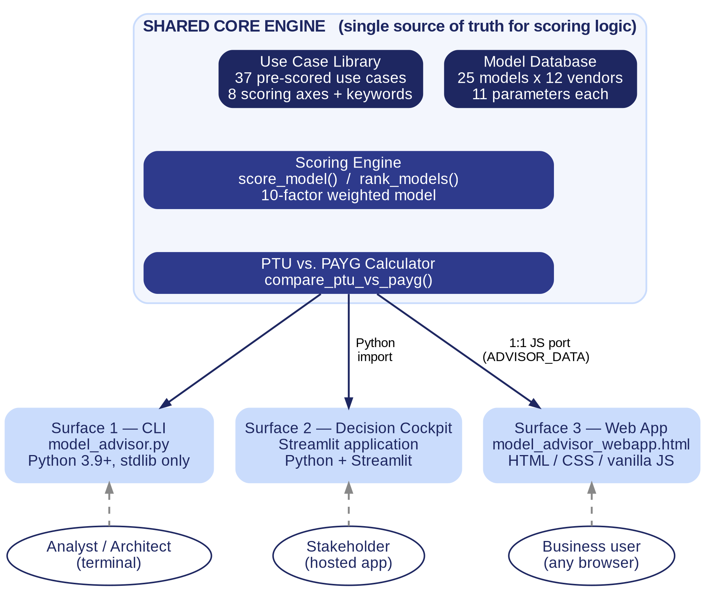
Figure 2.1 — High-level component architecture: one shared core, three consuming surfaces.

2.4 Design Principles
- Single source of truth for the recommendation logic: the Python core is authoritative; the JavaScript port must remain in exact parity (see Section 8.3 for the tech-debt implications of that duplication).
- Hard filters before soft scoring: capability gaps that make a model unusable for a task (missing context window, missing vision/audio/video, missing open weights) are enforced as disqualifying filters, not just score penalties — see Section 5.3.
- Transparency over false precision: every number that is not independently published by a vendor is labeled “planning default” in every surface's output, distinguishing it from a user-supplied “your value.”
- Under-provisioning costs more than over-provisioning: the scoring formula penalizes recommending a model that is too weak for a task more heavily than it penalizes recommending one with headroom to spare.
- Zero mandatory dependencies for the core and CLI: model_advisor.py runs on any Python 3.9+ installation with no pip install step, minimizing adoption friction for a first-pass architecture tool.

3. Architecture

3.1 Component Architecture
The system has exactly one authoritative data and logic layer (the “core”) and three thin consumers. The core is not a running service — it is a Python module (imported directly by the CLI and the Decision Cockpit) and a parallel JSON+JavaScript payload embedded in the web app. There is no shared database, API, or network call between surfaces; each surface is fully self-contained once it has its copy of the model/use-case data.
Layer | Responsibility
Model Database | 25 Model records (11 parameters each) with per-parameter source justification text
Use Case Library | 37 pre-scored UseCase records across 8 scoring axes, plus keyword lists for free-text matching
Scoring Engine | score_model() / rank_models() — deterministic 10-factor formula, identical logic in Python and JavaScript
PTU Calculator | compare_ptu_vs_payg() — reserved-capacity vs. per-token cost math, with every planning constant overridable
Surface 1: CLI | argparse-driven one-shot commands + a REPL chat loop; text output only
Surface 2: Decision Cockpit | Streamlit multi-page app; adds multi-model weighted comparison not present in the other two surfaces
Surface 3: Web App | Single static HTML file; DOM-rendered tables/cards driven by the embedded ADVISOR_DATA JSON

3.2 Deployment Architecture
- CLI: runs locally in any terminal against a local Python 3.9+ interpreter; no network access required; distributed as a single .py file.
- Decision Cockpit: a Streamlit server process (locally run via `streamlit run`, or deployed to any Streamlit-compatible host); stateless per session, no external database — all state lives in the Streamlit session and is recomputed from the embedded model/use-case tables on every interaction.
- Web App: a static file; can be opened directly from disk (file://) or hosted on any static file server / CDN; has zero server-side component and zero external network calls at runtime.

3.3 Recommendation Data Flow
All three surfaces funnel a user's request through the same four logical stages: match or infer a UseCase, score every Model against it, rank the results, and format the ranked output for that surface's UI. The heuristic fallback (Section 3.3, stage 2) is what lets the tool respond usefully even to free-text queries that don't exactly match one of the 37 curated use cases.
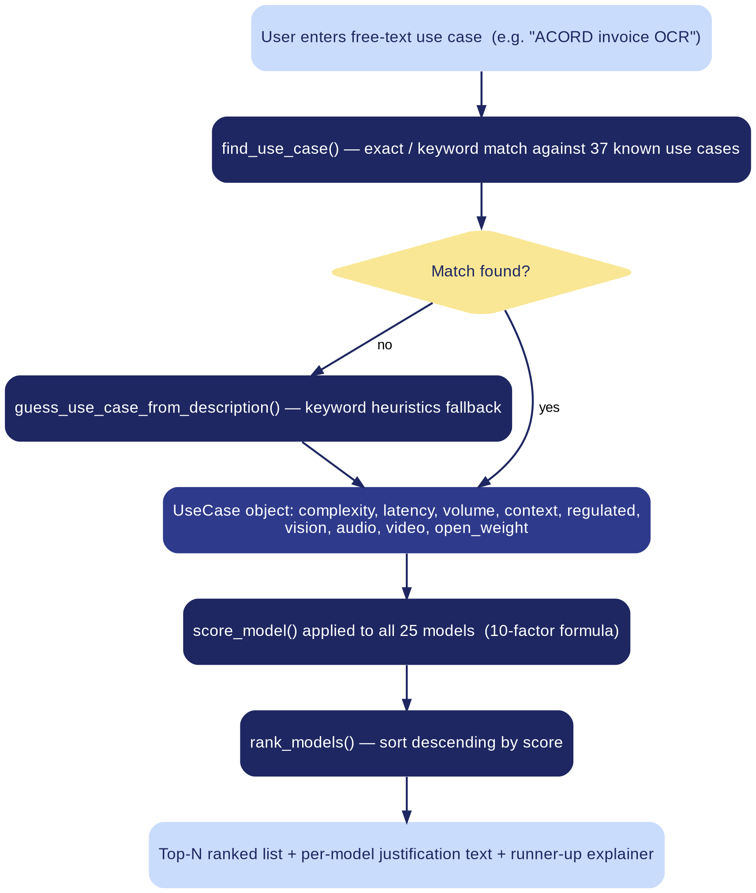
Figure 3.1 — End-to-end recommendation pipeline, from free-text query to ranked output.

4. Data Model

4.1 Model Entity
Every model in the database is one Model record with 19 fields covering pricing, capability, and provenance. blended_price() is a derived method — not a stored field — that applies Artificial Analysis's standard 7:2:1 cache-hit:input:output weighting to approximate realistic production traffic.
Field | Type | Description
name | str | Display name, primary key for lookups
vendor | str | Vendor / lab name
input_price | float | $ per 1M input tokens
output_price | float | $ per 1M output tokens
cache_hit_price | float | None | $ per 1M cached input tokens, if published
context | int | Maximum context window, tokens
intelligence | int | None | Artificial Analysis Intelligence Index score, or None if unpublished
speed | int | Approx. output tokens/second
ttft | float | Approx. time-to-first-token, seconds
knowledge_cutoff | str | Human-readable reliable knowledge cutoff date
release_date | str | Human-readable GA release date
eval_cost | float | None | $ to run the full Intelligence Index suite once, if published
reasoning | bool | Whether the model is reasoning-tuned
vision | bool | Native image input support
open_weight | bool | Whether weights can be downloaded / self-hosted
ocr_accuracy | float | None | Measured document/OCR accuracy %, if independently measured
audio_input | bool | Native audio understanding (not bolted-on transcription)
video_input | bool | Native video / frame-motion understanding
image_gen | bool | Vendor offers native or sibling image generation
notes | str | One-line vendor-level positioning note

4.2 UseCase Entity
Every pre-built use case is scored once, ahead of time, on eight axes — five numeric (1–5 scale) and three boolean capability flags — plus a keyword list that lets free-text queries match it without an exact title match.
Field | Type | Description
name | str | Display name, e.g. “FNOL triage”
category | str | Business category, e.g. “Claims”, “Underwriting”, “Reinsurance”
complexity | int 1–5 | Simple lookup (1) → deep reasoning (5); drives the Intelligence Index target
latency | int 1–5 | Batch-tolerant (1) → real-time (5); drives the speed/TTFT weighting
volume | int 1–5 | Low volume (1) → very high volume (5); drives cost weighting
context | int 1–5 | <8K tokens (1) → 2M+ tokens (5); drives the hard context-window filter
regulated | bool | Whether the workflow carries regulatory/compliance exposure
vision | bool | Whether the task requires native image input
open_weight | bool | Whether self-hosting / data residency is required
audio / video / image_gen | bool | Additional modality hard requirements, added for call-center, video-inspection, and image-generation use cases
keywords | list[str] | Synonyms used for free-text keyword matching (find_use_case())

4.3 PTUConfig Entity
Field | Type | Description
ptus_available | float | Number of PTUs the user has or is pricing out
ptu_hourly_cost | float | $ per PTU per hour — defaults by billing commitment, always overridable
tpm_per_ptu | float | None | Tokens/minute one PTU delivers for this model; None → per-model planning default
hours_per_month | float | Billing period assumption; defaults to 730 (24/7 monthly reservation)
output_weight | float | None | Input-token-equivalents one output token consumes against PTU capacity; None → derived from the model's output:input price ratio

4.4 Model Database Snapshot
The database currently holds 25 models across 12 vendors, plus a dedicated five-model Small Language Model (SLM) tier. All figures are sourced from vendor API pricing pages and the Artificial Analysis Intelligence Index, snapshotted June 2026 — treat as a point-in-time reference, not a live feed (see Section 11).
Model | Vendor | In $/M | Out $/M | Ctx | Intel. | tok/s | TTFT | Open | Vision | Audio | Video
Claude Haiku 4.5 | Anthropic | $1.00 | $5.00 | 200K | 30 | 120 | 0.8s | — | Yes | — | —
Claude Sonnet 4.6 | Anthropic | $3.00 | $15.00 | 1M | 42 | 90 | 1.5s | — | Yes | — | —
Claude Opus 4.7 | Anthropic | $5.00 | $25.00 | 1M | 54 | 50 | 13.3s | — | Yes | — | —
GPT-5.4 mini | OpenAI | $0.75 | $4.50 | 400K | 40 | 155 | 0.66s | — | Yes | — | —
GPT-5.4 | OpenAI | $2.50 | $15.00 | 1.1M | 51 | 166 | 2.5s | — | Yes | — | —
GPT-5.5 | OpenAI | $5.00 | $30.00 | 1.05M | 55 | 79 | 5s | — | Yes | — | —
Gemini 3.1 Flash-Lite | Google | $0.25 | $1.50 | 1M | 25 | 359 | 0.5s | — | Yes | Yes | Yes
Gemini 3.1 Pro | Google | $2.00 | $12.00 | 2M | 46 | 138 | 2.6s | — | Yes | Yes | Yes
Llama 4 Scout | Meta | $0.08 | $0.30 | 10M | 14 | 140 | 1s | Yes | Yes | — | Yes
Llama 4 Maverick | Meta | $0.27 | $0.85 | 1M | 14 | 110 | 1.2s | Yes | Yes | Yes | Yes
DeepSeek V3.2 | DeepSeek | $0.28 | $0.42 | 128K | 25 | 100 | 1s | Yes | — | — | —
DeepSeek R1 | DeepSeek | $0.55 | $2.19 | 64K | 40 | 90 | 1.8s | Yes | — | — | —
Mistral Large 3 | Mistral | $0.50 | $1.50 | 256K | 32 | 95 | 1.1s | Yes | — | — | —
Phi-4 | Microsoft | $0.13 | $0.50 | 16K | 5 | 35 | 2.1s | Yes | — | — | —
Command A | Cohere | $2.50 | $10.00 | 256K | 8 | 68 | 1.6s | Yes | — | — | —
Command A+ | Cohere | $2.50 | $10.00 | 200K | 37 | 201 | 0.35s | Yes | Yes | — | —
Qwen3.7 Max | Alibaba | $2.50 | $7.50 | 1M | 46 | 200 | 2.6s | — | — | — | —
Grok 4.3 | xAI | $1.25 | $2.50 | 1M | 38 | 139 | 16.6s | — | Yes | — | —
Nova Pro | Amazon | $0.80 | $3.20 | 300K | 13 | 75 | 1.5s | — | Yes | — | Yes
Nova Micro | Amazon | $0.04 | $0.14 | 128K | 10 | 300 | 0.4s | — | — | — | —
Gemma 4 E4B | Google | $0.04 | $0.08 | 128K | 15 | 140 | 0.9s | Yes | Yes | Yes | —
Llama 3.2 3B | Meta | $0.02 | $0.06 | 128K | 5 | 150 | 0.6s | Yes | — | — | —
Qwen3.5 9B | Alibaba | $0.10 | $0.30 | 262K | 32 | 90 | 1.3s | Yes | Yes | — | —
Ministral 3 8B | Mistral | $0.10 | $0.10 | 128K | 15 | 110 | 1s | Yes | — | — | —
Granite 4.1 8B | IBM | $0.05 | $0.10 | 128K | 12 | 130 | 0.8s | Yes | — | — | —
Table 4.1 — Full 25-model database. Pricing per 1M tokens (USD). “Intel.” = Artificial Analysis Intelligence Index.

4.5 Use Case Library Summary
The 37 use cases span the following business categories (count per family shown). Every use case also carries a free-text keyword list so a query like “FNOL triage” or “claim intake” resolves to the same pre-scored record.
Category | Use cases
Underwriting | 4
Claims | 3
Claims / SIU | 2
Distribution | 2
Life & Health | 2
Document processing | 2
Underwriting (Specialty) | 2
Underwriting ops | 1
Service | 1
Compliance | 1
Reinsurance | 1
Claims / Legal | 1
Underwriting leadership | 1
Pricing | 1
Actuarial | 1
Distribution / Retention | 1
Service / Retention | 1
Claims / Product | 1
Compliance / Actuarial | 1
Underwriting / Distribution | 1
Distribution (Agency) | 1
Underwriting (Simple risks) | 1
Service / Compliance | 1
Claims / Underwriting | 1
Claims / Life & Health | 1
Marketing / Distribution | 1
Operations / Marketing | 1

5. Scoring Engine Design

5.1 Overview & Design Rationale
score_model(model, use_case) returns a single real-valued score per model; rank_models(use_case) evaluates all 25 models and sorts descending. The score is a sum of ten independent adjustments — some continuous penalties/bonuses, some large fixed penalties that function as near-hard filters. The formula is intentionally asymmetric: getting a recommendation wrong in the direction of “too weak for the task” is penalized more heavily than “more capable than strictly necessary,” because a failed regulated workflow or a misread document costs far more than a slightly higher token bill.

5.2 The Ten Scoring Factors

1. Complexity → Intelligence target
target = INTEL_TARGET_BY_COMPLEXITY[use_case.complexity] (15/25/35/45/55 for complexity 1–5)
score -= |model.intelligence − target| × 1.3
if model.intelligence < target − 10: score −= 25 (additional under-provisioning penalty)

2. Latency → speed & TTFT
score -= model.ttft × 0.8 (baseline penalty at every latency level)
if use_case.latency ≥ 4: score += min(model.speed / 4, 40) − model.ttft × 3

3. Volume → cost weighting
if use_case.volume ≥ 4: score -= (model.output_price / 2 + model.input_price) × 2.5

4. Context → hard filter + headroom bonus
ctx_need = CONTEXT_FLOOR_BY_LEVEL[use_case.context] (8K/32K/200K/1M/2M for context 1–5)
if model.context < ctx_need: score -= 45 (near-disqualifying)
else: score += min((model.context − ctx_need) / 500,000, 6)

5. Regulated workflow → soft penalty / Anthropic bonus
if regulated and not model.reasoning and complexity ≥ 3: score -= 10
if regulated and model.vendor == “Anthropic”: score += 6 (benchmarked low hallucination rate)

6. Vision / OCR → hard filter + accuracy bonus
if use_case.vision and not model.vision: score -= 100 (disqualifying)
elif model.ocr_accuracy known: score += (ocr_accuracy − 85) × 2.2
else: score -= 6 (caution penalty for unpublished accuracy)

7. Open weights → hard filter
if use_case.open_weight and not model.open_weight: score -= 60

8. Audio → hard filter
if use_case.audio and not model.audio_input: score -= 120

9. Video → hard filter
if use_case.video and not model.video_input: score -= 120

10. Image generation → hard filter
if use_case.image_gen and not model.image_gen: score -= 80

5.3 Hard Filters vs. Soft Penalties
Factors 4 and 6–10 are treated as near-hard filters (single penalties of −45 to −120 points) because they represent capability gaps a model cannot compensate for on any other axis — a model either fits the required context window or it doesn't; either takes native audio input or it doesn't. Factors 1, 2, 3, and 5 are continuous soft adjustments that shape the ranking among otherwise-viable models.
Factor | Type | Rationale
Context window (#4) | Hard (−45) | No amount of prompt engineering fits a document into a window that's too small
Vision (#6) | Hard (−100) | A text-only model cannot process an image at all
Open weights (#7) | Hard (−60) | Self-hosting / data residency is a binary legal requirement, not a preference
Audio (#8) | Hard (−120) | Only a few models offer native audio understanding as of this snapshot
Video (#9) | Hard (−120) | Native video/frame-motion understanding is a rare capability gap, not a spectrum
Image generation (#10) | Hard (−80) | Generating an image is a different capability from reading one
Intelligence fit (#1) | Soft, asymmetric | Under-provisioning penalized 1.3x plus a −25 cliff; over-provisioning only costs headroom
Latency (#2) | Soft, tiered | A baseline TTFT tax applies everywhere; the speed bonus only activates at latency ≥ 4
Volume/cost (#3) | Soft, threshold | Only activates at volume ≥ 4, where price differences compound at scale
Regulated (#5) | Soft, small | A modest nudge toward reasoning-tuned models and Anthropic, not a disqualifier

5.4 Worked Example: ACORD / Invoice OCR
Use case profile: complexity 3, latency 3, volume 4, context 2, regulated = true, vision = true. This use case's vision hard-filter alone removes every non-vision model from serious contention; the volume-4 cost weighting then pulls the ranking toward the least expensive vision-capable models with strong measured OCR accuracy.
Observed output (Decision Cockpit, Tab 05 comparison run)
Recommended: Claude Sonnet 4.6 (Anthropic) — Intelligence 42, $3.00/M in, $15.00/M out. Runner-up: Qwen3.5 9B (Alibaba) — Intelligence 32, $0.10/M in, $0.30/M out, 262K context. The top-5 ranked table further included GPT-5.4 mini, Gemini 3.1 Flash-Lite, and Claude Haiku 4.5, all penalized relative to Sonnet 4.6 primarily on the regulated-workflow and OCR-accuracy factors despite lower list price.

Runner-up explanation is generated automatically by explain_runner_up(): when the #1 and #2 models differ meaningfully in price or intelligence, the tool states the trade-off in one sentence (e.g. “Qwen3.5 9B is cheaper but scores lower on Intelligence Index”) so the recommendation is never a black box.

6. PTU vs. PAYG Cost Calculator

6.1 Business Problem
Azure OpenAI (and a growing set of Foundry-hosted models) bills either per-token (PAYG) or via Provisioned Throughput Units (PTUs) — reserved capacity billed hourly regardless of usage. Whether PTU is cheaper depends entirely on volume and how much of the reserved capacity is actually used; Microsoft does not publish one universal number for the throughput a PTU delivers per model, its $/hour cost by commitment tier, or how heavily an output token consumes capacity versus an input token. The calculator turns these into explicit, overridable configuration values instead of hiding them.

6.2 Formulas
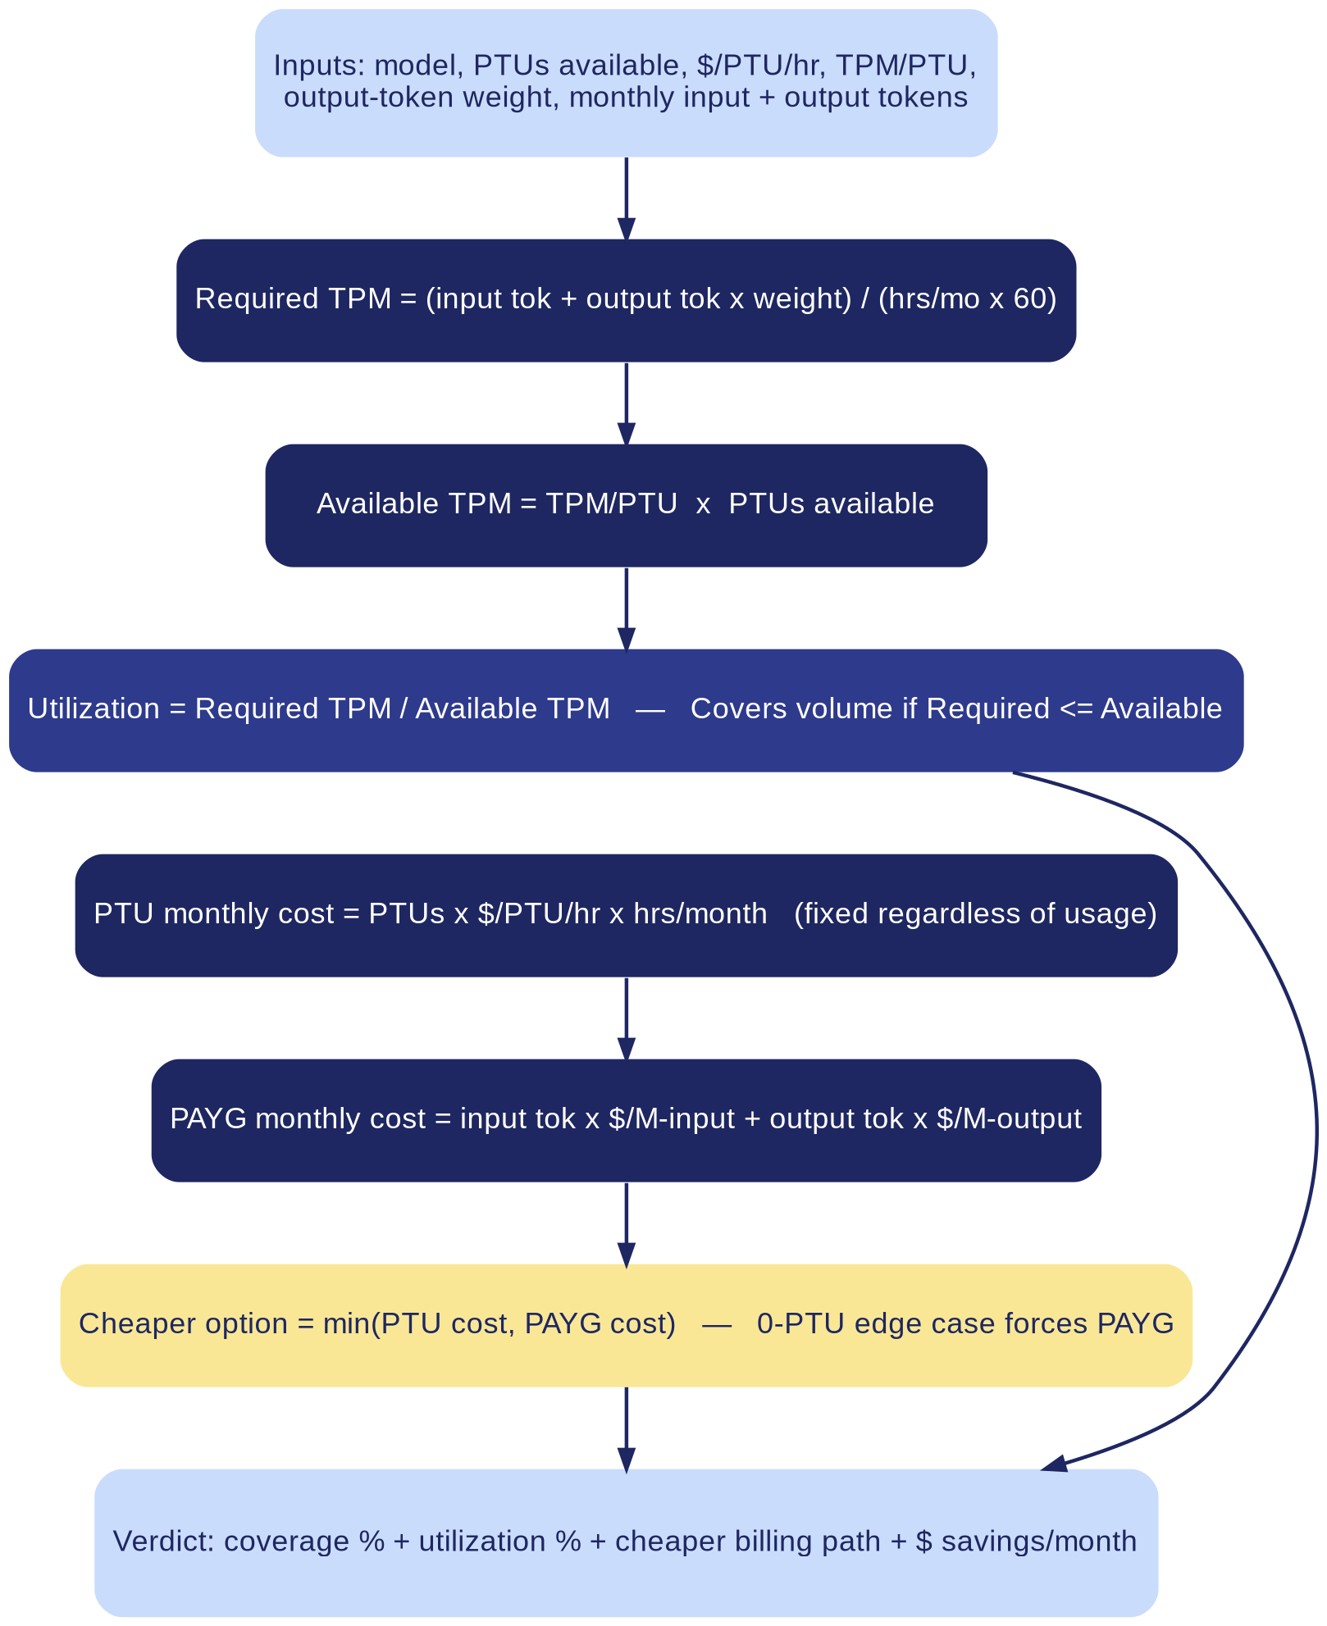
Figure 6.1 — PTU vs. PAYG calculation pipeline: from raw inputs to a cheaper-option verdict.

6.3 Configurable vs. Derived Parameters
Parameter | Default source | Override
ptu_hourly_cost | PTU_COST_DEFAULTS by billing tier: hourly ≈$3.35, monthly reservation ≈$2.02, annual reservation ≈$1.31 | --ptu-cost / manual entry
tpm_per_ptu | TPM_PER_PTU_DEFAULTS — a per-model planning estimate table (25 entries), fallback 2,500 TPM | --tpm-per-ptu / manual entry
output_weight | Derived: model.output_price / model.input_price (falls back to 4.0 if input price is 0) | --output-weight / manual entry
hours_per_month | 730.0 (24/7 monthly reservation assumption) | Not currently exposed as an override in the CLI flags

6.4 Interaction Modes & Reference Output
All three surfaces expose the same calculation through a different interaction style: the CLI offers a guided wizard (typing “ptu” in chat mode) or a one-line scriptable command (--ptu-model / --ptus / --monthly-tokens); the Decision Cockpit exposes it as a form-driven tab (Tab 05) plus a folded-in “What-if cost” panel on the Recommend tab; the web app exposes it as a manual-entry section on the same single page as the recommendation output.
Observed output (Decision Cockpit, Tab 05, Claude Haiku 4.5, 10 PTUs, hourly billing)
60,000,000 input + 40,000,000 output monthly tokens → Required throughput 5,936 TPM against 25,000 TPM available (23.7% utilization; PTUs comfortably cover this volume). PTU monthly cost $24,455.00 versus PAYG monthly cost $260.00 — PAYG is cheaper by $24,195.00/month (98.9%) at this volume, illustrating that reserved capacity only pays off at sustained high utilization.

The zero-PTU edge case is handled explicitly: a configuration with 0 PTUs provides zero capacity, so the comparator forces “PAYG” as the only viable option rather than reporting a false “PTU wins” result from a division degenerate case.

7. Surface 1 — Command-Line Tool Design

7.1 Command Reference
Command / flag | Purpose
python model_advisor.py | Launch interactive chat mode (REPL)
python model_advisor.py "<use case>" | One-shot recommendation for a single free-text query
--list | Print all 37 known use cases, grouped by category
--models | Print the full 25-model comparison table
--top N | Show top N ranked models instead of the default 5
--explain ["Model name"] | With a query: explain the top-recommended model. Alone or with --models: explain a named model's full parameter justification
--ptu-model / --ptus / --monthly-tokens | Required trio for a scriptable PTU vs. PAYG comparison (--monthly-tokens as INPUT:OUTPUT)
--ptu-cost / --ptu-billing / --tpm-per-ptu / --output-weight | Optional PTU parameter overrides; every one is individually labeled in the output as “(your value)” or “(planning default)”

7.2 Interactive Chat Mode
run_chat() implements a simple REPL: a free-text line is treated as a use-case query unless it matches one of a small set of reserved commands.
Typed command | Behavior
list / use cases / usecases | print_use_case_list()
models / model table | print_model_table()
ptu / ptus / ptu calculator | run_ptu_wizard() — step-by-step prompted PTU comparison
explain <model name> | print_explain_model() for that model
<query> +explain | Recommendation for <query> plus full justification for the top model
help / ? | Re-print the banner / usage summary
quit / exit / q | Exit the REPL

7.3 Output Formatting
All monetary values are formatted through a single fmt_money() helper for consistency. print_recommendation() prints the top model's headline card (model, vendor, intelligence, input/output price), a one-line “why this model” summary, an optional runner-up trade-off explanation, and a Top-N ranked table; --explain additionally invokes print_model_justification(), which walks every one of the 19 Model fields and prints its justify() text — either a model-specific note from the JUSTIFICATIONS lookup table or a generic PARAM_FALLBACK_JUSTIFICATIONS explanation of why that parameter matters at all.

8. Surface 2 — Browser Web App Design

8.1 Single-File Architecture
model_advisor_webapp.html is one self-contained file: CSS, HTML structure, and a <script> block embedding the full model and use-case database as a JSON literal (ADVISOR_DATA), followed by a second <script> block that re-implements scoreModel(), rankModels(), findUseCase(), guessUseCase(), and comparePtuVsPayg() in vanilla JavaScript. There are no build steps, no bundler, and no external script dependencies at runtime — the file can be opened directly from the local filesystem or hosted on any static server.

8.2 UI Sections
- Describe the use case — free-text entry field with a live-updating ranked recommendation as the user types, backed by the same find/guess use-case logic as the CLI.
- PTU / PAYG cost estimator — manual-entry form for the same reserved-capacity math described in Section 6, rendered as live-updating result cards.
- Full comparison table — the entire 25-model database rendered as a sortable/filterable HTML table.

8.3 Parity & Maintenance Risk
Architectural risk
The JavaScript scoring engine in model_advisor_webapp.html is a hand-maintained port of the Python scoring engine, not a shared library. Any change to score_model(), the INTEL_TARGET_BY_COMPLEXITY / CONTEXT_FLOOR_BY_LEVEL tables, or the PTU formulas in model_advisor.py must be manually mirrored in the corresponding JavaScript functions, or the web app and the CLI/Decision Cockpit will silently diverge and produce different recommendations for the same query. This is the single largest maintainability risk in the current architecture (see Section 11).

9. Surface 3 — Decision Cockpit (Streamlit) Design

9.1 Overview
The Decision Cockpit is a Streamlit application — “the same recommendation engine, the same PTU calculator, now in a Streamlit UI styled to match the HTML version” — built for stakeholders who want the full interactive experience without a terminal. It imports the Python core directly (no re-implementation, unlike the web app), and adds one capability the other two surfaces do not have: a multi-model, weighted, side-by-side Decision Cockpit comparison view. It is organized as six tabs.
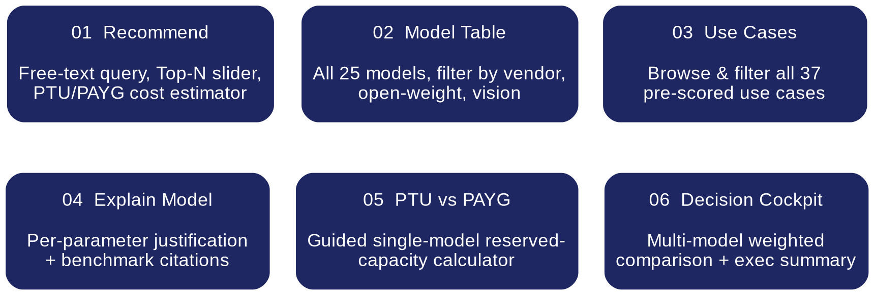
Figure 9.1 — Decision Cockpit tab structure.

9.2 Tab-by-Tab Design

01 — Recommend
Free-text use-case entry (with a “Pick from known use cases” expander), a Top-N results slider, a document-profile sub-form (PDF/DOC/OCR: document count, average pages, % scanned, primary task, latency expectation, regulated flag) that refines complexity/latency/volume/context scoring for document-heavy workloads, and an inline PTU/PAYG cost estimator that accepts a plain-English cost question plus key:value override lines.

02 — Model Table
The full 25-model database with filter controls for Vendor, Open weights, and Vision support; columns include blended price (7:2:1 weighting), context, Intelligence Index, speed, TTFT, and modality flags.

03 — Use Cases
A browsable, keyword-filterable list of all 37 known use cases grouped by category (Claims, Underwriting, Claims/SIU, Distribution, Underwriting ops, Service, Compliance, …), each expandable to show its full scoring profile.

04 — Explain Model
A per-model justification viewer: pick any of the 25 models to see vendor, release date, knowledge cutoff, open-weight status, and a plain-English justification for every one of its 19 parameters, plus an expandable benchmark-citations panel.

05 — PTU vs PAYG
A guided single-model calculator: choose the PTU hourly-cost method (planning default / derive from annual contract / derive from monthly contract / enter an exact rate), enter PTUs and monthly input/output tokens, and get required-vs-available TPM, utilization %, and a PTU-vs-PAYG monthly cost comparison card.

06 — Decision Cockpit
The multi-model business-decision view: pick any combination of models (e.g. GPT-5.4, GPT-5.4 mini, Claude Sonnet 4.6, Gemini 3.1 Pro, Qwen3.7 Max), set shared monthly volume and PTU assumptions, and adjust four weighting sliders — Quality %, Economics %, Latency %, Risk/Compliance % — to match organizational priorities. Produces a weighted-score ranking, a recommended model + best billing path + weighted score card, an auto-generated Executive Summary (cost advantage, quality trade-off, billing-path callouts), a full comparison table, and a CSV export.

9.3 Observed Reference Output — Decision Cockpit Run
Sample run comparing GPT-5.4, GPT-5.4 mini, Claude Sonnet 4.6, Gemini 3.1 Pro, and Qwen3.7 Max at 60M input / 40M output monthly tokens, hourly PTU billing, and weighting Quality 50% / Economics 30% / Latency 10% / Risk-Compliance 10%:
Model | Vendor | PAYG $/mo | Required TPM | Utilization | Cheaper billing
GPT-5.4 mini | OpenAI | $225.00 | 6,849 | 4.6% | PAYG
Qwen3.7 Max | Alibaba | $450.00 | 4,110 | 3.7% | PAYG
GPT-5.4 | OpenAI | $650.00 | 5,936 | 4.7% | PAYG
Gemini 3.1 Pro | Google | $600.00 | 6,849 | 6.2% | PAYG
Claude Sonnet 4.6 | Anthropic | $780.00 | 5,936 | 5.9% | PAYG

Result
Recommended for rollout: GPT-5.4 mini, best billing path PAYG, weighted score 82.9. Executive summary auto-text: “GPT-5.4 mini is ~$2,700.00 cheaper per year than Qwen3.7 Max under current assumptions; highest quality in this set is GPT-5.4 (+20.0 points) but it did not win overall after cost/latency/risk weighting; PAYG is cheaper for the winner at current traffic assumptions (PTU utilization 4.6%).”

10. Non-Functional Requirements
Requirement | How it is met
Zero mandatory dependencies (core/CLI) | model_advisor.py uses only the Python standard library (sys, re, textwrap, argparse, dataclasses, typing) — no pip install required
Cross-platform portability | Python 3.9+ on macOS, Windows, and Linux; the web app runs in any modern browser with no install
Transparency of assumptions | Every non-vendor-published figure is labeled “(planning default — verify with Azure's own calculator)” vs. “(your value)” in every surface's output
Extensibility | Adding a model or use case is a pure data change (one more Model(...) or UseCase(...) entry); the scoring engine requires no code change to accommodate new records
Deterministic, explainable output | score_model() is a pure function with no randomness; --explain / Tab 04 exposes the justification behind every parameter used in scoring
Data currency | Explicitly snapshotted “accessed June 2026”; the system does not claim to be a live pricing feed (see Section 11)

11. Known Limitations & Risks
- Point-in-time data snapshot: all pricing, context, and benchmark figures are accurate as of June 2026 and are not live-updated; vendor pricing and model line-ups change frequently and this database requires a periodic manual refresh cycle.
- JavaScript / Python scoring parity risk: the web app's scoring engine is a hand-maintained duplicate of the Python core (Section 8.3) — the single largest architectural maintenance risk identified in this design.
- Unpublished figures marked, not estimated: several fields (DeepSeek/Mistral/Qwen/Grok knowledge cutoffs; eval cost for most models) are not independently published by their vendors and are explicitly marked as such rather than silently guessed.
- Free-text fallback is heuristic: queries that don't match a known use case fall through to guess_use_case_from_description(), a keyword-based heuristic — users are advised to check the printed profile or use --list / Tab 03 to find the closest pre-built match.
- PTU planning constants are estimates: $/PTU/hour, tokens-per-minute-per-PTU, and the output-token capacity weight are not published by Azure as universal constants; defaults are rough planning estimates that must be verified against Azure's own capacity calculator before budget commitment.
- Recommendations are a starting hypothesis: outputs are derived from published benchmarks, not a controlled internal evaluation on the requesting organization's own documents and traffic — validation before vendor commitment is expected.

12. Companion Deliverables & Traceability
This design document is one of four artifacts sharing the same model database and scoring logic:
Artifact | Purpose
model_advisor.py | Zero-dependency CLI — authoritative implementation of the scoring and PTU logic
model_advisor_webapp.html | Self-contained offline browser app; JavaScript port of the same logic
Decision Cockpit (Streamlit) | Hosted multi-tab business application; imports the Python core directly and adds multi-model weighted comparison
Cross_Vendor_Model_Comparison_Insurance_Recommendations.pptx | Full slide deck, including a per-use-case Model-to-Use-Case Map
Model_Parameter_Reference_Justified.docx | 34-page reference document with the full parameter table and per-model justification for every value
Model Advisor — Architecture Overview (this document's companion deck) | Executive-level walkthrough of this same architecture, for stakeholder presentation

13. Appendix

A. Model Release Dates & Knowledge Cutoffs
Model | Vendor | Knowledge cutoff | Release date
Claude Haiku 4.5 | Anthropic | February 2025 | October 15, 2025
Claude Sonnet 4.6 | Anthropic | August 2025 | February 17, 2026
Claude Opus 4.7 | Anthropic | January 2026 | April 16, 2026
GPT-5.4 mini | OpenAI | August 2025 (est., family-aligned) | March 2026
GPT-5.4 | OpenAI | August 31, 2025 | March 5, 2026
GPT-5.5 | OpenAI | December 1, 2025 | April 23, 2026
Gemini 3.1 Flash-Lite | Google | January 2025 | March 4, 2026
Gemini 3.1 Pro | Google | January 2025 | March 2026
Llama 4 Scout | Meta | August 2024 | April 5, 2026
Llama 4 Maverick | Meta | August 2024 | April 5, 2026
DeepSeek V3.2 | DeepSeek | 2024-2025 (exact date not separately published by DeepSeek) | December 2025
DeepSeek R1 | DeepSeek | 2024-2025 (exact date not separately published by DeepSeek) | January 2025 (original R1); ongoing point releases since
Mistral Large 3 | Mistral | Mid-2025 (exact date not separately published by Mistral) | December 2025
Phi-4 | Microsoft | June 2024 | January 10, 2025
Command A | Cohere | June 1, 2024 | 2025
Command A+ | Cohere | April 1, 2025 | May 20, 2026
Qwen3.7 Max | Alibaba | 2025 (exact date not separately published by Alibaba) | May 19, 2026
Grok 4.3 | xAI | Not independently confirmed | April 30, 2026
Nova Pro | Amazon | December 2024 | December 2024
Nova Micro | Amazon | December 2024 | December 2024
Gemma 4 E4B | Google | January 2025 | April 2, 2026
Llama 3.2 3B | Meta | December 2023 | September 25, 2024
Qwen3.5 9B | Alibaba | 2025 (exact date not separately published by Alibaba) | March 2026
Ministral 3 8B | Mistral | Late 2025 (exact date not separately published by Mistral) | December 2025
Granite 4.1 8B | IBM | 2025 (exact date not separately published by IBM) | April 2026

B. PTU Planning Defaults — Billing Commitment Tiers
Billing commitment | $ / PTU / hour (planning default)
Hourly (on-demand) | $3.35
Monthly reservation | $2.02 (≈30–40% discount vs. hourly, reported)
Annual reservation | $1.31 (≈60–70% discount vs. hourly, reported)

C. Full Use-Case Category Index
All 37 use cases with their scoring profile (Complexity / Latency / Volume / Context, each 1–5) and key capability flags.
Use case | Category | Cx | Lt | Vol | Ctx | Reg. | Modal. | Open
FNOL triage | Claims | 3 | 4 | 4 | 3 | Yes | — | —
Underwriting document review | Underwriting | 4 | 2 | 2 | 5 | Yes | — | —
Commercial submission triage | Underwriting | 3 | 3 | 3 | 5 | — | — | —
Fraud ring detection | Claims / SIU | 4 | 3 | 3 | 2 | Yes | — | —
Claims document brief | Claims | 3 | 3 | 3 | 3 | Yes | — | —
Policy comparison (broker) | Distribution | 2 | 2 | 3 | 3 | — | — | —
Renewal data reconstruction | Underwriting ops | 3 | 2 | 2 | 4 | — | — | —
Producer / agent copilot | Distribution | 2 | 3 | 4 | 2 | — | — | —
Customer self-service chat | Service | 1 | 5 | 5 | 1 | — | — | —
Regulatory filing review | Compliance | 5 | 1 | 1 | 3 | Yes | — | —
Reinsurance treaty analysis | Reinsurance | 4 | 1 | 1 | 5 | Yes | — | —
Underwriting guideline Q&A | Underwriting | 2 | 3 | 4 | 2 | — | — | —
Accelerated life underwriting | Life & Health | 4 | 2 | 2 | 4 | Yes | — | —
Protective value / mortality analysis | Life & Health | 5 | 1 | 1 | 3 | Yes | — | —
Subrogation & litigation correspondence | Claims / Legal | 2 | 3 | 3 | 2 | — | — | —
Property risk modeling (imagery) | Underwriting | 3 | 2 | 3 | 2 | — | Yes | —
Portfolio appetite summarization | Underwriting leadership | 3 | 1 | 1 | 4 | — | — | —
ACORD / invoice OCR | Document processing | 3 | 3 | 4 | 2 | Yes | Yes | —
Policy document digitization | Document processing | 3 | 2 | 3 | 3 | Yes | Yes | —
Claim packet synthesis | Claims | 4 | 3 | 3 | 4 | Yes | Yes | —
Telematics-based dynamic pricing | Pricing | 4 | 2 | 4 | 2 | Yes | — | —
Actuarial experience studies | Actuarial | 4 | 1 | 1 | 5 | — | — | —
Propensity to buy / renew / lapse | Distribution / Retention | 2 | 3 | 4 | 2 | — | — | —
Renewal letter & coverage-gap generation | Service / Retention | 1 | 3 | 5 | 1 | — | — | —
Parametric claims triggers | Claims / Product | 3 | 4 | 3 | 1 | Yes | — | —
Algorithmic bias / discrimination testing | Compliance / Actuarial | 5 | 1 | 1 | 3 | Yes | — | —
AI/cyber liability underwriting | Underwriting (Specialty) | 5 | 1 | 1 | 3 | Yes | — | —
Specialty risk engineering reports | Underwriting (Specialty) | 4 | 1 | 2 | 5 | — | — | —
Predictive win-rate quoting | Underwriting / Distribution | 3 | 2 | 3 | 2 | — | — | —
Cross-sell / next-best-product | Distribution (Agency) | 2 | 3 | 4 | 1 | — | — | —
Agentic quote-and-bind work cells | Underwriting (Simple risks) | 5 | 2 | 2 | 2 | Yes | — | —
Synthetic media detection in claims | Claims / SIU | 4 | 2 | 2 | 2 | Yes | Yes | —
Call center voice transcription & QA | Service / Compliance | 3 | 3 | 4 | 2 | Yes | Yes | —
Video-based property/vehicle inspection | Claims / Underwriting | 4 | 2 | 2 | 2 | — | Yes | —
Telehealth / virtual claims consultation analysis | Claims / Life & Health | 4 | 2 | 1 | 2 | Yes | Yes | —
Marketing image generation for campaigns | Marketing / Distribution | 2 | 1 | 2 | 1 | — | Yes | —
Branch/claims-center signage and document mockups | Operations / Marketing | 1 | 1 | 1 | 1 | — | Yes | —
Cx = Complexity, Lt = Latency, Vol = Volume, Ctx = Context, Reg. = Regulated, Modal. = requires vision/audio/video/image-gen, Open = requires open weights.

