Statistical and Machine Learning-Based
Crime Pattern and Hotspot Analysis
Lab Assignment: Applying Probability and Statistics to Evaluate a Machine Learning Model
Subject: Applied Probability and Statistics
Submitted by: Aishwarya S Biradar
Programme: M.E. Big Data Analytics
Institution: Manipal School of Information Sciences, MAHE, Manipal
Code repository: https://github.com/<your-username>/crime-hotspot
Tools: Python, pandas, SciPy, scikit-learn, Streamlit

Summary
This project analyses 24,998 Chicago Police Department crime incidents (2017–2019). Crime patterns are described with frequency analysis, conditional probability, mean and variance, and correlation. Three models are then trained to predict crime hotspots, that is, whether a place (one of Chicago's 77 community areas) at a given weekday and time slot is high risk: Logistic Regression (baseline), Decision Tree and Random Forest.
All three models were evaluated on the same held-out test set of 647 place-time cells, using sampling, confidence intervals and hypothesis tests to answer the lab question: does a model really perform better, or could the observed difference be due to variation in the test sample?
Answer. Decision Tree (91.3%) and Random Forest (92.4%) are clearly better than Logistic Regression (76.0%): McNemar p < 10⁻¹⁷, and the 95% CIs of the gains (about +12 to +20 points) are far from zero. Random Forest's 1.1% edge over the Decision Tree is not significant (p = 0.35, 95% CI -0.8% to 2.9%). That difference could be due to test-sample variation.
A Streamlit web application lets a user choose a place and see its crime-pattern statistics, the high-risk periods predicted by all three models, and the riskiest places at any day and time.
Contents
1. Problem Statement and Dataset
2. Sampling and Experimental Methodology
3. Observations, Decision and Limitations
4. Where Probability and Statistics Are Used
5. Web Application
6. Code Structure and How to Run
References

1. Problem Statement and Dataset

1.1 Problem statement
Crime patterns vary with time, place and social factors, which makes crime analysis and prediction difficult. The objective is a data-driven framework that analyses crime data (type, time, location, frequency) to identify patterns and predict high-risk periods and locations.
The statistical question of the lab is: when one model scores higher than another on a test set, is the improvement real, or could it be due to which cases happened to fall in the test sample? A test set is a random sample, so each accuracy is only an estimate with sampling error.

1.2 Dataset
City of Chicago Data Portal, "Crimes – 2001 to Present" (Chicago Police Department): a random sample of 25,000 incidents from 2017-01-01 to 2019-09-29, as distributed in the open-source rcrimeanalysis package. Each row is one reported incident with its date and time, crime type, location type, community area, coordinates, and arrest and domestic flags.
Table 1: Dataset overview
Property | Value
Incidents (raw → cleaned) | 25,000 → 24,998
Days covered | 1,002
Community areas (places) | 77
Crime types → categories | 30 → 5 (property, violent, fraud, drugs/weapons, other)

1.3 Prediction target: high-risk place-time cells
Incidents are counted in every cell = (community area × weekday × time slot), giving 77 × 7 × 4 = 2,156 cells. The time slots are night (0–6 h), morning (6–12), afternoon (12–18) and evening (18–24).
A cell is high risk if its incident count is at least 16, the 75th percentile of training-cell counts (the top 25%). Model features are the area's location (latitude and longitude of its centre), weekday, time slot and a weekend flag.

2. Sampling and Experimental Methodology

2.1 Crime-pattern statistics
- Frequency analysis: relative frequency as an estimate of probability, P(A) = n(A) / N.
- Conditional probability: P(category | time slot) = n(category ∩ slot) / n(slot); one Bayes' theorem example.
- Mean and variance: of daily incident counts, and of incidents per cell by time slot.
- Correlation: Pearson r between each cell feature and the incident count, with the test H₀: ρ = 0.

2.2 Sampling
The 2,156 cells are split at random into 70% training (1,509 cells) and 30% held-out test (647 cells) with a fixed seed (42). The high-risk threshold is computed from training cells only, so no test information leaks into training. The high-risk share is 26.2% in training and 22.4% in test, so the two samples are similar. All three models are trained on the same training cells and evaluated on the same test cells, which makes the comparison paired.

2.3 Models
Table 2: The three models
Model | Role | How it works
Logistic Regression | Baseline | Linear model: log-odds of high risk = b₀ + b·x; features standardised
Decision Tree | Improved model 1 | If/else splits on the features (max depth 6, min 5 cells per leaf)
Random Forest | Improved model 2 | 300 trees, each on a bootstrap sample; the vote share is P(high risk)

2.4 Statistical evaluation
(a) Estimation: accuracy with a 95% confidence interval. Each test prediction is a Bernoulli trial (right or wrong), so the number correct K ~ Binomial(n, p) and accuracy p̂ = K/n. The Wilson score interval is used:
CI = [ p̂ + z²/2n ± z·√( p̂(1−p̂)/n + z²/4n² ) ] / (1 + z²/n), z = 1.96
Precision, recall, F1 and ROC-AUC are also reported, because high-risk cells are the minority class.
(b) Hypothesis test: McNemar's test. For each pair of models, H₀: both have the same accuracy; H₁: they differ. Because both models predict the same cells, only the cells where exactly one model is right matter: b = A right and B wrong, c = A wrong and B right. Under H₀, c ~ Binomial(b + c, ½); the exact binomial p-value is used. With three pairwise tests, each is judged at α/3 = 0.0167 (Bonferroni correction).
(c) Estimation: bootstrap 95% CI of the accuracy difference. The test cells are resampled with replacement 2,000 times, keeping each cell's predictions from both models together, and the accuracy difference is recomputed each time. The 2.5th and 97.5th percentiles give the 95% CI. If the interval contains 0, the difference could be due to test-sample variation.

3. Observations, Decision and Limitations

3.1 Crime patterns
Frequency. PROPERTY (43.0%) and VIOLENT (31.5%) crimes dominate. Incidents peak in the afternoon (32.3%) and evening (30.3%), against 16.1% at night. The busiest areas are Austin (5.7%), Near North Side (4.9%), Loop (3.9%).
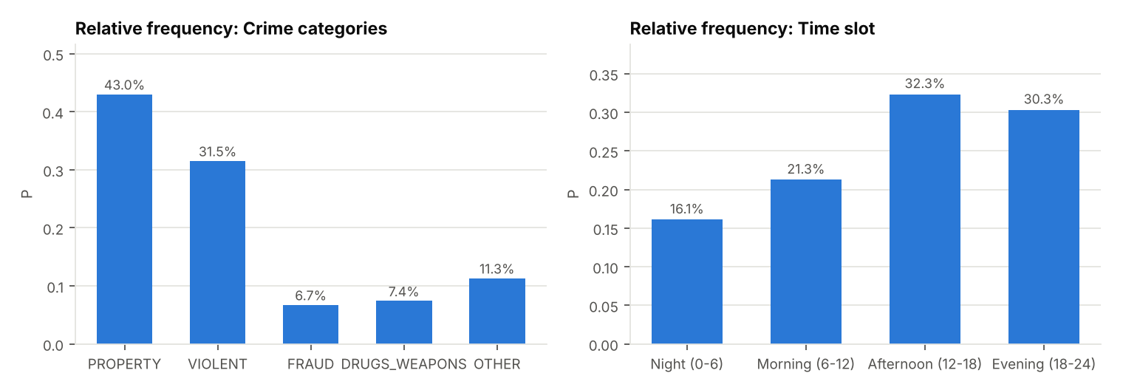
Figure 1: Relative frequency of crime categories and time slots
Table 3: Conditional probability P(category | time slot)
Time slot | PROPERTY | VIOLENT | FRAUD | DRUGS_WEAPONS | OTHER
Night (0-6) | 0.415 | 0.383 | 0.058 | 0.044 | 0.100
Morning (6-12) | 0.434 | 0.277 | 0.085 | 0.070 | 0.133
Afternoon (12-18) | 0.442 | 0.293 | 0.091 | 0.066 | 0.109
Evening (18-24) | 0.423 | 0.330 | 0.034 | 0.102 | 0.111

Conditional probability. The crime mix depends on the time of day: P(VIOLENT | night) = 0.383 against P(VIOLENT | morning) = 0.277, and fraud is rare in the evening (0.034). Bayes' theorem: P(VIOLENT | DOMESTIC) = P(DOMESTIC | VIOLENT)·P(VIOLENT)/P(DOMESTIC) = 0.364 × 0.315 / 0.164 = 0.698, matching the direct count.
Mean and variance. The city records a mean of 24.95 incidents per day in the sample (variance 30.67, SD 5.54), with similar weekday means (24.2–25.9). At the cell level, both the mean and the variance rise strongly from night to afternoon:
Table 4: Mean and variance of incidents per place-time cell
Time slot | Cells | Mean incidents | Variance | SD
Night (0-6) | 539 | 7.46 | 61.2 | 7.82
Morning (6-12) | 539 | 9.86 | 82.1 | 9.06
Afternoon (12-18) | 539 | 15.00 | 208.5 | 14.44
Evening (18-24) | 539 | 14.06 | 156.0 | 12.49

The large variance means a few places carry far more incidents than others: these are the hotspots.
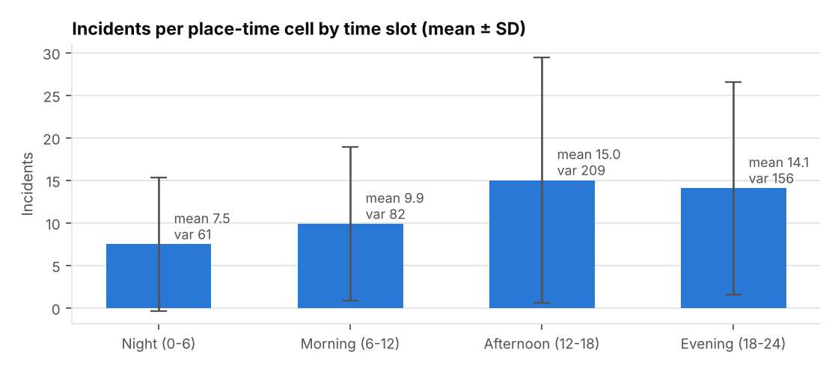
Figure 2: Mean ± standard deviation of incidents per cell by time slot
Correlation. slot: r = 0.239 (p = 2.4e-29); day_of_week: r = 0.010 (p = 0.6447); is_weekend: r = 0.006 (p = 0.7728); latitude: r = 0.056 (p = 0.0090); longitude: r = 0.071 (p = 0.0009). The time slot has the strongest linear relationship with the count. Latitude and longitude are only weakly correlated even though location matters a lot, because risk varies with location in a non-linear way (hotspots are scattered). A linear model therefore cannot capture location well, and the model results confirm this.
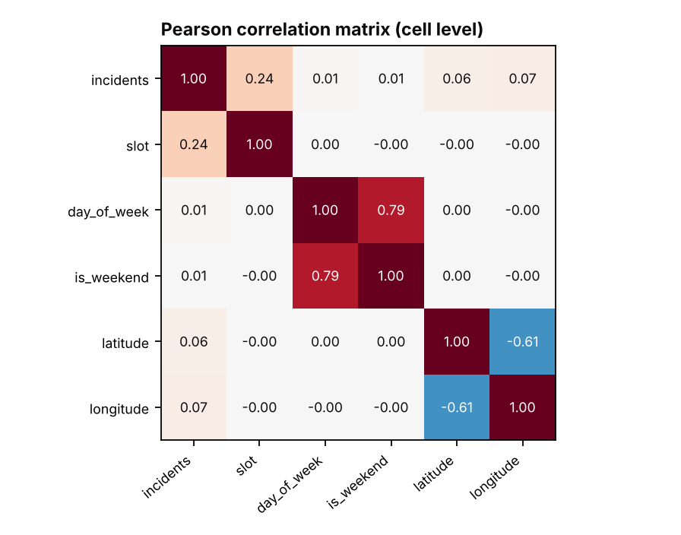
Figure 3: Pearson correlation matrix of cell features and incident count

3.2 Model comparison on the held-out test set
Table 5: Performance on the same 647 test cells
Model | Accuracy | 95% CI | Precision | Recall | F1 | ROC-AUC
Logistic Regression | 76.0% | 72.6% – 79.2% | 0.083 | 0.007 | 0.013 | 0.635
Decision Tree | 91.3% | 88.9% – 93.3% | 0.845 | 0.752 | 0.796 | 0.939
Random Forest | 92.4% | 90.1% – 94.2% | 0.893 | 0.752 | 0.816 | 0.957

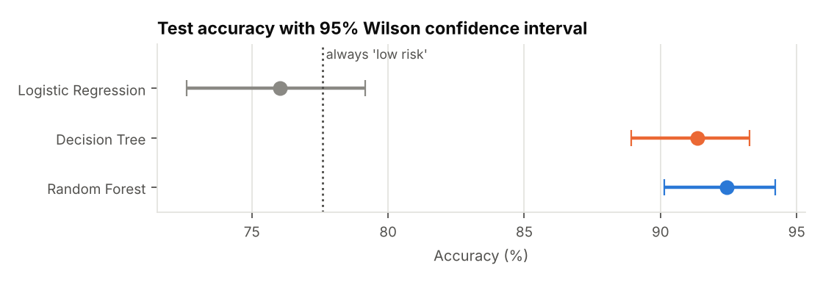
Figure 4: Test accuracy with 95% confidence intervals (dotted line = always predicting 'low risk')
Logistic Regression (76.0%) does no better than always predicting "low risk" (77.6%): its recall is only 0.007, so it almost never flags a hotspot. Both tree models find about 75% of hotspots with high precision. The confidence intervals of the tree models do not overlap with the baseline's, but they overlap heavily with each other.
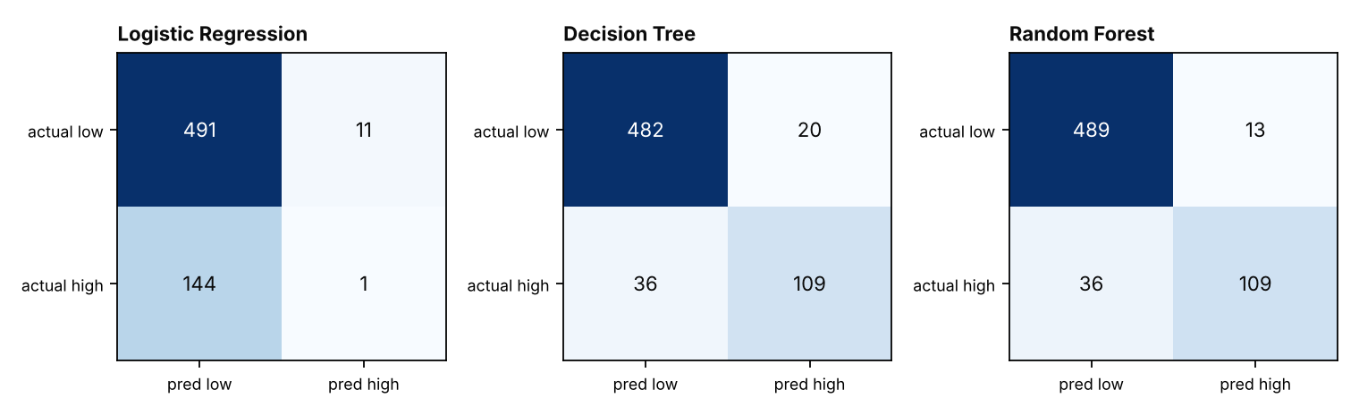
Figure 5: Confusion matrices on the test set
Table 6: Pairwise hypothesis tests (paired, same test cells)
Comparison | Accuracy diff. | Bootstrap 95% CI | b | c | McNemar p | Significant at α/3?
Decision Tree vs Logistic Regression | +15.3% | 11.9% to 18.7% | 20 | 119 | 2.4e-18 | Yes
Random Forest vs Logistic Regression | +16.4% | 13.1% to 19.6% | 13 | 119 | 1.3e-22 | Yes
Random Forest vs Decision Tree | +1.1% | -0.8% to 2.9% | 17 | 24 | 0.3489 | No

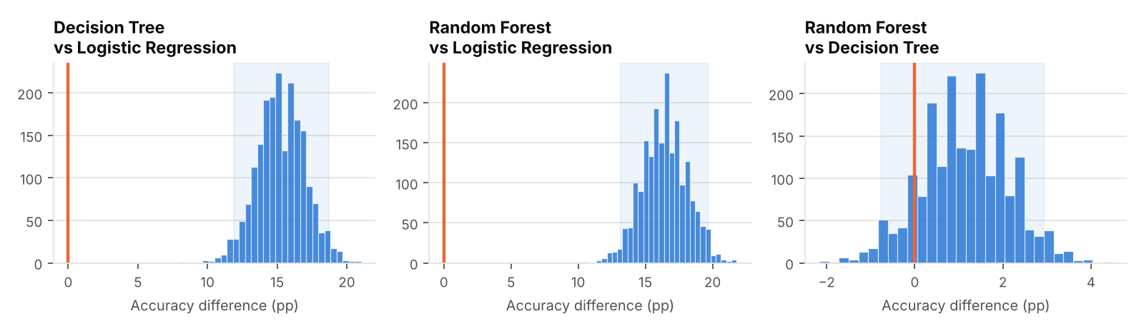
Figure 6: Bootstrap distributions of the accuracy difference with the 95% CI (shaded) and the no-difference line
Interpretation. For the Decision Tree vs Logistic Regression, the models disagree on 139 test cells, and the tree is right on 119 of them. Under H₀ such a lopsided split is essentially impossible (p = 2.4e-18), and the bootstrap CI (11.9% to 18.7%) is far from 0. The same holds for Random Forest vs Logistic Regression (p = 1.3e-22). For Random Forest vs Decision Tree, the split is only 24 vs 17 (p = 0.349), and the CI includes 0.

3.3 Hotspot prediction for a chosen place
For a chosen place, here Logan Square, the application shows its statistics and every model's predicted risk for all 28 weekday × time-slot periods. Logan Square recorded 499 incidents (2.0% of the city; rank #17 of 77), a mean of 0.50 incidents per day (variance 0.53), and an arrest probability of 15.8% against 20.2% citywide. Agreement of each model with the observed high-risk periods: Logistic Regression 43%, Decision Tree 86%, Random Forest 86%. The riskiest predicted periods (Random Forest) are Wed Afternoon (12-18) (0.89), Sun Evening (18-24) (0.87), Fri Afternoon (12-18) (0.86).
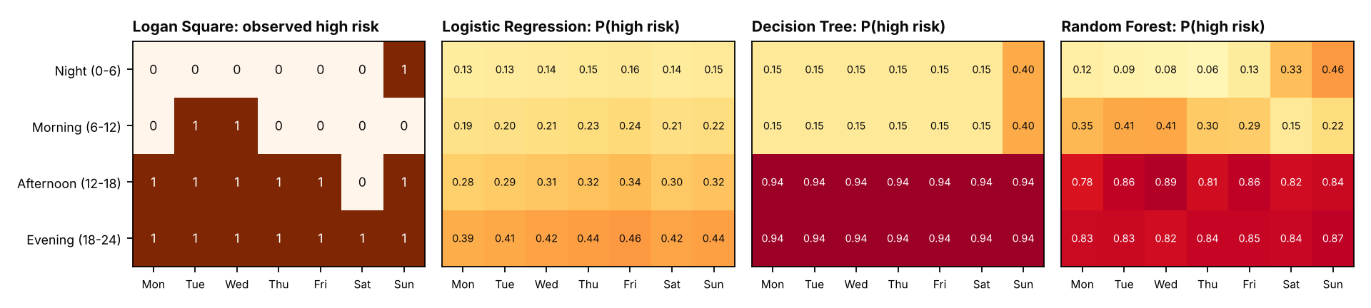
Figure 7: Logan Square: observed high-risk periods and the predicted P(high risk) of each model

3.4 Decision
Is the improvement real? Yes for both tree models over the baseline: Decision Tree +15.3% and Random Forest +16.4%, with McNemar p < 10⁻¹⁷ and bootstrap CIs well above 0. These gains cannot be explained by test-sample variation; location has a non-linear effect that only the trees capture. Between the two tree models, the +1.1% difference is not significant (p = 0.35; CI -0.8% to 2.9%), so it could be due to test-sample variation. Recommendation: use a tree model. Random Forest gives the highest accuracy and ROC-AUC and smoother risk probabilities, but the simpler Decision Tree is statistically just as accurate on this test set.

3.5 Limitations
- Sample of 25,000 incidents. Cell counts are small, so the high-risk label is noisy; the full Chicago data would give more reliable hotspots.
- Small test set (647 cells). A real 1-point difference between two good models cannot be detected with this many cells.
- Random split, not over time. Training and test cells come from the same years; a forward-in-time split would better test forecasting.
- Independence assumption. McNemar and the bootstrap treat cells as independent, but neighbouring areas and adjacent time slots are related.
- Recorded crime ≠ actual crime. Police data reflect reporting and patrol patterns.

4. Where Probability and Statistics Are Used
Table 7: Probability and statistics used in the project
Stage | Concept | Where in this project
Pattern analysis | Frequency, relative frequency as probability | P(category), P(time slot), busiest areas (3.1)
Pattern analysis | Conditional probability, Bayes' theorem | P(category | time slot); P(VIOLENT | DOMESTIC); P(category | place) in the app
Pattern analysis | Mean, variance, standard deviation | Daily counts; incidents per cell by time slot; per place in the app
Pattern analysis | Pearson correlation and test of H₀: ρ = 0 | Which features relate to the incident count
Labelling | Percentile (75th quantile) | Definition of a high-risk cell
Sampling | Random sampling, train/test split | 70/30 split of cells; same test set for all models
Modelling | Probability output P(high risk) | Logistic (sigmoid), tree leaf frequencies, forest vote share; risk maps
Modelling | Bootstrap sampling | Each Random Forest tree is trained on a bootstrap sample
Estimation | Binomial model of accuracy; Wilson 95% CI | Accuracy of each model (3.2)
Hypothesis testing | McNemar's exact test (Binomial), α, p-value | Pairwise model comparison (3.2)
Hypothesis testing | Bonferroni correction α/3 | Three comparisons at once
Estimation | Bootstrap 95% CI of a difference | Could the accuracy difference be zero? (3.2)

5. Web Application
The Streamlit application (streamlit run app.py) has three pages, selected in the sidebar.
- Hotspot predictor: the user chooses a place (any of the 77 community areas; type to search) and sees its crime-pattern analysis (incidents, rank, mean and variance per day, arrest probability, P(category | place) vs city, observed counts by weekday and time slot). It then shows the predicted P(high risk) for every period from all three models, the riskiest periods, and a check for a chosen day and time slot. A map and table rank the riskiest places at that time.
- Crime patterns: frequency analysis, conditional probability, mean and variance, correlation.
- Model comparison: sampling, accuracy with 95% CIs, confusion matrices, McNemar tests, bootstrap CIs and the conclusion.

Figure 8: Hotspot predictor: crime pattern of the chosen place and the three models' predicted high-risk periods
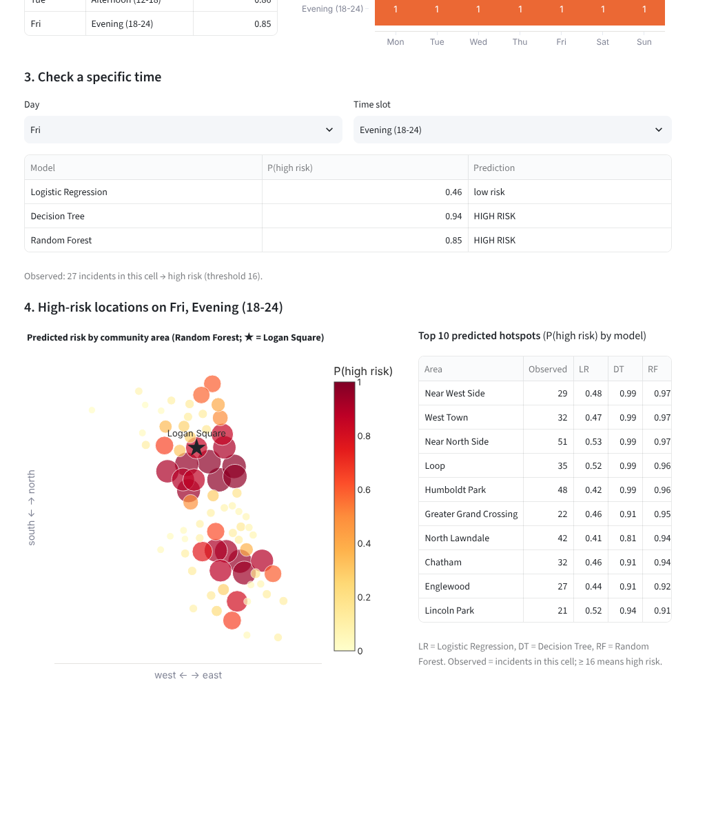
Figure 9: Hotspot predictor: prediction for a chosen time and the riskiest places at that time
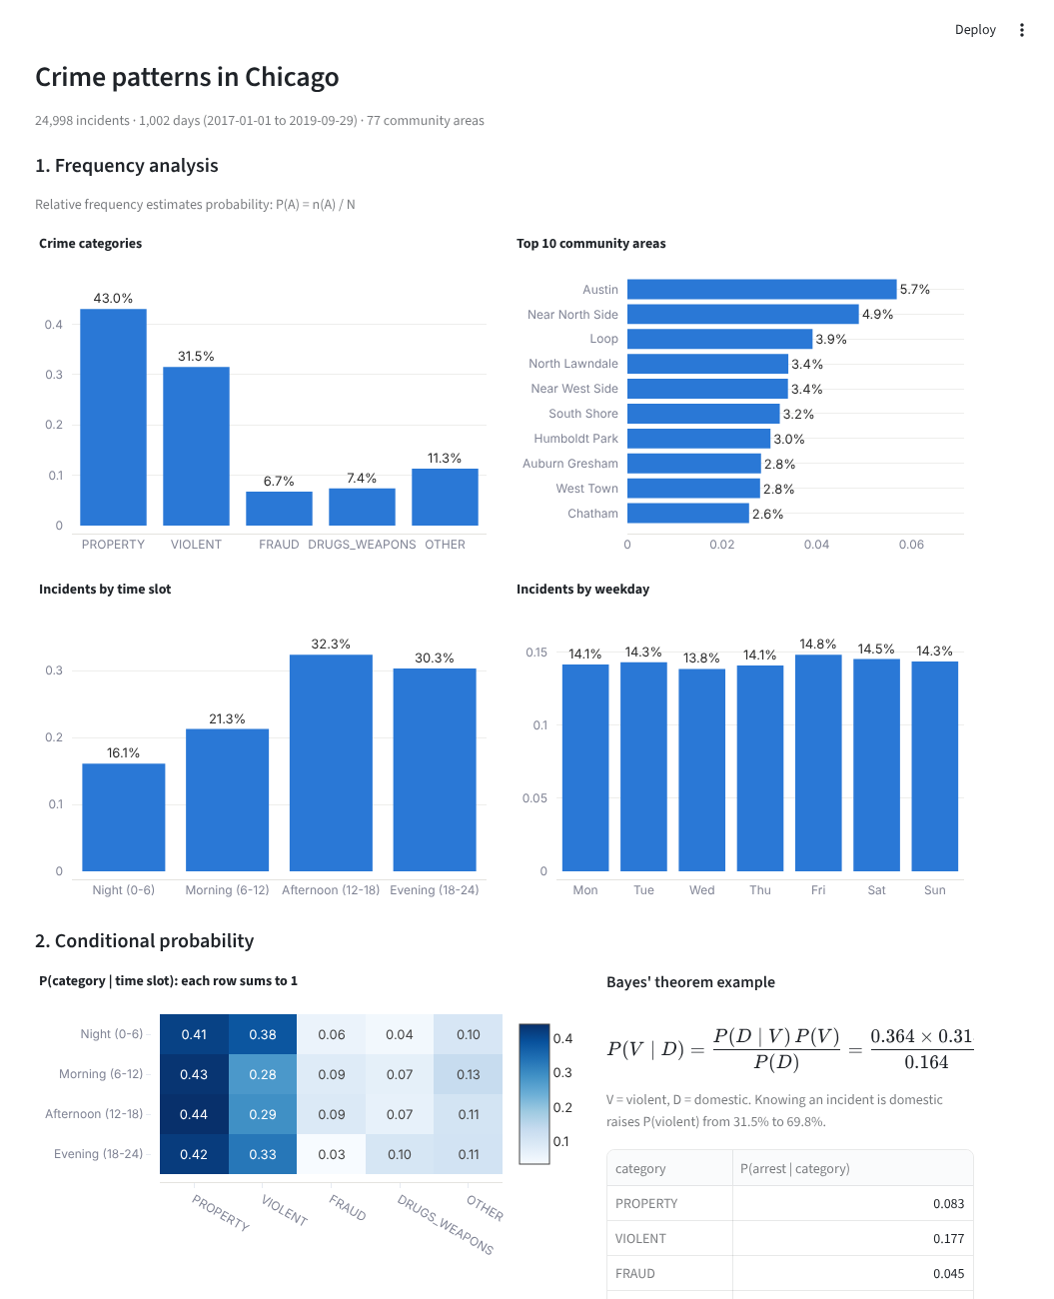
Figure 10: Crime patterns page
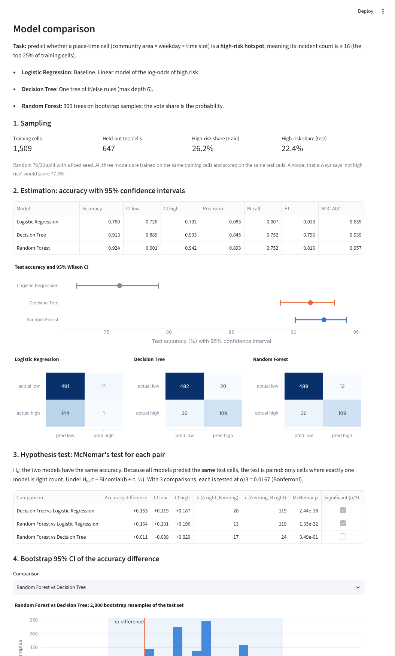
Figure 11: Model comparison page

6. Code Structure and How to Run
Table 8: Project files
File | Purpose
app.py | Web application: loads data, trains the models once (cached), page menu
main.py | Runs the whole analysis without the website; saves tables, figures, results.json
src/config.py | Settings, community-area names, crime categories
src/data.py | Load and clean incidents; build the place-time cells
src/statistics.py | Frequency, conditional probability, mean/variance, correlation
src/models.py | Train/test split, high-risk label, the three models
src/evaluation.py | Accuracy + Wilson CI, McNemar test, bootstrap CI
src/hotspot.py | Place profile, risk grid for a place, riskiest places
src/figures.py | Figures for this report
views/predictor.py, patterns.py, comparison.py | The three web pages
views/charts.py | Chart helpers
tests/test_statistics.py | Unit tests of the statistical functions

- python -m venv .venv, then .venv\Scripts\activate
- pip install -r requirements.txt
- streamlit run app.py (web application)
- python main.py (outputs folder: tables and figures)
- python -m pytest -q (tests)
Repository: https://github.com/<your-username>/crime-hotspot

References
- City of Chicago. Crimes – 2001 to Present. Chicago Data Portal. https://data.cityofchicago.org
- Spaulding, J. S. rcrimeanalysis: An Implementation of Crime Analysis Methods (R package).
- McNemar, Q. (1947). Note on the sampling error of the difference between correlated proportions or percentages. Psychometrika, 12(2), 153–157.
- Dietterich, T. G. (1998). Approximate statistical tests for comparing supervised classification learning algorithms. Neural Computation, 10(7), 1895–1923.
- Efron, B., & Tibshirani, R. J. (1993). An Introduction to the Bootstrap. Chapman & Hall.
- Montgomery, D. C., & Runger, G. C. (2014). Applied Statistics and Probability for Engineers (6th ed.). Wiley.

