Отчёт по визуальному анализу TimeLearner
Создано UTC: 2026-10-17T12:32:34.341036+00:00
Отчёт объединяет неизменяемые run bundles. Сходимость C++-обучения и качество классификации приведены отдельными показателями. Точность пересчитана каноническим selectivity_metrics.py из сохранённого Test/results.csv.

Опыт W01_CL50_N0_PSIoff
Run ID | attempt-0001
Тренер / режим | NNeuronTimeLearner; NormalizationMode=0; пресинаптическое торможение=False; паттерн=50 ms; вариант=AsymRm pack A
Эксперимент | начало: 2026-10-17T10:53:59+00:00 (input manifest setup timestamp; exact Console start unavailable); Test: 2026-10-17T11:50:58+00:00 (Test/results.csv filesystem timestamp); завершение: 2026-10-17T12:15:21+00:00 (provenance.json filesystem timestamp)
Сходимость C++ | converged_need0
Обнаружение цели | нет
Точность (legacy) | 7/8 (87.5%)
Точность (strict) | 7/8 (87.5%)
Точность из результата gate-скрипта | legacy=7/8 (87.5%); strict=7/8 (87.5%)
fires / matches | 00000000 / 01111111
Ложные срабатывания | legacy=0; strict=0; late FP=0
Качество формы ответа | ok_single; ok_audit=0; версия метрик=3
Run bundle | C:\Users\Bakhshiev\AppData\Local\Temp\TimeLearnerTraceReport-W01-20261017\bundle\attempt-0001
Исходный набор конфигов | /media/user/Data/NmsdkRuntime/TimeLearnerAudit-20261017/structural-quantized-lower-W01-20261017/runs/tl-w01-cl50-n0-step86m-acceptlower-20261017-01/W01/W01_CL50_N0_PSIoff/attempt-0001/runtime-input-overrides/W01/W01_CL50_N0_PSIoff
Console SHA-256 | 39bede6e7e3d04a3d737848c27cccaac2fbe4ae3ecf3793b39c453098af553d4
Git SHA | root=4d98b0d09f152d5d2434eff366bd099d92cc6bc4; PulseLib=f465f55529a9f89c5fefae786d95e921e34b16e3; Bin=a3840dea9e6e7106e129b2455a14ad3c4fa0af89
Трасса потенциала | C:\Users\Bakhshiev\AppData\Local\Temp\TimeLearnerTraceReport-W01-20261017\bundle\attempt-0001\Test\test_trace.csv (248008 samples)
Происхождение трассы | evaluation-only replay from saved trained state; начало=2026-10-17T12:01:49Z; основной Test=2026-10-17T12:06:06Z; завершение=2026-10-17T12:13:07Z; обучение повторно не запускалось; CSV replay побайтно совпал с исходным Test/results.csv; trace SHA-256=3af1d32a6e3b65fbbbf5587797c9aba04efa5a9f43e517a0691176658cdcb0f2; Console SHA-256=d73ff7d05a86e4ee7194466a83cc867f105c03ec561331c00ea6c10af46a1f85
Train C++ команда | /media/user/Data/NmsdkRuntime/TimeLearnerAudit-20261017/param-current-20261017/Bin/Platform/Linux/NeuroModelerConsole -c /media/user/Data/NmsdkRuntime/TimeLearnerAudit-20261017/structural-quantized-lower-W01-20261017/runs/W01_CL50_N0_PSIoff_20261017T105359Z_2079660_b0a88aec_work/Train/Project.ini -s -t 640.0 -x -S
Train status / rc | converged_need0 / -15 (wrapper stopped Console after the Need=0 exit grace period)
Test gate команды | GATE /usr/bin/python3 /media/user/Data/NmsdkRuntime/TimeLearnerAudit-20261017/diag-w04-n0-step86m-current-20261017/Bin/Configs/SpikeSamples/StructTrain/SelectivityAsymRm/scripts/phase9_preinh_bc_gate.py /media/user/Data/NmsdkRuntime/TimeLearnerAudit-20261017/structural-quantized-lower-W01-20261017/runs/W01_CL50_N0_PSIoff_20261017T105359Z_2079660_b0a88aec_work --test-t 40 --span-ms 50 --metric ltz_potential_max --skip-tipr-mid
Test gate результат | evaluated=True; rc=0; ok=True; error=
Метрики и вывод gate-скрипта | metrics_line: ok=0 n=8 acc=7 target_hit=0 fire_all=0 mode=silent fires=00000000 matches=01111111 fa=0  Точность: legacy=7/8 (87.5%); strict=7/8 (87.5%); fires=00000000; matches=01111111; target_hit_strict=0; false positives strict=0; ok_audit=0; response_quality=ok_single; metrics_version=3

Конфиги, фактически использованные в запуске
Train/Model_00.xml | matrix input override; final prelaunch XML not preserved  C:\Users\Bakhshiev\AppData\Local\Temp\TimeLearnerTraceReport-W01-20261017\bundle\attempt-0001\runtime-input-overrides\W01\W01_CL50_N0_PSIoff\Train\Model_00.xml  SHA-256: 2eb2cad53c511bacacff2a6e29dc2cdb50d84a2cce5d96f4de909c15890a5414
Train/Parameters_00.xml | matrix input override; final prelaunch XML not preserved  C:\Users\Bakhshiev\AppData\Local\Temp\TimeLearnerTraceReport-W01-20261017\bundle\attempt-0001\runtime-input-overrides\W01\W01_CL50_N0_PSIoff\Train\Parameters_00.xml  SHA-256: c425170eb6c8a2520fab33f7f90035fe6e3381c382585ca27a4b57ac90cc1cf7
Train/Project.ini | matrix input override; final prelaunch XML not preserved  C:\Users\Bakhshiev\AppData\Local\Temp\TimeLearnerTraceReport-W01-20261017\bundle\attempt-0001\runtime-input-overrides\W01\W01_CL50_N0_PSIoff\Train\Project.ini  SHA-256: 2d31a92640fa22c8c0c76660b42c41336ba73699da33e332f17a29c75faa528e
Train/Interface.xml | matrix input override; final prelaunch XML not preserved  C:\Users\Bakhshiev\AppData\Local\Temp\TimeLearnerTraceReport-W01-20261017\bundle\attempt-0001\runtime-input-overrides\W01\W01_CL50_N0_PSIoff\Train\Interface.xml  SHA-256: d7a807014797929daaae5f59395ce9ea011357c6e82a9f4418e08795a8c7ec87
Test/Model_00.xml | matrix Test input override; effective gate XML not preserved  C:\Users\Bakhshiev\AppData\Local\Temp\TimeLearnerTraceReport-W01-20261017\bundle\attempt-0001\runtime-input-overrides\W01\W01_CL50_N0_PSIoff\Test\Model_00.xml  SHA-256: 0a6c7fa2f8b772494ff210990c9c4bd70bb6030df1f68d2f01021671c8042276
Test/Parameters_00.xml | matrix Test input override; effective gate XML not preserved  C:\Users\Bakhshiev\AppData\Local\Temp\TimeLearnerTraceReport-W01-20261017\bundle\attempt-0001\runtime-input-overrides\W01\W01_CL50_N0_PSIoff\Test\Parameters_00.xml  SHA-256: ea2880613867c4d018d1005fcdc313f9b5d860a5d7807167cef332d9b83ed270
Test/Project.ini | matrix Test input override; effective gate XML not preserved  C:\Users\Bakhshiev\AppData\Local\Temp\TimeLearnerTraceReport-W01-20261017\bundle\attempt-0001\runtime-input-overrides\W01\W01_CL50_N0_PSIoff\Test\Project.ini  SHA-256: 2f85bcd0ac42c05a5c48a72dc5b9562644fa291280d1f0c64758bb764cce5444
Test/Interface.xml | matrix Test input override; effective gate XML not preserved  C:\Users\Bakhshiev\AppData\Local\Temp\TimeLearnerTraceReport-W01-20261017\bundle\attempt-0001\runtime-input-overrides\W01\W01_CL50_N0_PSIoff\Test\Interface.xml  SHA-256: d607a880f224f687853f921a365a8490e878cb7fb06a758793208ecb71e15c54

Скрипты и происхождение результата
matrix launcher Bin/Configs/SpikeSamples/StructTrain/scripts/run_timelearner_matrix_queue.py | SHA-256=7ed6b031fe1ba08e14e1ed632d5007d3f30786655d40d33c9d28016501779f69
matrix launcher Bin/Configs/SpikeSamples/StructTrain/scripts/timelearner_matrix.py | SHA-256=c7ec7a79361a4223504d965929ef1c51cd4cdf878fa943638b829d11c49d2f67
matrix launcher Bin/Configs/SpikeSamples/StructTrain/scripts/matrix_run_safety.py | SHA-256=d6c30d0723940a7293506d182310d286f1ecdcf60a494157b954f221cc2dec50
matrix launcher Bin/Configs/SpikeSamples/StructTrain/scripts/posttune_verify.py | SHA-256=a52c0099fe7eb0db46513873bfef6d17aacedb6a2aee55ff23eeb4eecb110da2
matrix launcher Bin/Configs/SpikeSamples/StructTrain/scripts/repro_cold_lib.py | SHA-256=95977b1dcc171fff4080029ecf63ea62c072eaa3aeb116e9608e2e4b629afd39
Orchestrator argv:
worker.log: C:\Users\Bakhshiev\AppData\Local\Temp\TimeLearnerTraceReport-W01-20261017\bundle\attempt-0001\worker.log | SHA-256=c01eccc8c7c13f846e62de95ecef3ac8ecf1374429bf76c754522211553d044e
post-flag: wait up to 90s for NM -S exit (Need=0 flag=0 tipr_settled=1)
post-flag grace expired — terminate NM
gate rc 0

Реакции по тестовым примерам
trial | class | fires | spike times, s | error | input times, ms
0 | 1 | 0 |  | fn | 0.00, 8.35, 25.00, 50.00
1 | 0 | 0 |  | ok | 0.00, 25.00, 41.70, 50.00
2 | 0 | 0 |  | ok | 0.00, 16.70, 25.00, 50.00
3 | 0 | 0 |  | ok | 0.00, 16.70, 33.35, 50.00
4 | 0 | 0 |  | ok | 0.00, 2.10, 25.00, 50.00
5 | 0 | 0 |  | ok | 0.00, 25.00, 47.95, 50.00
6 | 0 | 0 |  | ok | 0.00, 4.20, 8.35, 50.00
7 | 0 | 0 |  | ok | 0.00, 41.70, 45.85, 50.00

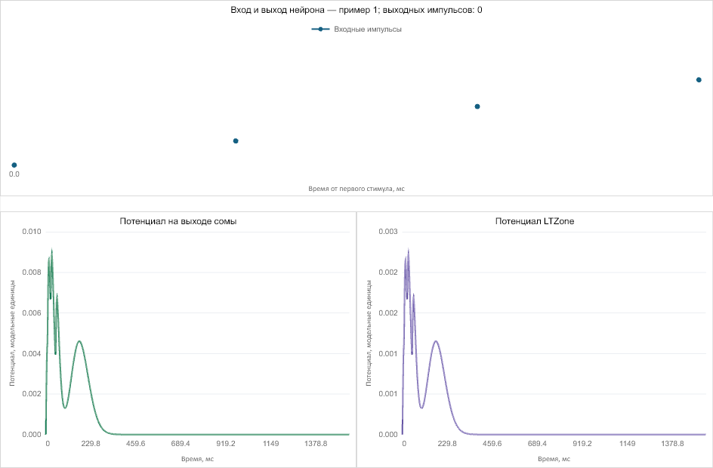

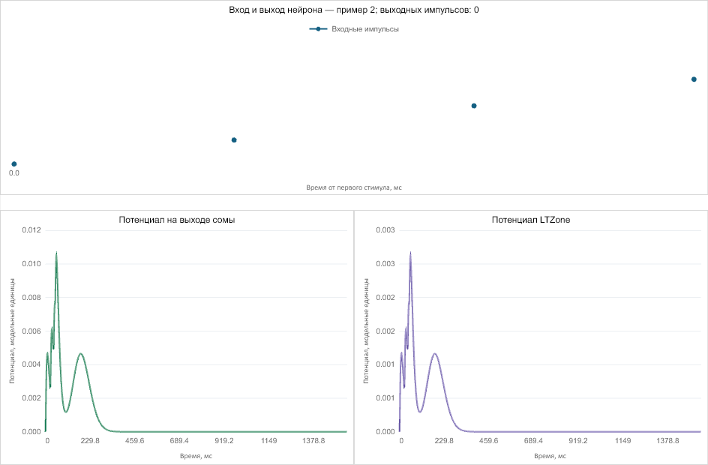

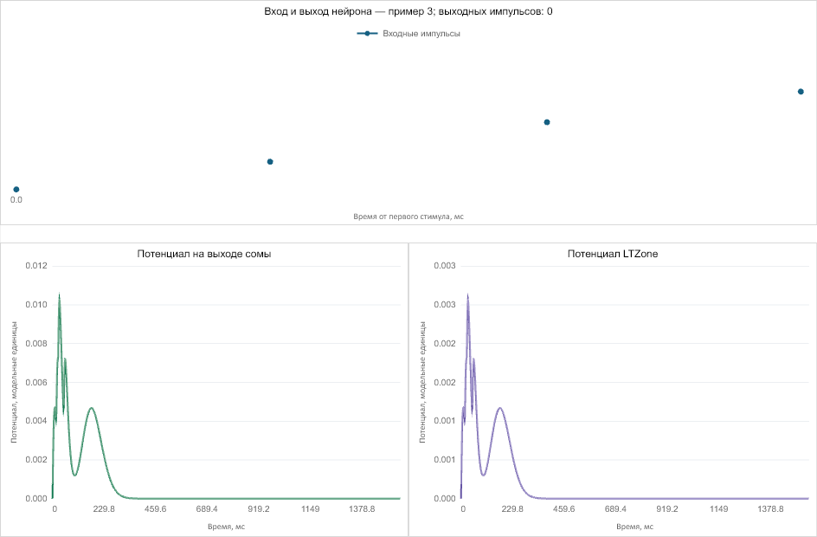

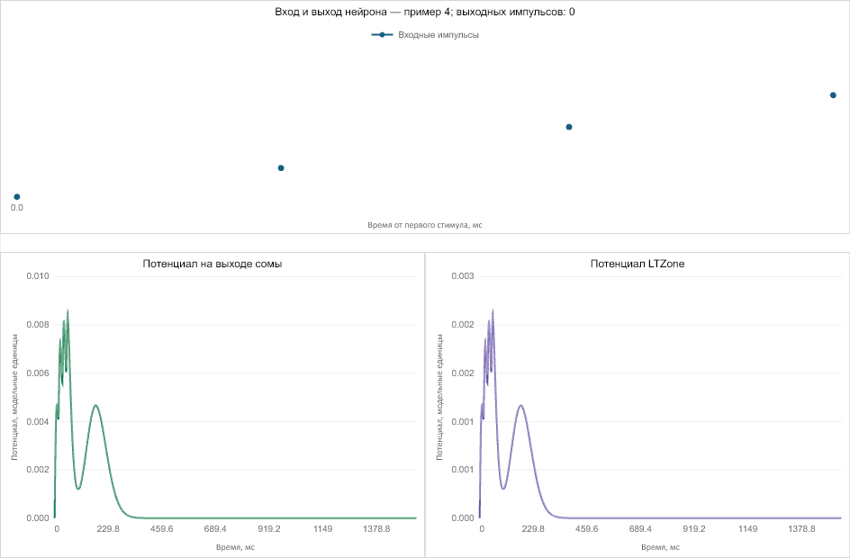

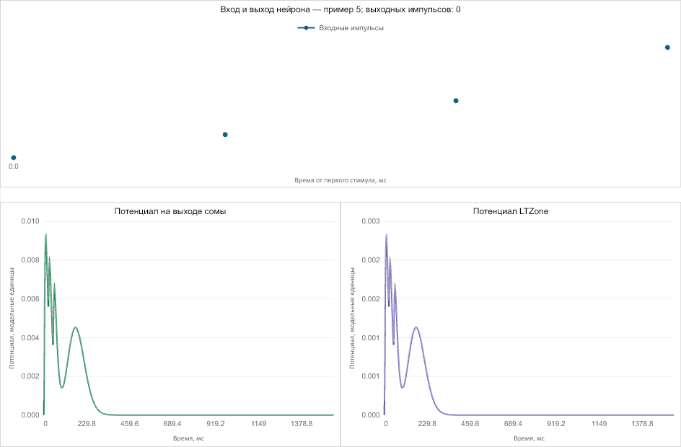

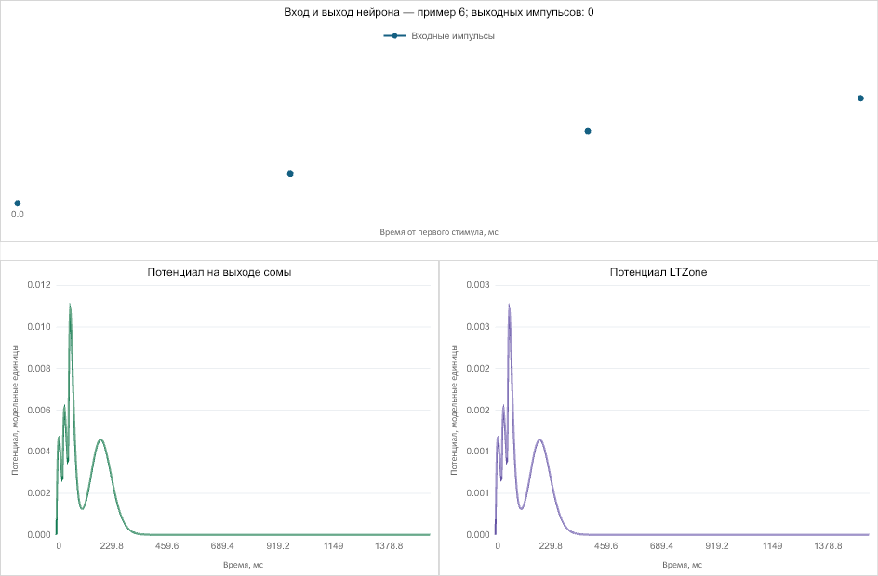

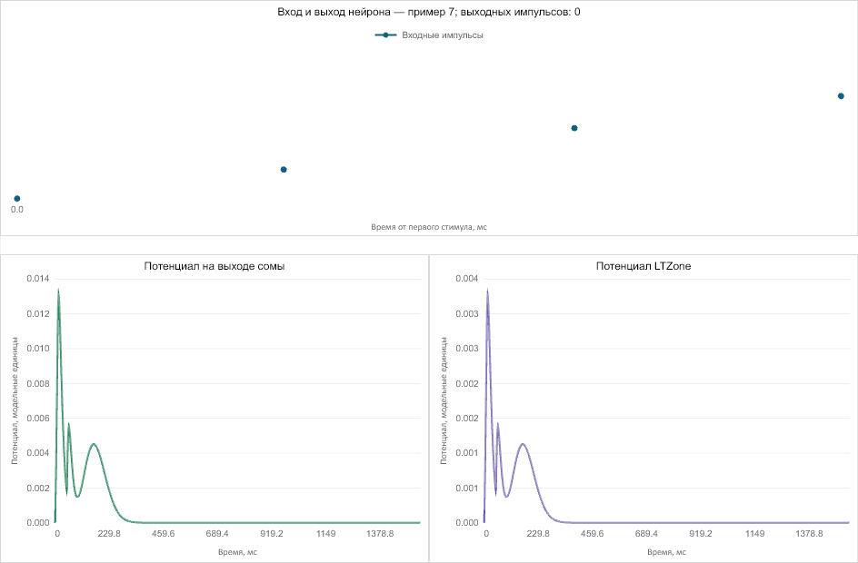

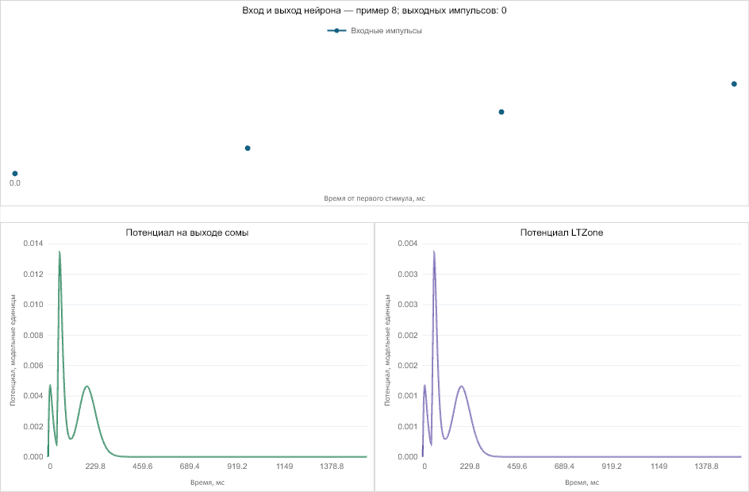
Сводка: запусков — 1; тестовых примеров — 8.

