Отчёт по визуальному анализу TimeLearner
Создано UTC: 2026-10-17T13:38:27.997704+00:00
Отчёт объединяет неизменяемые run bundles. Сходимость C++-обучения и качество классификации приведены отдельными показателями. Точность пересчитана каноническим selectivity_metrics.py из сохранённого Test/results.csv.

Опыт br25_nextseg
Run ID | attempt-0001
Тренер / режим | NNeuronTimeLearnerBranch (Branch); NormalizationMode=1; пресинаптическое торможение=False; паттерн=25 ms; вариант=Branch historical
Эксперимент | начало: 2026-10-17T13:04:26.942525+00:00 (runner prelaunch timestamp); Test: 2026-10-17T13:07:32.968146+00:00 (runner timestamp before invoking Test gate script); завершение: 2026-10-17T13:14:46.513745+00:00 (C++ run provenance)
Сходимость C++ | converged_posttune_finalized
Обнаружение цели | да
Точность (legacy) | 8/8 (100.0%)
Точность (strict) | 8/8 (100.0%)
Точность из результата gate-скрипта | legacy=8/8 (100.0%); strict=8/8 (100.0%)
fires / matches | 10000000 / 11111111
Ложные срабатывания | legacy=0; strict=0; late FP=0
Качество формы ответа | ok_single; ok_audit=1; версия метрик=3
Run bundle | C:\Users\Bakhshiev\AppData\Local\Temp\w10-visual-inputs-20261017\W10_HIST_br25_nextseg\attempt-0001
Исходный набор конфигов | /media/user/Data/NmsdkRuntime/TimeLearnerAudit-20261017/w10-current-positive-refreshed-20261017/runs/tl-w10-current-positive-refreshed-17-20261017-01/W10/W10_HIST_br25_nextseg/attempt-0001/runtime-input-overrides/W10/W10_HIST_br25_nextseg
Console SHA-256 | 2854684eceb651b775559a04729275d1229506ab1e03c2130b9caa94d93d9618
Git SHA | root=07760676ce8b78c2ed0ae0b11417f3640b86eae7; PulseLib=da307d3ac1169c72d2d0c030b67ec29ac93e267b; Bin=885312807bce3dcae4518a8720952c93049ff73f
Трасса потенциала | C:\Users\Bakhshiev\AppData\Local\Temp\w10-visual-inputs-20261017\W10_HIST_br25_nextseg\attempt-0001\Test\test_trace.csv (244008 samples)
Происхождение трассы | отдельный повтор Test для записи трассы не зафиксирован
Train C++ команда | /media/user/Data/NmsdkRuntime/TimeLearnerAudit-20261017/current-release-w10-positive-20261017/Bin/Platform/Linux/NeuroModelerConsole -c /media/user/Data/NmsdkRuntime/TimeLearnerAudit-20261017/w10-current-positive-refreshed-20261017/runs/br25_nextseg_20261017T130426Z_2160052_3e1fc59e_work/Train/Project.ini -s -t 320.0 -x -S
Train status / rc | done / -15
Test gate команды | /usr/bin/python3 /media/user/Data/NmsdkRuntime/TimeLearnerAudit-20261017/current-release-w10-positive-20261017/Bin/Configs/SpikeSamples/StructTrain/SelectivityBranch/scripts/phase8_tiprmin_gate.py /media/user/Data/NmsdkRuntime/TimeLearnerAudit-20261017/w10-current-positive-refreshed-20261017/runs/br25_nextseg_20261017T130426Z_2160052_3e1fc59e_work --span-ms 25 --pack A --test-t 40 --skip-tipr-mid --diagnostic-threshold 0.063683469053292696  /usr/bin/python3 /media/user/Data/NmsdkRuntime/TimeLearnerAudit-20261017/current-release-w10-positive-20261017/Bin/Configs/SpikeSamples/StructTrain/SelectivityBranch/scripts/phase8_tiprmin_gate.py /media/user/Data/NmsdkRuntime/TimeLearnerAudit-20261017/w10-current-positive-refreshed-20261017/runs/br25_nextseg_20261017T130426Z_2160052_3e1fc59e_work --span-ms 25 --pack A --test-t 40 --skip-tipr-mid --force-test-cpp-mid
Test gate результат | evaluated=True; rc=0; ok=True; error=
Метрики и вывод gate-скрипта | metrics_line: ok=1 n=8 acc=8 target_hit=1 fire_all=0 mode=selective fires=10000000 matches=11111111 fa=0  Точность: legacy=8/8 (100.0%); strict=8/8 (100.0%); fires=10000000; matches=11111111; target_hit_strict=1; false positives strict=0; ok_audit=1; response_quality=ok_single; metrics_version=3

Конфиги, фактически использованные в запуске
Train/Model_00.xml | exact prelaunch C++ snapshot  C:\Users\Bakhshiev\AppData\Local\Temp\w10-visual-inputs-20261017\W10_HIST_br25_nextseg\attempt-0001\prelaunch-inputs\Train\Model_00.xml  SHA-256: 9830cf8448a4d150cbcd72186096a1c015cc7a696e7290bc2c4782864ed6c05c
Train/Parameters_00.xml | exact prelaunch C++ snapshot  C:\Users\Bakhshiev\AppData\Local\Temp\w10-visual-inputs-20261017\W10_HIST_br25_nextseg\attempt-0001\prelaunch-inputs\Train\Parameters_00.xml  SHA-256: dae9c87214c59ad54d65a063ac9d4437a166d496b59aec881e9379d9b2d5520e
Train/Project.ini | exact prelaunch C++ snapshot  C:\Users\Bakhshiev\AppData\Local\Temp\w10-visual-inputs-20261017\W10_HIST_br25_nextseg\attempt-0001\prelaunch-inputs\Train\Project.ini  SHA-256: bda28d6054ebce424dd608a0a9f1ffc650e1ffb095ac5e971fce09e6c55d7867
Train/Interface.xml | exact prelaunch C++ snapshot  C:\Users\Bakhshiev\AppData\Local\Temp\w10-visual-inputs-20261017\W10_HIST_br25_nextseg\attempt-0001\prelaunch-inputs\Train\Interface.xml  SHA-256: 7421896b9bbdb52b394acd58b2f3973f0a5abf542a69c91fcdcdb761c6d3c9f0
Test/Model_00.xml | effective post-gate Test snapshot  C:\Users\Bakhshiev\AppData\Local\Temp\w10-visual-inputs-20261017\W10_HIST_br25_nextseg\attempt-0001\effective-inputs\Test\post-gate\Model_00.xml  SHA-256: 259dd6d6ad5ccecdde7a71d60da9675c1e3ea48c3fbc18640dacb0867cd7d9d0
Test/Parameters_00.xml | effective post-gate Test snapshot  C:\Users\Bakhshiev\AppData\Local\Temp\w10-visual-inputs-20261017\W10_HIST_br25_nextseg\attempt-0001\effective-inputs\Test\post-gate\Parameters_00.xml  SHA-256: 1b413c278eeb29c9bbfa7e7590c99389d71cc57393dc454727955f03be899dd4
Test/Project.ini | effective post-gate Test snapshot  C:\Users\Bakhshiev\AppData\Local\Temp\w10-visual-inputs-20261017\W10_HIST_br25_nextseg\attempt-0001\effective-inputs\Test\post-gate\Project.ini  SHA-256: 569937901633a393fc22a9c4882b6332babc47724d2cf2c020fad1671b7b4c54
Test/Interface.xml | effective post-gate Test snapshot  C:\Users\Bakhshiev\AppData\Local\Temp\w10-visual-inputs-20261017\W10_HIST_br25_nextseg\attempt-0001\effective-inputs\Test\post-gate\Interface.xml  SHA-256: 7421896b9bbdb52b394acd58b2f3973f0a5abf542a69c91fcdcdb761c6d3c9f0

Скрипты и происхождение результата
train_runner: Bin/Configs/SpikeSamples/StructTrain/scripts/posttune_verify.py | SHA-256=7382c11698e5d68c0180ab2aedee39cecf69766c6fc521b659cb38c03edd6805
matrix_queue_runner: Bin/Configs/SpikeSamples/StructTrain/scripts/run_timelearner_matrix_queue.py | SHA-256=7ed6b031fe1ba08e14e1ed632d5007d3f30786655d40d33c9d28016501779f69
matrix_runner: Bin/Configs/SpikeSamples/StructTrain/scripts/timelearner_matrix.py | SHA-256=c7ec7a79361a4223504d965929ef1c51cd4cdf878fa943638b829d11c49d2f67
branch_test_gate: Bin/Configs/SpikeSamples/StructTrain/SelectivityBranch/scripts/phase8_tiprmin_gate.py | SHA-256=83f6f695819fc448231ff45441dbdd74eab9dbadd532365e618caa1bcab37373
classic_test_gate: Bin/Configs/SpikeSamples/StructTrain/SelectivityAsymRm/scripts/phase9_preinh_bc_gate.py | SHA-256=6f3d0734c628b0c77f5a2cc52840f2e17d78118b1e423d93afe4879308e255d8
selectivity_metrics: Bin/Configs/SpikeSamples/StructTrain/scripts/selectivity_metrics.py | SHA-256=4af6ddd073224f4916fde0fbc71d8cd0ad50958f920a793e568667a01e4996cf
matrix launcher Bin/Configs/SpikeSamples/StructTrain/scripts/run_timelearner_matrix_queue.py | SHA-256=7ed6b031fe1ba08e14e1ed632d5007d3f30786655d40d33c9d28016501779f69
matrix launcher Bin/Configs/SpikeSamples/StructTrain/scripts/timelearner_matrix.py | SHA-256=c7ec7a79361a4223504d965929ef1c51cd4cdf878fa943638b829d11c49d2f67
matrix launcher Bin/Configs/SpikeSamples/StructTrain/scripts/matrix_run_safety.py | SHA-256=d6c30d0723940a7293506d182310d286f1ecdcf60a494157b954f221cc2dec50
matrix launcher Bin/Configs/SpikeSamples/StructTrain/scripts/posttune_verify.py | SHA-256=7382c11698e5d68c0180ab2aedee39cecf69766c6fc521b659cb38c03edd6805
matrix launcher Bin/Configs/SpikeSamples/StructTrain/scripts/repro_cold_lib.py | SHA-256=fdebce8859f638f332eddd08096cce80f58553fd41b846d02b1be7cdf10cf096
Orchestrator argv: /media/user/Data/NmsdkRuntime/TimeLearnerAudit-20261017/current-release-w10-positive-20261017/Bin/Configs/SpikeSamples/StructTrain/scripts/timelearner_matrix.py --worker W10 W10_HIST_br25_nextseg --quiet-debug-logs --stall-autosave-n 0
log Train/script-logs/run_posttune_verify.log | SHA-256=52de3d8557021a3551fda68df42ff2aee6e332df55e0fe24fa3121630ac3d67c
log Test/script-logs/run_gate.log | SHA-256=d4e704be6af2a10fa7be038cf82390f0a094e75f9484616dfde6672b61007d6b
log Test/script-logs/run_infer_mid.log | SHA-256=8fc36cbf14822cf4458c690d0ee4458fda7cf08b61c8af44bc484c255c17b61c
log Test/script-logs/run_posttune_gate.log | SHA-256=f6cc6ee61d90f019ef411cde076c7b9afc53ad4451733eac136329ce99bde33e
worker.log: C:\Users\Bakhshiev\AppData\Local\Temp\w10-visual-inputs-20261017\W10_HIST_br25_nextseg\attempt-0001\worker.log | SHA-256=71b356299fa83489d1c9db46481b8a4fc3f28e7c24c6d807e703b40687b96129
post-flag: wait up to 90s for NM -S exit (Need=0 flag=1 tipr_settled=1)
post-flag grace expired — terminate NM
gate rc 0
gate rc 0

Реакции по тестовым примерам
trial | class | fires | spike times, s | error | input times, ms
0 | 1 | 1 | 0.07325 | ok | 0.00, 4.15, 12.50, 25.00
1 | 0 | 0 |  | ok | 0.00, 12.50, 20.85, 25.00
2 | 0 | 0 |  | ok | 0.00, 8.35, 12.50, 25.00
3 | 0 | 0 |  | ok | 0.00, 8.35, 16.65, 25.00
4 | 0 | 0 |  | ok | 0.00, 1.05, 12.50, 25.00
5 | 0 | 0 |  | ok | 0.00, 12.50, 23.95, 25.00
6 | 0 | 0 |  | ok | 0.00, 2.10, 4.15, 25.00
7 | 0 | 0 |  | ok | 0.00, 20.85, 22.90, 25.00

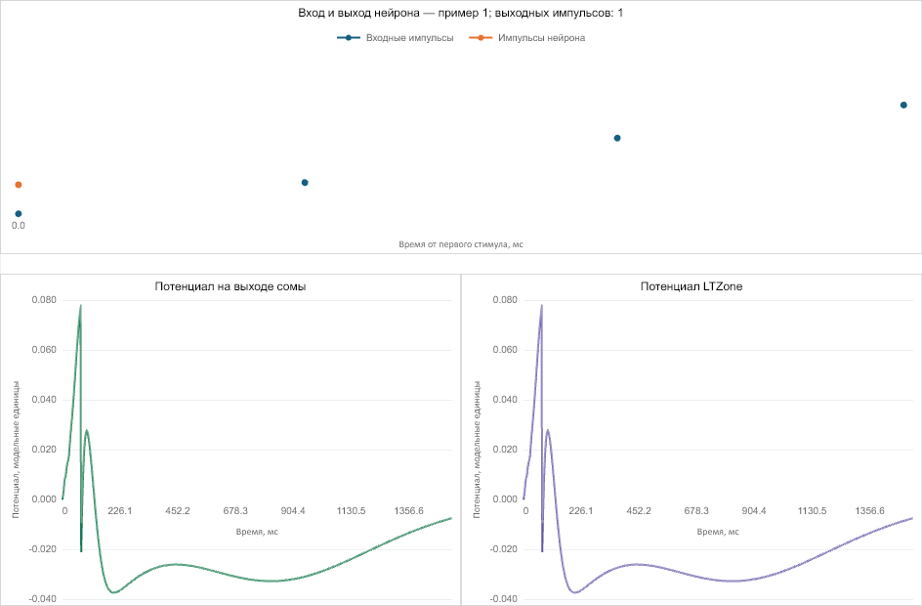

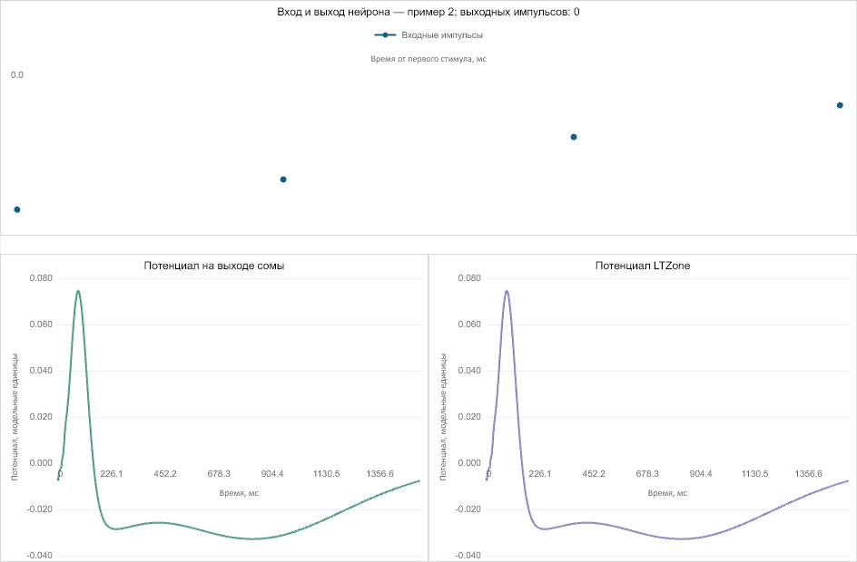

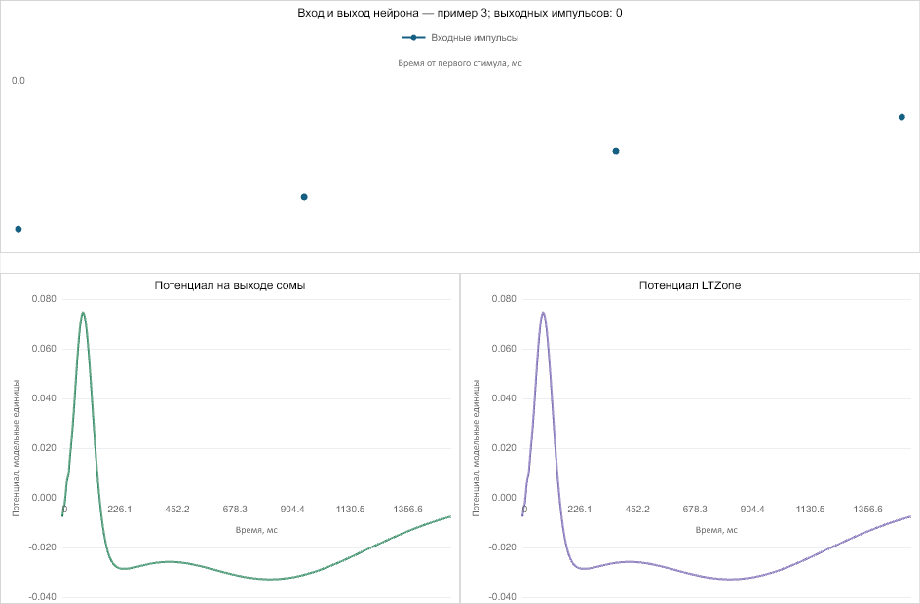

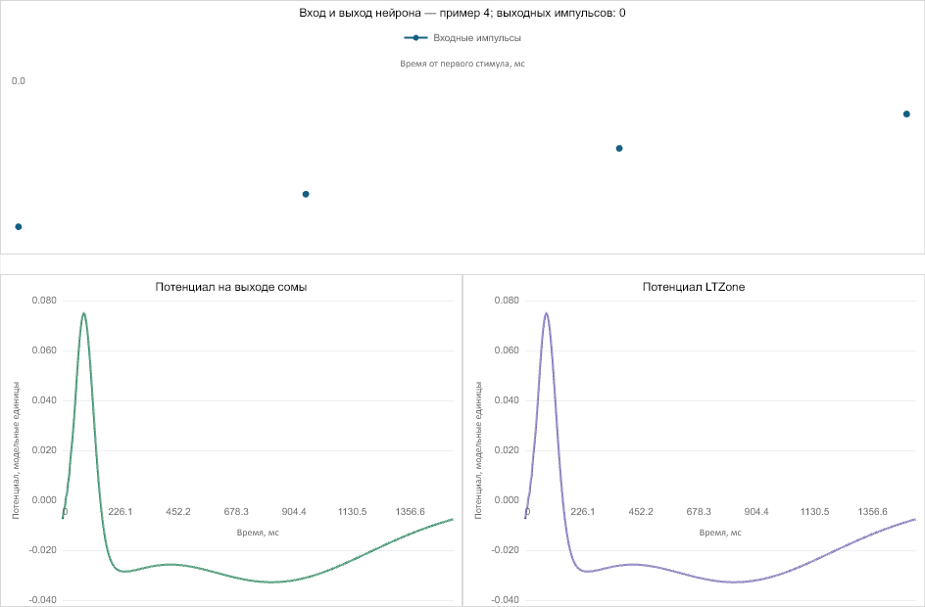

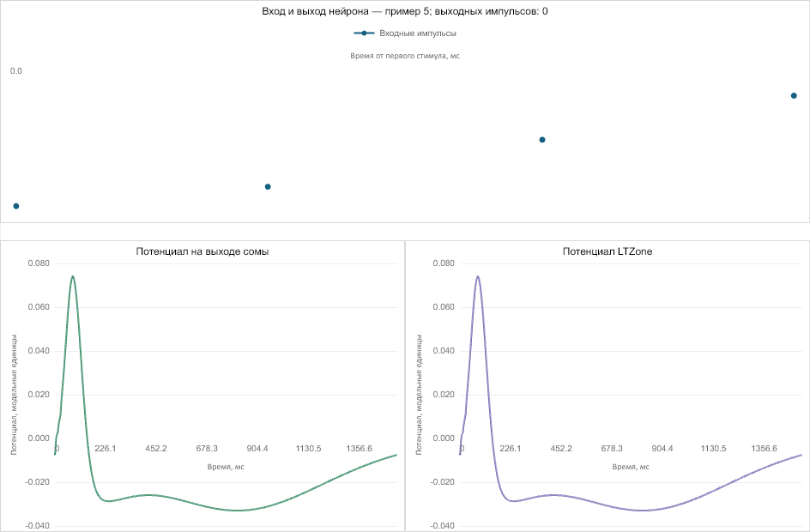

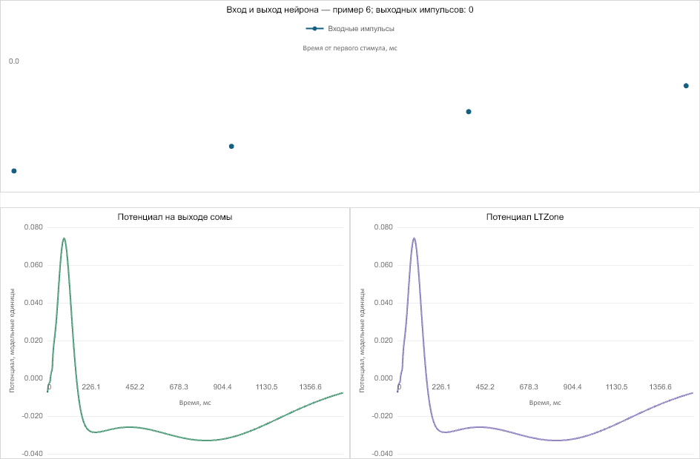

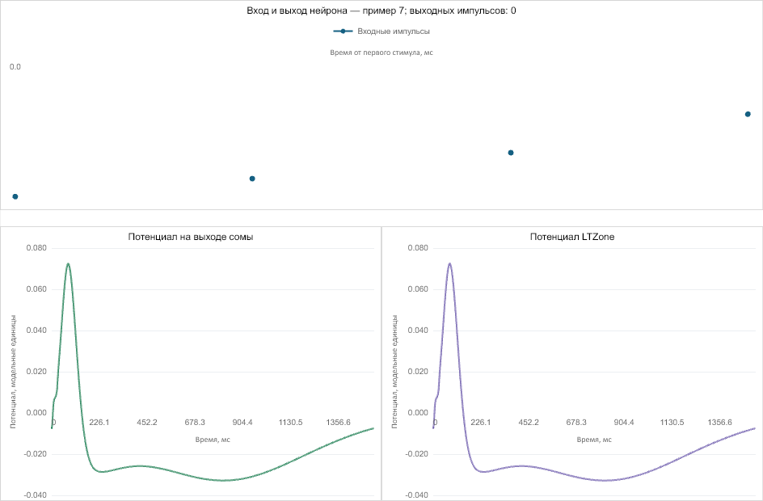

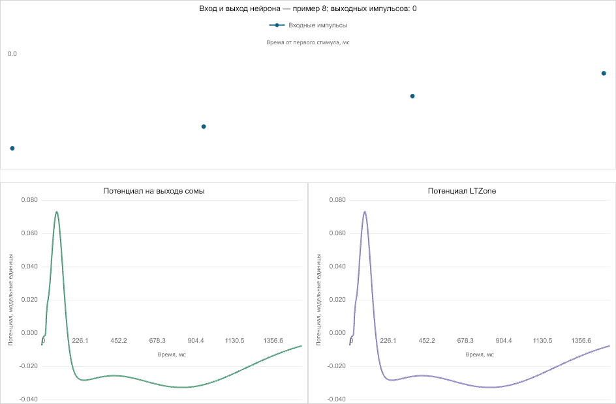

Опыт br50_gen
Run ID | attempt-0001
Тренер / режим | NNeuronTimeLearnerBranch (Branch); NormalizationMode=1; пресинаптическое торможение=False; паттерн=50 ms; вариант=Branch historical
Эксперимент | начало: 2026-10-17T13:04:26.920033+00:00 (runner prelaunch timestamp); Test: 2026-10-17T13:08:32.948302+00:00 (runner timestamp before invoking Test gate script); завершение: 2026-10-17T13:15:46.520076+00:00 (C++ run provenance)
Сходимость C++ | converged_posttune_finalized
Обнаружение цели | нет
Точность (legacy) | 7/8 (87.5%)
Точность (strict) | 7/8 (87.5%)
Точность из результата gate-скрипта | legacy=7/8 (87.5%); strict=7/8 (87.5%)
fires / matches | 00000000 / 01111111
Ложные срабатывания | legacy=0; strict=0; late FP=0
Качество формы ответа | ok_single; ok_audit=0; версия метрик=3
Run bundle | C:\Users\Bakhshiev\AppData\Local\Temp\w10-visual-inputs-20261017\W10_HIST_br50_gen\attempt-0001
Исходный набор конфигов | /media/user/Data/NmsdkRuntime/TimeLearnerAudit-20261017/w10-current-positive-refreshed-20261017/runs/tl-w10-current-positive-refreshed-17-20261017-01/W10/W10_HIST_br50_gen/attempt-0001/runtime-input-overrides/W10/W10_HIST_br50_gen
Console SHA-256 | 2854684eceb651b775559a04729275d1229506ab1e03c2130b9caa94d93d9618
Git SHA | root=07760676ce8b78c2ed0ae0b11417f3640b86eae7; PulseLib=da307d3ac1169c72d2d0c030b67ec29ac93e267b; Bin=885312807bce3dcae4518a8720952c93049ff73f
Трасса потенциала | C:\Users\Bakhshiev\AppData\Local\Temp\w10-visual-inputs-20261017\W10_HIST_br50_gen\attempt-0001\Test\test_trace.csv (248008 samples)
Происхождение трассы | отдельный повтор Test для записи трассы не зафиксирован
Train C++ команда | /media/user/Data/NmsdkRuntime/TimeLearnerAudit-20261017/current-release-w10-positive-20261017/Bin/Platform/Linux/NeuroModelerConsole -c /media/user/Data/NmsdkRuntime/TimeLearnerAudit-20261017/w10-current-positive-refreshed-20261017/runs/br50_gen_20261017T130426Z_2160050_f96e6fd5_work/Train/Project.ini -s -t 320.0 -x -S
Train status / rc | done / -15
Test gate команды | /usr/bin/python3 /media/user/Data/NmsdkRuntime/TimeLearnerAudit-20261017/current-release-w10-positive-20261017/Bin/Configs/SpikeSamples/StructTrain/SelectivityBranch/scripts/phase8_tiprmin_gate.py /media/user/Data/NmsdkRuntime/TimeLearnerAudit-20261017/w10-current-positive-refreshed-20261017/runs/br50_gen_20261017T130426Z_2160050_f96e6fd5_work --span-ms 50 --pack A --test-t 40 --skip-tipr-mid --diagnostic-threshold 0.06971080542257474  /usr/bin/python3 /media/user/Data/NmsdkRuntime/TimeLearnerAudit-20261017/current-release-w10-positive-20261017/Bin/Configs/SpikeSamples/StructTrain/SelectivityBranch/scripts/phase8_tiprmin_gate.py /media/user/Data/NmsdkRuntime/TimeLearnerAudit-20261017/w10-current-positive-refreshed-20261017/runs/br50_gen_20261017T130426Z_2160050_f96e6fd5_work --span-ms 50 --pack A --test-t 40 --skip-tipr-mid --force-test-cpp-mid
Test gate результат | evaluated=True; rc=0; ok=True; error=
Метрики и вывод gate-скрипта | metrics_line: ok=0 n=8 acc=7 target_hit=0 fire_all=0 mode=silent fires=00000000 matches=01111111 fa=0  Точность: legacy=7/8 (87.5%); strict=7/8 (87.5%); fires=00000000; matches=01111111; target_hit_strict=0; false positives strict=0; ok_audit=0; response_quality=ok_single; metrics_version=3

Конфиги, фактически использованные в запуске
Train/Model_00.xml | exact prelaunch C++ snapshot  C:\Users\Bakhshiev\AppData\Local\Temp\w10-visual-inputs-20261017\W10_HIST_br50_gen\attempt-0001\prelaunch-inputs\Train\Model_00.xml  SHA-256: eb219a3d9bf2c41c8ee09873702e951f6012c14f1c6381385b3d7ec307512dff
Train/Parameters_00.xml | exact prelaunch C++ snapshot  C:\Users\Bakhshiev\AppData\Local\Temp\w10-visual-inputs-20261017\W10_HIST_br50_gen\attempt-0001\prelaunch-inputs\Train\Parameters_00.xml  SHA-256: c96d14f29e1331b87464420ac33ae6af1ade23022013cafb275558beb7d09005
Train/Project.ini | exact prelaunch C++ snapshot  C:\Users\Bakhshiev\AppData\Local\Temp\w10-visual-inputs-20261017\W10_HIST_br50_gen\attempt-0001\prelaunch-inputs\Train\Project.ini  SHA-256: f6be78a789e74b742bb92a5b48f40e23d3921cc52a1f94329f52d14bad01df4b
Train/Interface.xml | exact prelaunch C++ snapshot  C:\Users\Bakhshiev\AppData\Local\Temp\w10-visual-inputs-20261017\W10_HIST_br50_gen\attempt-0001\prelaunch-inputs\Train\Interface.xml  SHA-256: 7421896b9bbdb52b394acd58b2f3973f0a5abf542a69c91fcdcdb761c6d3c9f0
Test/Model_00.xml | effective post-gate Test snapshot  C:\Users\Bakhshiev\AppData\Local\Temp\w10-visual-inputs-20261017\W10_HIST_br50_gen\attempt-0001\effective-inputs\Test\post-gate\Model_00.xml  SHA-256: 467bc2b350f725406969d745981d0cf0e1f8b8c09c728e506a1e8a91b529f99e
Test/Parameters_00.xml | effective post-gate Test snapshot  C:\Users\Bakhshiev\AppData\Local\Temp\w10-visual-inputs-20261017\W10_HIST_br50_gen\attempt-0001\effective-inputs\Test\post-gate\Parameters_00.xml  SHA-256: 9a464cc6c0bff8601404ab2b8e5453323d5360654f93e9860dbd95f963a08506
Test/Project.ini | effective post-gate Test snapshot  C:\Users\Bakhshiev\AppData\Local\Temp\w10-visual-inputs-20261017\W10_HIST_br50_gen\attempt-0001\effective-inputs\Test\post-gate\Project.ini  SHA-256: b90b90dc6380deb9f0a40e7c171a698ecbaea8fc0615d21ad1ab4c8898b80290
Test/Interface.xml | effective post-gate Test snapshot  C:\Users\Bakhshiev\AppData\Local\Temp\w10-visual-inputs-20261017\W10_HIST_br50_gen\attempt-0001\effective-inputs\Test\post-gate\Interface.xml  SHA-256: 7421896b9bbdb52b394acd58b2f3973f0a5abf542a69c91fcdcdb761c6d3c9f0

Скрипты и происхождение результата
train_runner: Bin/Configs/SpikeSamples/StructTrain/scripts/posttune_verify.py | SHA-256=7382c11698e5d68c0180ab2aedee39cecf69766c6fc521b659cb38c03edd6805
matrix_queue_runner: Bin/Configs/SpikeSamples/StructTrain/scripts/run_timelearner_matrix_queue.py | SHA-256=7ed6b031fe1ba08e14e1ed632d5007d3f30786655d40d33c9d28016501779f69
matrix_runner: Bin/Configs/SpikeSamples/StructTrain/scripts/timelearner_matrix.py | SHA-256=c7ec7a79361a4223504d965929ef1c51cd4cdf878fa943638b829d11c49d2f67
branch_test_gate: Bin/Configs/SpikeSamples/StructTrain/SelectivityBranch/scripts/phase8_tiprmin_gate.py | SHA-256=83f6f695819fc448231ff45441dbdd74eab9dbadd532365e618caa1bcab37373
classic_test_gate: Bin/Configs/SpikeSamples/StructTrain/SelectivityAsymRm/scripts/phase9_preinh_bc_gate.py | SHA-256=6f3d0734c628b0c77f5a2cc52840f2e17d78118b1e423d93afe4879308e255d8
selectivity_metrics: Bin/Configs/SpikeSamples/StructTrain/scripts/selectivity_metrics.py | SHA-256=4af6ddd073224f4916fde0fbc71d8cd0ad50958f920a793e568667a01e4996cf
matrix launcher Bin/Configs/SpikeSamples/StructTrain/scripts/run_timelearner_matrix_queue.py | SHA-256=7ed6b031fe1ba08e14e1ed632d5007d3f30786655d40d33c9d28016501779f69
matrix launcher Bin/Configs/SpikeSamples/StructTrain/scripts/timelearner_matrix.py | SHA-256=c7ec7a79361a4223504d965929ef1c51cd4cdf878fa943638b829d11c49d2f67
matrix launcher Bin/Configs/SpikeSamples/StructTrain/scripts/matrix_run_safety.py | SHA-256=d6c30d0723940a7293506d182310d286f1ecdcf60a494157b954f221cc2dec50
matrix launcher Bin/Configs/SpikeSamples/StructTrain/scripts/posttune_verify.py | SHA-256=7382c11698e5d68c0180ab2aedee39cecf69766c6fc521b659cb38c03edd6805
matrix launcher Bin/Configs/SpikeSamples/StructTrain/scripts/repro_cold_lib.py | SHA-256=fdebce8859f638f332eddd08096cce80f58553fd41b846d02b1be7cdf10cf096
Orchestrator argv: /media/user/Data/NmsdkRuntime/TimeLearnerAudit-20261017/current-release-w10-positive-20261017/Bin/Configs/SpikeSamples/StructTrain/scripts/timelearner_matrix.py --worker W10 W10_HIST_br50_gen --quiet-debug-logs --stall-autosave-n 0
log Train/script-logs/run_posttune_verify.log | SHA-256=b54210d733d105576512e72db7afaebcc928db0e90b10d41103cb441e8da885f
log Test/script-logs/run_gate.log | SHA-256=dc0763f6d7c764666fe55d31a4ab05908df2ba85841574d89384d9441d89f9d6
log Test/script-logs/run_infer_mid.log | SHA-256=9f46af2cb18653f3174bfb570d9c6ae41b26260bc63f791bb1be3cda08e5671b
log Test/script-logs/run_posttune_gate.log | SHA-256=808529f613bf8b1587789d20d83e85ac3be1e3fa815e9f62eb4792862f38f900
worker.log: C:\Users\Bakhshiev\AppData\Local\Temp\w10-visual-inputs-20261017\W10_HIST_br50_gen\attempt-0001\worker.log | SHA-256=14987a9747a6c7d86a8c6898430d7e12d52dc0ee45b544bb056d6b7cc2ee3690
post-flag: wait up to 90s for NM -S exit (Need=0 flag=1 tipr_settled=1)
post-flag grace expired — terminate NM
gate rc 0
gate rc 0

Реакции по тестовым примерам
trial | class | fires | spike times, s | error | input times, ms
0 | 1 | 0 |  | fn | 0.00, 8.35, 25.00, 50.00
1 | 0 | 0 |  | ok | 0.00, 25.00, 41.70, 50.00
2 | 0 | 0 |  | ok | 0.00, 16.70, 25.00, 50.00
3 | 0 | 0 |  | ok | 0.00, 16.70, 33.35, 50.00
4 | 0 | 0 |  | ok | 0.00, 2.10, 25.00, 50.00
5 | 0 | 0 |  | ok | 0.00, 25.00, 47.95, 50.00
6 | 0 | 0 |  | ok | 0.00, 4.20, 8.35, 50.00
7 | 0 | 0 |  | ok | 0.00, 41.70, 45.85, 50.00

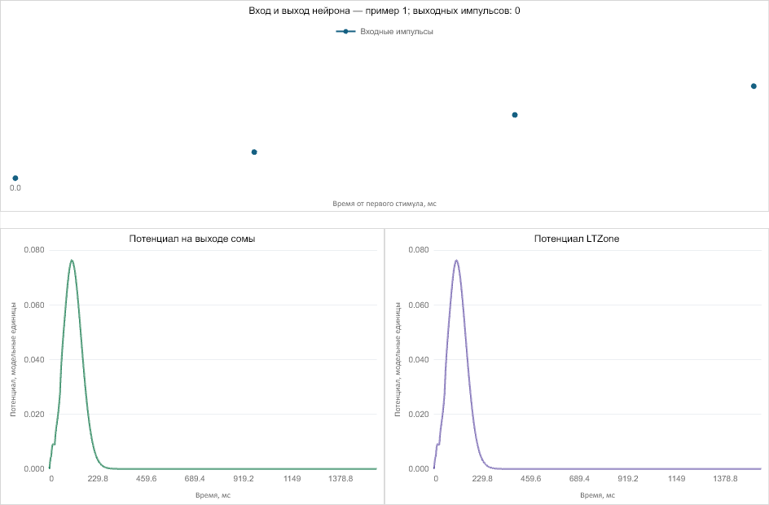

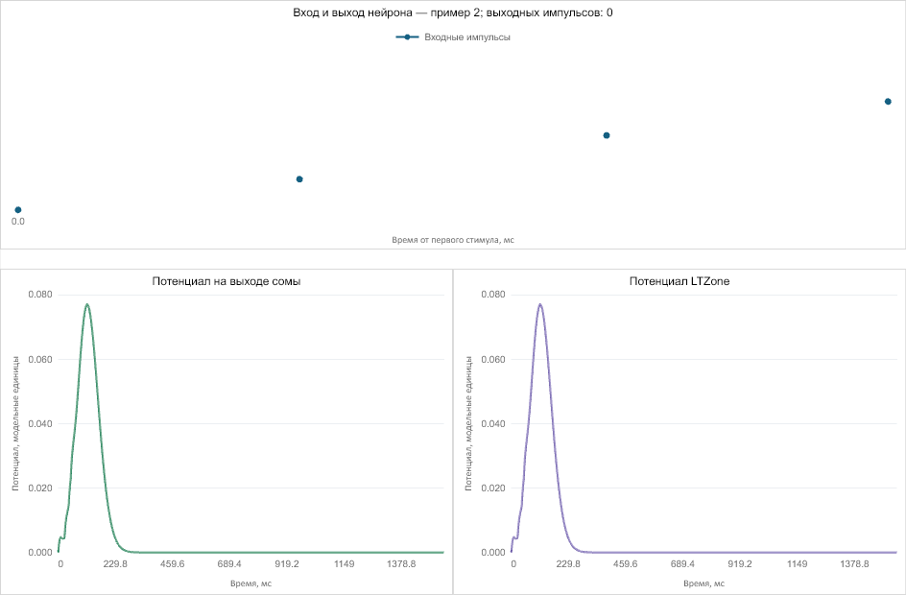

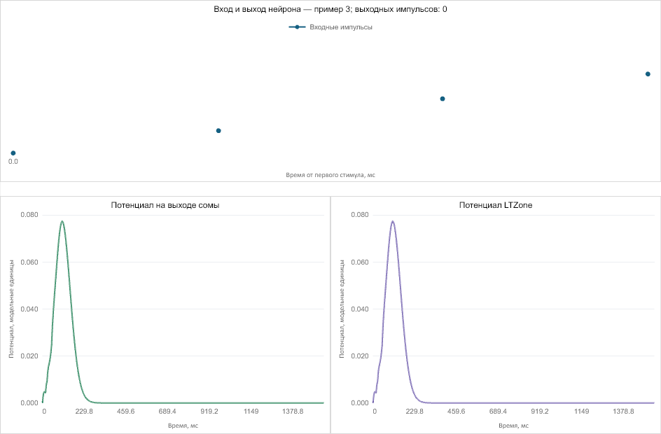

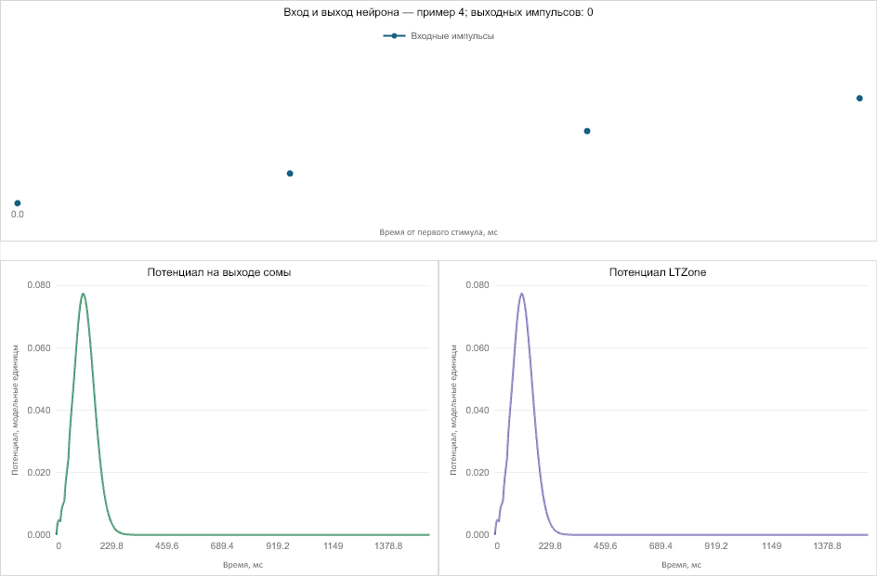

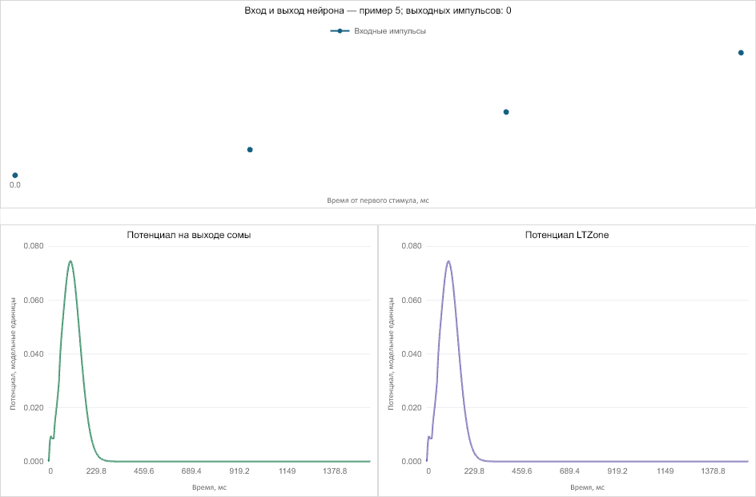

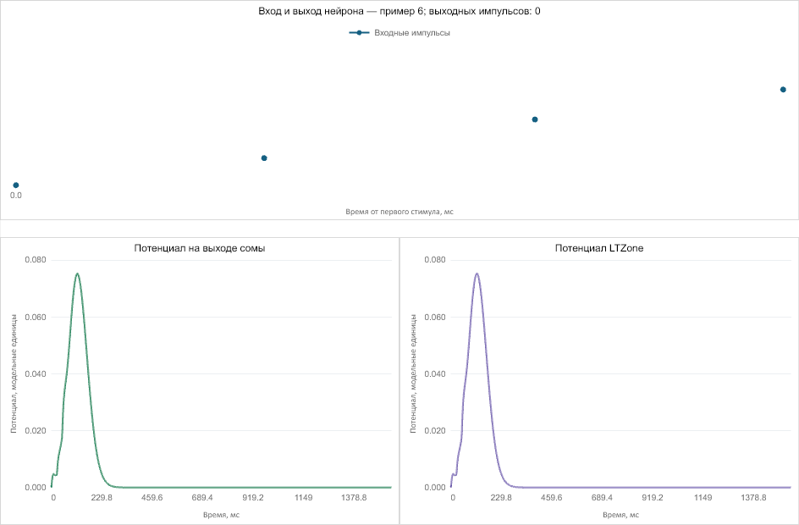

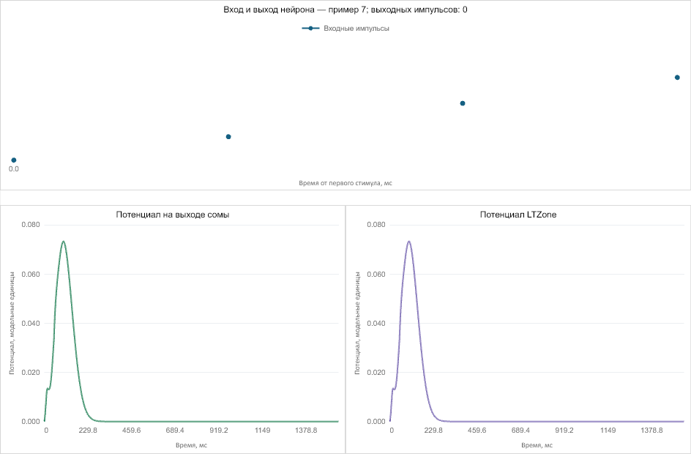

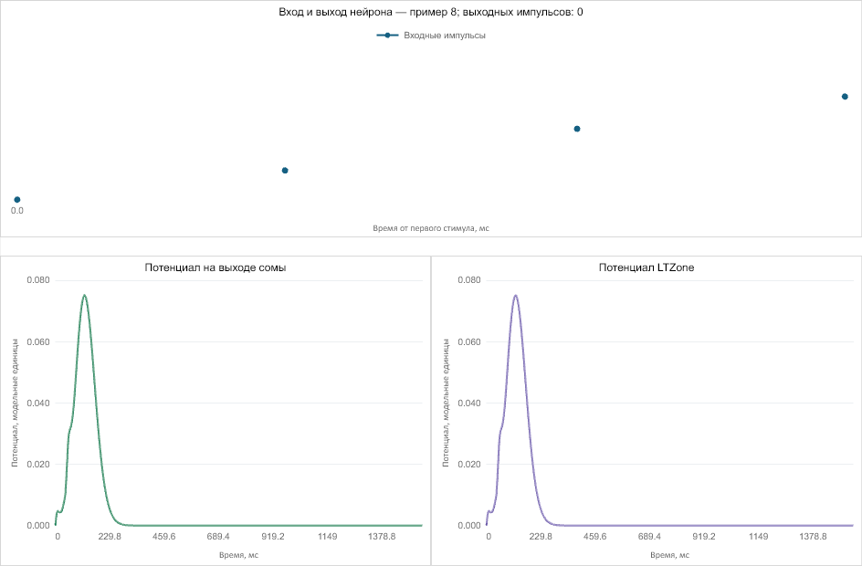
Сводка: запусков — 2; тестовых примеров — 16.

