**Bayzat Bugs Report:**

**Title:** Refresh issue after deleting filtered employees

**Steps:**

1. Login with account having at least 2 employees added, go to view employees
2. filter for one of the employees, and delete the employee

**System behavior:**

Page will not refresh after deleting the filtered employees and the results shows as zero, it does not go back to main view employee page

**Suggestion:**

Better to refresh the page after deleting and go back to main view page

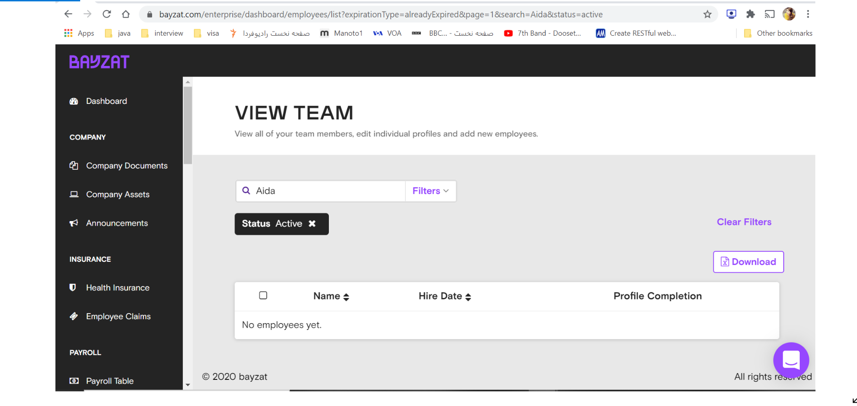

**Title:** session issue after logout, all the interactions remains the same

**Steps to reproduce:**

1. login and go to view page, filter some employee and select them in the table
2. don’t interact with the page until you are logged out
3. login again

**System behavior**:

you will see you are still on view page and the selections remains there, nothing refreshed after log out

**Suggestion**:

better to start from the login page and everything restarts

**Title** : performance issue for login call

**Steps:**

* login with the credentials provided after clearing cache

**System behavior**: it takes more than 10 seconds to login

CypressError: Timed out after waiting `100000ms` for your remote page to load.

Your page did not fire its `load` event within `100000ms`.

You can try increasing the `pageLoadTimeout` value in `cypress.json` to wait longer.

Browsers will not fire the `load` event until all stylesheets and scripts are done downloading.

When this `load` event occurs, Cypress will continue running commands.

**Title: Uncaught** TypeError exception after creating new employee (seen in network calls while running cypress test)

**Steps:**

1. login and go to add employee
2. put down mandatory fields
3. click on create employee button to create new employee

**System behavior:**

You will see type error exception occurring in network call, I saw this while running cypress test which caused my test to stop so I put a script in support file(index.js) to ignore it and continue my test.

Cypress.on('uncaught:exception', (err, runnable) => {

    // returning false here prevents Cypress from

    // failing the test

    return false

  })

**Instructions:**

* **I Used cypress fixtures to put user credentials as json format for my login function and I load and read the file in before function which I added**
* **I put baseUrl in cypress.json file for best practices**
* **I set up some timings in cypress.json file (defaultCommandTimeout, pagLoadtimeout, execTimeout)**
* **The test is called bayzat.spec.js and is under integration folder, it has before function for loading url, login, I put a separate function for add employee, and a function to generate random string data, the rest for navigation and assertions are in the test in ‘it’**
* **For assertions I mostly used contains and try to assert the values which are not changing and are not dependent to data which is changing, I assert static data like for employee list I assert the table name column and hire date as we might not have any employee in the table**
* **I set up video recording, and Videos are being generated under video folder after running from command prompt**
* **I Put a random string generator method to generate random employee names, last names and work emails for add employee function**
* **I separated add employee function for best practices and to reduce repeated code each time I want to create new employee**
* **I Set up Cypress DashBoard, and integrated it with github for my test runs and commits**
* **I set up configuration for screenshot failures**
* **put a script in support(index.js file) to prevent cypress from failing when you get uncaught exception**
* **method to run and see from dashboard with recording is in the following:**

**npx command to run and see from dashboard with recording:** cypress run --record --key e7a04f28-bcf8-4a4d-95d5-ab7e84e3976f

* **My GitHub link address: github address:** <https://github.com/aida-pbiazar/cypress-Test>
* **Due to some performance issue especially after employee creation then searching and deleting I had to put some timings, but I know according to best practices better to put a condition for timings so that we don’t make the test run slow, but for test purpose and time being I used some cy.wait() can be improved**
* **Regarding Bonus part for api integration, I needed abit more time and guidance for the api parameters and expected behavior, otherwise I was really interested to learn and do it**
* **Below is screenshot of my test passed from terminal and the dashboard result:**

