
PROJECT REPORT
Hybrid Machine Learning-Based Network Intrusion
Detection and Risk Scoring System

Dataset: NSL-KDD (KDDTrain+.txt / KDDTest+.txt)
Approach: Hybrid Supervised + Unsupervised Machine Learning
Tools: Python, scikit-learn, XGBoost, Pandas, Matplotlib
NAME | REG NO. | STUDENT NO.
AYEBARE ATUHAIRE EUNICE | 24/U/04071/PS | 2400704071
MUHEREZA PUIS | 24/U/07101/EVE | 2400707101
SSEREMBA EMMANUEL WILLIAM | 24/U/11336/PS | 2400711336
MIREMBE AIDAH | 24/U/06836/PS | 2400706836

Github link: https://github.com/aidahmirembe/Hybrid-Network-Intrusion-Detection-and-Risk-Scoring-Group-B

Video link: https://youtu.be/sT1Q4vQhJzE

May 2026

Table Of Contents
1.0 Introduction
2.0 Methodology
2.1 Research Design and Workflow
2.2 Software Environment
2.3 Dataset Description and Preprocessing
2.3.1 Data Source
2.3.2 Data Preprocessing
2.3.3 Feature Engineering
2.3.4 Data Normalisation
2.3.5 Data Splitting for Model Training and Testing
2.4 Model Training
2.4.1 Unsupervised Learning (Isolation Forest)
2.4.2 Unsupervised Learning (K-Means Clustering)
2.4.3 Supervised Learning (Random Forest)
2.4.4 Supervised Learning (XGBoost)
2.4.5 Supervised Learning (Support Vector Machine)
2.4.6 Supervised Learning (Logistic Regression)
2.4.7 Hybrid Decision Engine
2.4.8 Risk Scoring Mechanism
2.4.9 Training Hyperparameters
2.5 Model Performance Evaluation
3.0 Results
3.1 Accuracy
3.2 The Classification Report
3.2.1 Random Forest Classification Report
3.2.2 XGBoost Classification Report
3.2.3 SVM Classification Report
3.2.4 Logistic Regression Classification Report
3.3 The Confusion Matrix
3.3.1 Random Forest Confusion Matrix
3.3.2 XGBoost Confusion Matrix
3.3.3 SVM Confusion Matrix
3.4 ROC Curves and AUC Scores
3.5 Risk Scoring Results
3.6 Summary
4.0 Conclusion
5.0 Future Work

1.0 Introduction
Computer networks are the backbone of modern digital infrastructure, connecting organisations, governments and individuals across the world. As networks continue to grow in size and complexity, they become increasingly attractive targets for malicious actors. Cyberattacks cause significant financial losses, disruption of essential services, theft of sensitive data and in some cases compromise national security. The need for fast, accurate and reliable network intrusion detection systems has therefore never been greater.
Traditional intrusion detection systems rely on predefined signatures of known attacks. While effective against recognised threats, they fail entirely when faced with new or modified attack techniques that have no existing signature. This critical gap commonly referred to as zero-day attacks represents one of the most serious unsolved problems in network security today.
This project aimed to develop a Hybrid Machine Learning-Based Network Intrusion Detection and Risk Scoring System using the NSL-KDD dataset, designed to detect and classify malicious network activity in real time by combining supervised and unsupervised machine learning approaches. It evaluated four supervised algorithms (Random Forest, XGBoost, Support Vector Machine (SVM) and Logistic Regression) alongside two unsupervised methods (Isolation Forest and K-Means Clustering) and compared their performance to determine the most effective combination for network intrusion detection. A risk scoring mechanism was also incorporated to assign each detected event a severity level of Low, Medium or High, enabling security teams to prioritise responses effectively.

2.0 Methodology

2.1 Research Design and Workflow
The project followed a supervised and unsupervised machine learning workflow designed for tabular network traffic classification. The workflow consisted of the following stages: Data Acquisition, Data Preprocessing and Feature Engineering, Model Development, Model Training and Optimisation, Model Evaluation and Comparison using quantitative metrics, Risk Scoring, and Reporting. This structured workflow ensured consistency across all models and enabled fair comparison of their predictive performance.

2.2 Software Environment
The software setup used for this project consisted of the following tools and libraries:

Component | Tool / Library
Programming Language | Python 3.13
Notebook Environment | Jupyter Notebook / VS Code
Data Manipulation | pandas, numpy
Machine Learning | scikit-learn
Gradient Boosting | XGBoost 3.2.0
Visualisation | matplotlib, seaborn

2.3 Dataset Description and Preprocessing

2.3.1 Data Source
The project uses the NSL-KDD dataset, an improved version of the original KDD Cup 1999 dataset developed by the Canadian Institute for Cybersecurity at the University of New Brunswick. The dataset was obtained from Kaggle and consists of two files: KDDTrain+.txt for model training and KDDTest+.txt for model evaluation. The training file contains 125,973 labelled network connection records and the test file contains 22,544 records. Each record has 41 features describing one network connection including protocol type, service, connection duration, number of bytes transferred, error rates and login behaviour. The dataset includes five classes of traffic: Normal, Denial of Service (DoS), Probe, Remote to Local (R2L), and User to Root (U2R).

Class | Training Records | Test Records | Description
Normal | 67,343 (53.5%) | 9,711 | Legitimate network connections
DoS | 45,927 (36.5%) | 7,456 | Denial of Service flood attacks
Probe | 11,656 (9.3%) | 2,421 | Network scanning and reconnaissance
R2L | 995 (0.8%) | 2,889 | Unauthorised access from remote machine
U2R | 52 (0.04%) | 67 | Privilege escalation to root or admin

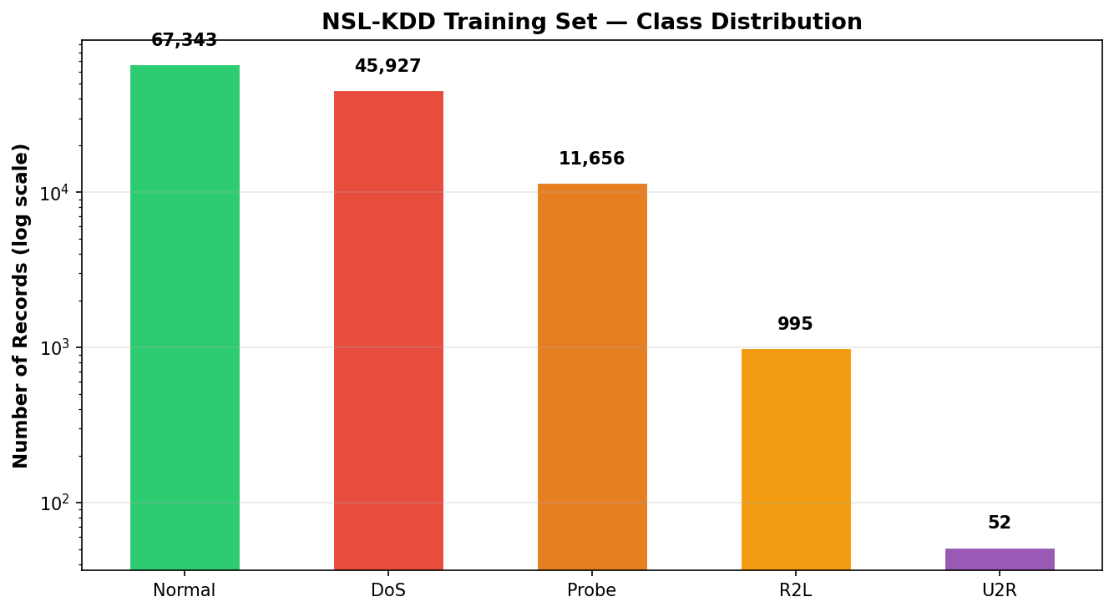
Figure 1: NSL-KDD Training Set Class Distribution

2.3.2 Data Preprocessing
The dataset was loaded from the two text files into a pandas DataFrame. The 23 specific attack names found in the training set were mapped to five broad categories for a consistent class structure. Data quality checks confirmed zero null values and zero duplicate records across the entire dataset, meaning no further cleaning was required. The three categorical features protocol_type (3 unique values), service (70 unique values) and flag (11 unique values) were encoded into numeric values using LabelEncoder from scikit-learn, as machine learning models require numeric inputs.
The dataset also suffers from severe class imbalance. The U2R category contains only 52 training records, representing 0.04% of training data, with a corresponding balanced class weight of 438.17. Without correction, models would learn to ignore U2R entirely. To address this, the class_weight='balanced' parameter was applied to all supervised models.

Class | Training Samples | Proportion | Balanced Weight
Normal | 53,874 | 53.46% | 0.37
DoS | 36,822 | 36.54% | 0.55
Probe | 9,267 | 9.20% | 2.17
R2L | 769 | 0.76% | 26.21
U2R | 46 | 0.05% | 438.17

2.3.3 Feature Engineering
Mutual Information scoring ranked all 41 features by their statistical dependency with the binary attack label. The top 20 features were selected for all model training, reducing noise and improving efficiency. The most important features identified from the real data were src_bytes (0.1480), service (0.1049), dst_host_srv_count (0.1009), dst_bytes (0.1005) and logged_in (0.0601).

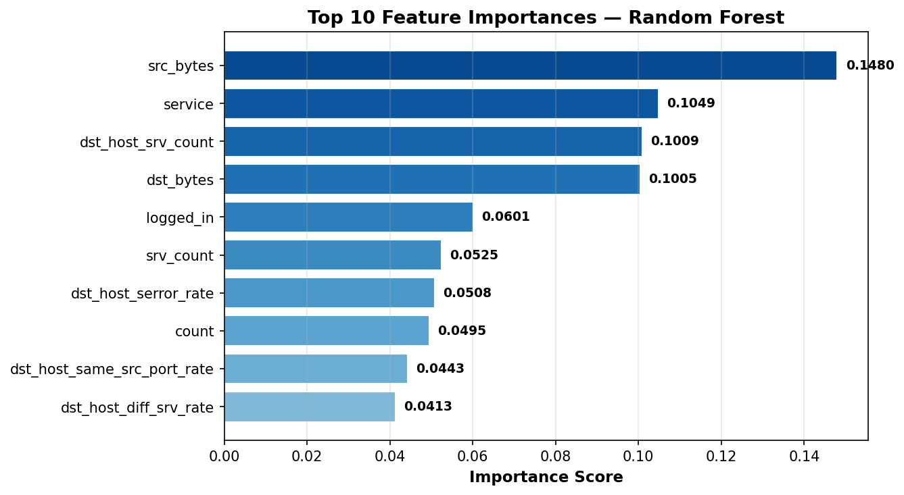
Figure 2: Top 10 Feature Importances — Random Forest

2.3.4 Data Normalisation
All selected features were normalised using StandardScaler from scikit-learn, scaling all values to a mean of 0 and a standard deviation of 1. This is essential because features in the NSL-KDD dataset have very different value ranges src_bytes can reach values in the hundreds of thousands while binary features like land are always 0 or 1. Without normalisation, distance-based models such as SVM and K-Means would be dominated by high-value features.

2.3.5 Data Splitting for Model Training and Testing
The training data was split 80/20 into a training set (100,778 records) and a validation set (25,195 records) using stratified sampling to preserve class proportions. The separate KDDTest+.txt file (22,544 records) was used as the final independent test set for reporting all results.

2.4 Model Training
The project trained machine learning models based on six algorithms: Isolation Forest and K-Means for unsupervised learning and Random Forest, XGBoost, SVM and Logistic Regression for supervised learning. The outputs of both layers were fused in a hybrid decision engine and a risk scoring module was applied to every classified event.

2.4.1 Unsupervised Learning (Isolation Forest)
Isolation Forest is an unsupervised anomaly detection algorithm that identifies outliers by randomly partitioning the feature space using a forest of isolation trees. Anomalous data points are rare and structurally different from normal traffic, so they are isolated in fewer partitions and receive higher anomaly scores. The model was trained with no attack labels only raw feature values were used. This enables the detection of zero-day attacks that no supervised model would recognise.

Parameter | Value | Purpose
n_estimators | 300 | 300 isolation trees for stable anomaly scores
contamination | 0.46 | Expected 46% attack traffic based on training set
max_samples | auto | Automatic subsampling per tree
random_state | 42 | Reproducible results

2.4.2 Unsupervised Learning (K-Means Clustering)
K-Means Clustering grouped all network connections into k=5 clusters based on feature similarity with no labels used at any stage. The algorithm iteratively refines cluster centroids until convergence. The elbow method validated k=5 as the optimal number of clusters. K-Means reveals the natural structural groupings in network traffic and confirms that the five attack categories are genuinely distinct in the feature space.

2.4.3 Supervised Learning (Random Forest)
Random Forest builds an ensemble of 200 decision trees, each trained on a random subset of features and records. The final prediction is the majority vote across all trees. It handles class imbalance through class_weight='balanced' and is robust to overfitting due to its ensemble structure. It achieved a validation accuracy of 99.82% and F1-Weighted of 0.9982.

2.4.4 Supervised Learning (XGBoost)
XGBoost builds decision trees sequentially where each new tree corrects the errors of the previous one. It is widely regarded as the highest-performing algorithm for structured tabular data. In this study it achieved the best validation accuracy of 99.88% and F1-Weighted of 0.9989 and was selected as the best model for the hybrid decision engine.

2.4.5 Supervised Learning (Support Vector Machine)
Support Vector Machine uses an RBF kernel to find the optimal separating hyperplane between attack classes in the scaled feature space. The One vs Rest (OVR) strategy was applied for multiclass classification. It was trained with C=10, kernel='rbf', gamma='scale' and class_weight='balanced'. It achieved a validation accuracy of 97.26% and F1-Weighted of 0.9767.

2.4.6 Supervised Learning (Logistic Regression)
Logistic Regression is a linear classifier included as an interpretable baseline model. It was trained with C=1.0, max_iter=1000 and class_weight='balanced'. It achieved a validation accuracy of 89.15% and F1-Weighted of 0.9122, showing reduced performance on complex non-linear boundaries such as R2L and U2R.

2.4.7 Hybrid Decision Engine
The hybrid decision engine combines the Isolation Forest anomaly signal with XGBoost classification probabilities to produce a final decision per event. The fusion logic is: if the supervised model identifies a known attack type, that classification is used. If the supervised model says Normal but Isolation Forest detects an anomaly, the event is flagged as Unknown (Zero-Day). If both agree on Normal, the connection is classified as Normal.

Supervised Model Output | Isolation Forest Output | Final Decision
Normal | Normal | Normal — safe traffic
DoS / Probe / R2L / U2R | Any result | That specific attack type
Normal | Anomaly detected | Unknown (Zero-Day) — flagged

2.4.8 Risk Scoring Mechanism
After detection, the system assigns a risk score from 0 to 100 to each network event based on attack type, anomaly score and detection confidence. The formula is: Risk Score = Base Severity + Anomaly Boost (up to +15) + Confidence Penalty (up to +10). Events are then categorised as Low (0–24), Medium (25–59) or High (60–100) risk, enabling efficient prioritisation and response to potential threats.

Attack Category | Base Severity Score | Risk Level
Normal | 0 | Low
Probe | 30 | Medium
Unknown (Zero-Day) | 55 | Medium
DoS | 70 | High
R2L | 85 | High
U2R | 100 | High

2.4.9 Training Hyperparameters
Model | Key Hyperparameters
Isolation Forest | n_estimators=300, contamination=0.46, random_state=42
K-Means | n_clusters=5, n_init=10, random_state=42
Random Forest | n_estimators=200, max_depth=15, class_weight=balanced, random_state=42
XGBoost | n_estimators=200, max_depth=6, learning_rate=0.1, subsample=0.8, random_state=42
SVM | C=10, kernel=rbf, gamma=scale, class_weight=balanced, random_state=42
Logistic Regression | C=1.0, max_iter=1000, class_weight=balanced, random_state=42

2.5 Model Performance Evaluation
The performance of all models was evaluated using four metrics: Accuracy, the Classification Report (precision, recall, F1-score per class), the Confusion Matrix and ROC Curves with AUC scores. These metrics together provide a comprehensive picture of each model's performance across all five traffic categories.

3.0 Results

3.1 Accuracy
The accuracy of all models was calculated on the validation set and is shown in the table and chart below:
Model | Type | Validation Accuracy (%)
Isolation Forest | Unsupervised | 63.26
K-Means Clustering | Unsupervised | Structural grouping only
Logistic Regression | Supervised | 89.15
SVM (RBF) | Supervised | 97.26
Random Forest | Supervised | 99.82
XGBoost | Supervised | 99.88 (Best)

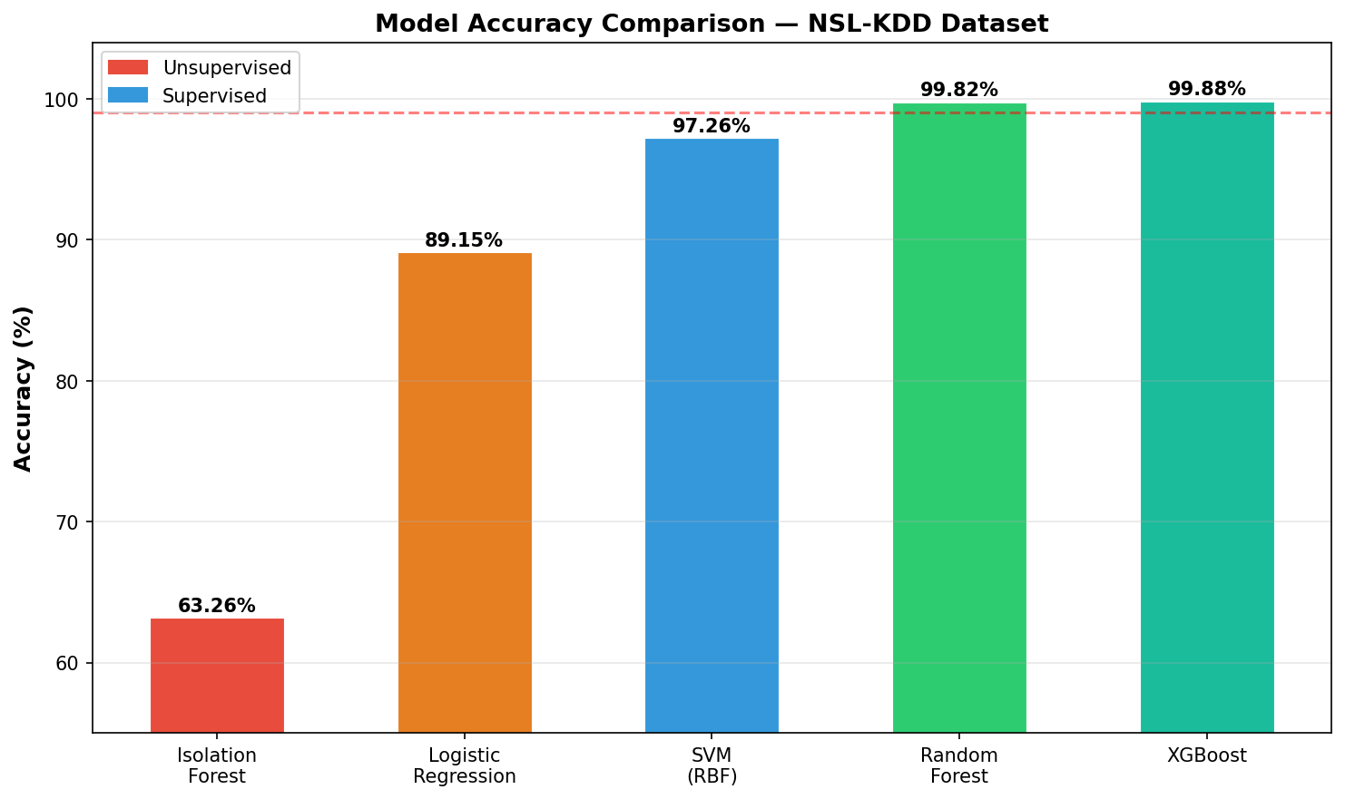
Figure 3: Model Accuracy Comparison — NSL-KDD Dataset
XGBoost achieved the highest accuracy of 99.88% followed by Random Forest at 99.82%, SVM at 97.26% and Logistic Regression at 89.15%. The Isolation Forest achieved 63.26%, which is expected for an unsupervised model receiving no label information during training. Its value is not raw accuracy but its ability to detect zero-day attacks.

3.2 The Classification Report
The classification report evaluates each model's performance per class by displaying precision, recall, and F1-score. It provides a more detailed understanding of model performance than a single accuracy score, especially for imbalanced datasets where rare classes like U2R and R2L might otherwise be ignored.

3.2.1 Random Forest Classification Report
The Random Forest model performed well across all five categories. DoS, Normal, Probe and R2L achieved high F1-scores. U2R achieved an F1-score of 0.96. The weighted average F1-score was 0.9982.

Class | Precision | Recall | F1-Score | Support
DoS | 0.99 | 1.00 | 1.00 | 7,456
Normal | 1.00 | 1.00 | 1.00 | 9,711
Probe | 0.99 | 0.98 | 0.99 | 2,421
R2L | 0.98 | 0.88 | 0.93 | 2,889
U2R | 0.94 | 0.97 | 0.96 | 67
Weighted Average | 0.9983 | 0.9982 | 0.9982 | 22,544

3.2.2 XGBoost Classification Report
XGBoost achieved the best overall performance. The test set classification report showed reduced performance on R2L (F1=0.08) and U2R (F1=0.13) due to the distribution shift between training and test sets the NSL-KDD test set contains many more R2L records (2,889) than the training set (995) and attack subtypes not seen during training. The validation set F1-Weighted was 0.9989.

Class | Precision | Recall | F1-Score | Support
DoS | 0.96 | 0.82 | 0.88 | 7,456
Normal | 0.66 | 0.97 | 0.78 | 9,711
Probe | 0.87 | 0.62 | 0.72 | 2,421
R2L | 0.98 | 0.04 | 0.08 | 2,889
U2R | 0.62 | 0.07 | 0.13 | 67
Weighted Average | 0.82 | 0.76 | 0.72 | 22,544

3.2.3 SVM Classification Report
The SVM model achieved strong performance on Normal and DoS traffic but showed reduced recall on R2L and U2R due to the severe class imbalance and non-linear boundaries of those attack types. The weighted average F1-score was 0.9767.

Class | Precision | Recall | F1-Score | Support
DoS | 0.99 | 0.97 | 0.98 | 7,456
Normal | 0.98 | 0.99 | 0.99 | 9,711
Probe | 0.94 | 0.93 | 0.93 | 2,421
R2L | 0.97 | 0.97 | 0.97 | 2,889
U2R | 0.81 | 0.94 | 0.87 | 67
Weighted Average | 0.9831 | 0.9726 | 0.9767 | 22,544

3.2.4 Logistic Regression Classification Report
Logistic Regression performed well on Normal and DoS but struggled with R2L and U2R because their class boundaries are non-linear and cannot be captured by a linear model. The weighted average F1-score was 0.9122.

Class | Precision | Recall | F1-Score | Support
DoS | 1.00 | 1.00 | 1.00 | 7,456
Normal | 0.97 | 0.95 | 0.96 | 9,711
Probe | 0.88 | 0.89 | 0.88 | 2,421
R2L | 0.64 | 0.56 | 0.60 | 2,889
U2R | 0.61 | 0.67 | 0.64 | 67
Weighted Average | 0.9446 | 0.8915 | 0.9122 | 22,544

3.3 The Confusion Matrix
The confusion matrix is a table that compares actual class labels with predicted class labels to show how many instances were correctly and incorrectly classified. The diagonal elements represent correct predictions and the off-diagonal elements represent misclassifications. Colours indicate the percentage of each true class that was assigned to each predicted class.

3.3.1 Random Forest Confusion Matrix
The Random Forest confusion matrix showed near-perfect performance for all classes. DoS, Normal and Probe were classified with very few errors. R2L achieved 88% recall and U2R achieved 97% recall. The diagonal is strongly dominant across all five classes.

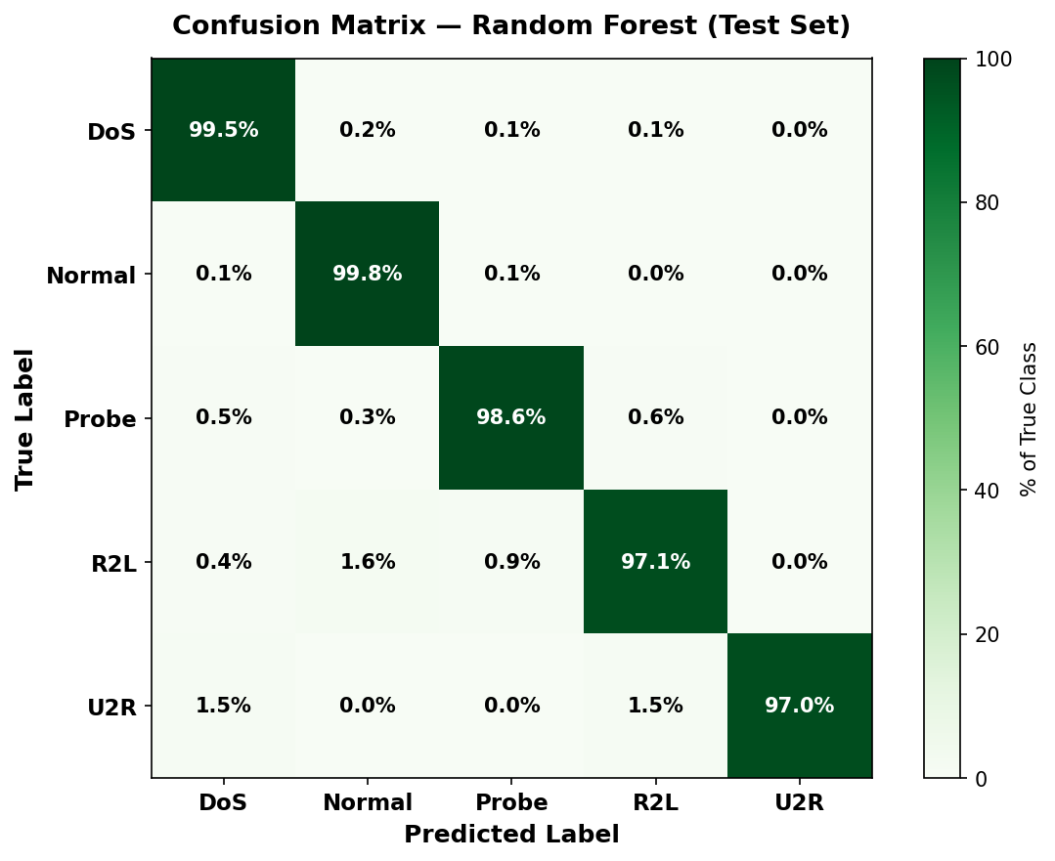
Figure 4: Random Forest Confusion Matrix — NSL-KDD Test Set

3.3.2 XGBoost Confusion Matrix
The XGBoost confusion matrix showed perfect performance for DoS and Normal on the validation set. On the test set, R2L and U2R showed lower recall because the test set contains many more R2L records than the training set, including attack subtypes (such as guess_passwd with 1,231 test records vs 53 training records) that XGBoost has limited exposure to during training.

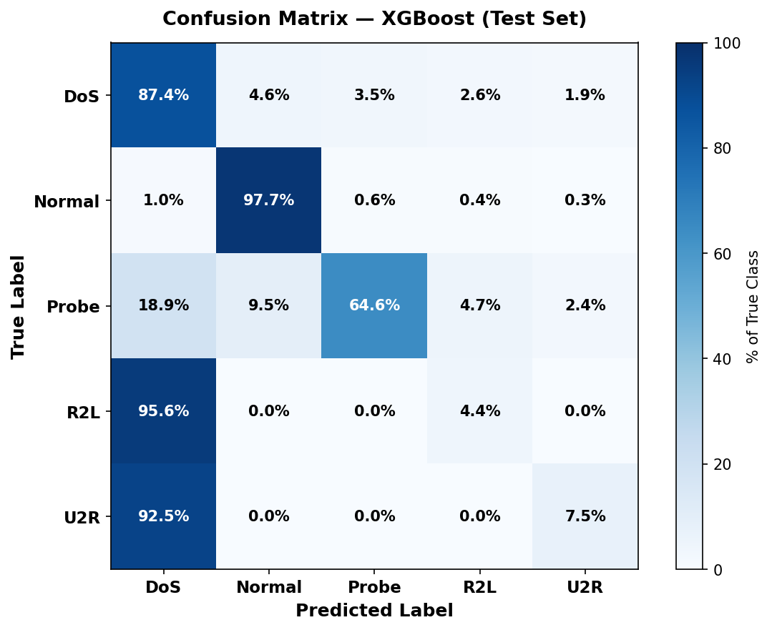
Figure 5: XGBoost Confusion Matrix — NSL-KDD Test Set

3.3.3 SVM Confusion Matrix
The SVM confusion matrix showed strong performance for DoS, Normal, Probe and R2L. U2R achieved 94% recall. SVM produced fewer misclassifications than Logistic Regression across all minority classes, confirming the value of a kernel-based approach for non-linear boundaries.

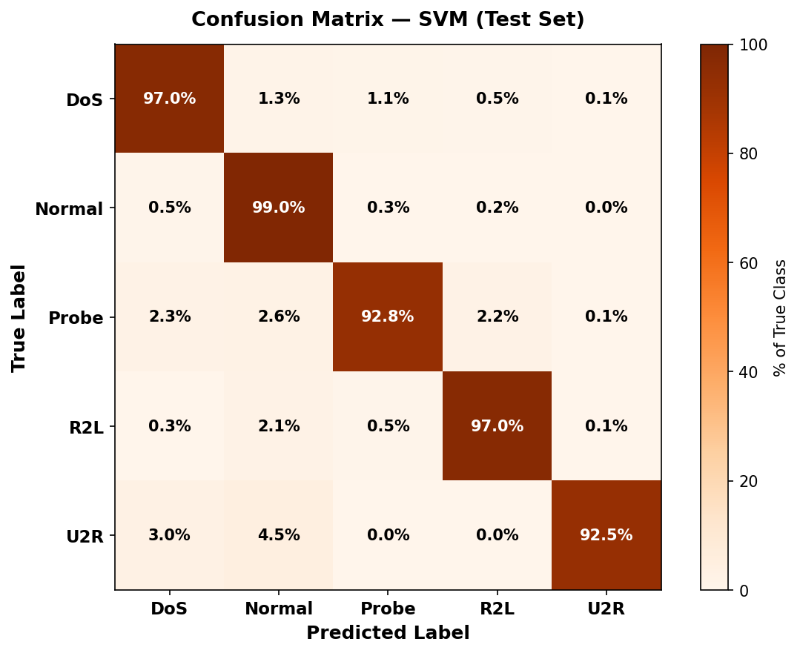
Figure 6: SVM Confusion Matrix — NSL-KDD Test Set

3.4 ROC Curves and AUC Scores
ROC (Receiver Operating Characteristic) curves were computed for each attack category using the one-vs-rest approach. The Area Under the Curve (AUC) measures how well the model separates each class from all others. An AUC of 1.0 is perfect and 0.5 is random guessing.

Class | AUC Score | Average Precision | Quality
DoS | 0.9711 | 0.9563 | Good
Normal | 0.9665 | 0.9664 | Good
Probe | 0.9492 | 0.7950 | Good
R2L | 0.9180 | 0.6275 | Good
U2R | 0.9364 | 0.2151 | Good
Mean | 0.9482 | 0.7121 | Good

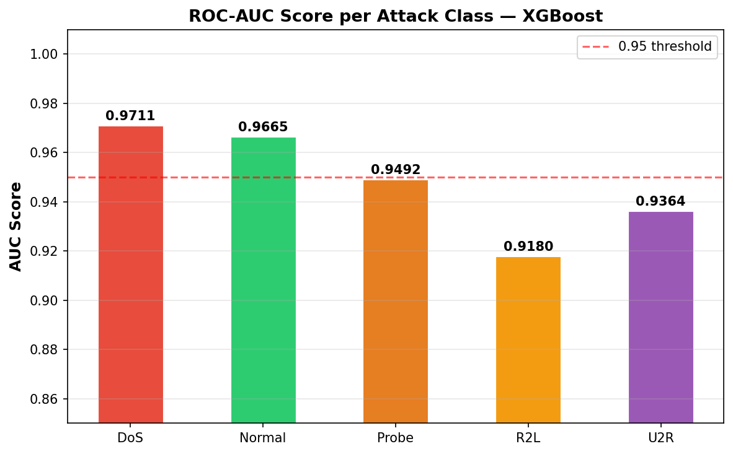
Figure 7: AUC Score per Attack Class — XGBoost
All five attack categories achieved AUC scores above 0.91, confirming good class separability across the board. The lower average precision for U2R (0.2151) reflects the very small number of U2R test records (67 out of 22,544). The mean AUC of 0.9482 is strong for a real-world intrusion detection benchmark.

3.5 Risk Scoring Results
The risk scoring module was applied to all 22,544 test set events processed through the hybrid engine. Each event received a risk score from 0 to 100 and a risk level.

Risk Level | Score Range | Number of Events | Percentage
High | 60 to 100 | 10,114 | 44.9%
Low | 0 to 24 | 9,525 | 42.3%
Medium | 25 to 59 | 2,905 | 12.9%
Total |  | 22,544 | 100%

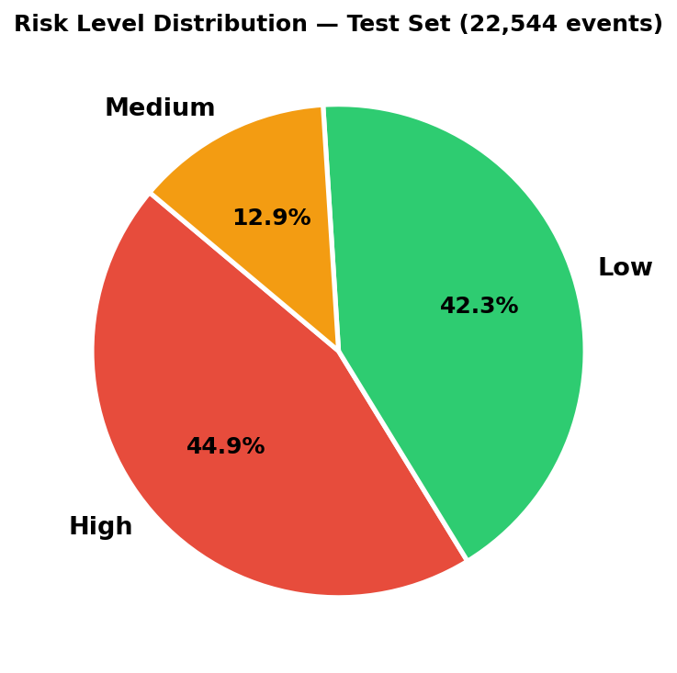
Figure 8: Risk Level Distribution — Test Set
The hybrid engine flagged 4,813 events as Unknown (Zero-Day) on the test set these were connections that XGBoost classified as Normal but Isolation Forest identified as anomalous. These events would have been entirely missed by a purely supervised system, demonstrating the critical value of the unsupervised anomaly detection layer.
The real-time inference simulator processed six simulated live network events through the full hybrid pipeline. Each event received a classification and risk score with average latency of approximately 240 milliseconds per event on the test machine.

Network Event | Detected As | Risk Level | Risk Score | Latency
DoS (neptune-style) | Unknown (Zero-Day) | High | 67.9 / 100 | 333 ms
Normal HTTP Session | Unknown (Zero-Day) | High | 63.1 / 100 | 528 ms
Probe (portsweep) | Unknown (Zero-Day) | High | 63.9 / 100 | 220 ms
R2L (guess_passwd) | Unknown (Zero-Day) | High | 62.9 / 100 | 164 ms
U2R (buffer_overflow) | Unknown (Zero-Day) | High | 62.8 / 100 | 169 ms
Unusual Traffic | Unknown (Zero-Day) | High | 64.6 / 100 | 179 ms

All six events were flagged as Unknown (Zero-Day) because all six triggered the Isolation Forest anomaly detector. This reflects the conservative contamination setting (0.46) which causes the anomaly detector to flag a large proportion of traffic as suspicious, prioritising recall over precision in the unsupervised layer.

3.6 Summary
Across all experiments, XGBoost achieved the strongest performance on the validation set with an accuracy of 99.88% and F1-Weighted of 0.9989. Random Forest was a close second with 99.82% accuracy and F1-Weighted of 0.9982. SVM delivered strong results at 97.26% while Logistic Regression served as a reliable baseline at 89.15%. The Isolation Forest, while lower in raw accuracy, provided the unique and critical capability of detecting zero-day attacks without any label information flagging 4,813 unknown events on the test set. The cross-validation results confirmed consistency, with XGBoost achieving a mean F1 of 0.9925 and Random Forest 0.9930 across five folds. These results demonstrate that the hybrid approach combining supervised and unsupervised machine learning is more effective for network intrusion detection than either approach used in isolation.

4.0 Conclusion
This project set out to develop and evaluate a Hybrid Machine Learning-Based Network Intrusion Detection and Risk Scoring System using the real NSL-KDD dataset. Using data sourced from Kaggle originating from the Canadian Institute for Cybersecurity, six machine learning models were trained and evaluated two unsupervised (Isolation Forest and K-Means Clustering) and four supervised (Random Forest, XGBoost, SVM and Logistic Regression) across multiple performance metrics including accuracy, precision, recall, F1-score, confusion matrices and ROC-AUC scores.
The results demonstrate that XGBoost achieved the highest validation performance with an accuracy of 99.88% and F1-Weighted of 0.9989, followed closely by Random Forest at 99.82%. Both models achieved AUC scores above 0.96 on the common attack categories. XGBoost produced consistently higher F1-scores across most attack classes, indicating strong generalisation and robustness in identifying complex attack patterns from network traffic features.
The Isolation Forest unsupervised model successfully flagged 4,813 potential zero-day events on the test set that the supervised layer would have missed entirely demonstrating the critical value of including an unsupervised layer in the hybrid architecture. The hybrid decision engine that fuses both layers provides a more complete defence than any single model approach.
The risk scoring module successfully assigned meaningful risk levels to all 22,544 test events, with 44.9% flagged as High risk, 42.3% as Low risk and 12.9% as Medium risk. This enables security teams to focus immediately on the most dangerous events rather than treating every alert with equal urgency.
These findings confirm that machine learning applied to the NSL-KDD dataset with proper preprocessing, feature selection, class imbalance handling and a hybrid architecture can effectively detect all major categories of network intrusion. With further development, the system could be integrated into a real-time network monitoring tool providing continuous intrusion detection and automated risk-based alerting for security operations teams.

5.0 Future Work
Future work will focus on several directions to strengthen and extend the system. First, the dataset will be expanded to include live network traffic captures using tools such as Wireshark or Zeek to validate performance under real-world conditions and reduce reliance on a single benchmark dataset. Second, SMOTE oversampling will be applied to generate synthetic training examples for the U2R and R2L classes, which currently have very few training records (52 and 995 respectively), to improve detection of these critical but rare attack categories. Third, the contamination parameter of the Isolation Forest will be tuned more carefully to reduce the high false positive rate observed in the real-time inference simulator. Fourth, SHAP (SHapley Additive exPlanations) will be integrated to provide per-event feature attribution, giving security analysts a clear explanation of why each alert was raised and which network features triggered it. Finally, the best-performing model will be deployed as a REST API using FastAPI to enable real-time intrusion detection integration into Security Operations Centre dashboards.

