

CSF3133 WEB-BASED INTERFACE DESIGN (K4)
LAB MODULE 5
SEMESTER III 2025/2026

PREPARED BY:
AIDA HUSNA BINTI MUHAMAD ZAIDI

NO MATRIK:
S76103

LECTURER:
TS. DR. WAN NURAL JAWAHIR BINTI HJ WAN YUSOF

LAB MODERATOR:
PN. WAN FATIN FATIHAH BINTI YAHYA

5.3 inline CSS
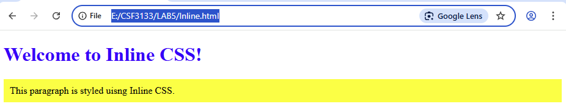
5.4 Internal Class
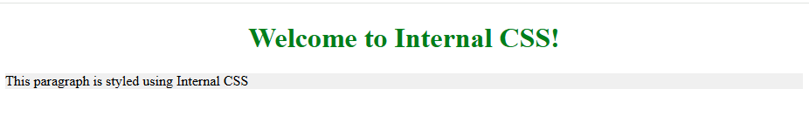
5.5 External CSS
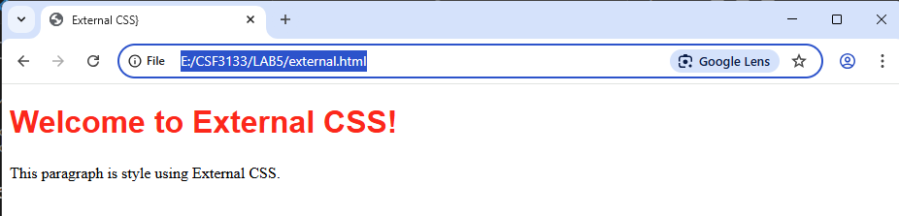

5.6 Link to file CSS (from another website)
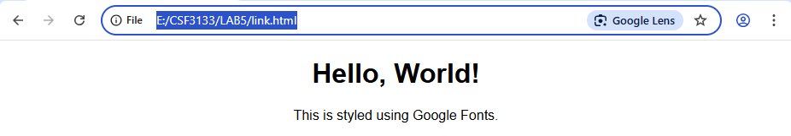
<!DOCTYPE html>
<html>
<head>
<title>Google Fonts Example</title>
<link href="https://fonts.googleapis.com/css2?family=Crimson+Pro" rel="stylesheet">
<style>
body{
font-family: 'Crimson Pro', serif;
text-align: center;
}
</style>
</head>
<body>
<h1>Hello, World!</h1>
<p>This is styled using Google Fonts.</p>
</body>
</html>
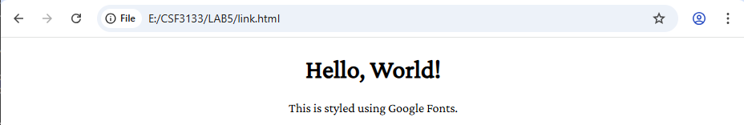

5.7 CSS Backgrounds
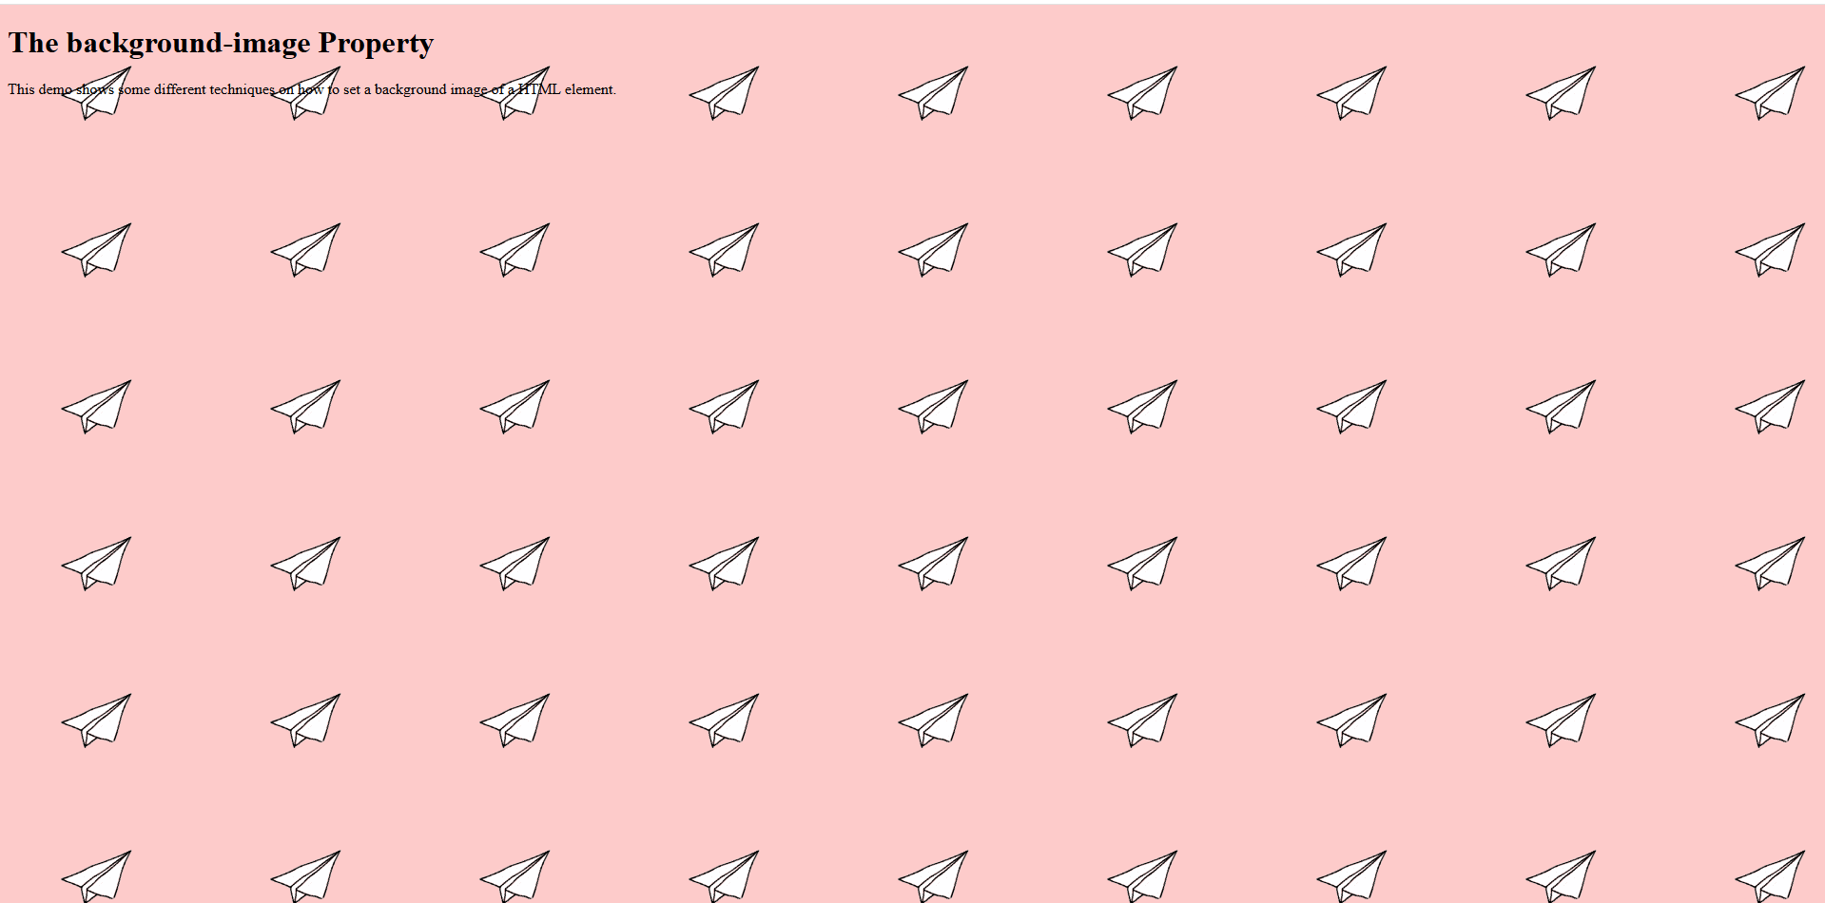
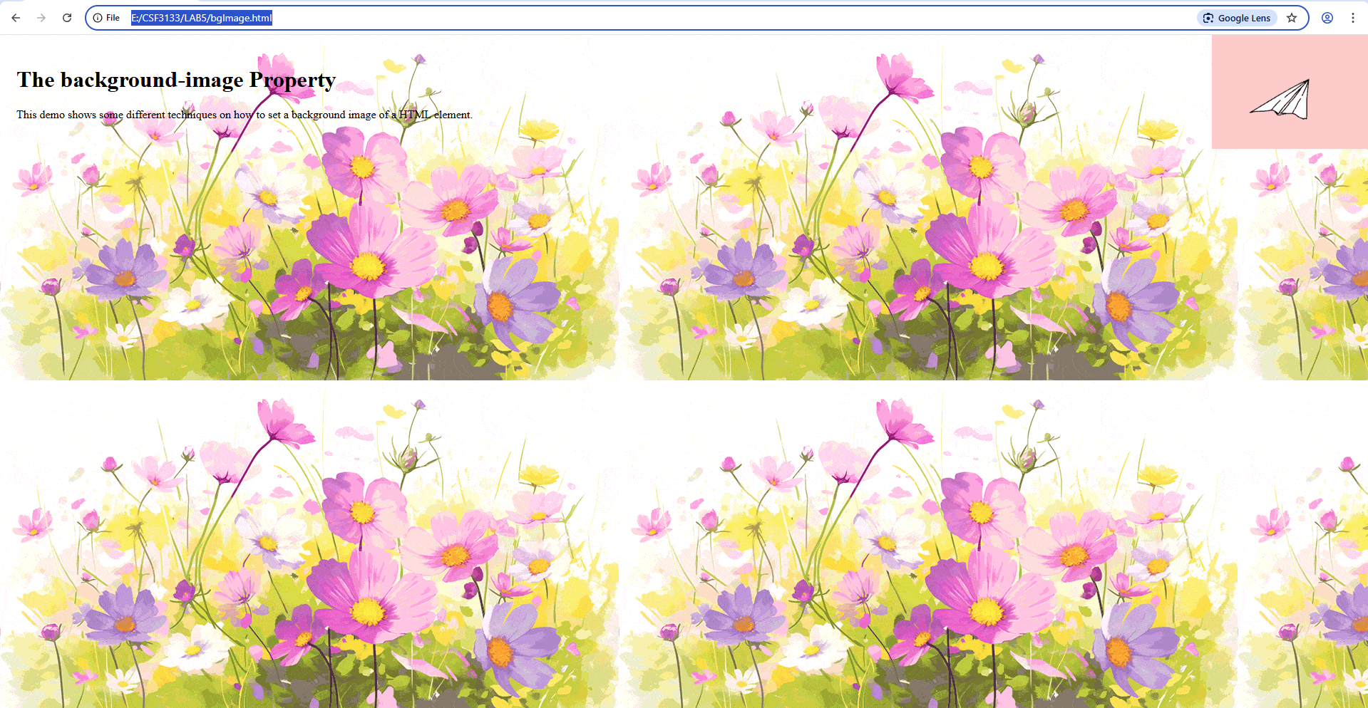

5.8 CSS Table
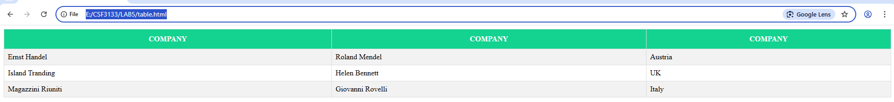

5.9 CSS Navigation Bar
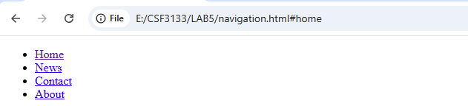
Style remove bullets and margin and padding from the list.
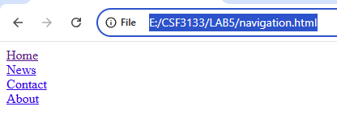
Style to create basic vertical navigation bar
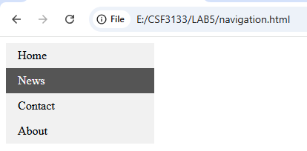
Change style to create horizontal navigation bar

5.10 Lab Exercise
<!DOCTYPE html>
<html lang="en">
<head>
<meta charset="UTF-8">
<meta name="viewport" content="width=device-width, initial-scale=1.0">
<title>UMT Information Page</title>

<!-- LINK TO umt.css FILE -->
<link rel="stylesheet" href="umt.css">
</head>

<body>
<header class="banner">
<img src="Logo_Rasmi_UMT.png" alt="logoRasmiUMT" class="inline-img">
<h1>Universiti Malaysia Terengganu</h1>
<p>Discovering the Deep Blue Future 🌊</p>
</header>

<main class="container">

<section id="about" class="card">
<h2>About UMT</h2>

<div class="tablebox">
<table>
<tbody>
<tr>
<th><b>Established</b></th>
<td>Year: 1979 (as Pusat Perikanan dan Sains Marin Universiti Pertanian Malaysia (UPM))</td>
<td>Year: 1999 (as Kolej Universiti Terengganu (KUT))</td>
<td>Year: 2001 (as Kolej Universiti Sains dan Teknologi Malaysia (KUSTEM))</td>
<td>Year: 2007 (as Universiti Malaysia Terengganu (UMT))</td>
</tr>

<tr>
<th><b>Location</b></th>
<!--colspan is use to merge the box in one cell-->
<td colspan="4">Kuala Nerus, Terengganu, Malaysia</td>
</tr>

<tr>
<th><b>Focus Areas</b></th>
<td colspan="4">Marine Science, Fisheries, Blue Economy</td>
</tr>
</tbody>
</table>
</div>
</section>

<section id="achievements" class="card">
<h2>Slogan</h2>
<p>
Terokaan Seluas Lautan, Demi Kelestarian Sejagat
</p>
<h2>Visi</h2>
<p>
Universiti Berfokus Marin Terunggul Dalam Negara dan Disegani Diperingkat Global
</p>
<h2>Misi</h2>
<p>
Menjana Ilmu Untuk Kesejahteraan Masyarakat dan Kelestarian Alam
</p>
<img src="aboutumt.jpg" alt="aboutumt" class="inline-img">
</section>

<aside class="card" aria-labelledby="sidebar-title">
<h3 id="sidebar-title">Why choose UMT?</h3>
<p>
The university offers specialized facilities, research centres, and industry links that help
students gain practical experience in marine and environmental fields.
</p>
</aside>

<section id="contact" class="card">
<h2>Contact & More</h2>
<p>
For more detailed information, visit the official UMT website:
<a href="https://www.umt.edu.my/" target="_blank" class="btn-link">
Visit UMT Official Website
</a>
</p><br>

<address>
Address:<br>
Universiti Malaysia Terengganu<br>
Kuala Nerus, Terengganu, Malaysia<br>
</address>
</section>

</main>

<footer class="site-footer">
<div class="container footer-inner">
<p>&copy; 2025 Universiti Malaysia Terengganu — Example page for Lab Exercise 5</p>
<p class="small">Prepared by: <b>Aida Husna</b>. Submit both <code>umt.html</code> and <code>umt.css</code>.</p>
</div>
</footer>

</body>
</html>

/* this root for the background and header, make the CSS simpler by using variables for the colors */
:root{
--bg: linear-gradient(180deg, #c8f1ff, #f7fcff);
--card: #ffffff;
--accent: #0077b6;
--accent2: #00b4d8;
--accent3: #90e0ef;
--muted: #40506b;
--highlight: #caf0f8;
--dark: #03045e;
}

/* Base and layout */
*{box-sizing:border-box}
html,body{
height:100%;
margin:0;
font-family:'Inter',system-ui,-apple-system,'Segoe UI',Roboto,'Helvetica Neue',Arial;
background:var(--bg);
color:var(--dark);
}
.container{max-width:1000px;margin:0 auto;padding:16px}

/* Wave effect background (header) */
/* The banner is used to make the header more interesting, such as by adding a gradient color effect */
header.banner{
background: linear-gradient(135deg, var(--accent), var(--accent2));
color:white;
text-align:center;
padding:48px 16px 80px;
position:relative;
overflow:hidden;
}
header.banner h1{font-size:36.8px;margin:0;text-shadow:0 3px 6px rgba(0,0,0,0.25);}
header.banner p{margin:6.4px;font-size:18.4px}

/* Decorative waves */
header.banner::after{
content:"";
position:absolute;
bottom:0;
left:0;
width:100%;
height:60px;
background:url('https://svgshare.com/i/vW9.svg') repeat-x bottom;
background-size:contain;
}

/* Card design */
.card{
background:var(--card);
padding:20.8px;
border-radius:18px;
margin:16px 0;
box-shadow:0 8px 24px rgba(0,0,0,0.08);
border:1px solid #e3f7ff;
transition:transform 0.25s ease, box-shadow 0.25s ease;
}
.card:hover{
transform:translateY(-4px);
box-shadow:0 10px 30px rgba(0,0,0,0.12);
}
.card h2, .card h3{
color: var(--accent);
margin-top:0;
font-weight:700;
}

/* Table styling */
.table-box{overflow:auto}
table{
width:100%;
border-collapse:collapse;
margin-top:8px;
border-radius:12px;
overflow:hidden;
}
table td, table th{
padding:11.2px 14.4px;
border:1px solid #d7f3ff;
text-align:left;
}
table th{
background:linear-gradient(180deg,var(--accent3),#ffffff);
font-weight:700;
color:var(--dark);
}
table tbody tr:hover{
background:#e9fbff;
transition:0.2s;
}

/* Images */
.inline-img{
max-width:260px;
position: center;
margin-top:12px;
border-radius:none;
box-shadow:0 8px 20px rgba(0,0,0,0.15);
border:3px solid var(--accent3);
}

/* Aside styling */
aside.card{
background:linear-gradient(180deg,#ffffff,#e3f8ff);
border-left:6px solid var(--accent2);
}

/* Footer */
.site-footer{
padding:20.8px 0;
margin-top:32px;
border-top:3px solid var(--accent3);
text-align:center;
background: linear-gradient(180deg, #e3f8ff, #ffffff);
}
.site-footer p{margin:0}
.small{color:var(--muted);font-size:14.4px}

/* Responsive */
@media (min-width:700px){
main.container{
display:grid;
grid-template-columns:2fr 1fr;
gap:16px;
align-items:start
}
.card{margin:0}
}

/* Interactive links */
a{color:var(--accent);font-weight:600;text-decoration:none}
a:hover{color:var(--accent2);}

/* Accessibility enhancements */
a:focus, button:focus{
outline:4px solid #caf0f8;
outline-offset:2px;
}

