Challenge Desktop

Create a new SQL Server database called Orders. Run the attached script to populate the database with tables and data.

Create a WinForms application running DevExpress 17.2 and .NET Framework 4.7.  
Create two screens:

Orders Screen

* The Orders screen should show a list of orders from the Orders table in the database.
* The data should be populated by a DevExpress grid, and the following columns should be shown: ReferenceNumber, OrderValue, OrderDate, CustomerName
* The OrderValue should be formatted to two decimal places and should use the currency format of the Windows environment.
* The OrderDate should be formatted to dd-MMM-yyyy (“01-Sep-2018”)
* The Customer Name field should be a combination of the Customer’s First Name and Last Name.
* A “View Customer” button should be present on every row after the additional columns. When clicked, it should load the View Customer Screen.   
    
  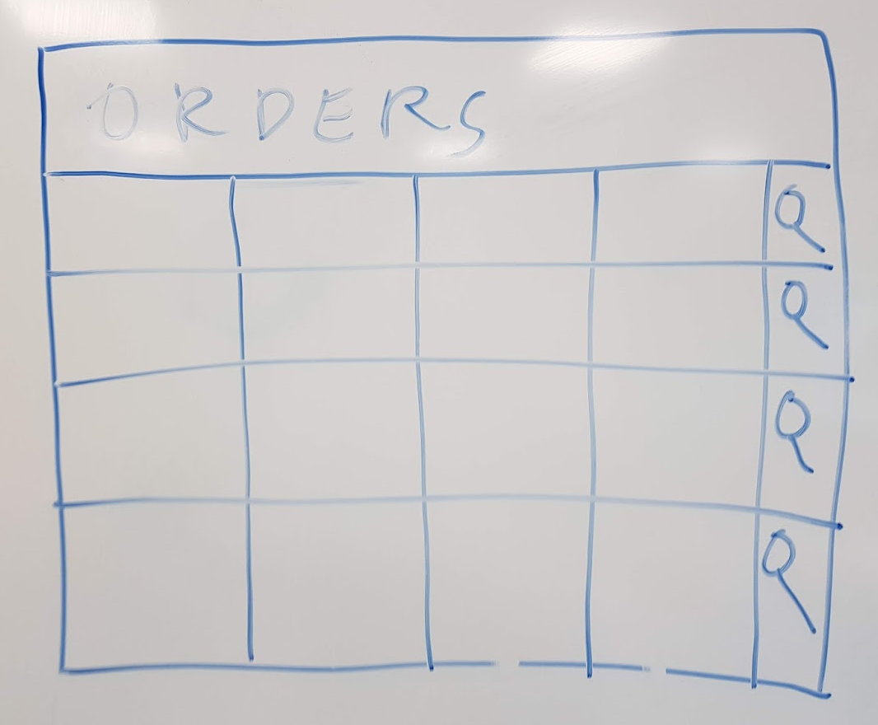

Customer Screen

* The View Customer Screen should be a form-based screen with the following fields:   
  First Name, Last Name
* The First Name and Last Name should be editable.
* The form should have a Cancel | Save button.
* When Save is clicked, the form should close.
* The previous screen should refresh the list of orders and show the changed Customer Name.

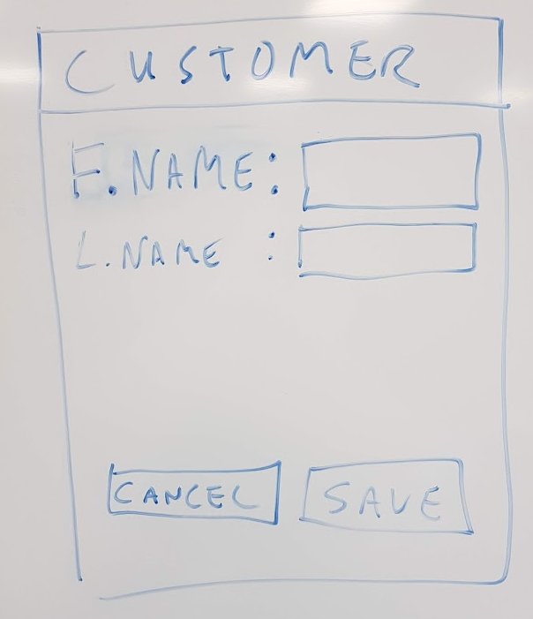

Requirements

* Use of an ORM
* Error handling

Desirable Requirements

* Use or configuration of an ORM for high performance
* Use of .NET Core Components
* Unit Tests
* Best practice DevExpress use
* Progress bar/loading bar on

Evaluation Criteria:

* Project organization: Evaluates project structure, documentation and use of version control;
* Technological innovation: Evaluates the use of newer technologies, provided they are stable;
* Coherence: Evaluates whether requirements have been met;
* Good practices: Evaluates whether the project follows good development practices, including security and optimization;
* Quality Control: Evaluates whether the project has quality assured by unit tests.

Notes:

The performance and adequacy of resources will be considered during the evaluation process. In addition, the evaluation will take place in all project components.

Submission Process:

The challenge must be delivered by GitHub with a link to the repo sent by email.

**Good Luck!!!**