Software Requirements Specification
for
<Autonomous Field Rover>
Version 1.0 approved
Prepared by <Nathan Lancaster, Austyn Smock, Aidan Pantoya>
<West Texas A&M University>
<9/11/2023>
Table of Contents
Table of Contents ii
Revision History ii
1. Introduction 1
1.1 Purpose 1
1.2 Document Conventions 1
1.3 Intended Audience and Reading Suggestions 1
1.4 Project Scope 1
1.5 References 1
2. Overall Description 2
2.1 Product Perspective 2
2.2 Product Features 2
2.3 Operating Environment 2
2.4 Design and Implementation Constraints 2
2.5 User Documentation 2
2.6 Assumptions and Dependencies 3
3. System Features 3
3.1 Navigation 3
3.2 Image Stitching and Photogrammetry 4
4. External Interface Requirements 4
4.1 User Interfaces 4
4.2 Hardware Interfaces 4
4.3 Software Interfaces 4
4.4 Communications Interfaces 4
5. Other Nonfunctional Requirements 5
5.1 Performance Requirements 5
5.2 Safety Requirements 5
5.3 Security Requirements 5
5.4 Software Quality Attributes 5
6. Other Requirements 5
Appendix A: Glossary 5
Appendix B: Analysis Models 6
Appendix C: Issues List 6

Revision History
Name | Date | Reason For Changes | Version
AP | 9/11/23 | Initial start | 1.0

Introduction

Purpose
<This document outlines the software requirements for the Autonomous Field Rover, a robot engineered for agricultural applications, specifically to autonomously map agricultural fields. In this document we will detail the software that enables the rover to operate both efficiently and effectively. The objective of this project is to assist farmers in monitoring their crops throughout their growth cycle. This capability enables early detection of anomalies in the growth process and provides a more convenient method for assessing crop quality.

The project will span two university semesters at WTAMU. The initial semester will be dedicated to the rover's navigation systems, while the subsequent semester will emphasize the development of a 3D field map and crop row visualization.>

Document Conventions
<
- High Priority: Bold
- Medium Priority: Italics
- Low Priority: Plain Text.
Table of Contents will follow numbers corresponding to requirements.
>

Intended Audience and Reading Suggestions
<This document is intended for developers, users, managers, and testers of the Autonomous Field Rover project. We suggest reading the entirety of this document and any manuals or instructions provided if you decide to adopt this project.>

References
<
- Twisted Fields. (2023). Acorn Precision Farming Rover. GitHub. https://github.com/Twisted-Fields/acorn-precision-farming-rover
- IFR Press Room. (2023). SERVICE ROBOTS Record: Sales Worldwide Up 32%. International Federation of Robotics. https://ifr.org/ifr-press-releases/news/service-robots-record-sales-worldwide-up-32
- Raspberry Pi. (2023). Raspberry Pi 4 Tech Specs. Raspberry Pi. https://www.raspberrypi.com/products/raspberry-pi-4-model-b/specifications/
- Python. (2023). Python 3.11.4. Python. https://www.python.org/downloads/release/python-3114/
- Intel Real Sense. (2023). Depth Camera 415. Intel. https://www.intelrealsense.com/depth-camera-d415/
- Raspberry Pi OS. (2023). Raspberry Pi Documentation - Operating System. Raspberry Pi. https://www.raspberrypi.com/documentation/computers/os.html

>

Overall Description

Product Perspective
<This farm robot stems from the ideas of Dr. Askarian (PhD. Electrical Engineering, WTAMU), Dr. Siddiqui (PhD. Computer Science, WTAMU), and collaboration with the Rowdy Rover Senior Capstone group. The development of robots for professional applications is growing; however, the development and investment into agricultural robots is behind, despite their obvious application (IFR Press Room). Our purpose is to make advancements in this field through this rover. The rover is designed from the group’s ideas given their resources and inspiration of the Twisted Fields rover (Twisted Fields). The purpose of the project is to fulfill the need for more accessible crop data and enhance students’ knowledge and experiences through an in-depth experimental project. The rover will utilize a light-weight chassis equipped with three high resolution cameras and a Raspberry Pi used for navigation and image processing. A 3D camera can be attached to ease the computational load for the Raspberry Pi for the potential VR use case. If necessary, additional hardware can be equipped to ensure fulfilment of requirements and optimal performance.>

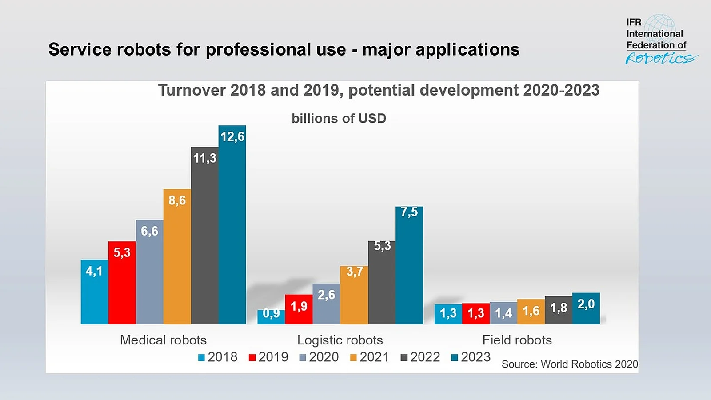

<The investment in robotics in the agricultural industry has fallen behind other industries (IFR Press Room).>

Product Features
<The Autonomous Agricultural Rover, designed to enhance modern farming practices, includes a list of features meant to improve the monitoring of agricultural crops:

- Smart Field Navigation: The rover is equipped with advanced algorithms that allow it to navigate through fields autonomously, identifying and avoiding obstacles, ensuring that every row of the field is covered without human intervention.

- Eco-friendly Energy Source: Integrated solar panels empower the rover to harness the sun's energy, reducing the carbon footprint and eliminating the need for conventional charging methods.

- Advanced 3D Mapping Capabilities: By integrating images from three distinct cameras, the rover creates a comprehensive 3D map of the field. This image stitching technique allows for a more detailed and accurate representation of the terrain and crop health.

- Intuitive Command Line Interface: Users can access real-time data and rover statistics through a user-friendly command line interface, ensuring that they're always in the loop regarding the rover's operations and the field's conditions.

- Intelligent Operational Features: The rover's smart design includes a 'return home' function, allowing it to automatically head back to its base station. Additionally, users can customize operational hours to suit their needs, and they also have the flexibility to pause the rover's work whenever necessary.

By integrating these features, the Autonomous Agricultural Rover is meant to be a sustainable tool for farmers, ensuring convenience in agricultural practices. More details of the features can be found within this document>

Operating Environment
<The software will operate through a Raspberry Pi 4B (Raspberry Pi) programmed in the latest version of – Python 3.11.4 (Python). We will make use of the Raspberry Pi’s built-in operating system, Raspbian, to incorporate a user interface. The rover will be equipped with 3 Intel Real Sense D415 Depth Cameras (Intel Real Sense). The rover is still under construction but will be built on a lightweight chassis and from inspiration from the Twisted Fields Rover (Twisted Fields). This rover will be deployed in all types of terrain. The terrain will naturally include dirt, mud, sand, puddles, overgrowth, weeds, blockages, etc.>

Design and Implementation Constraints
<The Rowdy Rover Capstone Group is not prepared to make excuses.>

User Documentation
<Current documentation is listed below, and the links can be found in our references:
- Python 3.11.4 (Python)
- Intel Real Sense D415 Camera (Intel Real Sense)
- Raspberry Pi 4B (Raspberry Pi)
- Raspberry Pi Operating System (Raspberry Pi OS)
>

Assumptions and Dependencies
<List any assumed factors (as opposed to known facts) that could affect the requirements stated in the SRS. These could include third-party or commercial components that you plan to use, issues around the development or operating environment, or constraints. The project could be affected if these assumptions are incorrect, are not shared, or change. Also identify any dependencies the project has on external factors, such as software components that you intend to reuse from another project, unless they are already documented elsewhere (for example, in the vision and scope document or the project plan).>

System Features

Navigation
3.1.1 Algorithms and Methods
< We will utilize Simultaneous Localization and Mapping (SLAM) algorithms to determine the robot's location within the map of the field being created. Two such algorithms include the EKF-SLAM algorithm and Graph-Based SLAM methods. We will implement an algorithm that detects when the rover is no longer over a row, will then find the next row to traverse without going out-of-bounds of intended traversal area (e.g., skipping rows and re-traversing rows). We will implement obstacle avoidance using techniques such as Potential Fields and Reactive Navigation. If these algorithms prove unattainable, we can implement two other techniques:
- We could map the path through an aerial image and give that to the rover.
- We could manually traverse the path once and store it for future use.>
3.1.2 Functional Requirements
<It is essential for the rover to be able to remain self-sufficient while deployed in the field. To accomplish this, navigation must be accurate and precise. Given varying field conditions and best paths, we must employ advanced path-finding techniques that keep the rover on the most optimum track.>

Image Stitching and Photogrammetry
3.1.1 Algorithms and Methods
< We will implement feature detection and matching algorithms such as SIFT, SURF, and ORB which will detect distinctive local features in images for use in stitching images together. Some image stitching algorithms we could implement would include RANSAC and Homography Transformation. To construct the 3D image, we will utilize Structure-from-Motion and Bundle Adjustment methods. For dense 3D meshes, we will utilize Multi-View Stereo techniques. Depth will be calculated using the attached depth sensing cameras or if that option becomes unavailable, we could implement Stereo Vision to estimate depth from disparity between images. We will visualize the map using common 3D model software and/or OpenGL or PCL.>
3.1.2 Functional Requirements
<Image stitching and photogrammetry is essential for creating the 3D map product which is the purpose of the rover. This will provide farmers with the information necessary to analyze their crops and determine what is best for them.>

External Interface Requirements

User Interfaces
<The primary mode of interaction between the user and the rover is facilitated through the Raspbian Command Line Interface (CLI). This interface is tailored for users familiar with the Linux environment, specifically on Raspberry Pi devices.>

Specifications

4.1.1 Platform Compatibility
<The CLI is designed to run on Raspbian OS, which means any device capable of running this OS, like a Raspberry Pi, can access the user interface.>

4.1.2 Autonomous Functionality
<While the Rover is designed to operate autonomously, the interface ensures users can remain informed of its operations. This is achieved by providing real-time access to:
- Battery Life: A numeric or graphical representation indicating the remaining power.
- Processed Images: Access to the latest images processed by the rover.
- Location: Provides the current geographical location of the rover.>

4.1.3 Commands
<The interface offers a list of commands for users to interact with the Rover. Some essential commands include:
- Stop & Wait to Charge: This command halts the Rover's operations and sets it to a charging mode.
- Return Home: Directs the Rover to navigate back to its starting or home location.
- Working Time: Sets the dates and times of operation.>

4.1.4 Documentation Access
<Users can readily access the Rover’s manual and specifications directly through the CLI, ensuring essential information and operating instructions are always at hand.>>

Hardware Interfaces
<The seamless interaction between the Rover's hardware and its software is ensured through the Raspberry Pi's efficient interfacing capabilities.

Specifications:

4.2.1 Rover-User Data Transfer: Data exchange occurs between the Raspberry Pi of the rover and the user. This interaction is undertaken by the following attributes:
- File System Organization: Data generated by the Rover is systematically arranged within labeled folders, making retrieval and review straightforward.
- Data Backup: Critical data from the Rover's Raspberry Pi can be regularly backed up to the user's hard drive. This guarantees data redundancy and safeguards against potential data loss.

4.2.2 Supported Device Types: While the software predominantly interfaces with Raspberry Pi devices, it is scalable and can potentially be adapted to other hardware platforms with similar capabilities.

4.2.3 Data & Control Interactions: The software product interfaces with various hardware components of the Rover:
- Cameras: Fetch data like images, environmental metrics, and location.
- Battery Management System: Continuously monitors and reports battery health and status.
- Navigation & Drive Systems: Accepts movement-related commands and updates the software on its execution status.>

Software Interfaces
<Describe the connections between this product and other specific software components (name and version), including databases, operating systems, tools, libraries, and integrated commercial components. Identify the data items or messages coming into the system and going out and describe the purpose of each. Describe the services needed and the nature of communications. Refer to documents that describe detailed application programming interface protocols. Identify data that will be shared across software components. If the data sharing mechanism must be implemented in a specific way (for example, use of a global data area in a multitasking operating system), specify this as an implementation constraint.>

Communications Interfaces
<Describe the requirements associated with any communications functions required by this product, including e-mail, web browser, network server communications protocols, electronic forms, and so on. Define any pertinent message formatting. Identify any communication standards that will be used, such as FTP or HTTP. Specify any communication security or encryption issues, data transfer rates, and synchronization mechanisms.>

Other Nonfunctional Requirements

Performance Requirements
<The rover will need to be able to detect obstacles in real time. The rover will need to be lightweight and travel in a way such that it will not collide with any crops or get stuck in the mud. Energy consumption will need to be within the capabilities of the attached solar panel and must be optimized so that the rover will not die in an unrecoverable state while on the field. The rover must be able to work autonomously on the field without any human interaction or intervention and operate as expected. There will be an interface to interact with the rover in real time to observe its operational status, observe environmental variables, and detect potential anomalies or errors in the operation of the rover. The rover will work during specified operation times of the day and will operate each specified day of each week.>

Safety Requirements
<Specify those requirements that are concerned with possible loss, damage, or harm that could result from the use of the product. Define any safeguards or actions that must be taken, as well as actions that must be prevented. Refer to any external policies or regulations that state safety issues that affect the product’s design or use. Define any safety certifications that must be satisfied.>

Security Requirements
<Specify any requirements regarding security or privacy issues surrounding use of the product or protection of the data used or created by the product. Define any user identity authentication requirements. Refer to any external policies or regulations containing security issues that affect the product. Define any security or privacy certifications that must be satisfied.>

Software Quality Attributes
<Specify any additional quality characteristics for the product that will be important to either the customers or the developers. Some to consider are: adaptability, availability, correctness, flexibility, interoperability, maintainability, portability, reliability, reusability, robustness, testability, and usability. Write these to be specific, quantitative, and verifiable when possible. At the least, clarify the relative preferences for various attributes, such as ease of use over ease of learning.>

Other Requirements
<Define any other requirements not covered elsewhere in the SRS. This might include database requirements, internationalization requirements, legal requirements, reuse objectives for the project, and so on. Add any new sections that are pertinent to the project.>
Appendix A: Glossary
<Define all the terms necessary to properly interpret the SRS, including acronyms and abbreviations. You may wish to build a separate glossary that spans multiple projects or the entire organization, and just include terms specific to a single project in each SRS.>
Appendix B: Analysis Models
<Optionally, include any pertinent analysis models, such as data flow diagrams, class diagrams, state-transition diagrams, or entity-relationship diagrams.>
Appendix C: Issues List
< This is a dynamic list of the open requirements issues that remain to be resolved, including TBDs, pending decisions, information that is needed, conflicts awaiting resolution, and the like.>

