ASG-HEVC

Overview

Running the Software

Legal Information

Overview

**ASG-HEVC** is the specific validation tool for the motion estimation/mode decision. Current tool was developed to analyze HEVC FEI (Flexible encoding infrastructure) encoder.

Tool helps to check:

* Motion estimation quality in cases w/ and w/o External MVP (FEI specific).
* Optimality of Inter/Intra predictions.

Tool is required for validation of the open source MSDK.

The picture below shows the typical validation pipeline.

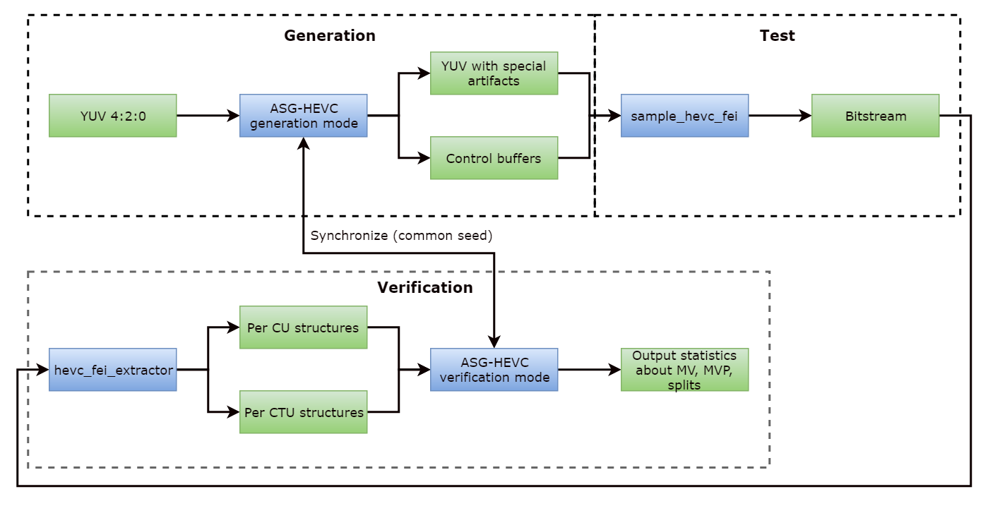

Running the Software

Usage:

asg-hevc -i InputYUVFile -o OutputYUVFile -w width -h height -n number_of_frames_to_process

The above params are required. If -pic_file or repack parameters are enabled, parameters -i InputYUVFile -o OutputYUVFile -w width -h height can be removed.

Additional options:

|  |  |
| --- | --- |
| -g <size> | GOP size. |
| -r <number> | Number of B frames plus 1. |
| -x <size> | DPB size in frames. |
| -idr_interval <interval> | IDR interval in frames. |
| -num_active_P <number> | Number of active references for P frames. |
| -num_active_BL0 <number> | Number of active List 0 references for B frames. |
| -num_active_BL1 <number> | Number of active List 1 references for B frames. |
| -generate | Run ASG in test stream generation mode. |
| -verify | Run ASG in test results verification mode. |
| -gen_split | Enable CTU splitting. |
| -no_cu_to_pu_split | Disable CU splitting into Pus. |
| -force_extbuf_mvp_block_size <size> | Force mfxFeiHevcEncMVPredictors::BlockSize field in MVP output buffer to a specified value. ALL output mfxFeiHevcEncMVPredictors structs will be affected. Supported values are 0, 1, 2 and 3. See MVPredictor description in HEVC FEI manual for details. |
| -mvp_block_size <size> | Actual MVP block size used in actual generation algorithm.  If -force_extbuf_mvp_block_size is not specified, this value is used in output mfxFeiHevcEncMVPredictors::BlockSize only for the structures for which MVPs were actually generated.  When -force_extbuf_mvp_block_size is specified and -mvp_block_size is not default algorithm for MVP generation is used : MVP block size equals to CTU size.  When both -force_extbuf_mvp_block_size and -mvp_block_size are specified : the 1st one value is used in the output ExtBuffer regardless to actual MVP block size.  Supported values are 0, 1, 2 and 3. |
| -force_symm_cu_part | Forces using only symmetric CU into PU partioning modes for inter prediction test. |
| -gen_inter | Generate inter CUs (inter prediction test). |
| -gen_intra | Generate intra CUs (intra prediction test). |
| -gen_pred | Generate MV predictors (inter prediction test). |
| -gen_mv | Generate motion vectors inside search window (inter prediction test).  If -gen_mv is not specified, then resulting MVs for PUs will be generated outside the search window only. |
| -gen_repack_ctrl | Generate/verify repack control data. |
| -pred_file <File> | Output file for MV predictors. |
| -pic_file <File> | Output file for pictures' structure. |
| -log2_ctu_size <size> | Log2 CTU size to be used for CU quad-tree structure. Default is 4. Cannot be less than min_log2_tu_size (described below). |
| -min_log2_tu_size <size> | Minimum log2 TU size to be used for quad-tree structure. Must be less than min_log2_cu_size (described below), default is 2. |
| -max_log2_tu_size <size> | Maximum log2 TU size to be used for quad-tree structure. Must be less than or equal to Min(log2_ctu_size, 5), default is 4. |
| -max_tu_qt_depth <value> | Maximum TU quad-tree depth inside CU. Overrrides min_log2_tu_size, default is 4. |
| -min_log2_cu_size <size> | Mminimum log2 CU size to be used for quad-tree structure. Cannot be less than max_log2_tu_size, default is 3. |
| -max_log2_cu_size <size> | Maximum log2 CU size to be used for quad-tree structure. Cannot be larger than log2_ctu_size, default is 4. |
| -block_size_mask <size> | Bit mask specifying possible partition sizes. |
| -ctu_distance <distance> | Minimum distance between generated CTUs (in units of CTU), default is 3. |
| -gpb_off | Specifies that regular P frames should be used, not GPB frames. |
| -bref | Arrange B frames in B pyramid reference structure. |
| -nobref | Do not use B-pyramid. |
| -pak_ctu_file <File> | Input file with per CTU information. |
| -pak_cu_file <File> | Input file with per CU information. |
| -repack_ctrl_file <File> | Output/input file with repack control data for repack control generation/verify. |
| -repack_stat_file <InputFile> | Input file with repack stat data for repack control verify. |
| -repack_str_file <File> | Input file with multiPakStr data for repack control generation/verify. |
| -log <File> | Log output file. |
| -csv <File> | File to output statistics in CSV format. |
| -config <File> | Input configuration file. |
| -sub_pel_mode <value> | Specifies sub pixel precision for motion vectors.  0 - integer, 1 - half, 3 - quarter (0 is default). |
| -mv_thres <value> | Threshold for motion vectors in percents (0 is default). |
| -numpredictors <number> | Number of MV predictors enabled. Used in verification mode to check NumMvPredictors FEI control works correctly.  Valid values are in range [1; 4] (4 is default). |
| -split_thres <value> | Thresholds for partitions in percents (0 is default). |
| -DeltaQP <value(s)> | Array of delta QP values for repack ctrl generation, separated by a space (8 values at max). |
| -InitialQP <value> | The initial QP value for repack ctrl verify (26 is default). |

Below are examples of command-lines that can be used to execute ASG-HEVC:

**Test of the inter prediction for p-frames with EMVP**

Run of the validation tool in the generation mode (CU 16x16)

asg-hevc -generate -gen_inter -gen_mv -gen_pred -gen_split -i input_1920x1088_250.yuv -o test.yuv -w 1920 -h 1088 -n 250 -g 2 -x 1 -num_active_P 1 -r 1 -log2_ctu_size 5 -no_cu_to_pu_split -max_log2_cu_size 4 -min_log2_cu_size 4 -mvp_block_size 1 -gpb_off -sub_pel_mode 0 -pred_file emvp.mvin

Run a test application

sample_hevc_fei -i test.yuv -o test.hevc -w 1920 -h 1088 -n 250 -f 25 -qp 2 -g 2 -GopRefDist 1 -gpb:off -NumRefFrame 1 -NumRefActiveP 1 -NumPredictorsL0 4 -NumPredictorsL1 4 -encode -EncodedOrder -mvpin emvp.mvin

Run an extractor

hevc_fei_extractor test.hevc mvmvp.ctustat mvmvp.custat

Run of the validation tool in the verification mode

asg-hevc -verify -gen_inter -gen_mv -gen_pred -gen_split -w 1920 -h 1088 -n 250 -g 2 -x 1 -num_active_P 1 -r 1 -log2_ctu_size 5 -no_cu_to_pu_split -max_log2_cu_size 4 -min_log2_cu_size 4 -mvp_block_size 1 -gpb_off -sub_pel_mode 0 -pak_ctu_file mvmvp.ctustat -pak_cu_file mvmvp.custat -mv_thres 80 -split_thres 80 -numpredictors 4

**Test of the inter prediction for b-frames with EMVP**

Run of the validation tool in the generation mode (CU 16x16)

asg-hevc -generate -gen_inter -gen_mv -gen_pred -gen_split -i matrix_1920x1088_250.yuv -o test.yuv -w 1920 -h 1088 -n 250 -g 32 -x 2 -num_active_P 1 -num_active_BL0 1 -num_active_BL1 1 -r 4 -log2_ctu_size 5 -no_cu_to_pu_split -max_log2_cu_size 4 -min_log2_cu_size 4 -mvp_block_size 1 -sub_pel_mode 0 -pred_file emvp.mvin

Run a test application

sample_hevc_fei -i test.yuv -o test.hevc -w 1920 -h 1088 -n 250 -f 25 -qp 2 -g 32 -GopRefDist 4 -gpb:on -NumRefFrame 2 -NumRefActiveP 1 -NumRefActiveBL0 1 -NumRefActiveBL1 1 -NumPredictorsL0 4 -NumPredictorsL1 4 -encode -EncodedOrder -mvpin emvp.mvin

Run an extractor

hevc_fei_extractor test.hevc mvmvp.ctustat mvmvp.custat

Run of the validation tool in the verification mode

asg-hevc -verify -gen_inter -gen_mv -gen_pred -gen_split -w 1920 -h 1088 -n 250 -g 32 -x 2 -num_active_P 1 -num_active_BL0 1 -num_active_BL1 1 -r 4 -log2_ctu_size 5 -no_cu_to_pu_split -max_log2_cu_size 4 -min_log2_cu_size 4 -mvp_block_size 1 -sub_pel_mode 0 -pak_ctu_file mvmvp.ctustat -pak_cu_file mvmvp.custat -mv_thres 70 -split_thres 60 -numpredictors 4

**Test of the multi-pass PAK**

Run a test application

sample_hevc_fei -i input_1920x1088_250.yuv -o test.hevc -w 1920 -h 1088 -n 250 -qp 24 -g 2 -GopRefDist 1 -encode -EncodedOrder

Run an extractor

hevc_fei_extractor test.hevc -multi_pak_str test.multipak

Run of the validation tool in the generation mode

asg-hevc -generate -gen_repack_ctrl -n 250 -g 2 -r 1 -repack_ctrl_file test.repakctrl -repack_str_file test.multipak -InitialQP 24 -DeltaQP 1 1 2 2 3 3 4 4

Run a test application

sample_hevc_fei -i input_1920x1088_250.yuv -o test.repack -w 1920 -h 1088 -n 250 -qp 24 -g 2 -GopRefDist 1 -encode -EncodedOrder -repackctrl test.repakctrl -repackstat test.repakstat

Run an extractor

hevc_fei_extractor test.repack -multi_pak_str test_repak.multipak

Run of the validation tool in the verification mode

asg-hevc -verify -gen_repack_ctrl -n 250 -g 2 -r 1 -repack_ctrl_file test.repakctrl -repack_stat_file test.repakstat -repack_str_file test_repak.multipak -InitialQP 24

Legal Information

**INFORMATION IN THIS DOCUMENT IS PROVIDED IN CONNECTION WITH INTEL PRODUCTS. NO LICENSE, EXPRESS OR IMPLIED, BY ESTOPPEL OR OTHERWISE, TO ANY INTELLECTUAL PROPERTY RIGHTS IS GRANTED BY THIS DOCUMENT. EXCEPT AS PROVIDED IN INTEL'S TERMS AND CONDITIONS OF SALE FOR SUCH PRODUCTS, INTEL ASSUMES NO LIABILITY WHATSOEVER AND INTEL DISCLAIMS ANY EXPRESS OR IMPLIED WARRANTY, RELATING TO SALE AND/OR USE OF INTEL PRODUCTS INCLUDING LIABILITY OR WARRANTIES RELATING TO FITNESS FOR A PARTICULAR PURPOSE, MERCHANTABILITY, OR INFRINGEMENT OF ANY PATENT, COPYRIGHT OR OTHER INTELLECTUAL PROPERTY RIGHT.**  
  
**UNLESS OTHERWISE AGREED IN WRITING BY INTEL, THE INTEL PRODUCTS ARE NOT DESIGNED NOR INTENDED FORANYAPPLICATION IN WHICH THE FAILURE OF THE INTEL PRODUCT COULD CREATE A SITUATION WHERE PERSONAL INJURY OR DEATH MAY OCCUR.**  
  
**Intel may make changes to specifications and product descriptions at any time, without notice. Designers must not rely on the absence or characteristics of any features or instructions marked "reserved" or "undefined." Intel reserves these for future definition and shall have no responsibility whatsoever for conflicts or incompatibilities arising from future changes to them. The information here is subject to change without notice. Do not finalize a design with this information.**   
  
**The products described in this document may contain design defects or errors known as errata which may cause the product to deviate from published specifications. Current characterized errata are available on request.**   
  
**Contact your local Intel sales office or your distributor to obtain the latest specifications and before placing your product order.**   
  
**Copies of documents which have an order number and are referenced in this document, or other Intel literature, may be obtained by calling 1-800-548-4725, or by visiting** [Intel's Web Site](http://www.intel.com/)**.**

MPEG is an international standard for video compression/decompression promoted by ISO. Implementations of MPEG CODECs, or MPEG enabled platforms may require licenses from various entities, including Intel Corporation.

Intel and the Intel logo are trademarks or registered trademarks of Intel Corporation or its subsidiaries in the United States and other countries.

**Optimization Notice**

**Intel's compilers may or may not optimize to the same degree for non-Intel microprocessors for optimizations that are not unique to Intel microprocessors. These optimizations include SSE2, SSE3, and SSE3 instruction sets and other optimizations. Intel does not guarantee the availability, functionality, or effectiveness of any optimization on microprocessors not manufactured by Intel.   
  
Microprocessor-dependent optimizations in this product are intended for use with Intel microprocessors. Certain optimizations not specific to Intel microarchitecture are reserved for Intel microprocessors. Please refer to the applicable product User and Reference Guides for more information regarding the specific instruction sets covered by this notice.**

**Notice revision #20110804**