Name: __Aidan Aalund, Alexa Aguilar Izquierdo, Paul Schnoebelen, Eric Zang, Brian Ahn____

EID: __ ala4225, aa88886, pds2239, etz87, ba26422_____

Semester: Fall 2025
Course: ECE445L

A) Objectives:
- In a few sentences, describe the purpose of the lab:

To learn about embedded system design, particularly when crafting the bill of materials and schematic of the embedded system.

B) Hardware Design Deliverables:
- Deliverable 1: Using KiCad, create a schematic for your design. Include a screenshot in the space below.
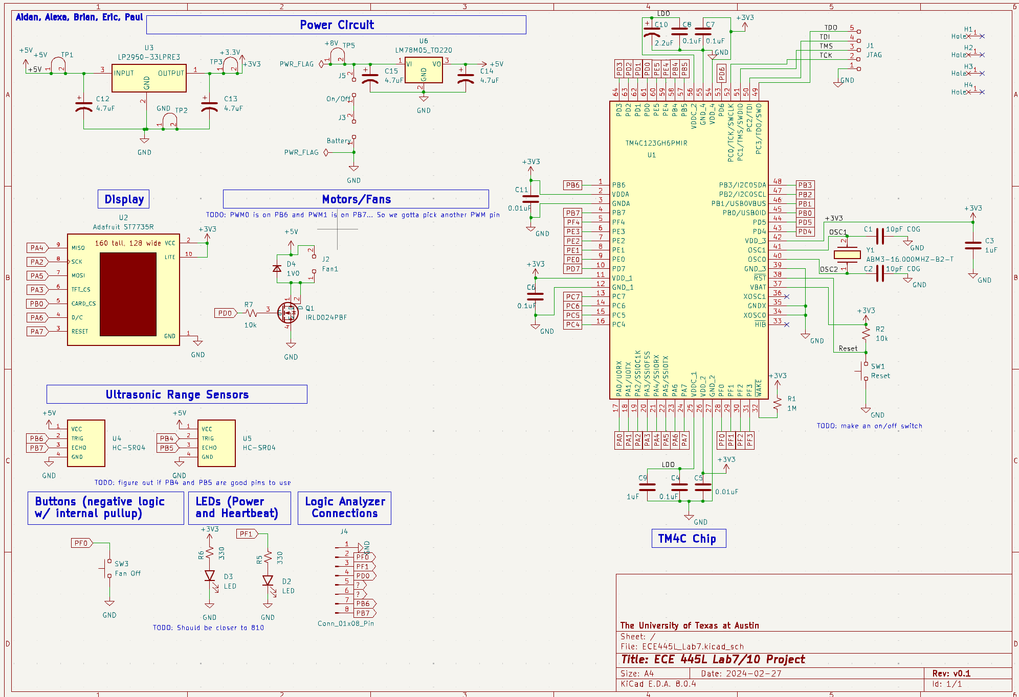

- Deliverable 2: Using KiCad, create a Layout for your design. Include a screenshot in the space below.
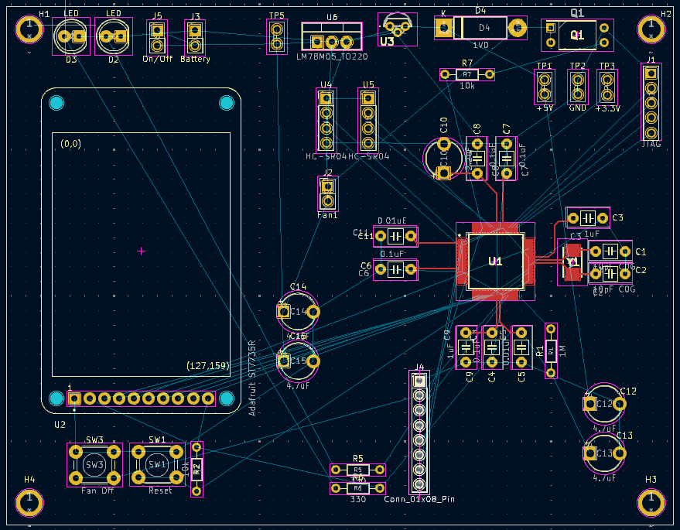

C) Software Design Deliverables:
I have pushed my project to GitHub for grading (Yes/No): Yes

- Deliverable 3: System design diagram of the modules created.
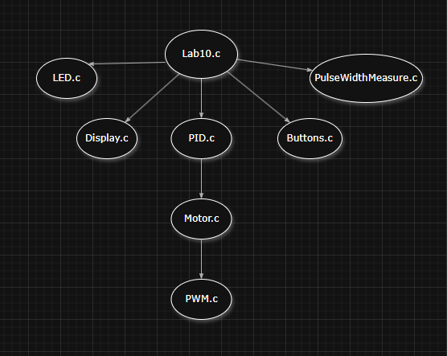
D) Deliverables:
- Deliverable 4: Total cost estimate
I have updated the bill of materials (Yes/No): Yes
Out of pocket costs: $56.99
Adjusted competition costs: $42.44

- Deliverable 5: Estimated current usage
TM4C: 45mA
Display: 50mA
Motors: 2(300mA)
Motion Sensor: 3(15mA)
Voltage Regulator: 100mA
LEDs: 2mA + 1mA
Total Current Usage: 45m + 2(300m) + 3(15m) + 100m + 2m + 1m + 50mA
= 0.843A

- Deliverable 6 (5pt EC): TIW Training
Alexa got 3D printing training, Aidan is in progress.
- Deliverable 7 (10pt EC): Discrete IC usage
Yes, check the layout.

- Deliverable 8 (10pt EC): Characterization of the system

E) Analysis and Discussion Questions:
- How did you debug your system? How intrusive was it?
We debugged our system through unit tests (‘test’ mains in each C file). In these unit tests we did a mix of intrusive breakpoint debugging and unintrusive functional debugging. For the PWM of the motor, we debugged the duty cycle and frequency with a logic analyzer (minimally intrusive). Once a module was unit tested, we performed integration tests by adding it to the Lab10.c main file and checking to see if behavior was the same as unit tests.

- What’s the difference between unit testing, integration testing, and functional testing?
Unit testing is testing a single component of the system in isolation, whereas integration tests check if the module can function in the system with other components active. Functional testing is to see if the system works as per the requirements document.

