Name: __Aidan Aalund, Alexa Aguilar Izquierdo, Paul Schnoebelen, Eric Zang, Brian Ahn____

EID: __ ala4225, aa88886, pds2239, etz87, ba26422_____

Semester: Fall 2024
Course: ECE445L

A) Objectives:
- In a few sentences, describe the purpose of the lab.

The purpose of this lab is to learn about the layout of an embedded system in the context of embedded system design. Examples include placement of bypass capacitors, routing power/digital/analog signals, and use of integrated circuits.

B) Hardware Design Deliverables:
- Deliverable 1: Using KiCad, create a schematic for your design. Include a screenshot in the space below.
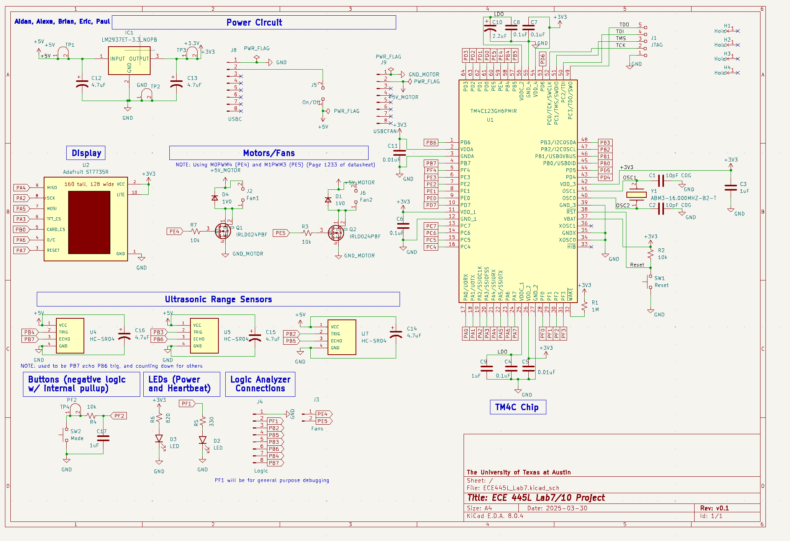

- Deliverable 2: Using KiCad, create a Layout for your design. Include a screenshot in the space below.
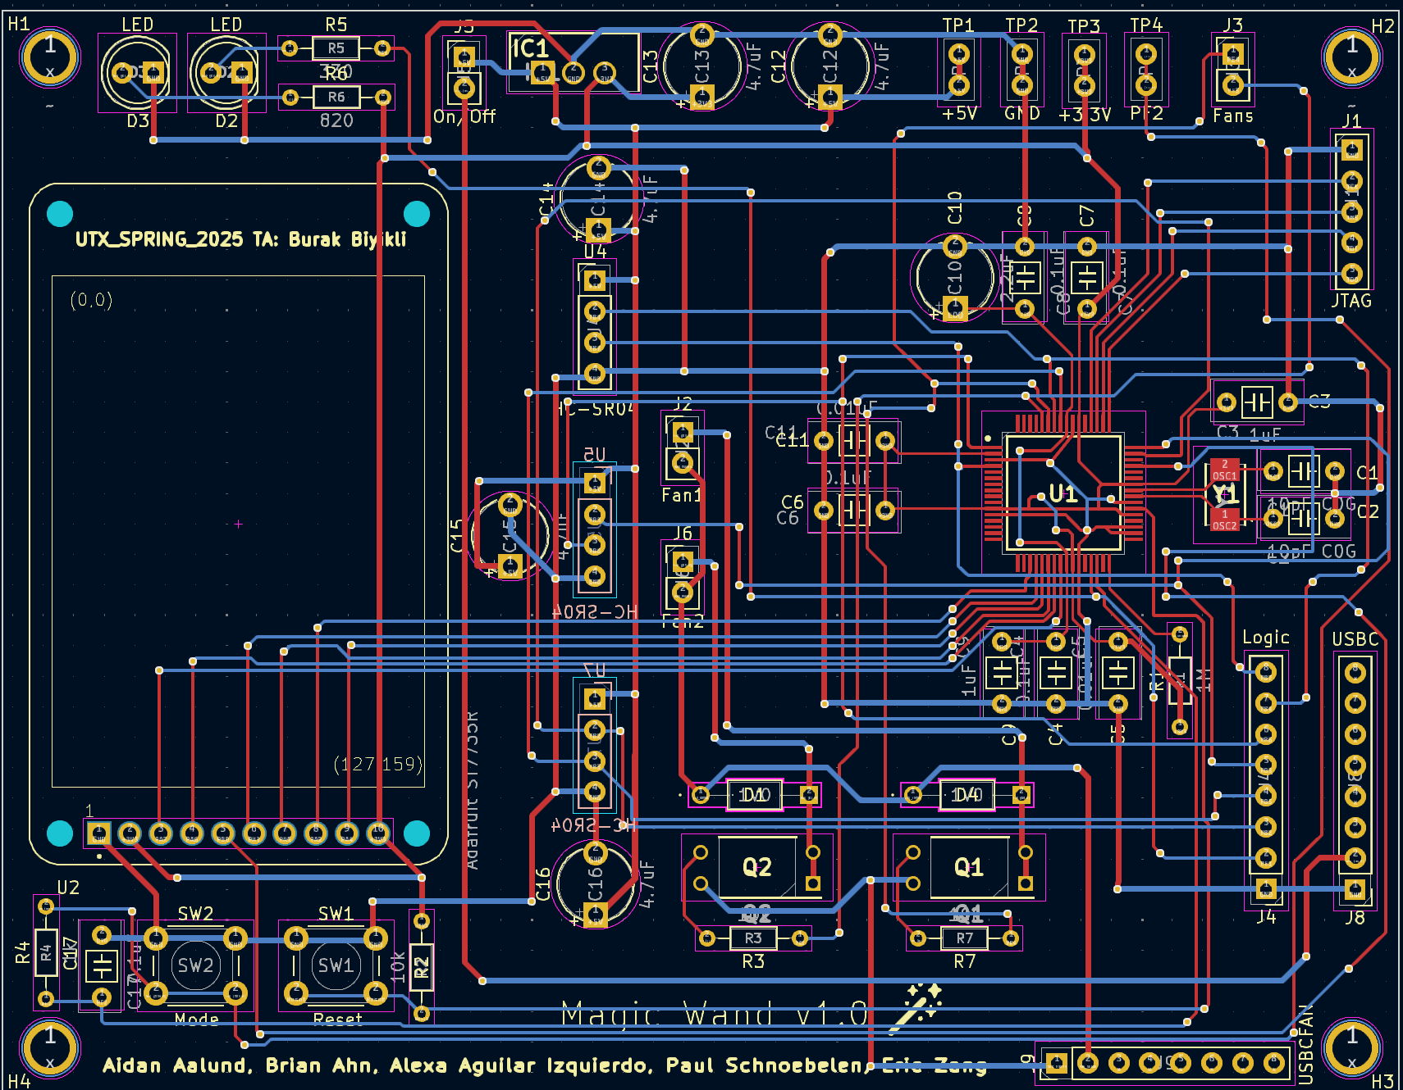

C) Software Design Deliverables:
- I have pushed my project to GitHub for grading (Yes/No): Yes

- Deliverable 3: System design diagram of the modules created.

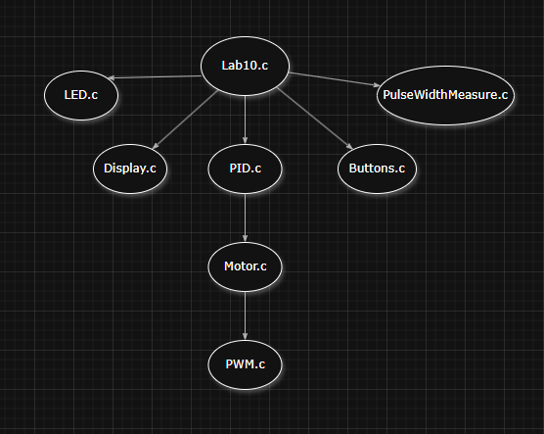
D) General Deliverables:
- Deliverable 4: Total cost estimate
I have updated the bill of materials (Yes/No): Yes
Out of pocket costs: $60.66
Adjusted competition costs: $44.94

- Deliverable 5: Description of tests added for lab 7B
Integration tests were added for all 3 sensors running at once with the motor.

- Deliverable 6 (10pt EC): Discrete IC usage
Yes, check the layout.
- Deliverable 7 (10pt EC): Characterization of the system

E) Analysis and Discussion Questions:
- What is the required naming scheme of the PCB submitted to us for review and ordering?
EIDs of all team members with underscores in between.

