Name: __Aidan Aalund, Alexa Aguilar Izquierdo, Paul Schnoebelen, Eric Zang, Brian Ahn____

EID: __ ala4225, aa88886, pds2239, etz87, ba26422_____

Semester: Spring 2025
Course: ECE445L

A) Objectives:
- In a few sentences, describe the purpose of the lab and the features of your project.

The purpose of the lab is to finish the design of an embedded system for real-world use. Our project’s features include 2 spinning fans that control the height of 2 ping-pong balls, a range sensor that takes the user’s hand position as input to control the height, a display, user buttons, and an enclosure.

B) Hardware Design Deliverables:
- N/A

C) Software Design Deliverables:
- I have pushed my project to GitHub for grading (Yes/No): Yes
- Deliverable 1: System design diagram of the modules created.
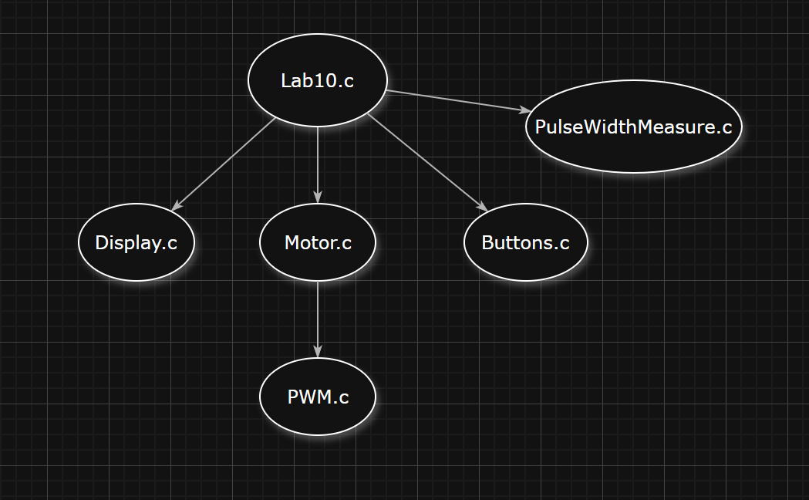
D) General Deliverables:
- Deliverable 2: Software Tests
We created different software modes to test our system. The first mode was called ‘hover’, which simply aimed to bring the ping-pong balls to the middle of the tube. This let us see the behavior of our control loop in a steady state without a changing target. After that, we created an ‘oscillation’ mode that slowly moved the ping-pong balls up and down the tube. Once both of these modes were tested, we created the ‘magic’ mode that lets the user’s hand control the position of the ball, intended as the main mode for the final product.
- Deliverable 3: Hardware Tests
We first powered the system from a power supply rather than a USB-C breakout board. Once we verified the power light LED and the display turned on, we ran the simple assembly program provided in ValvanoWare in debug mode to verify the TM4C was soldered correctly and the JTAG interface worked. After that we ran a simple test program that showed the readouts of the ultrasonic range sensors. To verify the fans worked, we used a function generator to give them a PWM signal independent of our TM4C.

- Deliverable 4: Power consumption

Current consumption of motors circuit at max PWM: 733mA
Current consumption of sensors and TM4C: 58mA
Total power consumption: 5V*733mA + 3.3V*58mA= 3.86W
- Deliverable 5 (10pt EC): Characterization of the system

E) Analysis and Discussion Questions:
- N/A

