Suricata Rules

- Nmap Scan

Simulation | Nmap Scan from Kali Linux (attacker) to Windows 10 (victim)  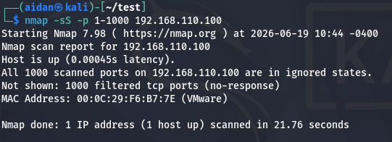
Rules | alert http any any -> $HOME_NET any (msg:"CUSTOM Oversized HTTP GET Request"; flow:to_server,established; http.method; content:"GET"; http.uri; byte_test:2,>,500,0,relative; classtype:attempted-recon; sid:20260603; rev:1;)
Verification

- FTP Brute Force

Simulation | FTP connection attempts from Kali Linux (attacker) to Ubuntu  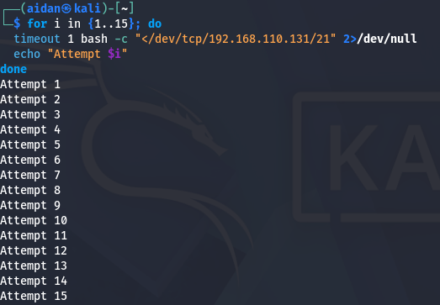
Rules | alert tcp any any -> $HOME_NET 21 (msg:"CUSTOM FTP Brute Force Attempt"; flags:S; threshold:type both, track by_src, count 10, seconds 30; classtype:attempted-admin; sid:20260704; rev:1;)
Verification

- Telnet Connection Attempt

Simulation | Telnet connection attempts from Kali Linux (attacker) to Ubuntu  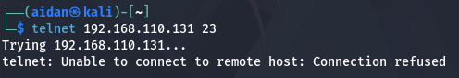
Rules | alert tcp any any -> $HOME_NET 23 (msg:"CUSTOM Telnet Connection Attempt"; flags:S; classtype:attempted-admin; sid:20260605; rev:1;)
Verification | 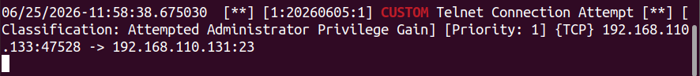

- Oversized HTTP GET Request

Simulation | Oversized HTTP GET request attempts from Kali Linux (attacker) to Ubuntu  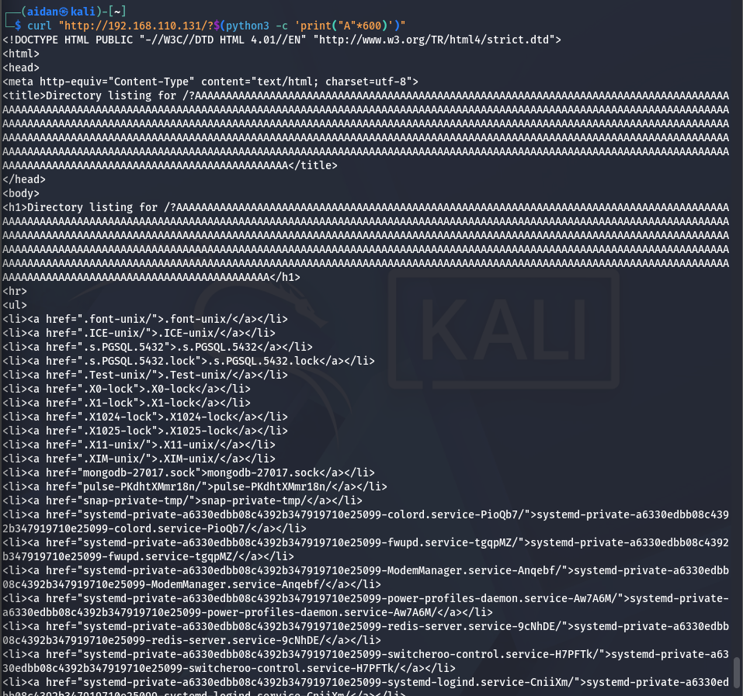  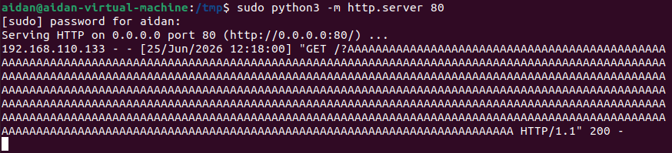
Rules | alert http any any -> $HOME_NET any (msg:"CUSTOM Oversized HTTP GET Request"; flow:to_server,established; http.method; content:"GET"; http.uri; byte_test:2,>,500,0,relative; classtype:attempted-recon; sid:20260603; rev:1;)
Verification | 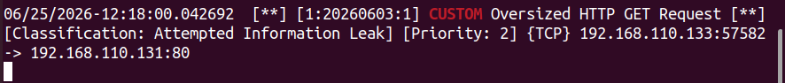

- HTTP with “admin” in URI

Simulation | HTTP /admin attempts from Kali Linux (attacker) to Ubuntu  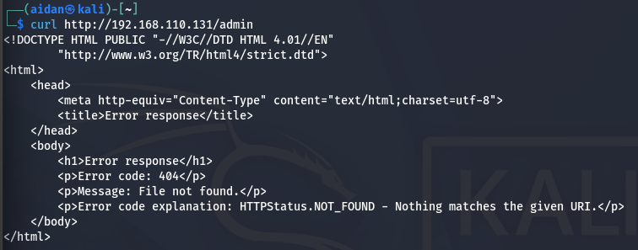
Rules | alert http any any -> $HOME_NET any (msg:"CUSTOM Admin Panel Scanning Detected"; flow:to_server,established; http.uri; content:"/admin"; nocase; classtype:web-application-attack; sid:20260606; rev:1;)
Verification

- Uncommon HTTP Method

Simulation | HTTP PUT request attempts from Kali Linux (attacker) to Ubuntu  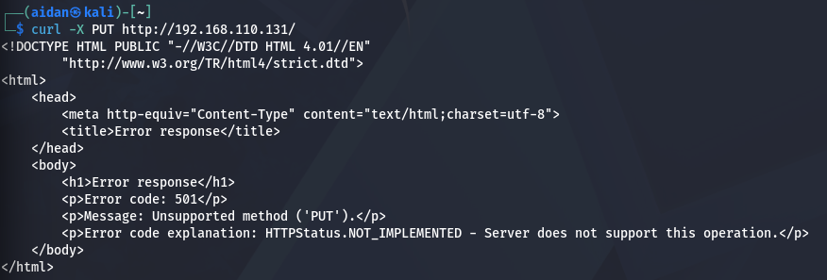
Rules | alert http any any -> $HOME_NET any (msg:"CUSTOM Uncommon HTTP Method Detected"; flow:to_server,established; http.method; content:"PUT"; nocase; classtype:attempted-recon; sid:20260608; rev:1;)
Verification

- Suspicious DNS Query

Simulation | DNS Lookup from Ubuntu to a known suspicious/malware domains (example: malware.test)  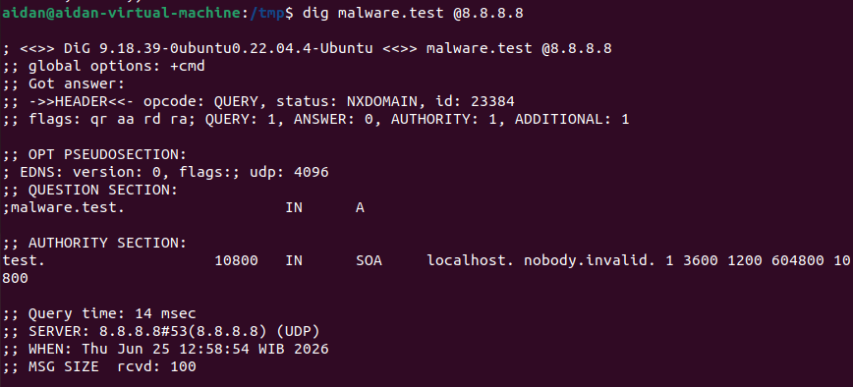
Rules | alert dns $HOME_NET any -> any 53 (msg:"CUSTOM Suspicious DNS Query - Test Domain"; dns_query; content:"malware.test"; nocase; classtype:bad-unknown; sid:20260610; rev:1;)
Verification

- Suspicious User-Agent

Simulation | HTTP PUT request attempts using curl from Kali Linux (attacker) to Ubuntu 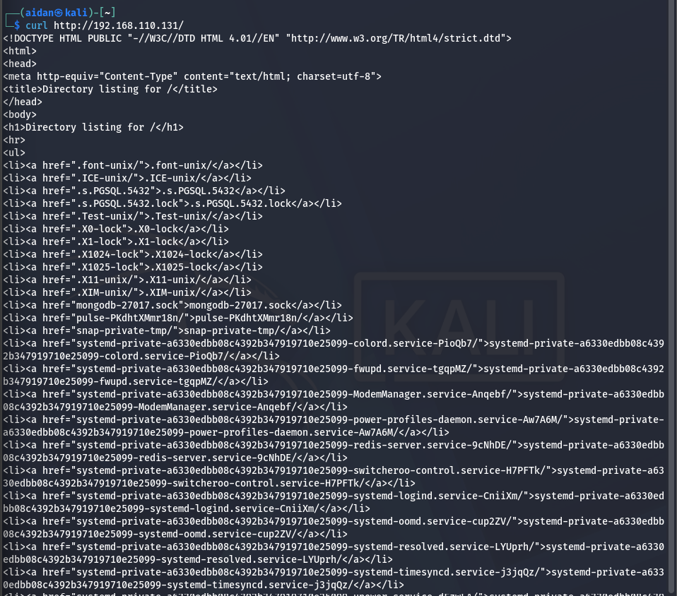
Rules | alert http any any -> $HOME_NET any ( msg:"CUSTOM Suspicious User-Agent Detected"; flow:to_server,established; http.user_agent; content:"curl"; nocase; classtype:attempted-recon; sid:20260609; rev:1;)
Verification

