ThyrIMsim: A Simulation Model of Thyroid-Immune System Dynamical Interactions in Hashimoto’s Thyroiditis

Aidan Boyne, edited by JD July 1 2023 (first pass), revised AB Oct 7. 23

_________________________________________________________________________________________________________________________

**Abstract**

Hashimoto’s Disease (HD) is a common autoimmune disorder characterized by destruction of thyroid tissue and subsequent hypothyroidism. Current treatment consists of hormone replacement therapy and is often sufficient to restore physiological thyroid hormone levels. Nevertheless, the immune system plays a significant role in disease progression and better understanding of the feedforward and feedback interactions may lead to more optimal hormone therapy and reveal new therapeutic targets. To this end, we present a mathematical simulation model of Hashimoto’s thyroiditis which incorporates the dynamic interactions of the immune system and thyroid. The model is fitted to UCLA health system patient data, extending the capabilities of our validated patient specific p-THYROSIM model, allowing it to simulate the interplay of relevant immune components and the thyroid of patients with HD.

_________________________________________________________________________________________________________________________

**Introduction**

Hashimoto’s Disease (HD), also known as chronic autoimmune thyroiditis or chronic lymphocytic thyroiditis, is an autoimmune disease in which thyroid cells are destroyed by cell and antibody-mediated immune processes. It is the most common autoimmune thyroid disease in iodine-sufficient areas of the world, including the United States. HD occurs in up to 10 percent of the population, particularly females, and its prevalence increases with age1. It causes roughly 30% of all cases of clinical hypothyroidism in the US2. HD is usually distinguished from other causes of hypothyroidism by elevated serum levels of thyroid peroxidase antibody (TPOAb) and, to a lesser extent, thyroglobulin antibody (TGAb), present in over 90% and 70% of HD patients3. These autoantibodies, along with lymphocyte infiltration of the thyroid, are thought to cause thyroid cell apoptosis and subsequent hypothyroidism in HD, though the exact mechanism through which cell death occurs is not known definitively4. Immune-mediated destruction of the thyroid results in decreased or eliminated endogenous production of metabolically active thyroid hormone triiodothyronine (T3) and its precursor thyroxine (T4). As a result, negative feedback of T3 and T4 upon the hypothalamus-pituitary-thyroid (HPT) axis is dramatically reduced causing serum levels of thyroid stimulating hormone (TSH) to rise dramatically5 (Figure 1).

The effects of thyroid hormones (THs) on the immune system, though not as well characterized as immune component effects on the thyroid, may also play a significant role in the onset and development of HD6. TH receptors exist on the nuclei of immune cells, including those of particular relevance to HD such as antigen presenting cells (APCs), helper T-cells, and B-cells5. These cells also produce T3 endogenously via T4 conversion. In vitro studies have shown that APCs under high concentrations of combined T3 and T4 display accelerated antigen uptake, while increased T3 levels were shown to increase B-cell proliferation6.

The effects of THs on T-cells are less clear, and different studies have found contradictory effects of thyroid hormone including T-cell apoptosis and enhanced T-cell anti-tumor activity7. Most clinical literature, however, suggests T3 and T4 inhibit inflammatory response and trigger T-cell apoptosis. This aligns with the common clinical observation of decreased T3 and T4 levels resembling central hypothyroidism during severe illness despite euthyroid TSH levels in a phenomenon known as non-thyroidal illness syndrome7. There is no consensus on effects of levothyroxine (LT4) treatment on TPOAb levels. Studies do show a negative correlation between LT4 and TPOAb. In clinical trials, treating HD patients with LT4 over an extended period of time show decreased measured TPOAb [ref] . Notably, a correlation between LT4-induced variation in cytokine release and reduction in TPOAb has been observed in some studies [ref], whereas others showed no concomitant effect of LT4 treatment on TPOAb or TGAb [refs].

In this work, we model and simulate the interplay of the immune system and thyroid in HD. We constructed ThyrIMsim, by augmenting our earlier patient-specific model p-THYROSIM8 to include a novel immune submodel, combined as the system cartoon model depicted in Figure 1. Several candidate models were fitted to anonymized, retrospectively collected data from patients in the UCLA Health system database diagnosed with HD, described in detail in the Methods section. The best preforming model was refined with a small cohort of XX patients.

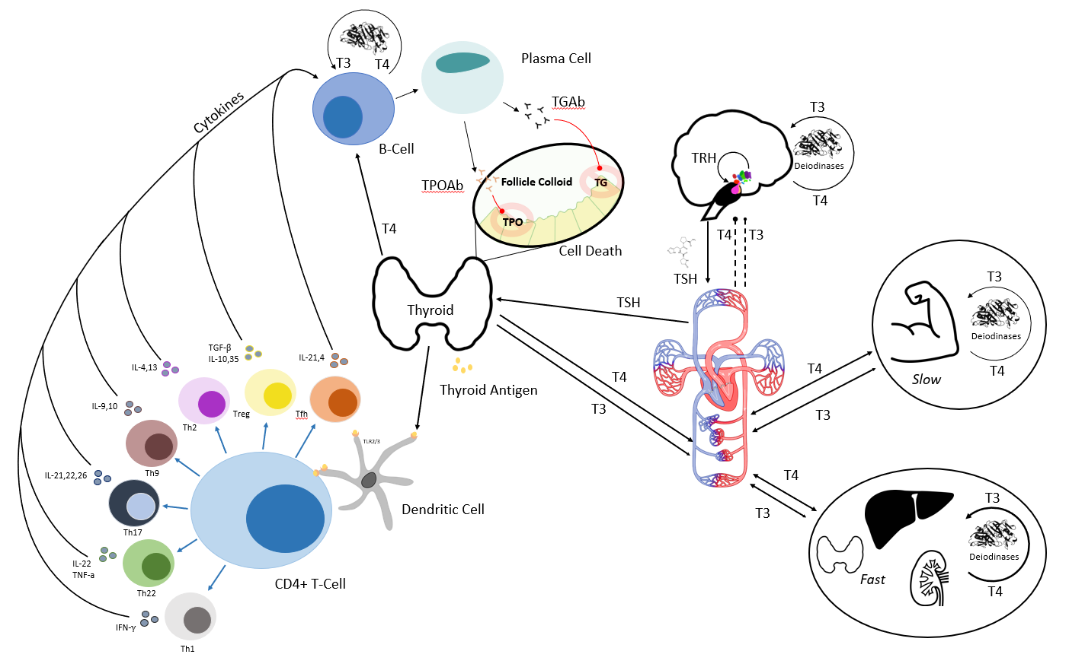

**Figure 1:** Cartoon model of primary feedforward and feedback thyroid-immune system component interactions in HD. The right side of figure depicts classical hypothalamus-pituitary-thyroid (HPT) axis regulation of thyroid hormones. Left depicts autoantigen recognition by antigen presenting cells (dendritic cell in the figure) and resulting autoantibody production by plasma cells, which causes thyroid cell death in HD. Cytokines, T-cells, antibodies and antigen presenting cells are grouped and simplified as appropriate in the model.

**Methods and Data**

**Data.** Longitudinal patient data was taken from the UCLA Health system Data Discovery Repository, a database comprised of partially de-identified and date-shifted patient UCLA Health electronic medical records dating back 5 years, to March 2018, to capture data using the latest assays. Patients were included in the study based on the following criteria: the patient(1) was diagnosed with HD at UCLA Health system facility between January 2018 and June 2023 (2) had one or more measurements of free T4 (FT4), free T3 (FT3), TSH, TPOAb, TGAb or lymphocyte reported in lab results between January 2018 and June 2023 (3) either received no thyroid medication or had a complete history of LT4 monotherapy during the period where lab data was available. Patients who had ever been diagnosed with thyroid cancer or diabetes or who were pregnant anytime between March 2013 and May 2023 were excluded from the study.

XX patients with XYZ characteristics were selected for fitting ThyroIMsim. from the remaining patient cohort of XX patients, (PATIENT STATS TABLE ABOVE),

**Compartment Selection.** The most essential compartments were chosen, beginning with TPOAb and TGAb, to maintain a balance between physiological accuracy and model complexity, in the context of data available for fitting, . These antibodies, the primary effectors in HD4, were grouped as a single compartment *Ab*. Stepping backward through the immune pathway, we then added plasma cells (*P*), which produce the antibody, and their progenitors, B-cells (*B*). B-cell dynamics are controlled primarily by CD4+ helper T-cells (*T*) and cytokines (*C*) released by the body and by the CD4+ cells themselves. Data was only available for the sum of these lymphocytes, and the compartments were fitted accordingly. To further reduce model complexity, the action of auto-antigen recognition and presentation to the CD4+ helper T-cells by APCs were lumped and incorporated numerically into model parameters9.

Lastly, we employed a modified functional thyroid size (*FTS*) compartment, modeled after previous work by Pandiyan et al., to capture the destructive effects of TPOAb and TGAb and serve as a feedforward bridge between immune and thyroid dynamics10. Along with the immune components, this results in a 6 state-variable subsystem that captures the essential component features of the immune-thyroid interaction in HD, comparable in size to existing immune system models in the literature9,11. Feedback from the thyroid to the immune subsystem is included as arrows from plasma T4 to immune components and it is assumed that the active hormone T3 is produced from plasma T4 (*T4*) entering these cells (ref).

**Model Dynamical Equations & their Basis**

*I. Immune Subsystem:*B-cell proliferation is activated by T-cells at a rate which varies with the amount of cytokine stimulation, captured by the first term of ordinary differential equation (ODE) (1) below (with additional explanation of the first term following ODE (6)). The number of B-cells circulating in plasma (*B*) is decreased by B-cell differentiation into Plasma cells (*P*) and by apoptosis. The effect of T4 on B-cell proliferation is hypothesized to be linearly proportional to plasma T4 concentration (*T4*) and is captured by the term $σ_{B}T_{4}$

|  |  |
| --- | --- |
| $$\frac{dB}{dt}=Φ_{B}\left(\frac{C}{C+τ_{B}}\right)T+σ_{B}T_{4}-{(δ}_{B}+Φ_{P}) B$$ | (Cells/ml)/hr) (1) |

Plasma cell levels are approximated as the difference between B-cell differentiation into plasma cells and natural plasma cell apoptosis at fractional rate $δ_{p}$ as in ODE (2) below. Similarly, cytokine production and degradation are simplified and approximated as the cytokine output of T-cells per hour minus the average degradation rate of relevant cytokines as in ODE (3), calculated via experimental half-life12 converted to fractional degradation rate $δ_{c}$. Further details on cytokine selection are found in the appendix.

|  |  |
| --- | --- |
| $$\frac{dP}{dt}=Φ_{P}B-δ_{P}P$$ | (Cells/mL)/hr (2) |
| $$\frac{dC}{dt}=Φ_{C}T-δ_{C}C$$ | (Cells/mL)/hr (3) |

The net rates of CD4+ T-cell proliferation and differentiation are aggregated into one state variable *T,* in ODE (4). Proliferation is captured by cytokine-dependent saturable inhibition and mass action with *T* and coefficient $σ_{T}$. Differentiation is a function of the availability of thyroid autoantigens, assumed to be linearly proportional to the functional thyroid size (*FTS*), with coefficient $Φ_{T}$. CD4+ T-cell degradation is again calculated from experimental half-life13, with fractional degradation rate $δ_{T}$.

|  |  |
| --- | --- |
| $$\frac{dT}{dt}=Φ_{T}FTS+σ_{T}T_{4}-η_{T}\left(\frac{C}{C+τ_{T}}\right)T-δ_{T}T$$ | (Cells/mL)/hr (4) |

Functional thyroid size (*FTS*) dynamics are modeled in ODE (5). *FTS* aggregates both the number of surviving thyroid follicular cells and the relative hormone output of the surviving cells. *FTS* increases in response to follicular cell stimulation by *TSH* (first term). Here, $\left(\frac{\text{TSH}}{\text{FTS}}{\text{FTS}}_{0}\right)$ represents the TSH-driven growth of functional thyroid size which increases as *FTS* approaches zero as the body attempts to increase *FTS* from its initial value *FTS0* by promoting thyroid growth and upregulating the amount of thyroid hormone produced by remaining thyroid follicular cells. It also increases as the thyroid attempts to regenerate via cell division and upregulates hormone secretion and excretion in response to a perturbed HPT-axis and cellular destruction14. *FTS* decreases as a result of follicular cell destruction by TPOAb (third term).

|  |  |
| --- | --- |
| $$\frac{d\text{FTS}}{dt}=Φ_{FTS}\left(\frac{{FTS}_{0}}{FTS}TSH\right)-δ_{FTS}\left(\text{FTS}\right)\left(\text{Ab}\right)$$ | mL/hr (5) |

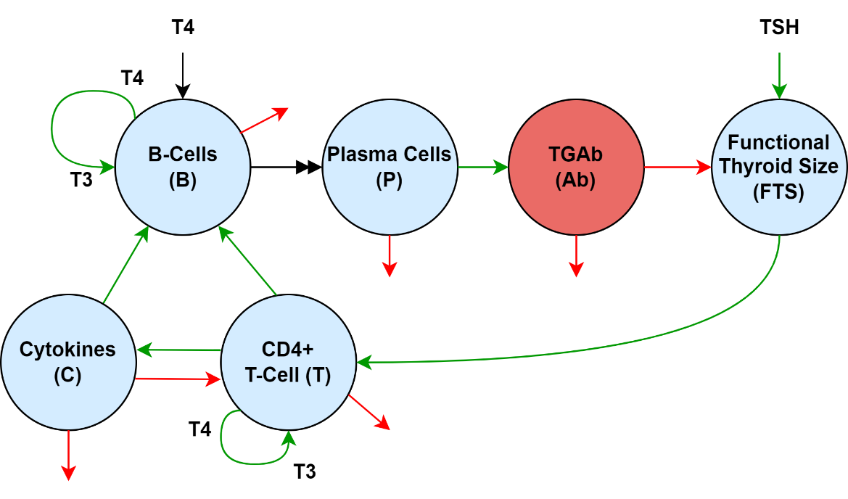

**Figure 2:** Immune system submodel. Green arrows represent stimulatory effects causing proliferation or differentiation, while red arrows represent degradation or destruction. T4 in plasma enters the B-cell and generates T3 for thyromimetic effects. The double-headed black arrow from B-cells to plasma cells indicates differentiation in which a B-cell matures into a plasma cell.

TPOAb and TGAb are aggregated into a single compartment *Ab* in ODE (6). The dynamics of antibody in plasma are modeled as the difference between plasma cell antibody production and the loss of antibody either through internalization by thyroid cells or due to degradation calculated from experimental half-life12.

|  |  |
| --- | --- |
|  | IU\(mL·hr)(6) |

The terms with form $\frac{C}{C+τ}$ in the B-cell and T-cell equations (1) and (4) represent the saturable, threshold-dependent cytokine production and activation of the cells. Cytokine levels far below the thresholds $τ_{B} and τ_{T}$ have little effect on cell dynamic, while the effect of very large cytokine levels is constant after the cell receptors are saturated11. The remaining terms represent standard growth ( $Φ_{i}$ and $σ_{i}$) and degradations ($δ_{i}$) as summarized in Table 1 below.

*II. Thyroid Hormone Regulation Subsystem Model:* The T3 and T4 secretion rates *SR3* and *SR*4 in p-THYROSIM are modified as in (7) and (8) below, to account for changing *FTS* and corresponding thyroid hormone production rates, by multiplying them by a proportionality constant dependent on the current *FTS* and the patient’s predicted euthyroid *FTS, FTS0*:

|  |  |
| --- | --- |
|  | ng/hr (7) |
|  | pg/hr (8) |

The remaining components and their parameter values in p-THYROSIM are unchanged in the physiological subsystem, under the assumption that only the thyroid gland and its associated component parameters are affected by the immune subsystem8.

*III. Full Model:* The integrated compartmental model is shown in figure 3.

|  |  |  |  |  |
| --- | --- | --- | --- | --- |
| **Parameter** | **Description** | **Value** | **Units** | **Source** |
| $$Φ_{B}$$ | B-cell activation rate | 3.6e3 | 1/hr | 9 |
|  | Plasma cell transformation rate | 1.08e4 | 1/hr | 9 |
|  | CD4+ helper T-cell activation rate | 2.89e5 | cell/(mL2·hr) | 11 |
|  | Cytokine production rate | 1.86e5 | molecule/(cell·hr) | 13 |
|  | Relative FTS growth rate | 1e3 | mL3/(mU·hr) | 8 |
|  | Ab production rate | 3.6e7 | molecules/(cell·hr) | 12 |
|  | B-cell death rate | 7.2e-3 | 1/hr | 14 |
|  | Plasma cell death rate | 7.2e-3 | 1/hr | 14 |
|  | CD4+ T-cell death rate | 3.21e-4 | 1/hr | 11 |
|  | Cytokine degradation rate | 6.80e2 | 1/hr | 10 |
|  | Functional thyroid destruction rate | 3.60 | mL/(molecules·hr) | 15 |
|  | Plasma Ab degradation rate | 6.26e-3 | mL2/(molecules·hr) | 12 |
|  | B-cell binding threshold | 18e4 | molecules/mL | 16 |
|  | T-cell binding threshold | 2e4 | molecules/mL | 16 |
|  | T4 B-cell stimulation rate | 3.60e5 | cell/(mcg·s) | Simulation |
| $$σ_{T}$$ | T4 T-cell stimulation rate | 32.8 | 1/s | 13 |
|  | T-cell cytokine stimulation rate | 1.0e-5 | mU/mL2 | 8 |
|  | Euthyroid *FTS* | 13.5 | mL | 17 |

**Table 1:** Initial parameter estimates and sources for ThyrIMsim. The rate $σ_{B}$ at which plasma T4 (via conversion to T3 in the cell) stimulates B-cell proliferation is unknown and is estimated using the initial ThyrIMsim model. Note state variables of the full model are influenced by parameters listed in terms of molecule number are converted to standard units before plotting. Parameters for the thyroid hormone regulation submodel can be found in Cruz-Loya et al6.

|  |  |  |  |  |
| --- | --- | --- | --- | --- |
| **State Variable** | **Description** | **Initial Value** | **Units** | **Source** |
| *B* | Activated B-cells | 100 | cells/mL | 9 |
| *P* | Plasma Cells | 80 | cells/mL | Simulation |
| *T* | Activated CD4+ Helper T-Cells | 805 | cells/mL | 18 |
| *C* | Cytokines | 6.022e15 | molecules/mL | 9 |
| *FTS* | Functional thyroid size | 11 | mL | 17 |
| *Ab* | Thyroid peroxidase antibody | 3.122e6 | molecules/mL | 17 |
|  |  |  |  |  |

**Table 2:** State variables and their initial condition values and reference sources. The cytokine state variable was estimated using the average value of plasma IL2 and IL4 recorded by Atitey et al9. Note *B*, *P* and *T* are combined into a single *Leukocyte* (*L*) compartment for graphing and parameter estimation.

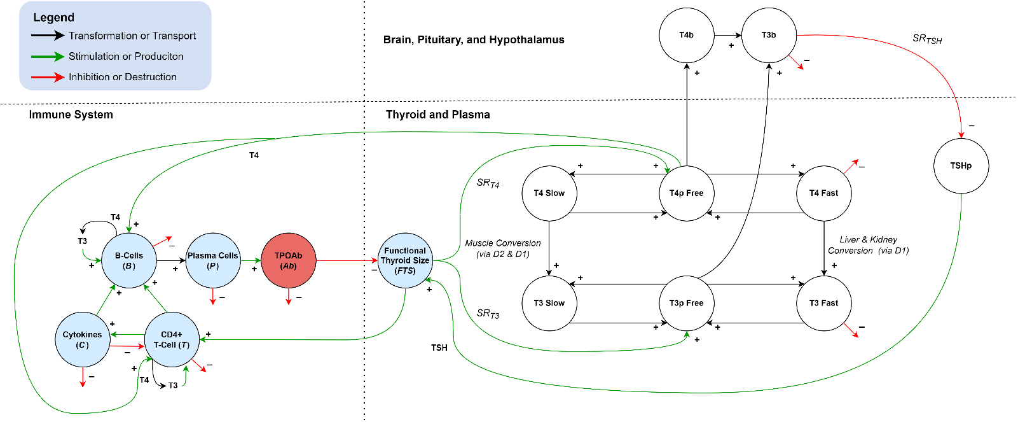

**Figure 3:** Complete model. Thyroid immune interaction occurs primarily via the functional thyroid compartment (*FTS*) which is upregulated by the thyroid subsystem (via TSH and T4 feedback) and downregulated by the immune system in Hashimoto’s disease. T3 also indirectly plays a role in controlling B-cell dynamics via intracellular conversion from plasma T4. Thyroid subsystem development and details can be found in Cruz-Loya et al8.

**Parameter Estimation.** The system of ODEs was implemented in the *Julia* programming language15 and solved using the *DifferentialEquations.jl*16 library. The library includes callback functionality, providing a simple way to incorporate discrete LT4 and LT3 dosages. Initial parameter values were estimated from literature when available (Table 1). The model was fitted to patient data in two stages. First, the model was fitted to median values of all available patient data for each state variable, yielding baseline parameter values. The model was then fitted to individual patient lab and medication data, giving a total of __ sets of parameters averaged to obtain the final mean parameter estimates presented in Table X (TODO).

The fitting process was performed using the Nelder-Mead optimization search routine in the *Optim.jl*17 library. The cost function for optimization was weighted least squares (*WLS*) (9):

$$WLS\left(p\right)=\sum_{j}^{j=1}{\sum_{i}^{i=1}{\frac{1}{μ_{j}}{\left(z_{ij}-y_{ij}\right)}^{2}}} (9)$$

where ***p*** is the vector of unknown optimized parameters; *i* is the index of time points *ti*; *j* is the index of the *jth* model output *yij* or output data measurement *zij* at time *ti*. The measured state variables or combinations of state variables are $FTS,\text{T4, T3, TSH, L, }\text{and}\text{ Ab}$, where *Ab = TPOAb* and Lymphocytes (*L*) = *B* + *T* + *P*. Variabilities for the estimated parameters were then obtained using Newton’s method along with a maximum likelihood loss function starting at the optimal parameters found via Nelder-Mead search, as explained in detail in Cruz-Loya et al. Final approximations of the inverse Hessian (an approximation to the covariance matrix) used in the search routine provide variability estimates for each fitted parameter [DiStefano 2015] and are given in Table 4.

**Parameter Estimate Variability.** TODO

**Results**

**Euthyroid Comparison to p-THYROSIM.** Before simulating HD, the ThyrIMsim model was validated for euthyroid patients by setting the initial values to zero for all immune state variables in Table 2 and running the model for 30 days. The results of this simulation were then plotted and compared to p-THYROSIM plots, as shown in Figure 4. Identical results for the two models indicate that ThyrIMsim is stable for euthyroid patients and will not switch from euthyroid to hypothyroid conditions without immune subsystem stimulation. ThyrIMsim was then run using the immune submodel parameters and initial conditions in Table 1 and Table 2. Results are plotted in Figure 5. (FIGURE 4-5 TO BE ADDED)

**Simulation of Steady-State Hypothyroidism.** TODO

**Predicting Treatment Response in HD Patients.** TODO

**Discussion**

The work presented in this paper addresses a crucial yet missing element in our dynamical thyroid modeling for hypothyroid as well as euthyroid subjects, by augmenting p-THYROSIM, a simulation program compiling over 50 years of our group’s research in computational thyroid regulation system modeling8,18. The addition of an immune submodel not only improves simulation accuracy for T3 and T4 levels but also provides insight into the quantitative levels of immune components and their feedforward or feedback interplay with thyroid system variables, and how they change over time in Hashimoto’s thyroiditis. Clinically, the model may provide physicians with continuous predictions of antibody levels, which often go unmeasured, allowing them to tailor treatment accordingly…. TO FINISH

**References**

1. Hollowell, J. G. *et al.* Serum TSH, T(4), and thyroid antibodies in the United States population (1988 to 1994): National Health and Nutrition Examination Survey (NHANES III). *J. Clin. Endocrinol. Metab.* **87**, 489–499 (2002).

2. Ragusa, F. *et al.* Hashimotos’ thyroiditis: Epidemiology, pathogenesis, clinic and therapy. *Best Pract. Res. Clin. Endocrinol. Metab.* **33**, 101367 (2019).

3. Fröhlich, E. & Wahl, R. Thyroid Autoimmunity: Role of Anti-thyroid Antibodies in Thyroid and Extra-Thyroidal Diseases. *Front. Immunol.* **8**, (2017).

4. Ralli, M. *et al.* Hashimoto’s thyroiditis: An update on pathogenic mechanisms, diagnostic protocols, therapeutic strategies, and potential malignant transformation. *Autoimmun. Rev.* **19**, 102649 (2020).

5. Jing, L. & Zhang, Q. Intrathyroidal feedforward and feedback network regulating thyroid h `ormone synthesis and secretion. *Front. Endocrinol.* **13**, (2022).

6. Jara, E. L. *et al.* Modulating the function of the immune system by thyroid hormones and thyrotropin. *Immunol. Lett.* **184**, 76–83 (2017).

7. Wenzek, C. *et al.* The interplay of thyroid hormones and the immune system – where we stand and why we need to know about it. *Eur. J. Endocrinol.* **186**, R65–R77 (2022).

8. Cruz-Loya, M., Chu, B. B., Jonklaas, J., Schneider, D. F. & DiStefano, J. Optimized Replacement T4 and T4+T3 Dosing in Male and Female Hypothyroid Patients With Different BMIs Using a Personalized Mechanistic Model of Thyroid Hormone Regulation Dynamics. *Front. Endocrinol.* **13**, 888429 (2022).

9. Thakar, J., Poss, M., Albert, R., Long, G. H. & Zhang, R. Dynamic models of immune responses: what is the ideal level of detail? *Theor. Biol. Med. Model.* **7**, 35 (2010).

10. Pandiyan, B., Merrill, S. J., Di Bari, F., Antonelli, A. & Benvenga, S. A patient-specific treatment model for Graves’ hyperthyroidism. *Theor. Biol. Med. Model.* **15**, 1 (2018).

11. Atitey, K. & Anchang, B. Mathematical Modeling of Proliferative Immune Response Initiated by Interactions Between Classical Antigen-Presenting Cells Under Joint Antagonistic IL-2 and IL-4 Signaling. *Front. Mol. Biosci.* **9**, (2022).

12. Conlon, P. J., Tyler, S., Grabstein, K. H. & Morrissey, P. Interleukin-4 (B-cell stimulatory factor-1) augments the in vivo generation of cytotoxic cells in immunosuppressed animals. *Biotechnol. Ther.* **1**, 31–41 (1989).

13. Tsukamoto, H. *et al.* Age-associated increase in lifespan of naïve CD4 T cells contributes to T-cell homeostasis but facilitates development of functional defects. *Proc. Natl. Acad. Sci.* **106**, 18333–18338 (2009).

14. Ozaki, T. *et al.* Thyroid Regeneration: Characterization of Clear Cells After Partial Thyroidectomy. *Endocrinology* **153**, 2514–2525 (2012).

15. Bezanson, J., Edelman, A., Karpinski, S. & Shah, V. B. Julia: A Fresh Approach to Numerical Computing. *SIAM Rev.* **59**, 65–98 (2017).

16. Rackauckas, C. & Nie, Q. DifferentialEquations.jl – A Performant and Feature-Rich Ecosystem for Solving Differential Equations in Julia. *J. Open Res. Softw.* **5**, (2017).

17. Mogensen, P. K. & Riseth, A. N. Optim: A mathematical optimization package for Julia. *J. Open Source Softw.* **3**, 615 (2018).

18. Eisenberg, M., Samuels, M. & DiStefano, J. J. Extensions, Validation, and Clinical Applications of a Feedback Control System Simulator of the Hypothalamo-Pituitary-Thyroid Axis. *Thyroid* **18**, 1071–1085 (2008).

**Appendix**

_________________________________________________________________________________________________________________________

*Complete code for the current model is available at*[**https://github.com/aidanboyne/BioCyb_UCLA**](https://github.com/aidanboyne/BioCyb_UCLA)

_________________________________________________________________________________________________________________________

**Summary of cytokines action in Hashimoto’s thyroiditis**

*Note: References cited in text*

1. **IFN**- $γ$: macrophage, NK, neutrophil activator. A relationship could be demonstrated between high y-IFN production and natural killer (NK) activity in T cell clones from thyroid and peripheral blood of HT patients (del Prete).
   * Tau G, Rothman P. Biologic functions of the IFN-gamma receptors. Allergy. 1999 Dec;54(12):1233-51. doi: 10.1034/j.1398-9995.1999.00099.x. PMID: 10688427; PMCID: PMC4154595.
   * Del Prete GF, Tiri A, Mariotti S, Pinchera M, Rici M, Romagnani S. Enhanced production of IFNγ by thyroid-derived T cell clones from patients with Hashimoto's thyroiditis. Clin Exp Immunol. 1987;69:323–31.
2. **TNF- $α$**: promotes inflammation and cell death, significantly higher in Hashimoto's and many other autoimmune disorders.
   * Jang DI, Lee AH, Shin HY, Song HR, Park JH, Kang TB, Lee SR, Yang SH. The Role of Tumor Necrosis Factor Alpha (TNF-α) in Autoimmune Disease and Current TNF-α Inhibitors in Therapeutics. Int J Mol Sci. 2021 Mar 8;22(5):2719. doi: 10.3390/ijms22052719. PMID: 33800290; PMCID: PMC7962638.
   * Díez, Juan J et al. “Serum concentrations of tumour necrosis factor-alpha (TNF-alpha) and soluble TNF-alpha receptor p55 in patients with hypothyroidism and hyperthyroidism before and after normalization of thyroid function.” Clinical endocrinology vol. 57,4 (2002): 515-21. doi:10.1046/j.1365-2265.2002.01629.x
3. **TGF**-:
   * 1. Suppresses the proliferation and differentiation of effector T-cells via inhibition of Th2-produced IL-2
     2. Initially suppresses Hashimoto's, then stimulates fibrosis at end stages of disease.
     3. Stimulates naive CD4+ T-cells transformation to effector T-cells
     4. 3.Alters the type of produced cytokines and mediates phenotypic metamorphosis among effector T-cells
     5. 4.Enhances TNF production by both CD4+ and CD8+ T-cells
     6. 5.Enhances the proliferation of CD8+ cells (in experimental mouse models)
     7. 6.Stimulates transformation of nTregs to iTregs via increased Foxp3 expression
     8. 7.Promotes Treg-induced inhibition of the exocytosis of granules
     9. 8.Inhibits the generation and activation of cytotoxic T lymphocytes (CTLs)
     10. 9.Suppresses the cytotoxicity of the CTLs via the transcriptional regression of genes encoding proteins, which are vital for CTLs function
     11. 10. Inhibits B-cell activation
   * Kardalas E, Maraka S, Papagianni M, Paltoglou G, Siristatidis C, Mastorakos G. TGF-β Physiology as a Novel Therapeutic Target Regarding Autoimmune Thyroid Diseases: Where Do We Stand and What to Expect. Medicina (Kaunas). 2021 Jun 14;57(6):621. doi: 10.3390/medicina57060621. PMID: 34198624; PMCID: PMC8232149.
4. **IL2:** promotes T-cell, B-cell proliferation. Upregulated by IL4. Primarily produced by B-cells9. One of primary cytokines considered in the model.
5. **IL4**: promotes B, T-cell growth and induces CD4+ differentiation indirectly upregulating IL2,4,10 production. Likewise, indirectly inhibits IFN- $γ$. One of the primary cytokines considered in the model along with IL2
   * Stephen T. Smiley, Michael J. Grusby, in Encyclopedia of Immunology (Second Edition), 1998
   * Bossowski, A., Harasymczuk, J., Moniuszko, A. et al. Cytometric evaluation of intracellular IFN-γ and IL-4 levels in thyroid follicular cells from patients with autoimmune thyroid diseases. Thyroid Res 4, 13 (2011). <https://doi.org/10.1186/1756-6614-4-13>
6. **IL9** - immune responses against parasites and pathogenesis of allergic diseases. Unlikely to be contributor to HT pathology.
   * Rojas-Zuleta, Wilmer Gerardo, and Elizabeth Sanchez. “IL-9: Function, Sources, and Detection.” Methods in molecular biology (Clifton, N.J.) vol. 1585 (2017): 21-35. doi:10.1007/978-1-4939-6877-0_2
7. **IL10** – immune response inhibitor. In Hashimoto’s disease, Th1 response overrides the effects of anti-inflammatory Th2-dependent mediators such as IL-10. When autoimmune processes have subsided (i.e. in late stage Hashimoto’s), IL-10 expression progressively decreases, even in the presence of lymphomononuclear infiltration.
   * de la Vega JR, Vilaplana JC, Biro A, Hammond L, Bottazzo GF, Mirakian R. IL-10 expression in thyroid glands: protective or harmful role against thyroid autoimmunity? Clin Exp Immunol. 1998 Jul;113(1):126-35. doi: 10.1046/j.1365-2249.1998.00628.x. PMID: 9697995; PMCID: PMC1905025.