ThyrIMsim: A Simulation Model of Thyroid-Immune System Dynamical Interactions in Hashimoto’s Thyroiditis

Aidan Boyne, edited by JD July 1 2023 (first pass)

_________________________________________________________________________________________________________________________

**Abstract**

Hashimoto’s Disease (HD) is a common autoimmune disorder characterized by destruction of thyroid tissue and subsequent hypothyroidism. Despite the significant role of the immune system in disease progression, current clinical treatment relies entirely on hormone replacement therapy and thyroid-immune system interactions remain largely unclear. We present a mathematical simulation model of Hashimoto’s thyroiditis which incorporates the dynamic interactions of the immune system and thyroid. The model is fitted to UCLA health system patient data, extending the capabilities of our validated patient specific p-THYROSIM model, allowing it to simulate the interplay of relevant immune components and the thyroid of patients with HD.

_________________________________________________________________________________________________________________________

**Introduction**

Hashimoto’s Disease (HD) is the most common autoimmune thyroid disease, causing roughly 30% of all cases of clinical hypothyroidism in the US1. HD is usually distinguished from other causes of hypothyroidism by the characteristic elevated thyroid peroxidase antibody (TPOAb) and, to a lesser extent, thyroglobulin antibody (TGAb) serum levels, present in over 90% (SOURCE) and 70% (SOURCE) of HD patients. These autoantibodies, along with lymphocyte infiltration into the thyroid, are thought to cause thyroid cell apoptosis and subsequent hypothyroidism in HD, though the exact mechanism through which cell death occurs is not known definitively2. The immune-mediated destruction of the thyroid results in the decreased or eliminated endogenous production of the metabolically active thyroid hormone triiodothyronine (T3) and its precursor thyroxine (T4). As a result, the negative feedback of T3 and T4 upon the hypothalamus-pituitary-thyroid (HPT) axis is dramatically reduced causing serum levels of thyroid stimulating hormone (TSH) to rise dramatically3 (Figure 1).

The effects of thyroid hormones (THs) on the immune system, though not as well characterized as immune component effects on the thyroid, may also play a significant role in the onset and development of HD4. TH receptors exist on the nuclei of immune cells, including those of particular relevance to HD such as antigen presenting cells (APCs), helper T-cells, and B-cells5.

In vitro studies have shown that APCs under high concentrations of combined T3 and T4 display accelerated antigen uptake, while increased T3 levels were shown to increase B-cell proliferation4. The effects of THs on T-cells are less clear, and different studies have found contradictory effects of thyroid hormone including T-cell apoptosis and enhanced T-cell anti-tumor activity5. Most clinical literature, however, suggests T3 and T4 inhibit inflammatory response and trigger T-cell apoptosis. This aligns with the common clinical observation of decreased T3 and T4 levels resembling central hypothyroidism during severe illness despite euthyroid TSH levels in a phenomenon known as non-thyroidal illness syndrome5.

In this work, we model and simulate the interplay of the immune system and thyroid computationally. We constructed ThyrIMsim, expanding upon our earlier patient specific model p-THYROSIM6 with a novel immune submodel based on the physiological system depicted in Figure 1. Several candidate models were fitted to anonymized, retrospectively collected data from patients diagnosed with Hashimoto’s disease in the UCLA Health system database described in detail in the methods section. The best preforming model was refined with a small cohort of XX patients.

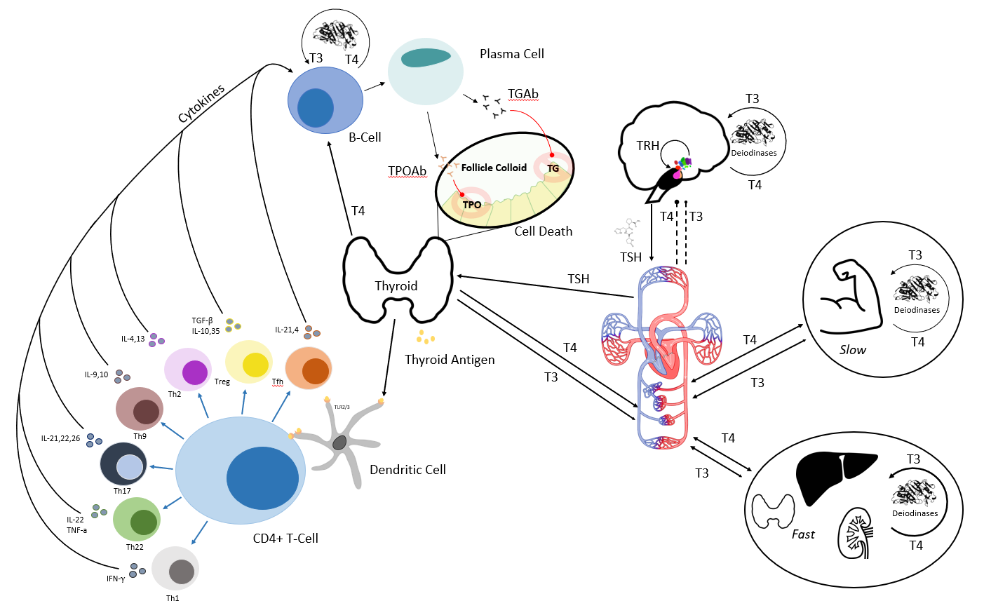

**Figure 1:** Cartoon model of primary feedforward and feedback thyroid-immune system component interactions in HD. Right side of figure depicts classical hypothalamus-pituitary-thyroid (HPT) axis regulation of thyroid hormones. Left depicts autoantigen recognition by antigen presenting cells (dendritic cell in figure) and resulting autoantibody production by plasma cells which causes thyroid cell death in HD. Cytokines, T-cells, antibodies, and antigen presenting cells are grouped and simplified as appropriate in the computational model.

**Methods and Data**

**Data.** Longitudinal patient data was taken from the UCLA Health system Data Discovery Repository, a database comprised of partially de-identified and date-shifted patient UCLA Health electronic medical records dating back 5 years, to March 2018. Patients were included in the study based on the following criteria: (1) the patient was diagnosed with Hashimoto’s thyroiditis at UCLA Health system facility between January 2018 and June 2023 (2) the patient had one or more of Free T4 (FT4), Free T3 (FT3), TSH, TPOAb, TGAb or Lymphocyte enumeration lab results between January 2018 and June 2023 (3) the patient either received no thyroid medication or had a complete history of thyroid medication (levothyroxine (LT4) and/orlyothyronine,) during the period where lab data was available. Patients who had ever been diagnosed with thyroid cancer or diabetes or who were pregnant anytime between March 2013 and May 2023 were excluded from the study.

From the pool of remaining patients (PATIENT STATS TABLE ABOVE), XX patients with XYZ characteristics were selected for fitting ThyroIMsim on induvial data sets.

**Compartment Selection.** To maintain a balance between physiological accuracy and model complexity in the context of data available for fitting, the most essential compartments were isolated beginning with TPOAb and TGAb. These antibodies, the primary effectors in HD2, were grouped as a single compartment *Ab*. Stepping backward through the immune pathway, we then added plasma cells (*P*), which produce the antibody, and their progenitors, B-cells (*B*). B-cell dynamics are controlled primarily by CD4+ helper T-cells (*T*) and cytokines (*C*) released by the body and by the CD4+ cells themselves. Data was only available for the sum of these lymphocytes, and the compartments were fitted accordingly. To reduce model complexity, the action of auto-antigen recognition and presentation to the CD4+ helper T-cells by APCs is incorporated into model parameters7.

Lastly, we employ a modified functional thyroid size (*FTS*) compartment modeled after previous work by Pandiyan et al. to capture the destructive effects of TPOAb and serve as a bridge between immune and thyroid dynamics8. Along with the immune components, this results in a 6 state-variable subsystem that captures the essential component features of the immune-thyroid interaction in HD, comparable in size to existing immune system models in the literature7,9.

**Model Dynamical Equations & their Basis**

*I. Immune Subsystem:*B-cell proliferation is activated by T-cells at a rate which varies with the amount of cytokine stimulation captured by the first term of Eq. (1) below. The number of B-cells circulating in plasma (*B*) is decreased by B-cell differentiation into Plasma cells (*P*) and apoptosis. The effect of T4 on B-cell proliferation is hypothesized to be linearly proportional to plasma T4 concentration (*T4*) and is captured by the term $σ_{B}T_{4}$

|  |  |
| --- | --- |
| $$\frac{dB}{dt}=Φ_{B}\left(\frac{C}{C+τ_{B}}\right)T+σ_{B}T_{4}-{(δ}_{B}+Φ_{P}) B$$ | (1) |

Plasma cell levels are approximated as the difference between B-cell differentiation into plasma cells and natural plasma cell apoptosis, as in Eq. (2) below. Similarly, cytokine production and degradation are simplified and approximated as the cytokine output of T-cells per second minus the average degradation rate of relevant cytokines calculated via experimental half-life10, as in Eq. (3). Further details on cytokine selection are found in the appendix.

|  |  |
| --- | --- |
| $$\frac{dP}{dt}=Φ_{P}B-δ_{P}P$$ | (2) |
| $$\frac{dC}{dt}=Φ_{C}T-δ_{C}C$$ | (3) |

CD4+ T-cell proliferation and differentiation are grouped into one ordinary differential equation (ODE) (4). Proliferation is captured by a cytokine-dependent saturable inhibition coefficient. Differentiation is a function of the availability of thyroid autoantigens, assumed to be linearly proportional to the functional thyroid size (FTS). CD4+ T-cell degradation is again calculated from experimental half-life11, with fractional degradation rate $δ_{T}$.

|  |  |
| --- | --- |
| $$\frac{dT}{dt}=Φ_{T}FTS-σ_{T}\left(\frac{C}{C+τ_{T}}\right)T-δ_{T}T$$ | (4) |

Functional thyroid size dynamics are modeled in ODE (4). FTS describes both the number of surviving thyroid follicular cells and the relative hormone output of the surviving cells. FTS increases in response to follicular cell stimulation by TSH. It also increases as the thyroid attempts to regenerate via cell division and upregulates hormone secretion and excretion in response to perturbed HPT-axis and cellular destruction21. FTS decreases as a result of follicular cell destruction by TPOAb and TGAb (Ab).

|  |  |
| --- | --- |
| $$\frac{d\text{FTS}}{dt}=Φ_{FTS}\left(\frac{{FTS}_{0}}{FTS}TSH\right)-δ_{FTS}\left(\text{FTS}\right)\left(\text{Ab}\right)$$ | (5) |

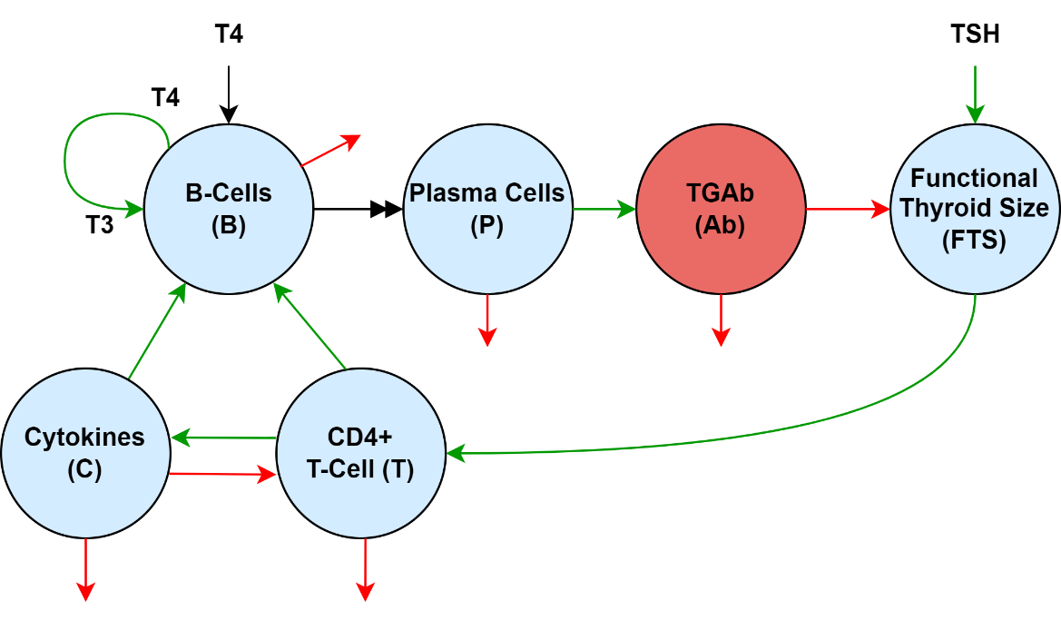

**Figure 2:** Immune system submodel. Green arrows represent stimulatory effects causing proliferation or differentiation, while red arrows represent degradation or destruction. T4 in plasma enters the B-cell and generates T3 for thyromimetic effects. The double-headed black arrow from B-cells to plasma cells indicates differentiation in which a B-cell matures into a plasma cell.

TPOAb and TGAb are grouped into a single compartment *Ab* in ODE (6). The dynamics of antibody in the blood were modeled as the difference between plasma cell antibody production and the loss of antibody either through internalization by thyroid cells or due to degradation calculated from experimental half-life12.

|  |  |
| --- | --- |
|  | (6) |

The terms with form $\frac{C}{C+τ}$ in the B-cell and T-cell equations (1) and (4) represent the saturable, threshold-dependent cytokine production and activation of the cells. Cytokine levels far below the thresholds $τB and tauT$ have little effect on cell dynamic, while the effect of very large cytokine levels is constant after the cell receptors are saturated9. The term $\left(\frac{\text{TSH}}{\text{FTS}}{\text{FTS}}_{0}\right)$ in *FTS* Eq. (5) represents the TSH-driven growth of functional thyroid size which increases as *FTS* approaches zero as the body attempts to increase *FTS* by promoting thyroid growth and upregulating the amount of thyroid hormone produced by remaining thyroid follicular cells. The remaining terms represent standard growth ( $Φ_{i}$ and $σ_{i}$) and leaks ($δ_{i}$) as summarized in Table 1 below.

*II. Thyroid Hormone Regulation Subsystem Model:* The T3 and T4 secretion rates *SR3* and *SR*4 in p-THYROSIM are modified as in (7) and (8) below, to account for changing *FTS* and corresponding thyroid hormone production rates, by multiplying them by a proportionality constant dependent on the current *FTS* and the patient’s predicted euthyroid *FTS*:

|  |  |
| --- | --- |
| $$SR_{4IM}=\frac{\text{FTS}}{{\text{FTS}}_{0}}\left(SR_{4}\right)$$ | (7) |
| $$SR_{3IM}=\frac{\text{FTS}}{{\text{FTS}}_{0}}\left(SR_{3}\right)$$ | (8) |

The remaining components and their parameter values in p-THYROSIM are unchanged, under the assumption that only the thyroid gland and its associated component parameters are affected by the immune subsystem.

*III. Full Model:* The full integrated compartmental model is shown in figure 3.

|  |  |  |  |  |
| --- | --- | --- | --- | --- |
| **Parameter** | **Description** | **Value** | **Units** | **Source** |
| $$Φ_{B}$$ | B-cell activation rate | 1 | 1/s | 9 |
|  | Plasma cell transformation rate | 3 | 1/s | 9 |
|  | CD4+ helper T-cell activation rate | 8.05 | cell/(mL2·sec) | 11 |
|  | Cytokine production rate | 51.84 | molecule/(cell·sec) | 13 |
|  | Relative FTS growth rate | 1e7 | mL3/(mU·s) | 8 |
|  | Ab production rate | 1e4 | molecules/(cell·s) | 12 |
|  | B-cell death rate | 2.0e-7 | 1/s | 14 |
|  | Plasma cell death rate | 2.0e-7 | 1/s | 14 |
|  | CD4+ T-cell death rate | 8.91e-7 | 1/s | 11 |
|  | Cytokine degradation rate | 0.189 | 1/s | 10 |
|  | Functional thyroid destruction rate | 1e-3 | mL/(molecules·s) | 15 |
|  | Plasma Ab degradation rate | 1.74e-6 | mL2/(molecules·s) | 12 |
|  | B-cell binding threshold | 18e4 | molecules/mL | 16 |
|  | T-cell binding threshold | 2e4 | molecules/mL | 16 |
|  | T3 B-cell stimulation rate | 100 | cell/(mcg·s) | Simulation |
| $$σ_{T}$$ | T-cell stimulation rate | 9.1e-3 | 1/s | 13 |
|  | Maximal growth ratio | 0.250 | mU/mL2 | 8 |
|  | Euthyroid *FTS* | 13.5 | mL | 17 |

**Table 1:** Initial parameter estimates and sources for ThyrIMsim. The rate $σ_{B}$ at which plasma T4 (via conversion to T3 in the cell) stimulates B-cell proliferation is unknown and is estimated using the initial ThyrIMsim model. Note state variables of the full model are influenced by parameters listed in terms of molecule number are converted to standard units before plotting. Parameters for the thyroid hormone regulation submodel can be found in Cruz-Loya et al6.

|  |  |  |  |  |
| --- | --- | --- | --- | --- |
| **State Variable** | **Description** | **Value** | **Units** | **Source** |
| *B* | Activated B-cells | 100 | cells/mL | 9 |
| *P* | Plasma Cells | 80 | cells/mL | Simulation |
| *T* | Activated CD4+ Helper T-Cells | 805 | cells/mL | 18 |
| *C* | Cytokines | 6.022e15 | molecules/mL | 9 |
| *FTS* | Functional thyroid size | 11 | mL | 17 |
| *Ab* | Thyroid peroxidase antibody | 3.122e6 | molecules/mL | 17 |
|  |  |  |  |  |

**Table 2:** State variable initial conditions and sources. The cytokine state variable was estimated using the average value of plasma IL2 and IL4 recorded by Atitey et al9. Note *B*, *P* and *T* are combined into a single *Leukocyte* compartment for graphing and parameter estimation.

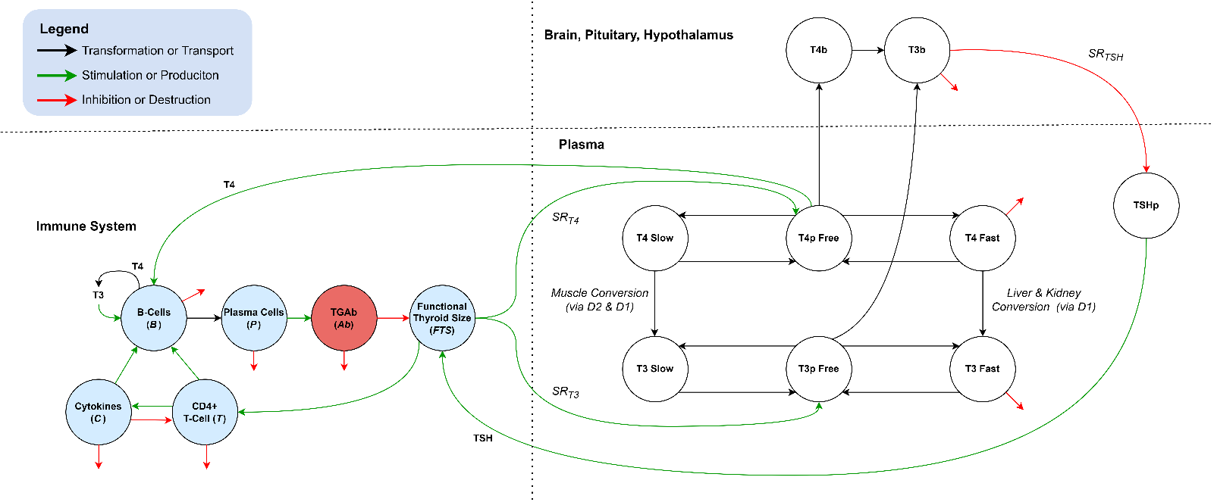

**Figure 3:** Complete model. Thyroid immune interaction occurs primarily via the functional thyroid compartment (*FTS*) which is upregulated by the thyroid subsystem and downregulated by the immune system in Hashimoto’s disease. T3 also plays a role in controlling B-cell dynamics. Thyroid subsystem development and details can be found in Cruz-Loya et al6.

**Parameter Estimation.** The system of ODEs was implemented in the *Julia* programming language22 and solved using the *DifferentialEquations.jl*23 library. The library includes callback functionality, providing a simple way to incorporate discrete levothyroxine and liothyronine dosages. Initial parameter values were estimated from literature when available (Table 1). The model was fitted to patient data in two stages. First, the model was fit to median values of all available patient data for each state variable, yielding baseline parameter values. The model was then fitted to individual patient lab and medication data, giving a total of __ sets of parameters averaged to obtain the final parameter estimates presented in Table X (TODO).

The fitting process was performed using the Nelder-Mead optimization search routine in the *Optim.jl*24 library. The cost function for optimization was weighted least squares (*WLS*) (9):

$$WLS\left(p\right)=\sum_{j}^{j=1}{\sum_{i}^{i=1}{\frac{1}{μ_{j}}{\left(z_{ij}-y_{ij}\right)}^{2}}} (9)$$

where *p* is the vector of unknown optimized parameters; *i* is the index of time points *ti*; *j* is the index of the *jth* model output *yij* or output data measurement *zij* at time *ti*. The measures state variables or combinations of state variables are $FTS,\text{T4, T3, TSH, Lymphocytes, Ab}$, where *Ab = TPOAb* and Lymphocytes = *B* + *T* + *P*. Variabilities for the estimated parameters were then obtained using Newton’s method along with a maximum likelihood loss function starting at the optimal parameters found via Nelder-Mead search, as explained in detail in Cruz-Loya et al. Approximations of the inverse Hessian used in the search routine provide variability estimates for each fitted parameter [DiStefano 2015] and are given in Table 4.

**Parameter Estimate Variability.** TODO

**Results**

**Euthyroid Comparison to p-THYROSIM.** Before simulating Hashimoto’s disease, the ThyrIMsim model was validated for euthyroid patients by setting the initial values for all immune state variables in Table 2 to zero and running the model for 30 days. The results of this simulation were then plotted and compared to p-Thyrosim as shown in Figure 4. Identical results in the two models indicate that ThyrosimIM is stable for euthyroid patients and will not switch from euthyroid to hypothyroid conditions without immune subsystem stimulation. ThyrIMsim was then run using the immune submodel parameters and initial conditions listed in Table 1 and Table 2. The results are plotted in Figure 5. (FIGURE 4-5 TO BE ADDED)

**Simulation of Steady-State Hypothyroidism.** TODO

**Predicting Treatment Response in HD Patients.** TODO

**Discussion**

The work presented in this paper addresses a crucial yet missing element in dynamical thyroid modeling by augmenting p-THYROSIM, a program compiling over 50 years of our group’s research in computational thyroid regulation system modeling6,19. The addition of an immune submodel not only improves simulation accuracy for T3 and T4 levels but also provide insight into the quantitative levels of immune components and their interplay with thyroid system variables, and how they change over time in Hashimoto’s thyroiditis. Clinically, the model may provide physicians with continuous predictions of antibody levels, which often go unmeasured, allowing them to tailor treatment accordingly…. TO FINISH

**References**

1. Ragusa, F. et al. Hashimotos’ thyroiditis: Epidemiology, pathogenesis, clinic and therapy. Best Practice & Research Clinical Endocrinology & Metabolism 33, 101367 (2019).

2. Ralli, M. et al. Hashimoto’s thyroiditis: An update on pathogenic mechanisms, diagnostic protocols, therapeutic strategies, and potential malignant transformation. Autoimmun Rev 19, 102649 (2020).

3. Jing, L. & Zhang, Q. Intrathyroidal feedforward and feedback network regulating thyroid hormone synthesis and secretion. Front. Endocrinol. 13, 992883 (2022).

4. Jara, E. L. et al. Modulating the function of the immune system by thyroid hormones and thyrotropin. Immunology Letters 184, 76–83 (2017).

5. Wenzek, C. et al. The interplay of thyroid hormones and the immune system – where we stand and why we need to know about it. European Journal of Endocrinology 186, R65–R77 (2022).

6. Cruz-Loya, M., Chu, B. B., Jonklaas, J., Schneider, D. F. & DiStefano, J. Optimized Replacement T4 and T4+T3 Dosing in Male and Female Hypothyroid Patients With Different BMIs Using a Personalized Mechanistic Model of Thyroid Hormone Regulation Dynamics. Front. Endocrinol. 13, 888429 (2022).

7. Thakar, J., Poss, M., Albert, R., Long, G. H. & Zhang, R. Dynamic models of immune responses: what is the ideal level of detail? Theor Biol Med Model 7, 35 (2010).

8. Pandiyan, B., Merrill, S. J., Di Bari, F., Antonelli, A. & Benvenga, S. A patient-specific treatment model for Graves’ hyperthyroidism. Theor Biol Med Model 15, 1 (2018).

9. Atitey, K. & Anchang, B. Mathematical Modeling of Proliferative Immune Response Initiated by Interactions Between Classical Antigen-Presenting Cells Under Joint Antagonistic IL-2 and IL-4 Signaling. Frontiers in Molecular Biosciences 9, (2022).

10. Conlon, P. J., Tyler, S., Grabstein, K. H. & Morrissey, P. Interleukin-4 (B-cell stimulatory factor-1) augments the in vivo generation of cytotoxic cells in immunosuppressed animals. Biotechnol Ther 1, 31–41 (1989).

11. Tsukamoto, H. et al. Age-associated increase in lifespan of naïve CD4 T cells contributes to T-cell homeostasis but facilitates development of functional defects. Proceedings of the National Academy of Sciences 106, 18333–18338 (2009).

12. Bonin, C. R. B., Fernandes, G. C., dos Santos, R. W. & Lobosco, M. Mathematical modeling based on ordinary differential equations: A promising approach to vaccinology. Human Vaccines & Immunotherapeutics 13, 484–489 (2017).

13. Bianca, C., Chiacchio, F., Pappalardo, F. & Pennisi, M. Mathematical modeling of the immune system recognition to mammary carcinoma antigen. BMC Bioinformatics 13 Suppl 17, S21 (2012).

14. Amanna, I. J. & Slifka, M. K. Mechanisms that determine plasma cell lifespan and the duration of humoral immunity. Immunol Rev 236, 125–138 (2010)

15. Korem Kohanim, Y. et al. Dynamics of thyroid diseases and thyroid‐axis gland masses. Molecular Systems Biology 18, (2022).

16. Burke, M. A. et al. Modeling the Proliferative Response of T Cells to IL-2 and IL-4. Cellular Immunology 178, 42–52 (1997).

17. Carlé, A. et al. Thyroid Volume in Hypothyroidism due to Autoimmune Disease Follows a Unimodal Distribution: Evidence against Primary Thyroid Atrophy and Autoimmune Thyroiditis Being Distinct Diseases. The Journal of Clinical Endocrinology & Metabolism 94, 833–839 (2009).

18. den Braber, I. et al. Maintenance of Peripheral Naive T Cells Is Sustained by Thymus Output in Mice but Not Humans. Immunity 36, 288–297 (2012).

19. Eisenberg, M., Samuels, M. & DiStefano, J. J. Extensions, Validation, and Clinical Applications of a Feedback Control System Simulator of the Hypothalamo-Pituitary-Thyroid Axis. Thyroid 18, 1071–1085 (2008).

20. Delivanis, D. A. et al. Pembrolizumab-Induced Thyroiditis: Comprehensive Clinical Review and Insights Into Underlying Involved Mechanisms. J Clin Endocrinol Metab 102, 2770–2780 (2017).

21. Ozaki, T. et al. Thyroid Regeneration: Characterization of Clear Cells After Partial Thyroidectomy. Endocrinology 153, 2514–2525 (2012).

22. Bezanson, J., Edelman, A., Karpinski, S. & Shah, V. B. Julia: A Fresh Approach to Numerical Computing. SIAM Rev. 59, 65–98 (2017).

23. Rackauckas, C. & Nie, Q. DifferentialEquations.jl – A Performant and Feature-Rich Ecosystem for Solving Differential Equations in Julia. The Journal of Open Research Software 5, (2017).

24. Mogensen, P. K. & Riseth, A. N. Optim: A mathematical optimization package for Julia. Journal of Open Source Software 3, 615 (2018).

**Appendix**

_________________________________________________________________________________________________________________________

*Complete code for the current model is available at*[**https://github.com/aidanboyne/BioCyb_UCLA**](https://github.com/aidanboyne/BioCyb_UCLA)

_________________________________________________________________________________________________________________________

**Summary of cytokines action in Hashimoto’s thyroiditis**

*Note: References cited in text*

1. **IFN**- $γ$: macrophage, NK, neutrophil activator. A relationship could be demonstrated between high y-IFN production and natural killer (NK) activity in T cell clones from thyroid and peripheral blood of HT patients (del Prete).
   * Tau G, Rothman P. Biologic functions of the IFN-gamma receptors. Allergy. 1999 Dec;54(12):1233-51. doi: 10.1034/j.1398-9995.1999.00099.x. PMID: 10688427; PMCID: PMC4154595.
   * Del Prete GF, Tiri A, Mariotti S, Pinchera M, Rici M, Romagnani S. Enhanced production of IFNγ by thyroid-derived T cell clones from patients with Hashimoto's thyroiditis. Clin Exp Immunol. 1987;69:323–31.
2. **TNF- $α$**: promotes inflammation and cell death, significantly higher in Hashimoto's and many other autoimmune disorders.
   * Jang DI, Lee AH, Shin HY, Song HR, Park JH, Kang TB, Lee SR, Yang SH. The Role of Tumor Necrosis Factor Alpha (TNF-α) in Autoimmune Disease and Current TNF-α Inhibitors in Therapeutics. Int J Mol Sci. 2021 Mar 8;22(5):2719. doi: 10.3390/ijms22052719. PMID: 33800290; PMCID: PMC7962638.
   * Díez, Juan J et al. “Serum concentrations of tumour necrosis factor-alpha (TNF-alpha) and soluble TNF-alpha receptor p55 in patients with hypothyroidism and hyperthyroidism before and after normalization of thyroid function.” Clinical endocrinology vol. 57,4 (2002): 515-21. doi:10.1046/j.1365-2265.2002.01629.x
3. **TGF**-:
   * 1. Suppresses the proliferation and differentiation of effector T-cells via inhibition of Th2-produced IL-2
     2. Initially suppresses Hashimoto's, then stimulates fibrosis at end stages of disease.
     3. Stimulates naive CD4+ T-cells transformation to effector T-cells
     4. 3.Alters the type of produced cytokines and mediates phenotypic metamorphosis among effector T-cells
     5. 4.Enhances TNF production by both CD4+ and CD8+ T-cells
     6. 5.Enhances the proliferation of CD8+ cells (in experimental mouse models)
     7. 6.Stimulates transformation of nTregs to iTregs via increased Foxp3 expression
     8. 7.Promotes Treg-induced inhibition of the exocytosis of granules
     9. 8.Inhibits the generation and activation of cytotoxic T lymphocytes (CTLs)
     10. 9.Suppresses the cytotoxicity of the CTLs via the transcriptional regression of genes encoding proteins, which are vital for CTLs function
     11. 10. Inhibits B-cell activation
   * Kardalas E, Maraka S, Papagianni M, Paltoglou G, Siristatidis C, Mastorakos G. TGF-β Physiology as a Novel Therapeutic Target Regarding Autoimmune Thyroid Diseases: Where Do We Stand and What to Expect. Medicina (Kaunas). 2021 Jun 14;57(6):621. doi: 10.3390/medicina57060621. PMID: 34198624; PMCID: PMC8232149.
4. **IL2:** promotes T-cell, B-cell proliferation. Upregulated by IL4. Primarily produced by B-cells9. One of primary cytokines considered in the model.
5. **IL4**: promotes B, T-cell growth and induces CD4+ differentiation indirectly upregulating IL2,4,10 production. Likewise, indirectly inhibits IFN- $γ$. One of the primary cytokines considered in the model along with IL2
   * Stephen T. Smiley, Michael J. Grusby, in Encyclopedia of Immunology (Second Edition), 1998
   * Bossowski, A., Harasymczuk, J., Moniuszko, A. et al. Cytometric evaluation of intracellular IFN-γ and IL-4 levels in thyroid follicular cells from patients with autoimmune thyroid diseases. Thyroid Res 4, 13 (2011). <https://doi.org/10.1186/1756-6614-4-13>
6. **IL9** - immune responses against parasites and pathogenesis of allergic diseases. Unlikely to be contributor to HT pathology.
   * Rojas-Zuleta, Wilmer Gerardo, and Elizabeth Sanchez. “IL-9: Function, Sources, and Detection.” Methods in molecular biology (Clifton, N.J.) vol. 1585 (2017): 21-35. doi:10.1007/978-1-4939-6877-0_2
7. **IL10** – immune response inhibitor. In Hashimoto’s disease, Th1 response overrides the effects of anti-inflammatory Th2-dependent mediators such as IL-10. When autoimmune processes have subsided (i.e. in late stage Hashimoto’s), IL-10 expression progressively decreases, even in the presence of lymphomononuclear infiltration.
   * de la Vega JR, Vilaplana JC, Biro A, Hammond L, Bottazzo GF, Mirakian R. IL-10 expression in thyroid glands: protective or harmful role against thyroid autoimmunity? Clin Exp Immunol. 1998 Jul;113(1):126-35. doi: 10.1046/j.1365-2249.1998.00628.x. PMID: 9697995; PMCID: PMC1905025.