Life on the edge: industrial footprint and edge effects variably influence the spatial distribution of a boreal small mammal

Aidan Brushett*¹, Emerald Arthurs¹, Jason T. Fisher²

* Correspondence author. Email: aidanbrushett@uvic.ca
¹ Equal co-authors; School of Environmental Studies, University of Victoria, Victoria, Canada
² School of Environmental Studies, University of Victoria, Victoria, Canada

Abstract
- Wildlife distributions are entrained by the integration of biophysical processes operating across spatial scales and levels of ecological organization. In the Boreal Plains of Alberta, Canada, development from the oil, gas, and timber industries is dramatically restructuring western boreal landscapes by altering both the composition and configuration of wildlife habitat.
- Using data from 430 camera-traps across 10 boreal landscapes from 2021 to 2024, we examined how landscape structure at multiple spatial scales influences the distribution of the North American red squirrel. We measured the relative abundance of squirrels across a gradient of anthropogenic disturbances and used multi-model selection to compare the relative influence of disturbance composition and configuration metrics on red squirrel detections.
- Red squirrel abundance was best explained by natural habitat characteristics on local spatial scales but had a negative relationship with anthropogenic edge density on the population level. Cumulative site disturbance positively affected red squirrels, possibly by providing resource complements at forest edges. Edge density interacted with cumulative site disturbance, such that edge effects were more strongly negative in heavily disturbed landscapes.
- We suggest that this pattern may be due to population-level shifts arising from increased encounters with mammalian and avian predators at forest edges. Anthropogenic disturbances that create a high amount of edge habitat, especially seismic lines, may have a disproportionately negative impact on red squirrels. that exceed predictions based on habitat composition alone.
- Synthesis and applications: The ecological mechanisms through which landscape structure impact wildlife extend beyond straightforward measures of habitat loss. Our findings highlight that both habitat composition and spatial configuration must be considered on appropriate spatial scales when assessing wildlife responses to anthropogenic development.

Keywords: Boreal ecology, camera trap, edge effects, configuration, landscape structure, wildlife distributions, spatial scale

Introduction
Human-caused alteration of landscapes is a dominant driver of changes to biodiversity globally (Johnson et al., 2017; Maxwell et al., 2016). As natural resource extraction, agriculture, and urban expansion encroach on wild spaces, wildlife are increasingly displaced or forced to compete for space with anthropogenic activities (Johnson et al., 2017; Shackelford et al., 2018). Uncovering the ecological mechanisms that drive this process, however, is a long-standing and pressing challenge facing ecologists. Landscapes are complex, multi-scale matrices of habitat, resources, energy, and organisms (Forman & Godron, 1981; Holling, 1992). Wildlife distributions are entrained by the integration of individual and population responses to biophysical processes across multiple spatial scales (Levin, 1992). Both the configuration and composition of landscapes, collectively deemed landscape structure (Dunning et al., 1992), exert a strong influence on local wildlife abundance—variations in either habitat amount or spatial patterning of habitat patches can lead to markedly different distributions of organisms, ecological processes, and community structures (Dunning et al., 1992; Tscharntke et al., 2012), providing a lens through which to understand disturbance effects on wildlife.

In terrestrial systems, anthropogenic disturbances change landscape structure through multiplex changes to both composition and configuration. Natural resource development, for example, reduces the total amount of habitat available to wildlife, while also reconfiguring remaining habitat into smaller, more-isolated patches via fragmentation (Didham, 2010; Wilson et al., 2016). The resulting mosaic of dissimilar habitat patches can further affect wildlife by influencing connectivity, edge habitat, resource availability, or predation risk (Haddad et al., 2015; Kremsater & Bunnell, 1999; Pfeifer et al., 2017). While the relationship between habitat loss and declines in terrestrial biodiversity is well established (Brooks et al., 2002), the independent, additional influence of landscape configuration is more contentious, with conflicting evidence for fragmentation effects presented across studies (see Fahrig, 2017; Fletcher et al., 2018; Martin, 2018). A critical challenge in determining the relative importance of each process is that fragmentation is hierarchically connected to habitat loss in many real-world ecological systems—most habitat loss also results in net increase in fragmentation (Didham et al., 2012; Ruffell et al., 2016). Yet, the differential ecological mechanisms of habitat loss and fragmentation have distinct consequences for the assembly and functioning of wildlife communities (Sousa, 1984; Swihart et al., 2006), and both must be evaluated in specific terrestrial systems when seeking to understand how human activities shape species distributions.

Few regions embody the challenge of understanding landscape structure more than the Boreal Plains of North America. Western boreal systems are characterized by a naturally heterogeneous mosaic of vegetation and biophysical traits, including wetlands, aspen parkland, conifer lowland, and forests in a variety of successional stages (Kenkel et al., 1997). Although the boreal has been stewarded and developed by humans for generations (Lewis, 1982; Timoney, 2003), the Boreal Plains have undergone unprecedented structural changes in recent decades at the collective hands of the timber, mining, and energy industries. Superimposed on the naturally ‘patchy’ ecosystems of the Boreal Plains is a pervasive network of cut blocks, roads, seismic lines, well pads, and processing facilities dedicated to the extraction, refinement, and transportation of natural resources (Pasher et al., 2013; Pickell et al., 2015). Disturbances such as fire are essential processes that maintain the ecological organization of western boreal systems (Weber & Flannigan, 1997), but the cumulative effects of decades of industrial development and fire suppression have eclipsed the influence of any natural processes to create an unprecedented spatial reorganization of boreal habitat and resources (Pickell et al., 2015). Although energy sector disturbances constitute less than 2% of the footprint of Alberta’s boreal forest by area (Alberta Biodiversity Monitoring Institute, 2023a), their high density and persistence have fundamentally transformed boreal landscape composition and configuration. For instance, over 1.8 million kilometers of seismic lines—persistent linear features used to map underground oil and gas deposits—stretch across the western boreal, producing disproportionate amounts of forest edge habitat, early-seral vegetation, and movement corridors through otherwise intact tracts of habitat (Dabros et al., 2018; Lee & Boutin, 2006).

Confronted by these novel landscapes, the resident wildlife of the Boreal Plains must contend with the vast footprint of natural resource industries (Venier et al., 2014). Virtually all boreal mammals have been impacted positively or negatively by anthropogenic activities in the western boreal (Curveira-Santos et al., 2024; Fisher & Burton, 2018). Past research has heavily emphasized the effects of habitat and disturbance composition on boreal mammals, wherein changes in resource availability have evoked a multitude of complex changes to population sizes, wildlife behaviours, and trophic and competitive interactions among species (Burgar et al., 2019; Fisher & Ladle, 2022; McKenzie et al., 2012; Tattersall et al., 2020). The effects of landscape configuration in the western boreal have received comparatively little attention, despite emerging empirical evidence that boreal wildlife responses to changing landscape structure can exceed predictions based on habitat composition alone (Smith et al., 2024).

Discriminating the interacting roles of habitat composition and configuration is critical for predicting wildlife outcomes in the Boreal Plains (Côté et al., 2016). Conceptual frameworks of fragmentation suggest that the importance of habitat configuration for wildlife populations varies non-linearly along a gradient of habitat availability, such that the ecological effects of fragmentation are most pronounced in landscapes that have low or intermediate amounts of suitable habitat (Andrén, 1994; Didham, 2010; Villard & Metzger, 2014). In the Boreal Plains, where levels of industrial land-use span large gradients, the effects of landscape structure are likely dependent on both spatial scale and characteristics of the habitat matrix. Thus, empirical studies that explicitly test species-specific relationships to landscape configuration and composition across spatial scales (e.g., Püttker et al., 2020) are critical to understanding the complete impacts of industrial development on boreal wildlife.

In this study, we present a case study of the North American red squirrel (Tamiasciurus hudsonicus) to investigate these concepts. Widespread throughout the Boreal Plains, red squirrels are seed predators whose dependence on mature, cone-producing conifer or mixed-forest ecosystems has been demonstrated across multiple spatial scales and ecozones (Fisher et al., 2005; Larsen, 2009; McDermott et al., 2020; Rusch & Reeder, 1978), representing an ideal model species for disentangling the role of landscape structure in western boreal systems. Natural and anthropogenic disturbances, including wildfire and timber harvesting, directly affect red squirrel habitat composition by removing key resources found in mature forest (reviewed by Fisher & Wilkinson, 2005). Likewise, cleared anthropogenic features characteristic of the energy industry infrastructure may offer few resource subsidies. Landscape structure’s impact on red squirrels has mostly been explored in the context of agricultural matrices (Bayne & Hobson, 2000; Patterson & Malcolm, 2010; but see Fisher et al., 2005). In boreal systems, oil, gas, and timber development can introduce changes to vegetation structure along forest edges (Harper et al., 2015; R. S. Jackson et al., 2023) that may decrease landscape permeability and red squirrel movement (Bakker & Van Vuren, 2004), affect squirrel behaviour (Anderson & Boutin, 2002), or influence the abundance (Tattersall et al., 2020), and functional responses (McKenzie et al., 2012) of co-occurring predators. Even in heavily disturbed landscapes, the cumulative footprint of seismic lines represents a small amount of habitat loss sensu stricto for red squirrels. A strict focus on the amount of environmental footprint is likely to underestimate true ecological effects due to the high density of industrial features and accompanying reconfiguration of habitat (Dabros et al., 2018). Explicitly testing the influences of composition and configuration on red squirrel distribution may yield valuable insights into the effects of landscape structure on ecological processes in rapidly changing Boreal Plains ecosystems more broadly.

Our specific objective was to investigate the degree to which habitat composition, anthropogenic disturbance composition, and configuration influence red squirrel distribution in the remaining habitat matrix of Boreal Plains landscapes, as well as the spatial scale of those effects. We hypothesized that: (i) both habitat loss and fragmentation from industrial development would influence red squirrel distribution, but (ii) the independent effects of habitat fragmentation would be greatest in landscapes where the amount of anthropogenic disturbance was high. To accomplish our objectives, we deployed 430 motion-activated cameras across the Boreal Plains that measured the relative abundance of red squirrels in landscapes with variable proportions and spatial patterns of forest habitat, seismic lines, cut blocks, and other industrial disturbances. We separately characterized landscape composition and configuration by determining the proportion of natural land cover or disturbance footprint in local landscapes, and derived three metrics representing the spatial pattern of habitat and disturbances: edge density created by anthropogenic features, effective mesh size, cohesion (isolation), and Shannon’s Evenness Index of remnant natural habitat. We expected that the relative abundance of red squirrels, as measured by detection rates on camera traps, would be highest in areas with a high proportion of mature conifer or mixed-wood forest relative to other natural habitat types. We also predicted that red squirrel relative abundance would be negatively related to the proportion of any cleared anthropogenic features (well pads, roads, and seismic lines). Finally, we expected that fragmentation effects (e.g., creation of anthropogenic edges or isolation of habitat patches) by industrial disturbances would have a negative, context-dependent relationship with red squirrel relative abundance, that was strongest in landscapes with high amounts of total disturbance.

Methods

Study area
The Boreal Plains ecozone spans 740 000 km² of the boreal forest in Treaty 8 Territory and encompasses a wide variety of vegetative land cover, climate, productivity, and human activity. The region is characterized by a mosaic of aspen parkland, mixed broadleaf, white spruce, and jack pine forest, black spruce lowland forest, as well as wetlands, muskeg, fens, and lakes. We studied ten landscapes (Fig. 1) representing aggregations of 3–5 watersheds with a total area of 1000–3000 km² (Bayne et al., 2021) across the Boreal Plains. Landscapes spanned a gradient of low–high industrial development intensity and a variety of anthropogenic land-use types that included timber harvesting, open pit bitumen mining, and in situ oil and gas extraction. Common disturbance features included timber cut blocks, seismic exploration lines, well pads, roads, pipelines, and processing facilities (Fig. 1) with varying degrees of human use or active restoration. Other common small- and medium-sized mammals in our study area included the American marten (Martes americana), fisher (Pekania pennanti), Canada lynx (Lynx canadensis), coyote (Canis latrans), snowshoe hare (Lepus americanus), and North American beaver (Castor canadensis), along with a diverse community of small rodents. Common avian predators of red squirrels included the northern goshawk (Accipiter gentilis) and great horned owl (Bubo virginianus).

Camera trapping and wildlife occurrence data
We deployed motion-activated camera traps within each of our ten landscapes between 2021 and 2024 with the intended purpose of monitoring red squirrels and other medium- to large-sized mammals up to the size of moose (Fig. 1). Cameras were deployed using a constrained stratified sampling design. First, we divided landscapes into 2 km² hexagonal cells and randomly selected ~60 potential cells for camera deployment within strata corresponding to either upland forest (low moisture, >50% deciduous) and lowland forest (high moisture, >50% coniferous), or forest type (broadleaf, coniferous, and mixed). Camera placements in randomly selected hexagonal cells were constrained to locations >100 m from roads and >1 km from neighbouring camera placements to maintain independent sampling. Infrared camera traps (Reconyx PC900 Hyperfire or Hyperfire II Professional; Holmen, WI, USA) were placed approximately 100 cm above the ground, facing a wildlife trail 3–7 meters away. To avoid confounding movement with habitat use (Stewart et al., 2018), cameras used in analyses were not directly deployed on human trails or seismic lines unless these features had clear wildlife signs. To maximize wildlife detectability, we applied a scent lure (O’Gorman’s Long Distance Call, MT, USA) once at each site at the time of deployment (either September or October). Camera traps were programmed to take photos continuously at high sensitivity when movement was detected within the field of view. A total of 430 cameras were deployed across the ten landscapes (mean 43 per landscape, range 36–50). Within the 2021–2024 sampling period, each camera was deployed for approximately one year (autumn to autumn; mean=347 days, SD= 67.2 days).

To quantify the occurrence of red squirrels in each landscape, all images of wildlife occurrences were reviewed and classified to the species level using the image processing software Timelapse 2.0 (Greenberg et al., 2019), then aggregated to identify independent detections of red squirrels. We defined independent detection events for red squirrels as those occurring >30 minutes apart at a given camera site. Previous evidence suggests that independent detections of red squirrels correlate well with density estimates from other field methods (Villette et al., 2017). Our models were insensitive to independent detections defined using different time thresholds (5 min, 30 min, 60 min). To create a response variable for statistical modelling, we binned red squirrel detections into monthly independent detections. We assumed that the number of monthly detections at each camera site represented a relative index arising from both the local abundance and intensity of site use of red squirrels at that site (Burton et al., 2015; Parsons et al., 2017). We treated non-detections as true absences and elected not to use occupancy models (MacKenzie et al., 2002) for our statistical analyses. Any given sampling month was excluded from our final dataset when there were fewer than fifteen days of available camera-trap data.

Measuring landscape structure
We used the Alberta Biodiversity Monitoring Institute (ABMI) 2021 Human Footprint Index dataset (Alberta Biodiversity Monitoring Institute, 2023b) to determine the amount and type of anthropogenic disturbance features across our study area, and the Wulder et al. (2024) Satellite-Based Forest Inventory to measure forest structure, amount of vegetative land cover, and fire disturbance across our study area. To characterize landscape structure, we derived several variables describing the anthropogenic and natural features surrounding each camera site which we hypothesized a priori to be ecologically related to red squirrel relative abundance (Table 1). Since habitat relationships arise on spatial scales that are taxa- and context-specific (Jackson & Fahrig, 2015; Wiens, 1989), we calculated all configuration and composition covariates at twenty-two spatial scales using concentric circular buffers of 50 m, 100 m, and 250–5000 m radii increasing by 250 m increments sensu Fisher et al. (2011). First, we measured landscape composition: this included the proportion of area around each camera site covered by each dominant land cover type (e.g., forest type, wetland, shrub) and recent (0–15 years) fire disturbance, as well as the proportion of area covered by anthropogenic disturbances (e.g., well pads, roads, timber harvest blocks 0–15 years old; Table 1). As a representation of total disturbance amount, we also adapted the methods of Bayne et al. (2021) to calculate the cumulative site disturbance at each camera location, which was the sum of the proportion of area covered by all anthropogenic disturbances. To measure landscape configuration, we superimposed and rasterized the Human Footprint Index from the Satellite Based Forest Inventory landcover types at a five-meter resolution and extracted four metrics which we hypothesized to correspond to potential mechanisms through which landscape structure affects the distribution of red squirrels (Table 1). Our configuration metrics included natural edge density, representing the total length of patch edges and boundary complexity created by anthropogenic features, effective mesh size, representing the average size of habitat patches and degree of fragmentation, cohesion, representing the connectivity of similar habitat patches, Shannon evenness index, representing dominance and how evenly different land cover types were distributed across the landscape. Cohesion was highly correlated with edge density (Spearman’s r = -0.95) and had very low variance among sites (Table 1). All covariates were processed using the sf (Pebesma, 2018), terra (Hijmans, 2015), and landscapemetrics (Hesselbarth et al., 2019) packages in R v4.3.0 (R Core Team, 2023).

Statistical analysis
Spatial responses of red squirrels to landscape structure were modeled using a multi-step, information theoretic approach (Burnham & Anderson, 2002). For all statistical analyses, we used generalized linear mixed models with a negative binomial distribution and logit link function to account for overdispersion of red squirrel detection data (Faraway, 2016). We opted against using a proportional negative binomial response due to the high overdispersion of red squirrel count data in our dataset and poor overall model fit during exploratory analysis. In each model we treated monthly independent detections as the response variable and included nested random intercepts of camera sites within arrays. Our models took the form:
detections_{ijk} ~ NegBin(μ_{ijk}, θ)
log(μ_{ijk}) = β₀ + β₁x_{1,ijk} + … + β_{n}x_{n,ijk} + u_{i} + v_{i(j)}

where μ_{ijk} is the expected count of independent detections of red squirrels at site i in array j during month k, θ is the overdispersion parameter of the negative binomial distribution, β_{n} is the linear coefficient for landscape covariate x_{n}, and v_{i(j)} and u_{i} are the nested random intercepts of site and array, which were assumed to have a normally distributed variance. All models were fit using maximum likelihood with the Laplace approximation.

All explanatory variables were scaled using standardized z-scaling to improve model convergence and interpretability of relative effect sizes. To test our ecological hypotheses about the relative importance of landscape composition and configuration on red squirrels, we first divided our explanatory variables into three categories corresponding to our ecological hypotheses: [i] composition of natural habitat, [ii] composition of anthropogenic features, and [iii] landscape configuration (Table 1). Since red squirrels may respond to different aspects of landscape structure at separate spatial scales (Fisher et al., 2005), we identified a best-fit scale within each category of predictors before testing our hypotheses. Specifically, within each of our three categories of predictors, we fit a model using all predictors at each of the twenty-two spatial scales (i.e., 50–5000m) and compared AICc scores across spatial scales to determine which one was best supported for statistical modelling. This approach allowed us to empirically evaluate the appropriate scales for modelling and flexibly incorporate the effect of natural habitat composition, anthropogenic composition, and landscape configuration on red squirrel distribution at separate spatial scales.

We performed model selection on a set of candidate models that corresponded to our hypotheses about habitat amount, habitat configuration, and context-dependent effects of habitat configuration using a hierarchical approach. To test whether natural habitat composition alone could describe red squirrel distribution (i.e., no disturbance or configuration effects), we performed model selection on a set of candidate models, including a global model of all fire and land cover type covariates sensu Chow-Fraser et al. (2022). We deemed this our ‘core model’, and included these variables in all models moving forward. We then combined covariates from each of the three categories into a candidate model set describing our hypotheses about the effects of landscape structure on red squirrel distribution. We did not include roads in any models due to their high correlation with other anthropogenic disturbances (especially well sites and industrial facilities) at our selected spatial scale. Configuration metrics were highly correlated with variables for anthropogenic disturbance type, so our candidate model set was not fully nested. Instead, we represented disturbance in any configuration models using interactions with the aggregate cumulative site disturbance metric, which was not highly correlated with any configuration variables. Our seventeen candidate models allowed us to compare the importance of various components of landscape structure for red squirrel distribution in our study area. We ranked candidate models using AICc scores to compare the importance of various components of landscape structure for red squirrel distribution and identify a best-supported model (Burnham & Anderson, 2002). We treated any candidate models with ∆AIC <3 as well-supported and interpreted them accordingly. Model validity was verified using diagnostic plots of residuals vs. fitted values and collinearity among predictors was assessed using variance inflation factors (VIFs; Zuur & Ieno, 2016). We further investigated model performance with parametric (simulation) bootstrapping by using our top-performing model as a ‘true’ data-generating process (full details in Supplementary Information S1). For a hypothetical scenario of 10 arrays and 43 cameras per array, we simulated 1000 new datasets by sampling landscape covariates from their observed distributions and generating squirrel detections for each camera site using the random variance structure and negative binomial distribution from our top-performing model. We refit the model to each simulated dataset to build an empirical distribution of coefficient estimates, then assessed the empirical precision (standard error) and bias (mean) of our fixed-effect estimates compared to the top model (Zuur et al., 2016). All model selection and top model evaluation were performed using the MuMIn (Barton, 2015) and performance (Lüdecke et al., 2021) packages in R.

Results
We gathered 149,273 camera trap-days of data and 683,259 images, producing 7,399 images and 4,747 independent detections of red squirrels. Red squirrels were detected at least once at 305 of 430 camera trap sites (naive occupancy = 0.709).

The first step of our analysis identified best-fit spatial scales for our three categories of landscape covariates at three separate spatial scales that had strong or moderate model support compared to other scales (Fig. 2). Natural land cover predictors were included in models at a 100 m spatial scale, while composition of anthropogenic features and landscape structure were both included at much larger spatial scales (4250 m and 2250 m, respectively; Fig. 2).

The highest performing ‘core’ natural land cover model variables included the proportion of conifer forest, mixedwood forest, broadleaf forest, and areas burned within 0–15 years (Table 2). However, this ‘core model’ was not well-supported compared to models that included anthropogenic disturbance composition or configuration variables (Table 2). Red squirrel distribution was best explained by a model including natural land cover, edge density, cumulative site disturbance, and an interaction between edge density and site disturbance (AIC = 9394.44, AIC_{w} = 0.568, R²_{conditional}= 0.101, R²_{marginal} = 0.744; Table 2), supporting our hypothesis of disturbance-mediated configuration effects. Red squirrel detections were negatively related to the proportion of broadleaf forest (β = -0.51, SE = 0.12, p <0.001; Fig. 3, Table 3), positively related to the proportion of mixed wood forest (β = 0.16, SE = 0.09, p = 0.08, Fig. 3, Table 3), and unrelated to the proportion of conifer forest (β = -0.03, SE = 0.11, p = 0.771; Fig. 3, Table 3). The amount of recent fire had a weak positive effect on red squirrels (β = 0.158, SE = 0.11, p = 0.16; Fig. 3). Overall, anthropogenic edge density had a weak effect on squirrel detections (β = -0.09, SE = 0.17, p = 0.59, Fig. 3, Table 3) that became much more strongly negative at high levels of cumulative site disturbance via an interaction term (β = -0.26, SE = 0.10, p = 0.01; Fig. 4). Unexpectedly, the effect of cumulative site disturbance itself was the opposite of our predictions and had a positive effect (β = 0.30, SE = 0.12, p = 0.01; Fig. 3). Across simulations, coefficients were accurately and precisely estimated for configuration and disturbance parameters (see Supplementary Information S1). Bootstrapped coefficient estimates showed low bias (deviation from ‘true’ model coefficients < 0.036) for all variables except recent fire (deviation = 0.17). The empirical standard error from bootstrapped coefficients had much higher precision for edge density, mixedwood, and site disturbance metrics (ratio of empirical SE:‘true’ SE <0.55), similar precision for natural land cover (ratio ~1.0), but much lower precision for recent fire (ratio = 32.9)

Our top model only had moderate separation from the second-ranked model (ΔAICc = 2.45, AIC_{w} = 0.156; Table 2), which included effects for the composition of most persistent energy-sector anthropogenic disturbances. Timber harvesting was not included in any well-supported models. In this model, red squirrel detections were negatively related to the proportion cover of seismic lines (β = -0.45, SE = 0.13, p = 0.001; Fig. 3), positively related to pipelines and transmission lines (β = 0.31, SE = 0.13, p = 0.02; Fig. 3), and neutrally related to inactive well sites (β = 0.01, SE = 0.14, p = 0.97; Fig. 3).

Discussion
Disturbance-mediated landscape configuration best-explained the spatial distribution of red squirrels in our study system. Our results highlight a complex, context-dependent relationship between red squirrel distribution, landscape composition, and landscape configuration that varies across locations and spatial scales. Overall, the effect of anthropogenic edge creation had a negative effect on red squirrels that held more explanatory power than any relationship to the composition of specific disturbance features. In alignment with our hypotheses, an increase in the amount of industrial disturbance on the landscape was accompanied by a more pronounced effect of edge habitat—as cumulative site disturbance increased, edge effects caused a sharper decline in red squirrel abundance. However, contrary to our predictions, the effect of cumulative site disturbance itself was positive. Within the boreal landscapes that we sampled, the total footprint of industrial disturbances seldom exceeded 25% of the total habitat matrix. The negative relationship between habitat amount and squirrel abundance predicted by theory (Andrén, 1994; Didham et al., 2012) may not manifest until a higher threshold of cumulative disturbance that is less common in Boreal Plains landscapes. Even in highly fragmented landscapes, red squirrels are adaptable and resilient to high amounts of habitat loss (Bayne & Hobson, 2000), suggesting that the industrial disturbances in our study system do not necessarily contribute to a complete loss of functional habitat and influence red squirrels through other ecological mechanisms.
Natural habitat and anthropogenic disturbance affected red squirrels at drastically different spatial scales that varied by over a full order of magnitude in our models, suggesting that they influence red squirrels via different individual- and population-level processes. Individual red squirrels respond to resource availability and habitat texture at fine spatial scales, matching their small body size and home range (Fisher et al., 1999). The 100 m scale at which natural composition influenced squirrels indicates that differences in squirrel detections across land cover types are most likely due to individual foraging behaviour and local habitat use (Rusch & Reeder, 1978). For instance, relative abundance of squirrels decreased sharply in landscapes with high proportions of deciduous forest, which contain few cone resources compared to conifer and mixedwood forests. The complementary resources found in mixed forest may provide greater foraging opportunities to red squirrels, especially through the boom-bust cycles of spruce cone masting (Hallworth et al., 2024). Although red squirrels are conifer specialists, they are also opportunistic foragers that will consume berries and fungi (Benhamou, 1996). The neutral effect of coniferous forest, however, suggests that in conifer-dominated systems like the Boreal Plains, even low densities of cone-producing trees may meet red squirrels’ resource requirements. Variation beyond a baseline amount of conifer may have a limited influence on the local abundance of a despotic species like the red squirrel. Our results also suggest that fire may increase resource availability for red squirrels by increasing production for tree species with cones opened and distributed by fire (Weber & Flannigan, 1997), but we have low certainty in this effect. In particular, low-intensity fire, including prescribed burning, may not have a negative effect on squirrels when key habitat features are retained (Russel et al., 2010). Overall, we suggest that red squirrels are distributed locally relative to resource quantity and quality on a spatial grain that is a function of their individual ecology.

In contrast to natural land cover, the effects of anthropogenic disturbance composition and configuration were best explained at much larger spatial scales (4250 m and 2250 m, respectively) that exceed the spatial perception of individual animals (Kotliar & Wiens, 1990), suggesting an influence on population-level processes rather than individual space use. Anthropogenic disturbances may mediate population processes such as dispersal, survival, or recruitment on larger meso-scales, rather than individual resource selection (Dunning et al., 1992). This aligns with Fisher et al. (2011), who proposed that large spatial scales (between 2000 m and 4000 m) best explained numerical population responses of squirrels to land-cover type rather than individual habitat use. Thus, we suggest that local resource availability and the configuration of landscape disturbances simultaneously impact red squirrel populations via mechanisms operating on separate scales. Ecological systems represent the integration of many spatial processes (Levin, 1992), and our results emphasize that variability in landscape structure must be studied at multiple levels of ecological organization to achieve a complete understanding of species distributions (Holling, 1992; Wiens, 1989).

The exact population-level mechanisms through which edge density negatively affected red squirrels are difficult to discern from this pattern-describing study. We propose several potential explanations for this relationship. First, the negative effect of edge density could be a reflection of decreased dispersal. Long-range sciurid dispersal is impacted by landscape structure (Hämäläinen et al., 2019; Merrick & Koprowski, 2016), and red squirrels are generally averse to crossing open habitat including timber harvest blocks (Bakker & Van Vuren, 2004), and disperse shorter distances in younger forest stands (Larsen, 2009). However, we note that in our second-supported model, the proportion of pipelines and transmission lines positively affected squirrel detections whereas the proportion of seismic lines negatively affected squirrel detections, despite both types of features representing a similar challenge to red squirrel dispersal. In addition, landscape cohesion—a strong proxy for structural connectivity and dispersal potential (Schumaker, 1996)—performed poorly in models, so we are cautious to accept this interpretation of edge density’s effect.

Alternatively, the negative impact of edge density may be caused by changes to predator-prey relationships. It is well established that the local abundance and movement of mammalian boreal predators, including coyotes, increases on industrial linear features like seismic lines (McKenzie et al., 2012; Tattersall et al., 2020). These features may change predator functional responses and increase predation events for secondary prey like red squirrels, especially if red squirrels are frequently exposed by crossing cleared disturbance features. Avian predators in particular are likely influential for red squirrel populations since red squirrels are a main prey species of raptors like the northern goshawk (Salafsky et al., 2007). Raptors use forest edges for perching (Mirski & Väli, 2021) in agricultural landscapes; edge features that permeate boreal habitat may provide increased visibility, which has been shown to increase predation rates by raptors (Opermanis, 2004).

Contrary to our hypotheses, red squirrel detections were positively related to cumulative site disturbance itself. Cleared anthropogenic features may offer resource complements (Dunning et al., 1992) to red squirrels by altering edge vegetation characterized by denser berry-producing shrubs, fungi, and early-successional herbaceous plants (Harper et al., 2015; Jackson et al., 2023). Fisher et al. (1999) demonstrated that red squirrels use a variety of food resources aside from conifer cones in western boreal systems, and that home range size decreased with increasing resource heterogeneity. Each specific disturbance type in our second-supported model had a different influence on the abundance of red squirrels, and we propose that this disparity is driven by the varying amounts of predation risk and resource complementation that they represent. For instance, pipelines and transmission lines, which had a positive effect in our model, are generally much wider features than seismic lines. These wider features allow for stronger intensity of light, microclimate changes, and edge effects that extend further into surrounding habitat (Franklin et al., 2021; Abib et al., 2019), in turn increasing their potential value as a resource complement. In addition, there is widespread evidence for mesocarnivore use of seismic lines, especially coyotes (Tattersall et al., 2020; Clare et al., 2023), a predator of red squirrels (O’Donoghue et al., 2001; Latham et al., 2013), but there is less evidence for predator use along more exposed features like transmission lines. As such, we suggest that pipelines and transmission lines provide complementary resources for red squirrels while seismic lines provide comparatively fewer resources, while also representing increased predation risk. Previous research aligns with this inference: Beirne et al. (2021) found that a negative relationship between seismic line density and red squirrel abundance that accompanied by increased predator use, and Skatter et al. (2020) found that a positive relationship between red squirrels and pipelines or transmission lines (Skatter et al., 2020).

Caveats paragraph (collapsed into discussion)
Small, cursorial species such as red squirrels can be difficult to measure with precision using camera traps. Our camera traps were designed to simultaneously capture a wide variety of mammal species, and effectively allowed us to model red squirrel distribution across a large spatial extent that would be unfeasible using other field-based methods. Furthermore, although we sampled a gradient of anthropogenic disturbance, camera traps were not directly deployed on anthropogenic disturbance features. Our stratified design was intended to measure red squirrel distribution within the matrix of remaining boreal habitat. As a result, this study may not have captured localized, individual responses to disturbance features, such as the negative effect of timber harvesting documented in other studies (Fisher & Wilkinson, 2005). The proposed mechanism of changes to predation at forest edges warrants further investigation by studies of predation rates or co-occurrence with red squirrels at the edges of anthropogenic disturbance features. We suspect that a large proportion of this shift in predation is driven by raptors like great-horned owls and northern goshawks, but raptor dynamics in disturbed boreal landscapes are poorly understood. Since camera traps generally do not reliably detect birds, synthetic studies or supplementary sources of data (e.g., automated recording units) will likely be required to study mammalian and avian communities concurrently.

Conclusions
Our study demonstrates that red squirrel distribution in the Boreal Plains is influenced by landscape composition and configuration across multiple spatial scales. Each type of disturbance in our study had different influences on red squirrel abundance. We successfully generalized this relationship into a single model describing interacting positive effects of disturbance amount and negative effects of edge density, which we propose are mediated through resource complementation and increased predation, respectively. The ecological mechanisms through which landscape structure impacts red squirrels extend beyond straightforward measures of habitat loss. Expanding the findings of Smith et al. (2024), our work emphasizes the multi-faceted influence of energy sector disturbances in boreal systems. Although red squirrels do not top the list of conservation priorities in the Boreal Plains, their responses to industrial land-use underscore the importance of considering both configuration and composition of anthropogenic disturbances when assessing impacts to mammal populations. Habitat alteration via industrial development and fragmentation are often collinear—there are few industrial development scenarios in which cumulative site disturbance is high but impacts on configuration are low. Our work provides evidence that a strict focus on landscape composition may underestimate the full ecological impact of industrial development on wildlife communities. The multiscale modeling framework presented in this study encompassed an integration of multiple individual- and population-level processes, and could be applied to other species to better understand scale-dependent responses of wildlife to disturbances. As human influence over wild landscapes expands, the management of industrial activities will require cumulative risk approaches (e.g. Tyack et al., 2022) that encompass interacting stressors on wildlife and an increasing appreciation of the multiple ecological mechanisms through which disturbance reshapes the structure and function of ecological communities.

Author contributions
Aidan Brushett and Emerald Arthurs conceived the study, designed the methodology, analyzed the data, and wrote the first draft of the manuscript; Aidan Brushett, Emerald Arthurs, and Jason Fisher collected the data; Jason Fisher oversaw the experimental design; All authors contributed meaningfully to the final draft of the manuscript and gave final approval for publication.

Acknowledgements
Field data were collected by ______________. We are grateful for the comments of _______. Funding was provided by the Oil Sands Monitoring (OSM) program, Natural Sciences and Engineering REsearch Council (NSERC), and University of Victoria’s Applied Conservation Macro Ecology (ACME) lab. Mention Treaty 8 territory?

Conflict of interest
The authors have no conflict of interest to declare.

Data availability statement
All data and scripts used to conduct this analysis are available in the GitHub repository https://github.com/aidanbrushett/OSM_red_squirrel_distribution

Graphical Abstract
Does anyone have any ideas?? Jeff Dixon??

Supporting Information
Detailed simulation outputs, including coefficient distributions and diagnostics, are available in the supporting file (S1_top_model_simulations.html).

References
Abib, T. H., Chasmer, L., Hopkinson, C., Mahoney, C., & Rodriguez, L. C. E. (2019). Seismic line impacts on proximal boreal forest and wetland environments in Alberta. The Science of the Total Environment, 658, 1601–1613. https://doi.org/10.1016/j.scitotenv.2018.12.244
Alberta Biodiversity Monitoring Institute. (2023a). Status of Human Footprint in Alberta. https://doi.org/https://archive.abmi.ca/home/reports/2023/human-footprint
Alberta Biodiversity Monitoring Institute. (2023b). Wall-to-Wall Human Footprint Inventory - Year 2021. https://doi.org/https://abmi.ca/data-portal/46.html
Anderson, E. M., & Boutin, S. (2002). Edge effects on survival and behaviour of juvenile red squirrels (Tamiasciurus hudsonicus). Canadian Journal of Zoology, 80(6), 1038–1046. https://doi.org/10.1139/z02-087
Andrén, H. (1994). Effects of Habitat Fragmentation on Birds and Mammals in Landscapes with Different Proportions of Suitable Habitat: A Review. Oikos, 71(3), 355–366. https://doi.org/10.2307/3545823
Bakker, V. J., & Van Vuren, D. H. (2004). Gap‐Crossing Decisions by the Red Squirrel, a Forest‐Dependent Small Mammal. Conservation Biology, 18(3), 689–697. https://doi.org/10.1111/j.1523-1739.2004.00149.x
Barton, K. (2015). Package ‘mumin.’ Version 1.18.
Bayne, E., Dennett, J., Kohler, M., Ball, J., Bidwell, M., Braid, A., Chetelat, J., Dillegeard, E., Farr, D., Fisher, J., Freemark, M., Foster, K., Godwin, C., Hebert, C., Huggard, D., McIssac, D., Narwani, T., Nielsen, S., Pauli, B., … Mundy, L. (2021). Oil Sands Monitoring Program: A Before-After DoseResponse Terrestrial Biological Monitoring Framework for the Oil Sands. (OSM Technical Report Series No. 7).
Bayne, E., & Hobson, K. (2000). Relative use of contiguous and fragmented boreal forest by red squirrels (Tamiasciurus hudsonicus). Canadian Journal of Zoology, 78(3), 359–365. https://doi.org/10.1139/z99-219
Beirne, C., Sun, C., Tattersall, E. R., Burgar, J. M., Fisher, J. T., & Burton, A. C. (2021). Multispecies modelling reveals potential for habitat restoration to re-establish boreal vertebrate community dynamics. Journal of Applied Ecology, 58(12), 2821–2832. https://doi.org/10.1111/1365-2664.14020
Benhamou, S. (1996). Space use and foraging movements in the American red squirrel (Tamiasciurus hudsonicus). Behavioural Processes, 37(2), 89–102. https://doi.org/10.1016/0376-6357(95)00073-9
Brooks, T. M., Mittermeier, R. A., Mittermeier, C. G., Da Fonseca, G. A. B., Rylands, A. B., Konstant, W. R., Flick, P., Pilgrim, J., Oldfield, S., Magin, G., & Hilton‐Taylor, C. (2002). Habitat Loss and Extinction in the Hotspots of Biodiversity. Conservation Biology, 16(4), 909–923. https://doi.org/10.1046/j.1523-1739.2002.00530.x
Burgar, J. M., Burton, A. C., & Fisher, J. T. (2019). The importance of considering multiple interacting species for conservation of species at risk. Conservation Biology, 33(3), 709–715. https://doi.org/10.1111/cobi.13233
Burnham, K., & Anderson, D. (2002). Model Selection and Multimodel Inference (K. P. Burnham & D. R. Anderson, Eds.). Springer New York. https://doi.org/10.1007/b97636
Burton, A. C., Neilson, E., Moreira, D., Ladle, A., Steenweg, R., Fisher, J. T., Bayne, E., & Boutin, S. (2015). REVIEW: Wildlife camera trapping: a review and recommendations for linking surveys to ecological processes. Journal of Applied Ecology, 52(3), 675–685. https://doi.org/10.1111/1365-2664.12432
Chow-Fraser, G., Heim, N., Paczkowski, J., Volpe, J. P., & Fisher, J. T. (2022). Landscape change shifts competitive dynamics between declining at-risk wolverines and range-expanding coyotes, compelling a new conservation focus. Biological Conservation, 266, 109435. https://doi.org/10.1016/j.biocon.2021.109435
Clare, J. D. J., Zuckerberg, B., Liu, N., Stenglein, J. L., Van Deelen, T. R., Pauli, J. N., & Townsend, P. A. (2023). A phenology of fear: Investigating scale and seasonality in predator–prey games between wolves and white‐tailed deer. Ecology (Durham), 104(5), e4019-n/a. https://doi.org/10.1002/ecy.4019
Constantinou, A., Burton, A. C., Simard, S., & Hodder, D. (2025). Initial Effects of Clearcutting and Partial Retention Forest Harvesting Methods on Some Small Mammals in Northern British Columbia. Journal of Ecosystems and Management, 25(1). https://doi.org/10.22230/jem.2025v25n1a637
Côté, I. M., Darling, E. S., & Brown, C. J. (2016). Interactions among ecosystem stressors and their importance in conservation. Proceedings of the Royal Society B: Biological Sciences, 283(1824), 20152592. https://doi.org/10.1098/rspb.2015.2592
Curveira-Santos, G., Marion, S., Sutherland, C., Beirne, C., Herdman, E. J., Tattersall, E. R., Burgar, J. M., Fisher, J. T., & Burton, A. C. (2024). Disturbance-mediated changes to boreal mammal spatial networks in industrializing landscapes. Ecological Applications, 34(6), e3004. https://doi.org/10.1002/eap.3004
Dabros, A., Pyper, M., & Castilla, G. (2018). Seismic lines in the boreal and arctic ecosystems of North America: environmental impacts, challenges, and opportunities. Environmental Reviews, 26(2), 214–229. https://doi.org/10.1139/er-2017-0080
Didham, R. K. (2010). Ecological Consequences of Habitat Fragmentation. In Encyclopedia of Life Sciences. Wiley. https://doi.org/10.1002/9780470015902.a0021904
Didham, R. K., Kapos, V., & Ewers, R. M. (2012). Rethinking the conceptual foundations of habitat fragmentation research. Oikos, 121(2), 161–170. https://doi.org/10.1111/j.1600-0706.2011.20273.x
Dunning, J. B., Danielson, B. J., & Pulliam, H. R. (1992). Ecological Processes That Affect Populations in Complex Landscapes. Oikos, 65(1), 169–175. https://doi.org/10.2307/3544901
Fahrig, L. (2017). Ecological Responses to Habitat Fragmentation Per Se. Annual Review of Ecology, Evolution, and Systematics, 48(Volume 48, 2017), 1–23. https://doi.org/10.1146/annurev-ecolsys-110316-022612
Faraway, J. J. (2016). Extending the Linear Model with R. Chapman and Hall/CRC. https://doi.org/10.1201/9781315382722
Fisher, J. T., Anholt, B., & Volpe, J. P. (2011). Body mass explains characteristic scales of habitat selection in terrestrial mammals. Ecol Evol, 1(4), 517–528. https://doi.org/10.1002/ece3.45
Fisher, J. T., Boutin, S., Hannon, & Susan, J. (2005). The protean relationship between boreal forest landscape structure and red squirrel distribution at multiple spatial scales. Landscape Ecology, 20(1), 73–82. https://doi.org/10.1007/s10980-004-0677-1
Fisher, J. T., & Burton, A. C. (2018). Wildlife winners and losers in an oil sands landscape. Frontiers in Ecology and the Environment, 16(6), 323–328. https://doi.org/10.1002/fee.1807
Fisher, J. T., & Ladle, A. (2022). Syntopic species interact with large boreal mammals’ response to anthropogenic landscape change. Science of The Total Environment, 822, 153432. https://doi.org/10.1016/j.scitotenv.2022.153432
Fisher, J. T., & Wilkinson, L. (2005). The response of mammals to forest fire and timber harvest in the North American boreal forest. Mammal Review, 35(1), 51–81. https://doi.org/10.1111/j.1365-2907.2005.00053.x
Fletcher, R. J., Didham, R. K., Banks-Leite, C., Barlow, J., Ewers, R. M., Rosindell, J., Holt, R. D., Gonzalez, A., Pardini, R., Damschen, E. I., Melo, F. P. L., Ries, L., Prevedello, J. A., Tscharntke, T., Laurance, W. F., Lovejoy, T., & Haddad, N. M. (2018). Is habitat fragmentation good for biodiversity? Biological Conservation, 226, 9–15. https://doi.org/10.1016/j.biocon.2018.07.022
Forman, R. T. T., & Godron, M. (1981). Patches and Structural Components for A Landscape Ecology. BioScience, 31(10), 733–740. https://doi.org/10.2307/1308780
Franklin, C. M. A., Filicetti, A. T., & Nielsen, S. E. (2021). Seismic line width and orientation influence microclimatic forest edge gradients and tree regeneration. Forest Ecology and Management, 492, 119216-. https://doi.org/10.1016/j.foreco.2021.119216
Greenberg, S., Godin, T., & Whittington, J. (2019). Design patterns for wildlife‐related camera trap image analysis. Ecology and Evolution, 9(24), 13706–13730. https://doi.org/10.1002/ece3.5767
Haddad, N. M., Brudvig, L. A., Clobert, J., Davies, K. F., Gonzalez, A., Holt, R. D., Lovejoy, T. E., Sexton, J. O., Austin, M. P., Collins, C. D., Cook, W. M., Damschen, E. I., Ewers, R. M., Foster, B. L., Jenkins, C. N., King, A. J., Laurance, W. F., Levey, D. J., Margules, C. R., … Townshend, J. R. (2015). Habitat fragmentation and its lasting impact on Earth’s ecosystems. Science Advances, 1(2). https://doi.org/10.1126/sciadv.1500052
Hallworth, M. T., Sirén, A. P. K., DeLuca, W. V., Duclos, T. R., McFarland, K. P., Hill, J. M., Rimmer, C. C., & Morelli, T. L. (2024). Boom and bust: the effects of masting on seed predator range dynamics and trophic cascades. Diversity and Distributions, 30(8). https://doi.org/10.1111/ddi.13861
Hämäläinen, S., Fey, K., & Selonen, V. (2019). The effect of landscape structure on dispersal distances of the Eurasian red squirrel. Ecology and Evolution, 9(3), 1173–1181. https://doi.org/10.1002/ece3.4806
Harper, K. A., Macdonald, S. E., Mayerhofer, M. S., Biswas, S. R., Esseen, P., Hylander, K., Stewart, K. J., Mallik, A. U., Drapeau, P., Jonsson, B., Lesieur, D., Kouki, J., & Bergeron, Y. (2015). Edge influence on vegetation at natural and anthropogenic edges of boreal forests in Canada and Fennoscandia. Journal of Ecology, 103(3), 550–562. https://doi.org/10.1111/1365-2745.12398
Hesselbarth, M. H. K., Sciaini, M., With, K. A., Wiegand, K., & Nowosad, J. (2019). landscapemetrics: an open‐source R tool to calculate landscape metrics. Ecography, 42(10), 1648–1657. https://doi.org/10.1111/ecog.04617
Hijmans, R. (2015). terra: Spatial Data Analysis. R package version 1.8-43. https://doi.org/https://github.com/rspatial/terra
Holling, C. S. (1992). Cross‐Scale Morphology, Geometry, and Dynamics of Ecosystems. Ecological Monographs, 62(4), 447–502. https://doi.org/10.2307/2937313
Jackson, H. B., & Fahrig, L. (2015). Are ecologists conducting research at the optimal scale? Global Ecology and Biogeography, 24(1), 52–63. https://doi.org/10.1111/geb.12233
Jackson, R. S., Dennett, J. M., & Nielsen, S. E. (2023). Effects of oil sands disturbances on shrub and tree structure along forest edges in Alberta’s boreal forest. Canadian Journal of Forest Research, 53(8), 642–653. https://doi.org/10.1139/cjfr-2023-0005
Johnson, C. N., Balmford, A., Brook, B. W., Buettel, J. C., Galetti, M., Guangchun, L., & Wilmshurst, J. M. (2017). Biodiversity losses and conservation responses in the Anthropocene. Science, 356(6335), 270–275. https://doi.org/10.1126/science.aam9317
Kenkel, N., Walker, D., Watson, P., Caners, R., & Lastra, R. (1997). Vegetation dynamics in boreal forest ecosystems. Community Ecology, 12, 97–108.
Kotliar, N. B., & Wiens, J. A. (1990). Multiple Scales of Patchiness and Patch Structure: A Hierarchical Framework for the Study of Heterogeneity. Oikos, 59(2), 253. https://doi.org/10.2307/3545542
Kremsater, L., & Bunnell, F. (1999). Edge effects: theory, evidence, and implications to management of western forests. (pp. 117–153).
Larsen, K. W. (2009). Dispersal in a gradient of habitats: Activity by juvenile North American red squirrels (Tamiasciurus hudsonicus) in varying-age forest stands. Écoscience, 16(1), 75–83. http://www.jstor.org/stable/42902023
Latham, A. D. M., Latham, M. C., Boyce, M. S., & Boutin, S. (2013). Spatial relationships of sympatric wolves (Canis lupus) and coyotes (C. latrans) with woodland caribou (Rangifer tarandus caribou) during the calving season in a human-modified boreal landscape. Wildlife Research (East Melbourne), 40(3), 250–260. https://doi.org/10.1071/WR12184
Lee, P., & Boutin, S. (2006). Persistence and developmental transition of wide seismic lines in the western Boreal Plains of Canada. Journal of Environmental Management, 78(3), 240–250. https://doi.org/10.1016/j.jenvman.2005.03.016
Levin, S. A. (1992). The Problem of Pattern and Scale in Ecology: The Robert H. MacArthur Award Lecture. Ecology, 73(6), 1943–1967. https://doi.org/10.2307/1941447
Lewis, H. T. (1982). A Time for Burning. 17. Boreal Institute for Northern Studies, University of Alberta.
Lüdecke, D., Ben-Shachar, M., Patil, I., Waggoner, P., & Makowski, D. (2021). performance: An R Package for Assessment, Comparison and Testing of Statistical Models. Journal of Open Source Software, 6(60), 3139. https://doi.org/10.21105/joss.03139
MacKenzie, D. I., Nichols, J. D., Lachman, G. B., Droege, S., Andrew Royle, J., & Langtimm, C. A. (2002). Estimating site occupancy rates when detection probabilities are less than one. Ecology, 83(8), 2248–2255. https://doi.org/10.1890/0012-9658(2002)083[2248:ESORWD]2.0.CO;2
Martin, C. A. (2018). An early synthesis of the habitat amount hypothesis. Landscape Ecology, 33(11), 1831–1835. https://doi.org/10.1007/s10980-018-0716-y
Maxwell, S. L., Fuller, R. A., Brooks, T. M., & Watson, J. E. M. (2016). Biodiversity: The ravages of guns, nets and bulldozers. Nature, 536(7615), 143–145. https://doi.org/10.1038/536143a
McDermott, J. P. B., Whitaker, D. M., & Warkentin, I. G. (2020). Constraints on range expansion of introduced red squirrels (Tamiasciurus hudsonicus) in an island ecosystem. Canadian Journal of Forest Research, 50(10), 1064–1073. https://doi.org/10.1139/cjfr-2019-0369
McKenzie, H. W., Merrill, E. H., Spiteri, R. J., & Lewis, M. A. (2012). How linear features alter predator movement and the functional response. Interface Focus, 2(2), 205–216. https://doi.org/10.1098/rsfs.2011.0086
Merrick, M. J., & Koprowski, J. L. (2016). Altered natal dispersal at the range periphery: The role of behavior, resources, and maternal condition. Ecology and evolution, 7(1), 58–72. https://doi.org/10.1002/ece3.2612
Mirski, P., & Väli, Ü. (2021). Movements of birds of prey reveal the importance of tree lines, small woods and forest edges in agricultural landscapes. Landscape Ecology, 36(5), 1409–1421. https://doi.org/10.1007/s10980-021-01223-9
O’Donoghue, M., Boutin, S., Murray, D. L., Krebs, C. J., Hofer, E. J.,Breitenmoser, U., … Nams, V. O. (2001). Coyotes and lynx. In C. J.Krebs (Ed.), Ecosystem dynamics of the boreal forest: The Kluane project(pp. 276–323). New York, NY: Oxford University Press.
Opermanis, O. (2004). Appearance and vulnerability of artificial duck nests to avian predators. Journal of Avian Biology, 35(5), 410–415. https://doi.org/10.1111/j.0908-8857.2004.03243.x
Parsons, A. W., Forrester, T., McShea, W. J., Baker-Whatton, M. C., Millspaugh, J. J., & Kays, R. (2017). Do occupancy or detection rates from camera traps reflect deer density? Journal of Mammalogy, 98(6), 1547–1557. https://doi.org/10.1093/jmammal/gyx128
Pasher, J., Seed, E., & Duffe, J. (2013). Development of boreal ecosystem anthropogenic disturbance layers for Canada based on 2008 to 2010 Landsat imagery. Canadian Journal of Remote Sensing, 39(1), 42–58. https://doi.org/10.5589/m13-007
Patterson, J. E. H., & Malcolm, J. R. (2010). Landscape structure and local habitat characteristics as correlates of Glaucomys sabrinus and Tamiasciurus hudsonicus occurrence. Journal of Mammalogy, 91(3), 642–653. https://doi.org/10.1644/09-mamm-a-118.1
Pebesma, E. (2018). Simple Features for R: Standardized Support for Spatial Vector Data. The R Journal, 10(1), 439. https://doi.org/10.32614/RJ-2018-009
Pfeifer, M., Lefebvre, V., Peres, C. A., Banks-Leite, C., Wearn, O. R., Marsh, C. J., Butchart, S. H. M., Arroyo-Rodríguez, V., Barlow, J., Cerezo, A., Cisneros, L., D’Cruze, N., Faria, D., Hadley, A., Harris, S. M., Klingbeil, B. T., Kormann, U., Lens, L., Medina-Rangel, G. F., … Ewers, R. M. (2017). Creation of forest edges has a global impact on forest vertebrates. Nature, 551(7679), 187–191. https://doi.org/10.1038/nature24457
Pickell, P. D., Andison, D. W., Coops, N. C., Gergel, S. E., & Marshall, P. L. (2015). The spatial patterns of anthropogenic disturbance in the western Canadian boreal forest following oil and gas development. Canadian Journal of Forest Research, 45(6), 732–743. https://doi.org/10.1139/cjfr-2014-0546
Püttker, T., Crouzeilles, R., Almeida-Gomes, M., Schmoeller, M., Maurenza, D., Alves-Pinto, H., Pardini, R., Vieira, M. V, Banks-Leite, C., Fonseca, C. R., Metzger, J. P., Accacio, G. M., Alexandrino, E. R., Barros, C. S., Bogoni, J. A., Boscolo, D., Brancalion, P. H. S., Bueno, A. A., Cambui, E. C. B., … Prevedello, J. A. (2020). Indirect effects of habitat loss via habitat fragmentation: A cross-taxa analysis of forest-dependent species. Biological Conservation, 241, 108368. https://doi.org/10.1016/j.biocon.2019.108368
Ruffell, J., Banks‐Leite, C., & Didham, R. K. (2016). Accounting for the causal basis of collinearity when measuring the effects of habitat loss versus habitat fragmentation. Oikos, 125(1), 117–125. https://doi.org/10.1111/oik.01948
Rusch, D. A., & Reeder, W. G. (1978). Population Ecology of Alberta Red Squirrels. Ecology, 59(2), 400–420. https://doi.org/10.2307/1936382
Russel, R. E., Lehmkuhl, J. F., Buckland, S. T., & Saab, V. A. (2010). Short-Term Responses of Red Squirrels to Prescribed Burning in the Interior Pacific Northwest, USA. The Journal of Wildlife Management, 74(1), 12–17. https://doi.org/10.2193/2008-342
Salafsky, S. R., Reynolds, R. T., Noon, B. R., & Wiens, J. A. (2007). Reproductive Responses of Northern Goshawks to Variable Prey Populations. The Journal of Wildlife Management, 71(7), 2274–2283. https://doi.org/10.2193/2006-357
Schumaker, N. H. (1996). Using Landscape Indices to Predict Habitat Connectivity. Ecology, 77(4), 1210–1225. https://doi.org/10.2307/2265590
Shackelford, N., Standish, R. J., Ripple, W., & Starzomski, B. M. (2018). Threats to biodiversity from cumulative human impacts in one of North America’s last wildlife frontiers. Conservation Biology, 32(3), 672–684. https://doi.org/10.1111/cobi.13036
Skatter, H. G., Kansas, J. L., Charlebois, M. L., & Skatter, S. (2020). Long-term snow track monitoring to understand factors affecting boreal forest mammal density in an expanding in situ oil sands area. Canadian Wildlife Biology and Management, 2, 107–131.
Smith, R. M., Fisher, J. T., & Shackelford, N. (2024). Evaluating the impacts of anthropogenic development on large mammals across protected and industrialized landscapes in Western Canada [University of Victoria]. https://hdl.handle.net/1828/16338
Sousa, W. P. (1984). The Role of Disturbance in Natural Communities. Annual Review of Ecology and Systematics, 15, 353–391. http://www.jstor.org/stable/2096953
Stewart, F. E. C., Fisher, J. T., Burton, A. C., & Volpe, J. P. (2018). Species occurrence data reflect the magnitude of animal movements better than the proximity of animal space use. Ecosphere, 9(2), e02112. https://doi.org/10.1002/ecs2.2112
Swihart, R. K., Lusk, J. J., Duchamp, J. E., Rizkalla, C. E., & Moore, J. E. (2006). The roles of landscape context, niche breadth, and range boundaries in predicting species responses to habitat alteration. Diversity and Distributions, 12(3), 277–287. https://doi.org/10.1111/j.1366-9516.2006.00242.x
Tattersall, E. R., Burgar, J. M., Fisher, J. T., & Burton, A. C. (2020). Boreal predator co-occurrences reveal shared use of seismic lines in a working landscape. Ecology and Evolution, 10(3), 1678–1691. https://doi.org/10.1002/ece3.6028
Timoney, K. P. (2003). The changing disturbance regime of the boreal forest of the Canadian Prairie Provinces. The Forestry Chronicle, 79(3), 502–516. https://doi.org/10.5558/tfc79502-3
Tscharntke, T., Tylianakis, J. M., Rand, T. A., Didham, R. K., Fahrig, L., Batáry, P., Bengtsson, J., Clough, Y., Crist, T. O., Dormann, C. F., Ewers, R. M., Fründ, J., Holt, R. D., Holzschuh, A., Klein, A. M., Kleijn, D., Kremen, C., Landis, D. A., Laurance, W., … Westphal, C. (2012). Landscape moderation of biodiversity patterns and processes - eight hypotheses. Biological Reviews, 87(3), 661–685. https://doi.org/10.1111/j.1469-185X.2011.00216.x
Tyack, P. L., Thomas, L., Costa, D. P., Hall, A. J., Harris, C. M., Harwood, J., Kraus, S. D., Miller, P. J. O., Moore, M., Photopoulou, T., Pirotta, E., Rolland, R. M., Schwacke, L. H., Simmons, S. E., & Southall, B. L. (2022). Managing the effects of multiple stressors on wildlife populations in their ecosystems: developing a cumulative risk approach. Proceedings of the Royal Society B: Biological Sciences, 289(1987). https://doi.org/10.1098/rspb.2022.2058
Venier, L. A., Thompson, I. D., Fleming, R., Malcolm, J., Aubin, I., Trofymow, J. A., Langor, D., Sturrock, R., Patry, C., Outerbridge, R. O., Holmes, S. B., Haeussler, S., De Grandpré, L., Chen, H. Y. H., Bayne, E., Arsenault, A., & Brandt, J. P. (2014). Effects of natural resource development on the terrestrial biodiversity of Canadian boreal forests. Environ Rev, 22(4), 457–490. https://doi.org/10.1139/er-2013-0075
Villard, M.-A., & Metzger, J. P. (2014). REVIEW: Beyond the fragmentation debate: a conceptual model to predict when habitat configuration really matters. Journal of Applied Ecology, 51(2), 309–318. https://doi.org/10.1111/1365-2664.12190
Villette, P., Krebs, C. J., & Jung, T. S. (2016). Evaluating camera traps as an alternative to live trapping for estimating the density of snowshoe hares (Lepus americanus) and red squirrels (Tamiasciurus hudsonicus). European Journal of Wildlife Research, 63(1), 7. https://doi.org/10.1007/s10344-016-1064-3
Walpole, A. A., & Bowman, J. (2011). Patch occupancy by squirrels in fragmented deciduous forest: effects of behavior. Acta Theriologica, 56(1), 63–72. https://doi.org/10.1007/s13364-010-0010-0
Weber, M. G., & Flannigan, M. D. (1997). Canadian boreal forest ecosystem structure and function in a changing climate: impact on fire regimes. Environmental Reviews, 5(3–4), 145–166. https://doi.org/10.1139/a97-008
Wiens, J. A. (1989). Spatial Scaling in Ecology. Functional Ecology, 3(4), 385–397. https://doi.org/10.2307/2389612
Wilson, M. C., Chen, X.-Y., Corlett, R. T., Didham, R. K., Ding, P., Holt, R. D., Holyoak, M., Hu, G., Hughes, A. C., Jiang, L., Laurance, W. F., Liu, J., Pimm, S. L., Robinson, S. K., Russo, S. E., Si, X., Wilcove, D. S., Wu, J., & Yu, M. (2016). Habitat fragmentation and biodiversity conservation: key findings and future challenges. Landscape Ecology, 31(2), 219–227. https://doi.org/10.1007/s10980-015-0312-3
Wulder, M. A., Hermosilla, T., White, J. C., Bater, C. W., Hobart, G., & Bronson, S. C. (2024). Development and implementation of a stand-level satellite-based forest inventory for Canada. Forestry: An International Journal of Forest Research, 97(4), 546–563. https://doi.org/10.1093/forestry/cpad065
Zuur, A. F., & Ieno, E. N. (2016). A protocol for conducting and presenting results of regression‐type analyses. Methods in Ecology and Evolution, 7(6), 636–645. https://doi.org/10.1111/2041-210X.12577

Figures and Tables
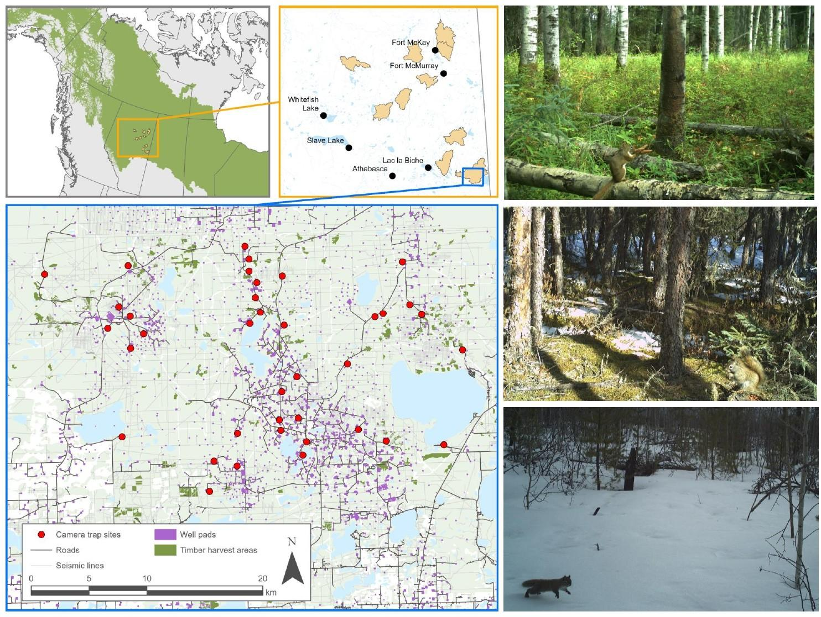
Figure 1. Ten landscapes within the Boreal Plains selected for sampling, representing a gradient of anthropogenic land-use and environmental traits. Camera trap placements within a given landscape followed a constrained stratified design based on vegetation characteristics. Red squirrels were detected year-round in a variety of habitat types (total independent detections = 4747).
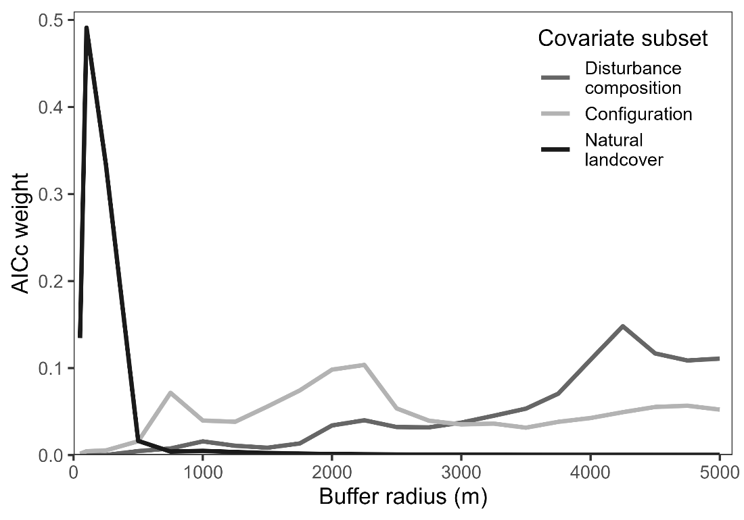
Figure 2. AIC model weight as a function of spatial scale for categories of covariates including the composition of natural features (NATURAL), composition of anthropogenic disturbance (COMP), and landscape configuration (CONFIG). The spatial scale with the highest model weight was identified as the best-fit scale for that category of covariates and used during model fitting to describe the effect of landscape structure on red squirrel abundance in the Boreal Plains.
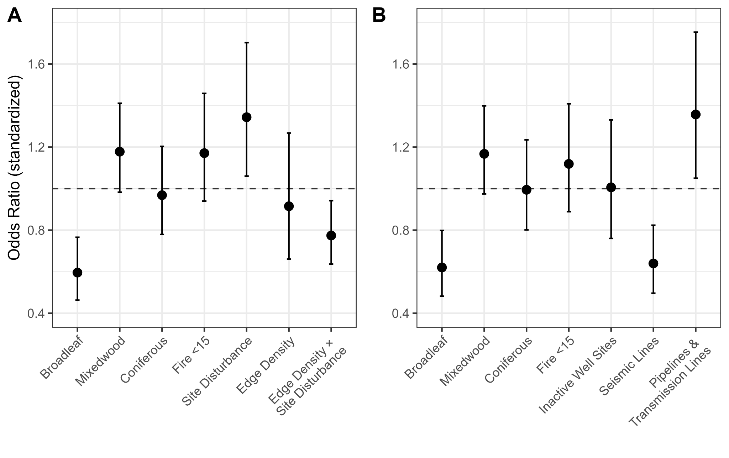
Figure 3. Odds ratios with 95% confidence intervals for standardized coefficients for [A] the top-ranked model explaining red squirrel detections as a function of edge density and cumulative site disturbance, and [B] the second-ranked model (ΔAICc = 2.45, AIC_{w} = 0.156) explaining red squirrel detections as a function of anthropogenic disturbance type. Both models were fit using mixed-effect negative binomial models.
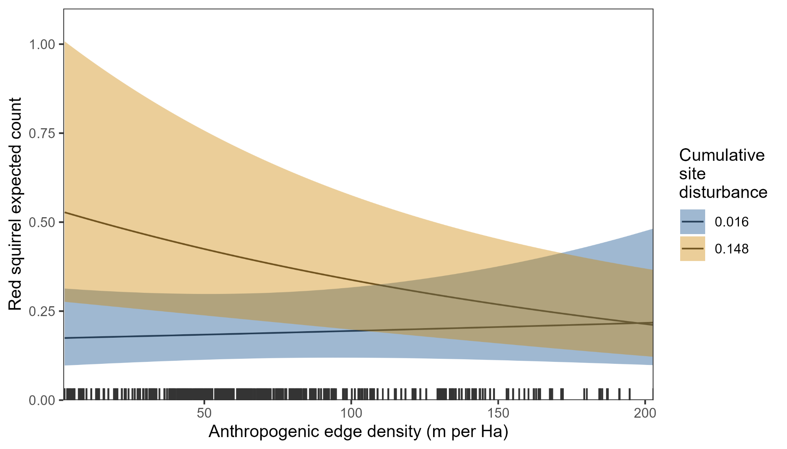
Figure 4. Conditional effect of anthropogenic edge density from top model explaining red squirrel detections at high (90% quantile) and low (10% quantile) cumulative site disturbance. Density of lines along the x-axis indicates the frequency of the data value.

Table 1. Covariates included to describe the composition of natural habitat, composition of anthropogenic features, and landscape configuration on red squirrel abundance in the Boreal Plains
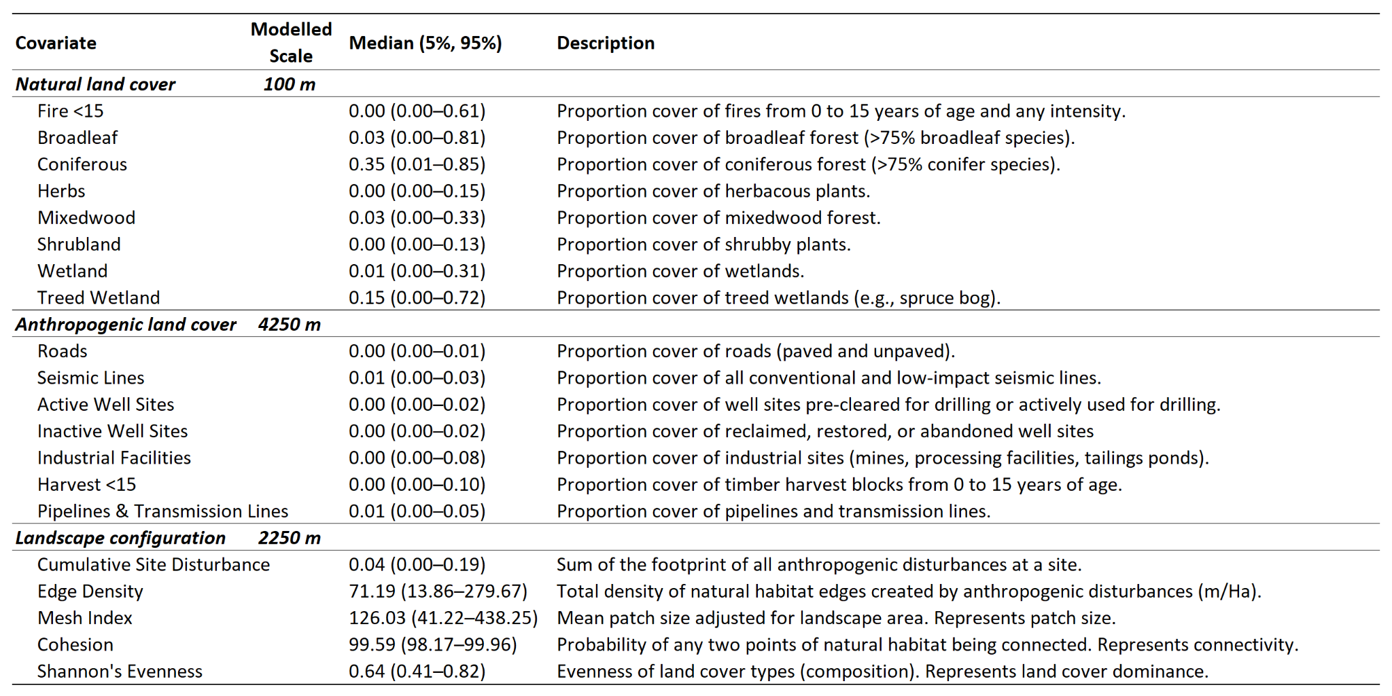
Table 2. Model selection results from candidate hypotheses describing impact of the composition of natural features, composition of anthropogenic features, and landscape configuration on red squirrel abundance in the Boreal Plains. Top models (within 3 AIC units) are shown in bold.
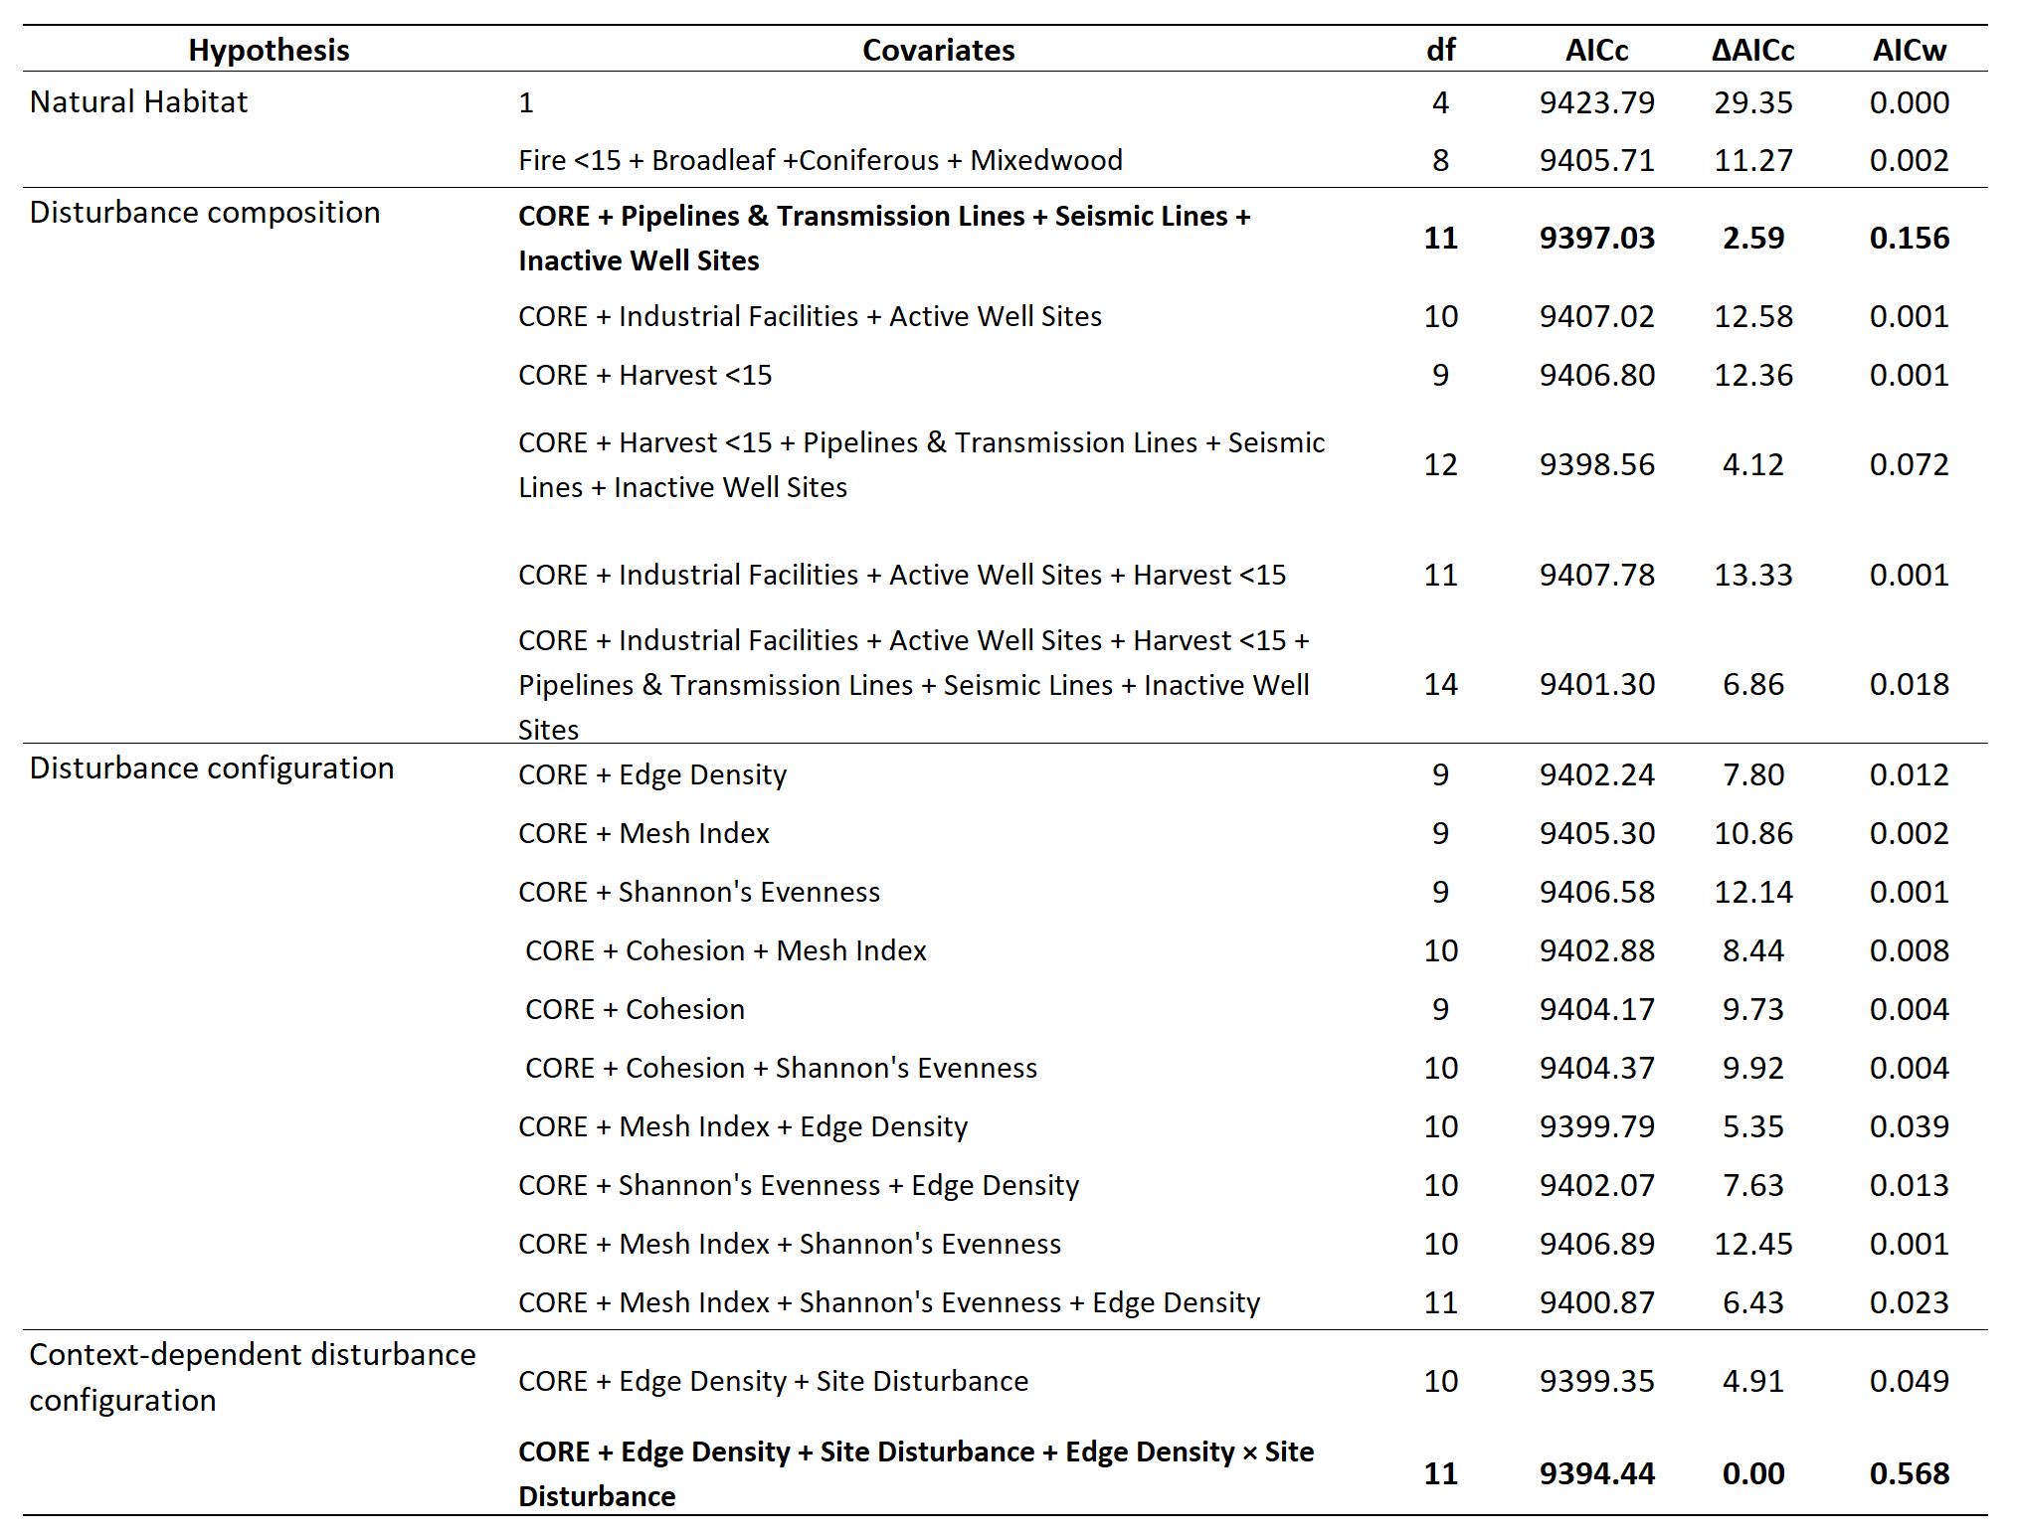
Table 3. Coefficient estimates for the top-performing model explaining red squirrel detections as a function of natural landscape composition, edge density, and cumulative site disturbance. Models were fit using mixed-effect negative binomial models.
