Life on the edge: industrial footprint and edge effects variably influence the spatial distribution of a western boreal small mammal.

Aidan Brushett

Emerald Arthurs

# does marissa belong here?

Jason T. Fisher

Abstract

Industrial development in the Boreal Plains of Alberta, Canada,

1 | Introduction
Landscapes are complex matrices of habitat patches, resources, energy, and organisms (Forman & Godron, 1981). The structure of a landscape arises from both its composition and configuration, where ‘composition’ refers to the types and amounts of habitat, and ‘configuration’ to their spatial arrangement (Dunning et al., 1992; Forman & Godron, 1981). Landscape structure plays a critical role in mediating local species-habitat relationships. Variations in either habitat amount or spatial patterning of habitat patches can lead to markedly different distributions of organisms, ecological processes, and community structures (Dunning et al., 1992; Tscharntke et al., 2012).
Human-caused alteration of landscapes is the dominant driver of changes to biodiversity globally (Johnson et al., 2017; Maxwell et al., 2016). Anthropogenic land use such as natural resource extraction, agriculture, and urban expansion, are increasingly encroaching on wild spaces and displacing wildlife (Johnson et al., 2017; Shackelford et al., 2018). Disturbances fundamentally alter landscape structure through both direct and indirect mechanisms: development often reduces the total amount of habitat available to wildlife, while also reconfiguring the habitat that remains (Wilson et al., 2016). Habitat patches that are smaller or more fragmented affect wildlife by influencing connectivity, edge habitat, resource availability, and behaviour (Anderson & Boutin, 2002; Haddad et al., 2015; Pfeifer et al., 2017). Although biodiversity generally declines in heavily disturbed landscapes, some species may derive supplementary or complementary resources from the matrix created by human-altered habitats (Fahrig, 2003; Magioli et al., 2019). The differential behavioural- and population-level responses of species to habitat alteration have fundamental consequences for the assembly and functioning of ecological communities (Sousa, 1984; Swihart et al., 2006), underscoring the importance of understanding how human activity alters landscape structure for conservation efforts.
Considerable recent scientific controversy and debate has attempted to clarify the relationships between habitat loss, habitat configuration, and species diversity (Fahrig, 2017; Fletcher et al., 2018; Martin, 2018). The role of habitat amount (and loss thereof) in explaining terrestrial biodiversity is widely accepted and supported by empirical evidence (Brooks et al., 2002), yet the role of habitat configuration remains contentious and has even been dismissed altogether by some studies (e.g., Fahrig, 2013). Isolating the possible effects of landscape configuration—namely, fragmentation—is challenging since fragmentation is collinear with and hierarchically connected to habitat loss in many real-world ecological systems: most habitat loss also results in net fragmentation (Didham et al., 2012; Ruffell et al., 2016). Nevertheless, discriminating among the ecological mechanisms arising from each type of habitat alteration is critical for predicting outcomes for wildlife (Côté et al., 2016). The effects of habitat fragmentation are likely context-dependent, varying non-linearly along a gradient of suitable habitat amount within the landscape matrix (Andrén, 1994; Didham et al., 2012; Villard & Metzger, 2014). At low or intermediate amounts of suitable habitat—where configuration has the most variability—fragmentation may produce ecological impacts distinct from those predicted by habitat loss alone (Andrén, 1994; Villard & Metzger, 2014). Thus, the direct and indirect effects of landscape structure on wildlife distributions likely require explicit empirical testing instead of assumption across taxa and environmental contexts (Püttker et al., 2020).
The ecological uncertainty surrounding landscape structure compels a focused investigation in the Nearctic boreal forest, where landscapes form a heterogeneous mosaic of vegetation and biophysical traits, including wetlands, aspen parkland, conifer lowland, and forests in a variety of successional stages (Kenkel et al., 1997). The western boreal forest has been stewarded and developed by humans for generations (Lewis, 1982; Timoney, 2003), but in recent decades the Boreal Plains have undergone unprecedented structural changes at the collective hands of the timber, mining, and energy industries. Superimposed on the naturally ‘patchy’ ecosystems of the Boreal Plains is a pervasive network of cut blocks, roads, seismic lines, well pads, and processing facilities dedicated to the extraction, refinement, and transportation of natural resources (Pasher et al., 2013; Pickell et al., 2015). In recent decades, the cumulative effects of intense industrial development have eclipsed any natural processes to give rise to an unparalleled spatial patterning of habitat and resources, creating new complexity in boreal landscape structure (Pickell et al., 2015). Although energy sector disturbances constitute less than 2% of the footprint of Alberta’s boreal forest by area (Alberta Biodiversity Monitoring Institute, 2023), their high density and persistence have fundamentally transformed boreal landscape composition and configuration. For instance, over 1.8 million kilometers of seismic lines—persistent linear features used to map underground oil and gas deposits—stretch across Alberta’s forest, producing disproportionate amounts of early-seral vegetation, forest edge habitat, and movement corridors through otherwise intact tracts of boreal habitat (Dabros et al., 2017, 2018; Lee & Boutin, 2006).
Confronted by these novel landscapes, the resident wildlife of the Boreal Plains are forced to compete for space with natural resource development with widespread consequences for ecosystems and species persistence (Venier et al., 2014). A large body of research indicates that virtually all boreal mammals have been impacted either positively or negatively by landscape change induced by natural resource development (Curveira-Santos et al., 2024; Fisher & Burton, 2018; Wittische et al., 2021). Past research has heavily emphasized the effects of habitat and disturbance amount on boreal mammals, wherein changes in resource availability have evoked a multitude of complex changes to population sizes, wildlife behaviours, and trophic and competitive interactions among species (Burgar et al., 2019; Fisher et al., 2021; Fisher & Burton, 2018; McKenzie et al., 2012; Tattersall et al., 2020). There has been comparatively little attention given to the effects of landscape configuration in boreal research (but see Smith et al., 2024).
The North American red squirrel (Tamiasciurus hudsonicus) is one boreal species for which the spatial distribution of habitat may be an important ecological factor in landscapes transformed by industrial land-use. Ubiquitous throughout the Nearctic boreal forest, red squirrels are seed predators whose spatial distribution is shows a strong dependence on mature, cone-producing conifer or mixed-forest ecosystems that has been demonstrated across multiple spatial scales and ecozones (Fisher et al., 2005; Larsen, 2009; McDermott et al., 2020; Rusch & Reeder, 1978). Both natural and anthropogenic sources of disturbance—namely, wildfire and timber harvesting—directly affect red squirrel density by removing key resources found in mature forest; cleared anthropogenic features offer few potential resource subsidies (Fisher & Wilkinson, 2005; Russel et al., 2010). However, the influence of spatial configuration of habitat red squirrel distribution remains largely unexplored. The behaviour, survival, and abundance of red squirrels differs in heterogeneous habitats or along forest edges (Anderson & Boutin, 2002; Bayne & Hobson, 2000; Fisher et al., 2005), but these processes have not been evaluated in boreal landscapes dominated by natural resource extraction. For instance, even in heavily disturbed landscapes the cumulative footprint of seismic lines rarely exceeds 4% by area and habitat loss sensu stricto for red squirrels is minimal; however, distinct mechanisms related to habitat configuration may still have an important effect. Fragmentation of core red squirrel habitat by industrial disturbances can introduce changes to vegetation structure along forest edges (Harper et al., 2015), decrease landscape permeability and red squirrel movement (Bakker & Van Vuren, 2004), or influence the abundance (Tattersall et al., 2020) and functional responses (McKenzie et al., 2012) of co-occurring predators. Disentangling the influences of composition and configuration on red squirrel distribution may yield valuable insights into the effects of landscape structure on ecological processes in rapidly changing Boreal Plains ecosystems.

Given the stark contrast between edge and interior habitat, there are often differences in species diversity (Slater et al., 2024), composition and abundance in edge habitat (Forman & Gordon 1981; Pfeifer et al., 2017), as edge habitat can both represent increased forage resources and increased risk (Kremsater & Bunnell, 1999).

As such, in this study we investigated the degree to which habitat composition and configuration influence red squirrel distribution in Boreal Plains landscapes with a gradient of habitat and disturbance characteristics. Aligning with conceptual frameworks of fragmentation (Didham et al., 2012), we hypothesized that: (i) both habitat loss and fragmentation from industrial development will influence red squirrel distribution, but (ii) the independent effects of habitat fragmentation are greatest in landscapes where the amount of suitable natural habitat (e.g., mature forest) available to red squirrels is low. To accomplish our objectives, we deployed 414 motion-activated cameras across the Boreal Plains that measured the relative abundance of red squirrels in landscapes with variable proportions and spatial configurations of forest habitat, seismic lines, cut blocks, and other industrial disturbances. We separately measured the effect of industrial disturbance on the composition and configuration of each landscape by determining the proportion of natural land cover or disturbance footprint in local landscapes, and by deriving three measures of landscape fragmentation: anthropogenic edge density, core habitat area, and cohesion (isolation) of remnant natural habitat. We expected that the relative abundance of red squirrels would be highest in areas with a high proportion of mature conifer or mixed-wood forest relative to other natural habitat types. We also predicted that red squirrel relative abundance would be negatively related to the proportion of cleared anthropogenic features (well pads, roads, and seismic lines) in all landscapes. Finally, we expected that fragmentation effects (e.g., creation of anthropogenic edges or isolation of habitat patches) by industrial disturbances would have a negative relationship with red squirrel relative abundance that is strongest in landscapes with high amounts of disturbance.
2 | Methods
2.1 | Study area
The Boreal Plains ecozone spans 740 000 km² of the boreal forest in Treaty 8 Territory and encompasses a wide variety of vegetative land cover, climate, productivity, and human activity. The region is characterized by a mosaic of aspen parkland, mixed broadleaf, white spruce, and jack pine forest, black spruce lowland forest, as well as wetlands, muskeg, fens, and lakes. We studied ten landscapes (Fig. 1) representing watershed aggregations with an area of 1000–3000 m² (Bayne et al., 2021) across the Boreal Plains that span a gradient of low–high industrial development intensity and a variety of anthropogenic land-use types that include timber harvesting, open pit bitumen mining, and in situ oil and gas extraction. Common disturbance features include timber cut blocks, seismic exploration lines, well pads, roads, pipelines, and processing facilities (Fig. 1) with varying degrees of human use or active restoration. Other common small- and medium-sized mammals in our study area included the American marten (Martes americana), fisher (Pekania pennanti), Canada lynx (Lynx canadensis), coyote (Canis latrans), snowshoe hare (Lepus americanus), and North American beaver (Castor canadensis), along with a diverse community of small rodents. Common avian predators of red squirrels include the northern goshawk (Accipiter gentilis) and great horned owl (Bubo virginianus).
2.2. | Camera trapping and wildlife occurrence data
We deployed motion-activated camera traps within each of our ten landscapes between 2021 and 2024 using a constrained stratified sampling design intended to measure red squirrels and other medium- to large-sized mammals (Fig. 1). First, we divided our landscape into 2 km² hexagonal cells and randomly selected ~60 potential cells for camera deployment within strata corresponding to either upland forest (low moisture, >50% deciduous) and lowland forest (high moisture, >50% coniferous), or forest type (broadleaf, coniferous, and mixed). Camera placements in selected hexagonal cells were constrained to locations >100 m from roads and >1 km from neighbouring camera placements to maintain independent sampling. Infrared camera traps (Reconyx PC900 Hyperfire or Hyperfire II Professional; Holmen, WI, USA were placed approximately 100 cm above the ground, facing a wildlife trail 3–7 meters away. To avoid confounding movement with habitat use (Stewart et al., 2018), cameras used in analyses were not directly deployed on human trails or seismic lines unless these features had clear wildlife signs. To maximize detectability of red squirrels, we applied a scent lure (O’Gorman’s Long Distance Call, MT, USA) at each site at the time of deployment (September or October). Camera traps were programmed to take photos continuously at high sensitivity when movement was detected within the field of view. A total of 430 cameras were deployed across the ten landscapes (mean 43 per landscape, range 36–50); Table 1). Within the 2021–2023 sampling period, each camera was deployed for approximately one year (autumn to autumn; mean=347 days, SD= 67.2 days).
To quantify the occurrence of red squirrels in each landscape, all images of wildlife occurrences were reviewed and classified to the species level using the image processing software Timelapse 2.0 (Greenberg, 2019), then aggregated to identify independent detections of red squirrels. We defined independent detection events for red squirrels as those occurring >30 minutes apart at a given camera site. To create a response variable for statistical modelling, we binned detections into monthly independent detections. We assumed that the monthly number of detections at each camera site represented a relative index of both the abundance and intensity of site use of red squirrels at that site (Burton et al., 2015; Parsons et al., 2017). We treated non-detections as true absences and elected not to use occupancy models (cite McKenzie) for our statistical analyses due to _____ (loss of info from binning frequency data into binary? Closure assumptions violated?). Any given month was excluded from our dataset when there were <15 days of available data.
2.3. | Landscape analysis
We used the Alberta Biodiversity Monitoring Institute’s (ABMI) 2021 Human Footprint Index dataset (ABMI, 2021) to determine the amount and type of anthropogenic disturbance features across our study area, and Wulder’s et al. (2024) Satellite-based forest inventory to measure forest structure, vegetative land cover, and fire disturbance across our study area. To characterize landscape structure, we derived several variables describing the anthropogenic and natural features surrounding each camera site which we hypothesized a priori to be ecologically related to red squirrel relative abundance. Since habitat relationships arise on spatial scales that are taxa- and context-specific (Wiens, 1989; Jackson & Fahrig, 2015), we calculated all configuration and composition covariates at twenty-two spatial scales using concentric circular buffers including 50 m, 100 m, and 250–5000 m increasing by 250 m increments sensu Fisher et al. (2011). First, we measured landscape composition: this included the proportion of area around each camera site covered by each dominant land cover type (e.g., forest type, wetland, shrub) and recent (0–15 years) fire disturbance, as well as the proportion of area covered by anthropogenic disturbances (e.g., well pads, roads, timber harvest blocks 0–15 years old; Table 2). As a representation of total disturbance amount, we also calculated a cumulative disturbance index at each camera site, which followed the methods of Bayne et al. (2021) and summed the proportion of area covered by all anthropogenic disturbances. To measure landscape configuration, we superimposed and rasterized the Human Footprint Index on the Satellite Based Forest Inventory landcover types at a five-meter resolution and extracted four metrics which we hypothesized to correspond to potential mechanisms through which landscape structure affects the distribution of red squirrels (Table 2). Our configuration metrics included natural edge density, representing the total length of patch edges and boundary complexity created by anthropogenic features, effective mesh size, representing the average size of habitat patches and degree of fragmentation, contagion, representing the clumpiness or interspersion of habitat types, Shannon evenness index, representing dominance and how evenly different land cover types were distributed across the landscape, and mean nearest neighbour distance, representing the average isolation of habitat patches of the same land cover type. All covariates were processed using the sf, terra, and landscapemetrics packages (CITATIONS) in R v4.3.0 (R Core Team, 2023).
2.4. | Statistical analysis
We modeled the spatial responses of red squirrels to landscape structure using a multi-step, information theoretic approach. For all statistical analyses, we used generalized linear mixed models with a negative binomial distribution to account for overdispersion of red squirrel detection data (Zuur et al., 2007). We opted against using a proportional negative binomial response due to the high overdispersion of red squirrel count data in our dataset and poor overall model fit during exploratory analysis. In each model we treated monthly independent detections as the response variable and included nested random intercepts of camera sites within arrays. Specifically, our models took the form:
detections_{ijk} ~ NegBin(μ_{ijk}, θ)
log(μ_{ijk}) = β₀ + β₁x_{1,ijk} + … + β_{n}x_{n,ijk} + u_{i} + v_{i(j)}
where μ_{ijk} is the expected count of independent detections of red squirrels at site i in array j during month k, θ is the overdispersion parameter of the negative binomial distribution, and v_{i(j)} and u_{i} are the nested random intercepts of site and array, which were assumed to have a normally-distributed variance.
All explanatory variables were scaled using standardized z-scaling to improve model convergence and interpretability of relative effect sizes. To test our ecological hypotheses about the relative importance of landscape composition and configuration on red squirrels, we first divided our explanatory variables into three categories corresponding to our ecological hypotheses: [i] composition of natural habitat, [ii] composition of anthropogenic features, and [iii] landscape configuration (Table 2). Since red squirrels may respond to different aspects of landscape structure at separate spatial scales (Fisher et al., 2005), we identified a best-fit scale within each category of predictors before testing our hypotheses. Specifically, within each category of predictors, we fit a series of ‘sub-models’, hypothesized a priori to influence red squirrel detections, using all predictors at each of the twenty-two spatial scales (i.e., 50–5000m) and compared AICc scores to identify which spatial scale was best supported. This approach allowed us to empirically evaluate the appropriate scales for modelling and flexibly incorporate the effect of natural habitat composition, anthropogenic composition, and landscape configuration on red squirrel distribution at separate spatial scales (described in results and Table ##). We then used the best supported spatial scale in candidate models for each category of variable.
We performed model selection on a set of candidate models that corresponded to our hypotheses about habitat amount, habitat configuration, and context-dependent effects of habitat configuration using a hierarchical approach. To test whether natural habitat composition alone could describe red squirrel distribution (i.e., no disturbance or configuration effects), we initially built a model with the best-supported covariates representing natural habitat amount only using stepAIC to reduce a global model of all fire and land cover type covariates (sensu Chow-Fraser et al., 2018). We deemed this our ‘core model’, and included these variables in all models moving forward. We then combined covariates from each of the three categories into a candidate model set describing our hypotheses about the effects of landscape structure on red squirrel distribution. We did not include roads in any models due to their high correlation with other anthropogenic disturbances (especially well sites and industrial facilities) at our selected spatial scale. Configuration metrics were highly correlated with variables for anthropogenic disturbance type—a common challenge for Boreal Plains research (e.g., Smith et al. 2024) and fragmentation research more generally (CITE)—so our candidate model set was not fully nested. Instead, we represented disturbance in any configuration models using interactions with the aggregate Cumulative Footprint Index (CFI) metric, which was not highly correlated with any configuration variables. Our fifteen candidate models allowed us to compare the importance of various components of landscape structure for red squirrel distribution in our study area. We ranked our twelve candidate models using AICc scores to compare the importance of various components of landscape structure for red squirrel distribution and identify a best-supported model (Burnham and Anderson, 2002). We treated any candidate models with ∆AIC <3 as well-supported and interpreted them accordingly. Model assumptions were verified using diagnostic plots of residuals vs. fitted values and collinearity among predictors was assessed using variance inflation factors (VIFs; Zuur et al., 2016). We will evaluate model performance by simulating 10,000 datasets of landscape structure and refitting our model to determine predictive accuracy (Zuur et al., 2016; to be completed after class). Model selection and top model diagnostics were performed using the MuMIn (Bartoń, 2024) and performance (CITE) packages in R v4.3.0 (R Core Team, 2023).
Notes:
- Monthly decreased overdispersion vs weekly occurrence frequency
- Quadratic harvest^2 improved AIC but barely changed coefficients or predicted effects, positive effect of harvest consistent across models.
- Remove outliers? Other students found AIC improvement but no change for coefficients
- OLD IDEA: separate sub-models for NATURAL COMP, ANTHRO COMP, CORE HABITAT, EDGE, COHESION would help with correlation (possibly) and provide more clarity on configuration mechanisms (e.g. disturbance relief, connectivity, edge effects)?
- Interact anthropogenic edges with predator density??

3 | Results
In total, we gathered 149,273 camera trap-days of data and 683,259 images, producing 7,399 images and 4,747 independent detections of red squirrels. Red squirrels were detected at least once at 305 of 430 camera trap sites (naive occupancy = 0.709).
The first step of our analysis identified best-fit spatial scales for our three categories of landscape covariates at three separate spatial scales that had strong or moderate model support compared to other scales (Figure). Natural land cover predictors were included in models at a 100 m spatial scale, while composition of anthropogenic features and landscape structure were both included at much larger spatial scales (4250 m and 2250 m, respectively).
The highest performing ‘core’ natural land cover model variables included the proportion of conifer forest, mixedwood forest, broadleaf forest, and areas burned within 0–15 years. However, this ‘core model’ was not well-supported compared to models that included anthropogenic disturbance composition or configuration variables (provide AIC score and weight here or point to table?). Red squirrel distribution was best explained by a model including natural land cover, edge density, cumulative site disturbance, and an interaction between edge density and site disturbance (AIC_{w}=0.568, R²_{conditional}= 0.099, R²_{marginal}=0.744), supporting our hypothesis of disturbance-mediated configuration effects. Red squirrel detections were negatively related to the proportion of broadleaf forest (β=-0.51, SE = 0.12, p<0.001), positively related to the proportion of mixed wood forest (β=0.16, SE = 0.09, p = 0.08), and unrelated to the proportion of conifer forest (β=-0.03, SE = 0.11, p = 0.771). The amount of recent fire had a weak positive effect on red squirrels (β=0.158, SE=0.11, p=0.16). Overall, anthropogenic edge density had a weak effect on squirrel detections (β=-0.09, SE=0.17, p=0.59) that became much more strongly negative at high levels of cumulative site disturbance via an interaction term (β=-0.26, SE = 0.10, p = 0.01). Unexpectedly, the effect of cumulative site disturbance itself was the opposite of our predictions and had a positive effect (β=0.30, SE = 0.12, p = 0.01).
Our top model had only moderate separation from the second-supported model (ΔAICc = 2.45, AIC_{w}=0.156), which included effects for all vegetated anthropogenic disturbance features except for timber harvesting. In this model, red squirrel detections were negatively related to the proportion cover of seismic lines (β=-0.45, SE = 0.13, p = 0.001), positively related to pipelines and transmission lines (β=0.31, SE = 0.13, p = 0.02), and neutrally related to inactive well sites (β=0.01, SE = 0.143, p = 0.97).

4 | Discussion

The synergistic effects of landscape composition and configuration drive species …lol. As hypothesized and aligning with our conceptual framework, the overall amount of suitable habitat remaining caused fragmentation effects to increase, whereas as cumulative site disturbance increased, edge effects became more pronounced. Contrary to our hypotheses, the overall effect of cumulative site disturbance was positive. Within the study area, the highest amount of cumulative site disturbance was ~ 30% (i.e. > 70% of habitat remaining) therefore this only represents a moderate level of disturbance in which there are remaining intact forest patches. Strong negative impacts on species may not occur until less than 30% of suitable habitat remains, therefore the landscapes included in this analysis did not exceed this threshold. Higher squirrel abundance in fragmented landscapes (Bayne & Hobson, 2000

At our top modelled spatial scales, we found a negative influence of broadleaf forest, positive influence of mixed forest and a neutral effect of conifer forest. The association with mixed forest likely is related to resources, as squirrels are conifer specialists but will opportunistically utilize other resources such as berries and fungi (Fisher et al., 2005; others). The neutral effect of conifer was unexpected, but may be an artifact of the lack of separation between lowland and upland forest given the large difference in utility to squirrels. Low-intensity fire may decrease shrub density and improve cone production (cites) explaining the positive effect of recent fire, or potentially due to opportunistic foraging (Fisher et al., 2005) (cites).

The effects modeled in our study were incorporated on drastically different scales, and as a result likely affected red squirrels at different individual- and population-level processes. The best spatial scale explaining red squirrel relationship to natural land-cover variables was 100 meters. Squirrels respond to resource availability and habitat texture at fine spatial scales, matching their small body size and home range (Fisher, 1999) and indicate intensity of site use by individuals (Rusch and Reeder, 1978). At the scale of each camera trap, red squirrels are distributing and dispersing relative to resource quantity and quality, a spatial grain that is a function of size (Holling, 1992). While a species response to landscape heterogeneity will be dictated by its perception of grain and extent (Kotliar & Wiens, 1990),

In contrast, the effects of anthropogenic disturbance composition and configuration were best explained at much larger spatial scales that exceed the range of perception of individual animals (4250 m and 2250 m, respectively)-- representing patterns at the meso-scale (Holling, 1992) and far beyond the grain of perception of the red squirrel. Although individual squirrels are not responding to the amount of disturbance, population processes are mediated at the larger meso-scales that are unrelated to individual perception. Anthropogenic disturbance may affect population processes such as dispersal, immigration and emigration, rather than individual resource selection (Pulliam ?). Similarly, Fisher et al., (2011) found a large-scale best explained squirrel response to land cover, representing a numerical population response. Local resources and landscape disturbance scales are simultaneously impacting red squirrel populations via separate mechanisms (Levin, 1992). Broadly, heterogeneity created by disturbance governs the distribution of predator species and resources across the landscape. Ecological systems represent integration of spatial processes on multiple scales, variability and distributions must be studied at multiple scales and not just one (Levins 1992 can be cited here). Predators interact with landscape at larger scale

I dont know how to start this paragraph. At a large spatial scale, we found that edge effects negatively affect red squirrel occurrence, which could be a reflection of decreased dispersal. Red squirrels are generally averse to crossing open habitat (crossing studies) which could be a possible mechanism to explain the negative effect of seismic lines, which introduce a large amount of edge. However, we note that pipelines and transmission lines were positive, and likely represent a similar challenge to squirrel dispersal. In addition, cohesion — a strong proxy for landscape connectivity and dispersal potential (cites) — performed poorly, therefore, we are cautious of this interpretation of edge effects.

Alternatively, negative edge effects and the negative effect of seismic lines could be caused by predator functional responses. It is well established that many boreal mammal predators use seismic lines for movement (cites), which may provide opportunistic predation opportunities on red squirrels (?). We did not measure avian predators in this study, which are likely regulate red squirrel populations

Paragraph 1a:
- Were the hypotheses supported? Partially
- We were correct in hypothesizing that there is an interaction but it was not the direction we thought, increasing negative effect of edges but positive CFI
- Does this align with conceptual framework re: fragmentation? Andren, Fahrig, Didham
  - Frame in terms of information in intro
- Curiously, against our expectations, CFI was positive
- We suggest that the highest levels of CFI in the study area (e.g. maximum 30% site disturbance) still only represent a moderate/intermediate level of anthropogenic disturbance and did not have the same negative impact as anticipated.
  - E.g. Andren 199X proposed 30% remaining habitat as a threshold
- Positive effect unless it creates a lot of edges
- This paints a much more complex story than we initially anticipated:
Paragraph 1b. “At our modeled spatial scales, our top model found ___ and ___.”
- Interpret our top model.
- Discussion of coefficient directions and why

Paragraph 2a. “The effects modeled in our study were incorporated on drastically different scales, and as a result likely affected red squirrels at different individual- and population-level processes. .
- Scale notes from Aidan + Emerald – drastically different scales
- Natural and disturbances affecting squirrels on different scales/population processes
  - Reflects resources on the local scale, intensity of space use by individuals
    - Cite other squirrel ecology papers
  - “Squirrels (like many small mammals) respond to resource availability and habitat texture at fine spatial scales, matching their small body size and home range (cite squirrel home range paper that links range size to a 100 meter scale).”
  - Local scale and meso scale etc. etc.
Paragraph 2b. Discuss the broader scale disturbance effects.
- Conclude that this scale which is way beyond perception of individual squirrels affects population processes.
- “though individual squirrels may not be responding to disturbance amount, population processes are mediated on the larger meso-scales”
- Broadly, patterns of disturbance affecting other species distributions and distribution of resources.
[Short] Paragraph 2c (or interspersed throughout 2a and 2b where appropriate). Invoke how it ties into previous boreal squirrel work (Fisher et al. 2011 in particular)
- Invoke how this ties into a large body of literature (e.g. Levins, King hierarchy, Pulliam & Danielson, Holling 1992**)

Paragraph 3: What are those population processes that are being affected?
- Pattern-describing study, can only hypothesize the ecological mechanisms that give rise to this pattern.
- 1. (this feels fuzzy and maybe like a bit of a stretch??). Edge effects could decrease dispersal rates/metapopulation structure (3–4 papers like crossing behaviour, NFLD barrier to squirrel dispersal, etc.) that have large-scale negative effects on squirrel abundance.
  - What is the max distance they will cover?
  - Dispersal up to 1600m in boreal habitats. Kemp and Keith 1970.
However, pipeline + transmission line was positive in our second model – despite likely presenting a similar challenge to squirrel movement
**Additional line of evidence against dispersal: cohesion is generally accepted as a strong proxy for connectivity/dispersal that is robust to dispersal types/the way the landscape is digitized, and it did not come out as important in any models
SO we are cautious to fully accept this mechanism as explaining our results.
- 2. Predator functional responses. Huge collection of OSM/boreal literature about predator community use of seismic lines (especially Algar/Tattersall papers). Opportunistic predation, better line of sight, etc. Doubt a huge relationship between predators and squirrel detections (good rebuttal for why we didn’t use preds as a response variable). Biggest culprit? Avian predators that we could not directly measure. Line of sight into forest from edges, steepened functional response/lower search time. Predators interacting with the environment at larger scales due to much larger mobility, HR size, etc., can invoke this in scale discussion (below). Edge-mediated changes to predator-prey dynamics between squirrels and avian predators.
  - Are there any papers that look at avian predation in fragmented landscapes?
  - https://zslpublications-onlinelibrary-wiley-com.ezproxy.library.uvic.ca/doi/full/10.1111/j.1469-1795.2010.00379.x

Paragraph 4: Contrary to our expectations, CFI had a positive effect when low edges, but was mediated through the creation of edge habitat–i.e. positive effect of CFI diminishes if high edge is present.
- Possible resource complementation? Negative effect on squirrel predators (e.g., large-scale reduction of raptors in disturbed systems?) Really not sure.
- No clue, ***BUT these specific scenarios with high CFI and low edges are not common in real boreal study systems. Our CFI and config metrics were correlated—the creation of larger human footprints almost invariably creates edge habitat.
- [from Aidan notes] “not all disturbances are made equal. Second-supported model showed a strong negative effect of seismic lines on red squirrels. This is supported by other literature (Skatter et al. and Beirne are good papers). Thus although the aggregate effect of total industrial disturbance was a net positive, specific disturbance types that introduce a high amount of edge—especially very thin linear features like seismic lines—could still have a negative impact on red squirrels and the differential effects/ecological mechanisms of different disturbances cannot be discounted.” Compared to pipeline/transmission line, which are not
- Seismic lines (2-6m) can be gridded in a 200 m pattern and so this represents a very considerable amount of edge creation for a low amount of footprint, especially compared to pipelines/transmission lines, which might be how these disturbances differ.

Caveats/future directions section:
- Better landcover data, upland/lowland distinction
- on/near/off feature sampling would help.
- No data on avian predators or predation rates
- Dont have any information on actually ‘activity’ on the disturbance features - ex. roads all treated the same whether they are busy vs inactive

Conclusion:
- No one gives a shit about squirrels but they are interesting and underappreciated
- Multiplex
- Our work expands on Smith et al. (2024), which illustrated the effect of configuration on wildlife species
- This multi-scale modelling framework could be applied to other species / multi species to better-understand how ecological processes at multiple spatial scales entrain wildlife distributions (Holling, 1992 has a good call to action about this at the end).
- ***Disturbance affects everything from a moose to a squirrel. As wildlife management begins to emphasize a full network of stressors on an ecological community…. Appreciation for ecological effects on all members of the community at multiple levels of organization. Effects extend beyond predictions anticipated by considering habitat loss sensu stricto. Aidan has good citations to tie this back to wildlife management/ecosystem understanding in general.
- “Configuration important, can have an effect on red squirrels that exceeds predictions based on habitat composition alone”

Aidan general thoughts:
- Red squirrels are resilient fuckers and can probably adapt to whatever the heck they want
Aidan thoughts on CFI being positive:
- Results only partially supported our hypothesis about when configuration matters most (Didham, Andren, etc.). Positive effect of CFI. We suggest that the highest levels of CFI in study area (e.g. maximum 30% site disturbance) still only represent a moderate/intermediate level of anthropogenic disturbance. At these low to intermediate levels, had a positive effect. Why?? Need to do some digging here before I feel comfortable making an interpretation. Heterogeneity? Resource complementation? Competitive advantage over other small mammals? Effect is only positive after controlling for the effect of anthro edges (can test this statistically****).
- However, must caution against assuming all disturbances are made equal. Second-supported model showed a strong negative effect of seismic lines on red squirrels. This is supported by other literature (Skatter et al. and Beirne are good papers). Thus although the aggregate effect of total industrial disturbance was a net positive, specific disturbance types that introduce a high amount of edge—especially very thin linear features like seismic lines—could still have a negative impact on red squirrels and the differential effects/ecological mechanisms of different disturbances cannot be discounted.
  - Vegetation structure and density of veg decrease resource availability? Edge effects of forest/canopy structure can extend 35-50 m into the forest (cite Jackson 2023).
  - Seismic lines can be gridded in a 200 m pattern and so this represents a very considerable amount of edge habitat creation for a low amount of cumulative disturbance!

Emerald thoughts on CFI/questions
- Impacts to squirrels predators?
- How do birds of prey respond to high CFI?
- If seismic is negative, is it the block features that are more positive?
- Does this level of disturbance improve cone production? Is there any evidence of differences in productivity of the landscape?

  - Could edges suffer from reduced cone production because the abrupt change in vegetation structure?? Have to read those seismic papers (Davros; Jackson)
  - cumulative disturbances may reduce the densities of some predators (can cite OSM papers, need to find some other raptor ones)
  - Possible resource complementation? Squirrels often follow the boom/bust cycle of the spruce cone mast. Do disturbances (at these low/intermediate levels) provide some sort of complementary resource that helps them ride through the ‘bust’ and stabilize resource levels?

What is the mechanism for edge effects? Two possible explanations:
- This is a pattern-describing study so we can only begin to hypothesize about the exact ecological mechanisms driving this pattern.
  - 1. (this feels fuzzy and maybe like a bit of a stretch??). Edge effects could decrease dispersal rates/metapopulation structure (3–4 papers like crossing behaviour, NFLD barrier to squirrel dispersal, etc.) that have large-scale negative effects on squirrel abundance.
    - What is the max distance they will cover?
    - Dispersal up to 1600m in boreal habitats. Kemp and Keith 1970.
However, pipeline + transmission line was positive in our second model – despite likely presenting a similar challenge to squirrel movement, so we are cautious to fully accept this mechanism as explaining our results.
  - 2. Predator functional responses. Huge collection of OSM/boreal literature about predator community use of seismic lines (especially Algar/Tattersall papers). Opportunistic predation, better line of sight, etc. Doubt a huge relationship between predators and squirrel detections (good rebuttal for why we didn’t use preds as a response variable). Biggest culprit? Avian predators that we could not directly measure. Line of sight into forest from edges, steepened functional response/lower search time. Predators interacting with environment at larger scales due to much larger mobility, HR size, etc., can invoke this in scale discussion (below). Edge-mediated changes to predator-prey dynamics between squirrels and avian predators.

Aidan thoughts on scale:
Disparity of natural and disturbance spatial scales may reflect their importance to different biological processes that are a part of RESQ ecology. Ecological systems represent integration of spatial processes on multiple scales, variability and distributions must be studied at multiple scales and not just one (Levins 1992 can be cited here).
- 1. On a fine spatial scale, natural cover represents squirrel resource availability (cones, etc.). Explains strong aversion to broadleaf and positive to mixedwood and fire (can cite a couple papers about the value of low-intensity fire). Local resource availability is important and on this scale, squirrels are likely distributing in relation to resource availability (can invoke optimal foraging or especially ideal free distribution here).
  - Squirrels (like many small mammals) respond to resource availability and habitat texture at fine spatial scales, matching their small body size and home range (cite squirrel home range paper that links range size to a 100 meter scale). Theory that supports this is in Holling 1992 cross-scale morphology. “mammals of all trophic levels utilize resources in their foraging areas in the same way by measuring the spatial grain of habitat patches with a resolution defined as a function of their size”
  - Neutral effect of conifer probably because it includes lowland sites, which are frequently not sampled in squirrel studies (e.g., Fisher et al. 2005) and generally seen as less suitable habitat. Need to parse this into upland/lowland next time or for publication.
- 2. On a broad scale: disturbance and edge effects affect dispersal, connectivity, population processes on a larger scale that is not governed by the perceptual scale of individual animals.
  - On what Holling calls the mesoscales: “contagious disturbance processes such as fire, insect outbreak, plant disease, and water flow dominate the formation of patterns over spatial scales of hundreds of metres to hundreds of kilometres.”
  - SO IN SUMMARY: though individual squirrels may not be responding to disturbance amount, population processes are mediated on the larger meso-scales. Different scales = individual-level versus population-level processes or interactions with other species on large scales.
- Our results support the conclusions of Fisher et al. 2011. We can write a similar sentence to this one and acknowledge that our findings support this: “we hypothesize that landscape heterogeneity affects population processes such as dispersal, immigration, and emigration, rather than foraging (Pulliam 1988). Patch size, proximity, and heterogeneity drive population dynamics and determine probabilities of local population persistence at large scales.”

Emerald thoughts on scale:
- What aidan said
- Are there any processes on the ‘meso-scales’ that we can point to directly?

Aidan caveats:
- Cameras not set up for squirrels. Some challenges with detectability.
- Upland/lowland distinction.
- No measures of avian predators or rodents including microtines.
- Unknown mechanisms.
- Did not sample directly on disturbance features – all cameras were placed in forested land cover and thus the direct effect of harvesting is low. We measured the effect of these disturbances on squirrels in the remaining matrix of forest habitat, not the direct impact of timber removal like many other studies that have found a negative effect. Argue that for our purposes the effect of harvesting possibly didn’t extend beyond the boundary of cutblocks itself (does this contradict our conclusion about other disturbance features?). Cutblocks create very little edge habitat compared to linear features. Better sampling for this (e.g. ABMI’s on/near/off-feature camera placements are slay for this).

Should mention somewhere why it’s important to study squirrels. TBH not a big conservation concern, but a great case study and really underscores that boreal industry development has truly affected every species down to the size of a squirrel!!

Papers that could be cited:

Beirne et al. 2021. Multispecies modeling:
- Like 70% of variance in models was due to random effects (so our R^2 isn’t terrible!!)
- increase in squirrels following restoration of seismic lines
- Mounding height was positively related, and line density had a negative effect on squirrels
- Could this be cited to support that there could be some predation process impacted by seismic lines? Absolutely, also Tattersall et al. 2020 (shared use of seismic lines)
Schumaker, N.H. (1996), Using Landscape Indices to Predict Habitat Connectivity. Ecology, 77: 1210-1225. https://doi.org/10.2307/2265590
- Generic paper that can be invoked if we talk about landscape metrics and connectivity, cohesion in particular is well-supported here but weirdly it didn’t work for us (and was SO correlated with edge density but performed poorly in models). Maybe better as a methods paper.
Jesse E. H. Patterson, Jay R. Malcolm, Landscape structure and local habitat characteristics as correlates of Glaucomys sabrinus and Tamiasciurus hudsonicus occurrence, Journal of Mammalogy, Volume 91, Issue 3, 16 June 2010, Pages 642–653, https://doi.org/10.1644/09-MAMM-A-118.1
- number of patches, forest cover, mean proximity index, and distance to NN patches.
- Red squirrels only associated with basal area of conifers
- 2 and 3 km spatial scales worked best
- They don't report on it but mean nearest-neighbor distance did have an affect

Dabros 2017. Edge influence of low-impact seismic lines for oil exploration on upland forest vegetation in northern Alberta (Canada). https://doi.org/10.1016/j.foreco.2017.06.030
- Corroborates our idea that edge effects are (a) present and (b) important ecologically
- “Low impact seismic lines cause significant edge influence on ecological factors. Reduced herbaceous and non-vascular vegetation on lines, edges, and/or near edges.”
R.S. Jackson, J.M. Dennett, and S.E. Nielsen. 2023. Effects of oil sands disturbances on shrub and tree structure along forest edges in Alberta's boreal forest. Canadian Journal of Forest Research. 53(8): 642-653. https://doi.org/10.1139/cjfr-2023-0005
- This study provides evidence of edge effects from anthropogenic footprints associated with energy exploration on trees and shrubs in the boreal forest of Alberta. We found that edge sealing, conceptualized as a thickening of tall, woody vegetation growth at disturbance edges, was common to multiple disturbance types
- Effects observed up to 50m into the forest.
Walpole, A.A., Bowman, J. Patch occupancy by squirrels in fragmented deciduous forest: effects of behavior. Acta Theriol 56, 63–72 (2011). https://doi.org/10.1007/s13364-010-0010-0
- No effect of isolation/patch size on patch occupancy on ‘running’ species (i.e. red squirrels). Species-specific behaviours mediate effects – not consistent even among rodents
- Red squirrels are resilient fuckers
Skatter et al. 2020 squirrel and human activity. : Long-term Snow Track Monitoring to Understand Factors Affecting Boreal Forest Mammal Density in an Expanding In Situ Oil Sands Area.

5 | Tables and Figures we could possibly include (likely don’t want everything)

Table 1. Summary of covs
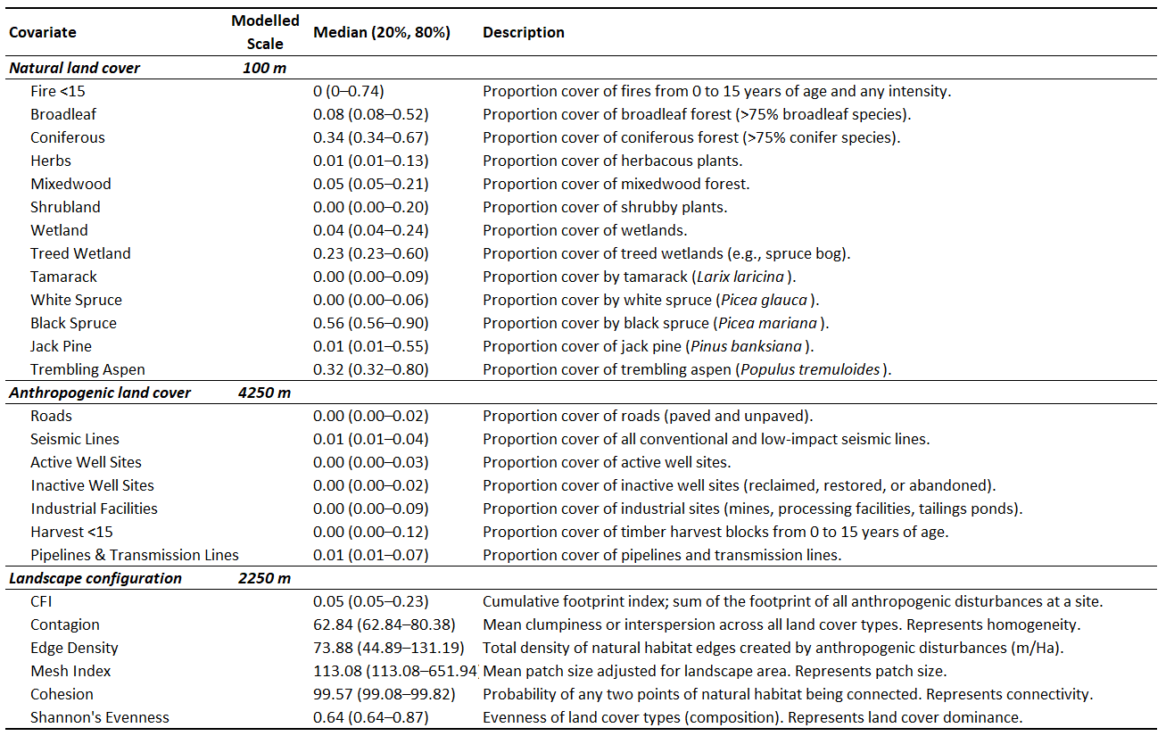

Table 2. Results of model selection. Bolded models within 3 AIC units
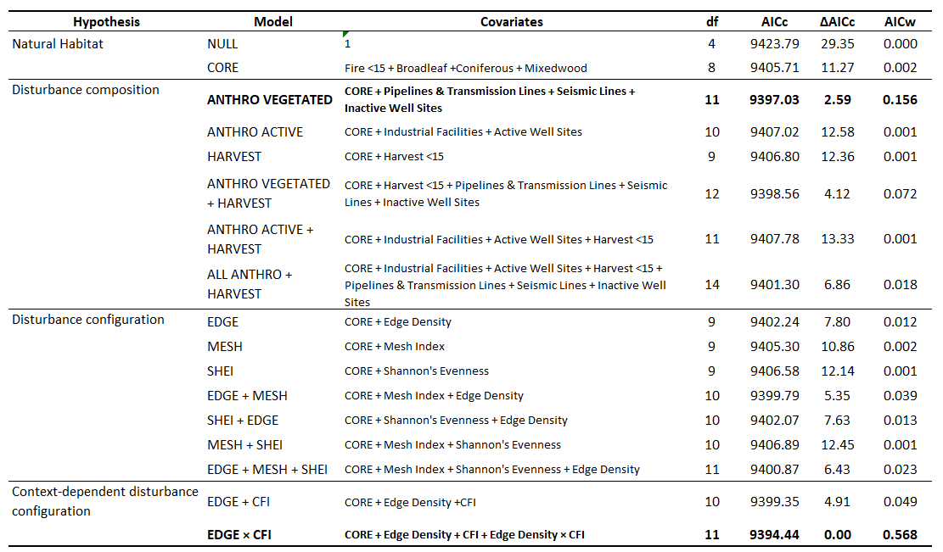

Table 3. Coefficient estimates for the top model (EDGE x CFI)
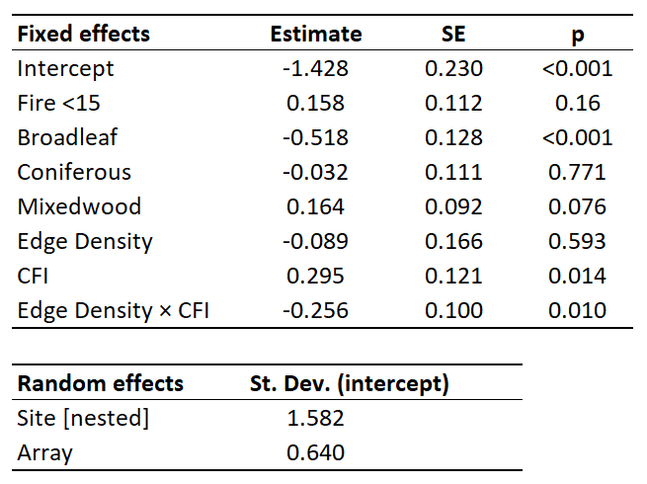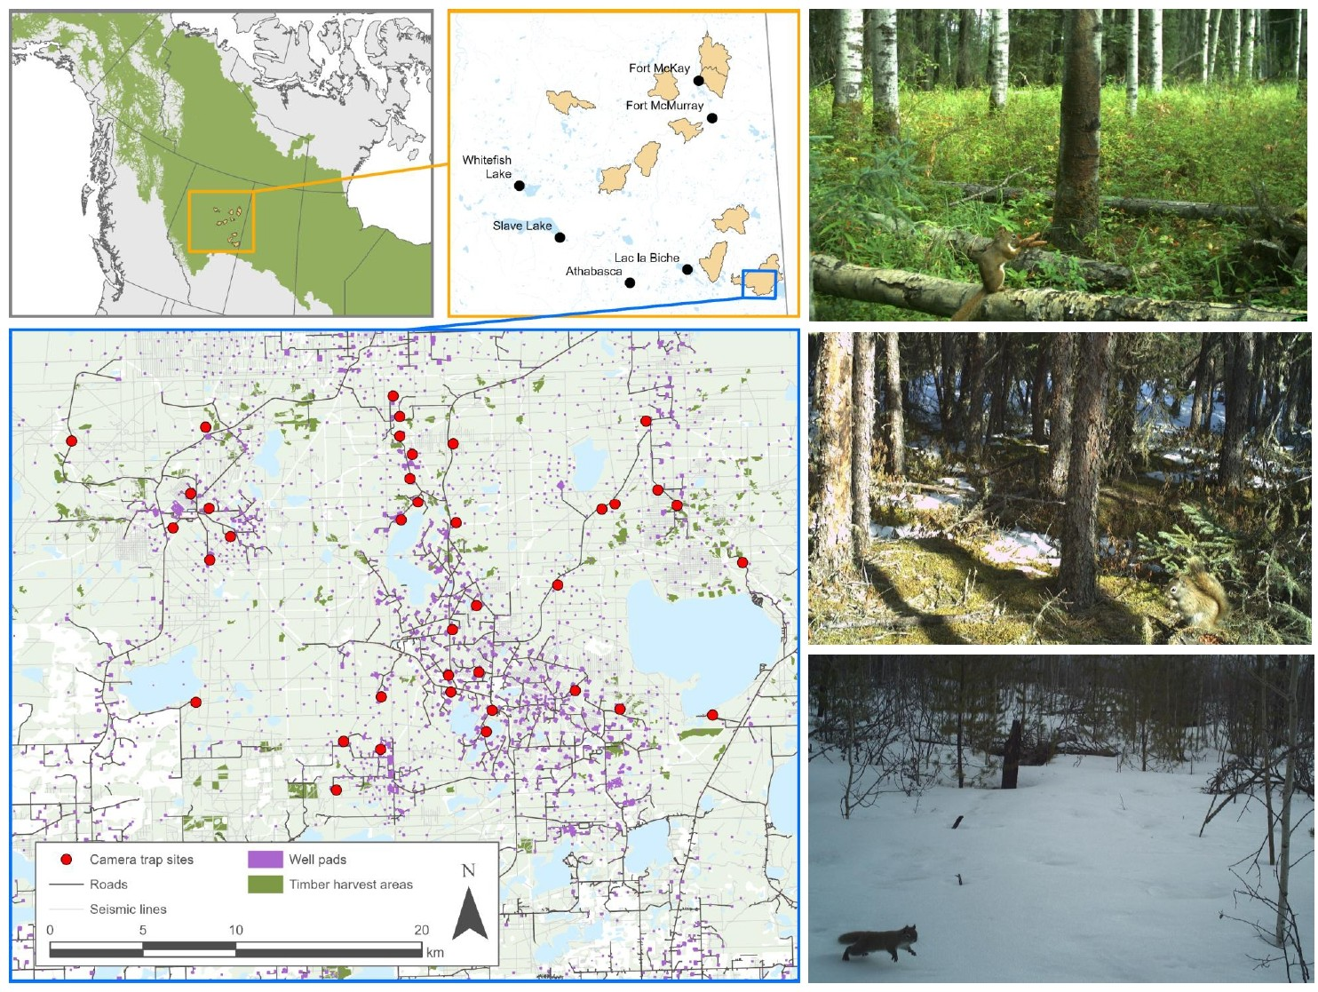
Figure 1. Ten landscapes within the Boreal Plains selected for sampling, representing a gradient of anthropogenic land-use and environmental traits. Camera trap placements within a given landscape followed a constrained stratified design based on vegetation characteristics. Red squirrels were detected year-round in a variety of habitat types (total independent detections = 4747).
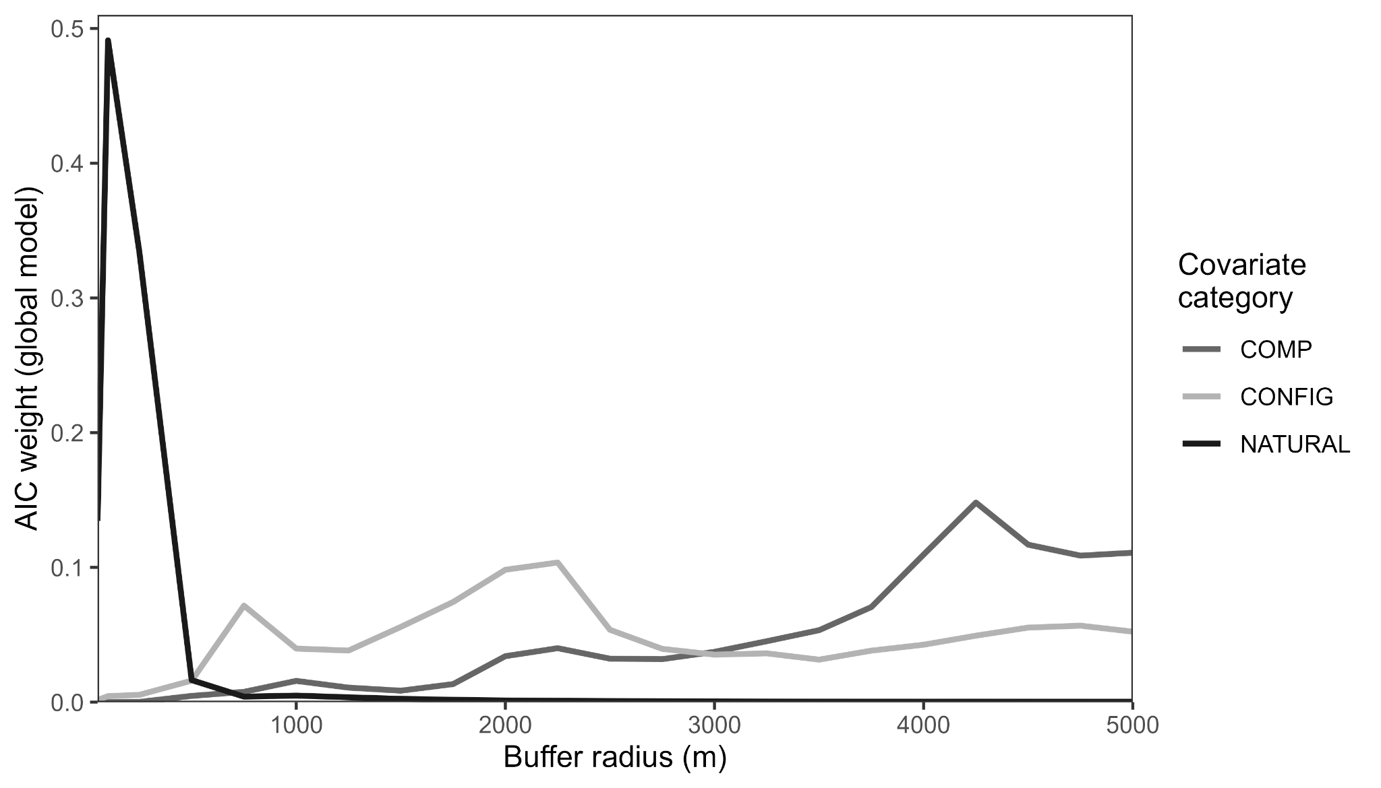
Figure 2. Top spatial scales as identified by scale analysis.

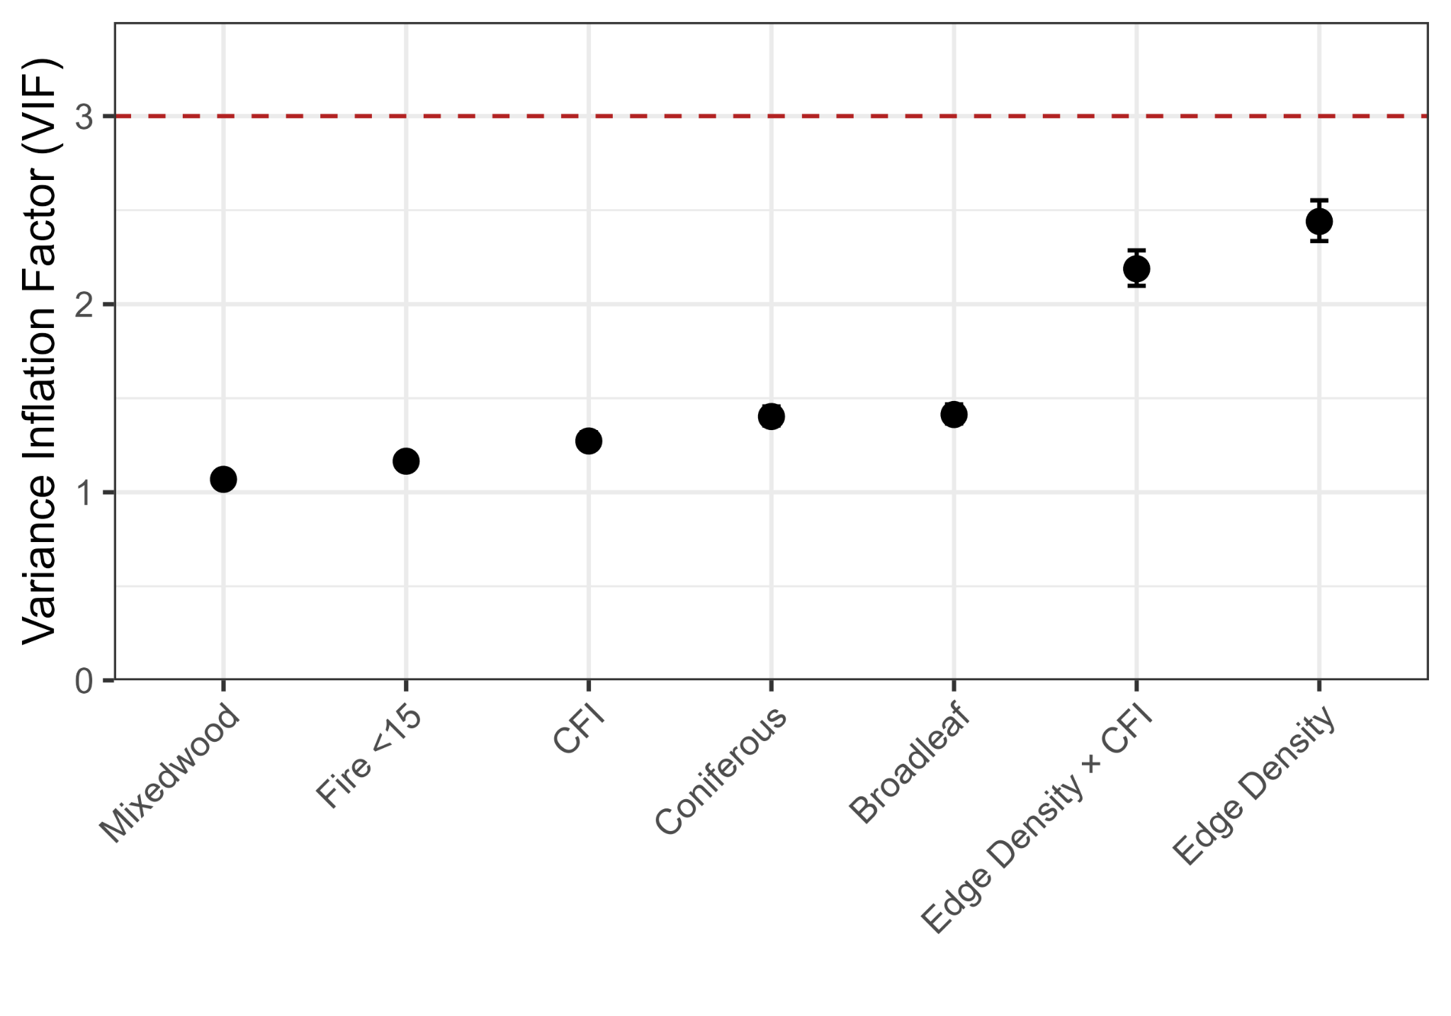
Figure 3. Variance inflation factors for the best-supported model.
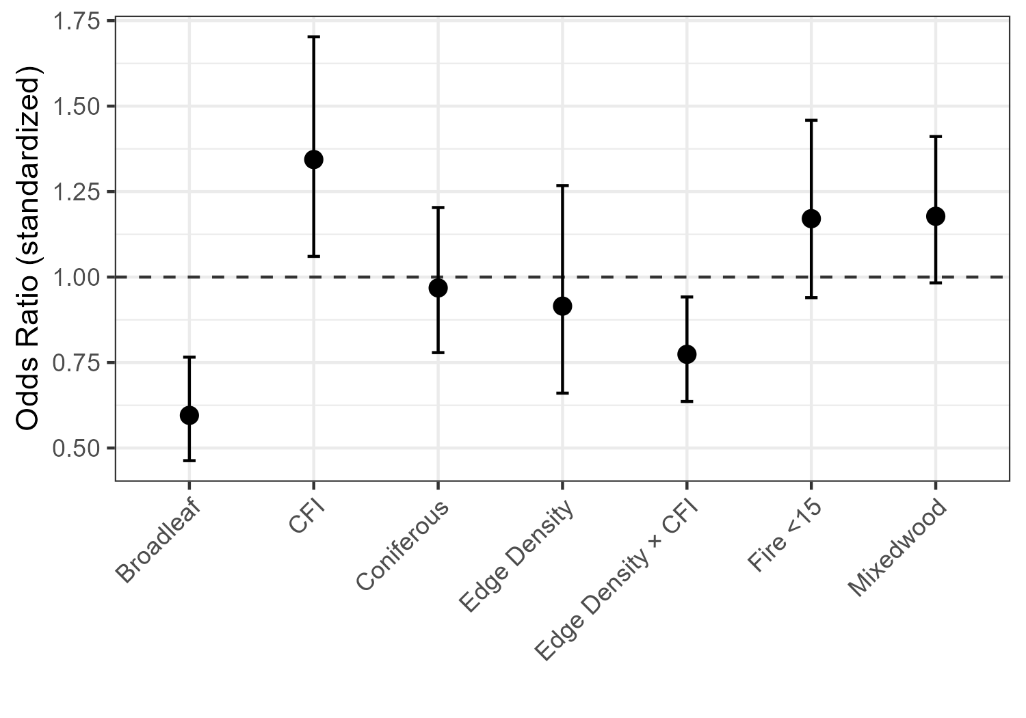
Figure 4. Odds ratios for standardized coeffs from top model.
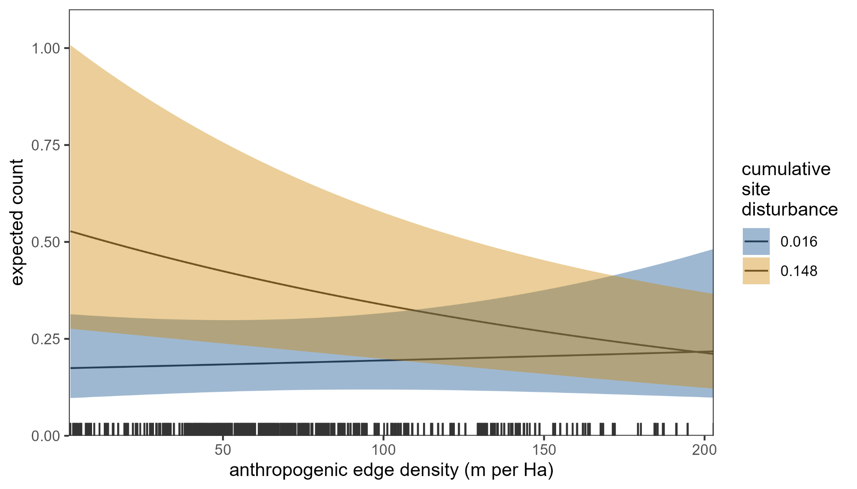
Figure 5. Conditional effect of anthropogenic edge density on red squirrel detections at high (90% quantile) and low (10% quantile) cumulative site disturbance.
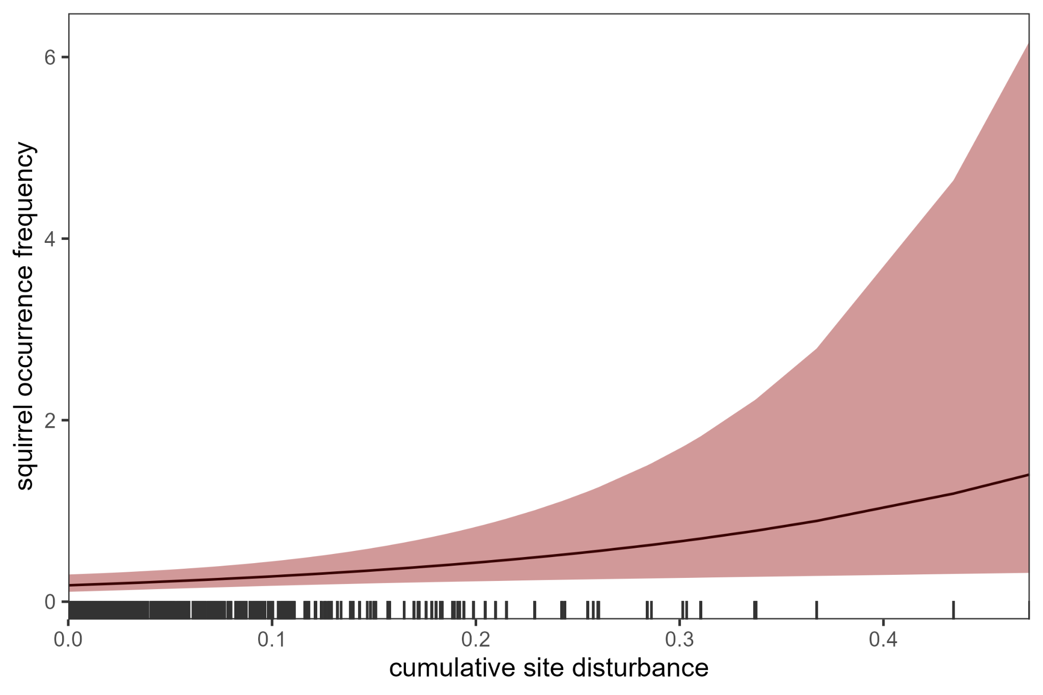
Figure 6. Conditional effect of cumulative site disturbance on red squirrel detections.
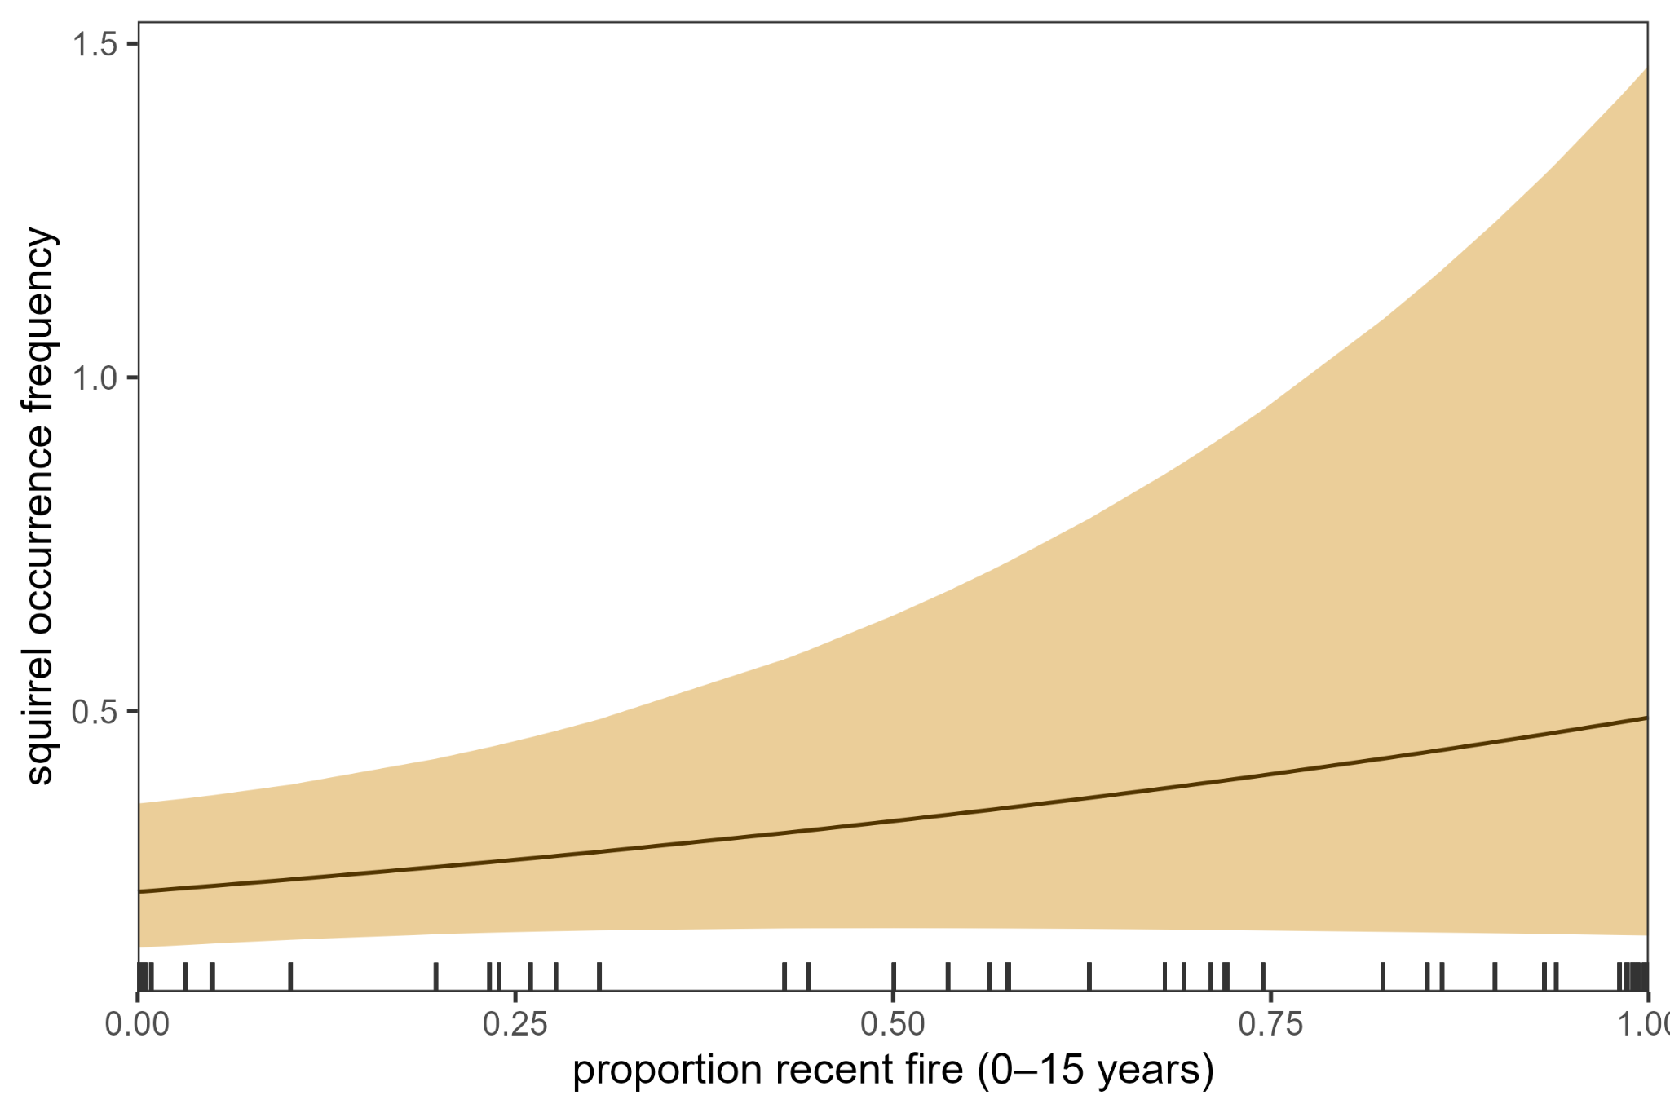
Figure 7. Conditional effect of recent fire disturbance on red squirrel detections.
6 | References
Bartoń, K. (2024). MuMIn: Multi-Model Inference_. R package version 1.48.4,
<https://CRAN.R-project.org/package=MuMIn

