QRC Overfitting Audit
Is the quantum reservoir model overfitted, and does the quantum circuit do anything a minimal classical model cannot?
Run 2026-10-15 · Paper test window 1997-08 to 2017-12 (245 months) · Holdout 2018-01 to 2026-08 (104 months) · Rolling training window 571 months

Verdict
The readout is not overfitted in the usual sense. The problem is that the paper's settings were chosen on the test window, and a plain linear model on the same inputs matches QR2 there. On new data from 2018 to 2026, the QR2 recipe forecasts worse than every classical baseline.
- Test/train MSE ratio 1.26× (QR2) vs 1.29× (linear): QR2 overfits no more than linear does.
- Linear 0.1016 vs QR2 0.1038, 1997–2017: a statistical tie (Diebold–Mariano p = 0.66).
- 0 of 40: random input sets where QRC beat linear on the same inputs.
- Holdout MSE, 2018–2026: 0.281 for the QR2 recipe vs 0.177 for linear.
Summary. In one sentence: entanglement is necessary for QRC to work, but QRC working only gets you to where linear regression already is.

D1. Train vs test loss
The readout is closed-form ridge regression, so there is no training curve over epochs. The comparable check is the in-sample error of each rolling fit against its out-of-sample error. Every model shows a similar gap of about 1.24× to 1.47×, and QR2 sits in the middle of that range.
The gap is mostly market regimes changing, not memorization. With 20 parameters and 571 months, overfitting alone would give a ratio near 1.07. Test loss spikes in 2000–02, 2008–09 and 2011 for every model, while training loss stays flat.
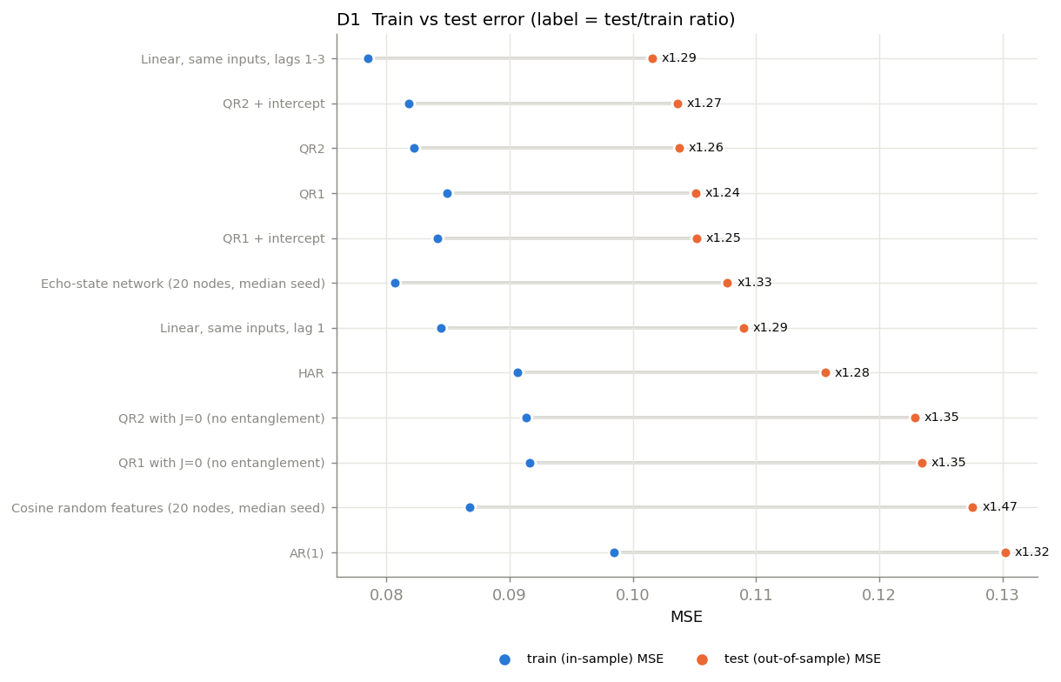
Figure D1a. Blue = in-sample MSE, orange = out-of-sample MSE. Labels give the test/train ratio.
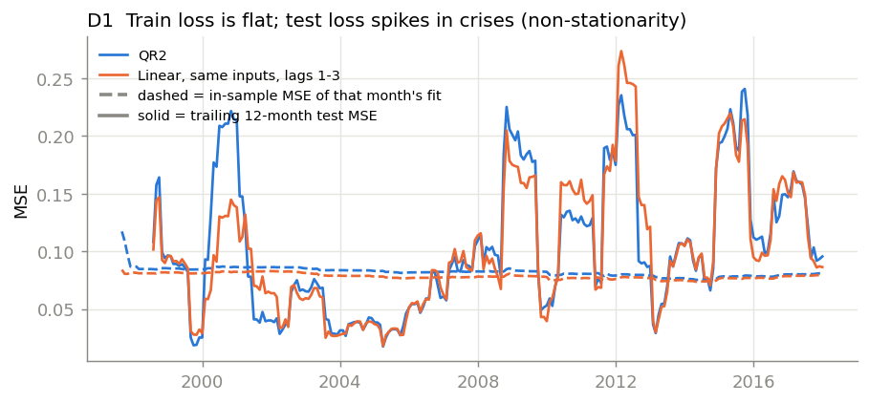
Figure D1b. Dashed: in-sample MSE of each month's fit. Solid: trailing 12-month test MSE.

D2–D3. Regularization path and learning curve
If the readout were overfitting, a stronger ridge penalty would lower the test error. It does not: QR2's best penalty improves test MSE by only 0.1%. The learning curves flatten well before the full 571-month window, and linear stays below QR2 at every training length.
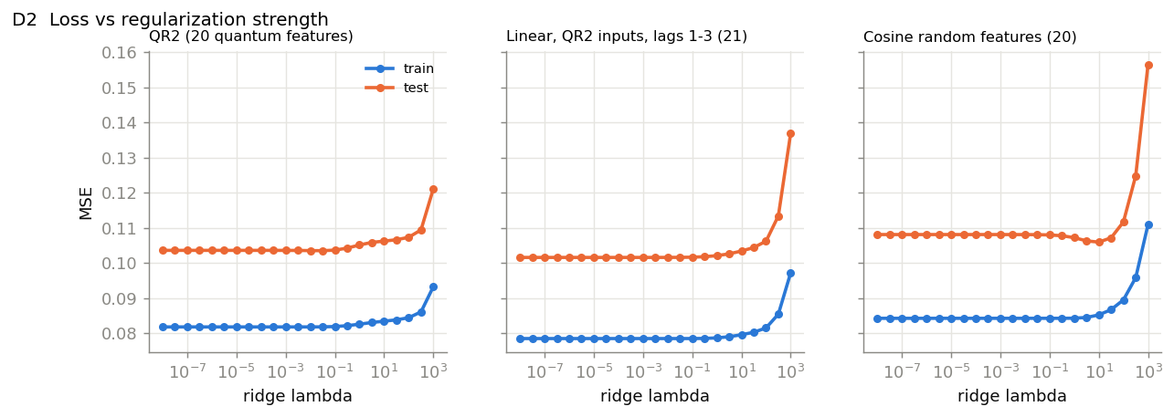
Figure D2. Train and test MSE vs ridge λ (features standardized per window, unpenalized intercept).
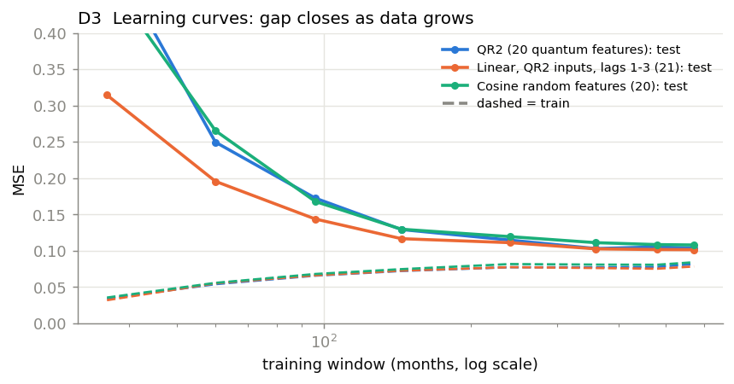
Figure D3. Test MSE on the same 245 months vs training-window length. Dashed = in-sample MSE.

D4. Selection bias
This is where the overfitting is. The paper's coupling matrix, memory depth and input set each look like the best of many options tried on the test window.
- The paper's coupling matrix for QR2 ranks 2nd of 20 random matrices. The median matrix scores 0.1111, worse than QR2's 0.1038.
- Memory depth K = 3 is the single best of K = 1 to 5 (0.1038, against 0.1099 to 0.1141 for the others).
- On 40 random 7-input sets, QRC lost to a linear model on the same inputs every time, with or without a readout intercept. Median MSE: QRC 0.1225, linear 0.1102.
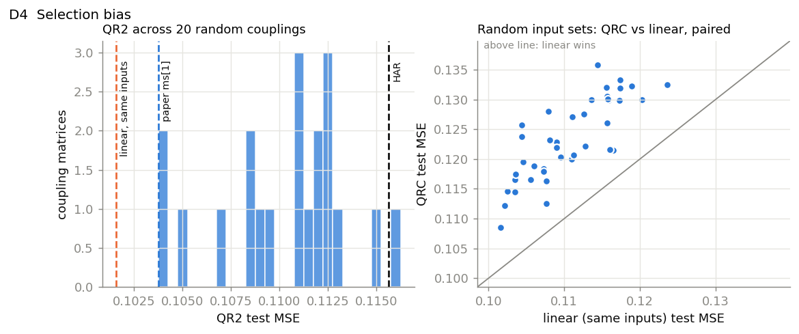
Figure D4. Left: no coupling matrix beats linear. Right: every point is above the diagonal, so linear wins on every input set.

D5. Replacing the quantum circuit
Each model below uses QR2's 7 inputs, the same 571-month rolling window and the same ridge readout. Only the feature map changes.
Model, 1997–2017 | MSE | QLIKE | Params | ΔMSE vs QR2 (95% CI) | DM p
Linear, same inputs, lags 1–3 | 0.1016 | 1.374 | 22 | −0.0002 (−0.0010, 0.0006) | 0.66
QR2 (paper) | 0.1038 | 1.400 | 20 | — | —
QR1 (paper) | 0.1051 | 1.443 | 10 | +0.0001 (−0.0006, 0.0008) | 0.78
Echo-state network, 20 nodes (median of 30 seeds) | 0.1077 | 1.507 | 21 | +0.0003 (−0.0008, 0.0013) | 0.53
Linear, same inputs, lag 1 | 0.1090 | 1.463 | 8 | +0.0004 (−0.0006, 0.0012) | 0.35
HAR | 0.1156 | 1.569 | 4 | +0.0010 (−0.0000, 0.0020) | 0.06
QR2 with J = 0 (no entanglement) | 0.1229 | 1.708 | 20 | +0.0015 (0.0006, 0.0024) | 0.001
Cosine random features, 20 (median of 30 seeds) | 0.1276 | 1.714 | 21 | +0.0019 (0.0001, 0.0044) | 0.06
AR(1) | 0.1302 | 1.718 | 2 | +0.0021 (0.0009, 0.0035) | 0.002
Random walk | 0.1428 | 1.878 | 0 | +0.0032 (0.0014, 0.0056) | 0.003

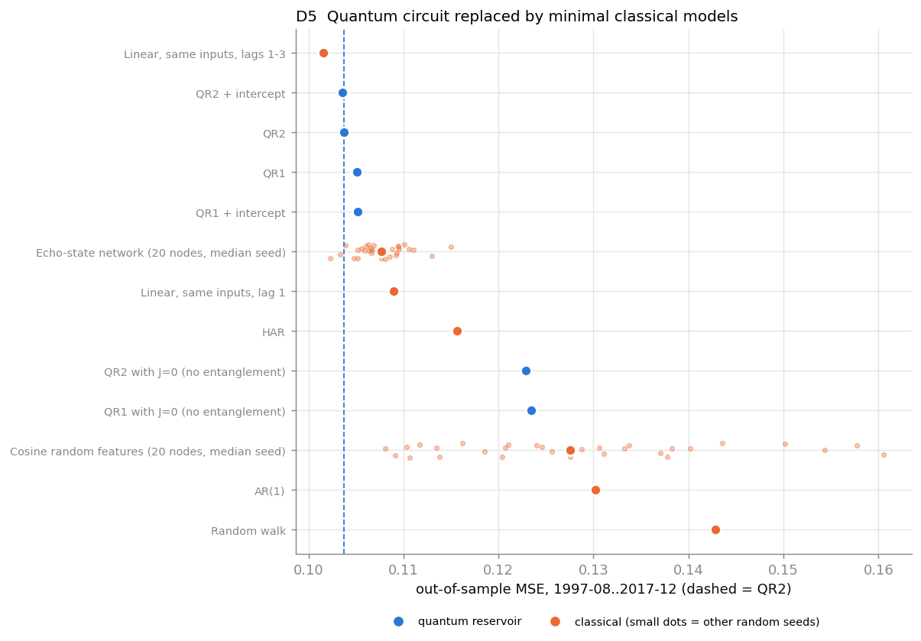
Figure D5. Blue = quantum reservoir, orange = classical. Small dots are other random seeds. Dashed line = QR2.
Entanglement matters. With the couplings set to zero, the same circuit scores 0.1229, significantly worse than QR2 (p = 0.001). The entangling dynamics are what bring QRC up to linear-model accuracy.
The quantum features are close to classical. A median of 99.6% of the variance of each QR2 feature is reproduced by linear, cos and sin terms of the 3 lagged inputs (lowest feature: 76%).

D6. True holdout, 2018–2026
The extended data in 1950-2026.csv was never used for any modelling choice. MKT and STR are missing after 2017, so this test cannot run the exact paper model. It uses a fixed set chosen before seeing any results: every QR1 or QR2 input that exists in the new period (RV, DP, IP, RV_q, DEF, EP, INF). The coupling matrix, V, K and λ are the paper's.
Model, holdout inputs | MSE 1997–2017 | MSE 2018–2026 | Holdout QLIKE
AR(1) | 0.1302 | 0.1757 | 1.026
Linear, same inputs, lags 1–3 | 0.1143 | 0.1772 | 1.044
Echo-state network, 20 nodes | — | 0.1823 | 1.077
HAR | 0.1156 | 0.1871 | 1.086
QR1 recipe | 0.1179 | 0.2165 | 2.315
Random walk | 0.1428 | 0.2287 | 1.423
QR2 recipe | 0.1196 | 0.2812 | 5.416

None of 40 coupling matrices beat linear on the holdout (median 0.2468, best 0.1946). Adding a readout intercept changed nothing (0.2815).
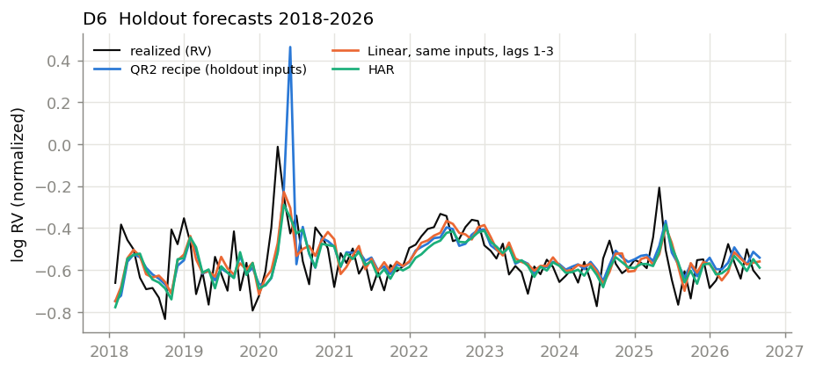
Figure D6. Holdout forecasts. QR2 follows the classical forecasts closely except in May 2020.
May 2020. The COVID drop in industrial production put IP at −0.132, three times beyond its training range (−0.044 to 0.024). QR2 forecast +0.46 against a realized −0.43, and linear forecast −0.30. That one month is about a third of QR2's holdout error. Stronger regularization does not fix it (λ = 1 still forecasts +0.34). Without the five worst months, QR2 still trails linear: 0.1296 vs 0.1223.

What this means for the research
The finding is "no quantum advantage, and settings tuned to the test window," not "the model memorized noise." The paper's claim has to change. A number of claims still hold up: QRC matches strong classical baselines on 1997–2017, it needs entanglement to do so, and it beats HAR, AR(1) and the random walk there.

Recommended next steps, in order
- Lock the protocol. Choose the coupling matrix, K, V, λ and inputs on a validation split inside the training window only. Then score once on 1997–2017 and once on 2018–2026.
- Report distributions, not the best draw. Give the median and spread over many coupling matrices, or average forecasts across several matrices.
- Benchmark against the strongest classical models. Linear on the same lags and an echo-state network, with Diebold–Mariano and Model Confidence Set tests on the holdout.
- Fix the input encoding. Scale inputs inside each training window and limit how far an out-of-range value can rotate a qubit.
- Try new circuits one at a time against the locked holdout. Daily RV is the most promising target.
- Lead with hardware feasibility. The existing shot, Trotter-depth and noise results show this accuracy is reachable on a small device.

Method notes
- MSE and QLIKE are on the original log-RV scale, using the repo's MSE() and compute_qlike(). QR2 reproduces the paper's 0.1038 exactly.
- Confidence intervals come from a moving-block bootstrap with 12-month blocks. DM tests use squared loss and a Newey–West variance with 6 lags.
- The coupling-matrix histogram uses 20 matrices from the earlier quick-mode research suite.
- RV_q and RV_a were checked for look-ahead. Both are built from months t−1 and earlier only.
- Reproduce with: python overfitting_diagnostics.py (outputs in results/diagnostics/).

