Aidan Collins

March 11, 2015

Data Structures and Algorithms

Homework 4

Question 1

Pseudo code:

Select item takes In to iterators and a functor

For every item form the first to last iterator the functor is applied on them

If that contition is true the item used is stored

At the end of the loop either returns the last item that the functor returned true for item or

The item in the last iterator

Closest stop t is a functor that takes in two doubles, latitude and longitude and stores them as its member variables it also has a shortest_dist double member variable initially set to the max value for a double

The operator() takes in a trainstopdata and calculated the distance form its latitude/longitude and the private member variables latitude/longitude and compares them to shortest dist and then changes shortest dist to the calculated distance if it it less than shortest dist

Preconditions:

The use inputs the appropriate input to start the algorithm

There is at least one trianStopData with latitude and longitude in a data structure with forward iterating capabilities

Post conditions:

A trainStopData name will be displayed.

Question 2

A **B**

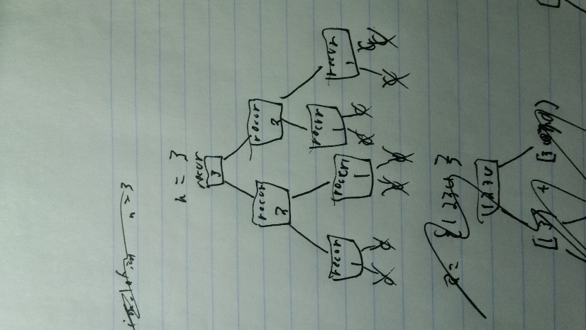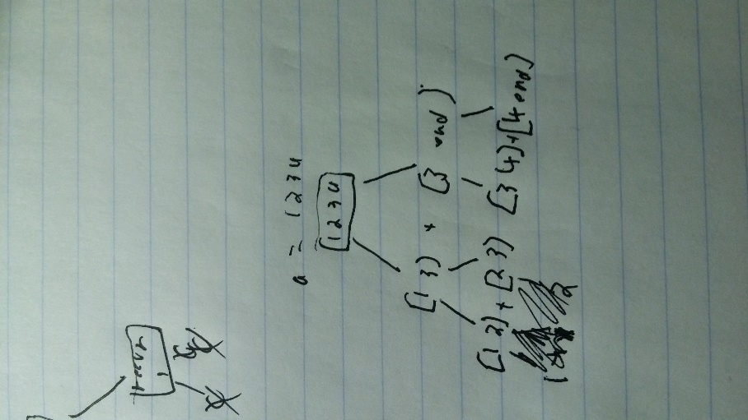

Question 3

itrStart = a.begin();

itrEnd = a.end()

itrMid = a.begin() + (a.size()/2);

Question 4

1. (A.size()/2)
2. Itr, A.end()
3. merge(A.begin(),itr,itr,A.end(),D)
4. D.end()

Question 5

1. 4:2:1:0:0:

*

2:1:0:0

1:0:0

*

***

1. O(nlog(n)^2)

Question 6

1. 4:2:1:0

Question 7

n=3 is 5 function calls, n=4 is 9 function calls, n=5 is roughly 15 because 5+4+3+2+1 = 15

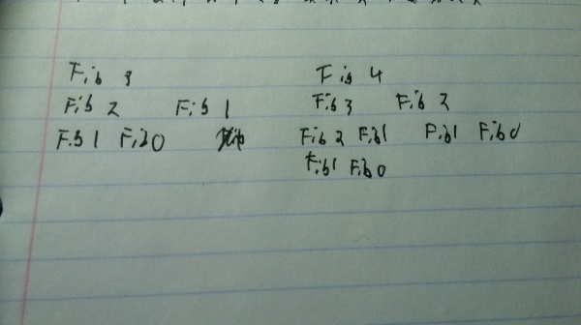

Question 8

8,9,-11,2,0,3

-11,8,9,2,0,4

-11,2,8,9,0,3

-11,0,2,8,9,3

-11,0,2,3,8,9

Question 9

8,9,-11,2,0,3

8,9,-11,2,0,3

-11,2,8,9,0,3

-11,2,8,9,0,3

-11,2,8,9,0,3

-11,0,2,3,8,9

Question 10

0,-11,2,3,3,9,3

-11,0,2,3,3,9,3

-11,0,2,3,8,9

-11,0,2,3,8,9

Question 11

1. 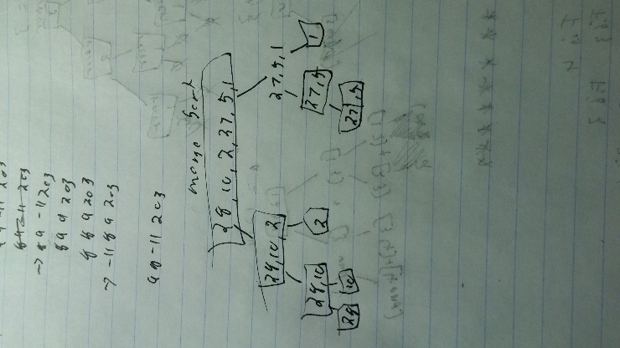(b)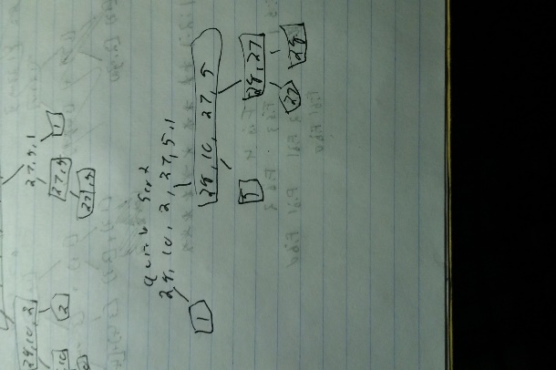

Question 12

1. O(n^2)
2. O(nlog(n))
3. O(nlog(n))

Question 13

O(nlog(n))

Question 14

Because i+1 will always be in the correct position at that point

Question 15

|  |
| --- |
| a |
| ab |
| abc |
| abcd |

X = d

|  |
| --- |
| abc |

x = c

|  |
| --- |
| abce |
| abc |
| ab |
| abf |

X=f

|  |
| --- |
| abfg |

X = g

|  |
| --- |
| abf |

X = f

Question 16

{1,0,0,0}

{1,2,0,0}

{1,2,3,0}

X = 1

{1,2,3,0}

{1,2,3,5}

{1,2,3,5}

{6,2,3,5}

X = 3

{6,2,3,5}

{6,2,3,5}

{6,2,3,5}

X = nothing

{6,7,3,5}