Milestone One

Aidan DiGregorio
Faculty of Computing & Data Sciences, Boston University
Module C: Data Science Capstone
Professor Joshua Von Korff
June 28, 2026

1. Problem Statement / Description
This capstone project is to address public health disparities in the U.S. for cancer mortality. It seeks to uncover how demographic and socioeconomic factors affect these cancer mortality disparities for certain groups. The core research question is to investigate how these factors play a role in higher or lower life expectancy outcomes when it comes to cancer mortalities. This will be a project in which policymakers, public health workers, and healthcare providers can identify vulnerable groups that need targeted, high-impact resource allocation to mitigate the disparities. In order to answer this project’s research question, a variety of datasets are utilized in order to capture a high granularity of the U.S. beyond surface level trends:
- CDC Multiple Cause of Death (2018-2020): Provides the high-resolution mortality outcomes necessary to identify recent trends.
- National Cancer Institute County-Level Rates: Allows for geographic clustering analysis to identify regional outliers.
- NCHS/KFF Life Expectancy: Provides the historical context needed to determine if current cancer disparities are part of a broader longitudinal trend.
- Census Demographic Data: Enables risk-adjustment for age and sex, ensuring disparities aren't simply a reflection of local population distributions.
- USDA Socioeconomic Indicators: Essential for isolating the impact of poverty and unemployment from clinical health factors.
2. Modeling Techniques
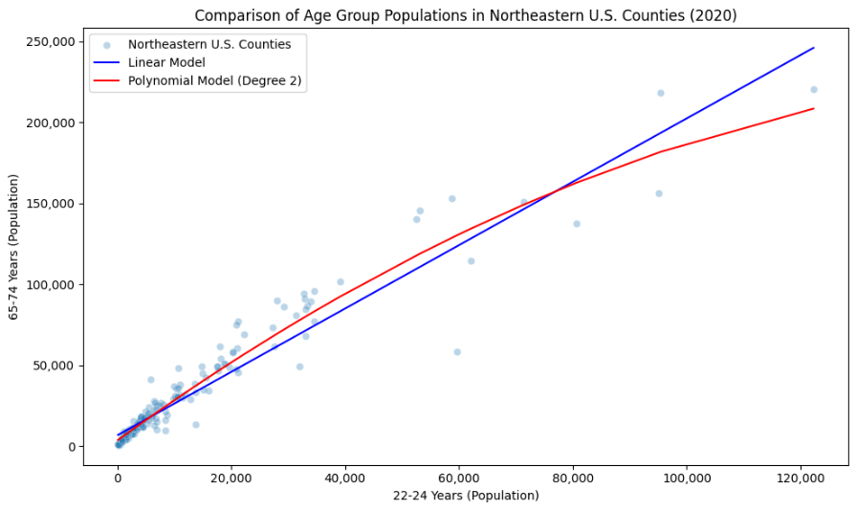
Polynomial terms were applied by squaring age group population features in order to build a non-linear regression curve for census population data. For example, all county populations of Northeastern U.S. states were plotted for two age groups (22-24 years and 65-74 years) and a regular linear regression was applied with a polynomial degree 2 linear regression model, using the 22-24 year age group as the square feature, to compare the effectiveness in predicting the 65–74-year-old populations. Overall, the polynomial model was better than the linear model since it produced a lower mean absolute error (4,239 people compared to the linear model’s 9,678). Both models were strong in capturing the variance of the data (linear explained 89.86% of the variance while polynomial is 94.61%). The polynomial interaction term applied to the model implies that there were non-linear relationships that a line couldn’t capture as well. Using life expectancy data, the interaction between the year the data was collected and a female sex feature (0 for male, 1 for female) used in an ordinary least squares regression. The p-value for this interaction term was 0.008 and its variance inflation factor was 3289.90. The OLS model had an R2 score of 78.3%. The intreaction term was statistically significant and aided in more accurate predictions of the average life expectancy. There is high multicollinearity with this model due to the interaction term, but it helped to uncover that the interaction between the year and whether the sample was male or female resulted in an increased coefficient of 0.0279 years for female average life expectancy growth compared to males. Lasso regression was applied with a five-fold cross-validation to the USDA Socioeconomic Indicators dataset. The optimal alpha was 10.0 and produced a test MAE of $10,342.01 in predicting median household income compared to $6,423.32 for a second Lasso model using all features. While the errors increased, its R2 reduced to a more realistic figure for socioeconomic data analysis (29.19% vs. 71.17%). According to Duke University, “if R-squared is very close to 1, and the data consistes of time series, this is usually a bad sign rather than a good one.” In socioeconomics a lower R2 score is not necessarily bad due to the significant variance in social and ecomoic condtions. Ridge regression was applied with five-fold cross validation to the CDC demographic data to predict the total population of U.S. counties in 2020. Two models were used for comparison (one includes all features and the second drops all features that had to do with 2020). The optimal alpha was 0.01 for both models, the models produced a test RMSE of 2,568 and 11,073 respectively. Significant multicollinearity was uncovered due to the 2020 features including enough information to nearly explain the entire target (R2 of 99.99%). The second model was reduced to R2 of 99.89, but due to the nature of the dataset being time series population aggregates, building models off of this dataset would requre new features outside of the aggregate counts. Elastic Net regression with five-fold cross validation was applied to the same data with the same target. The optimal alpha was 10, optimal L1 ratio was 0.7, and the model produced an RMSE of 59,294 with an R2 of 96.80%. This model handled the multicollinearity better as there was less overfitting and a lower R2 to explain the variance of the data, however realistically the high RMSE does not perform well in predicting the total population of counties throughout the country due to the high error biased towards larger counties.
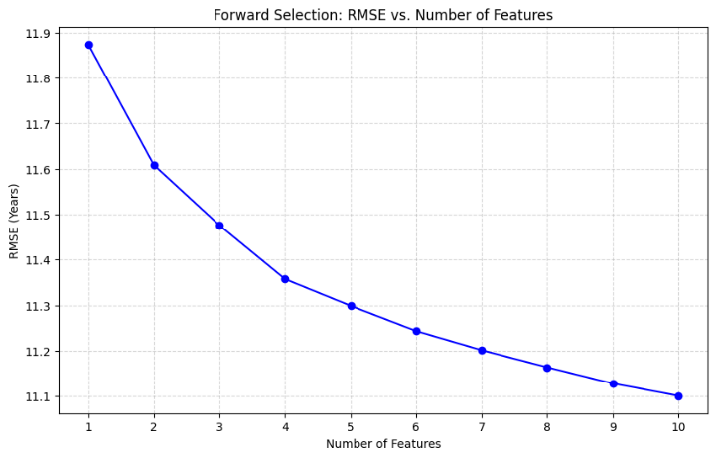
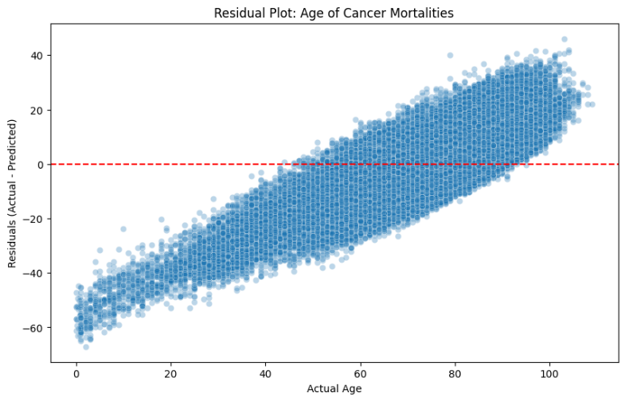
Being more in-depth, forward feature selection was applied to the cancer mortality dataset in order to predict the age in which patients died from cancer. The forward selection algorithm set a maximum of 10 features out of the data’s 110, a five-fold cross validation with the scoring set to negative RMSE. With a limit of 10 features, the final selection were categorical features such as whether the patient was widowed, had never married, had prostate cancer, the place of death, cause of death being neoplasms of meninges, brain, and other parts of the central nervous system, whether the patient’s race was white, place of death being a nursing home, cause of death being a neoplasm of the cervix uteri, cause of death being a neoplasm of the bladder, and patient’s resident status. The feature selection ran the RMSE of each step in the 10 step selection process and showed little improvement from an RMSE of 11.8744 years in step 1 to an RMSE of 11.1008 years at step 10. This implies that the model was quickly able to capture the impactful predictive power and then the RMSE began to plataeu as more features were added. Backward selection was applied to the NCHS life expectancy dataset to predict average life expectancy in years using 5-fold cross-validation with a scoring criteria of negative RMSE. The minimum features was set to 1. It started with all 10 features with a test RMSE of 1.6856 yeas. The final selection was the age-adjusted death rate, whether the sample’s race is Black, and whether the sample’s sex is male. This resulted in a 1.6416 test RMSE which shows there is minimal improvement in not using all features. For the cancer mortality dataset, a PCR pipeline was created using StandardScaler, PCA with n_components set to 0.95, and the regressor being linear regression. The model predicted the age target with a test RMSE of 11.024 years, keeping 82 components and dropping 27. To see the performance of the regression, the residuals were plotted to understand the difference between the actual target values and the predicted target values. The red line indicates perfect residuals where the difference is 0. The predictions on the lower range for age are significantly higher since the residuals are into the negative. In contrast, the higher end face lower age predictions. A similar pipeline was created using partial least squares regression and StandardScaler. Compared to the PCR model, its test RMSE was 10.97 years while just keeping 5 components and dropping 104. The PLSR model massively reduced the complexity of dimensionality while maintaining and improving upon the predictive power.
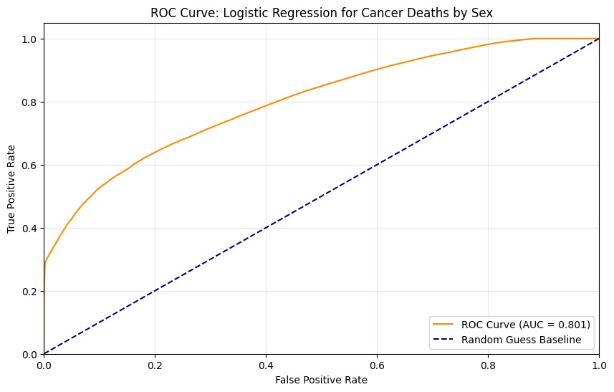
The second more in-depth model techniques focuses on applying logistic regression and feature scaling. Three logistic models were created to test the effectiveness of different regularizations in accurately classifying the sex of the patient who died from cancer. The first baseline model’s penalty was None, solver was saga, maximum iterations was 1000, and the tolerance was 1e-3. The second and third models included all the same parameters except for penalty (2nd had an L1 penalty and 3rd had an L2 penalty). The three baseline models had the same accuracy and log loss values of 0.725 and 0.506 respectively. In an attempt to find a separation in accuracy and log loss for each model, a three-fold cross-validation was applied using GridSearchCV and testing different C values (0.01, 0.03, 0.1, 0.3, 1, 10). All models had a C value of 10 and they maintained the same accuracy and log loss values as the baseline models. This is due to the fact that the hypertuning could not outpace the predictive capabilities set by the dataset’s quality. No more tuning could result in better metrics. However, the ROC curve and AUC score of 0.801 implies that the models have very accurate predictions compared to randomly guessing where AUC would be 0.5.
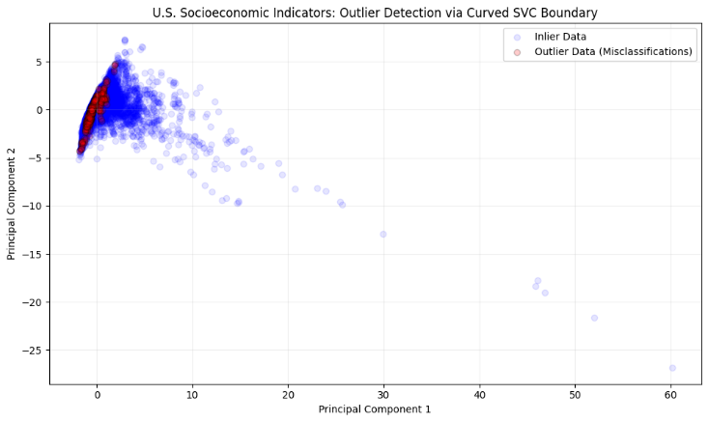
With the USDA socioeconomic dataset, PCA was used to reduce the dimensionality to two principal components and then a support vector machine pipeline with StandardScaler, kernel set to rbf, C set to 1.0, and gamma set to 0.1 was used to find a curved boundary for the target of whether a county was a metro or rural county. It resulted in highlighting outlier data that were significantly outside the majority of the data variance for each type of county. This highlighted the most significant outliers in the data based on complex relationships from multiple features. Decision trees were used to classify the race of patients who died from cancer. A baseline decision tree classifier with default parameters set, resulted in an accuracy of 67% and weighted averages of precision, recall, and F1-score of 68%, 67%, and 68% respectively. GridSearchCV with three-fold cross-validation was used to find optimal parameters, leading to a higher accuracy of 78%, weighted averages of precision, recall, F1-score of 75%, 78%, and 72% respectively. This shows that hyper-tuning was able to capture more of the multivariable relationships of the data to better predict whether the patient was non-white or white. Random forest regressors were applied to the cancer mortality dataset in order to predict the age of patients when they died from cancer. Compared to other regression models focusing on this target, the random forest model had a lower test RMSE of 10.56 years. Though it had an R2 score of 33.58%, that is a strong R2 score for healthcare-related data analysis.
3. Overfitting
In order to address overfitting, feature selection methods such as forward and backward selection, dropping features with high multicollinearity, and limiting the model parameters to set ranges were all strategies to balance the model performance and avoiding memorization of the datasets. For example, forward selection set a maximum number of features that could be used in order to predict the age of the patient when they died from cancer. If all features were used in the regression model, it likely would have memorized the data rather than capturing enough predictive power to generalize. With my ridge regression, I dropped features in order to avoid multicollinearity. While the R2 of the model reduced and overfit less, sometimes it is crucial to understand the inner workings of the dataset before model building. This is because the data were simply aggregates and thus all features were related to one another which leads to high multicollinearity. Dropping or creating new features in order to make predictions were one of the ways I was able to significantly reduce the overfitting. The population aggregates were changed to percentage population changes from the previous decade and it resulted in a significant drop from near perfect R2 (99%) to roughly a more generalized capture of the variance at 50%.
4. Metrics and Hyperparameter
During this milestone, each of the models required different metrics given the nature of the model’s algorithm but also to have an interpretable metrics for the data. For example, mean absolute percentage error was used in the random forest model. The mean absolute percent error is a powerful metric for this capstone because we need to consider proportionality when trying to uncover health disparities, a more interpretable and accurate way of comparing the trends of different groups. MAE and RMSE were used to interpret numerical target errors such as years. Both were considered as MAE gets the average error in positive terms while the RMSE accounts for larger values so there is less of an impact on error calculation. For classification tasks, F1, precision, accuracy, and recall, as well as looking at confusion matrices provided an in-depth evaluation of model performance when the target was categorical such as race.
5. Exploratory Data Analysis
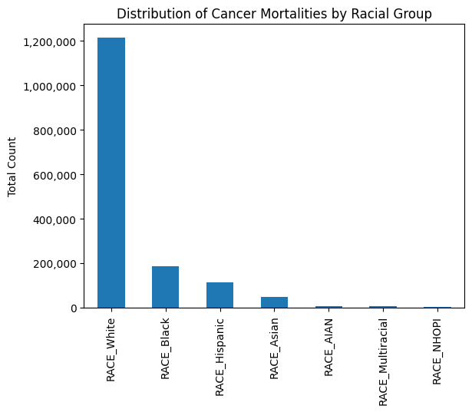
Through the model building process, I discovered new insights into the data. For example, analyzing the demographic dataset was crucial in my understanding of the model building process or else it would have led to significant overfitting with poor generalization. Understanding the features and structure of the dataset is crucial for the model building process, something that sometimes seems overlooked. This was an important lesson in this capstone because I was able to adapt how the data was structured while maintaining its characteristics in order to build a more comprehensive model. Another important aspect was to analyze the distribution of classes when running classification models. Without understanding the imbalances and looking strictly at the metrics such as accuracy is a misleading result because accuracy would favor the majority class and failing to capture the patterns of the minority class.
6. Expected vs. Unexpected Results
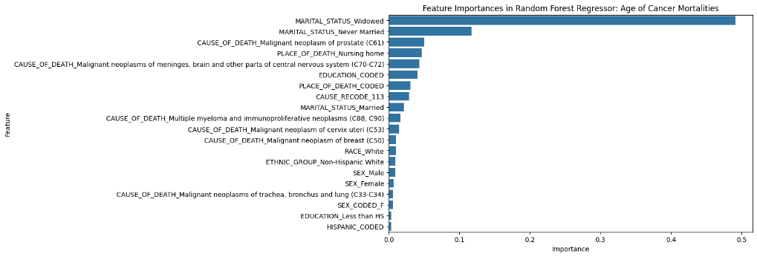
There were some unexpected results from running the different techniques on the datasets for this capstone. For example, the random forest model to predict the age of the patient who died from cancer resulted in uncovering potential social variables that vastly impact when someone dies from cancer. The most interesting factors have to do with marital status (widowed or not, married before or not), whether the patient died at a nursing home or not, and level of education. This shows that there may be a social aspect that contributes to the age of death from cancer on whether they have a support network (most commonly their spouse) and the education level. On the other hand, expected results were that the aggregate demographic dataset provided little model-building capability on its own without doing feature engineering. It serves more as supplemental information to the capstone alongside socioeconomic data to find structural inequities in life expectancy and cancer outcomes. However, it was important to use it in building models because it taught a valuable lesson that you can extract predictive power with generalization by manipulating the features while maintaining its overall characteristics (i.e. converting aggregates to percentage changes.).

AI Appendix
Google Gemini was used to debug a ValueError during logistic regression model development. I provided the model code and asked why I was getting a ValueError. It explained that I used the wrong solver for the L1 penalty (lbfgs instead of liblinear or saga).
Full prompt: https://gemini.google.com/share/0f0ea79a8f59
Citations
Arias, E., Xu, J., & Kochanek, K. (2025, July 15). United States life tables, 2023. National Vital Statistics Reports, 74(6). United States. Retrieved from https://stacks.cdc.gov/view/cdc/174591

CDC. (2024). National Program of Cancer Registries. SEER*Stat Database - United States Department of Health and Human Services, Centers for Disease Control and Prevention and National Cancer Institute. Retrieved from https://www.cdc.gov/cancer/npcr/index.htm

Daniel. (2023, September 4). Advanced missing values imputation technique to supercharge your training data. Retrieved March 10, 2026, from https://youtu.be/KWrZ59nLLSg?si=XtQUO2dH8F2f4Nzi

Maternal, Child, and Adolescent Health Needs Assessment, 2023-2024. (2025, August 11). San Francisco Open Data. Retrieved from https://catalog.data.gov/dataset/maternal-child-and-adolescent-health-needs-assessment-2023-2024

Muonneutrino. (n.d.). US Census Demographic Data. Kaggle. Retrieved from https://www.kaggle.com/datasets/muonneutrino/us-census-demographic-data

National Cancer Institute. (2024). SEER*Stat Database - United States Department of Health and Human Services, Centers for Disease Control and Prevention and National Cancer Institute. Retrieved from http://seer.cancer.gov/

National Cancer Institute. (n.d.). Cancer Profiles. Retrieved from https://statecancerprofiles.cancer.gov/data-topics/incidence.html

National Center for Health Statistics. (2018). Mortality Multiple Cause Files. CDC. Retrieved from https://www.cdc.gov/nchs/data_access/vitalstatsonline.htm

National Center for Health Statistics. (2019). Mortality Multiple Cause Files. CDC. Retrieved from https://www.cdc.gov/nchs/data_access/vitalstatsonline.htm

National Center for Health Statistics. (2020). Mortality Multiple Cause Files. Retrieved from https://www.cdc.gov/nchs/data_access/vitalstatsonline.htm

NCHS - Death rates and life expectancy at birth. (2020, November 10). Centers for Disease Control and Prevention. Retrieved from https://catalog.data.gov/dataset/nchs-death-rates-and-life-expectancy-at-birth

Ndugga, N., Hill, L., & Artiga, S. (2026, March 6). Racial Disparities in Life Expectancy. KFF. Retrieved from https://www.kff.org/racial-equity-and-health-policy/racial-disparities-in-life-expectancy/

Schroeder, J., Van Riper, D., Manson, S., Knowles, K., Kugler, T., Roberts, F., & Ruggles, S. (2025). IPUMS National Historical Geographic Information System: Version 20.0. Minneapolis, MN: IPUMS. doi:http://doi.org/10.18128/D050.V20.0

Teboul, A. (2022). Diabetes Health Indicators Dataset. Kaggle. Retrieved from https://www.kaggle.com/datasets/alexteboul/diabetes-health-indicators-dataset

U.S. Department of Agriculture, Economic Research Service. (2025, January 1). County-level Data Sets. Unemployment and median household income for the United States, States, and counties, 2000–23. Retrieved from https://www.ers.usda.gov/data-products/county-level-data-sets/county-level-data-sets-download-data

(Duke University, n.d.)

