**Bachelor of Science (Honours)**

**Computing**

**Semester 8**

**Module:**

**Game Design and Development**

**Individual CA1**

**2-D Game creation using Phaser 3 framework**

Lecturer: Enda Lee

Submission Date: 14th March 2019

**Student Details: Word Count**

Aidan Dunne X00126748

2204

**Declaration**

The above-named student declares that the content of this Continuous Assessment project is solely the work of the individual whose name appears on this cover sheet. The work of any other authors has been cited and referenced in full.

Table of Contents

Introduction 3

Super Mario Bros 3 Level 4

Critical Assessment of Super Mario Bros. 3 5

Gameplay 5

Goals 5

Genre 5

Player Interaction/Perspective 6

Modern Evaluation of Super Mario Bros. 3 7

Graphics 7

Enemies 7

Characters 8

Gameplay 9

Difficulty level 9

Conclusion 10

Bibliography 11

# ****Introduction****

For the purpose of this assignment, I am required to create a 2-D game of my choice from the eighty’s or early ninety’s. I will supply a brief description of my approach to my level I have created, I will also critically assess my chosen game by describing in detail the gameplay, the goals of the game, the players interaction with the game and their perspective, the genre of game, etc. I will recreate a particular level from my chosen game to the best of my ability and make it as close to the original as possible by using similar graphics and music/sound effects. To do this I will be using Phaser 3 framework. I will also evaluate the game in a modern context and make recommendations on how I feel the game could be improved , more specifically I will make 5 recommendations on aspects such as, graphics, sound effects, user interaction, etc. The game I have decided to choose is Super Mario Bros. 3. The main reason I have chosen this game is I remember playing it a lot as a kid and would like the opportunity to recreate the game.

# Super Mario Bros 3 Level

In this section I will give a brief description of the level I have created and the approach I took to create the level. To test and deploy this game locally on my machine I used NodeJS and webpack to bundle all my configuration together I did by following a tutorial I will link in my references.

The first step I took in creating my level from the Super Mario Bros 3, was choosing a specific level to create, for this process I decided to create just a generic level from the middle of the game where there was no boss enemy to defeat at the end and to complete the level all the player has to do is make it to the flagpole at the end of the map. With the level picked my next step was to find and create the assets I planned to use for the game. This process took quite a long time as it took a lot of searching across the internet to find all the images I needed and also trying to find all the audio clips I needed. Once I had all the assets I needed to create the map, the sprites/characters and then audio files.

To create the map I used Tiled. To create the sprites/characters I used Texture Packer and then finally to create the audio clips for the game I used the Phaser editor which allowed me to create audio sprites. The next step I took was to start configuring the characters and enemies including their animations. Once I had all of this done the next step was to start creating my scenes, I had done a lot of research online, looking at multiple tutorials on different ways to do the game and how to configure different elements in the game. I decided to go with a scenes approach containing the preload, create and update methods, so I had three scenes for my level, the BootScene, the TitleScene and the GameScene each containing their appropriate methods.

The last step I took was to test the game and have family members & friends test the game and give me feedback on what features they liked and what they felt should be changed to improve the game.

# Critical Assessment of Super Mario Bros. 3

## Gameplay

Super Mario Bros 3 is a two-dimensional, side-scrolling platform game based quite similarly on the previous games from the Super Mario Bros series. As in previous games of the Super Mario series, Super Mario Bros 3 contains the usual gameplay features that a regular player would be very accustomed to seeing, such as, running, jumping, sliding and the usual animations that are common to the series. The general gameplay is quite smooth and easy on the eye as with each new instalment of the game, things like graphics and design had improvements added to them so with this not being the first game in the series a lot of improvements have been added to it. In Super Mario Bros 3 the player can navigate Mario or Luigi through the world using 2 screens, one is the map which shows the player there progress through the game and what level they’re currently on and what is left to do in the game, the second screen is the actual level play which the player aims to complete. In the games levels a player can collect coins and powerups from breaking boxes and jumping on enemies to defeat them. By completing these levels the player can progress through the map and eventually make it to the last level where the player will meet the boss enemy who will usually be tough to defeat. The player would usually have a certain number of lives for example 3, to attempt to complete a level.

## Goals

The main goal of Super Mario Bros 3 is for the player is to get to the final level and defeat the boss to complete the game with the best possible score. To achieve this goal, the player first needs to complete all the levels and smaller goals along the way to the final level. For each level the main goal is to reach the flagpole at the end of the level while collecting as much points as possible and having as many lives remaining as possible! The user collects points along the way by collecting coins, defeating enemies and getting powerUps.

## Genre

The Super Mario series is in the genre of platform based games and this instalment of the series is no different, Super Mario Bros 3 is also a platform game.

## Player Interaction/Perspective

As I said in the gameplay section of this report the Mario Bros series is a two-dimensional side-scrolling platform game and Super Mario Bros 3 is no different to the game that came before it in this series, so the perspective of this game is a side-scrolling platform game. Player interaction is a huge element of this game, the player can interact with pretty much everything in this game, from the blocks, to the pipes and then even the flagpole at the end of each level. The player can also interact the enemies in the game, the player can either defeat the enemies, be defeated by the enemies or just try to avoid them altogether.

# Modern Evaluation of Super Mario Bros. 3

In this section I will evaluate the Super Mario Bros 3 in a modern context and then make 5 recommendations on how I feel the game can be improved.

Over the years there has been a lot more instalments in the Super Mario Bros series these new games brought with them a few new features and characters being introduced to the series as well as brand new levels with different goals to complete them. Below I will give my 5 recommendations which I feel will help improve the game.

## Graphics

For the year that Super Mario Bros 3 came out the graphics were really good but now that the year is 2019 and the original Super Mario Bros 3 is just over 30 years old the graphics are very outdated and I feel like if the graphics where to be improved it would improve the game greatly. Phaser 3 is brand new technology and can produce very clear and precise graphics for platform games with that being said, I would improve the graphics for the game by finding much more HD assets and sprites to use in the game. I feel that modern graphics could improve the game greatly.

## Enemies

In Super Mario Bros 3, the enemies are very generic in what they do and by that I mean the enemies will just move side to side until they collide with an obstacle, in this case they will just turn and start to move in the opposite direction. The enemies can cause damage to the player by colliding with the player on all sides unless the user jumps onto the enemy. I feel that if we could improve the enemies range of movement then that would in turn would improve the game itself, I am suggesting that we enable the enemies to be able jump. Below is how I would try to enable this feature in Phaser 3.

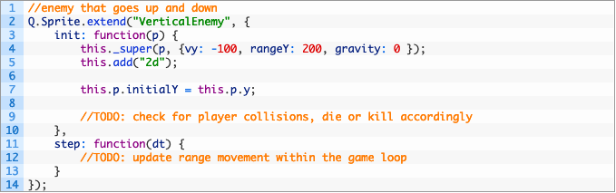

## Characters

In Super Mario Bros 3 the player only has a choice of using Mario or Luigi and the enemies are very limited as well, there is a Goomba which is the basic mushroom enemy and then there is the turtle enemy. I feel one improvement that could be made to this game is to add more characters and enemies to the assets as the code that they use would be the exact same but by doing this you would expand the game and give the player more to play with. For example you can add specific sprites for Wario, Toad, Yoshi, Princess Daisy etc and this would expand the game as a player can then pick what player they wish to use. Also adding more enemies to the game makes the game more fun as the player won’t be coming up against the same two enemies for the whole game. Some enemies I would add are Boos and Hammer Bro. The code I would user to allow to Hammer Bro enemy to throw hammers would be something along the lines of the below code.

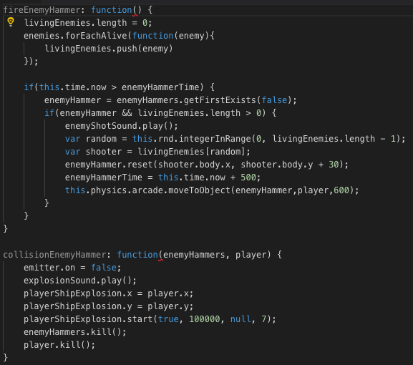

## Gameplay

Another feature that I feel could be improved in Super Mario Bros 3 is the gameplay of each level. For the most part of the series the gameplay and goals always stay the same and very rarely change, the goal is to get to the flagpole at the end of the level and then progress to the next level. If the player is defeated before he reaches the flagpole then he must start the level all over again and lose all of their points! My suggestion is to add a checkpoint feature to the game so that if a player reaches a certain point in the game then if the player is defeated he/she will return to the checkpoint and not the very beginning of the level. Below is rough guide as to how I would plan to implement the checkpoint into Super Mario Bros 3.

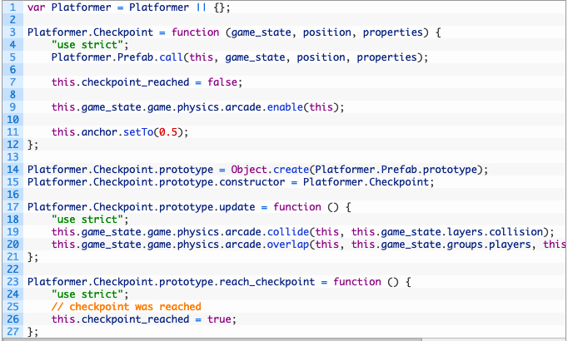

## Difficulty level

My final recommendation to attempt to improve Super Mario Bros 3, is to add an option at the start screen to let the player choose a level of difficulty they wish to play the game at. I would give the user three options, easy, average & hard. I would then plan to have a copy of the map and then alter with more obstacles and enemies depending on which level the user picked, so for example if the user picked the hard level it would have a lot more enemies and obstacles then if the user chose the easy level. I feel this would be a big improvement to the game as it would allow players to either improve their ability or get to try out the game at different levels rather than just one generic difficulty.

# Conclusion

In conclusion to the above critical assessment, modern evaluation and five significant improvements that I feel can be made to improve Super Mario Bros 3, I have successfully assessed the game in great detail in my critical assessment of the game discussing the main features such as gameplay, graphics, characters, etc. In the modern evaluation I have mainly focused on the five significant improvements that I feel can be made to improve the game. The five main sections that I feel can be improved in Super Mario Bros 3 and have suggested to be improved are, Graphics, Gameplay, Characters, Enemies & last one.

# Bibliography

Academy, Z., 2018. *Adding Enemies to a HTML5 Mario-Style Platformer.* [Online]   
Available at: https://gamedevacademy.org/adding-enemies-to-a-html5-mario-style-platformer/  
[Accessed Febuary 2019].

Academy, Z., 2018. *Platformer Tutorial with Phaser and Tiled – Part 2.* [Online]   
Available at: https://gamedevacademy.org/platformer-tutorial-with-phaser-and-tiled-part-2/  
[Accessed Febuary 2019].

Blog, S., 2018. *A Modern Web Development Setup For Phaser 3.* [Online]   
Available at: https://snowbillr.github.io/blog//2018-04-09-a-modern-web-development-setup-for-phaser-3/  
[Accessed Febuary 2019].

Gallup, C., 2016. *Phaser Enemy Shooting.* [Online]   
Available at: http://www.christophergallup.com/phaser-enemy-shoot/  
[Accessed Febuary 2019].

Unkown, Unkown. *Super Mario Bros 3.* [Online]   
Available at: https://www.mariowiki.com/Super_Mario_Bros._3  
[Accessed Febuary 2019].

Unkown, Unkown. *Super Mario Bros. 3.* [Online]   
Available at: https://en.wikipedia.org/wiki/Super_Mario_Bros._3  
[Accessed Febuary 2019].