Donuts & Boba Site Plan

Aidan Greenwood

WDD 130

Overview

Purpose

The purpose of this website is to advertise and sell specialty donuts and soda-based boba drinks. The site will allow customers to browse products, learn about the business, view featured menu items, and add products to a shopping cart.

Audience
The target audience includes teenagers, college students, families, and anyone looking for a fun dessert or drink. Customers who enjoy specialty donuts, sweet treats, and soda-based boba drinks will find the site useful.

Branding

Website Logo
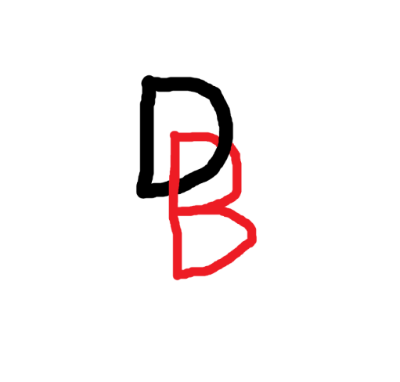

Style Guide

Color Palette
Primary | Secondary | Accent 1 | Accent 2
#E9EDF5 | #EFC69B | #4CE0B3 | #F497DA

Typography

Heading Font: Knewave Static

@import url('https://fonts.googleapis.com/css2?family=Knewave&display=swap');

Paragraph Font: Comic Neue Static

@import url('https://fonts.googleapis.com/css2?family=Comic+Neue:ital,wght@0,300;0,400;0,700;1,300;1,400;1,700&display=swap');

Navigation
Home Donuts Boba Drinks Cart

Content

Home:
This page just needs something over the hero image. Like:
“Welcome to Donuts & Boba”

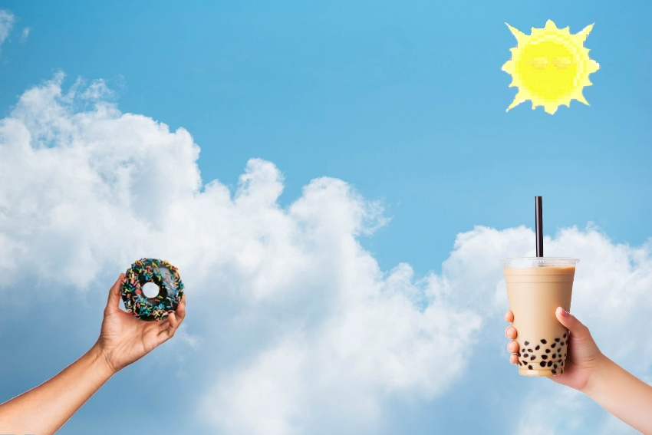

Page 2 – Donuts:

Card 1 (can also be used as the featured on the home page):
Title: Clentaminator Cruller

P: A light vanilla cruller coated in colorful strawberry, lime, and blueberry glazes. Sweet, fruity flavors blend together to create a bright and refreshing treat.

Img:

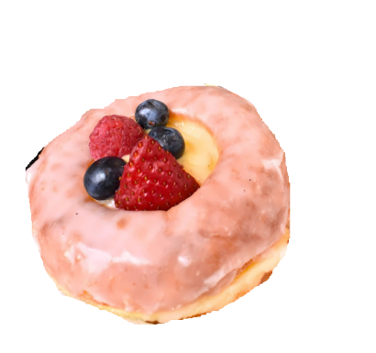

Card 2:
Title: Nebula Arcana

P: A rich blueberry cake donut topped with purple icing and sparkling candy pieces. Sweet berry flavors make this donut both colorful and delicious.

Img:

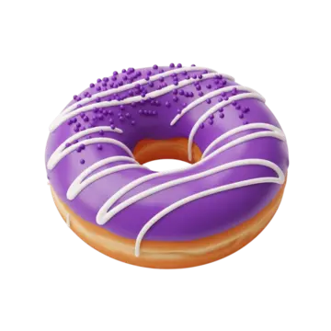

Card 3:
Title: Naughty Present

P: A chocolate-filled donut covered with red frosting and festive sprinkles. Every bite combines rich chocolate flavor with a sweet holiday finish.

Img:

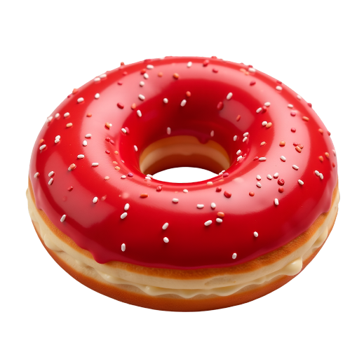

Card 4:
Title: Spelunker Glowstick

P: A lemon-glazed donut topped with yellow icing and candy pieces. Its bright citrus flavor makes it stand out from the crowd.

Img:

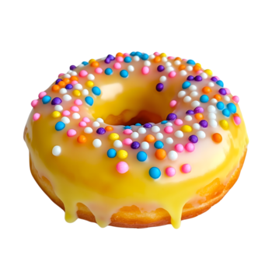

Page 3 – Boba Drinks:

Card 1 (can also be used as the featured on the home page):
Title: Starfurry Fizz

P: A sparkling lemonade boba drink with sweet raspberry and pomegranate flavors. Refreshing and bright, it is perfect for a warm day.

Img:

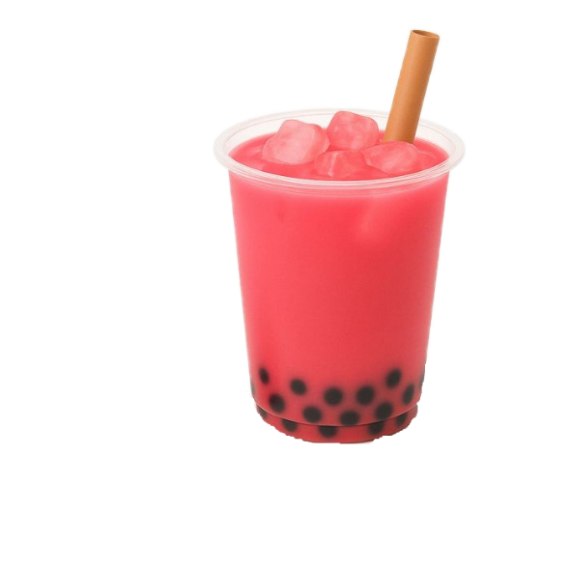

Card 2:
Title: The King Slime

P: A blue raspberry soda-based boba drink packed with sweet berry flavor and bursting with color.

Img:

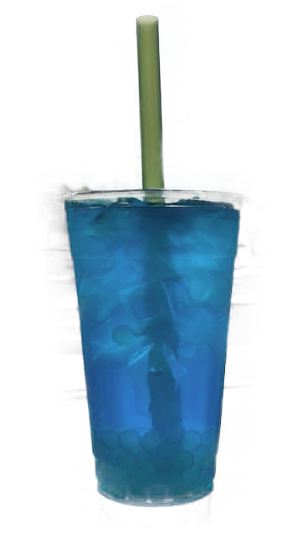
Card 3:
Title: Strange Brew

P: A mixed-fruit boba drink combining cherry, grape, and berry flavors into one sweet and refreshing beverage.

Img:

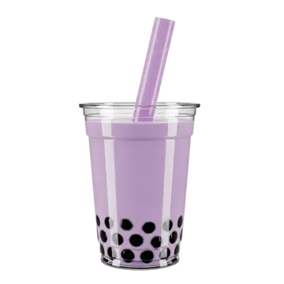

Card 4:
Title: Ambrosia

P: A tropical mango and pineapple boba drink with a smooth, fruity flavor and a golden appearance.

Img:

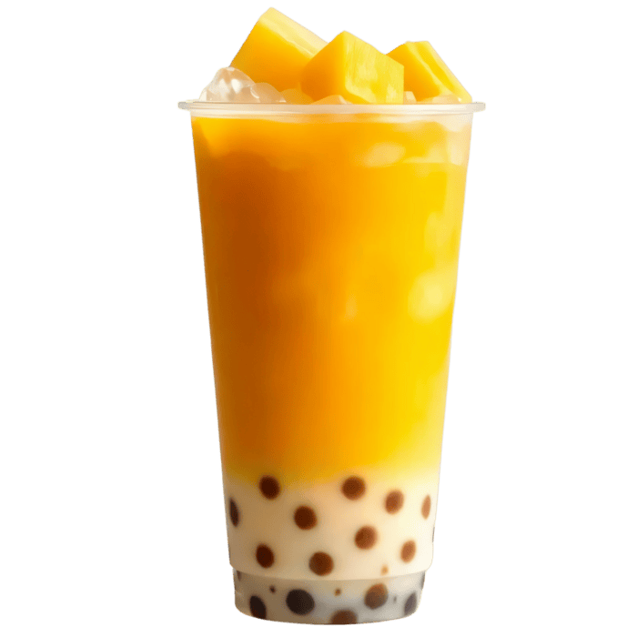

Wireframes

Home
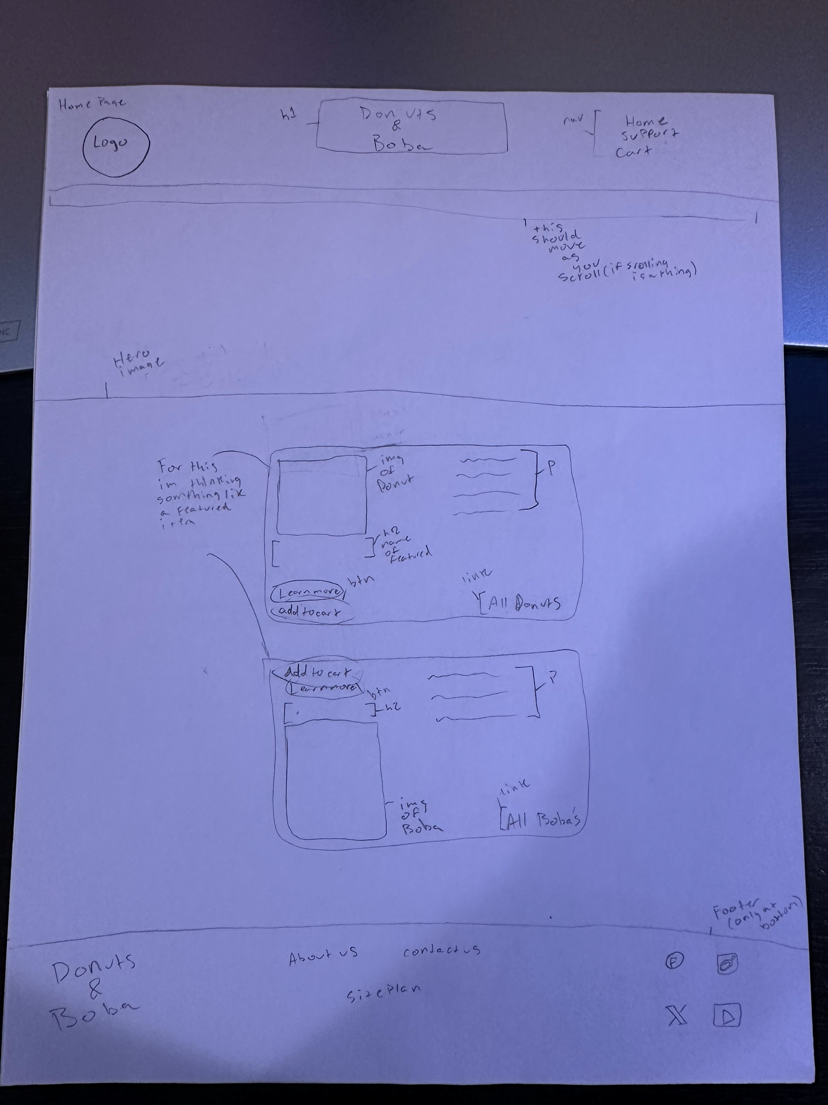

Page 2

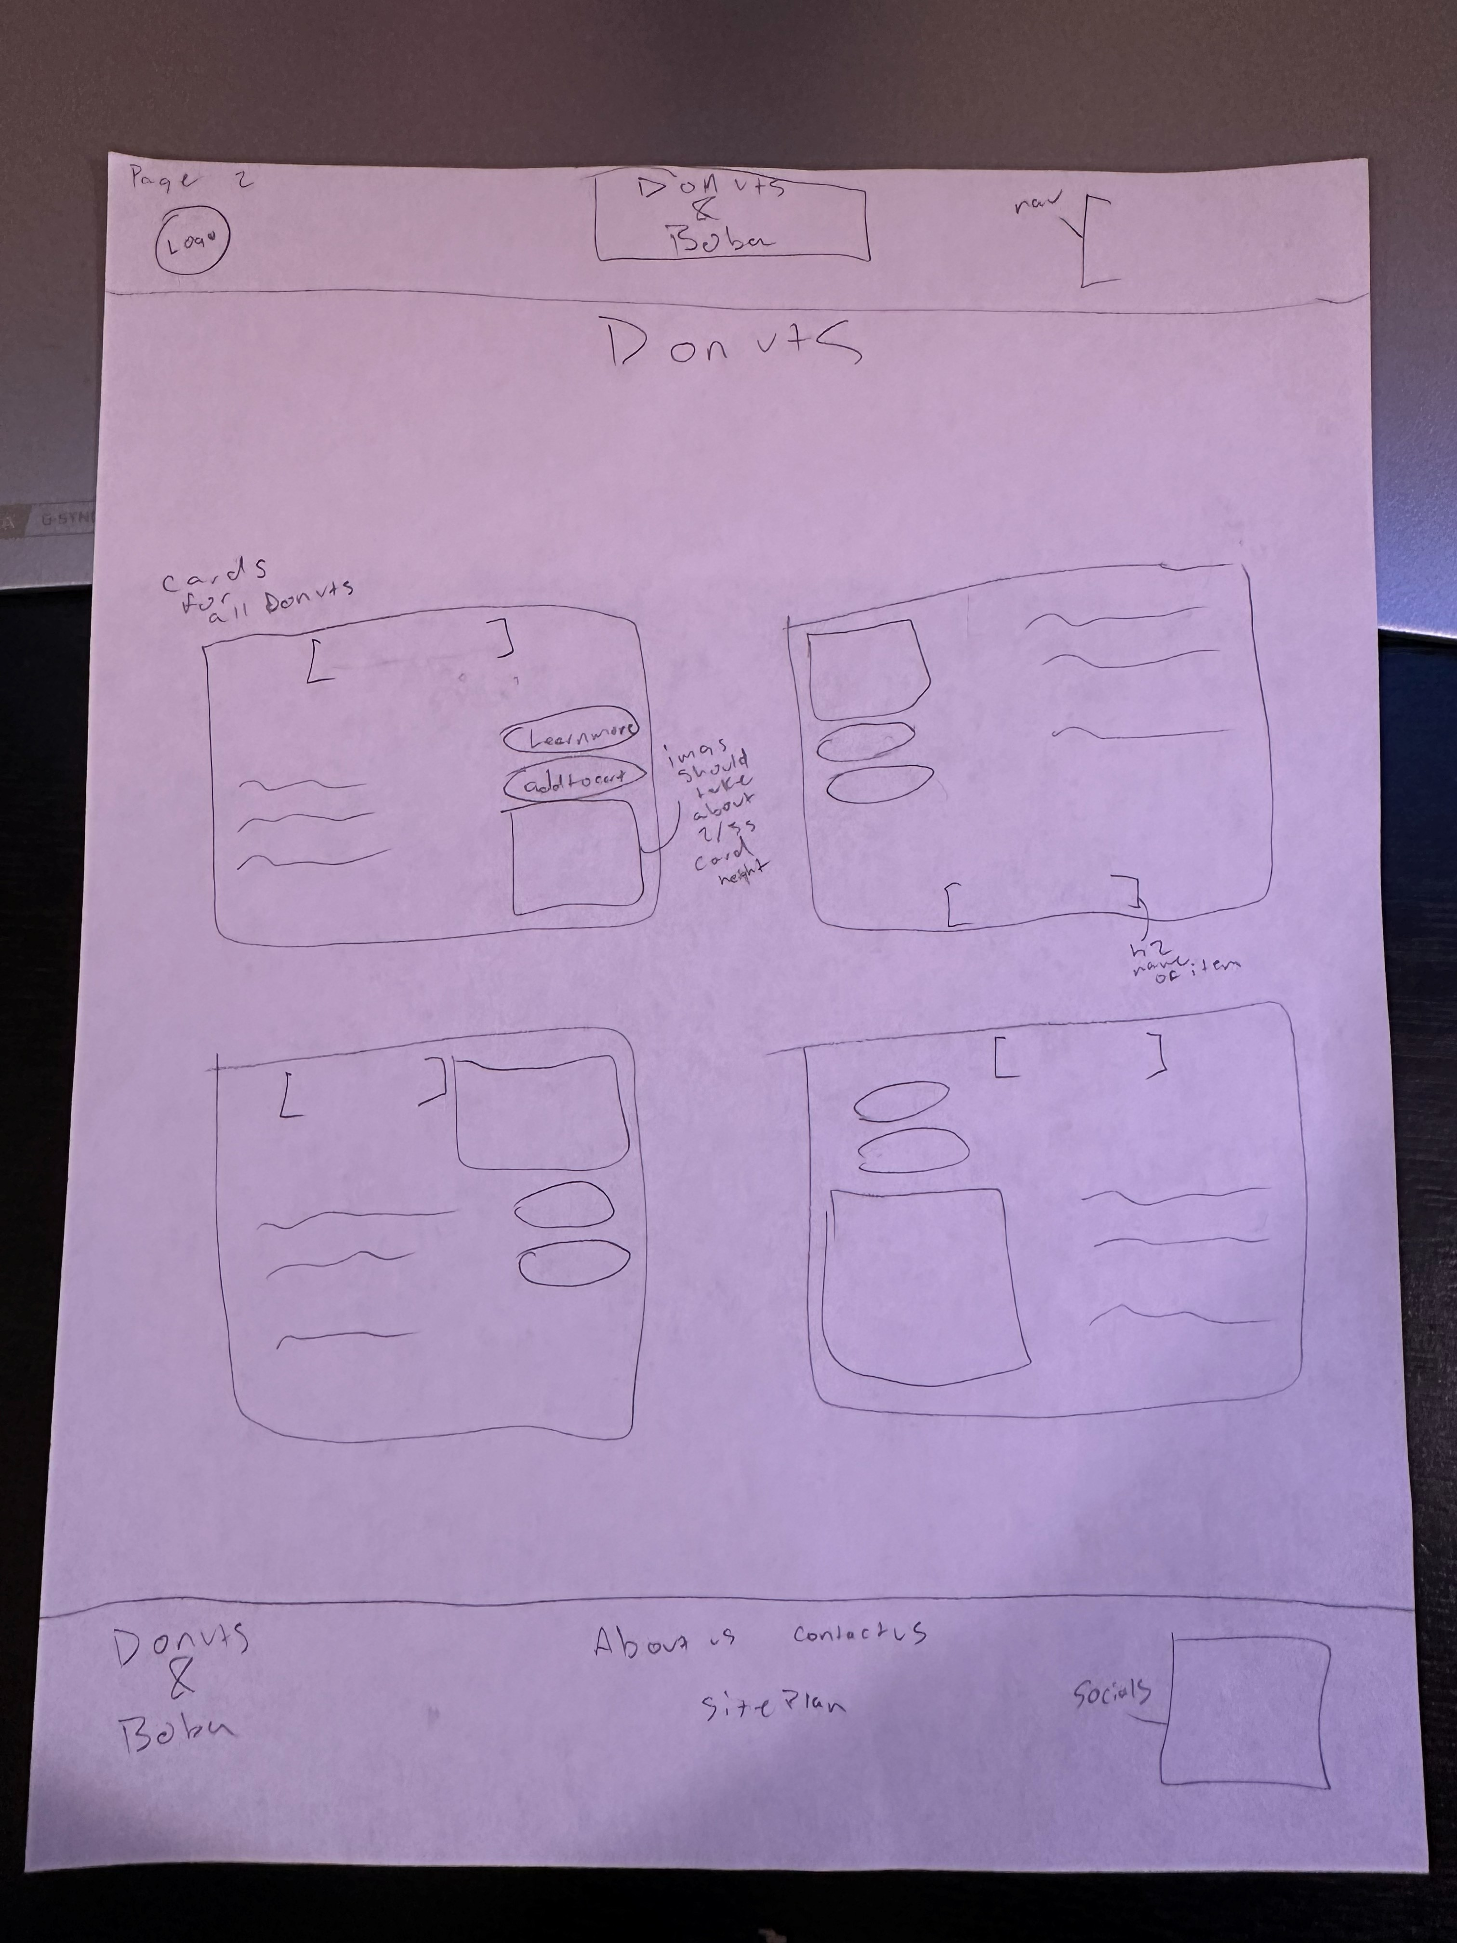

Page 3

