# IST359 Project Template

**Project Name:** Home Barista Database  
**Author:** Aidan Harrington

# Idea

Explain what your database idea is about. You should try to cover what it is, what is does, etc.

Why do you want to keep track of this data?

I want to keep track of (hypothetical) coffee taste tests with varying beans, grind sizes, and brewing methods.

# Business Rules – 10 pts + 10 pts for Complexity

## Entities

In this section, include a bulleted list of conceptual entities for your database idea. Please describe each entity briefly.

* **Coffee Bean –** The beans purchased to be ground, brewed, and compared.
* **Coffee Brewer –** The device or machine used to brew the coffee
* **Brew –** The instances/trials of each bean and brewer, to be compared
* **Rating –** The conclusions drawn from testing each brew.

## Attributes

In this section, include a complete list of attributes for each entity. Be sure to indicate the attribute types. Example:

* **Coffee Bean –** ID [RU], Name [R], origin, brand [R], roast type [R], roast date
* **Coffee Brewer –** ID[RU], Name [RU], recommended grind [R], brew type
* **Brew –** ID[RU], Actual grind size [R], brewer [R], bean [R], star rating [RD],
* **Rating –** ID [RU], Extraction star rating [R], Pairing star rating [R], flavor star rating [R]

## Relationships

In this section list the relationships among the entities as required of the conceptual model.

* A **brew** consists of one and only one **brewer.** A **brewer** is a part of zero or many **brews.**
* A **brew** consists of one and only one **bean.** A **bean** is a part of zero or many **brews.**
* A **brew** is assigned one and only one **rating**. A **rating** is applied to one or many **brews**.

# Conceptual Model / ERD Diagram 15 pts

Paste your Visio diagram below. The best way to get a good diagram is use file -> save as -> browse -> portable network graphics format in Visio. Then insert the file you saved here. If it’s blurry and hard to read, expect a deduction.

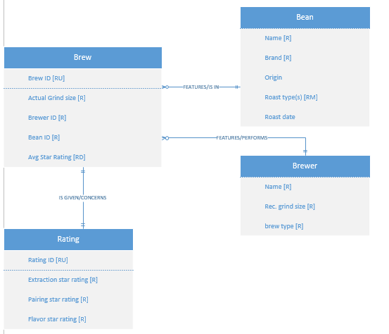

# Logical Model

Paste your Vertabelo diagram below

