**Friday, June 15th**

So flight to Toronto was chill, I passed out immediately and don’t even remember the plane taking off. Same thing on the way to Vancouver; I pretty much slept the whole time except for one quick wake up to read our conversation this morning over and over and over again. Got a bus to the ferry terminal and then had a great ferry ride to the island - it was windy but I sat outside and appreciated the fresh air!

My grandma picked me up in downtown Victoria and brought me to her apartment which is BEAUTIFUL. She has decorated it with trinkets from living abroad for most of her adult life and it’s really quite stunning. My great aunt and great grandma (who is 97!!) came over and we had the cutest little dinner ever where I updated them on school, work and the fam. Then I went for a walk by myself by the water to digest my food and unwind, which is so nice because her apartment is a 1 minute walk away from the water. I listened to a variety of songs and let all my feelings fight for a spot in my brain which is a difficult task because I fell 29184 different things at once.

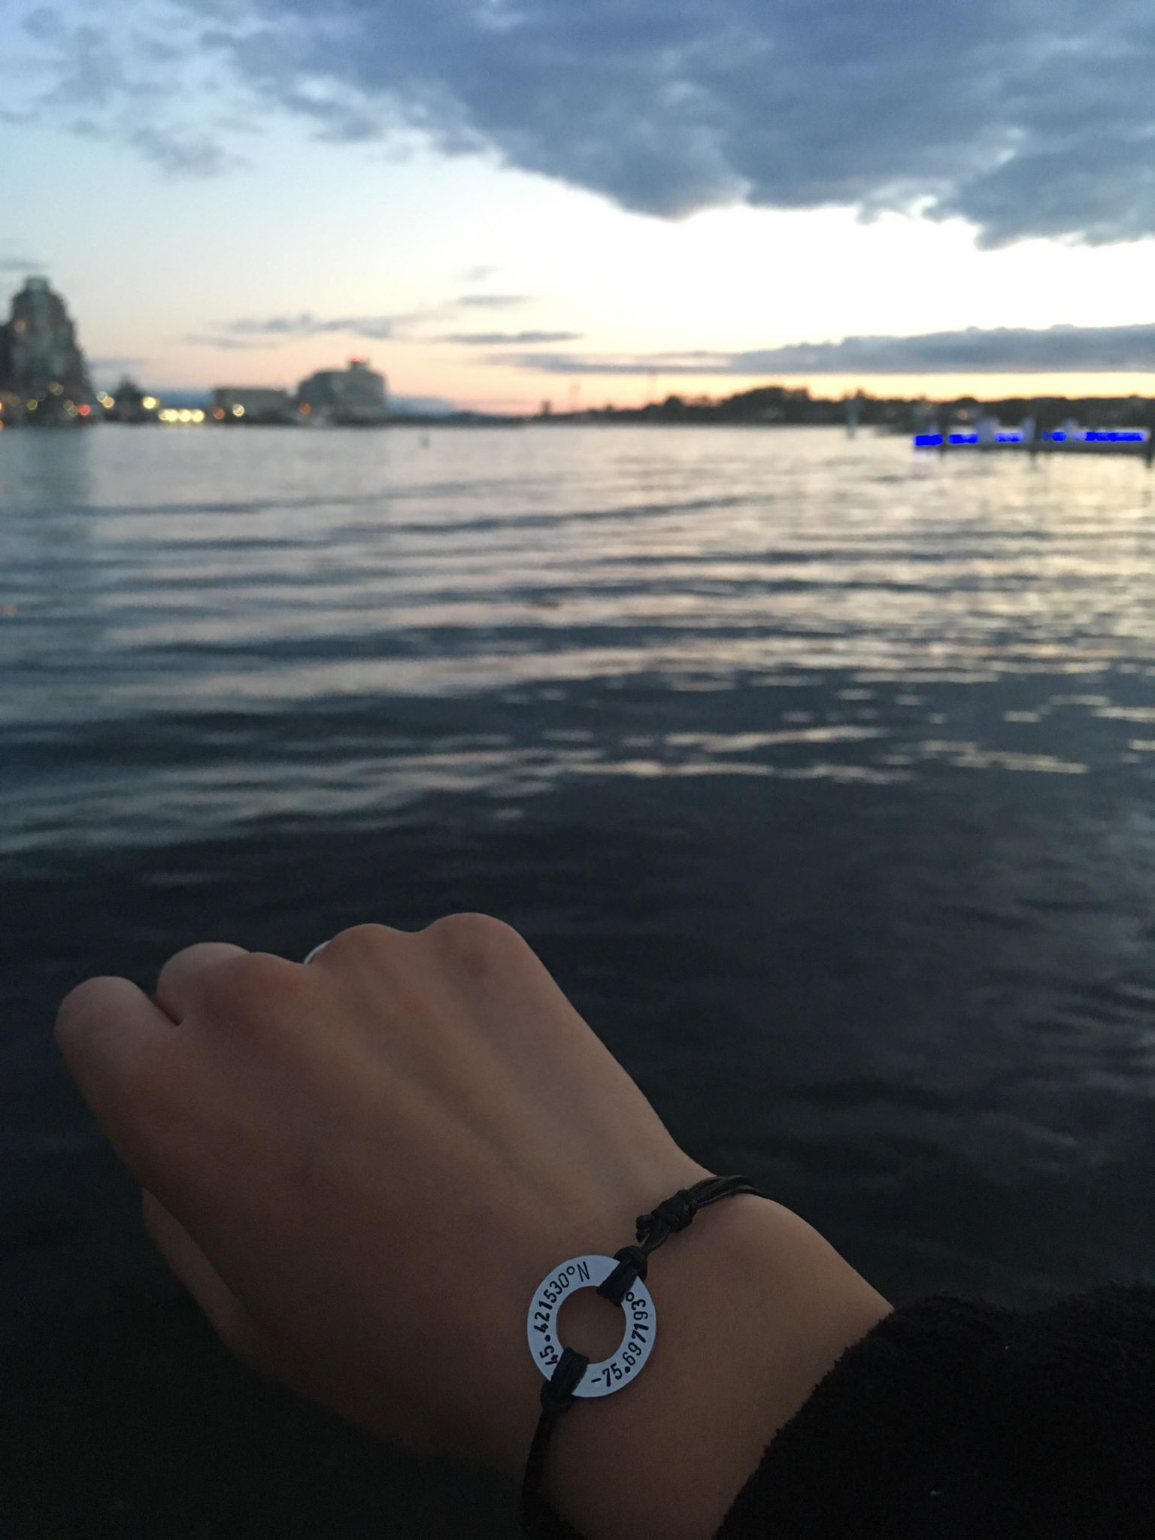

Victoria was awesome! I visited my great grandma, went on 2 found some cool structure thingy and saw some seals, visited the UVic campus, walked around the parliament buildings, explored a popular tourist area called Fisherman’s Wharf, and took a « H2O taxi » across James Bay to get back to my grandmas condo! Flew to Vancouver and then to Taipei which was a pretty long flight but I mostly slept and listened to music.

**Saturday, June 16, 2018**

I’m in the Taiwan international airport trying to blend in and most definitely not blending in whatsoever got a little update for ya now that I have some wifi!!

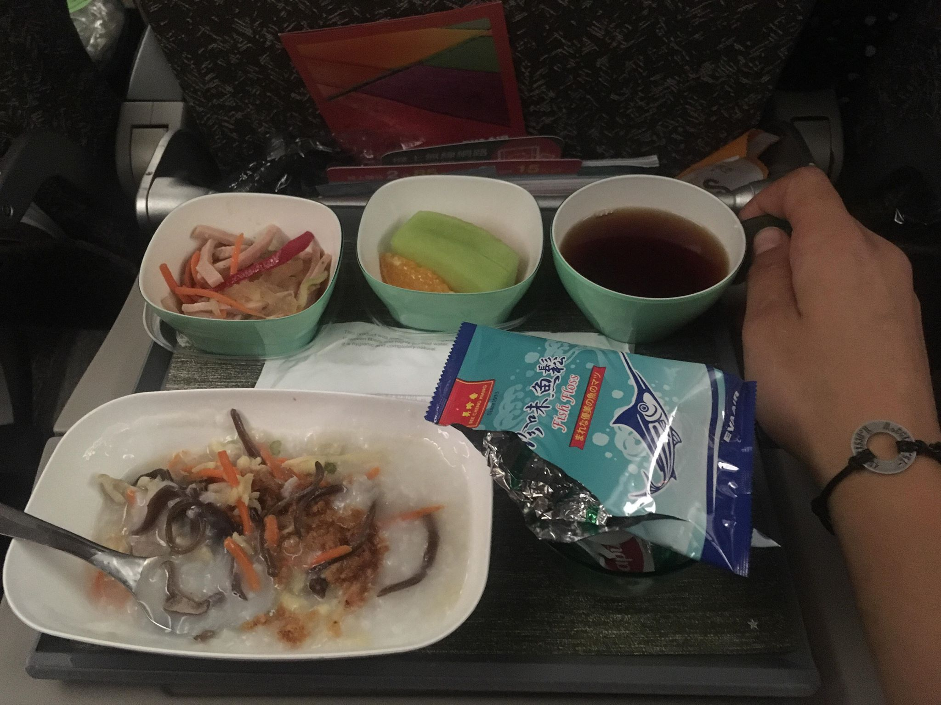

So we had an option between “Western style” or “Chinese style” breakfast and I’m not about that weak shit so I got the Chinese one. It came with this thing called “Fish Floss” that came in a little package as you can see. I had no idea how to eat it so I just started spooning it into my mouth, it is kinda like the texture of like moist sand but it tastes like fish and sugar. Anyways I saw a lady a couple seats up and she was dumping her fish floss onto the main course of the meal which makes so much more sense and I looked so dumb once I got that figured out it was fine, then my fish floss was on top of this rice porridge/soup thing with black fungus and chicken and ginger... another interesting breakfast combo. So I’m alive and already making mistakes but it’s fine!! It’s 6am here so I’m gonna try to sleep a bit more at the airport and then try to figure out the bullet train!

It's been good I haven't really done much yet, my flight arrived at 4:30 this morning but by the time I got through customs and got my bag it was about 5:30. We don't have to be anywhere until 6pm tonight so I have most of the day to adjust and prepare which is good. I curled up in the airport with my purse as a pillow and towel as my blanket and passed out super hard on a couple chairs for the past few hours. I'm still at the airport just figuring out how the bullet train works and sending some emails and then I'm gonna yolo it and take the train super early and just wander around the taipei train station until I have to meet up with the group!

**Sunday, June 17**

my host family does not speak English so google translate is my friggen lifeline 

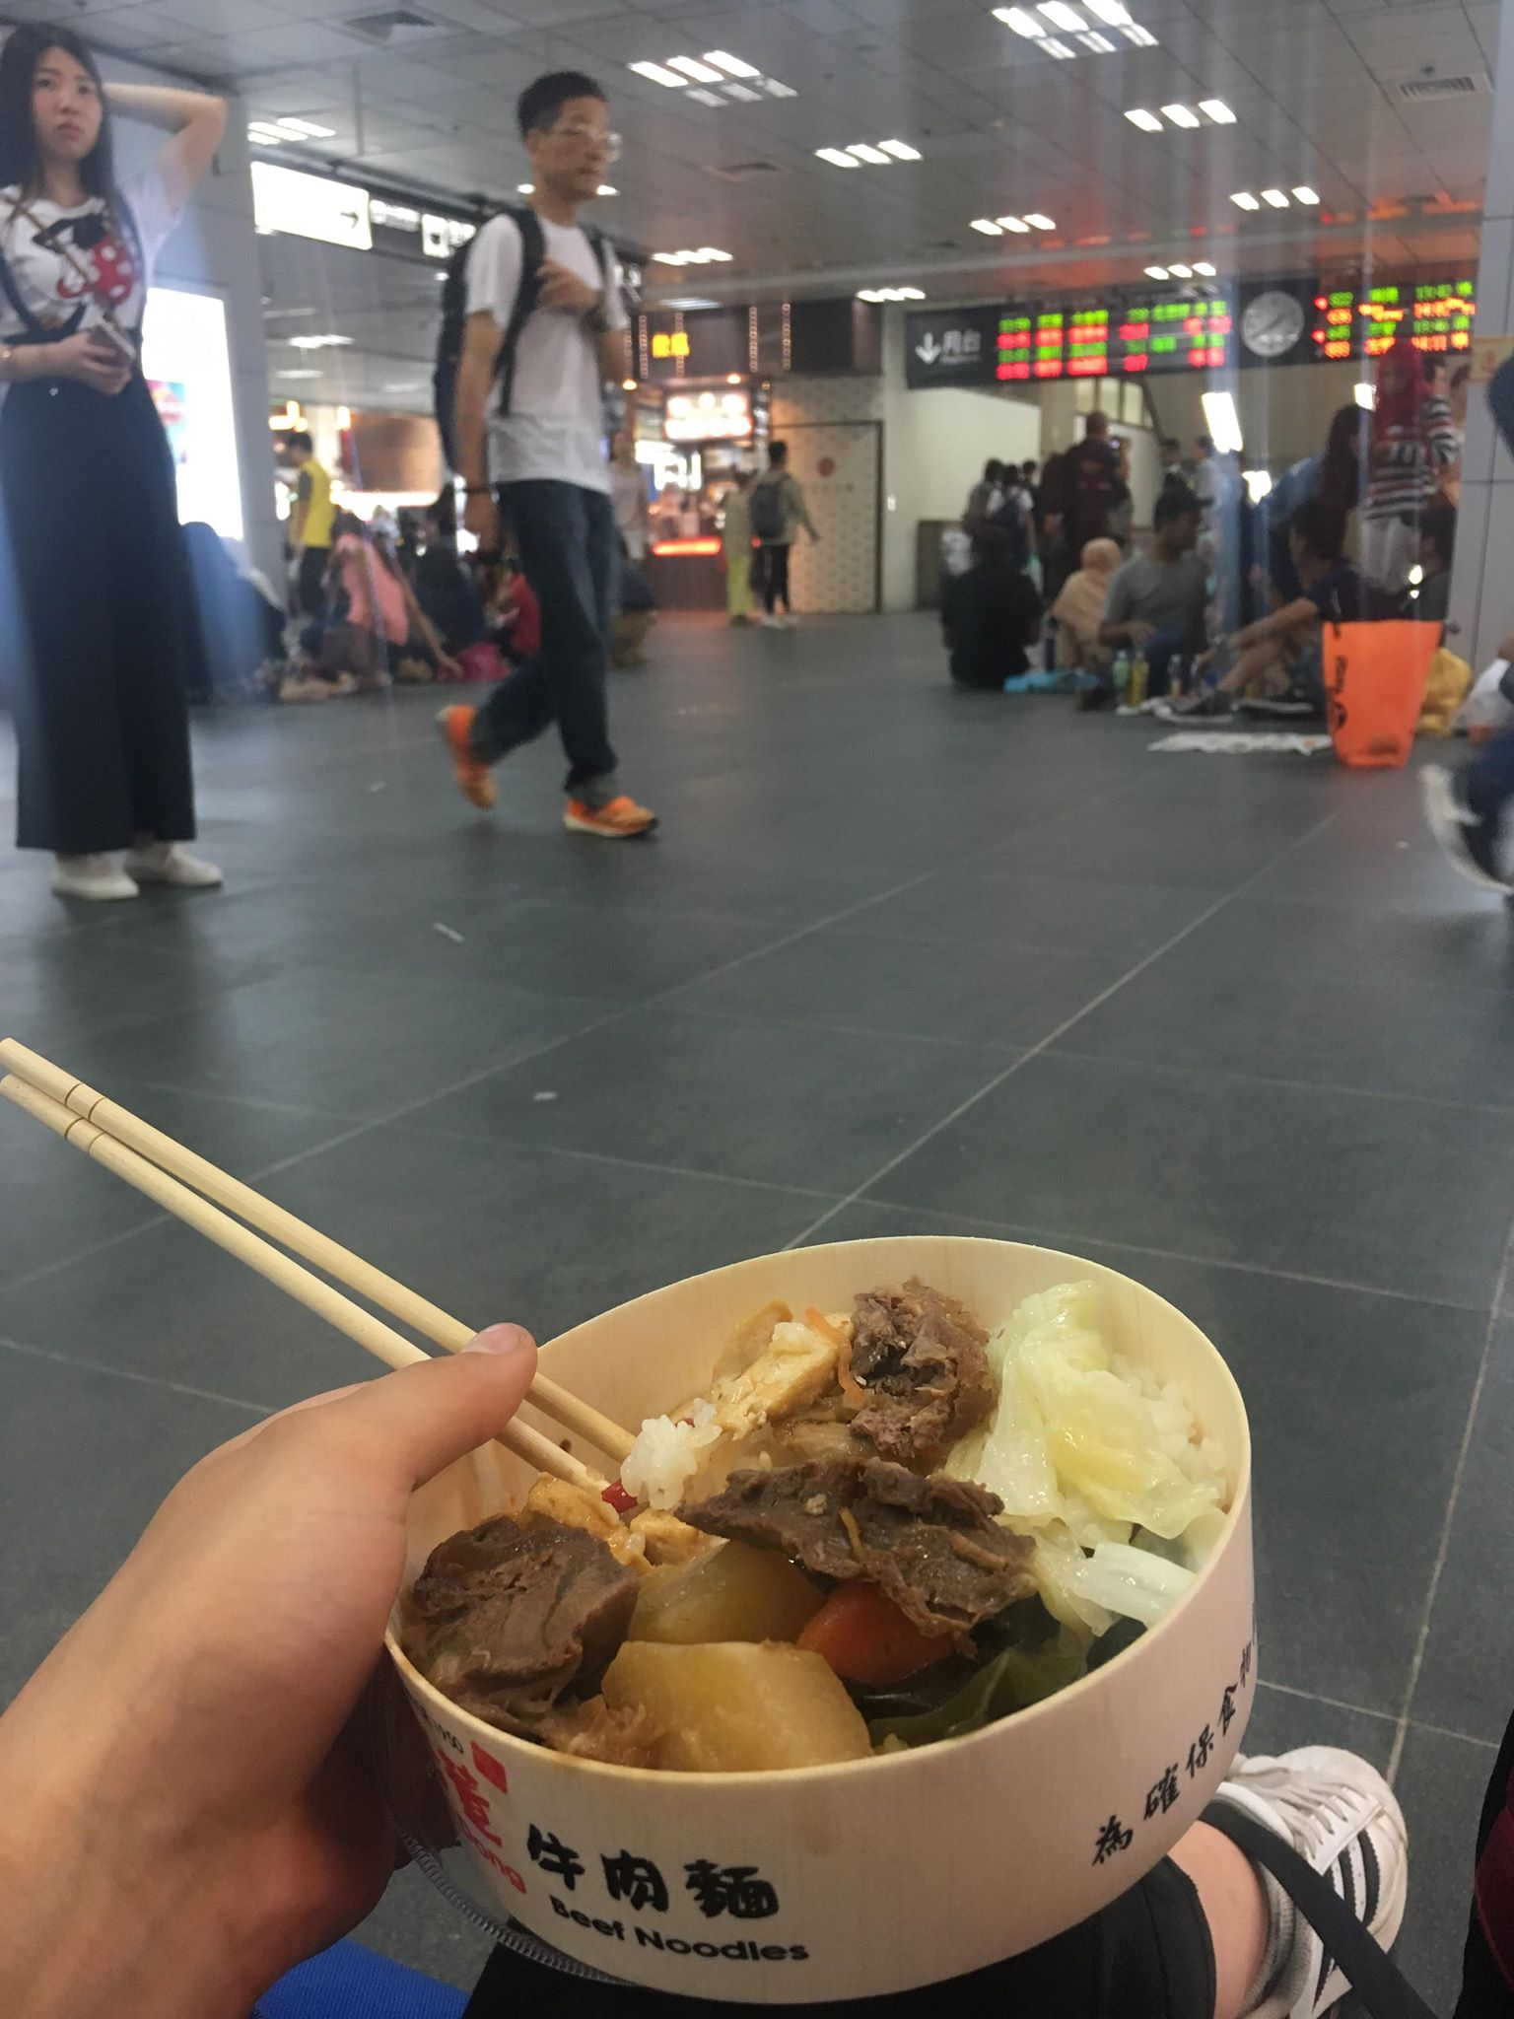The Taipei main station where I ate lunch

The train station was absolutely nuts. It was air conditioned so people just sat on the ground EVERYWHERE!! Then pics from dinner, we walked around a random night market and found a temple in the middle of it

I am SO tired so I don’t have the energy to explain everything but I’ll have you know that the first thing I ate at dinner were tofu-style blocks of congealed duck blood... and the second thing I ate was pig intestines

## **Monday, June 18th**

So today was FILLED with activity! Went for a run this morning and there was a bit of broken translation so my host siblings insisted that they come with me, so they brought me to a track and watched me run which was the cutest thing ever hahaha. Then I ate I’m not even sure what for breakfast I honestly couldn’t tell you, then off to primary school for the day! We had a packed day of training where we practiced running games, talked about the logistics of camp and so on. It was a TON of information to take in and a bit overwhelming but super awesome I feel like I already learned a lot and have lots to look forward to over the next few days in terms of learning and prepping for camp!

Okay SO to answer your questions the training is for the rest of this week, then we have a couple orientation camps where we aren’t being paid and the kids aren’t paying to go to them, it’s just like practice kinda at schools like we’re doing one in an aboriginal village. The other counsellors are super cool! There’s 12 of us in total, 9 girls 3 guys and they’re all really nice - a ton from Canada and a couple from UK and Ireland. Most of them seem super sick and I think we’ll work well together to run camps! Their host families are close for some and farther for others. For example today after training I was walking home with Minnie and she brought me to this guys house who had another counsellor there and we played a bunch of Chinese board games before going home.

Dinner tonight was Baboo shoots with this sweet manyonnaise stuff, squid, pork, chicken and stir fried cabbage

Oh and this soup I’m not really sure what it was they told me melon ribs? Whatever that means lol

My breakfast that my host brother got from me at a stand on the way back from my run

Part of my breakfast which included red tea and to be honest I have absolutely no clue stuff what that stuff was I just ate it

**Tuesday, June 19th**

So update for today!! Not really much to tell you except we had training all day which was pretty exhausting but good. We got a bit more clarity on what we're doing over the next few days which was super helpful. Today we went over countless activities that we can do as warmup, as transition games, to recollect a class, and how to plan and deliver a basic english lesson. It's honestly pretty tough in my opinion because so much of it is working off of the proficiency level of the class and figuring out what sort of activities click with them which will definitely take a lot of trial and error. Lots to learn for sure!! I was also told by my boss (David) and a couple other counsellors that he is thinking we'll be the "lead" counsellors for the upcoming week of camp which is pretty cool. It kind of means we have a bigger role in overseeing the camp and ensuring everyone's activities will run smoothly so that's awesome and I'm excited to have a role with more responsibility.

I have a bunch of planning to do for tomorrow so I'm caught up with that and hopefully going to bed early because as the UK counsellors say "I'm just shattered" (I'm super tired) but I might have to nap and then wake up because lots of lessons that need planning for tomorrow!!

5:32am - I'm doing prep for today and then I'm running in a bit

Yes! Not as big as tomorrow though. Tomorrow and Friday we're running "charity camps" that are 13x 40 minute sessions over the two days, each with a different group of kids. It's a chance for us to practice all our games and run through them so today we're planning out all those!

**Thursday June 21st**

Yes today was awesome!!! I woke up early and went for a nice run - it's so funny here people mainly use motorcycles to get around and my runs are pretty much "dodge the motorcycles" because they don't stop for anything hahahaha. It's so awesome to run down the streets in the morning because they're filled with fruit vendors, noodle shops open for breakfast, people praying with incense, and tons of other neat things to look at. Then we went to camp and had 6 sessions today, all of which were with different kids

The sessions went well! We had 2 of the sessions in a classroom to mimic real english class for real camp, and 4 sessions to practice morning warmup games, camp songs, and larger group activities. They were all a little bit different based on what grade they were (1-5), and definitely a couple didn't go as well but today was a really good learning experience.

For example one of the session we were trying to play Cops and Robbers but we were on a super hard surface and within like 5 mins of playing 3 kids had fallen and really hurt themselves and I was running it so I legit scrapped the entire plan that I had for the lesson and went a totally different direction with the session. It ended up working out and was a really good opportunity to learn what sorts of things are going to click based on age, english proficiency, and group size

So yeah it was a high energy, high enthusiasm, fast-paced day! Tomorrow we have the same thing pretty much but totally new students and we have to create new activities to test out.

Here’s me using my height to my advantage because kids are obsessed with high fives

At the end of the day we sang camp songs as kids left school and apparently I got really into it

**Friday June 22, 2018**

Alright and today was just absolutely bonkers. So same style as yesterday, we're at an elementary school and had 6 sessions that were 40 minutes long for all different grades of kids. I had 2 sessions specifically that I was in charge of, a grade 1 group and a grade 5 group. They actually went super well and I was really happy! At one point there was some guy from the news filming my lesson so I think there's a snippet of my on some chinese news station rn hahaha. I almost lost my voice by the end of the day but I had a blast and the activities I ran were really well received by the kids so I was super happy about that. As soon as school ended we got picked up right away by our host families and I went with one of the other counsellors (Emma's) family because Minnie had school today until 9pm

So we went straight to the hospital because the little boy in the family had broken his arm at school and picked him up, then we went to a temple! It was so beautiful and I am always blown away by the intricacy of their designs as well as how there is a universal understanding of respect when you walk into a temple

So we walked around and the moms explained to us the rituals in a temple and we actually got to try a couple of them which was really neat! Then we headed off to a second temple, this one was built in the name of Confucius who is very famous in Chinese history as being a teacher and life philosopher to thousands of students. This one had some really neat features too; its amazing everything in the temple is set up for a specific reason. For example, they planted peach and plum trees because they make lots of fruit, and that represents the breadth of students across china that confucius touched with his thoughts education and life in general. So lots to see at that temple!

THEN we went to this place called the chiang kai-shek memorial hall which was the second president of taiwan - a huge area built to honour them. This was incredible! It was a huge space with these buildings that were beautifully architected and were used for music and theatre respectively. We didn't walk around too much mostly just took pictures and admired the buildings becuase we had other places to be!

A couple pics from this mornings English lessons, a panorama of the first temple, Minnie walking me to school, and a view of what the busy streets look like in Taiwan! Reminds me of New York City with all the colourful signs

After all that we went to a night market! These things are actually insane lemme tell you. I tried to take some videos but there's just no comparison to actually being there. Imagine a long sidewalk with food stands, shops and everything you can imagine crammed on each side and hundreds of people walking around - that's the vibe. It was hot, sweaty and busy but incredible. People bustling around, vendors shouting, families eating... it is quite a sight to see. We spent a couple hours there while our host families expertly guided us around and bought us tons of snack things; stinky tofu (a very very famous food in china because it smells really bad but is a classic dish), these deep fried sweet potato balls, green mango with passion fruit, shaved ice with beans and other weird toppings, freshly steamed dumplings, steak bites, and more things that I don't even remember. It was actually really really cool and I felt like I really experienced a piece of taiwan tonight!

And then we drove downtown to Taipei 101 which is the talllest building in taiwan (101 floors) to look at it. You can actually take an elevator up but it was late at night so we just took pictures outside. That was awesome because its a pretty famous building so super neat to see (and if you couldn't guess its SO tall). Then we drove quickly to another memorial hall for the first president of taiwan. This was also awesome - a huge building in a very large, open area that had a giant statue inside. Finally we headed home and I am tired to my bones. Up at 5:30 this morning, camp all day, and 5 stops tonight before getting home. I'm absolutely exhausted but my soul feels alive!!! This is the first chance I've really had to see the city and understand important landmarks so it's been a crazy, amazing night. Tomorrow we spend all day with our host families which I'm really excited about because i think we're doing some fun stuff tomorrow

Some of the food pictured are whole squids, cow stomachs, and a plethora of meat that I’m not really sure I want to know what everything is

**SUNDAY JUNE 24th**

So my morning was pretty rushed with packing and eating breakfast and trying to get to school on time - but I got it done and it was so sad Minnie and her mom walked me to the school and then Minnie started crying when we said bye and then her mom was crying and speaking to me in Chinese and it was really touching and sad

So then we had training at the school for a few hours and then took a bus to the mountains and I was feeling SO carsick because it was a hot bus and we were driving up this winding path up the mountain  
  
But it was fine we got there and finished eating lunch which was Taiwanese pizza pizza which has some funny toppings like breaded fish balls, potatoes, squid, mayo

And then back into training! So our boss David ngl is a little bit unorganized and flustered so Tal and I who is one of the other lead counsellors kind of took over and legit planned out this entire three day camp with a detailed schedule and timetable and everything which was pretty exhausting. I’m a little confused why our boss doesn’t have it figured out, like basic things such as the schedule of the day weren’t set in stone so we took charge and organized the next 3 days of camp

And anyways that took a while to do and we finished around 9:45 so since then we’ve been back at the hostel showering and getting ready for bed

Also we’re legit straight up in the mountains, it’s this tiny village with a small school and no joke we’re surrounded by giant green peaks all around us and there are a couple of suspension bridges and it’s actually crazy I’ll have to send you some snaps tomorrow it’s unbelievable I’m so excited to run

Today was a huge day! We are up in the mountains which is honesty a bit magical and hard to believe. The school is for aboriginal children and their English level is almost nothing so that was a really big challenge to adjust our lessons and explanations to have as little speaking as possible. The day went fairly well, we had to switch up some activities because of a thunderstorm but overall the activities went fairly smoothly and the kids were engaged for the most part.

I also ran this morning and it was absolutely killer, I had a wicked stair workout because the hostel we’re staying at is maybe a 10 minute walk from the school down a TON of stairs so I did a workout on that today

**MONDAY JUNE 25th**

Today was a huge day! We are up in the mountains which is honesty a bit magical and hard to believe. The school is for aboriginal children and their English level is almost nothing so that was a really big challenge to adjust our lessons and explanations to have as little speaking as possible. The day went fairly well, we had to switch up some activities because of a thunderstorm but overall the activities went fairly smoothly and the kids were engaged for the most part.

I also ran this morning and it was absolutely killer, I had a wicked stair workout because the hostel we’re staying at is maybe a 10 minute walk from the school down a TON of stairs so I did a workout on that today

And then after work we had preparing for tomorrow for a couple hours and debriefing and then dinner, then a few of us WENT SWIMMING!! It was so fun we climbed down under the suspension bridge and went swimming in the water even though there was s pretty big current and I had a moment of total awe, it was the first time I’ve really had my mind off camp and it was so fun to let loose a little and I just took in the scenery and the cold water and that I’m breathing and that life isn’t perfect but it’s going and I’m doing it

So yeah that was sweet and then all of us hung out together and listened to music + played cards + chatted about our lives and now I’m about to head to bed!

**TUESDAY June 26, 2018**

I was put in charge of today, there are three lead counsellors so today was my day to be in charge of running making sure everything went smoothly and transitioning the kids between activities which was a solid task. Water activities were so fun, someone took a bunch of sweet pics of a nice camera so I’m pumped to get those!

**WEDNESDAY JUNE 27**

Amazing last day of orientation. I had an English class today and we learned body parts and it was tough but fun! Then we had a circus themed afternoon and I did tons of gymnastics for the kids it was super fun and sweaty

**FRIDAY JUNE 29, 2018**

Yo girl has pink eye

And today was a little rough I went on a good hike but then we weren’t told we had to plan for camp today but we ended up having to do a bunch of work for camp and then I left the mountains early to go to the optometrist

Yep that should be fine, I’m travelling to a new city today so once we find a hostel

**MONDAY JULY 2, 2018**

Today was actually pretty shitty not gonna lie. I was up at 4:45am planning my lessons for today, did a quick run and off to first day of camp. We had never been to the school because new city so didn’t know what we had access too, my boss is all over the place, the director who is supposed to answer me questions just started the job so she knows less than me... so today was a headache and a half.

It also rained hard no joke the entire entire day from about 5am-4pm so we had to improvise a ton of our activities that we had planned

And in general it was just very stressful with 50 new kids, a facility you don’t know, super limited resources, etc

Yeah it was fine, the kids had a blast and the parents were really happy it’s just a lot of stress right now as I’m figuring out the ropes

**TUESDAY JULY 3, 2018**

Sorry I had a soccer game with my host brothers haha

***How is the new host family?***

They’re good! The little boys are named Luke and Cruz but unfortunately they don’t speak English so it’s hard to talk to the

But they love to play soccer in the kitchen! And the parents are lovely, they really try hard to speak English with me which is really appreciated

Camp today was pretty hard too, the school doesn’t want us going in a lot of areas so we’re very limited in space which is a problem when you have 50 screaming children. A typhoon also hit japan recently and Taiwan is getting the outskirts of it so it rained again the entire day which is really frustrating because we barely have any indoor space...but we’re doing the best with what we have. It’s a tough go and today was exhausting as camp always is. We did tie dye tshirts which was fun but super labour intensive to set up - the kids are gonna love their shirts tomorrow though so that’ll be great. I need to sleep more because I felt pretty horrible today and I think I’m getting sick which is the last thing I need right now. My host family noticed how much I was coughing and they gave me a bunch of mystery drugs to take I have no idea what I swallowed (spitters are quitters) but let’s hope it helps me! Trying to stay positive and I really hope everything will smooth out because it’s been a bumpy and stress filled few days but it’s all part of the experience I suppose.

**WEDNESDAY JULY 4, 2018**

Ah okay sorry I was talking to another counsellor in another city about our camps and how disorganized and stressful our boss is. David (my boss) is kind of an asshole and doesn't give us a lot of structure and then expects us to run a fantastic, out of this world camp without ever having been to the school and having next to no resources so that's a little bit of a struggle! It's hard to explain but he also kind of acts very demeaning like the way we do things can never be perfect, but then compliments us half the time and gives offhanded passive aggressive comments the other half of the time. Anyways he is super all over the place so I was talking to another one of the lead counsellors and we were venting about it and how we're gonna survive the rest of the summer.

Apart from my boss camp is good! It's never perfect and camp can never be but they're kids and that's understandable. The goal is for them to use a bit of english and have fun which they totally are!

Today in the morning I ran a game of scattegories in my english class (except I just gave them a category, no letter) and they LOVED it! It was so cute they got super into it and spelt everything wrong like tennuss for tennis and ameerca for america haha it was really fully. I was also trying to learn their chinese names which is so hard because they're so complicated and I cannot pronounce them. But I asked them to give me a chinese name and it was hilarious they all jumped up to the chalkboard and wrote out all these chinese characters and it took me a while to actually say it right - I have to learn how to write it properly now!

The afternoon today we had obstacle courses and relay races! The kids were also super cute. I ran the obstacle courses and had them building little pyramids out of cups, rolling giant dice, and running through hula hoops. They got super hyped up about it and went HARD which was hilarious. Relay races we cut up a bunch of letters on paper and in teams you had to race one at a time and bring back letters until you spelled out the alphabet which was hectic but fun! We also did three legged races and a couple other relays which all had to be inside sadly because it has legit rained every single day this week the entire day.

Then I went home with my host family and did a super short but intense 20 minute workout in my room right before dinner which was short but blessed because I've been slacking a bit the past few days and it really makes me feel like shit when I don't exercise enough

Then I ate dinner with my host family and they are SO so kind I'm always blown away by the gratitude of strangers who barely know me. They could tell how tired I was yesterday and insisted I stop playing soccer with the boys to go to bed, and have offered me medicine and every food possible. I showed them pictures of my family and they marvelled at how tall we all are (classic) and Cruz + Luke love seeing pictures of my dog and cat. I was showing pictures to my camp kids yesterday of you and they thought you were so "cool" and "tall"!

Minnie also facetimed me randomly like an hour ago because she got a pet hamster that she named jessica and really wanted to show me! She's so cute, I would love to see her again before I fly to singapore so I might be able to do that - we'll see.

Anyways that's all I got for now! Done chatting with other counsellors, lesson plans done for tomorrow, showered, ate lots of food obviously and heading to bed because I am determined to get a good in run tomorrow morning! Sorry I've been a little all over the place the past few days it's been pretty rough. I'm actually okay though, apart from my wacko boss I can handle it! Momma Gibson didn't raise no weak bitch no sir

**THURSDAY JULY 5, 2018**

It was better. Not amazing, not perfect, but making it work. Today my english class was sweet, we brainstormed all the animals they knew and then I had my students each pick 6 animals, draw pictures of them and write about them like "This is a lion. It lives in the jungle. It is very scary. It is yellow and orange" and it was so cute they had lots of fun! The afternoon is always more hectic because we have all 50 kids together and it rained again (surprise) so we had a dance party in the basement which was actually hilarious. We did the cha cha slide, the macarena and a bunch of frozen songs and at then end played some EDM and tryed to get a little mosh pit going

Yes the other counsellors wanted younger kids so I was given the most advanced class but they're awesome! The class sizes are small and it's when I feel like I get to connect with the kids most because I'm not running around yelling

And I'm feeling better - not the best, but okay. It's so interesting how much seemingly mindless things make a difference - like exercising this morning was hard to wake up but sore legs is such a good feeling, and today I brushed my hair for the first time in a while because I actually had time after my shower instead of throwing it up and those things make me feel a lot better

**FRIDAY JULY 6, 2018**

I’ve rarely been so relieved for a week to be over

Today was fun! We had water day and the weather was actually great for once so we ran a bunch of outdoor water games and did gunge which is this slime stuff that gets poured on a counsellor at the end of each week

Then I actually got to hang out with the other counsellors which was amazing we went out for handmade noodles and then chilled in a market and talked about camp.

I’m so pumped to sleep in tomorrow and then do stuff with my host fam!

Playing water pong with the kids, gunge, a bunch of ducks in the market, my dinner, squad and our volunteer Jenny who showed us around the city!

I know I've told you this week was shitty and it seriously was. I've been feeling really stressed and down and today when I got back from an outing with my host family I just had to go lie down for a while even though I wasn't tired. I got up eventually to do some work and then we headed out for dinner with my fam and we went to go eat Hot Pot which I haven't had yet since coming here and it was really good! And my host Mom Alice is actually so nice and I love chatting with her even though it's mostly broken english. Today we were talking about kids and she and her husband were telling me how badly they wanted to have a girl and ended up with 2 boys, and this week I've really felt like Alice's daughter because she noticed how tired I was this week and took care of me. Anyways at dinner today I really feel like I connected with her and I was having such a great time and it just really hit me that I need to approach this whole situation differently. Some things suck but I'm in Taiwan and I'm having an amazing time and I need to get my mental game together and keep moving forward and get through this week.

**MONDAY JULY 9, 2018**

Monday was good! Tiring as per usual but we got through today without any huge hiccups. We have an experienced director at camp this week which is amazing because she knows how camp runs but is very organized (unlike David) so I’m feeling optimistic about this week! We might have a typhoon hit Taiwan this week so that could mean tons of rain and wind which wouldn’t be ideal but we’ll manage. We have the « final show » on Friday which is pretty much a performance that you put on with your English class that the parents come to watch. I started working on it with my class today and they’re the cutest it’s gonna be fun! Then tonight went to my host moms bff’s house for dinner which was amazing because obviously there was food involved. They gave me this super expensive tea that apparently costs $10,000NT per kg - so around $435 Canadian which is nuts. That’s about all I did - tried to talk to them, showered, wrote in the journal and off to bed for an early start tomorrow.

**TUESDAY JULY 10, 2018**

oday was actually awesome. Finally!! Camp wasn't perfect and can never be perfect but things went smoothly, they're finally learning the warmup songs and the weather was nice and I planned egg drop for the afternoon activity and it was bomb!! SO much fun and the kids loved it

And I ran this morning and had a delicious home cooked dinner and I get to talk to you tomorrow so feeling good right now

Working with Ollie and Aaron on a script for this « final show » we have to put together for Friday that the parents are coming to watch

**WEDNESDAY JULY 11, 2018**

Market with my host mom was so fun, I actually bought a couple things for myself for the first time since being here so that’s exciting! Scavenger hunt today was pretty jokes as well, and gotta keep working on that final show for Friday! Lots of pics coming your way watch out

**THURSDAY JULY 12, 2018**

Also I’ll tell you about my day quick too! Today we worked on the final show in class which was pretty jokes and hopefully it goes well when the parents come tomorrow!

We did ”science day” today which was so far away from science but the kids loved it. We did this magic milk experiment with food colouring, milk and dish soap and they all thought it was so cool then we spent a while cleaning the classrooms and then gunge time. So every week a counsellor gets gunged - kids get gunge points throughout the week in English class for participating, good behaviour and for helping out at camp. Then then can choose to give their gunge points to whoever they want and the person with the most at the end of the week gets gunged

And this week I had about 500 points and the next closest was maybe 200

So somehow this week I earned myself the nickname « alien pig » because I play that role in my final show but now the kids just chant that to get my attention

Then I pretended to run away and the kids chased me down and brought me back

And then one of the counsellors has a bunch of tape cut up and they all got to tape me to the ground

nd then we had leftover eggs from egg drop so I suggested kids get to come up and crack them on me

Me at this place where the tide rises super high every day and you can only visit twice a day to walk around, there are crabs legit everywhere

**FRIDAY JULY 13, 2018**

It was hilarious! They’re not actually good performances but super cute and the parents love it so everyone’s happy!

Hard to say goodbye to the kids though, they melt my heart

Yeah so I’m on a bus right now to another city - Tainan. Tonight I stay in a hostel there and then tomorrow night I’m taking a train to Chaiyi, the city where my camp is gonna be and I’ll be meeting up with my host family Saturday night

**SATURDAY JULY 14, 2018**

I’m with my new host fam right now, got here last night on the train and they were waiting at the train station with the kids holding a sign that said « Welcome to Chaiyi Kiana! » they’re so cute! The girl is 3 and her name is Queena and the boy is 6 and his name is Bruce (!!!) I’m gonna head out for a quick run rn and then eat breakfast and prep for my camp meeting so I gotta go! Good luck in Mtl and thanks for sticking around for a couple months and accepting that I’ll always have at least 3 boyfriends.

Did a short run this morning and it’s so nice there’s this river really close to my house and it has a quiet path beside it that’s perfect for running so no excuses these next 2 weeks! Then I did the most Asian thing ever - hopped on a motorbike with the fam and drove into town, swerving in and out of bikes and food vendors, stopped on some random corner and without even getting off the bike, ordered scallion pancakes (super popular here) from a little shop and drove home.

Precamp meeting was pretty chill, this camp will have its challenges but going into it feeling way more relaxed. Got picked up and went straight to dinner which again was such an Asia thing - stopped on the side of some random road where there was this small tent thing set up with just a tarp over a metal structure and sat at a super short table on stools

**“**How old are you? 180 oh my god... how tall is your dad? Your brothers? Wow! Do you have a boyfriend? Can I see a picture of him? Wow so handsome!! So handsome! Is he taller than you?“

**MONDAY JULY 16, 2018**

And then go to bed! Had a wicked workout this morning it was SO hot but right along a river so really pretty I can’t complain.

Day 1 was good! We’re actually not in a school it’s a community centre so not gonna lie our facilities are pretty shit, we don’t have real classrooms or an outdoor field or play area (just the front entrance area of the community centre which is concrete) but we don’t really have an option so gonna make it work! The kids seem nice though, should be a good camp.

Went out for dinner with 2 other families and ate hotpot which was fun! Then Bruce had to go to the doctor so he asked me to come with him so I just got back from that

**WEDNESDAY JULY 18**

FYI every host family I’ve been to has explicitly told me that I can come back to Taiwan and stay at their houses anytime and that ”your boyfriend can stay too”!

A couple of the other counsellors are ballin so hard with their host fans but I am still super super grateful English is definitely hard with this fam but they’re really sweet so I can’t complain at all

It was good! Did a workout in my room this morning with the AC on full blast, taught a lesson on body parts in English class, then I ran this afternoons activities which was obstacle course, cross the lava and relay races. Super fun but really hot! Then I went to dinner at my host mom’s parents house which was kind of intimidating because legit no one spoke a word of English but I was fine, ate some weird ass things again

**THURSDAY JULY 19, 2018**

Yesterday was good! We ran some circus activities and I just walked over children to entertain them and then we did some carnival stuff which the kids loved - teaching them gambling early with poker chips and blackjack it was awesome hahaha

Today is my day again so I’m ripping some sweet arts and crafts - paper airplanes, magic milk, and things called rain sticks so it should be a good time and pretty chill.

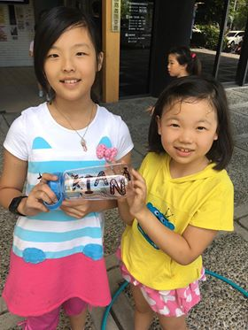

Here are 2 girls that decorated my water bottle for me during one of the break times! So cute and the girl on the left is legit named “Ting” which all the counsellors think is hilarious to say

And yesterday driving home there was this cool celebration going on on the street right outside my house - it was the Tiger God’s birthday so they were having a celebration for it which is apparently pretty normal but I thought it was super cool

**SATURDAY JULY 21, 2018**

Yesterday for me was all over the place! We started off driving up to this mountain and stopped along the way at this beautiful park that a lot of couples go to for photo shoots because it’s love themed

Anyways we got to the mountain and we were so high up it was seriously in the clouds. We went on a hike around an area where they grow really famous tea in taiwan which was so sick. Then we went to a history museum for the kiddos and watched a drum performance and played in the kids area, then went to this old train station which was also pretty neat

I also never told you about camp on Friday but it was whack, we had water day but then it started thunder storming so we changed to a “fashion show” where the kids have to make the counsellor a costume out of garbage

**MONDAY JULY 23, 2018**

My workout was good, yesterday I had a pretty long run so today was just a chill run and then some arms and abs - my fam has some weights in their house which is amazing

I start at 8:45 but its a 40 minute drive every morning

Did some tie dye yesterday, ripping some egg drop today, scavenger hunt tomorrow, minute to win it Thursday, and final show on Friday

I told you about Saturday already but Sunday was even better. My fam took me to an oyster farm that doubles as a local attraction. It’s the only place in taiwan where you can get a ride on this cow that’s used for oyster farming which is pretty sick! Most people only get to ride the cow for a couple minutes around the oysters, but we actually got there first and got a ride from the parking lot out to the water which was pretty sweet.

The water level was too high when we got there so we had to wait for it to lower while the farmers brought us lines of oysters. We got to break them off the lines and shake the baskets to get rid of any dead oysters or empty shells. Then they started cleaning them off and my host mom sweet talked a guy into letting me open an oyster myself! I got to it it raw too which ngl I thought was really gross and salty but yolo it was hilarious and when are you ever gonna eat seafood that fresh?! Then they cooked some of them and some clams too and we got to eat more food while we just chilled in the water. Once the tide was low enough we got to actually rake for our own clams! That was also fun and Bruce and queens loved it haha

**TUESDAY JULY 24, 2018**

Bit of a long day with the kiddos but that’s pretty normal. Ran some egg drop today which was sweet and it was raining a lot today so nice that it was inside!

**THURSDAY JULY 26, 2018**

it was just a really special moment for me this morning so I thought I’d share

This morning I went for my last run in this city and every morning there’s this man on the path doing tai chi every single day. Since the day I’ve arrived he’s always been there and everytime I run past him he claps for me and says something in Chinese I don’t understand. Anyways so today I was like yolo and I stopped running to try and talk to him! He said a whole bunch of shit that I didn’t know, but I told him I was from Canada and that I’m 18 and that I didn’t understand him hahaha. It was so cute though he’s seriously made me smile every run and I think he was asking me how long I was in taiwan so I showed him a calendar and explained the cities I’ve been to. The only thing I could understand was “piaolong” which means beautiful in Mandarin which was so cute!! and he took out his towel and starting wiping all the sweat off my face and pinching my nose it was so jokes

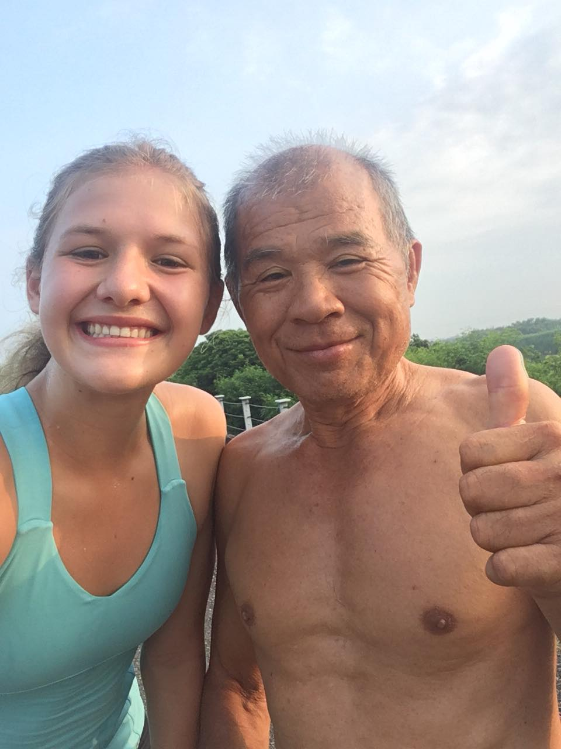

**FRIDAY JULY 27, 2018**

I’m in the mountains and I’m so so so excited for this weekend - we have so many sick things planned for us and we’re legit staying at a kung-fu centre

And today was fun! Final show was good and a little sad to say goodbye to the kids, but pumped to be back with everyone this weekend it was a very happy reunion

I’m heading to bed because I’m getting up early tomorrow as usual to run before Tai chi and yoga and apparently there are some pretty nice mountain views so should be awesome!

**SUNDAY JULY 28, 2018**

So Friday night after camp we took a train to Douliu, a small city in Taiwan. We took a long cab ride partway up a mountain and got out at this place called The Serendipity Retreat. It is owned by this guy called Nono who was a 3x national kung fu champion in taiwan, and now owns this centre where he teaches fighting, Chinese massage, yoga, takes in travellers as kind of a hostel, and educated underprivileged youth in the city. It’s seriously a magical place and it sounds stupid but the vibes in this place are amazing. So simple, calm, peaceful, and focused. Anyways Saturday morning I woke up early and ripped a quick 10km which was accompanied by a beautiful mountain skyline. As soon as I got back we had an hour of tai chi + yoga which was super fun because we learned how to do some takedowns and try them on each other. After breakfast we had a kung-fu session which was amazing!!! It was SO fun and I got super into it and was going hard punching these guys hahahah. We did that mixed with a Tai chi choreo sequence which was also awesome.

We also had our camp prep meeting which was good, worked in our groups to plan camp 3 and make posters. Later we had a Chinese massage lesson and got to learn how to do some basic moves on others and got to get massaged by our partners as well which was sweet. For dinner we had a bbq and cooked Taiwanese food over the fire, everyone had some beers and then we got to watch a performance from some of Nono’s students. Afterwards they let us try their twirling sticks and tried to teach us for almost an hour which was hilarious. Following that most people got super drunk and I pretty much just washed puke down the sink and put people to bed for the next few hours

This morning Tal and I decided we wanted to find this temple that our friend had skateboarded past yesterday. Even though we both went to bed past 1am we wanted to see the sunrise so said fuck it and were out the door at 5am to the temple. On the way there we bumped into a pack of monkeys in the trees which was so special - totally wild and in their natural habitat! Anyways so this temple is abandoned and fenced off, you can’t actually get into it. We found a place where you could jump and grab onto a ledge and scramble up so we did that, but then the stairs leading into the temple were barricaded by this huge wall. It took us like 20 minutes but I found old pieces of pottery and stacked them up, and Tal found an old piece of hose that we threw around a pillar and propelled ourselves up the side of the staircase to get into the temple. I legit felt like it was the movies, dead quiet and the temple was eerily deserted and they clearly made a big effort to keep people out because it was nearly impossible to get in

Anyways this temple had a MASSIVE and I mean seriously gigantic Buddha on top of it which was absolutely breathtaking. We walked around and took a bunch of pictures and tried to unlock doors and follow staircases to every possible floor, it was a bit sketchy but seriously one of the coolest things I’ve ever done in my life. It was so incredibly beautiful and such an adventure and I felt so alive it was actually unbelievable. And I have a bunch of pics to show you from it; so because the temple was abandoned we climbed all over things, which wouldn’t be okay if it was a real temple. I have a bunch of pictures on the religious statues which I actually wouldn’t post anywhere because without knowing the circumstances it can be considered pretty disrespectful to touch all the Gods. So I’ll show you those which we took in pure awe and for memories since they can’t go anywhere. After a couple hours we went back, had tai chi and yoga again, then an amazing freshly cooked breakfast. After packing we got to learn cupping which was so sick! Nono told me I have a really tight neck because I’m so tall and have to look down at children so he did a bunch of shit on my neck and it’s so sore now, but was so cool to watch mine and others people’s skin swell and bruise

After that we did some acro yoga! So fun and I’ve done a ton of this stuff with Tass so I was going nuts and trying a bunch of fun poses. Made homemade pizzas for lunch and then, after a bit of chilling in the hammocks, packed up and got on a bus to the next city, Hsinchu. I’m here now with my new host family about to go to bed

**FRIDAY AUGUST 3, 2018**

Today was good but pretty exhausting. We went over some verb tenses in English class this morning and you saw on those snaps but it was so funny they were all writing sentences about you we had water day which is always super fun but a lot of set up and clean up so took a while after work to leave the school in good shape for the weekend. Then we went to another host family’s house where a bunch of counsellors met up tonight and it was SO fun! We had a huge potluck and there were a bunch of kids, adults, directors and volunteers there just all hanging out. One of the volunteers named Klay has a motorcycle and we all went outside and he let us drive it around the block which was so fun, it’s really exhilarating to ride!! Was nice to just relax a bit and hang out with people from other camps, but now I’m home and I’m absolutely toasted. Gonna sleep in a bit tomorrow for sure

**SATURDAY AUGUST 4, 2018**

So Saturday... started off with a calligraphy class which was sick, I was really bad and they made us write entirely with our right hands because it’s traditional so that made it even harder but it was so sick. Gives me so much respect for people like that because everyone has their own thing and you can tell that the teacher has invested years into mastering his art and it’s really neat to watch him move the brush on paper. Then we went to a tea museum, it was mostly in Chinese so I didn’t learn that much but still interesting to look at all the different types of teapots! Tried some of the tea and then headed to the mall. It was actually really interesting to see a mall in Taiwan, it was so sick they had a basketball court in the middle of the mall and a huge arcade and VR booths. We actually got to go into the arcade and played some games like darts + there was even a batting cage that I was super scared to try but did it anyways and it was so fun even though I sucked then we ate at this hotpot restaurant that was in the mall and it was really neat. All you can eat which was insane and there was so much food that I wasn’t even sure what it was but ate it all and it was delicious. Even had a classic taiwan dessert of sweet black bean soup with peanut powder on top which is just so random I think it’s hilarious

**SUNDAY AUGUST 5, 2018**

Sunday was even busier! Started off by going to a temple because it was some gods birthday, I still don’t understand their beliefs here but anyways the temple was SO busy it was nuts, people everywhere buying incense and leaving fruit and food out as sacrifice and praying everywhere it was really quite fascinating. Then we went to a smaller town and made this traditional tea called Leicha tea! It originated from tribes in Taiwan a long time ago and is a mix of ground up beans, seeds, nuts and tea that you mix with water to create this tea that’s hard to describe, it’s almost like a meal because it’s pretty filling from everything they add in. That was actually really neat, we got to grind it up ourselves!

Me trying to have a conversation with some random guy at the temple, grinding up pumpkin seeds, green tea, sesame seeds, peanuts, etc

Then we went to another place to make our own instant noodles! The noodles in the city I’m in right now (Hsinchu) are really special because of the wind the city gets that dried the noodles to give them a very distinct flavour and texture. So we separated the noodles and they dried them (in a machine just for times sake), then we got to put them in packages and use a sealing machine to close them off! We also got to make these kind of rice buns from scratch which was also sick

Then we went to the west coast of Taiwan to a beach! Got to swim in the ocean and it was so warm and salty. Saw a nice sunset and had a moment where I was floating in the water and I just thought about how crazy it is that I’m here and I’m so fortunate to have this opportunity.

And then today camp was good! Egg drop, cup song is coming along nicely, and made some taiwan dessert today with my host fam after dinner. Also 100% doing mountain camp which I’m absolutely amped about, gonna learn so much

**TUESDAY AUGUST 7, 2018**

one of the guys at camp plays frisbee and we've been trying to get one all summer and it FINALLY came in

And I was fuckin wired on the thought of you or something idk but we legit ignored all our kids on break and threw it around all day

And I was fuckin wired on the thought of you or something idk but we legit ignored all our kids on break and threw it around all day

**WEDENESDAY AUGUST 8, 2018**

Had a scavenger hunt today and then an auction; they collected clues and money over the course of the hunt and then could use that money in an auction to buy things like throwing whipped cream in a counsellors face, handstand walking over them, etc. Was fun!

**FRIDAY AUGUST 10, 2018**

Busy weekend planning mountain camp! Gonna be interspersed with lots of activities though. I left my host family that I’m with rn and I’m staying with tal’s fam for the next 2 days because we have to work out a lot of camp logistics

Probably gonna run a bit, bike a bit, and heading up to the mountains Sunday so will be running around as usual

The bar was fun! Pretty short though, not all that exciting. Went to one of the volunteers houses beforehand and ate dinner + chilled, then spent maybe a bit over an hour at the bar? Was pretty chill, we had a whole floor to ourself and danced to a bit of music and drank

**SATURDAY AUGUST 11, 2018**

And today was good!! Went for a run this morning around a beautiful paved trail that was absolutely packed with people running on it. Got lost for a while and ended up finding two BEAUTIFUL tracks and I found hurdles too so I’m going really early tomorrow morning to do a hurdle workout, I’m so pumped!!!!! Then ate breakfast and did work for a few hours regarding mountain camp, tons of planning as always but it should be quite the time I’m really excited for it. So the kids in this family I met at the beginning of the summer and they’re super awesome, their names are Jenny and Charlie. Jenny is 10 and she is seriously the most incredible kid ever. Her mom gave her instructions and she walked us to the train station, got us on two different trains an hour away from home to this small village near the mountains (there are so many mountains here!). We walked around, ate a bit of food and then went into this believe it or not museum that was so cool!! Tons of live animals that had weird mutations like conjoined turtles, snakes with feet growing back, etC

Then we went to a legit poop museum 😂it was really tiny but hilarious there were tons of poop samples from different animals and random facts it was so jokes. We walked around some more and I’m trying to find a sick necklace from here but no luck so we headed home. Got home and immediately left for dinner, walked around for 3 and a half hours stopping at random places in the city to walk through markets, eat some street food, visit a couple temples, etc. I’m absolutely pooped but it was an awesome day. I feel really lucky that we have such amazing host families as part of this program because they’re seriously so special and show you the real Taiwan

I also am going to miss these kids the most, I loved the girls in my class we actually really bonded especially this girl named Chloe; she was mischievous and sassy but I loved her to death and I’m gonna actually miss her. It’s kind of sad, you only spend two weeks with these kids but kids in taiwan generally live much different childhoods, it’s a lot more about studying and being quiet than playing, so I think a lot of them are exposed to a lot of fun when they come to camp. So many kids left on Friday being like “see you next year!” Or even “see you next week!” Which breaks my heart a bit because I’m never going to see any of these kids again, and with some of them I really felt like we connected

Try to make camp fun everyday so I hope they’ll remember and it’ll remind them why English is so important and can be fun

Oh Aidan the questions got weirder everyday... on the last day Chloe stood facing the blackboard and slapped her hands on it and was like “kiana does your boyfriend do this?” And I was like uhhhh what? And she mimicked making out with someone against the blackboard and all the girls were squealing and giggling lmao I was trying so hard not to laugh 😂I told them that we only high five though so don’t worry they’re on the same page as us

**MONDAY AUGUST 12, 2018**

Greetings from the mountains! No wifi up here so relying on people’s hot spots which is a bit dodgy. Today was incredible! We worked with the scouts coach almost all day doing a ton of things; archery, slacklining, rope tying, real life angry birds with a catapault, tree climbing with legit harnesses and belaying which was SO much fun. A bunch of other small activities too that involve team building and scavenger hunt skills

And then this evening we layed some more groundwork for mountain camp... it’s actually nuts my boss seriously doesn’t really have anything planned for this camp or any logistics confirmed for us, we are designing it entirely plus the scout so that’s a lot but it’s also nice to have freedom. The views here are incredible and I’m trying to get tons of exercise and photo uploading done this week!