### Effect of Mass on Motion of a Falling Object

The first time we dropped the balls we used a technique where we held both balls in one hand next to each other, level, and tried to drop them at the same time. According to the laws of motion, if let go at the same time both balls should have constant acceleration and hit the floor at the same time, assuming both objects have equal drag. This is because the force equation is F = ma where a = gravity, a constant, which means all objects on earth fall at the same rate in a vacuum. The only way the experiment could fail is due to human error or unequal drag. The way we would arrive at a conclusion was by listening to the sound the balls make when they hit the floor, and if there were two distinct sounds, we would have been unsuccessful. What we heard was one distinct sound when the balls hit the floor, so the best conclusion we could make with the tools available to us was that they hit the floor at the same time. However, this is by no means conclusive. One way we could have definitively proved they hit the ground at the same time was by recording the impact area perpendicular to the balls with a high FPS high-resolution camera. Then we could have analyzed the footage frame by frame to visually measure using pixels when both balls impacted the ground.

We saw the metal ball bounce higher when it hit the ground, which is expected because the metal ball's mass was 0.0695kg compared to the plastic ball's 0.00097kg. This goes back to the force equation F = ma = (0.0695kg)(9.81m/s^2) = 0.6818N for the metal ball, and F = (0.00097kg)(9.81m/s^2) = 0.0095157N. This shows that the metal ball had a higher force when it hit the ground, so when it bounced, it moved upwards faster than the plastic ball.

Even though we were seemingly able to get the balls to hit the ground on the first try, the method was not consistent, so we devised a technique to drop the balls with as little human error as possible with the tools we had in the room. First, we set up a straight edge perpendicular to the edge of the table and lined up a box with a handle to be parallel to the edge. The box was moved forward to touch the two balls on the edge of the table as close to the edge as possible without falling off. Then grab the handle on the top of the box in the middle to equally distribute the force, and slowly pull the box to the edge, along the straight edge, so that the balls would fall at the same time. The method was seemingly successful in our first attempt, evaluated by listening for one or two distinct sounds. We also dropped a pencil along with both balls to test if the method would work on objects of different shapes. The first attempt was a failure because the objects had different dimensions so the box couldn't line up all the objects to the edge correctly, so the balls fell while the pencil stayed on the table. To remedy this, we put an object in between the box and the pencil to increase the length of the box where the pencil was to be set at the edge with the balls. This attempt was better in that all the objects fell in closer intervals, but they still didn't hit the ground at the same time. This was due to us not having an object with the correct width to set the pencil at the edge along with the balls and the different drag forces on the two balls and the pencil. The drag on the pencil was greater because of the pencil's larger surface area. One way the drag issue could have been solved is by taping a weight to the tip of the pencil to cause it to fall tip first, like how when a person dives into the water the best way to avoid the resistive force is to dive. In this analogy, the way we were dropping the pencil would have been a belly flop.

### Calibrating and Testing Equipment

The first step to calibrating the equipment was to set up Capstone to test the numbers, then we started recording. To test if the motion sensor was correct, we used a yardstick to corroborate the position in meters displayed in Capstone. When moving the basketball closer to the sensor we found the lower limit. Then we moved the basketball away from the sensor attempting to find the upper limit, which we could not find because it was further than the floor. We could conclude that the upper limit was greater than 1.778m.

Another limitation we found is fundamental to mathematics. When calculating the velocity at a point with position, there need to be at least two recorded points of position. This is due the velocity equation relative to position being (p_2 – p_1)/(t_2 – t_1) or Delta p/Delta t. So if they only have one data point and you take (t_2, p_2) to be the same as (t_1, p_1) the velocity would equal 0/0, which is illegal. This also means that to calculate acceleration relative to position, there needs to be at least four points of position. This means that there is a limitation to how fast the program can react to changes in velocity, which is the time it takes to gather a new position data point, which is 0.1s. This limitation has a negligible effect on our experiments because none are performed in this short of a time frame.

We also tested how far off the center we could be with an object we put a yardstick in the ground and measured how far side to side we could move an object relative to the middle directly below the sensor. We concluded the sensor had a very limited horizontal field of view, but a large vertical field of view. We also tested if the horizontal field of view was smaller at the lower limit of the sensor than at the upper limit. This was done by dropping an object on the edge of the horizontal range at the lower limit, and seeing if the sensor was able to pick up the object at the bottom. The results of this experiment were inconclusive due to the plastic ball being too wide to conclusively say there is no difference.

### Characterizing Free Fall with a Motion Sensor

The next experiment we did was dropping a basketball below the sensor and letting it bounce twice measuring the position, velocity, and acceleration. I believe the main component in this experiment was acceleration. Acceleration described how the ball gathered velocity when falling and why the ball kept losing velocity in the -y direction.

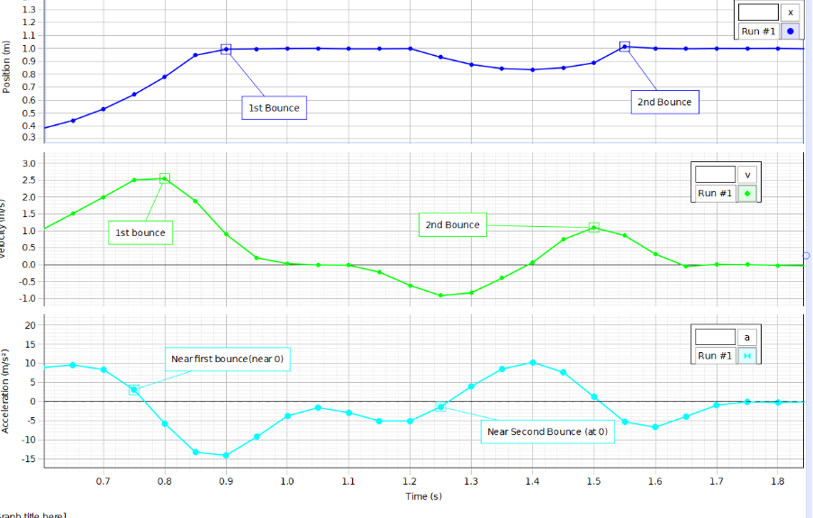

First, we dropped the basketball from 1.54m above the ground directly below the sensor. During the initial fall, the basketball would build up velocity at a constant rate of 9.8m/s^2. The ball hit the ground causing the velocity to drop to 0m/s and losing some force. With the leftover force from the initial drop, the normal force caused the ball to bounce up into the air with constant positive acceleration due to gravity. The velocity decreased to be negative due to the force of the first bounce decreasing the ball's position relative to the sensor. The acceleration increased the ball's velocity past 0m/s to be positive causing the position to increase again. Then the ball hit the ground for the second bounce conserving enough force to cause another bounce.