The experiment for this lab was to have a pulley with a rope attached to a cart and a mass at the other end. The force generated by the pulley on the cart would be caused by the mass at the end of the rope being dropped and accelerated by gravity. We would move the cart up 0.5m from the pulley and let go of the cart measuring the position of the cart over time. The objective of this lab was to determine the acceleration of a cart when pulled by a rope, and then to calculate the mass of the cart using the acceleration and compared it to the actual mass measured from a scale. We predicted that the acceleration would be a constant value. This relates to theory in that the acceleration that acts on the mass at the other end of the rope would be constant due to gravity, a constant, and since the mass was a constant value, the force would be constant. The force of the mass falling would be equal to the tension in the rope assuming that the surface the art is on is frictionless. With these assumptions, we can assume that the acceleration of the cart would be constant because the force is constant.

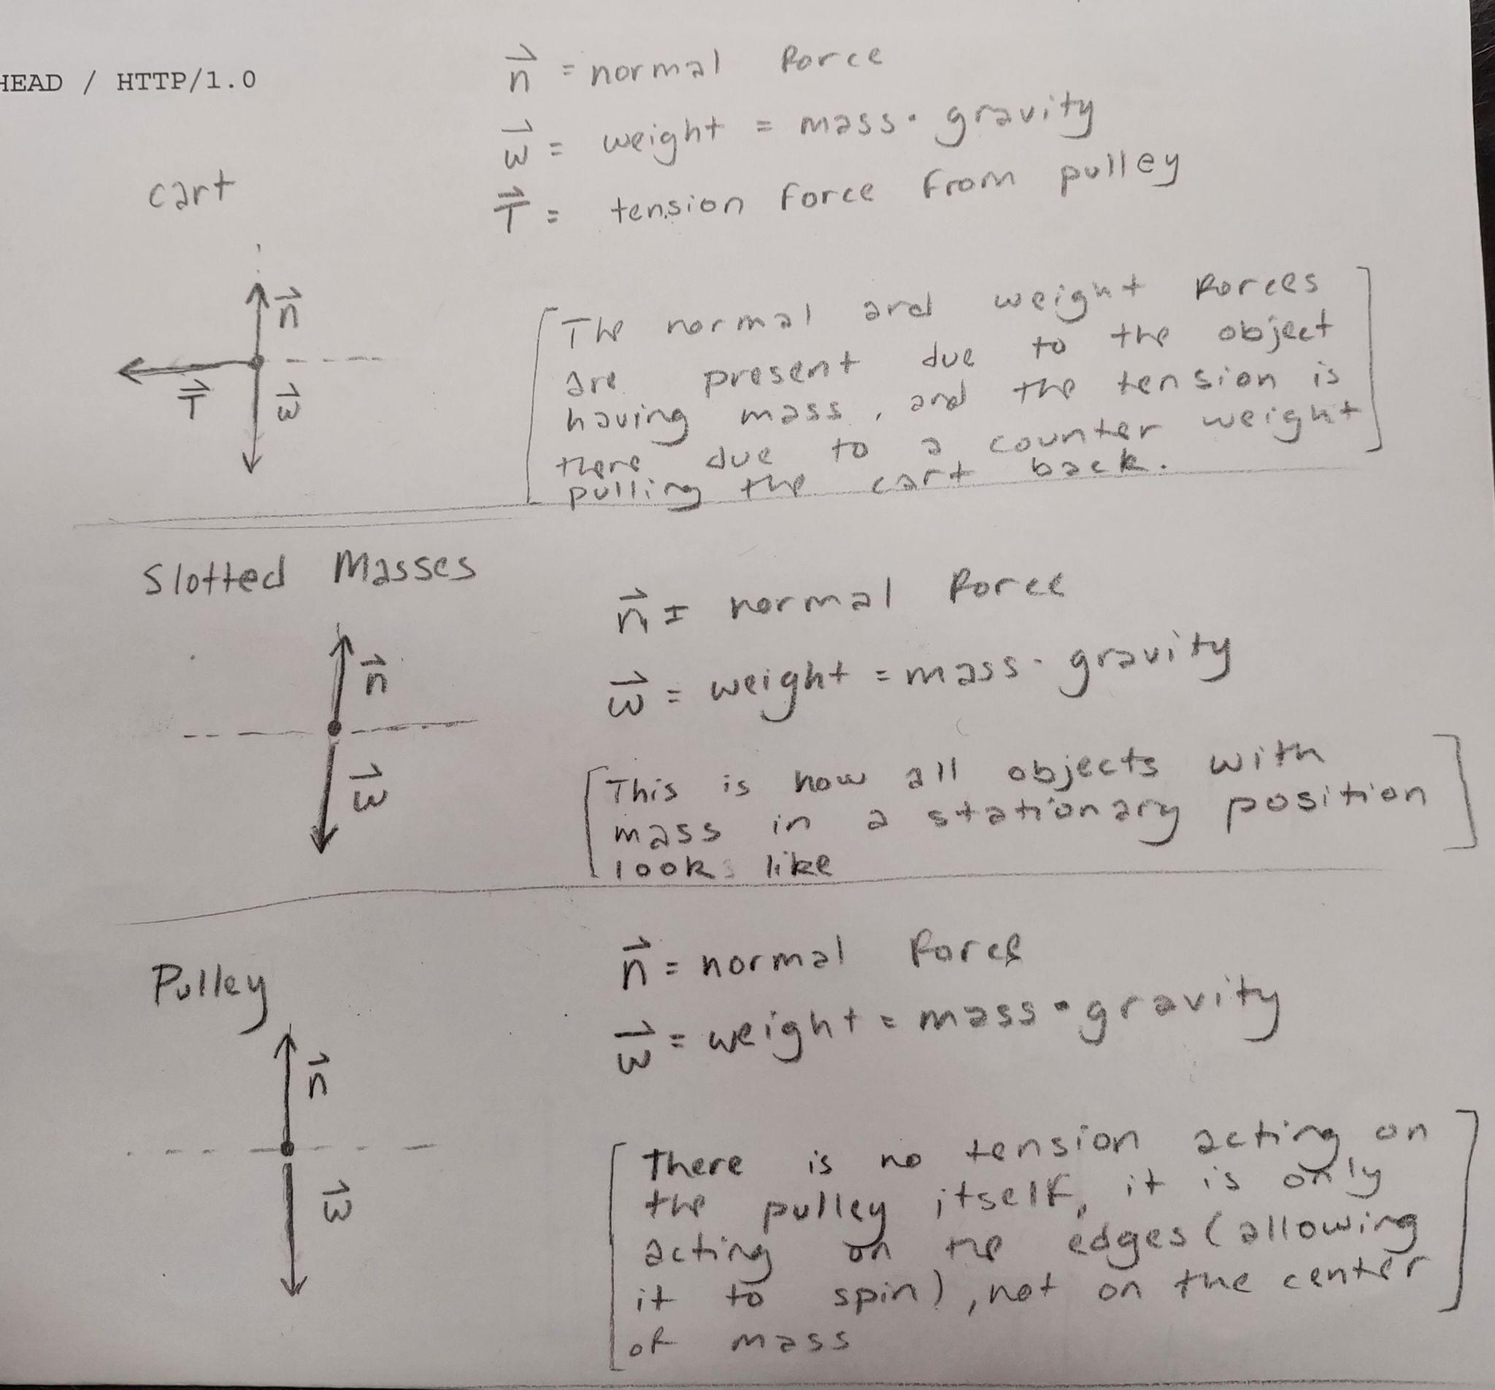

Here are the free-body diagrams that our predictions are based on. Here you can see that the cart's normal force is equal to its weight (mass of the cart * gravity), so we know that the only force acting on the cart is the tension caused by the mass on the other end of the rope being accelerated downwards by gravity assuming the track is a frictionless surface, even though it's not. The idea behind the track being frictionless is that the weight (mg) which is equal to the normal force coupled with rolling friction means that the friction on the cart should have a negligible effect on the results. The friction will also be constant so it should only subtract a constant value from the tension force, according to the theory of forces.

For the first trial, we set the cart at 0.5m away from the pulley with 0.06kg attached to the rope and let it go. Here is capstones graph of what happened.

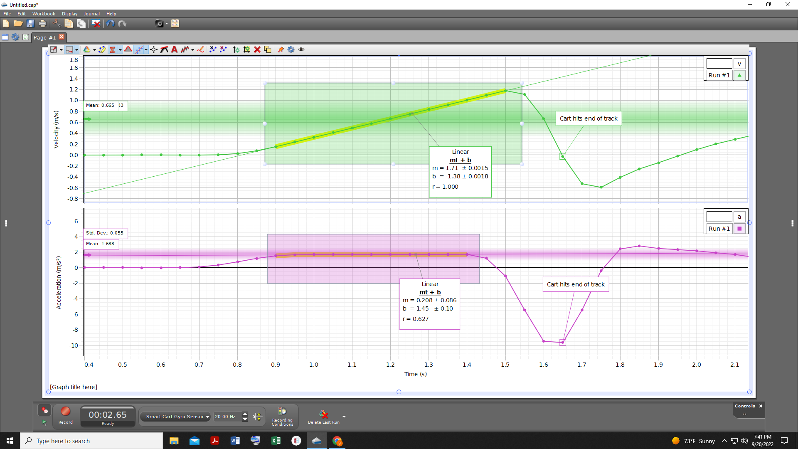

The graph here shows the velocity calculated from position (m/s) also known as velocity, and change in velocity over time (m/s^2) also known as acceleration. There were two ways to measure the acceleration according to theory, one being the slope of the velocity graph in the linear section, which turned out to be 1.71, and taking the mean of the constant section of the acceleration graph, which was 1.704. The difference between the two can be explained by the greater uncertainty in the velocity graph. Here is the table of our results for the three trials.

**0.06kg trial**

|  |  |
| --- | --- |
| Trials | Acceleration (m/s^2) |
| 1 | 1.704 |
| 2 | 1.715 |
| 3 | 1.714 |
| Average: 1.711m/s^2 | |
| Standard Deviation : 0.004967m/s^2 | |

One thing that deviates from theory here is that all our accelerations should be the same in each trial. I think the reason this happened is due to the points we used to calculate the acceleration from the graph. We must have taken slightly different snapshots of our results in capstone, causing us to catch some of the initial resting data. According to theory gravity should instantly cause the coins to accelerate so I think this is due to the way capstone collects position data. Capstone collects a position data point every 0.05 seconds, so I think that when we let go of the cart causing it to move it was in between two data points, causing capstone to pick up some initial resting state in a data point that we used in our calculations. The way this can be fixed is by using some mechanism to hit record at the same time the cart is let go, which would record more accurate data.

Here are the other two trials we performed with different masses on the ends.

**0.04kg trial**

|  |  |
| --- | --- |
| Trials | Acceleration (m/s^2) |
| 1 | 1.213 |
| 2 | 1.218 |
| 3 | 1.215 |
| Average: 1.215m/s^2 | |
| Standard Deviation : 0.00208m/s^2 | |

**0.02 kg trial**

|  |  |
| --- | --- |
| Trials | Acceleration (m/s^2) |
| 1 | 0.645 |
| 2 | 0.643 |
| 3 | 0.644 |
| Average: 0.644m/s^2 | |
| Standard Deviation : 0.0008m/s^2 | |

Here we can see that the average acceleration decreased by 0.5m/s^2 from 0.06kg mass to 0.04kg mass, then 0.6m/s^2 between the 0.04kg mass and the 0.02kg mass. According to theory since the mass is decreasing linearly the force upon the cart caused by tension should also decrease linearly because force = ma and no exponents are implying a linear graph. This means that the cart's acceleration should also decrease linearly but that is not what we see. The error must be caused by capstones data collection but I’m not certain. It could also be the case that the masses of the coins were not exactly 0.02kg each, which would also explain the error.

Here we show that force trends linearly upward with acceleration.

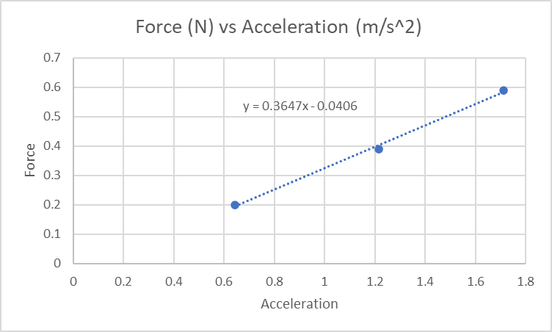

In the graph, you can see that the second point is slightly lower, which is due to the error previously discussed in how the difference should be linear, but overall the line trends linear. Now that we have the graph we were able to calculate the mass of the cart. Since F (N) = mass (kg) * acceleration (m/s^2) we can derive the equation m = F/a, values that we have. So plugging in F as tension (mass * 9.8) and then acceleration we can calculate the mass of the cart. So according to the third trial the mass of the cart was (0.02 * 9.8)/0.644 = 0.3043kg, for the second trial (0.04 * 9.8)/1.215 = 0.3226kg, and the first (0.06 * 9.8)/1.7 = 0.3459. So if we take the average of all the masses calculated we should approach a value closer to the actual mass of the system, which comes out to 0.3243kg. Next, we measured the actual system mass with a scale to be 0.2538kg which means we had around a 27% error calculated by the equation (0.3243-0.2538)/0.2538.

In conclusion, this lab was meant to experiment with the relationship between force, mass, and acceleration using newtons force equation F = ma. We were able to find the acceleration by measuring the change in the change of position over time using the mean of the constant section of a capstone graph. For the 0.02kg mass trial this turned out to be 0.644m/s^2 on average. Using that measurement for multiple trials along with the force which was equal to the tension caused by the mass of the coin(s) * gravity we could calculate the mass of the cart. The force of tension for the 0.02kg mass was 0.02 * 9.8 = 0.196N because the only acceleration acting on it was gravity. Using the equation m = F/a and plugging in the respective values m = (0.02 * 9.8)/0.644 = 0.3043kg. We did this calculation for all three trials and took the average calculated mass to be 0.3243kg which is much more than the actual mass of 0.2538kg, which came to be a 27% error. This means that our calculations were consistent with Newton's 2nd law because our error was less than 30%. I think newton formulated the laws of motion through experiments, then correlated those experiments to the math. Newton didn't have access to the tools we have today but he did have access to a measuring device that could be used to measure position.