The objective of this lab was to examine how forces interacted with each other through newtons 3nd law. Newtons 3rd law states that every force applied to some mass will generate an equal force in opposition to it. To test the theory we used two carts and capstone to measure the Newtons of force applied to each cart, and in theory they should both measure equal and opposite newtons of force. This means that if one cart applies 10N of force to the other cart, the other cart should apply -10N of force back to the cart. The reason for this is because given that mass is always positive the acceleration in the F=ma equation would be negative for one force and positive for the other because they are being accelerated in opposite directions.

For part 1 of the lab we attached two carts of he same mass together with a wire. In theory as stated before the force on the red cart should be opposite to the force on the blue cart. Here is the graph that capstone produced on the Newtons of force on each cart.

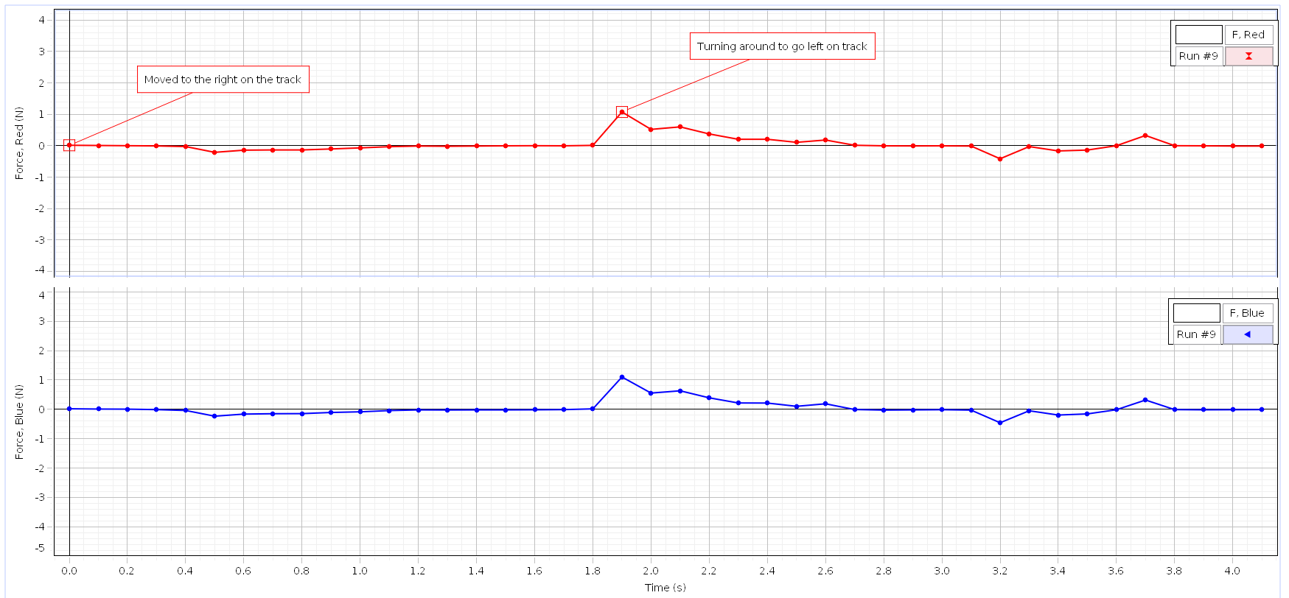

In the graph here you can see that the magnitude of the forces are equal but the forces are not opposites, which is not what theory predicts should happen. The reason for this can be explained by the way capstone measures the position of each cart. Capstone measures the positive direction for each cart to be opposites of each other, so one carts positive x direction is the others negative x direction. In the wire there is a small margin of error caused by the hole that attaches to each cart to not be perfectly fit. The way to fix this margin of error would be to fit the circle the wire attaches to each cart to get rid of the slack. The next experiment we did for part 1 was using a wired connection with unequal mass. Newtons 3rd law states that the magnitude of each force should be the same. Here is the graph of the experiment.

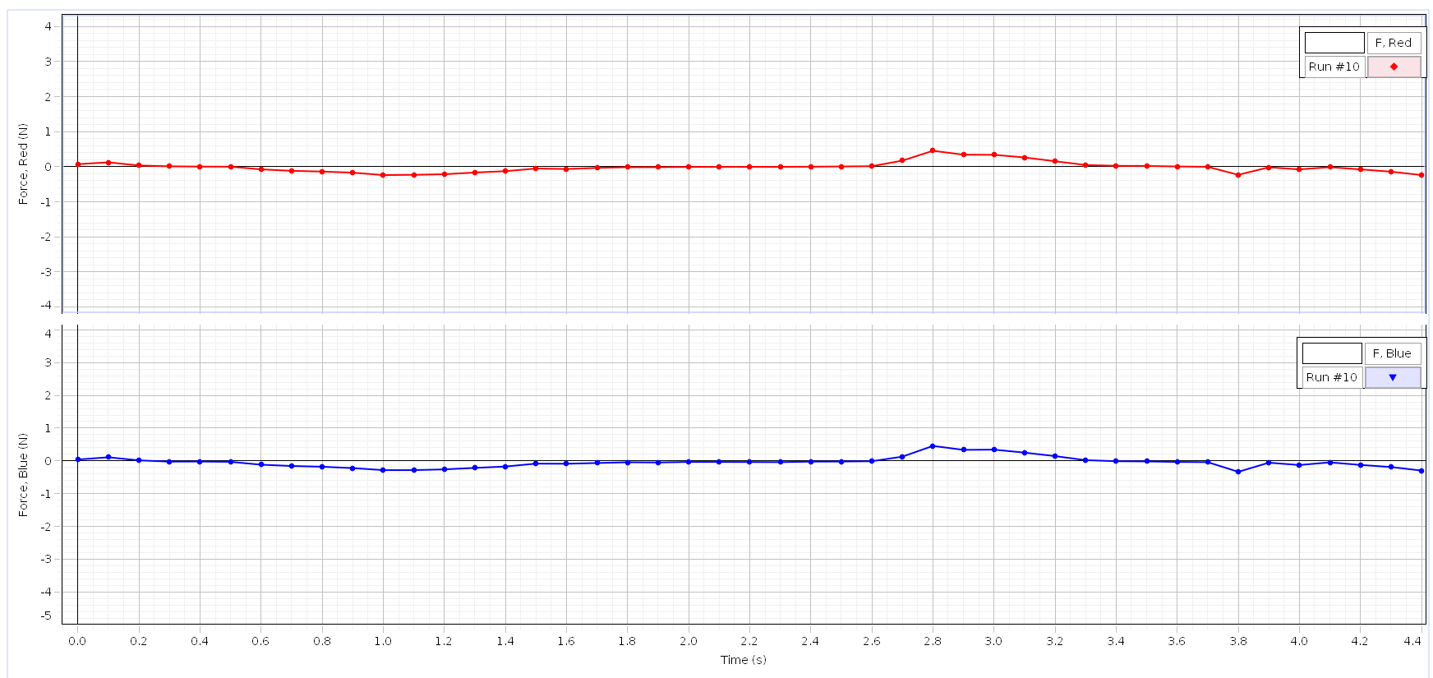

Here you can see that the magnitude of the forces is the same for each cart, just like theory states. The next experiment we did was using the same mass with a string connector. Newtons 2nd applies differently here because of the slack in the string. Here is the graph of our results.

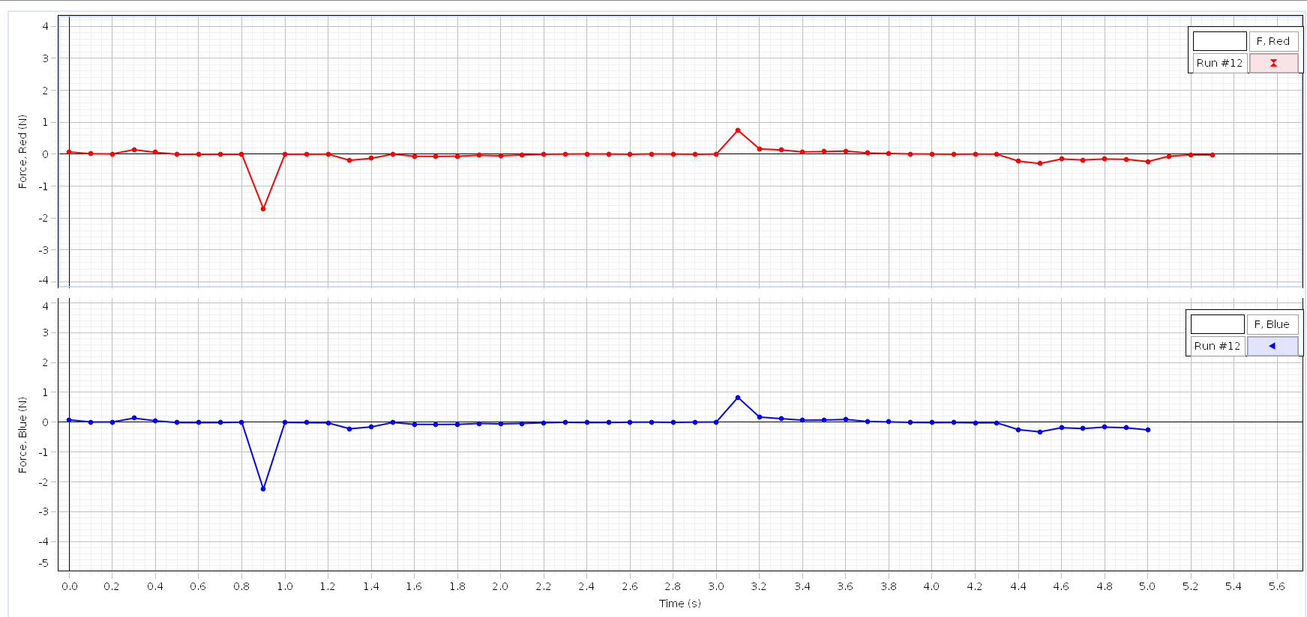

Here you can see 2 deviations from what we would expect capstone to produce. First the red carts graph goes on longer than the the blues. I think this is a mistake by capstone because the program was lagging when we hit the record button. The other deviation is that the first spike from the red cart has slightly less force that the blue spike. This can be explained by the slack in the string causing capstone to see less force when the blue cart slows down which causes an unequal transfer of force.

For part 2 we tested how different attachments effected the force measured for each cart in capstone when they collided with each other. For the first experiment we we had two carts with equal masses with springs screwed on. The blue cart was accelerated into the red cart, theory says that the graphs should be equal. Here is the graph of the experiment.

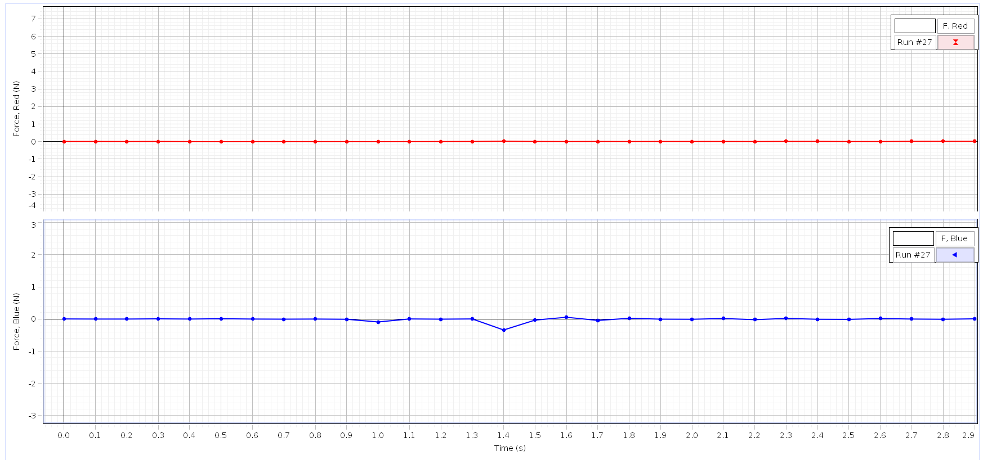

Here we can see that when the blue cart was accelerated into the red cart no force was measured on the red cart. This happened because the red cart was too close to the end of the track causing the force to be instantly transferred into the wall of the track. The next experiment was accelerating both with springs into each other. Here is the graph for that.

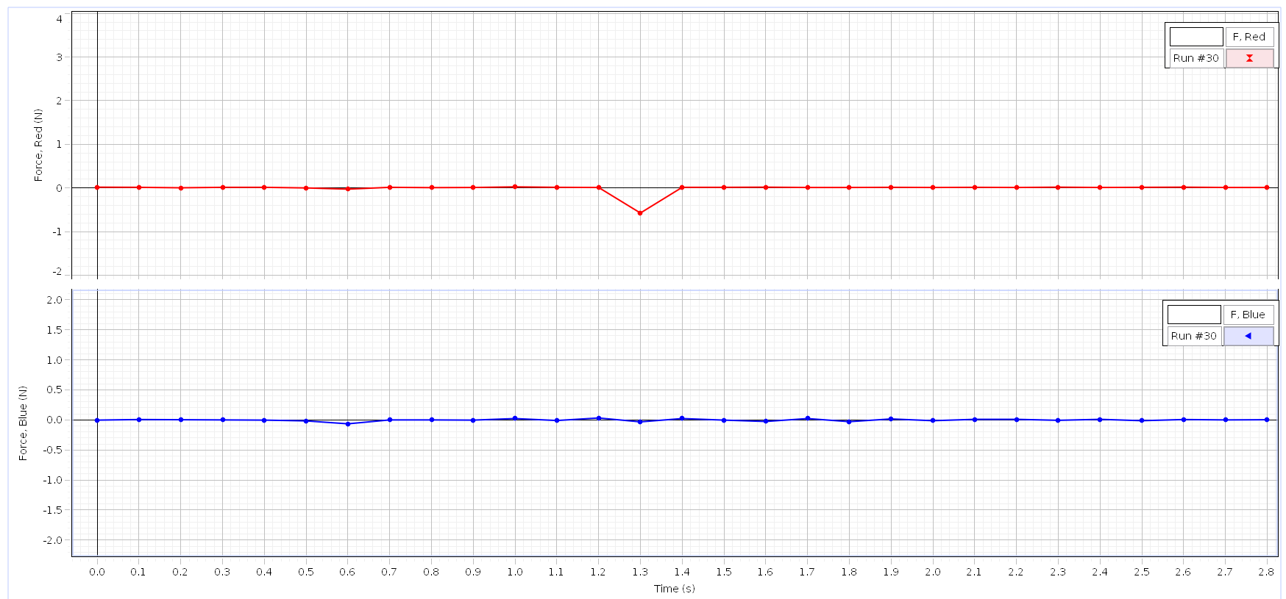

The reason the forces are different I think is because the amount of force used on each cart to cause them to collide into each other was different. The way to fix this error would be to use the ejector part of the cart where equal force would be applied which would yield the same magnitudes on the graph. The next experiment was using the spring attachment with an unequal amount of mass and acceleration the blue cart int the stationary red cart. In theory the forces should be equal to each other, here is the graph capstone recorded.

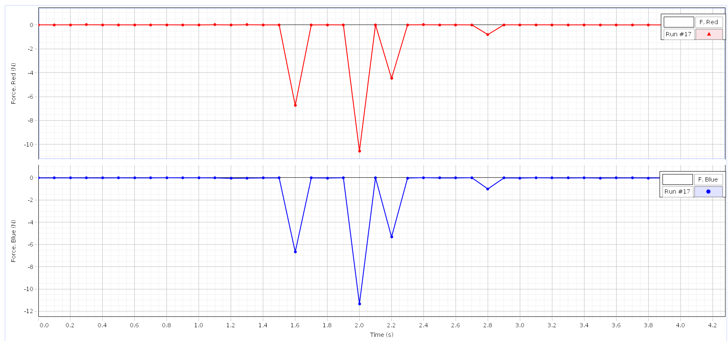

Here you can see the forces are exactly equal, which is expected. One interesting note about this experiment was how the force was transferred into the red cart which had less mass than the blue cart. When the two carts collided the cart with more mass transferred its force into the red cart into the form of higher acceleration than the blue cart, and when the red cart transferred its force into the blue cart it had much less acceleration. The next experiment performed was when the carts were accelerated into each other, with more mass on blue.

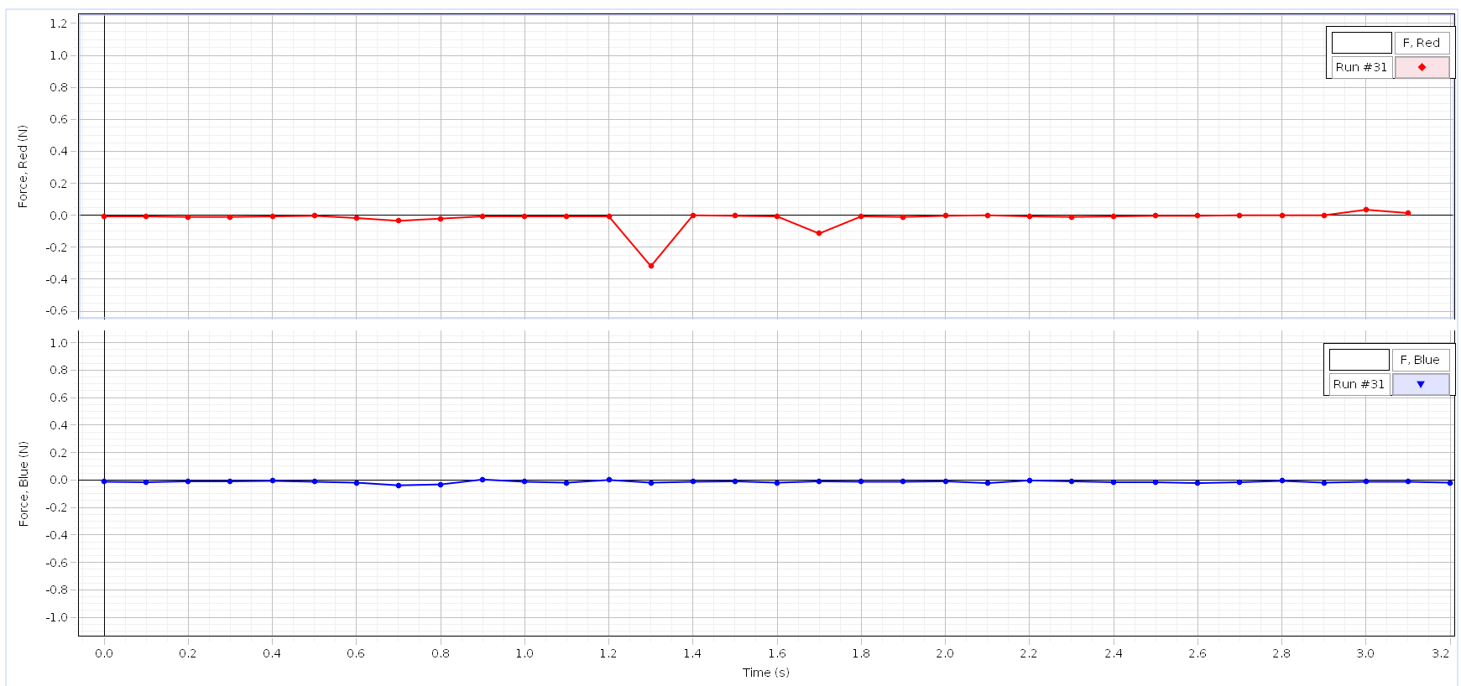

Here you can see that the force experienced by the red cart was different from the force experienced by the blue cart. I think this is due to the error as stated above where the red cart and the blue cart were accelerated into each other with different amounts of force causing the graphs to be unequal. The next experiment performed was with a different attachment, the sticky one. The force experienced by both carts should have the same magnitude, here is the graph.

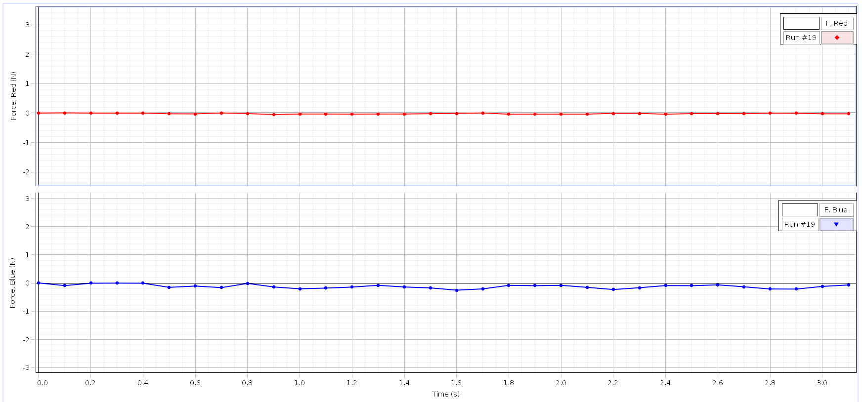

Here you can see that the forces experienced by each cart were slightly different. This can be explained by the sticky attachment causing the force to be unevenly transferred because when the carts stick to each other they cannot accelerate away from each other. We did another experiment using the sticky attachment where the carts were accelerated into each other.

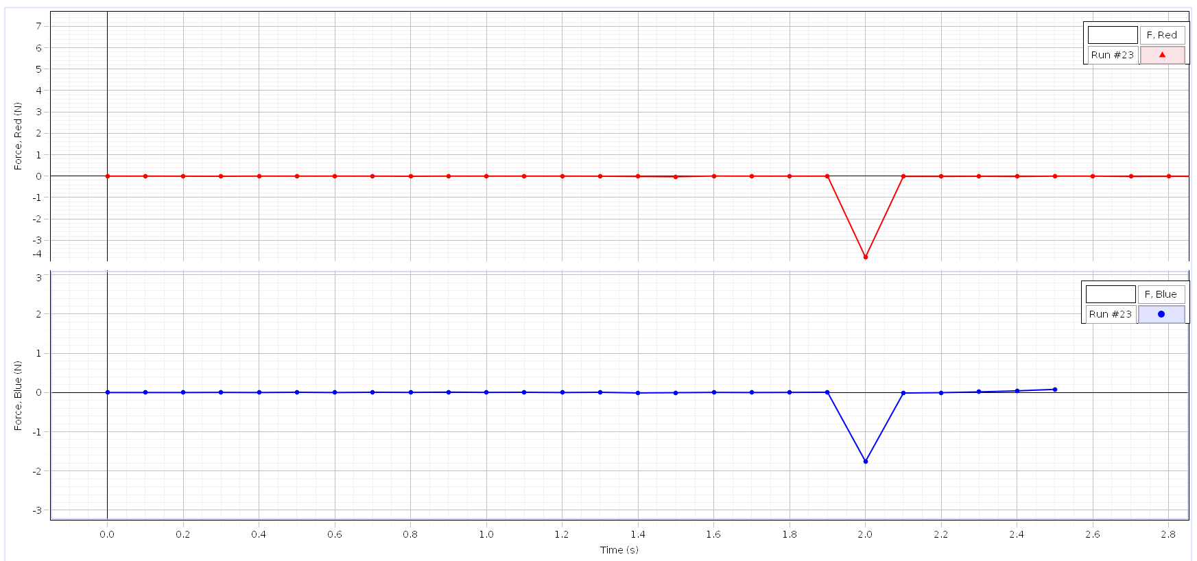

Here you can see the forces were the forces were nearly the same magnitude, even though theory says they should be equal. The error that happened here is the same that has been discussed above, where the forces that accelerated the carts into each other were unequal. The final set of experiments for part 2 was with the sticky attachment, with more mass on the blue cart.

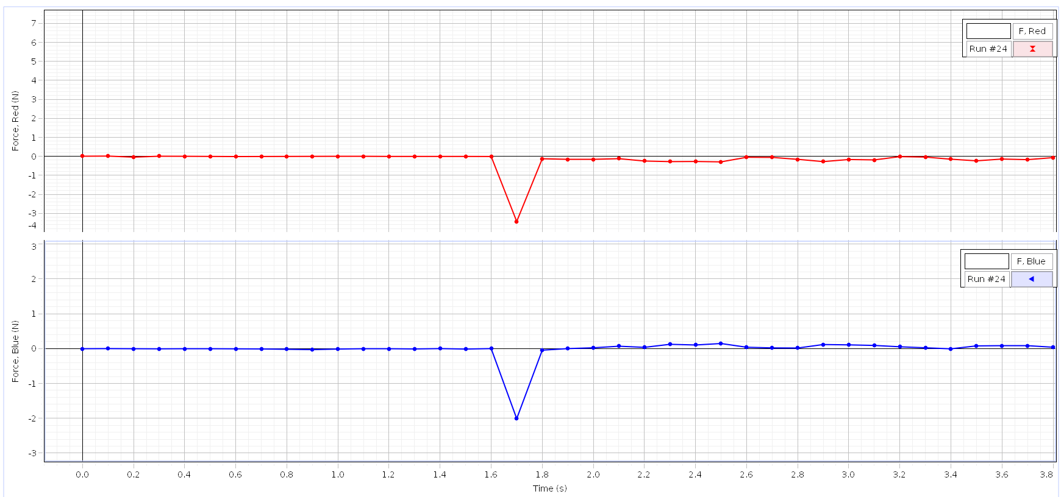

Here you can see that the forces experienced by both are nearly equal. The reason they are different is because of an error with capstone. Next we performed the same experiment with unequal masses. In theory the forces experienced by both should be equal, but as seen in the past experiments the sticky attachment causes unequal transfer of force, so we should expect them to be different.

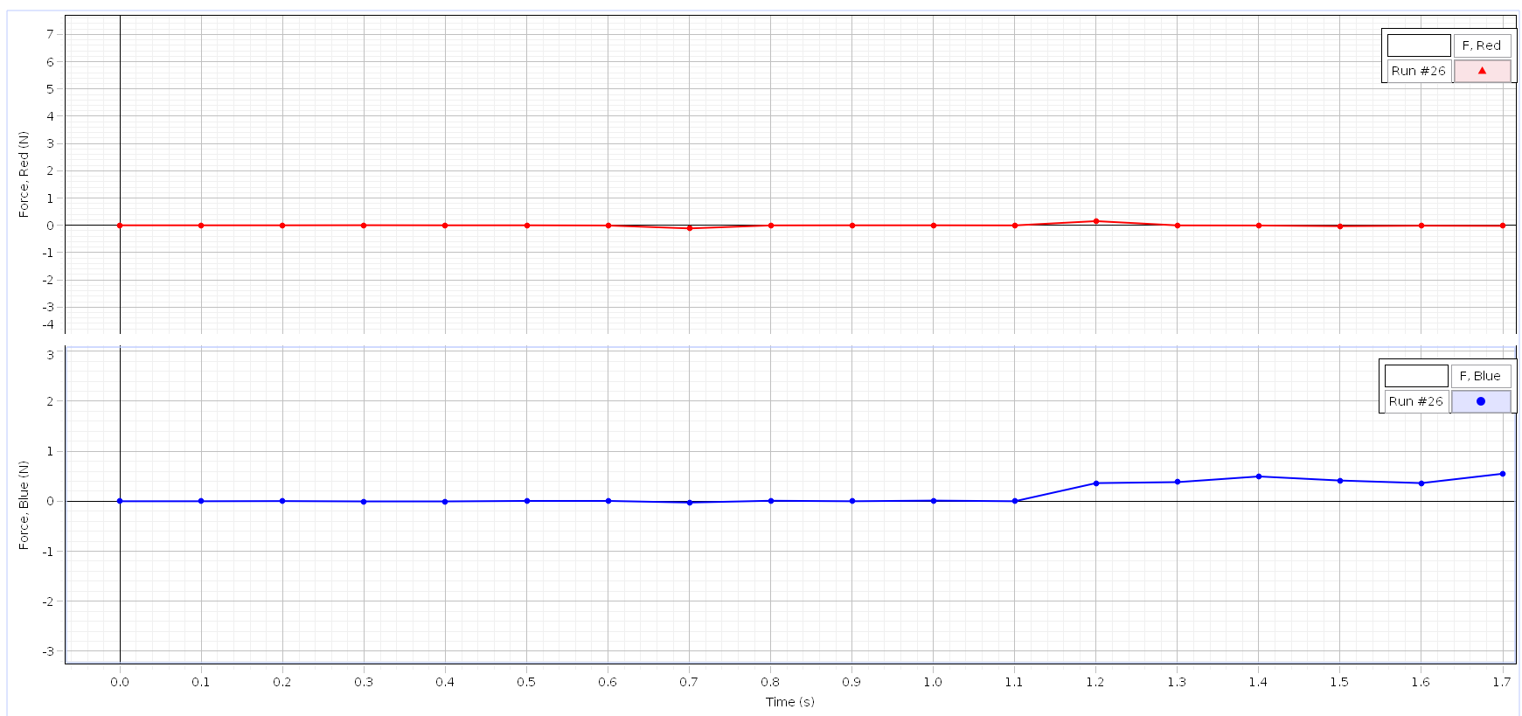

Here you can see that the magnitudes are unequal because the carts would stick to each other when they collide.

In conclusion Newtons 3rd law doesn’t always show it’s self in the way you might expect. While a lot of the time the magnitudes of the forces are the same for each cart, some of the time they are not. This is caused caused by either errors in our measurements, or other outside factors. For example, with the sticky attachment the carts after colliding would stick to each other, causing the force measured by capstone to be different magnitudes because the force would transfer back through the sticky attachment back into the source cart. So we can conclude that Newtons law always holds true, but it doesn’t always present itself in the way we might first expect.