The objective of lab 7 was to analyze the movement of a cart on a track through the concepts of work and energy. We compared the carts work to its kinetic energy. Important equations in this lab were the work equation, W = total_force * displacement * cos theta, where theta is the angle of the direction of displacement to magnitude of the net force. Another useful equation was kinetic energy, k = ½ * mass * velocity^2.

The first experiment performed in the lab was where we angle the track upwards at 4.7 degrees from the table, attached a string to the cart, and pulled it up the ramp parallel to the ramp with a consistent force. Ideally the force we record would be 0N because there would be not acceleration but because the angle and force were estimated by a human, it was prone to human error. The reason that it was prone to error was because looking at the force graph in capstone, it was all over the place, far from a consistent 0N. The reason the force needed to be consistent was because the work equation requires a constant force to be accurate, because that would mean that the acceleration would be 0m/s^2. There are two ways to resolve to get accurate calculations without assuming the force was 0N. One is to take the sum of all work for each period on the graph, which would yield an accurate amount of work only limited by how fast capstone records data. Another easier and more practical solution would be to take the average net force on the cart and use that figure in the work calculation. This way we could get accurate results even if the force was not consistent throughout the experiment. Here is the graph capstone recorded of the first experiment.

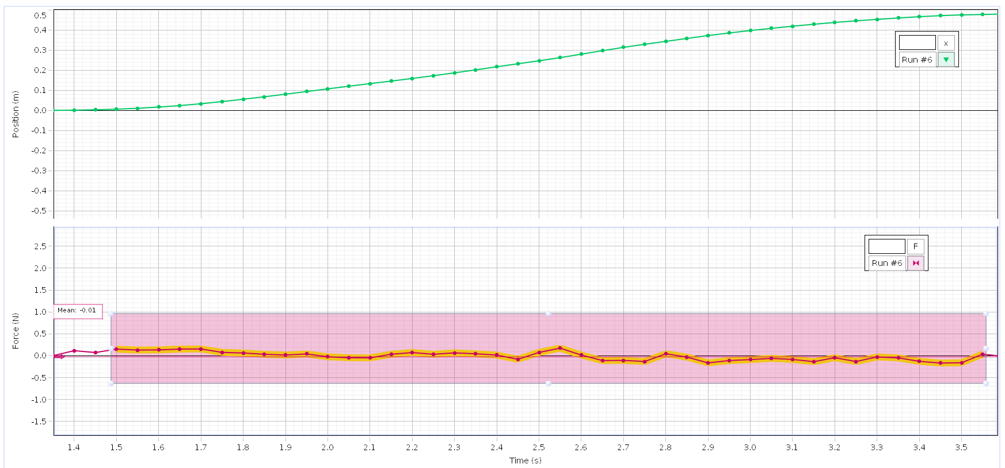

Unfortunately this was the first and only experiment we performed because after our first run through of the four experiments we noticed our force graphs were completely wrong, they were many times higher than they should have been. Because of this we had to redo the experiments but didn’t have time to finish the rest.

In the graph you can see the predicted human error occur, with the force graph far from a consistent number. In theory this number should be 0 because ideally the cart would have exactly 0 acceleration, making F = ma F = m*0 = 0N. To remedy this we took the mean of the force graph like discussed above which would yield accurate results, but we could have also just assumed the force was 0N. There was also another hangup we had with capstone that we did not think of beforehand. When capstone reads the amount of force on an object, it is only reading the force directly put on it. This wouldn’t have an effect in the experiment where the force was as the same angle as the displacement, but in the 60 degree trial (which we did not perform) capstone would have show the force that directly applied to the object to displace it, which was in the x direction, but not the force in the y direction. So capstone would not record the net force which is needed in the work equation.

In order to remedy this we had two options, either calculate the net force on the object using the angle, or prove that capstones recorded force was equivalent to F_net * cos theta. When visualizing a diagram of the cart, capstone is only recording the force that causing it to displace in the x direction, the y component of the net force just offsets the carts normal force meaning the track was pushing back against the weight of the cart less because the force in the y component was pulling it up. The y force was not enough to cause the cart to lift off the track so in effect the y force did nothing the alter our calculations. Here is a image that describes the math discussed here.

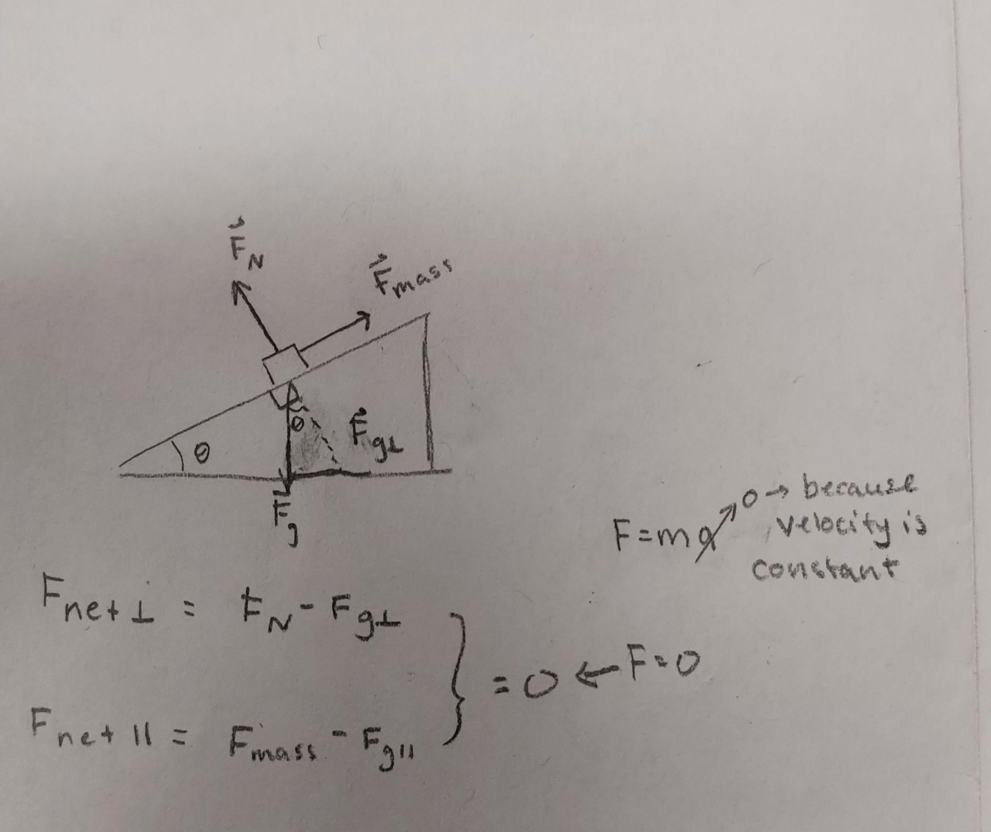

Here you can see that the equation for the applied work = (F_capstone/cos theta) * d(cos theta). In this equation (F_capstone / cos theta) * cos theta cancels out making the equation for work = F_capstone * d. From this we can assume that the work equation capstone already accounts for the F_net * cosine theta, or in other words it is only the force in the x direction. So to find the work we only needed to multiply the average force capstone recorded by the total displacement, which yielded the applied work to the cart.

The total work that we would expect to see in the cart would be equal to the change in kinetic energy from the bottom of the ramp to the top at 0.5m, The equation we would yield from this is 0.5 * mass * velocity_final^2 – 0.5 * mass * velocity_initial^2. In theory the velocity of the cart was supposed to be consistent all the way up the ramp so the change in kinetic energy should be 0 because the initial velocity should be equal to the final velocity, in practice this did not occur due to human error.

In conclusion we have to be careful with how we analyze the forces to be applied to the work equation. If we were not careful then we could have taken the force capstone output as the net force, which would have yielded completely incorrect results. For our one experiment it would not have made a difference since the angle of the displacement to the force was 0, meaning that the force capstone recorded was equal to the net force. But for an experiment where the angle was not 0, we would have to be aware of what force exactly was being recorded, otherwise out calculations would be totally off.