The theory for lab 8 involved using Newton's 2nd law to identify the forces involved. When in the water the only two forces acting on an object floating on top of the water are weight in the -y direction and a buoyancy force in the positive y direction. If an object is floating then the buoyancy force is equal to the weight force, and if it's sinking then the buoyancy force is less than the weight force. Here is the free-body diagram of a submerged object.

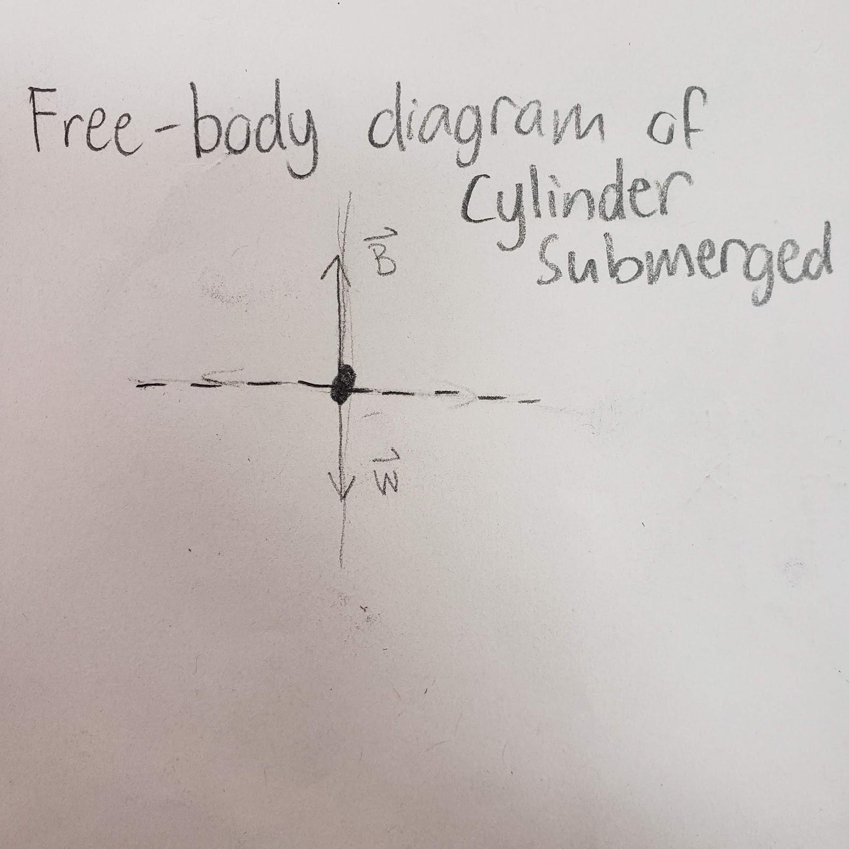

For our specific use case in this lab, there was one other force acting on the submerged object, which was the force the sensor applies to the object which holds it in place. This means that the full newtons 2nd law equation is F_buoyancy – F_weight – F_sensor = 0. The buoyancy force that a fluid puts on an object is calculated with the equation F_buoyancy = p_f* V_o * g where p_f is the density of the fluid, which was 1000kg/m^3 in this lab. V_o is the volume of the submerged object, in this lab, there were two volumes. Then multiplied by g which is the acceleration of gravity on the object, which is 9.8m/s^2 on earth.

For this lab, we were tasked with submerging cylinders with two different densities and measuring the buoyancy force caused by the water pushing the cylinder into the sensor. The buoyancy equation depends on how volume is submerged in the water. This means that as the volume of the submerged object increases, the buoyancy force increases, at a linear rate. So according to theory the buoyancy force should increase with the depth of the object. Theory states that two objects of the same volume should have equal buoyancy forces, but the force we measure may not be the same because of the different masses of the objects. This is because a greater mass implies a greater weight force. Theory states that the buoyancy force should be less than the weight if the object is denser, which means the object would sink. This implies that if an object is denser than water we should see the force measured from the sensor decrease with increased depth, because the buoyancy force is greater, meaning that the sensor doesn’t have to exert as much force to cause the net force to be 0. This goes opposite for an object that is less dense than water because without the force sensor exerting a force on the object it would just float on top of the water, so to increase the depth of the object the force sensor has to exert more force to make the net force 0.

The data that we collected throughout the trials did generally follow what theory states. One such example in our data is with the submerged metal rod where theory states that the buoyancy force should decrease with increased depth because the metal rod was denser than water. Here are the graphs of this experiment.

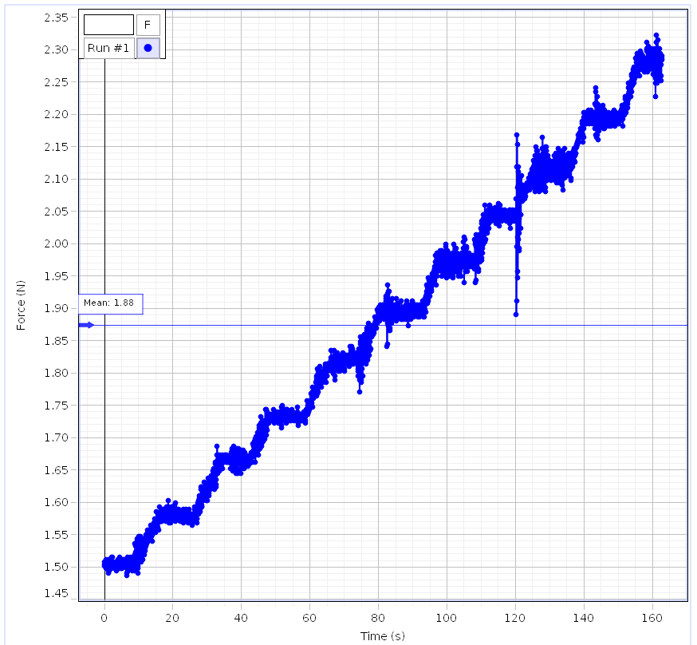

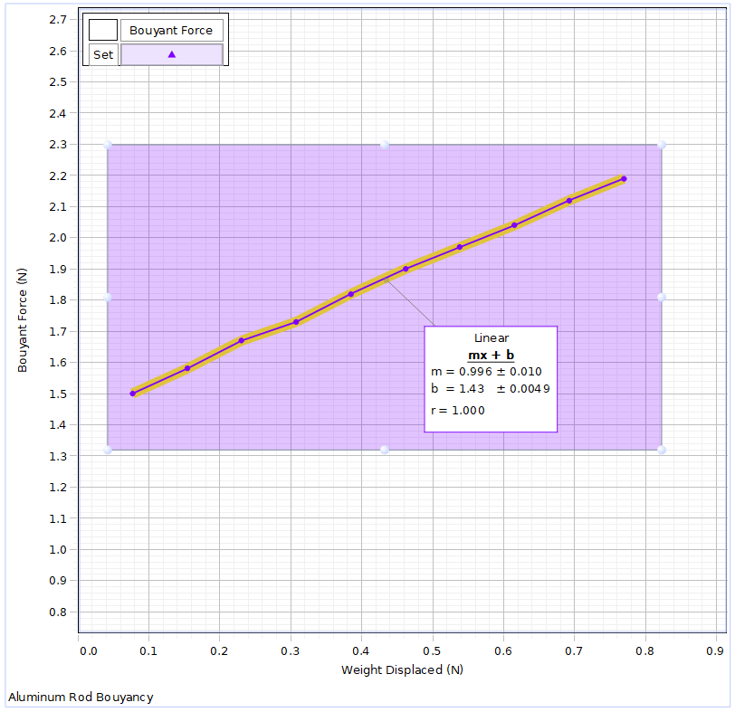

In this graph, we decreased the depth of the object approximately every 10 seconds, and you can see that the graph is trending upwards with decreased depth which is what theory predicts would happen in this scenario. In the graph, there is one odd section at around 120 seconds. When we recorded the data the jack made a small but sudden drop at about 120 seconds into the experiment which caused the force sensor to read inaccurate values. This was not due to human error, but a fault in the jack which we think was a flaw in the threading on the bolt.

We also did the same experiment with the wood rod which is less dense than water. In this scenario where the force is recorded starting when it is fully submerged, we would expect as depth decreased for the force to decrease because the weight is less than the buoyancy force. Here is the graph of the experiment.

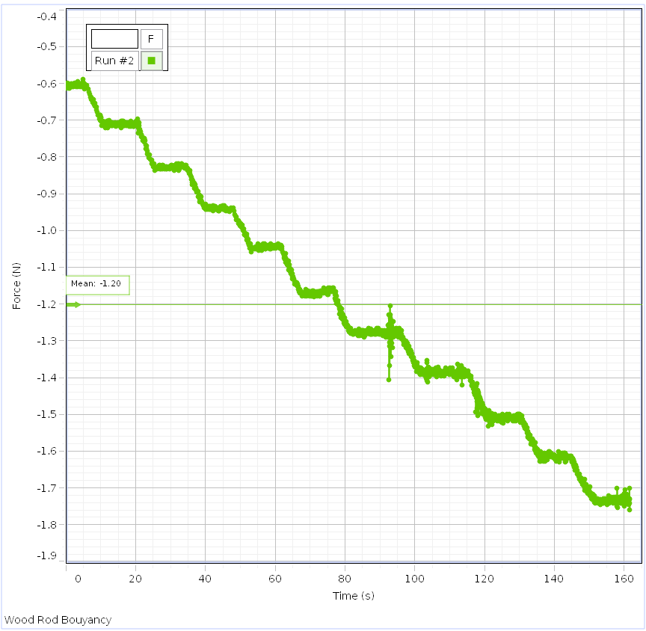

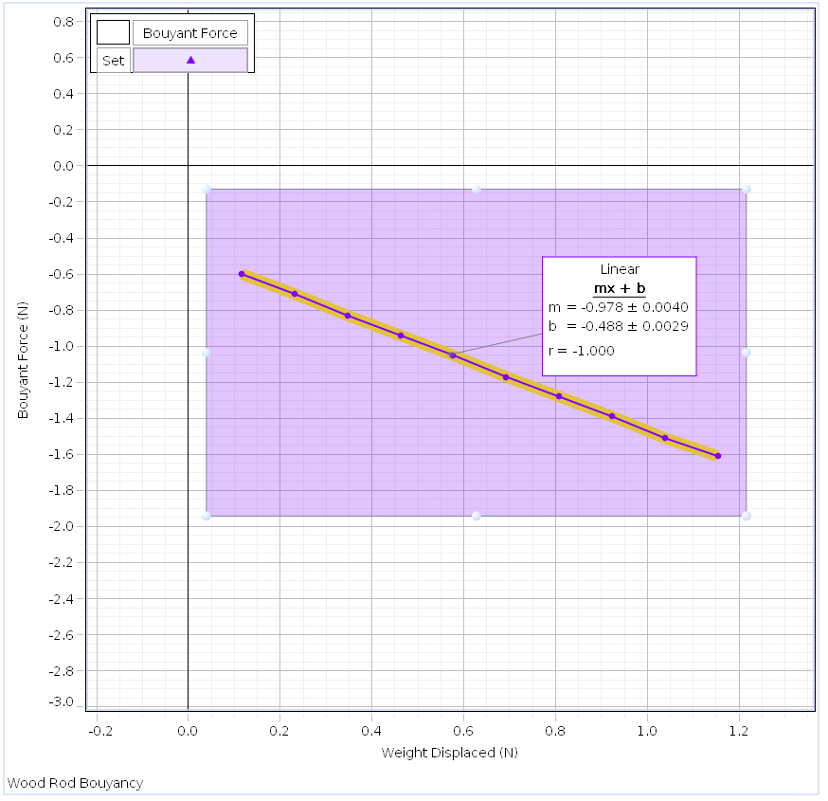

The graph does exactly what we would expect in this scenario, meaning that both experiments prove that theory is true. The Archimedes principle states that the buoyant force of an object is equal to the weight of the fluid that an object displaces. In both our graphs you can see that in general, the weight displaced and the buoyancy force are not equal at any point in both graphs of the weight displaced vs buoyancy force, so it seems that Archimedes' principle is not held.

Next, we were tasked with calculating the density of each material using the ratio between p_unknown / p_water = w_unknown / F_buoyancy. Theory states that if the material sinks in water, it is dense, and if it floats, it is less dense. Here are our calculations.

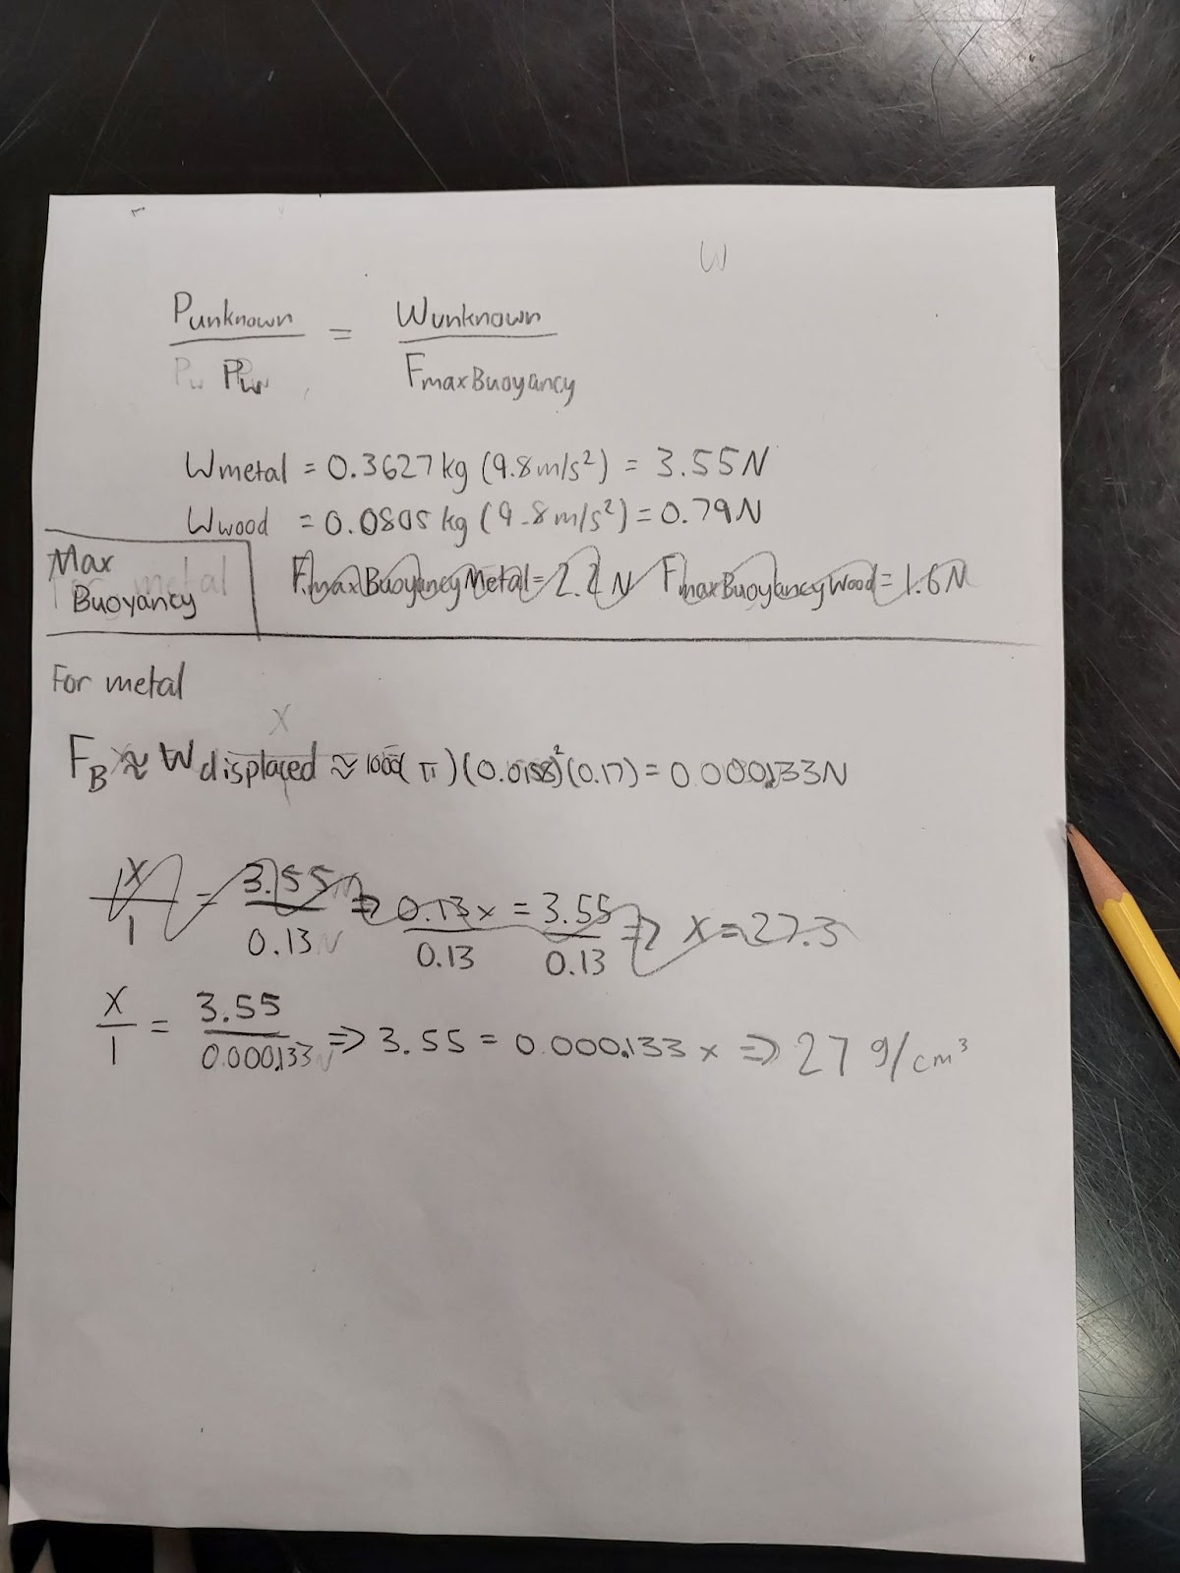

We were only able to calculate the metal one, which as expected is greater than the density of water. The only issue is that the actual density of the metal rod was 2.7g/cm^3, so the answer we got was 10 times greater than the actual density.

There were a couple of errors that occurred, one was with the jack being unstable. This could be remedied by testing if the jack is stable before using it. The other error that occurred was in our calculations. We knew that the density of the metal rod was 2.7g/cm^3, but the answer we got was 27g/cm^3. I think the reason this happened was a misplaced decimal point somewhere in the calculations which caused the decimal to be shifted.

In conclusion, the data we recorded did partially prove theory to be true. With the metal rod, we expected that with each decrease in depth the magnitude of force recorded by the sensor would increase, and the graph showed exactly that. And with the wooden rod, we expected the magnitude of the force the sensor recorded to decrease with decreased depth. The issue is that Archimedes' principle stated that the buoyancy force is equal to the weight displaced but that is not what was shown on both weight displaced vs buoyancy force graphs.