The main component of lab 10 was the use of a spring, and because of that the theory of springs. One of the most important equations for understanding springs is Hooke’s law, the equation for which is F (force) = - k (spring constant) * x (change in position). The equation contains three parts, the the force of the springs which is equal to mass * acceleration, the spring constant, which defines how much force is generated for a single unit in the change in position. And the change in position which is calculated by measuring the length of the spring compressed, then measuring the length of a spring extended, and subtracting the compressed length from it.
The goal for this lab was to experimentally determine if the spring obeys Hooke’s law, and also to calculate the spring constant. The way we were meant to do this was with two methods, using a differential equation, and by plotting how the oscillations period changes when adding mass to the spring. The idea behind plotting the points when adding mass was that by recording the displacement and force we effectively have a y and x, in a linear equation. For the other method of experimentally determining Hooke’s law using a differential equation, the idea was to measure the oscillations of the spring with different masses. The differential equation we needed to used was the one that best fit the oscillations of the spring, and the equations that work best in this instant are the sine and cosine functions. We would end up using the sine function because it was present on capstone. The idea behind this was that if we could fit a sine function, we could measure the angular frequency (the radial measurement of the rate of rotation) of the oscillations and calculate the period of oscillations using the equation 2(pi)/omega. The equation we would be using to calculate the spring constant (k) was omega = sqrt(k/m) so 1/(omega)^2 vs mass should produce a linear equation relating to the spring constant. The way to calculate how ideal our spring was is to measure the mass, with a more ideal spring being closer to 0kg, but we did not weigh the spring. A pendulum and harmonic oscillator should behave similarly because a pendulum is also considered a simple harmonic oscillator.
For the first method to experimentally determine Hooke’s law, we found that the line of the graph was linear and that the slope of the graph was ¼ or 0.25n/m. The data for that is below.
Mass (g) | Δs (cm) | Force (N)
100 | 2.5 | 0.98
200 | 6.5 | 1.96
300 | 10.5 | 3.03
400 | 14 | 4.00
500 | 18 | 4.98
600 | 21.5 | 5.97
700 | 25.5 | 6.95
800 | 29.5 | 7.92
900 | 33 | 8.91
1000 | 37 | 9.90
1100 | 41 | 10.87
1200 | 45 | 11.85
NOTE : The labels for force and displacement on the graph are switched
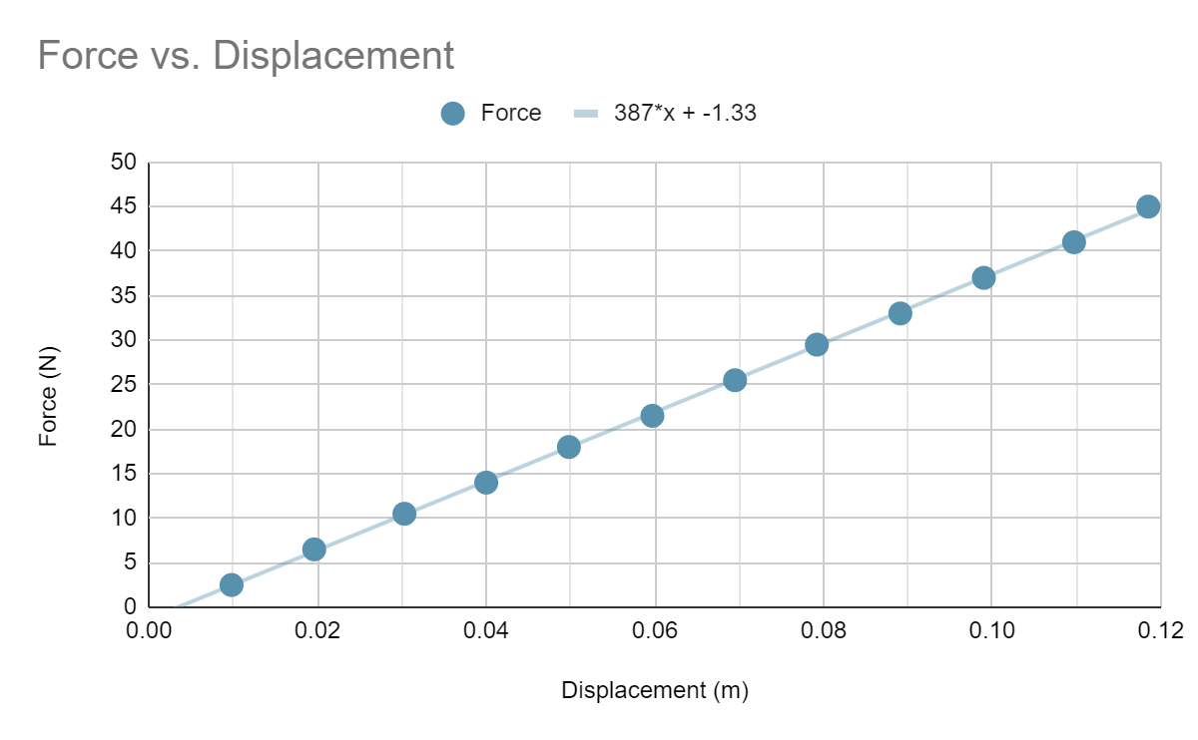
The first figure is the data and when plotted the graph produces a line. The point of plotting the graph was to see if the data was linear, which it clearly is because the line of best fit passes through all the points of the graph. Since the force vs Delta x relationship was linear we could make the determination that Hooke’s law did apply, so a spring constant could be calculated.
For the second method using a differential equation, we were able to determine that the spring constant was 0.0394n/m. Here is the graph of the data we collected as the mass increased. The masses effect on the angular frequency is displayed in the table below.
Mass (g) | Omega (Rad/s) | Oscillation period (s)
100 | 12.82 | 0.49
200 | 9.97 | 0.63
300 | 8.38 | 0.75
400 | 7.39 | 0.85
500 | 6.76 | 0.93
600 | 6.22 | 1.01
700 | 5.76 | 1.09
800 | 5.42 | 1.16
900 | 5.15 | 1.22
1000 | 4.91 | 1.28
1100 | 4.69 | 1.34
1200 | 4.49 | 1.40
Based on the table it seems that as the mass decreases linearly angular frequency exponentially increases. This aligns with what theory says because in the equation omega = sqrt(m/k) which shows the same relationship.
I also noticed that as the amplitude got bigger the period of oscillation would also get bigger. You can see this in the table because the mass is proportional to the amplitude (which is the change in x) because the there is more force accelerating the spring increasing the change in x and as mass increases the period increases, meaning the amplitude also increases. This aligns with what theory says about the period because in the equation for the period of a spring oscillating T = 2pi sqrt(m/k) we know that mass is proportional to amplitude and we know that as the mass increases it slightly increases the period according to the equation. The reason that the slope of 1/omega^2 vs m is equal to the spring constant is because 1/omega^2 = k * 1/m which shows k as the slope of the graph.
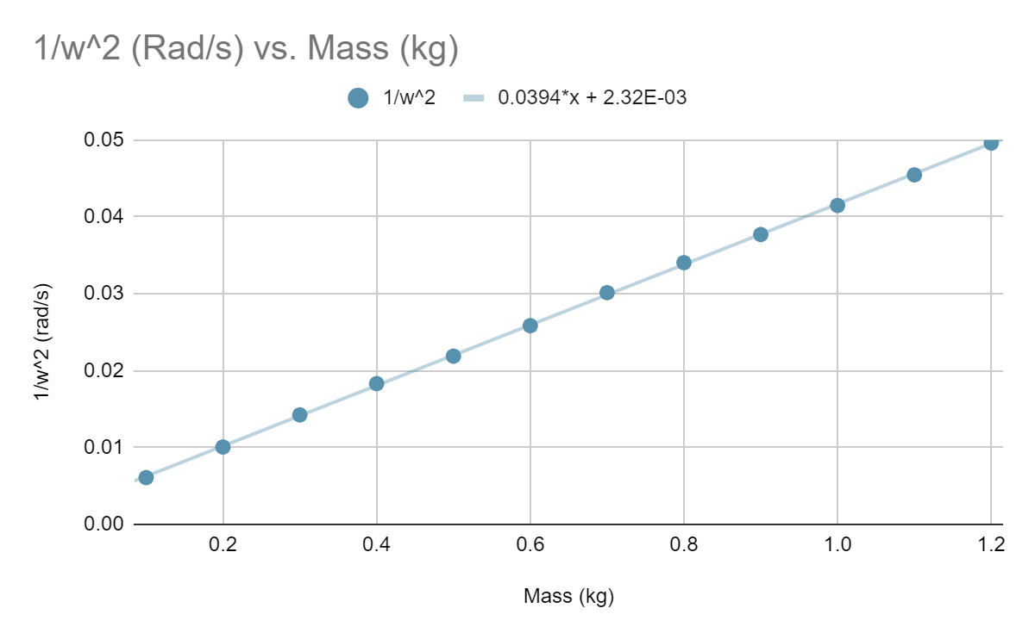
As you can see the relationship is linear, which means Hooke’s law is being obeyed. The issue is that the spring constant calculated with the slope in this graph is very different from the spring constant calculated from the slope from the other method. I think that the error that occurred was the spring swinging from side to side causing some of the energy from the y oscillation to be transferred to an x oscillation which wasn’t being recorded by the sensor. This happened because we recorded the spring oscillating for too long on multiple points of data. The error between the two methods with the spring constants calculated as 0.25n/m and 0.0394n/m was around 500%. The graph did not have a y intercept of 0rad/s, which is explained by the spring not being completely ideal.
In conclusion both methods determined that the spring followed Hooke’s law because both graphs were linear, but the spring constants calculated were entirely different. With the calculations being 0.25n/m for the first method, and 0.0394n/m with the second. The error between the two was around 500% which means a serious error occurred somewhere. I believe that the first method yielded a more accurate result because because the only possible errors that occurred those measurements was incorrectly measuring the displacement, which we were careful not to do, and the fact that the spring was not ideal.

