The theory behind lab 11 involves frequencies, resonance, and standing waves in a string. To understand this lab you first have to understand how frequency relates to resonance. While messing around with the vibrator we noticed that there was a certain frequency where the string would vibrate the most this is known as a standing wave, the end points of the standing wave are known as nodes and the points where the amplitude is the highest is known as an anti-node. A standing wave is a vibration where the amplitude of the wave is constant. A standing wave occurs when the frequency of the vibration resonates with the material that is vibrating, this is known as the resonant frequency. There are multiple factors that effect the resonant frequency of a string. These are the length of the string, the tension, and the density. Multiples of the frequency where one standing wave occurs will also produce a standing wave, but with the number of anti-nodes equal to the multiple. The equation for the frequency of a standing wave in a string under tension is f = n/2L * sqrt(T/u), where n is the number of anti-nodes, L is the length, T is the tension force in newtons, and u is the density of the string.
There are multiple equations that can be used to calculate the frequency that will produce a standing wave. The first involves the number of anti-nodes where the frequency = An where A is a constant.
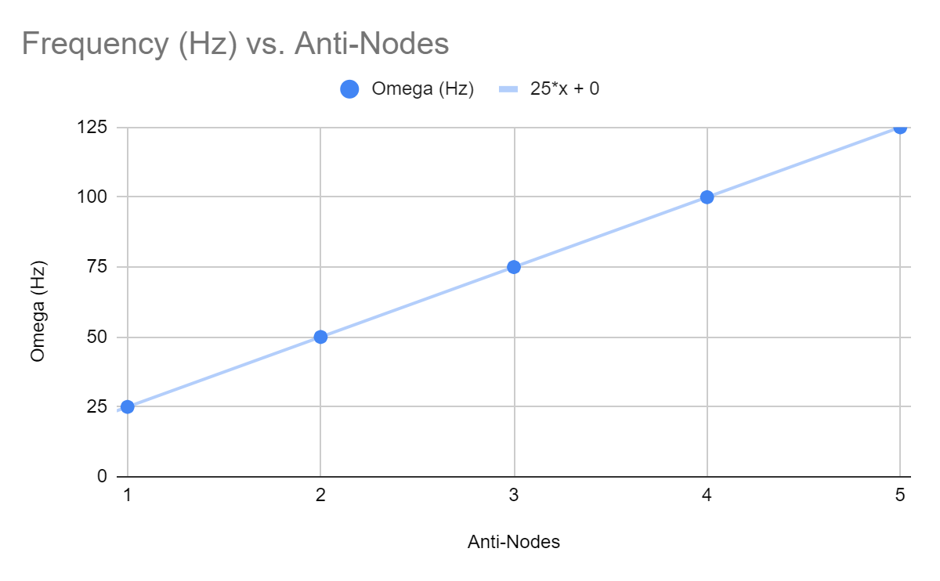
You can see this equation born out in the data, where the frequency is equal to the number of anti_nodes * resonant_frequency = frequency of the vibration. This equation aligns with theory in that the multiples of the resonant frequency that produces a single standing wave will also produce a standing wave with the number of anti-nodes equal to the multiple. In the full equation for frequency it shows that the number of anti-nodes linearly effects the resonant frequency which is borne out in the data.
Another equation that can be used to calculate the frequency of the wave is the tension in the string. The equation is Frequency = A * sqrt(T) where T is the tension in kilograms and A is some constant. Here is the data that support this.
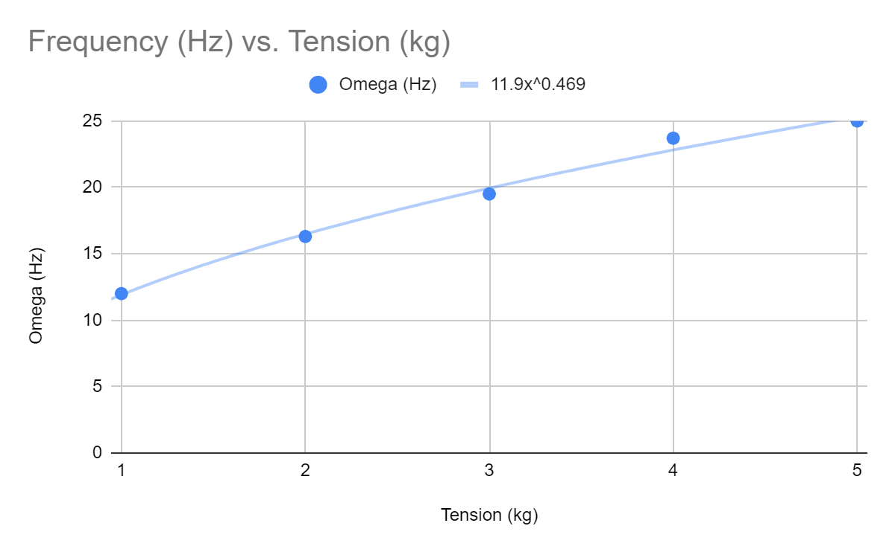
The data scales in a ½ power fashion which means that increasing the tension of the string will cause the resonant frequency to increase but over time the increase in frequency per single unit of tension will decrease over time, this is known as a diminishing return. The data and derived equation aligns with theory in that in that the equation we got was the mass to the ½ power and the equation that theory provides is also to a ½ power, with the tension in Newtons instead of mass. To convert the mass to Newtons we would only need to multiply the mass by 9.8m/s^2 because gravity was the only acceleration acting on the object. Assuming that the density was 1g*m^3, the equation that we derived would be exactly the same as the tension part of the formula.
The next equation for frequency that was derived was f = A/sqrt(u) where A is a constant and u is the density.
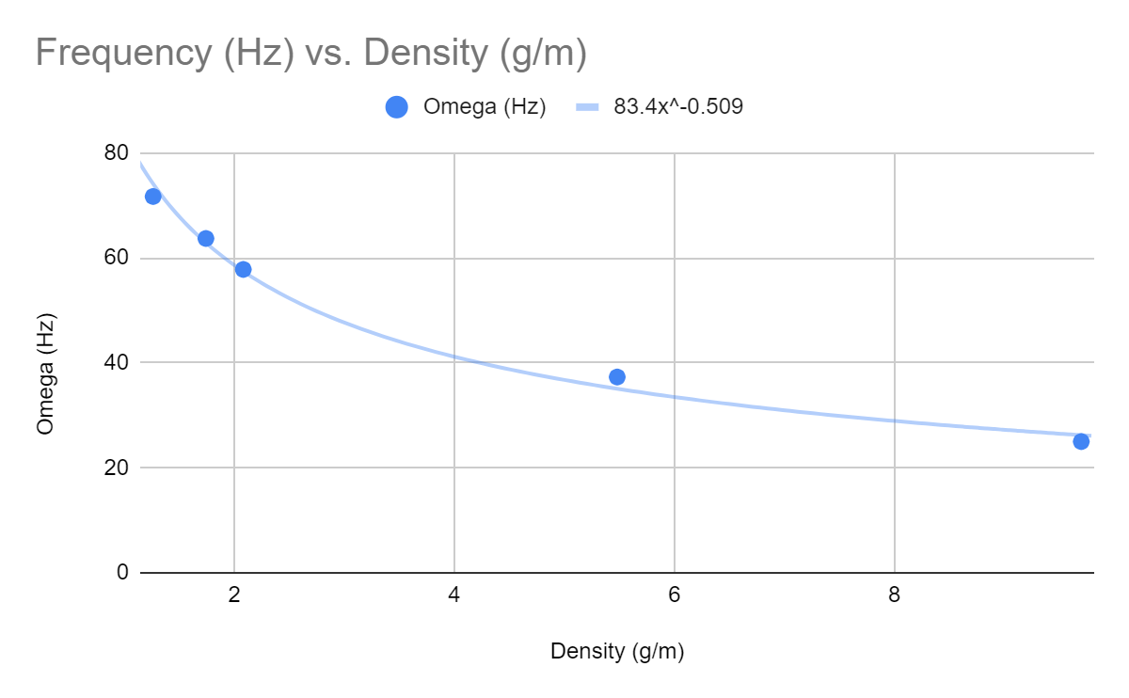
Here we can see that as the the density increases the frequency also decreases, but at a – ½ power rate. This means that over time as the density increases a single unit the frequency will decrease by less over time. In the equation provided by theory we see that the density u is also an inverse power series. Assuming that the tension is 1N the equation that we derived and the equation theory provides are the same, in that they both suggest that density has an inverse square root effect on the frequency of a standing wave on a string.
The next equation was the equation for length that we calculated was f = A/L where L is the length of the string and A is a constant. Here is the data.
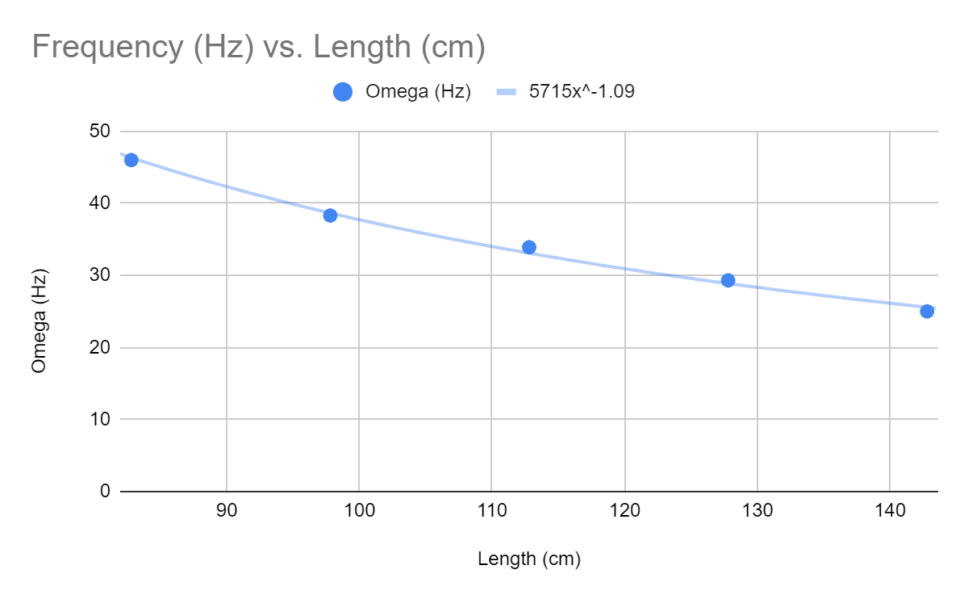
Here you can see that as the length of a string increases the frequency decreases, but not linearly, over time decrease in frequency for a single unit of length will get smaller. This is borne out in the equation theory provides in assuming n, the number of anti-nodes is 1, the effect that the length of a string has on the resonant frequency is A/L, and we can assume that ½ in the theory for equation is the constant A, meaning the data we collected perfectly aligns with theory.
Overall the equations we derived can be put together to get a complete frequency equation, which can be seen here.
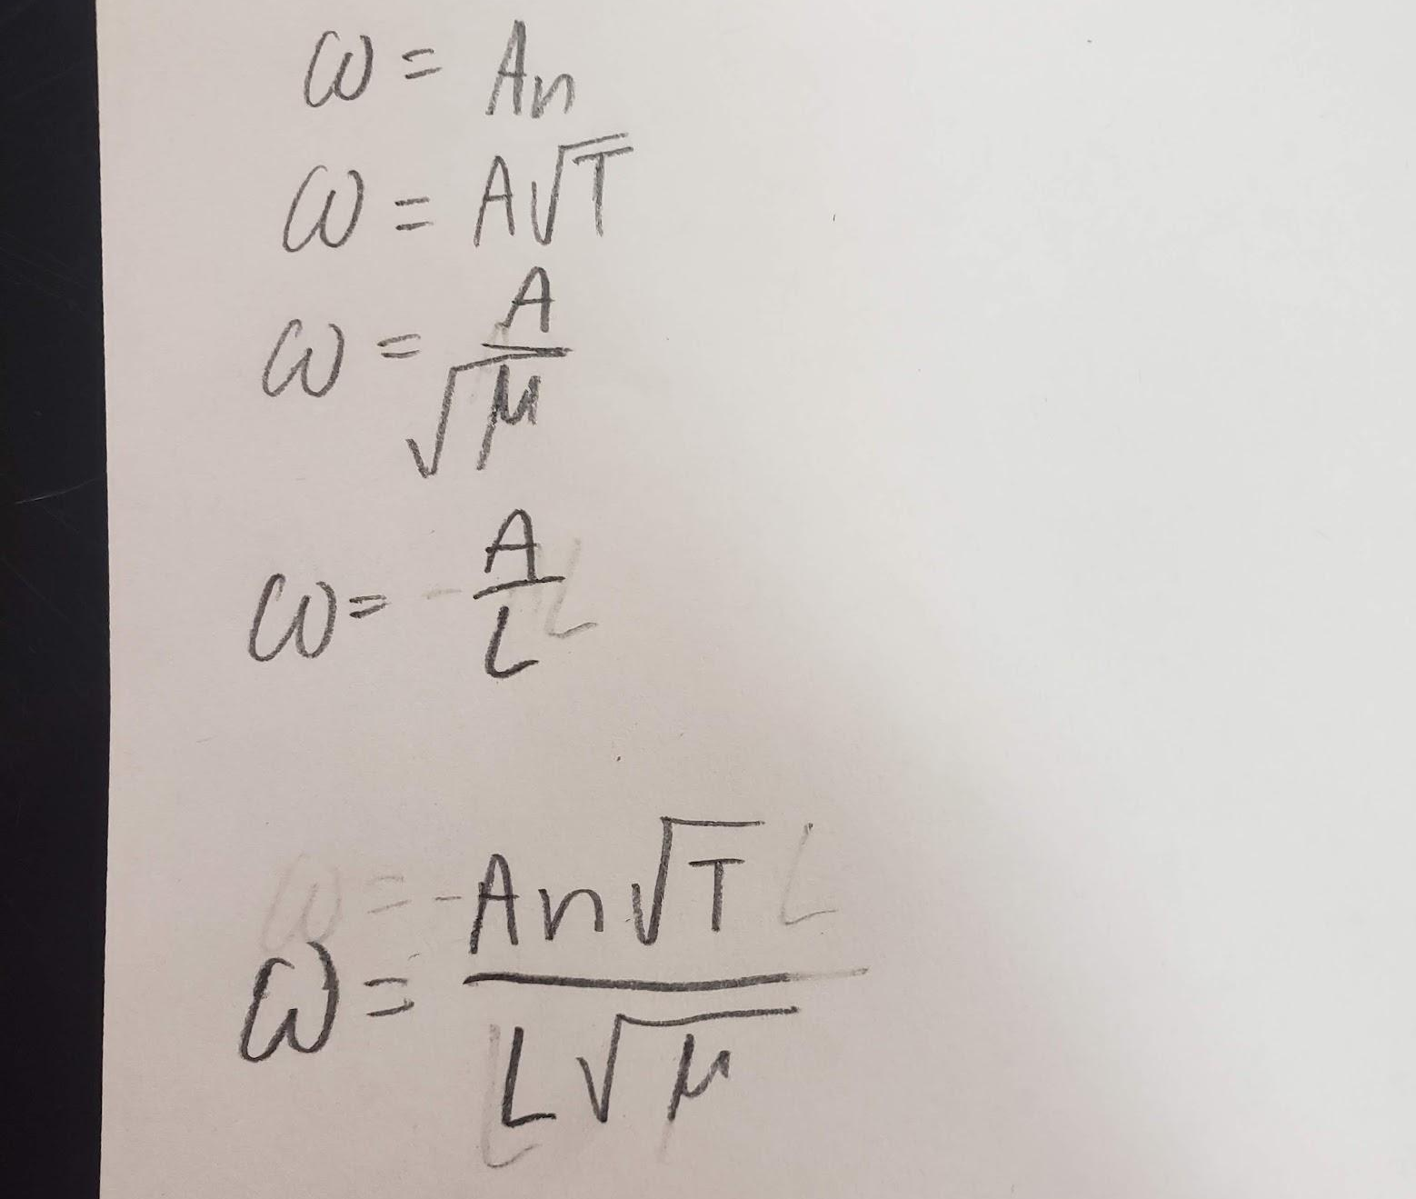
In this case W is the frequency. This equation is the exact same as the equation that theory suggests when we substitute ½ in for A. Since sqrt(T)/sqrt(u) = sqrt(T/u) we can safely conclude that the equation derived from the data perfectly aligns with theory.
There was an error that could have occurred in the lab, but it is evident that they did not have a significant effect on conclusion. The error was that when we were adjusting the length of the string our measurements weren’t precise. The way the ruler was positioned left it at an angle, meaning that the lengths we recorded were slightly larger than they actually were. The reason this didn’t have a significant effect on the data was that the error was consistent so it didn’t cause problems.
In conclusion we were able to perfectly replicate the equation provided by theory with our data. The relationships between the variables in the equation for frequency all aligned with their theoretical counter parts. The number of anti-nodes had a linear relationship, tension had a ½ power relationship, density had a – ½ power relationship, and length had an inverse relationship according to our data and theory.

