The goal for lab 9 was to calculate the moment of inertia for two masses using two methods, the principle of conservation of mechanical energy, and using the rotary motion sensor. The moment of inertia, or in other words, the rotational inertia describes how difficult it is to change the velocity of a rotating object. The total moment of inertia is equal to the sum of all moment of inertia's in the system. With the fundamental concept we can combine known moment of inertia’s to get unknown moment of inertia's. The basic for the moment of inertia for an object rotating d displacement from the center of rotation is , which is known as the parallel axis theorem. I_CoM is the moment of inertia located at the center of rotation. The equation is . These two equations are just one way to calculate the moment of inertia. The other way is to use the conservation of mechanical energy. We can derive the equation for the moment of inertia with the masses off the rotating bar.
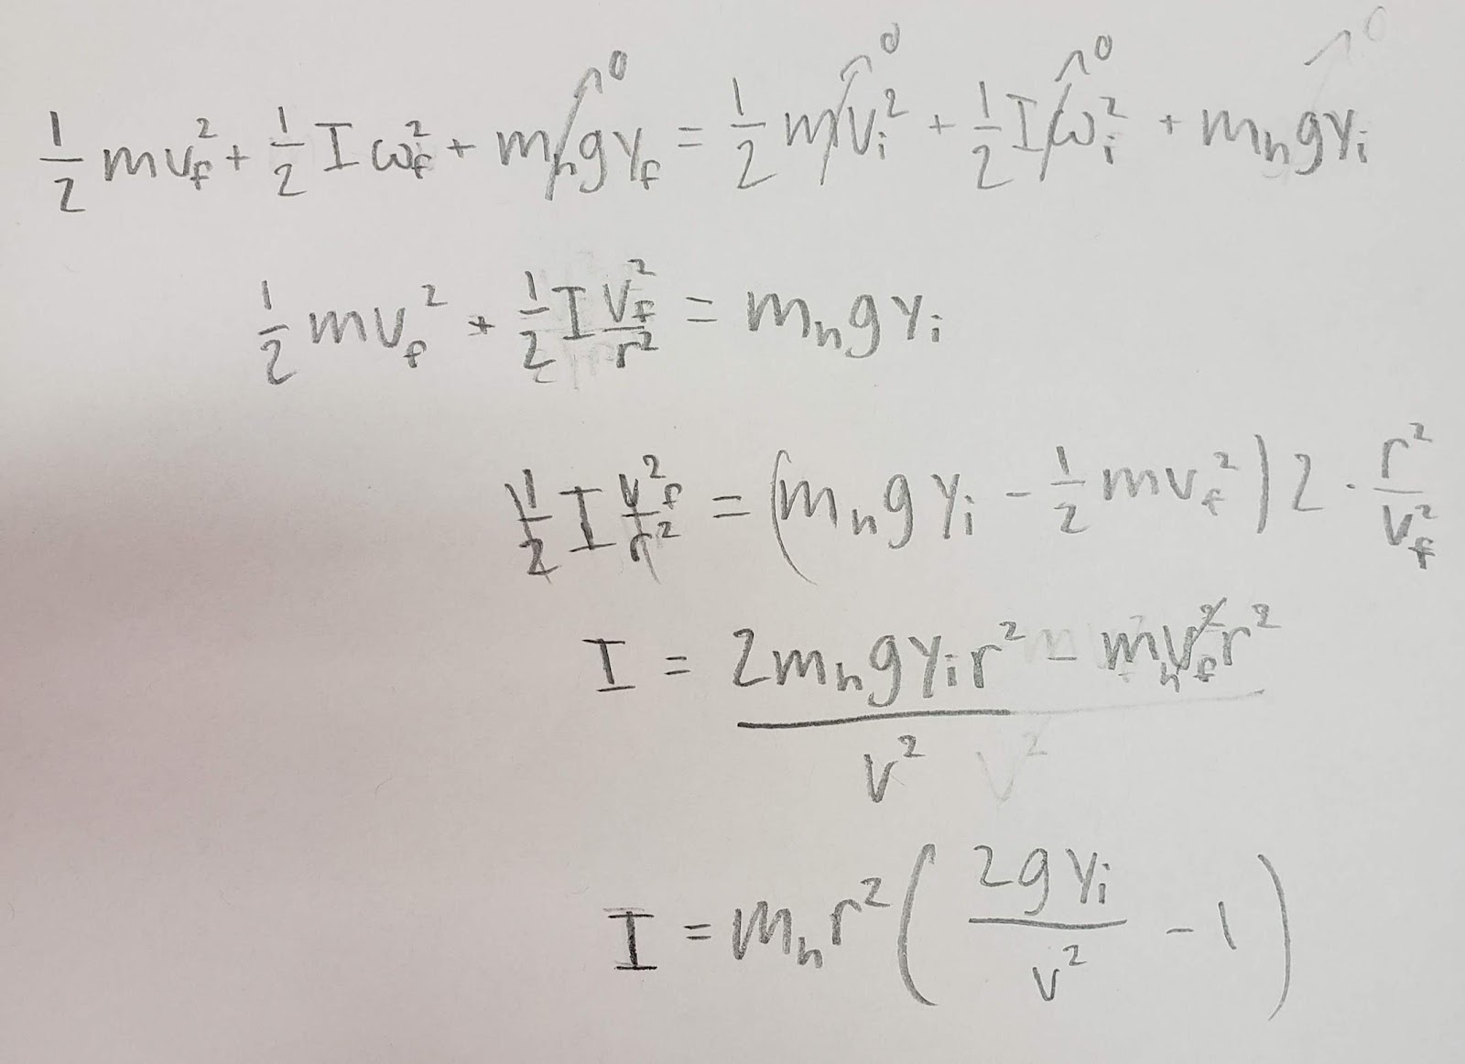
This is the derivation of the inertia without cylinders. This equation is based off the idea that the E_f = E_i. With the system there were three different sources of energy present. The first is the kinetic energy of the mass being dropped, the second is the kinetic energy of the rotating mass, and the third is the potential energy of the falling mass. With the final kinetic energy side of the equation we know that at that point all of the potential energy would have been converted to kinetic energy, so we 0 out the potential energy. And with the initial side of the equation, all the energy is stored as gravitational potential energy, which has yet to be converted to kinetic energy. Now solving for I we got the equation . With this equation we could derive the moment of inertia for rotary motion sensor with the masses on. Here is the derivation for that.
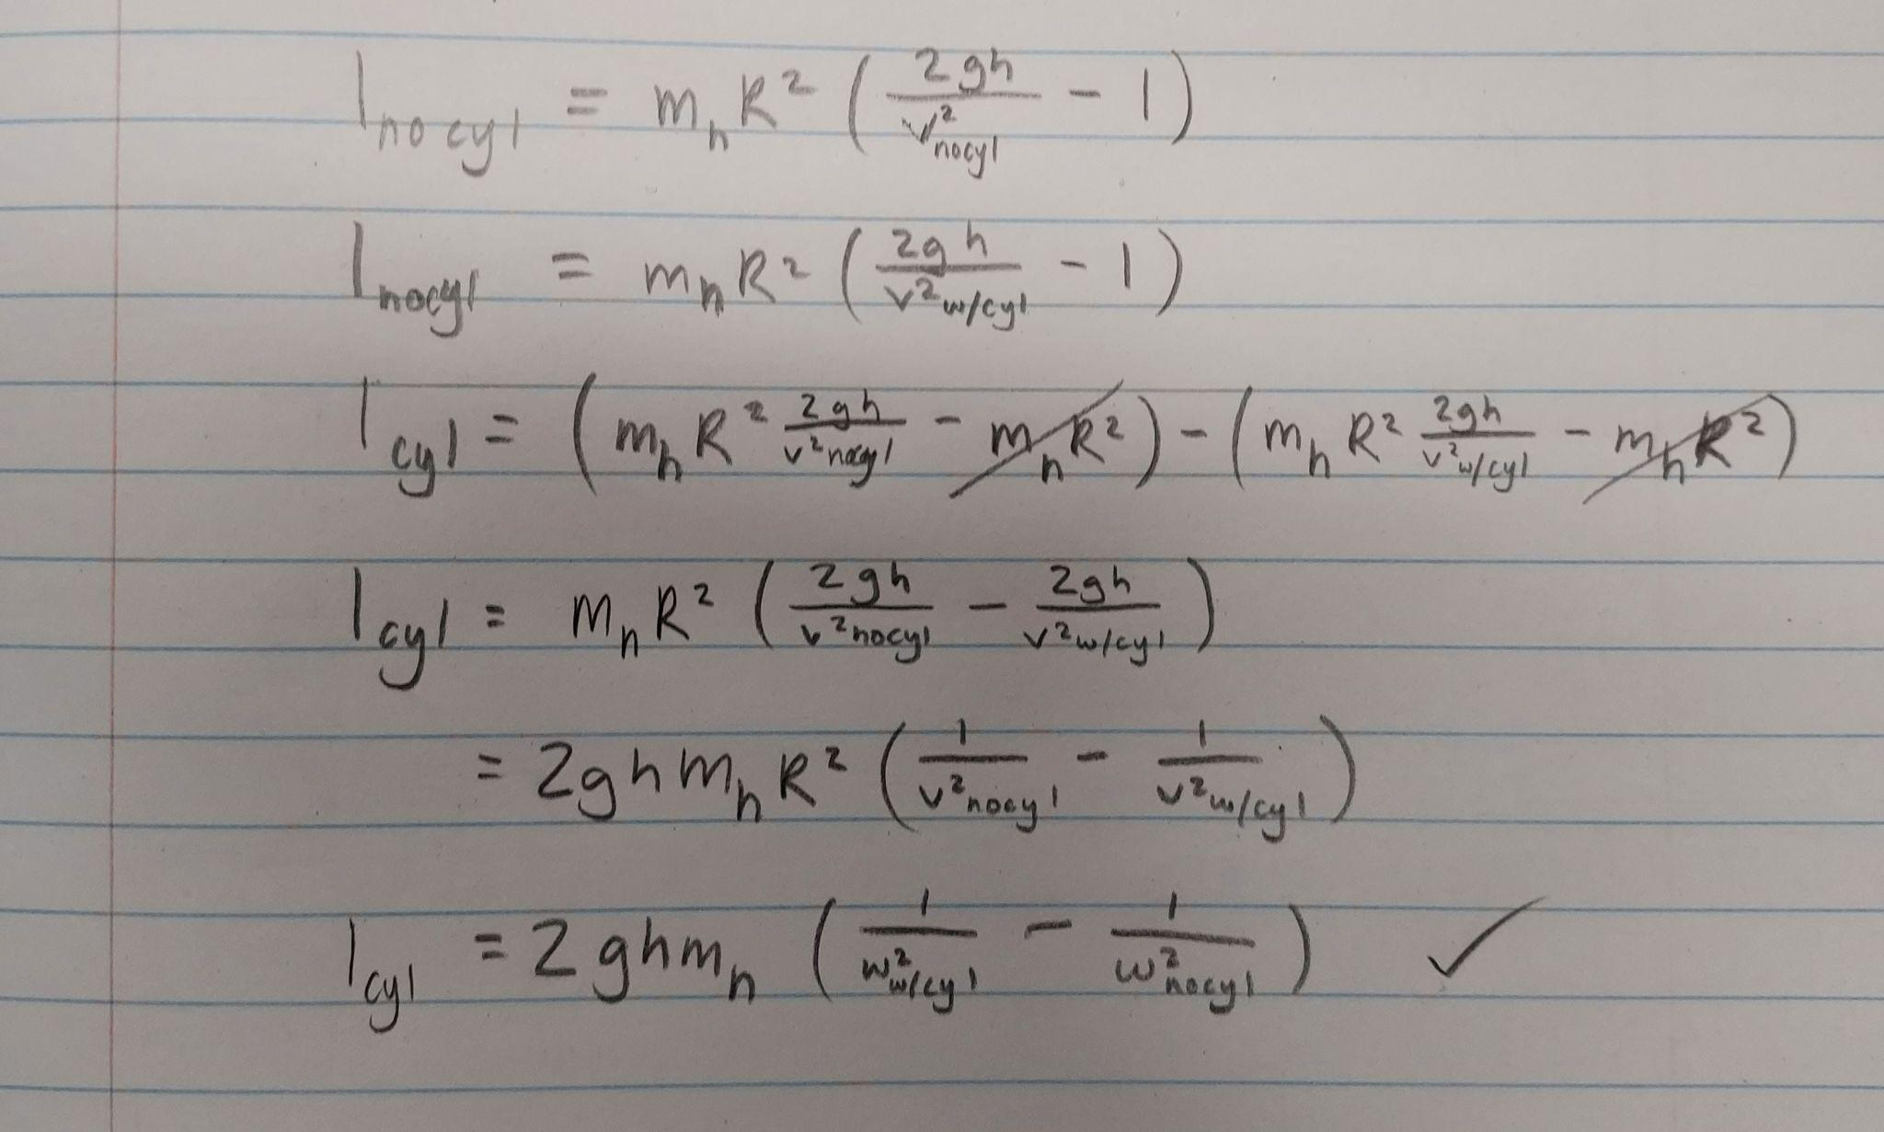
The derivation here is based on the idea that the total moment of inertia is the sum of all moments of inertia. With this in mind we knew that the moment of inertia with the cylinders is equal to the difference of the total moment of inertia and the moment of inertia with no cylinders. With these equations we had all the tools needed to derive the moment of inertia of the system using both methods.
First we calculated the moment of inertia using the first method, the equation . Here is the calculation for the moment of inertia for the center of mass.
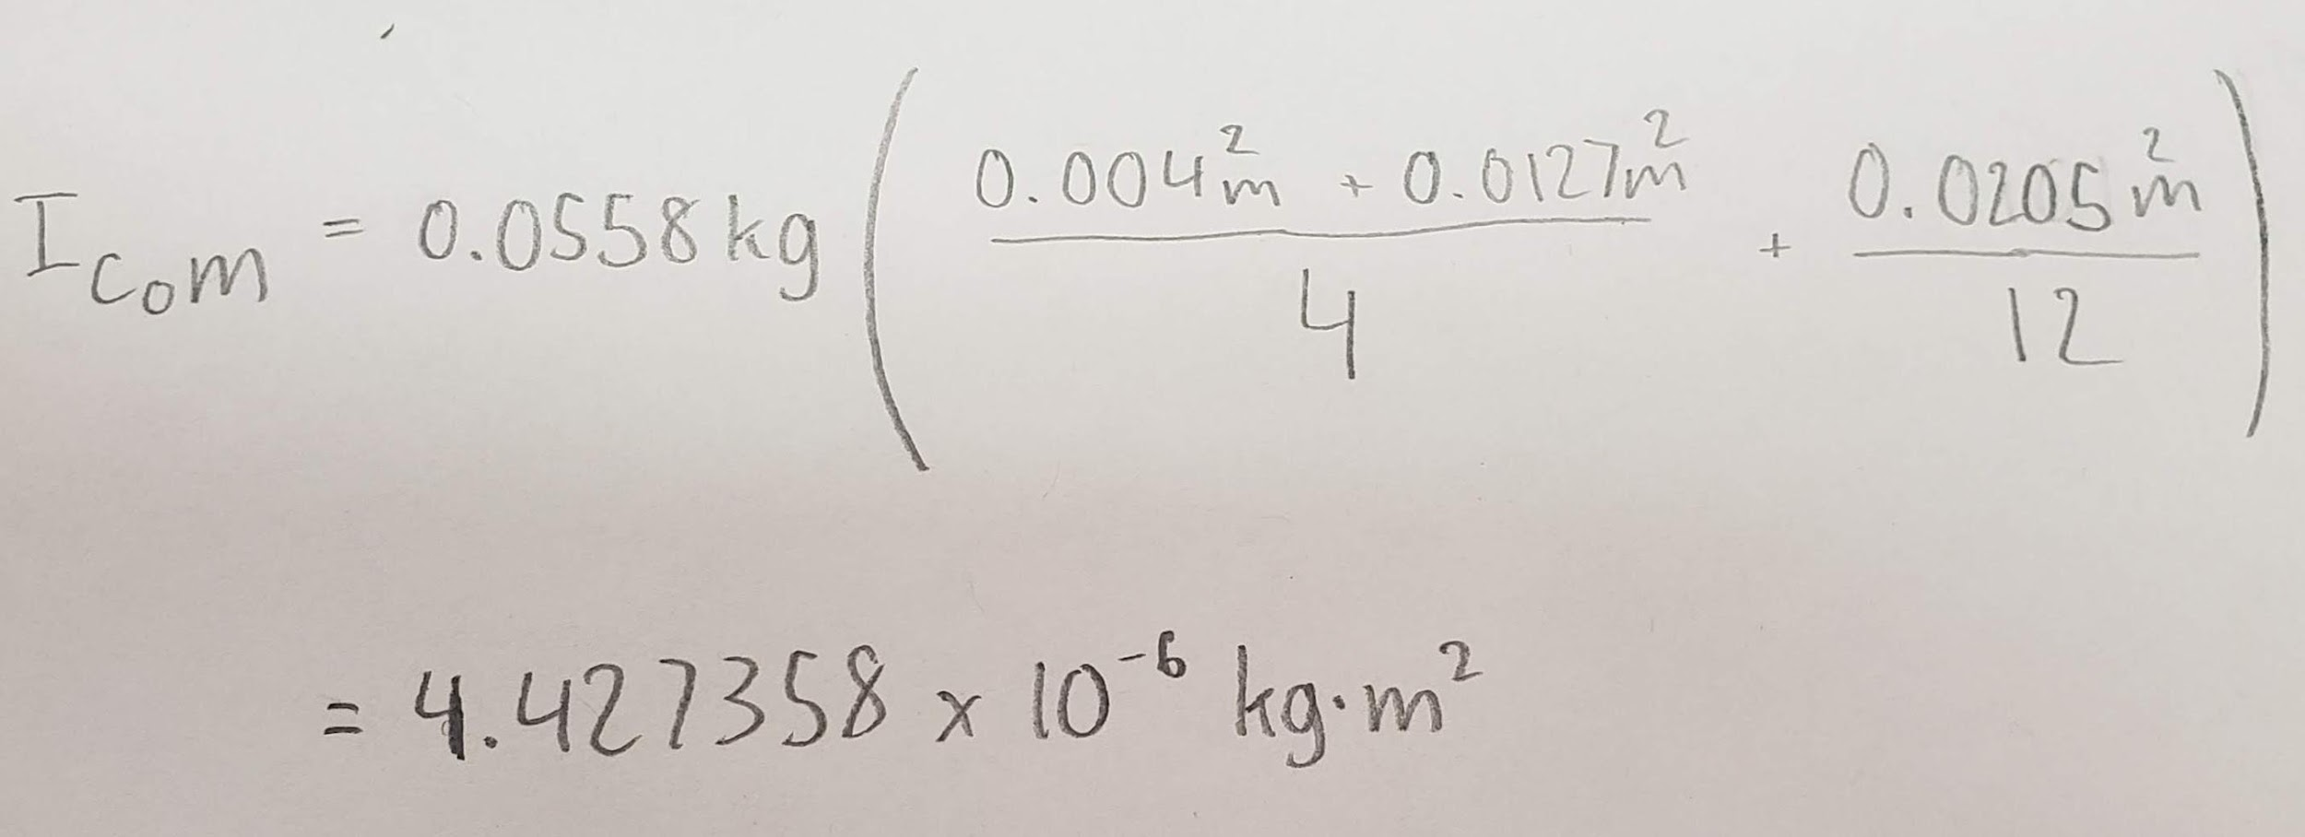
Then using the parallel axis theorem we calculated the total moment of inertia for the system.
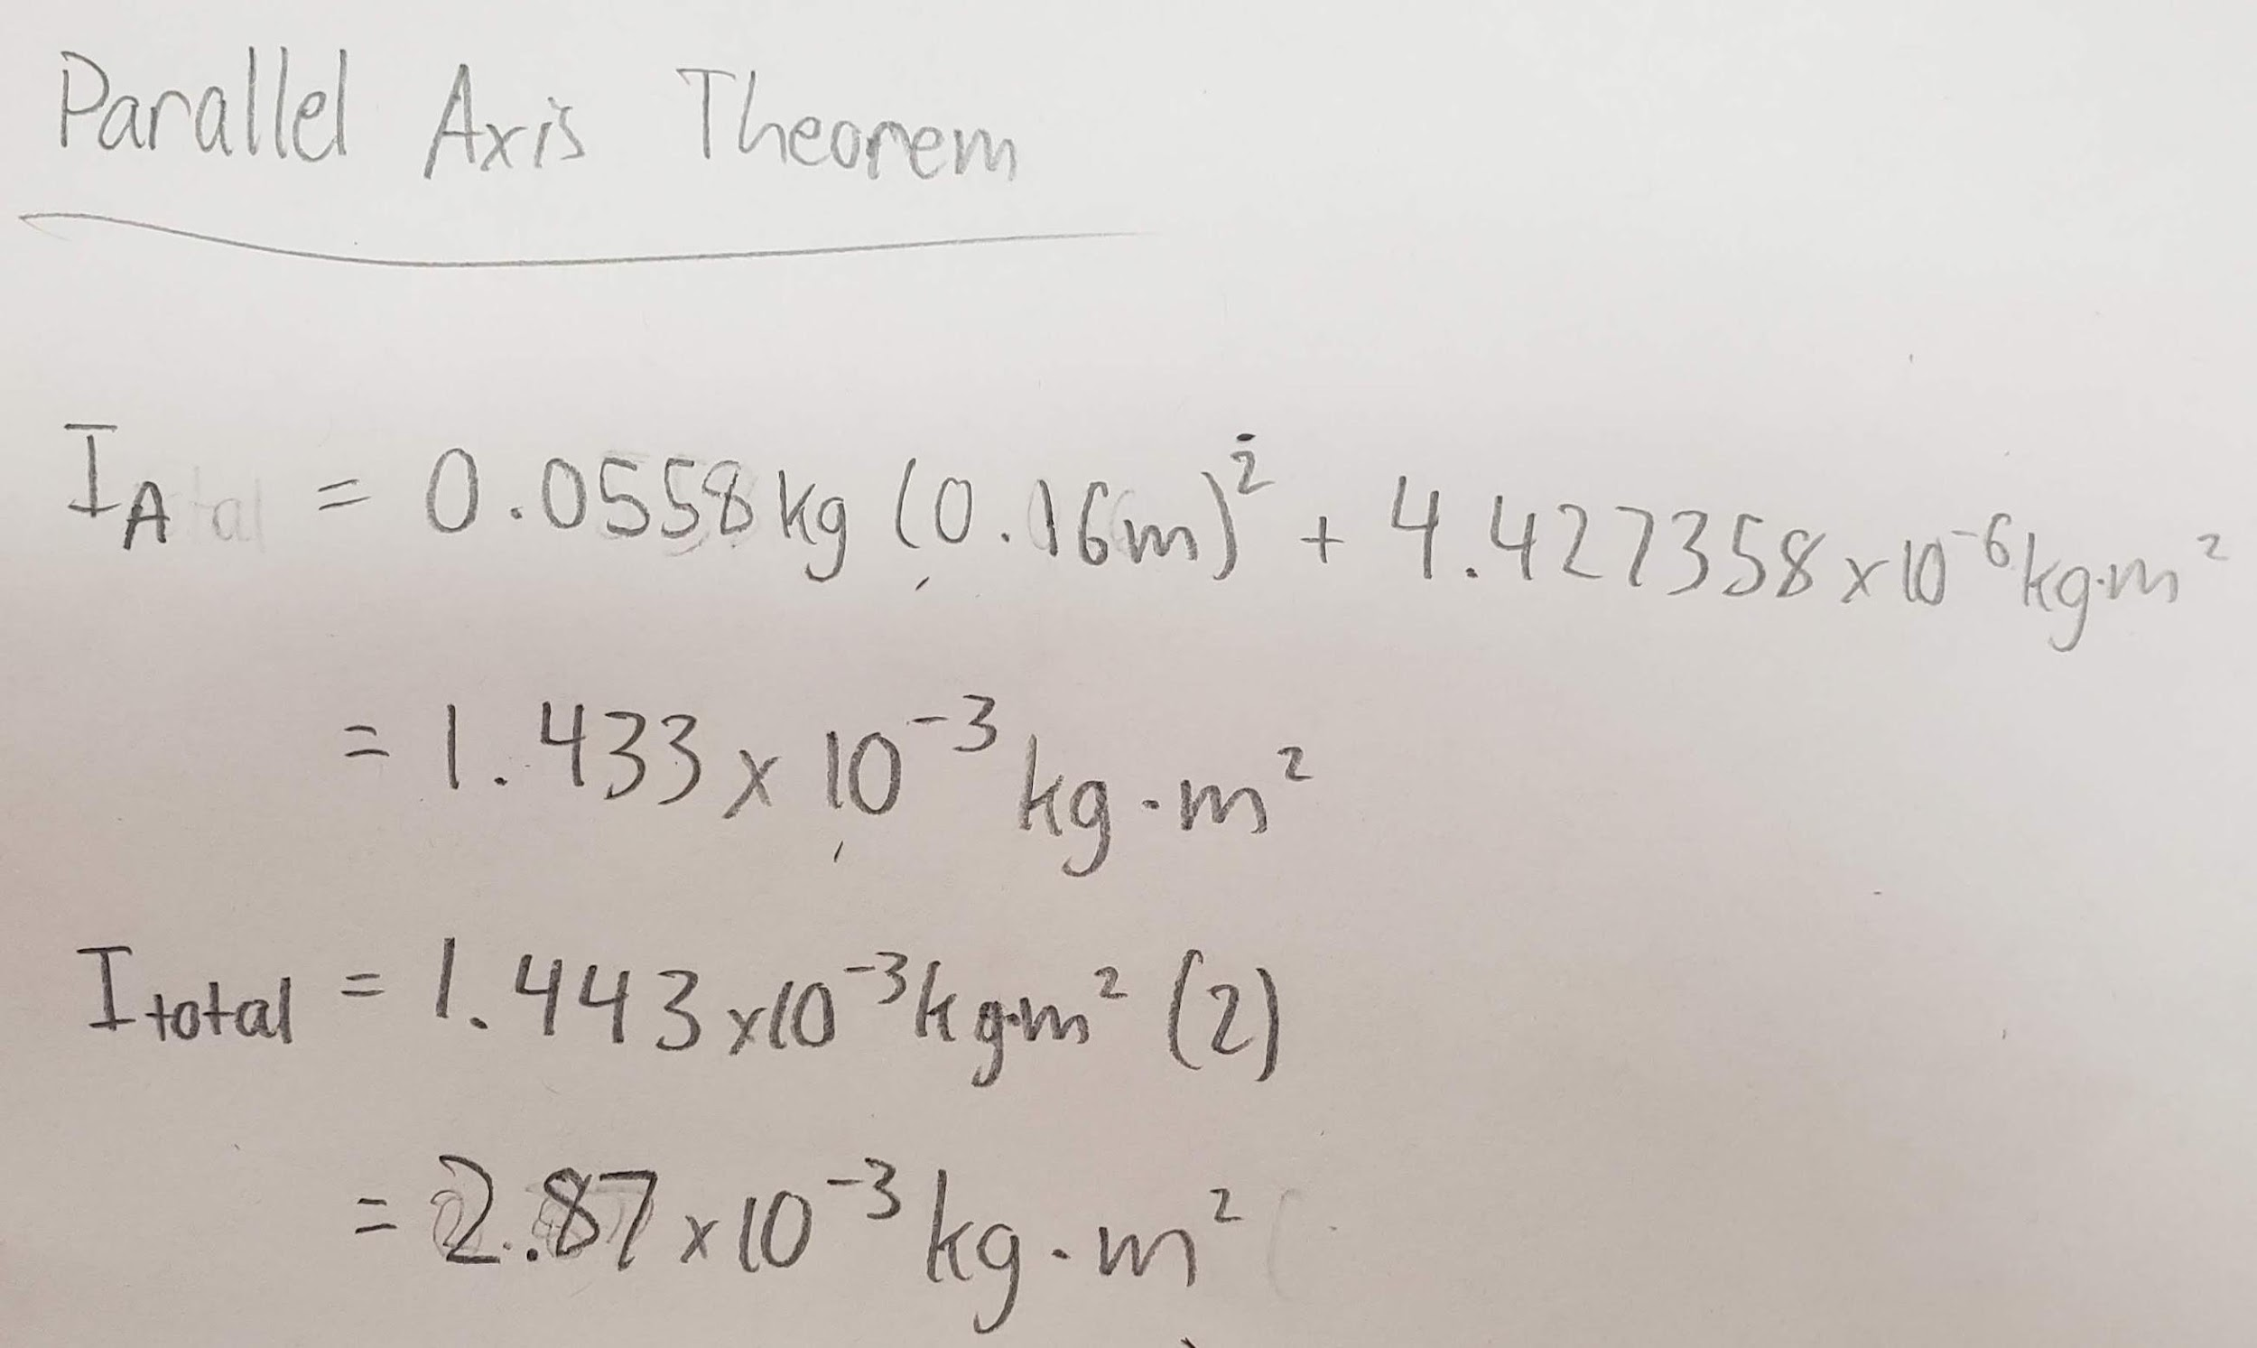
This was the first method used to calculate the moment of inertia for the system, and we will compare this to the other method derived using the concept of the conservation of mechanical energy.
Using capstone we were able to find the peak angular velocity (the bottom of the graph) on capstone which we used for the calculations. Here is an example of that.
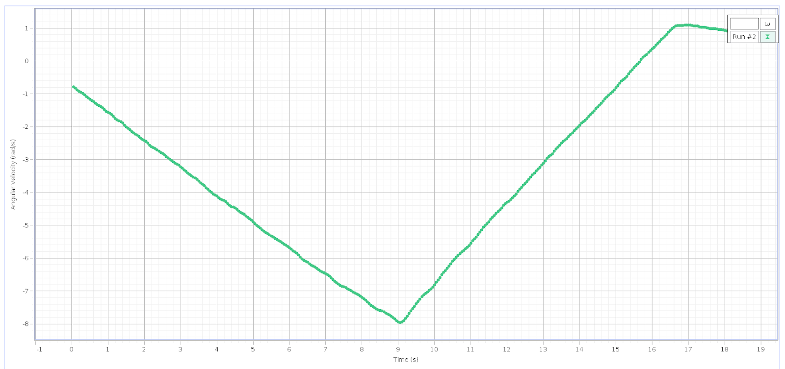
And here is the table of all values collected in terms of omega, which is v/R.

Mass (+/- .001 kg) | (+/- .001 rad/s) | (+/- .001 rad/s)
5 g | -14.268 | -7.956
10 g | -20.188 | -11.097
15 g | -24.507 | -13.497
20 g | -28.216 | -15.533
25 g | -31.460 | -17.293
30 g | -34.325 | -19.068
We then took the values in the table, calculated the moment of inertia for the cylinders with this equation , then took the average, which turned out to be 1.116x10^-3. Compared to the value calculated using the parallel axis theorem which was 2.87x10^-3 the difference is 1.745x10^-3 which is a 60% error. The only explanation I can conceive to explain this error is that our numbers were recorded improperly with capstone due to errors in calibration.
If the cylinders were moved further out it would increase the moment of inertia. The best way to analyze this is with the parallel axis theorem . If the cylinders were moved out the diameter would increase causing the moment of inertia to increase meaning that the velocity would decrease because its more difficult to move. The velocity should exponentially decrease with linear increases in diameter. And inversely the velocity should exponentially increase with linear decreases in diameter.
In conclusion our calculations were off by quite a lot. The error between the value calculated by the parallel axis theorem and value calculated by the momentum conservation theorem was 60%, which is a massive error. The explanation I came up with to explain this error was a error in the calibration of equipment from capstone, which caused the values we observed to be different from the actual values. Using the parallel axis theorem we could conclude that velocity scales inverse and exponentially with diameter, which intuitively makes sense because when spinning in a chair if you concentrate your center of further towards the center you spin faster.

