**Aidan Hopper**

5711 160th Ave East

Sumner, WA, 98390

Phone: 253.985.5876 Email: [aidanhop1@gmail.com](mailto:aidanhop1@gmail.com)

February 2, 2022

Brent Hayward

MuleSoft Company

929 108th Ave NE,

Bellevue, WA, 98004

Dear Mr. Hayward,

I am interested in the internship opportunities offered in the Futureforce University Recruiting program. The listing I am interested in is the Software Performance Engineer internship.

Currently I am a student at Central Washington University pursuing a BS in Computer Science. Throughout my life I’ve aquired a lot of experience in the CS space in common tools, programming languages, and concepts.

I’ve done multiple projects in and out of school including the navigation of data structures and chess in the pygame graphics library. This is why I am a great fit for MuleSoft, because of my strong sense of motivation and passion for CS. With this I can assist MuleSoft in it’s goal to provide distributed systems for cloud-scale software.

I have experience working retail in the past as a Courtesy Clerk then Pickup, both for Kroger. Combined I worked these jobs for two years where I gained a lot of work experience. These jobs taught me basic workplace ettiquite, teamwork, and problem solving.

Thank you for considering my application for the Software Performance Engineer internship. I plan on following up with the Futureforce hiring manager in two weeks reguarding my application. Contact me at 253.985.5876.

Sincerely,

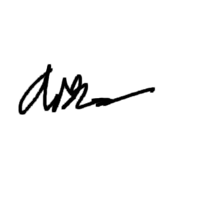

Aidan Hopper

Enclosures: resume