Notes:

- Parent company is SalesForce.

- Aquired MuleSoft for $6B.

- Recruiting division for University students is called Futureforce.

- CEO of MuleSoft is Brent Hayward.

- Provides a Enterprise Service Bus which helps with communication for service oriented software.

- ESB provides a way to intregrate many applications together under one infrastructure.

- Goal is to build and operate distrubuted systems for cloud-scale services.

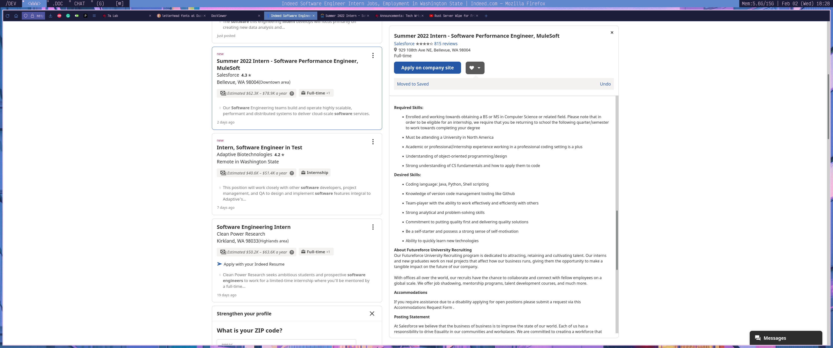**Job Posting**