{% if sig_block_date_field == ‘Today’ %}October 31, 2023{% elif sig_block_date_field == ‘Different Date’ %}{{sig_block_alternate_date}}{% else %}[DATE]{% endif %}

**Via {{addressee_service_methods.true_values()}}{% if addressee_service_methods.true_values()|length < 2 and addressee_service_methods.true_values()[0] == ‘Email’ %} Only{% endif %}**

{{doc.letter_address_block}}

Re: *{{case.short_title}}*; {{court.short_name}} Case No. {{case.nonbreaking_case_number}}

**{{letter_subject_line}}**

Dear {{addressee.salutation(with_name=True)}},

{%p if showifdef(‘doc.letter_type’) == ‘disco_mc_ltr’ %}

{% if include_client_id %}Our office represents {{case.client_plus_short_name_string}}. {% endif %}We write in a good faith attempt to meet-and-confer regarding your client’s discovery responses and in accordance with CCP § 2016.040.[1] {% if mc_ltr.include_separate_statement %}Enclosed, you will find a draft Separate Statement of Items in Dispute setting forth a detailed analysis of the deficiencies of select responses, while the body of this letter will focus on efforts to informally resolve the dispute. {% endif %}Please promptly confirm your receipt of this correspondence{% if mc_ltr.propose_call_or_meeting %}, and allow me to suggest a {{comma_and_list(mc_ltr.propose_call_or_meeting.true_values(), and_string='or').lower()}} to discuss this once you’ve had a chance to review and consider our position. If you’re amenable, please let me know your availability so we can coordinate scheduling{% endif %}.

Background

First, a brief recap of the timing and service of the discovery methods at issue.

{%p for method in methods %}

On {{method.requests_service_date}}, {{method.propounding_parties}} ({{method.propounding_parties_short_ref}}) propounded {{method.full_method}}, Set {{ method.set_no}}, consisting of {{method.number_propounded}} {{method.short_unit_plural}}{% if not showifdef(‘method.interrogatories_type’) == ‘g_frogs’ %} numbered {{method.start_range}}–{{method.end_range}},{% endif %} on {{method.responding_parties}} ({{method.responding_parties_short_ref}}) via {{method.requests_service_method}}.

{%p if method.response_deadline_extensions.there_are_any %}

{%p if method.response_deadline_extensions.number() > 1 %}

Our office granted {{method.responding_parties_short_ref}} {{nice_number(method.number_of_extensions_granted, use_word=True)}} extensions to respond to {{method.full_method}}, Set {{method.set_no}}:

{%p endif %}

{% for extension in method.response_deadline_extensions %}On {{extension.date_granted}}, we {% if not loop.first %}again {% endif %}agreed via {{extension.how_granted.lower()}} to extend {{method.responding_parties_short_ref}}’s response deadline{% if not loop.first %}, this time{% endif %} from {{extension.old_deadline}} to {{extension.new_deadline}}. {% endfor %}

{%p endif %}

On {{method.responses_service_date}}, {{method.responding_parties_short_ref}} served{% if showifdef(‘method.verified’) %} verified{% endif %} responses by {{method.responses_service_method}} consisting of {{method.responses_type}}.{% if method.responses_privilege_claimed %} {% if method. responses_privilege_log_served %}A purported privilege log was served along with the responses.{% else %}Despite the responses’ invocation of privilege, no privilege log accompanied the responses.{% endif %}{% endif %}{% if method.responses_type != ‘objections only’ %}{% if not method.verified %} We received no signed verifications with these responses, and the law is clear that “[u]nsworn responses are tantamount to no responses at all.” (*Appleton v. Super. Ct.* (1988) 206 Cal.App.3d 632, 636; see also *Allen–Pacific, Ltd. v. Super. Ct.* (1997) 57 Cal.App.4th 1546, 1551 [unverified responses are not in “substantial compliance” with the law], disapproved on other grounds in *Wilcox v. Birtwhistle* (1999) 21 Cal.4th 973.){% endif %}{% endif %}{% if method.name.text == ‘Requests for Production’ %}{% if not method.docs_were_produced %} No documents or ESI were produced.{% else %}

{% if method.doc_production_full_partial != ‘unclear’ %}{{method.responding_parties_short_ref}} made a {{method.doc_production_full_partial}} production of the documents via {{method.doc_production_manner}}{% if method.doc_production_manner[‘Other’] %}and {{method.doc_production_manner_other}}{% endif %}.{{production_description}}{% endif %}

{% if method.doc_production_full_partial == ‘unclear’ %}It was not clear from the responses whether the document production to date is full and complete, or if it is a partial production, with more to come. We request clarification on this point.{% endif %}{% endif %}{% endif %}

{%p if method.responses_untimely %}

{{method.responding_parties_short_ref}}’s responses were due to be served on xxx, and are thus untimely. Unless {{method.responding_parties_short_ref}} affirmatively moves for relief, the law is clear that all objections, including those based on privilege or work product protection, are deemed waived. (§§ 2030.290(a), 2031.300(a); *Leach v. Super. Ct.* (1980) 111 Cal.App.3d 902, 905-906; *Brown v. Super. Ct.* (1986) 180 Cal.App.3d 701, 712 [even Fifth Amendment protection is waived by failure to timely object].)

Please be aware that {{method.responding_parties_short_ref}} may only obtain relief from {{method.responding_parties.pronoun_possessive(‘’)}} waiver of objections by noticed motion. (§ 2030.290(a); see also Weil & Brown et al., *Cal. Prac. Guide: Civ. Pro. Before Trial* (The Rutter Group 2023) ¶ 8:1033 [“Noticed motion required: A noticed motion for relief from waiver is required [i.e.,] such relief cannot be granted ex parte, or where the only motion pending is a motion to compel.”] [Int. punct. omitted.])

{{method.responding_parties_short_ref}} must immediately serve substantive responses without objection to {{method.propounding_parties_short_ref}}’s {{method.full_method}}, Set No. {{method.set_no}}.

{%p endif %}

{%p endfor %}

{%p if not mc_ltr.include_separate_statement %}

Discovery Deficiencies

{%p for method in methods %}

**{{ method.full_method }}, Set No. {{ method.set_no }}**

Of the {{method.number_propounded}} {{method.full_method.lower()}} propounded, {{nice_number(method.number_of_challenged_responses, use_word=True)}} of {{method.responding_parties_short_ref}}’s responses fail to comply with the Discovery Act for the reasons detailed below. The noncompliant responses are numbers {{comma_and_list(method.list_of_challenged_response_numbers)}}.

{%p for ncr in method.ncr %}

**{{ method.short_unit_singular | capitalize }} No. {{ ncr }}:**

*{{ncr.question}}*

**Response:**

*{{ncr.answer}}*

**Reasons to Compel Further Response:**

The response fails to comply with the Discovery Act and is deficient for the following reasons:

{%p for deficiency in ncr.deficiencies.true_values() %}

{%p if dataloader.load_row(to_int(deficiency))["Summary"] != ‘’ %}

{{r dataloader.load_row(to_int(deficiency))["Summary"] | inline_markdown }}

{%p endif %}

{{r dataloader.load_row(to_int(deficiency))["Blurb"] | inline_markdown }}

{%p endfor %}

{%p if ncr.add_custom_critique %}

{{ ncr.custom_critique }}

{%p endif %}

{%p endfor %}

{%p endfor %}

{%p endif %}

Proposed Resolution

We have no desire to engage in law and motion, and our firm faithfully adheres to our meet-and-confer obligation to “talk the matter over, compare . . . views, consult, and deliberate”[2] in a good faith effort to resolve discovery disputes. To that end, if you know of any legal authority or persuasive argument contrary to the deficiencies we’ve identified, please forward it promptly to my attention, and I will thoroughly review and carefully consider it.

{%p if mc_ltr.proposal_list.any_true() %}

We are earnest in our desire to resolve this matter without wasteful litigation. As long as we can procure the discovery to which our client is entitled, we are willing to consider {{mc_ltr.proposal_list.true_values()}} along with any reasonable compromise you may propose.

{%p endif %}

Meet-and-Confer & Litigation Timing

We request that you do the following:

1. Email me back at your next reasonable opportunity to confirm you’ve received and are considering this letter;
2. Not later than {{mc_ltr.response_deadline}}, respond in writing to this letter with specific and on-point legal authority in support of any contrary position you may hold, or else serve verified, code-compliant further responses to our client’s {{methods}} that cure each of the deficiencies pointed out in {% if mc_ltr.include_separate_statement %}the separate statement accompanying {% endif %}this letter;
3. {%p if mc_ltr.request_to_extend_MTC_deadline %}
4. Confirm an agreement to continue § 2031.310(b)’s 45-day Motion to Compel deadline until {{mc_ltr.proposed_MTC_extension_deadline}} in order to give the parties sufficient time to confer on these issues.
5. {%p endif %}

We’re hopeful that reasonable minds will come to an agreement here, and we look forward to a cooperative and successful resolution of this matter.

{%p else %}

xxxxx.{% if showifdef(‘letter_attachment_choice’) == ‘include_enclosure_line’ %}

Enclosed for your review {{to_oxford_comma_or_bulleted_list(enclosure_list)}}{% endif %}

{%p endif %}

Cordially,

{%p if doc.sign %}

{%p if not set_AID_as_author %}

{{user_signature}}

{%p else %}

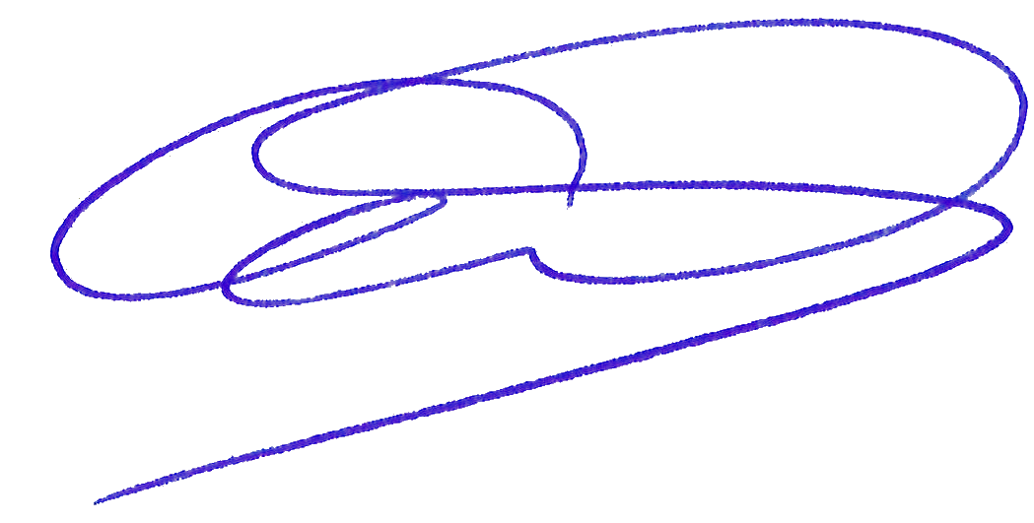

{%p endif %}

{%p endif %}

{{author[0].name.full()}}

{{title_case(author[0].law_firm_role)}},

{{author[0].law_firm}}

{%p if showifdef(‘letter_attachment_choice’) == ‘include_enclosure_line’ %}

Enclosure(s):

{{';\\n'.join(validate_and_correct_delimiters(enclosure_list).split('; '))}}

{%p endif %}

{%p if showifdef(‘letter_attachment_choice’) == ‘include_enclosure_line’ and include_cc_recipients %}

{%p endif %}

{%p if include_cc_recipients %}

cc:

{%p for recipient in letter_cc_recipients %}

{{recipient}}{% if not loop.last %};{% endif %}

{%p endfor %}

{%p endif %}

1. . All unspecified statutory citations below are to the California Code of Civil Procedure.
2. . *Ellis v. Toshiba Am. Info. Sys., Inc.* (2013) 218 Cal.App.4th 853, 880 [internal quotes and punctuation omitted].)