COMP1312 (Sem1 CW): Banking System in C

Installation Guide
- Install ‘banking_system_azck1e25.zip’
- Unzip the file into an accessible directory in your computer.
- Leave all files within the unzipped ‘banking_system_azck1e25’ directory.
- Within the ‘src’ directory, you should see ‘main.c’
- Compile ‘main.c’ using a C compiler and store the executable file inside ‘src’.
- Run ‘main.exe’.

Diagram of File Structure

Usage Instructions
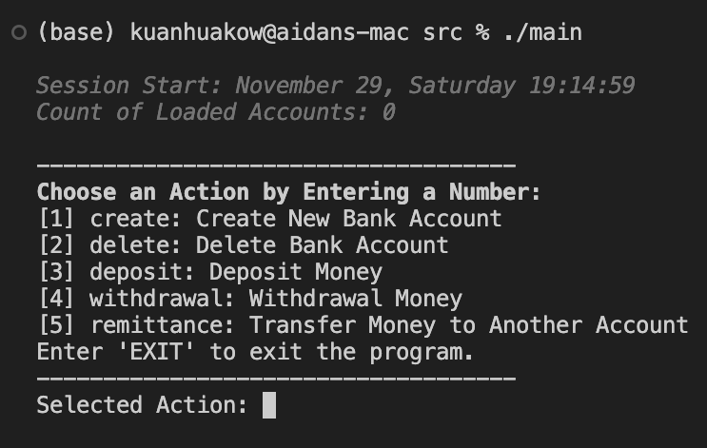
Menu:
- The menu UI will appear on execution of ‘main.exe’.
- Enter either the corresponding command or number to select an action.

Create an Account:
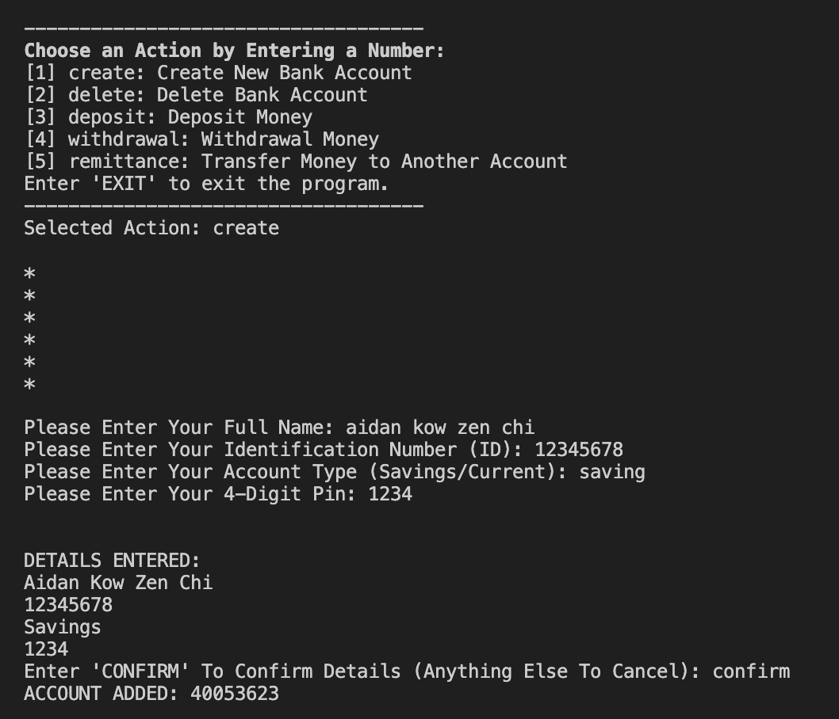
- Entering ‘create’ (case-insensitive) or ‘1’ will allow you to create an account.
- Within the following input fields, you must enter:
- Their full name.
- Their UoSM ID (8 numerical digits).
- The desired account type – entering ‘saving’, ‘savings’ or ‘current’ (case-insensitive).
- A 4-digit pin
- You are then re-displayed, and asked to confirm, the information you just entered.
- Typing ‘confirm’ (case-insensitive) will create an account with the given details.
- Entering anything else into the input field will cancel the action.
- You will be assigned a randomly generated 7-9 digit bank account number, once the account has been created.

Delete an Account:
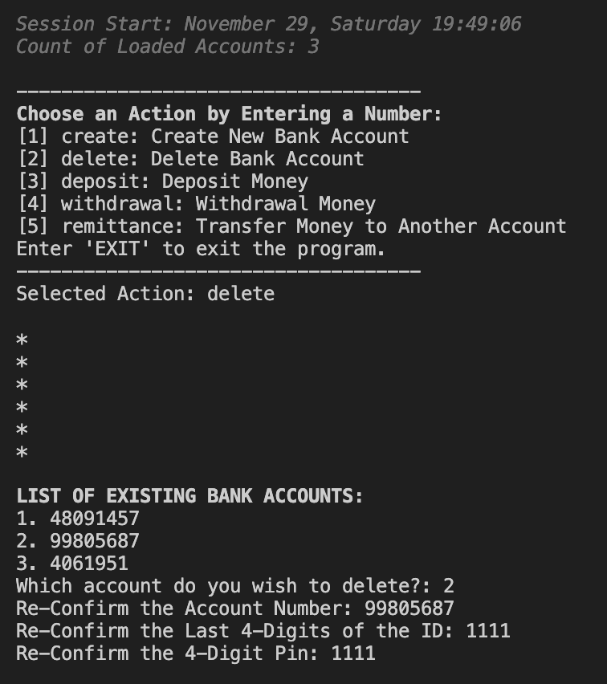
- Entering ‘delete’ (case-insensitive) or ‘2’ will allow you to delete an account.
- If there are accounts in the database, the program will display you a list of the accounts that exist.
- Enter either the account number (e.g.: 99805687), or the list number (e.g.: 2), of the account you want to delete.
- The program will then verify your identity by asking you to enter:
- The bank account number.
- The last 4 digits of your UoSM ID.
- Your 4-digit pin.
- Once all these credentials match, the account will be deleted.

Deposit Money into an Account:
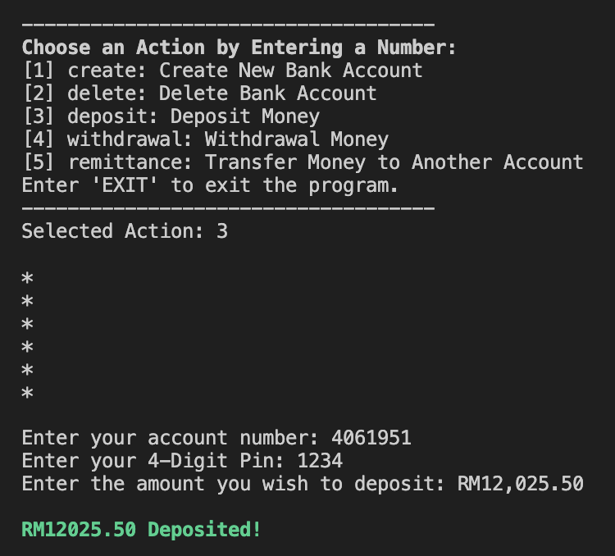
- Entering ‘deposit’ (case-insensitive) or ‘3’ will allow you to deposit money into an account.
- The program will prompt you to enter the account number of the bank account you want to deposit money into.
- You will then be required to enter the 4-digit pin of that account.
- Once the correct pin is entered, you will be asked the amount you want to deposit into the account.
- Amounts must be ≤ 50,000 or ≥ 0.
- Commas (‘ , ‘) are ignored, hence entering 12,000 and 12000 will both result in a deposit of RM12,000.

Withdrawing Money from an Account:
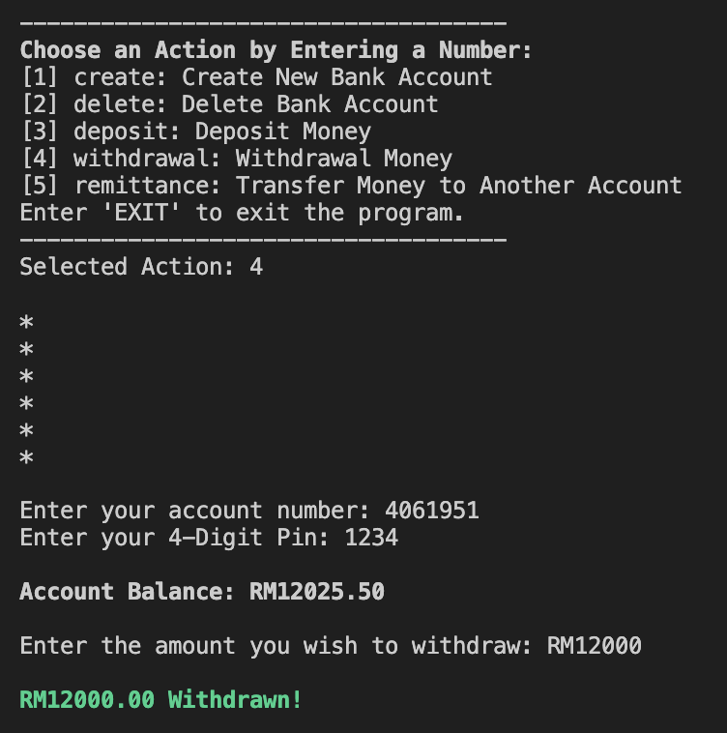
- Entering ‘withdrawal’ (case-insensitive) or ‘4’ will allow you to withdraw money from an account.
- The program will prompt you to enter the account number of the bank account you want to deposit money into.
- You will then be required to enter the 4-digit pin of that account.
- Once the correct pin is entered, you will be displayed your account balance, and asked the amount you want to withdraw from the account.
- You can only withdraw an amount ≤ your current balance.
- Commas (‘ , ‘) are ignored, hence entering 12,000 and 12000 will both result in a withdrawal of RM12,000.

Remittance to an Account:
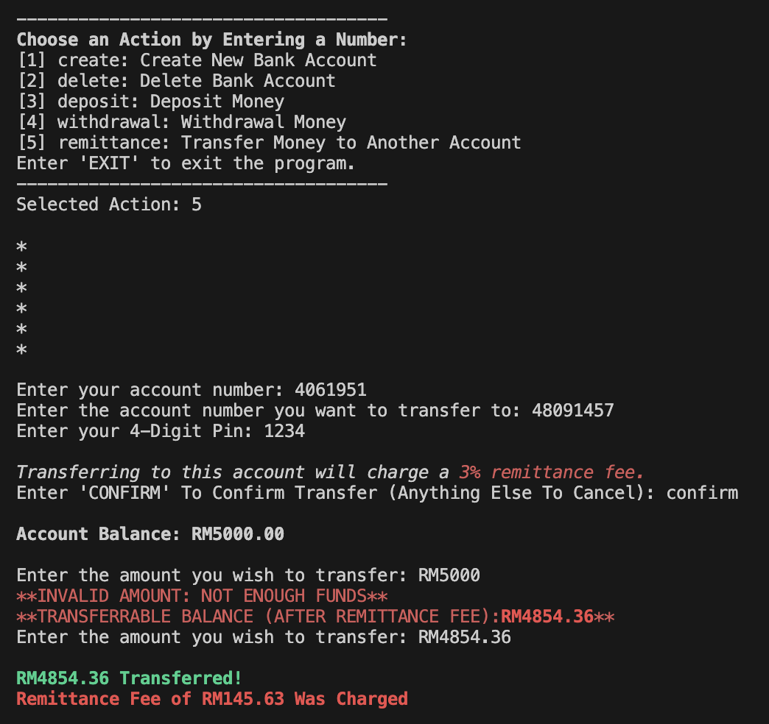
- Entering ‘remittance’ (case-insensitive) or ‘5’ will allow you to remittance to an account.
- You will be prompted to enter the account you want to send money from, then a different account you want to send the money to.
- You will also be asked to verify your 4-digit pin.
- Once the pin is correctly entered, you will be displayed your account balance, and asked the amount you wish to transfer.
- You can only withdraw an amount ≤ your current balance (including the cost of the remittance fee).
- Depending on the account types of both bank accounts, there may be a remittance fee charge.
- If the sender is a ‘Savings’ account and the receiver is a ‘Current’ account, a 2% remittance fee will be charged.
- If the sender is a ‘Current’ account and the receiver is a ‘Savings’ account, a 3% remittance fee will be charged.
- The program will ask you to confirm if you are agree to pay these charges, by asking you to enter ‘confirm’ (case-insensitive).
- The remittance fee will then be deducted from your account.

