Malaysian Market (KLSE Screener) Tracker
Website Link: www.klsescreener.com/v2/markets
Unix Script for Data Collection
web-scraper.sh
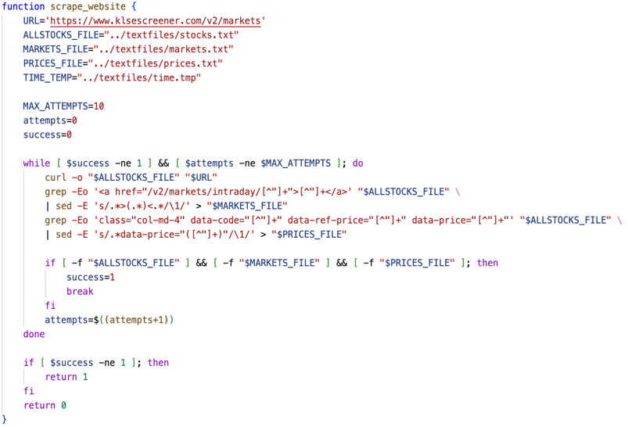
The scrape_website function curls the raw HTML from the KLSE screener website and stores it in stocks.txt. Looking at the HTML tags, I found that market names were stored in an <a> tag, in the format:
<a href="/v2/markets/intraday/(market code)">(market name)</a>,
so I used a regular expression pattern and grep to find all strings that fit this format, then used sed to write only the market names into markets.txt. The same process is used to find the market prices, which are stored in the HTML code in the format: class="col-md-4" data-code="(data code)" data-ref-price="(market average/expected price)" data-price="(current market price)", to get the current market price and store it in prices.txt.
For error handling in this process, after the market names and prices are attempted to be fetched, the files are checked if they exist in the directory. If they are, that means the program fetched the data successfully, the success variable is set to 1 and the while loop is broken – causing the function to return 0 (exit code 0). Otherwise, the entire process is repeated until maximum attempt of 10 is reached. By the end of the 10 attempts, if the files are not created in the directory, and the process has failed, the function will return 1 (exit code 1). This error handling is necessary, in the event the website is down or if there’s no internet connection.

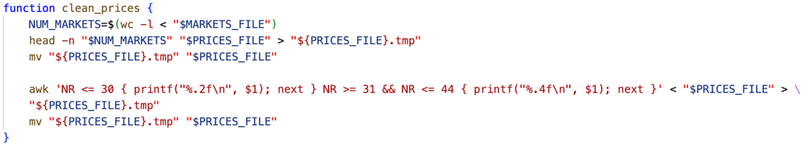
The clean_prices function gets the number of lines in markets.txt, then uses that number to trim prices.txt to map the markets to their prices 1-to-1. This is necessary, as before this, prices.txt stored extra info scraped from the website that wasn’t needed. In prices.txt, the first 30 markets were stocks and commodities (prices rounded to 2dp) and the last 14 markets were foreign exchange (currency exchange rates rounded to 4dp). These prices were formatted according to their line number.
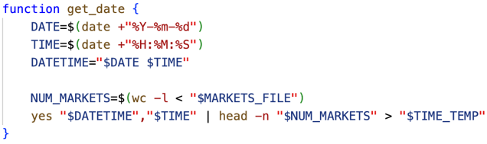
The get_date function uses the date command to get the current date and time, in the formats YYYY-MM-DD and HH:MM:SS. It then combines them into a datetime type for the purpose of plotting and SQL storage. Both the datetime and time is repeated for the number of lines equal to the number of markets, into time.tmp. This is so that each line maps to markets.txt – making it easier to combine the files later to store the correct data.
The time is appended after datetime, simply for the purpose of checking whether the markets are open. The code for this can be seen in insert-data.sh.
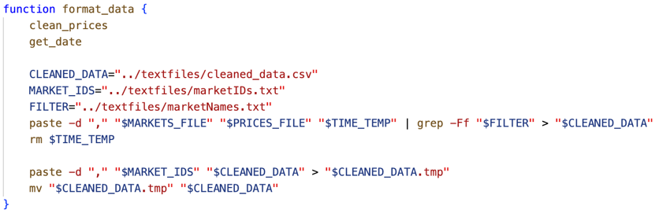
The format_data function calls the clean_prices and get_date functions, and writes all the required data into the main data file: cleaned_data.csv, and removes the temporary time.tmp file. I manually created a marketNames.txt to use as a filter – so that only the 14 markets I specified are fetched. I also manually created marketIDs.txt, containing the IDs of each market, which will be used to identify them in the MySQL database. The csv file contains data in the format: MarketID,MarketName,Price,Datetime,Time.
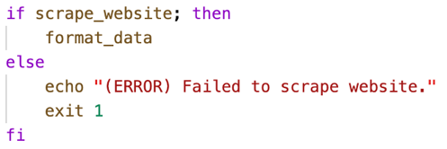
This final conditional statement is essentially the main error handling code block for this shell script. It attempts to scrape the website (calling the scrape_website function). If it succeeds, it calls format_data. Otherwise, the script exits with code 1 (unsuccessful).

MySQL for Data Storage
Entity Relationship Diagram (ERD) of MySQL database:
Within my database, each market has its own dedicated table, storing information on each plot – specifically its MarketID, which is a foreign key of the Markets table, and the price level and timestamp of a given plot. The primary key of each market table is an AUTO_INCREMENT INTEGER, called DataPointID – so that each plot is easily identifiable; the first plot will have ID 1, the second plot will have ID 2, etc. The Markets table serves as a list of all markets, storing their market IDs, names, and the name of the graph for that market (e.g.: CPO-graph.png).

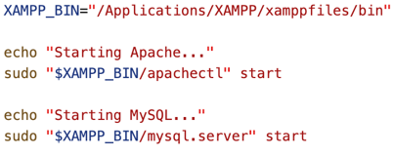
start-database.sh
This shell script is extremely short – it simply starts the MySQL database and Apache server. Alternatively, the servers can be started using the XAMPP application itself, or by simply running the commands in the terminal directly.

create-database.sh
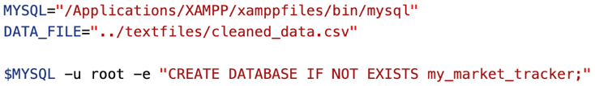
For readability, and ease of modification for other programmers, the file path of the MySQL client within my computer is assigned to a constant called MYSQL. The same is done for the cleaned_data.csv, which will be used to insert the scraped data into the MySQL database. A MySQL query to create the database ‘my_market_tracker’ (Malaysian Market Tracker) is run – with -u root (the MySQL superuser) and -e ‘execute’ the following SQL query.
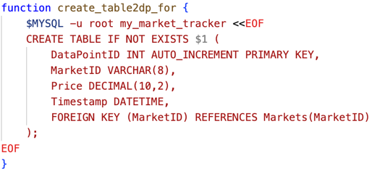
The create_table2dp_for function is used to create the tables for the non-forex markets which store prices in 2 decimal places. It defines DataPointID an auto-increment integer primary key, and defines the other relevant attributes, such as the MarketID, Price, and Timestamp, and creates a foreign key constraint, declaring MarketID as a foreign key from the Markets table.
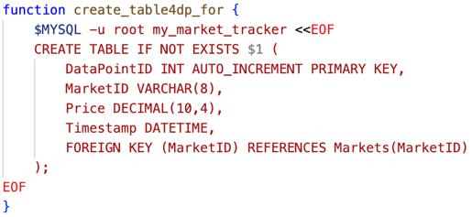
The create_table4dp_for function is used to create the tables for the forex markets which store prices in 4 decimal places. It defines DataPointID an auto-increment integer primary key, and defines the other relevant attributes, such as the MarketID, Price, and Timestamp, and creates a foreign key constraint, declaring MarketID as a foreign key from the Markets table.
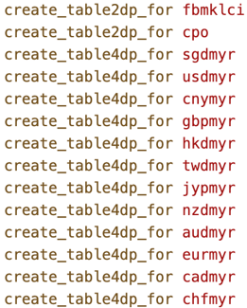
This block of code calls the create_table2dp_for function for the FTSE Bursa Malaysia KLCI market (FBMKLCI), as well as the Crude Palm Oil (CPO) market, then calls the create_table4dp_for function for the following forex markets: SGD/MYR, USD/MYR, CNY/MYR, GBP/MYR, HKD/MYR, 100 TWD/MYR, 100 JYP/MYR, NZD/MYR, AUD/MYR, EUR/MYR, CAD/MYR, and CHF/MYR. I chose all these markets from KLSE Screener as these are all the markets that have prices listed in MYR (Malaysian Ringgit), rather than other currencies. They all therefore relate to the Malaysian market – hence, the name “Malaysian Market Tracker”.

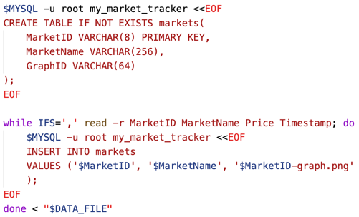
The first block of code executes the MySQL query to create the Markets table – defining the attributes: MarketID (primary key) MarketName and GraphID (name of the graph.png). The next code block iterates through cleaned_data.csv, declaring the Input File Separator (IFS) as a comma (‘ , ‘), to read the CSV values. It inserts the MarketID, MarketName and (MarketID)-graph.png for each market as a record in the markets table. This fills the Market table with all the markets being tracked by the program.
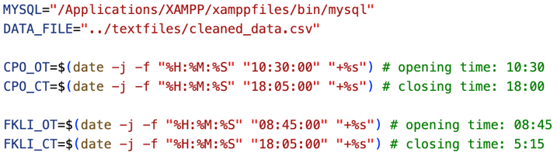
insert-data.sh
These constants specify the Crude Palm Oil and FBMKLCI market opening and closing times (rounding up to the next hour, and adding 5 extra minutes – to give leniency for the program to fetch the last price at the market closing time).
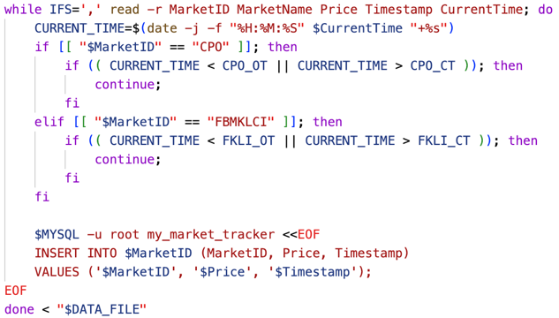
This code block iterates through cleaned_data.csv, fetches the different fields, and assigns the values to the variables: MarketID, MarketName, Price, Timestamp and CurrentTime. It uses the CurrentTime to check if the data fetched is between the market’s opening and closing times – meaning the market is open. This is to prevent the repeated price values from being fetched when the market is closed. This is only done for the Crude Palm Oil and FBMKLCI markets, as these are the only markets which have closing times. The other 12 markets are all foreign exchange, meaning they operate 24/5 (closed on weekends). After this check is done, if the current market is open, it will insert the data into the corresponding table in the database. If it is closed, it will skip the current iteration and repeat the check for the next market.
Unix Script for Plotting
plotter.sh
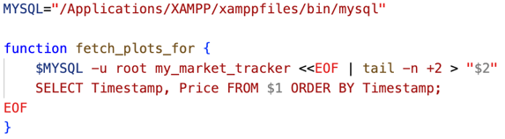
The fetch_plots_for function selects the Timestamp and Price of each record from a table (given as an argument) and orders the data by Timestamp – with the earliest timestamp first, and the most recent timestamp last.
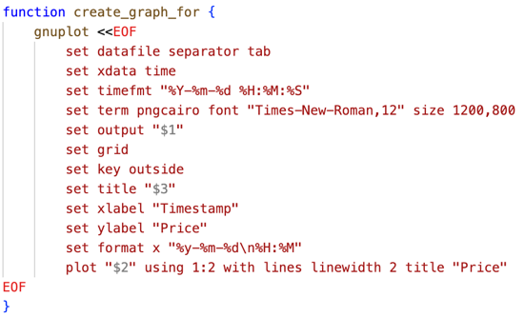
The create_graph_for function uses the gnuplot command to create the graph for a given market (given as an argument). It reads from a .dat file (stored in the plots folder), and sets the x-axis to time, in the format: YYYY-MM-DD HH:MM:SS – and the y-axis to the price. A .png file will be created in the graphs folder, named after the GraphID of the corresponding market, as per in the database. The labels and titles are also added, along with a grid, and the key set outside.

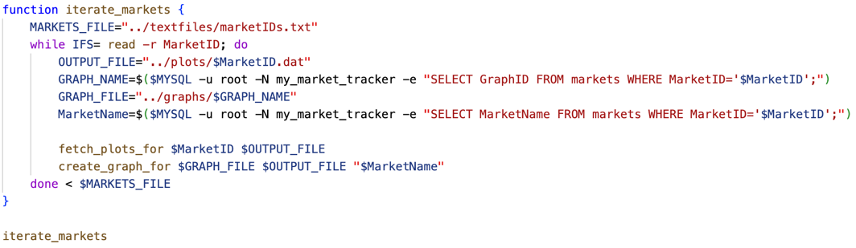
The iterate_markets function reads the marketIDs.txt file to get the MarketIDs of each market, which is then used to get the MarketName, as well as GraphID, by using MySQL queries. These values will be passed in as arguments to the fetch_plots_for and create_graph_for functions – which are called in this function.

tracker.sh
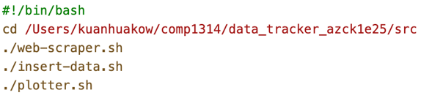
This shell script runs the web-scraper.sh, insert-data.sh, and plotter.sh shell scripts – to fetch, store, and create a graph for the data – once the tracker.sh script is run. This was used for
my crontab, which scraped data every hour, on weekdays. (all stock and forex markets are closed on weekends)

Use of Git for Version Control:
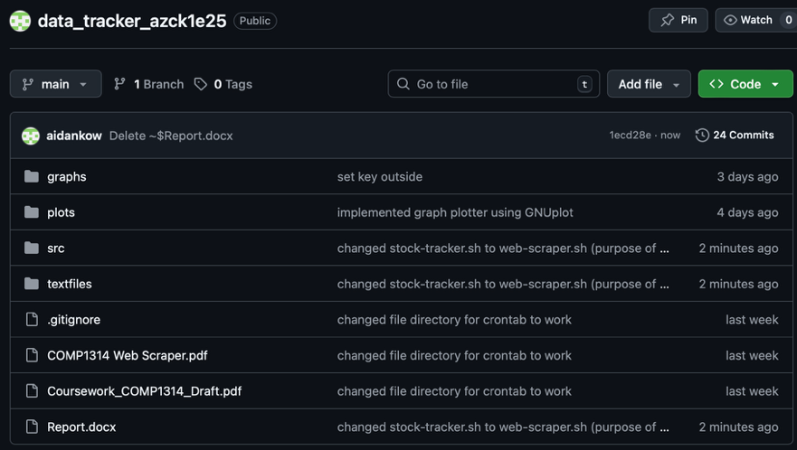
During my development of this project, I frequently committed to GitHub, to keep track of the version history of the program. On a few occasions, I resorted to using a previous version that I committed to GitHub to rewind changes made to the code – which allowed me to have a safety net to fall back on when experimenting on code. I also added fitting commit messages to most of my commits, so that documentation of my progress and reasons for code changes was clear. I uploaded all necessary folders, files and scripts to GitHub, so that the entire project was publicly accessible. In total, there were 24 commits over a 2-week period.

