Aidan Leuck

CS 230 Challenge 4 Email Harvester

Results:

https://www.boisestate.edu/coen-cs/people/faculty

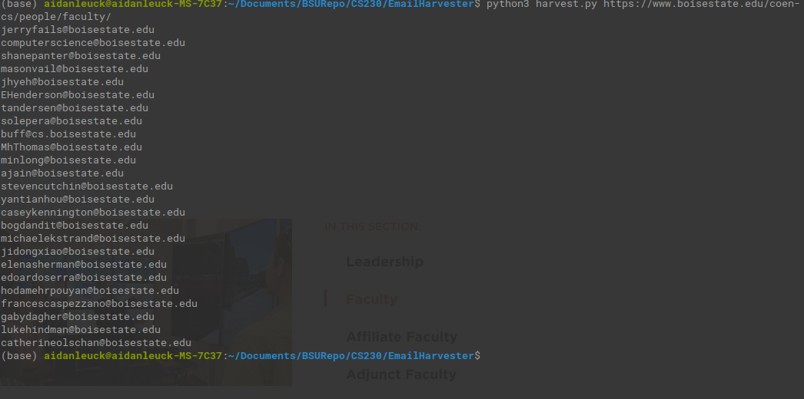
http://www.bgibson.com/Company/Staff-Directory

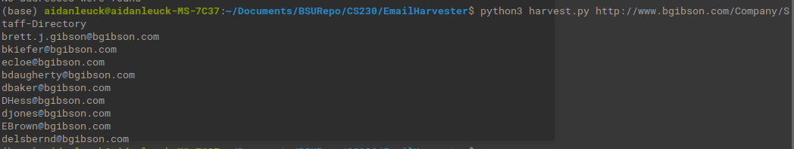
https://www.cl.cam.ac.uk/~bjc63/

https://www.cl.cam.ac.uk/~jac22/

https://www.cl.cam.ac.uk/~ah793/
https://www.cl.cam.ac.uk/~ad260/
https://sites.google.com/view/jinghan/contact
http://miguelballesteros.com/

I did struggle with this assignment a little, but by the end I was able to successfully get 6/8 websites email addresses harvested. The reason I struggled with this so much is that I do not have a ton of experience with regular expressions. I have dabbled here and there, but nothing to this degree. For this reason, I spent a lot of the time figuring out how regex worked. Once I had figured it out it wasn’t too difficult besides doing Anuj Dawar’s address. It took a lot of different steps such as removing html tags and attributes in order to put the email back together. Eventually I was able to do it, but I basically had to write a separate function in order to handle Dawar. As for the two that I was not able to harvest, I believe that in order to gather their addresses I would have to write some kind of AI rather than just using regex. An AI would have to understand what an email address is and what makes it valid. I think I would have to write an AI on these two because Jon Crowcroft repeats his email address in the form of a link. Using regex it would have no idea that the parts of the address was repeated, for example the output from a regex would probably look something like Jon.Crowcroft@cl.cam.cl.cam.ac.uk. This is because the link also includes the cl.cam part as well. A human would be able to discern this, but regex would not. I would also use an AI for Miguell’s because he does [firstname][lastname]1@gmail.com. Regex would not know what the correct firstname and lastname are, but an AI who had knowledge of naming might be able to find a name on the website and then interpolate the address. Overall, I really enjoyed this assignment and I gained some valuable knowledge about Regex.

