Task 2: Test log
Description of test | Test data to be used (if required) | Expected outcome | Actual outcome | Comments and intended actions
Testing to see if the “Rolsa” logo button sends the user to the correct place |  | The user should be redirected to the “home” page | The user is redirected to the home page. | No intended actions.
Testing to see if the “energy usage” button in the navigation bar sends the user to the correct place. |  | The user should be redirected to the “energy-usage” page | The user is redirected to the “energy-usage” page | No intended actions
Testing to see if the “carbon footprint” button in the navigation bar sends the user to the correct place. |  | The user should be redirected to the “carbon-footprint” page | The user is redirected to the “carbon-footprint” page | No intended actions
Testing to see if the “Installations and consultations” button in the navigation bar sends the user to the correct place. |  | The user should be redirected to the “installations-and-consultations” page | The user is redirected to the “installations-and-consultations” page | No intended actions
Testing to see if the “Green energy products” button in the navigation bar sends the user to the correct place. |  | The user should be redirected to the “green-energy-products” page | The user is redirected to the “green-energy-products” page | No intended actions
Testing to see if the “Log in” button in the navigation bar sends the user to the correct place. |  | The user should be redirected to the “log-in” page | The user is redirected to the “log-in” page | No intended actions
Testing to see if the “sign up” button on the sign in page sends the user to the correct place |  | The user should be redirected to the “sign-up” page | The user is redirected to the “sign up” page | Works as intended, no intended actions.
Testing that once on the “sign-up” page, the user is sent to the correct place if they select the “log in” button on the form |  | The user should be redirected back to the “log-in” page | The user is redirected back to the “log-in” page | No intended actions.
Testing to see if the “calculate carbon footprint” button on the “carbon-footprint” page sends the user to the correct place |  | The user should be redirected to the “carbon-footprint-calculator” page | The user is redirected to the “carbon-footprint-calculator” page | No intended actions.
Adding data into the “tblProduct” table in the database | Product data | This data should be put into the table with no issues | Test1: The data was not put into the table and had issues  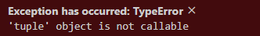  Test2: The data was not put into the table and I got the same issue | Test 1:  I plan to check online sources to see if I have executed the data into the table correctly.  Test 2:  The code I had written was correct.  Found that I hadn’t added commas between each row of data.  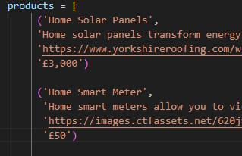  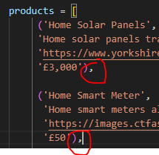
Testing that data from the sign-up page is sent to the database | Firstname: test  Surname: 1  Email: test@gmail.com  Password: test123 | Once the submit button “sign-up” is selected the data should be inputted into the database table “tblCustomer” and the user should be redirected to the “log-in” page | The user sent to the “log-in” page and the data is sent to the database table “tblCustomer” and stored under a new unique “customerID” | Works as intended.  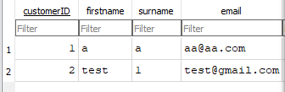
Testing that the sign-up page does not allow users to enter an email that exists in the database | Firstname: test  Surname: 1  Email: test@gmail.com  Password: test123 | Once the submit button is selected, an error should be outputted, displaying to the user that the email already exists. | Once the submit button is selected an error is displayed to the user saying “An account using this email already exists.” | Works as intended  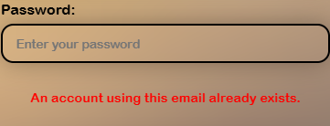
Testing that data is NOT inputted into the database if the user inputs an email that already exists in the database | Firstname: test  Surname: 1  Email: test@gmail.com  Password: test123 | Once the submit button is selected, an error will display and the data will not be inputted in to the database. | Once the submit button is selected, the error appears and the data is NOT inputted into the database | Works as intended.
Testing that the button on the navigation bar appears as “Account” instead of “Log In” when the user is logged in |  | The button should display “Account” because I (the user) am logged in | The button does display as “account” | Works as intended, no actions
Testing that the “Account”/”log in” button sends the user to the correct places |  | Test1:  If the user is logged in and the button says “Account”, the button should take the user to the page “account”  Test2:  If the user is NOT logged in and the button says “Log In”, the button should take the user to the “log-in” page. | Test1:  When the user is logged in and the button says “Account”, the user is sent to the “account” page.  Test2:  When the user is NOT logged in and the button says “Log in”, the user is sent to the “log-in” page. | Works as intended, no actions required.
Testing if the page “green-energy-products” is receiving product information from the table “tblProduct” in the database through flask. |  | The page should display all products stored in the database on separate cards, showing their image and name. | Test1:  The page does not display the correct information, the card has been created but no information is shown.  Test2:  The page displays the correct information for each item in the “tblProducts” table. | Test1:  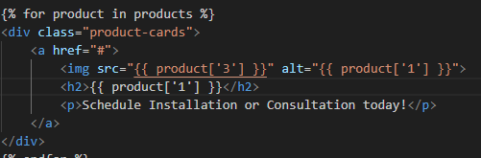  I have realized that I have added apostrophes(‘) unnecessarily.  Instead of this:  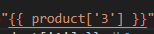  It should look like this:  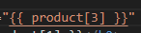  Test2:  Works as intended, no further actions
Testing that when a product is clicked, the user is redirected to the “product-info” |  | When the user clicks one of the product cards, they should be redirected to the “product-info” page | Test1: An error occurred “parameters are of unsupported type”  Test2:  An error occurred “parameters are of unsupported type”  Test3:  An error occurred “parameters are of unsupported type”  Test4:  An error occurred “parameters are of unsupported type”  Test5:  An error occurred “parameters are of unsupported type”  Test6:  Error: 'product' is undefined  Test7:  When the user selects a product card, they are redirected to the “product-info” page | Test1:  I will check that the “product_id” variable is an integer. Print(value(product_id))  And I found that it is an integer.  Test2:  Checking what value is being passed for “product_id”  Test3:  Trying a different way to query  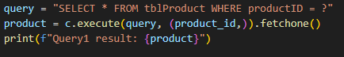  This outputted the correct information, all info from the product with the productID “1”.  Test4:  Printing all of the ids  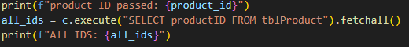  Ids are in a tuple  Test5:  Realized the difference between the query in test3 and my query was a comma. in (product_id))  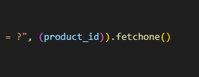  It should have been:  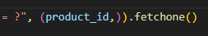  Test6:  Changing the variable from “selected_product” to “product”  Test7:  Works as intended, no further actions required  Test2:  It was an integer. I will check that the value of the product is the corresponding product clicked.
Testing that the “product-info” page displays the correct information when a user selects a product card on “green-energy-products” page. |  | Once the user selects a product card, they will be redirected to the “product-info” page, and this page SHOULD contain the information of the product they selected.
Add more rows and tables as required.

